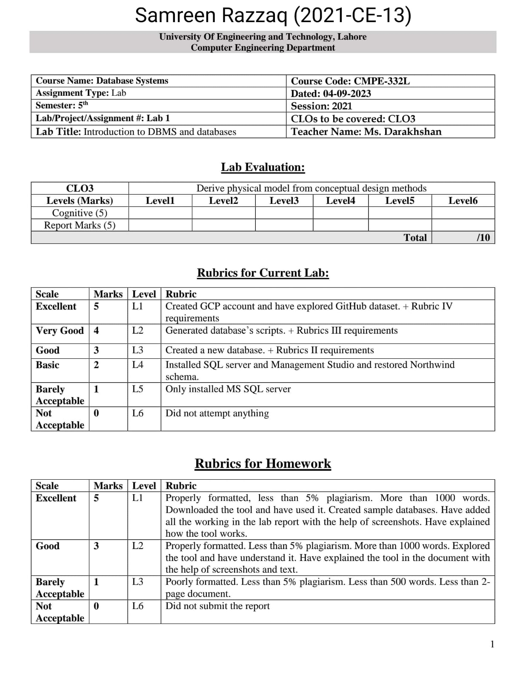

**Homework Questions:**

Explore one additional tool for database models, run it on your machine and write your learning experience in a document named as DBtool_2021_CE_13.docx format.

**MySQL Workbench:**

MySQL Workbench is an integrated development environment (IDE) specifically designed for MySQL database development. It offers a range of features for database modeling, design, and administration.

Here's a brief overview of MySQL Workbench and some key features:

1. Database Design

2. Query Development

3. Data Migration and Import/Export

4. Administration and Server Management

5. Collaboration and Version Control

6. Extensibility

Some key learning points may include:

* How to create and modify database models using the visual designer.
* Writing and executing SQL queries.
* Data import/export and migration tasks.
* Managing database servers and user privileges.
* Exploring performance tuning options.

Overall, MySQL Workbench is a powerful tool for database modeling and management, and learning to use it effectively can significantly enhance your database development skills.