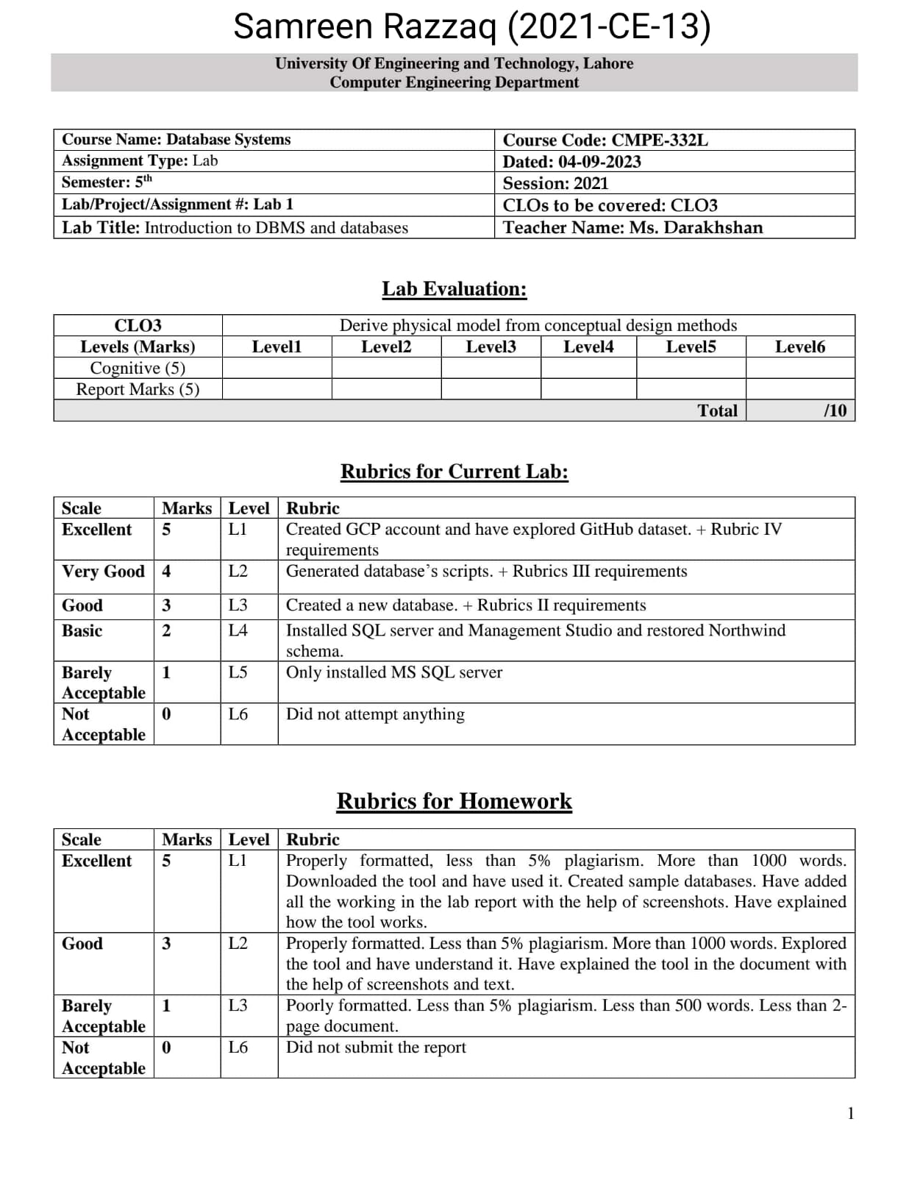

**Homework Questions:**

• Write your understanding related to Bigquery and GitHub dataset in the file GCP_2021_CE_X.docx and submit on google classroom.

There are some basic information of BigQuery:

**BigQuery:**

BigQuery is a cloud-based data warehouse and analytics platform provided by Google Cloud. It uses an SQL-like language called BigQuery SQL for querying and analyzing large datasets.

There are some terminologies we use in BigQuery:

1. Querying Tables

2. Filtering Data

3. Aggregating Data

4. Joining Tables

5. Grouping Data

6. Ordering Data

7. Creating Temporary Tables

8. Working with Date and Time

9. Subqueries

10. Advanced Analytics

**Exploring BigQuery:**

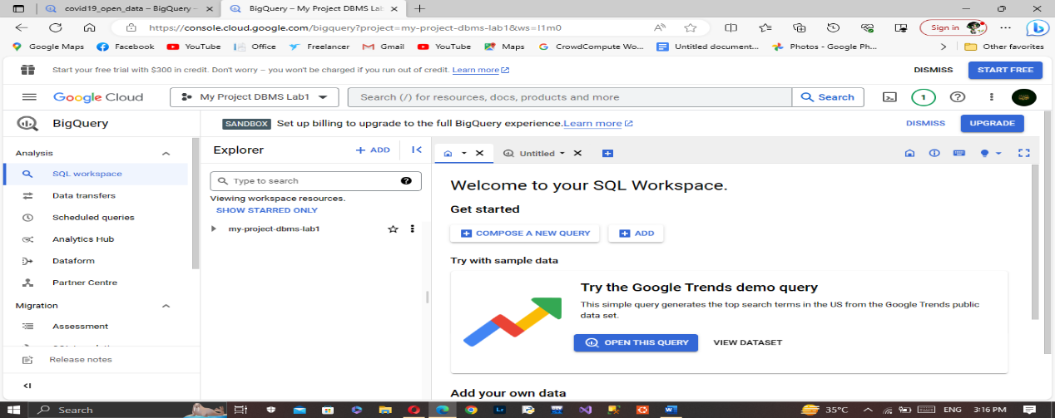 I explore about BigQuery in which I learn how to compose new queries and view various queries from SQL Workspace. Like this:

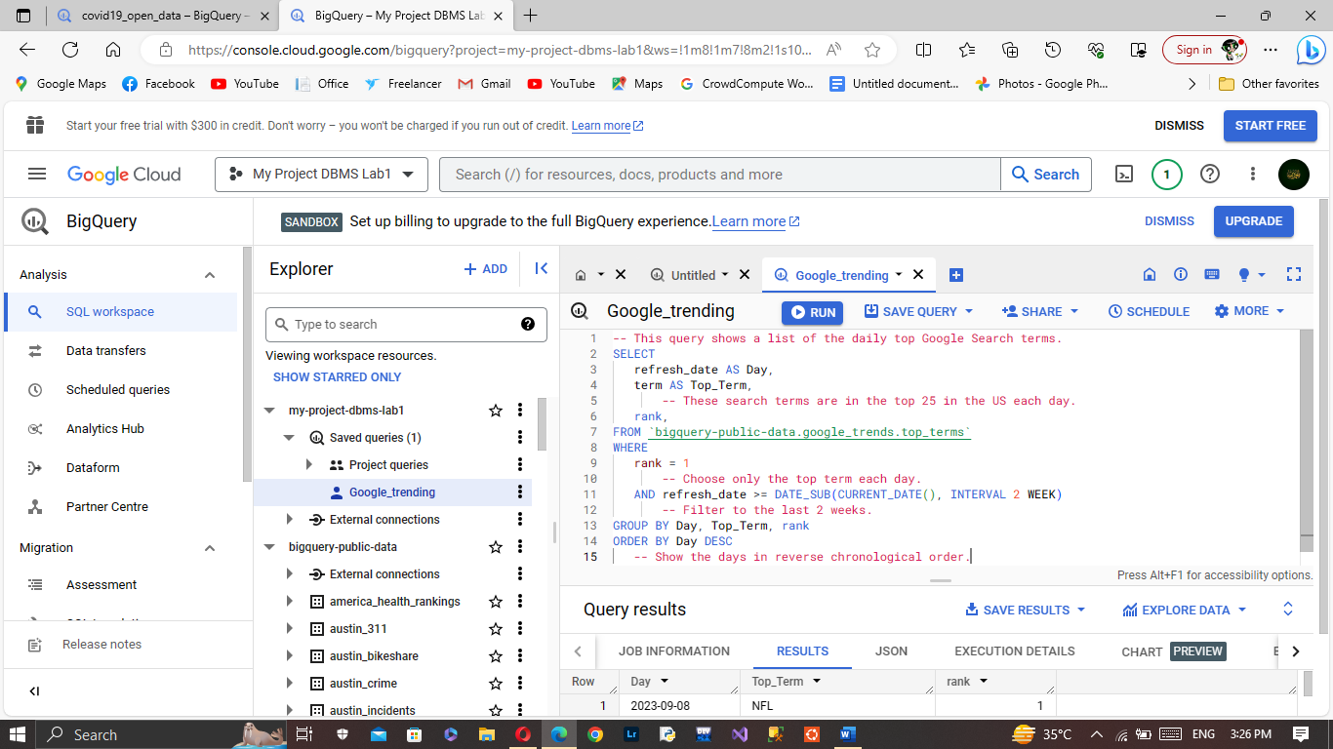I also view already existing query of Google_trends:

And explore the results of this query: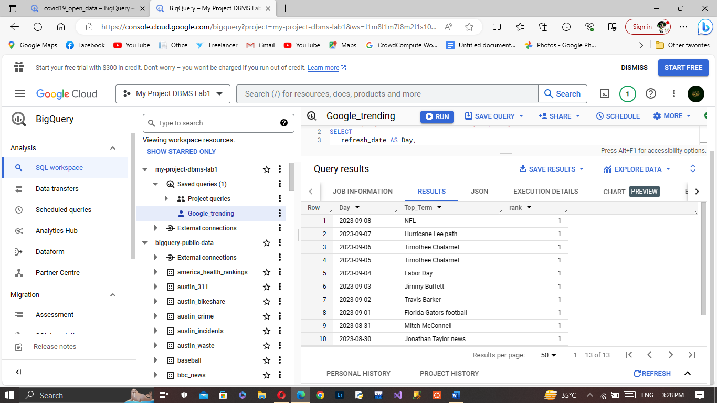

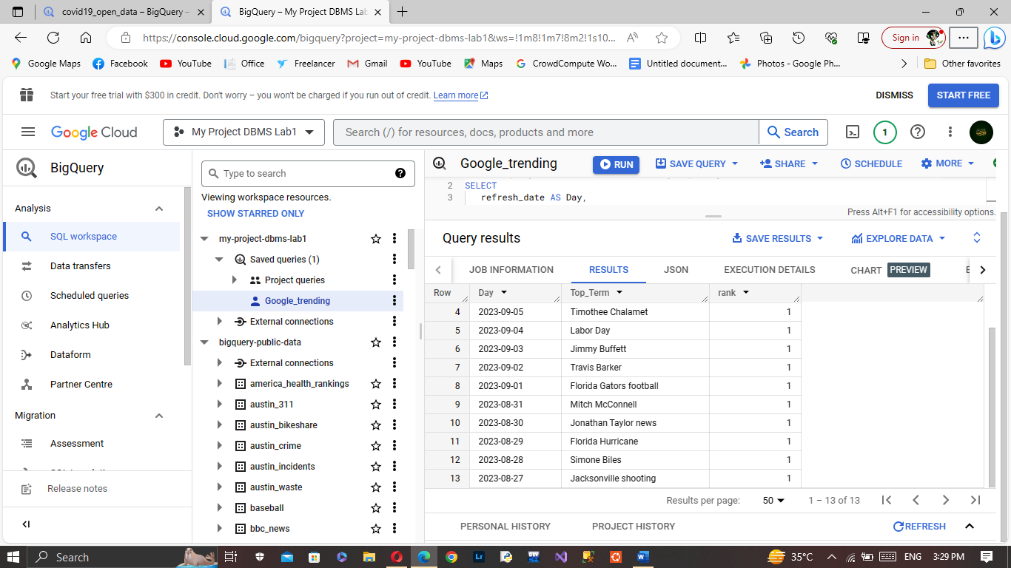

**Exploring of Datasets:**

I explore many datasets from SQL Workspace. I learn that how to create new data sets and view various datasets. Like this:

1. Data set information of GitHub_repository:

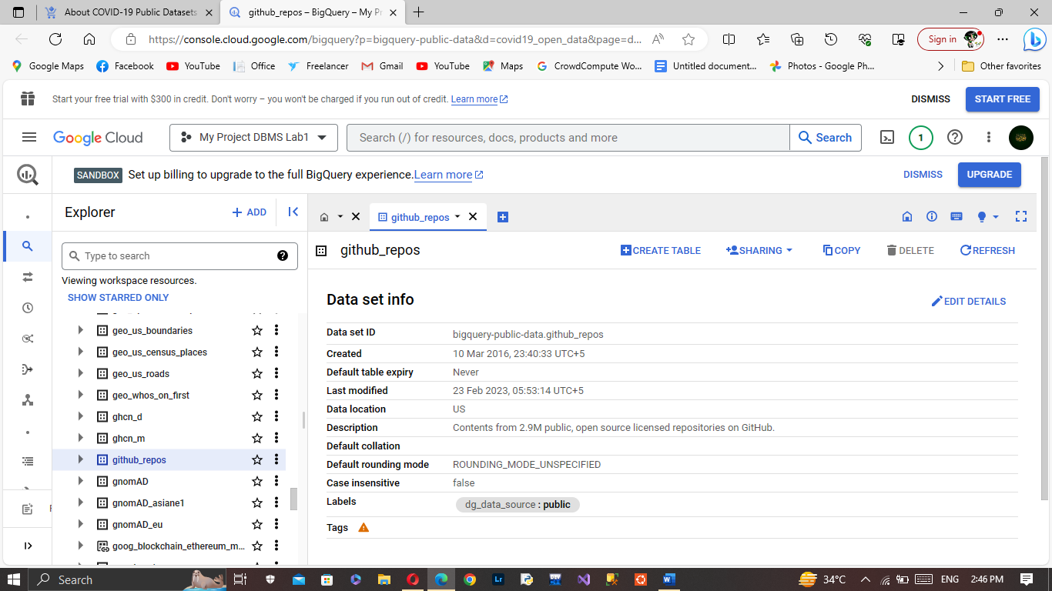

1. Data set information of Google_trends:

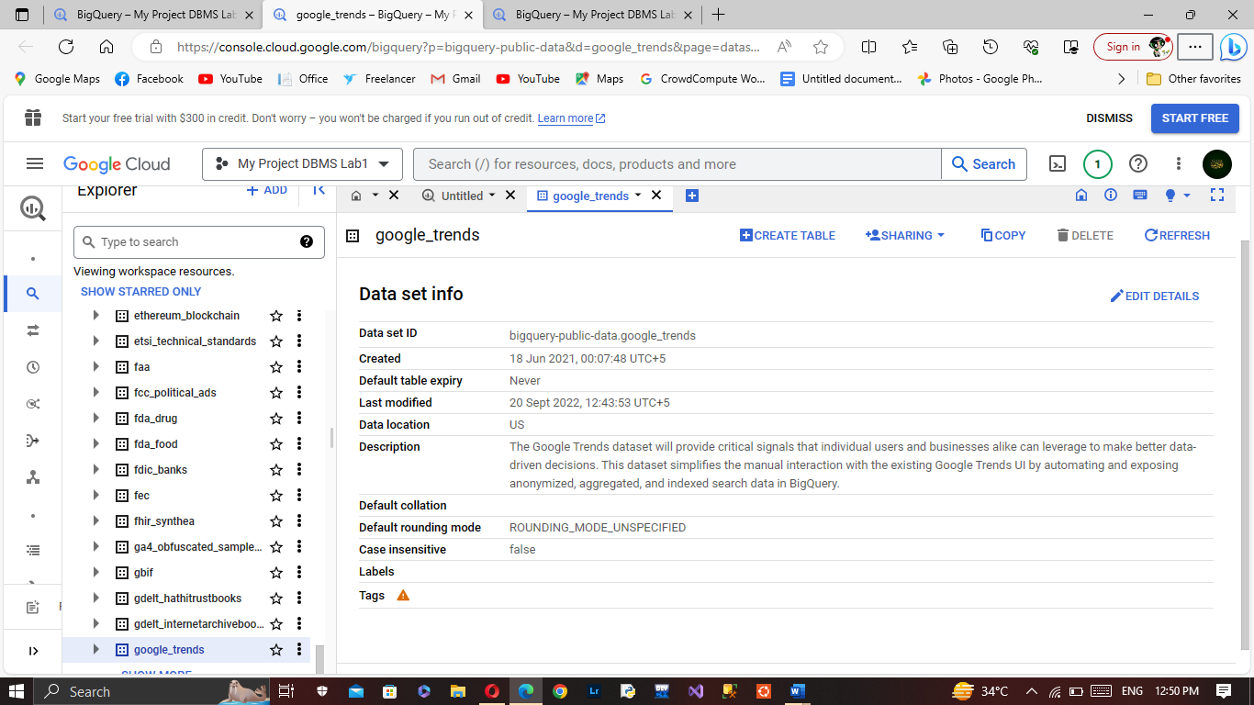

1. Data set information of covid19_open_data:

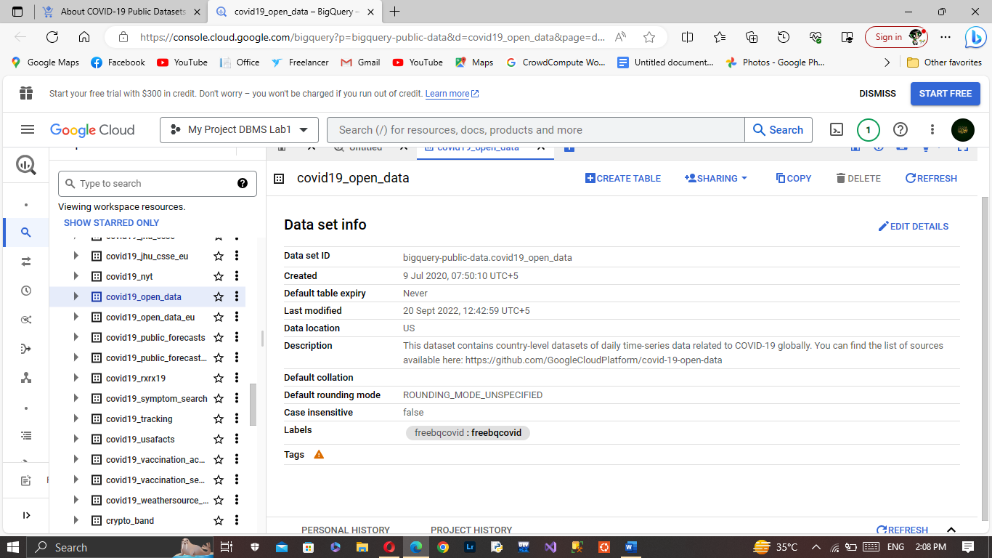

We can also create new data sets :

