**Additional work (practice)**

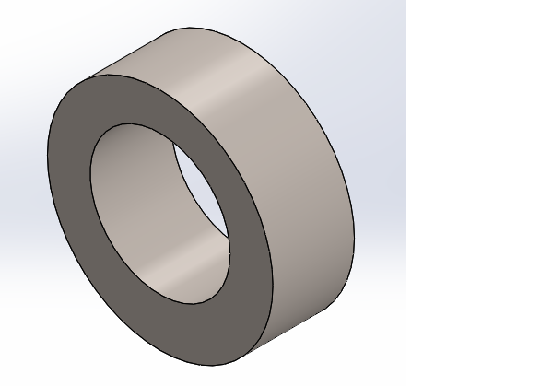

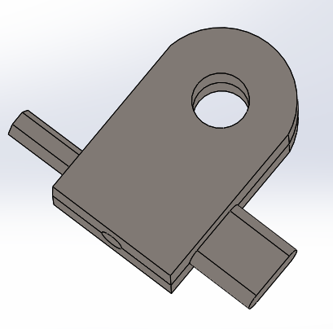

**Lab Session 1:** To introduce CAD/CAM, software packages, its advantages, disadvantages, and applications.

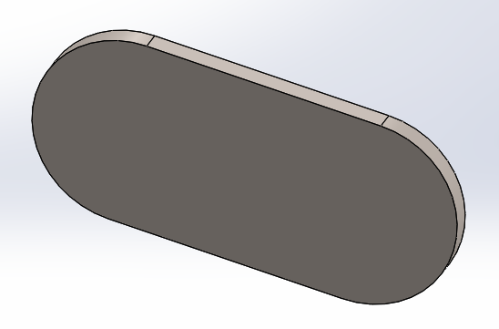

**Lab Session 2:** To design the 3D model of the part on Solid works by using Extrude, Extrude-Cut, Fillet & Chamfer commands.

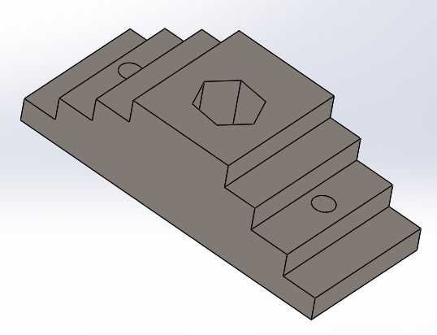

**Lab Session 3:** To execute Mirror, Pattern & Revolve Command in 3D environment and practice drawings for these commands.

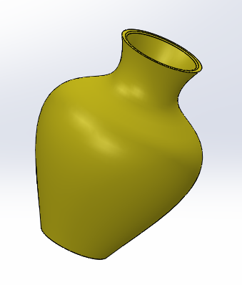

**Lab Session 4:** To execute sweep feature in 3D environment and modelling objects and practice drawings.

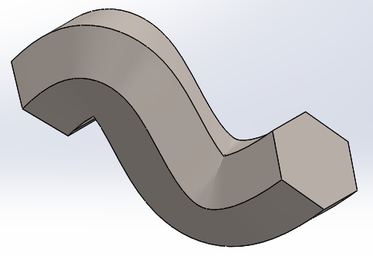

**Lab Session 5:** To execute Loft feature in 3D environment and modelling objects and practice drawings for these commands.

**Cup**

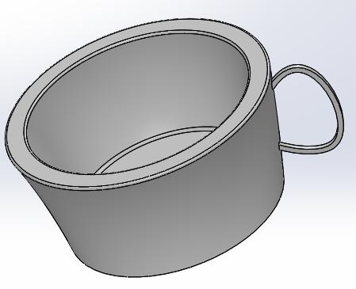

**Lab Session 6:** To execute Loft Cut and Revolve Cut feature in 3D environment and modelling objects and practice drawings for these commands.

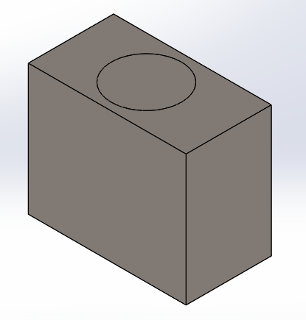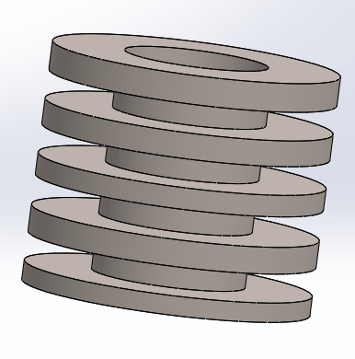**Using Mirror command in 3-D**

**Lab Session 7:** To familiarize students with Assembly environment and practical drawing to make and then assemble.

**Flange Coupling**

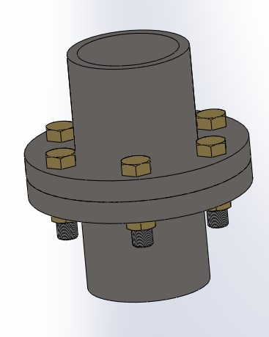

**Lab Session 8:** To generate hexagonal nut and bolt in part interface and mate them in assembly interface.

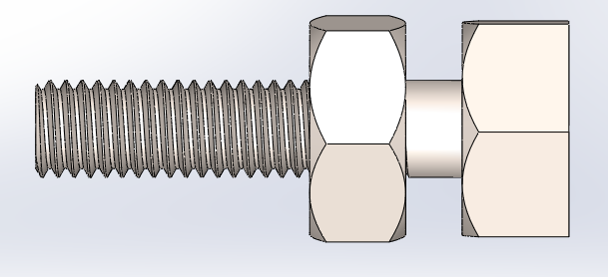

**Lab Session 9:** Making machine parts by using solid works.

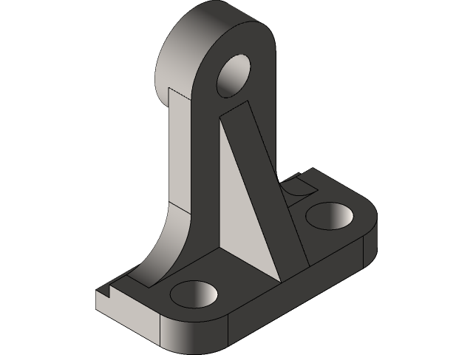

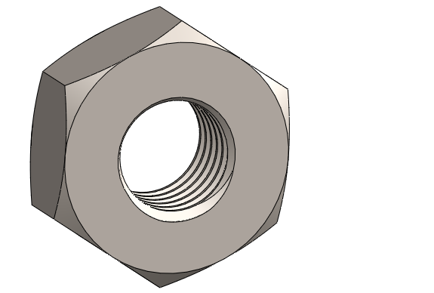**Assignment 1:** SolidWorks Nut and Bolt, Thread Feature and Animation**.**

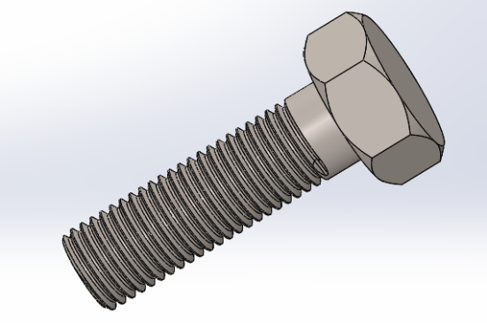**Nut and Bolt**

**By assembling these components, the final result is:**

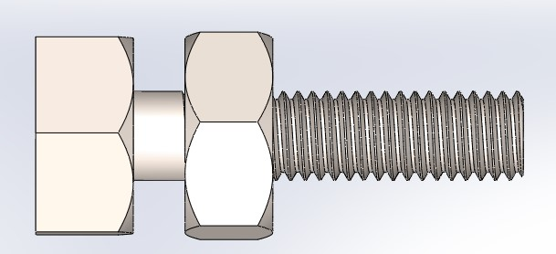

**Assignment 2:** Roller Support Assembly in SolidWorks.

**Belt and Roller**

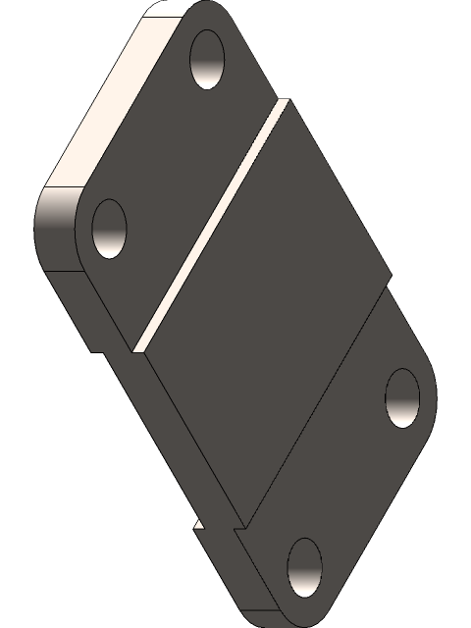

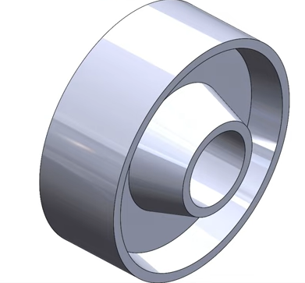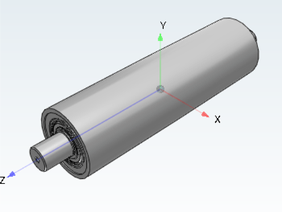

**By assembling these components, the final result is:**

