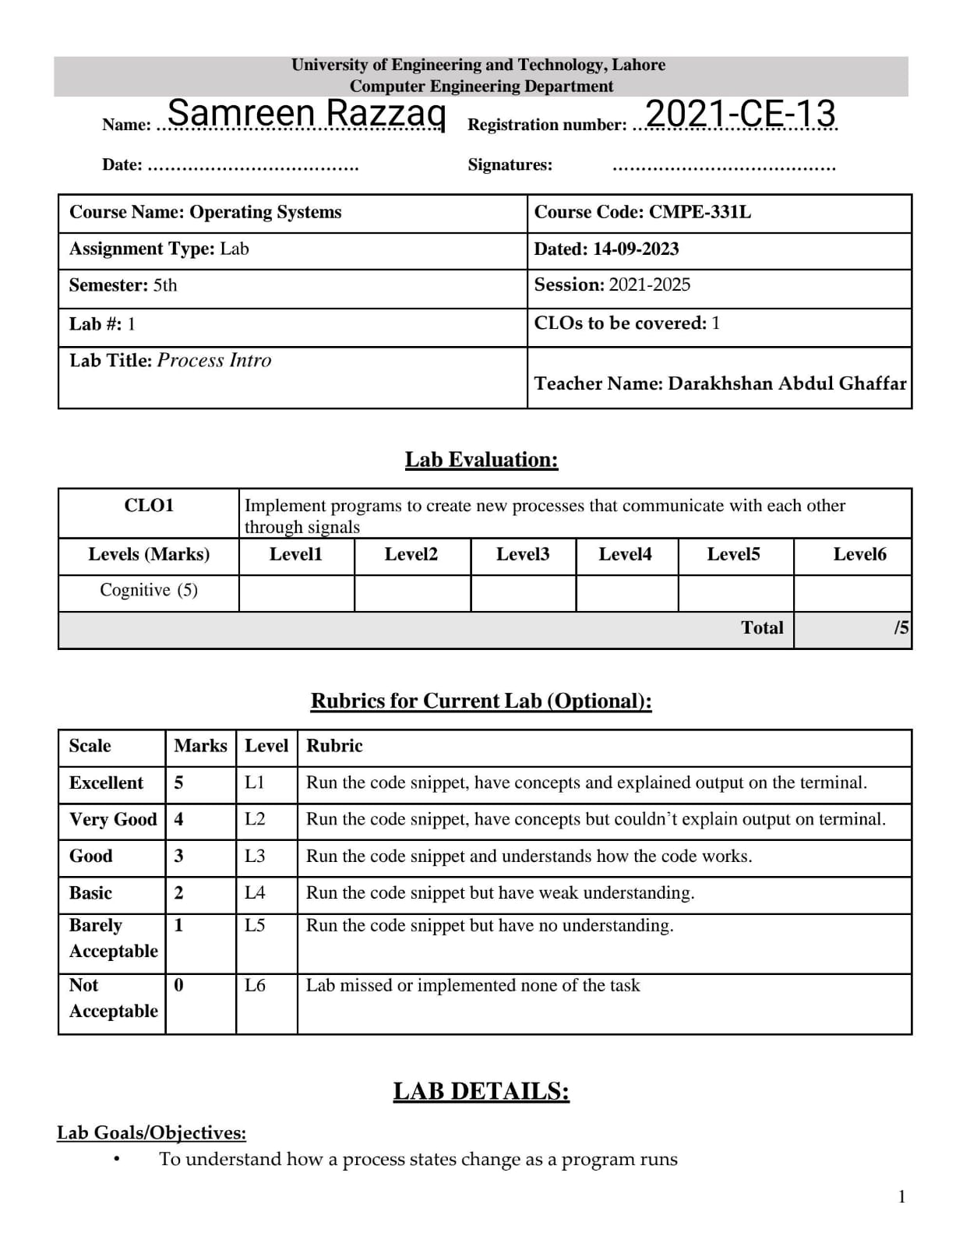

**Lab Tasks:**

1. **Run process-run.py with the following flags: -l 5:100,5:100. What should the CPU utilization be (e.g., the percent of time the CPU is in use?) Why do you know this?**

We firstly put -l 5:100,5:100 command. In this we see that it has 5 instructions two times and 100% chances that it required CPU. Now see the result:

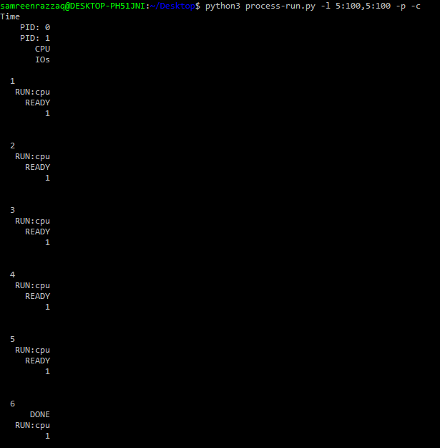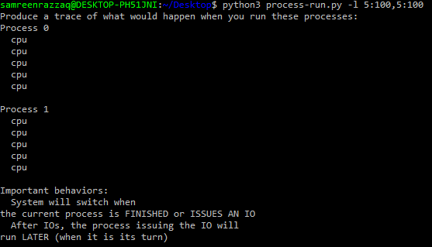 And then we give command -l 5:100,5:100 -p -c. Here -p is the flag, it gives us information about stats. Like this:

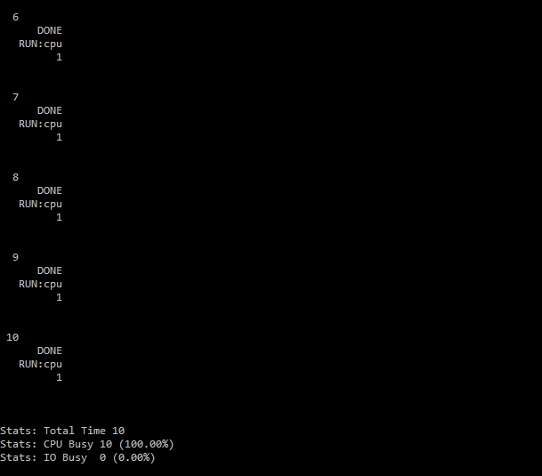

1. **Now run with these flags: ./process-run.py -l 4:100,1:0. These flags specify one process with 4 instructions (all to use the CPU), and one that simply issues an I/O and waits for it to be done.**

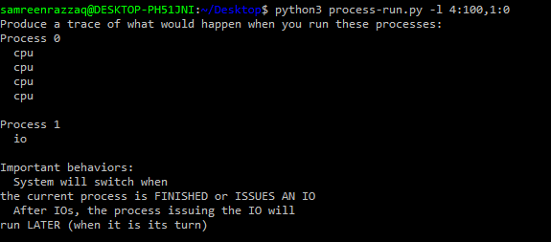We firstly put -l 4:100,1:0 command. In this we see that firstly there is 4 instructions and 100% chances that it required CPU. And then there is 1 instruction that run on io . Now see the result:

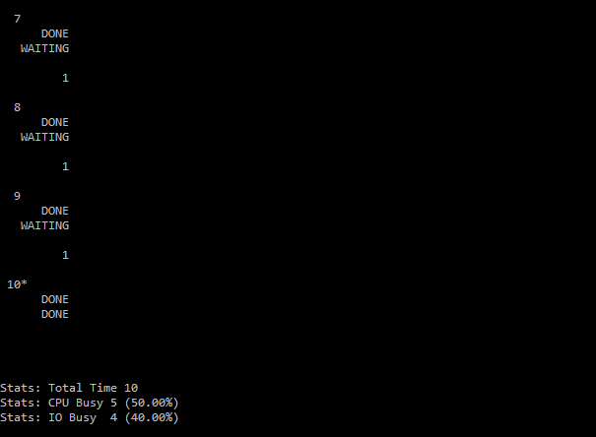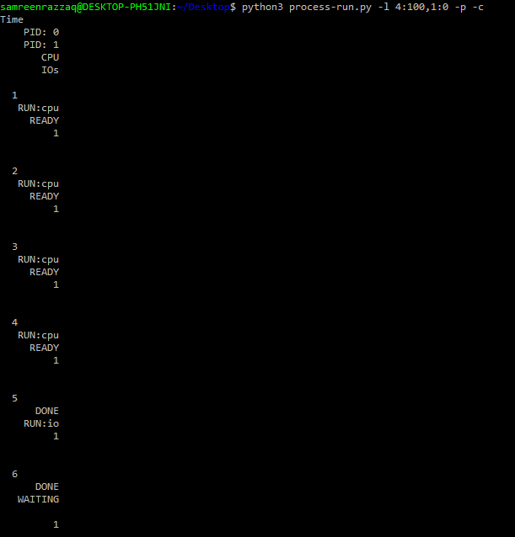And then we give command -l 4:100,1:0 -p -c. Here -p is the flag, it gives us information about stats. Like this:

**How long does it take to complete both processes?**

CPU takes 50% and IO takes 40%. We calculate this by using:

As we know, total time=10:

Then,

**5/10 * 100** = **50.00%** (CPU Busy in 5 instructions)

**4/10 * 100 =** **40.00%** (IO Busy in 4 instructions)

So, this is the time that it takes to complete both processes.

1. **Switch the order of the processes: -l 1:0,4:100. Why? (As always, use -c and -p to see if you were right)**

We firstly put -l 1:0,4:100 command. In this we see that firstly there is 1 instruction that run on io. And then there is 4 instructions and 100% chances that it required CPU. Now see the result:

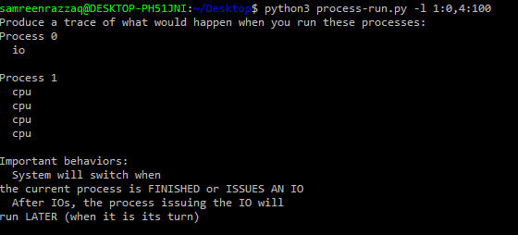

And then we give command -l 1:0,4:100 -p -c. Here -p is the flag, it gives us information about stats. Like this:

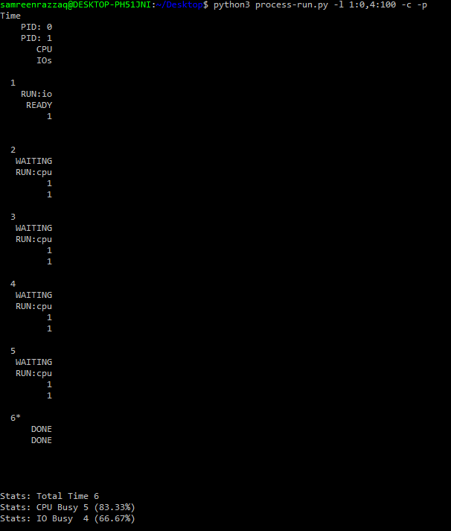

**What happens now? Does switching the order matter?**

Yes, switching matters. In Q#2, firstly CPU takes instruction then IO takes. During IO’s instruction is run, CPU waits (its time is lost). CPU is in ideal condition. But in Q#3, firstly IO takes instruction the CPU work. In this process, CPU’s time is not lost. In this, CPU’s time is save and then CPU and io work together.

CPU takes 83.33% and IO takes 66.67%. We calculate this by using:

As we know, total time=6:

Then,

**5/6 * 100** = **83.33%** (CPU Busy in 5 instructions)

**4/6 * 100 =** **66.67%** (IO Busy in 4 instructions)

So, this is the time that it takes to complete both processes.