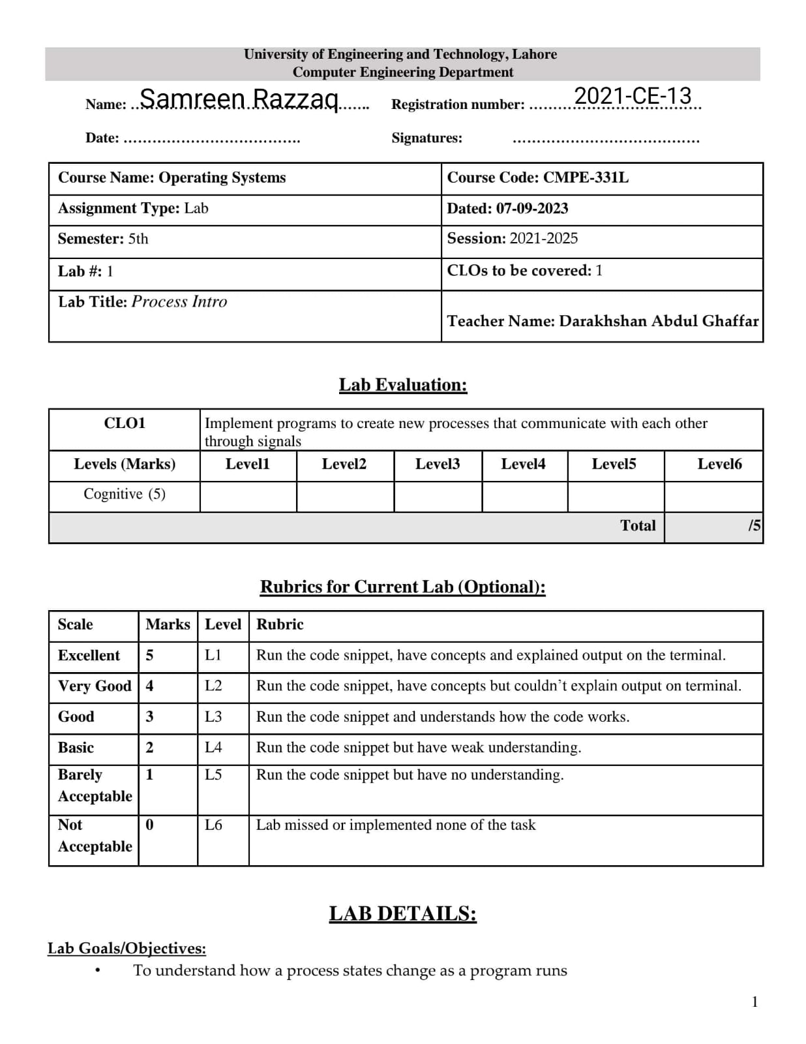

**Homework Tasks:**

**In this task, you will understand the hardware configuration of your working machine using the /proc file system.**

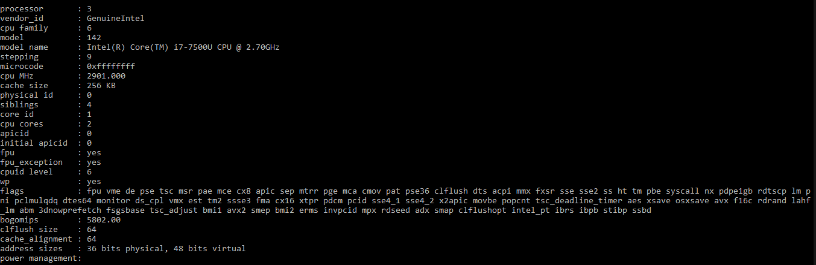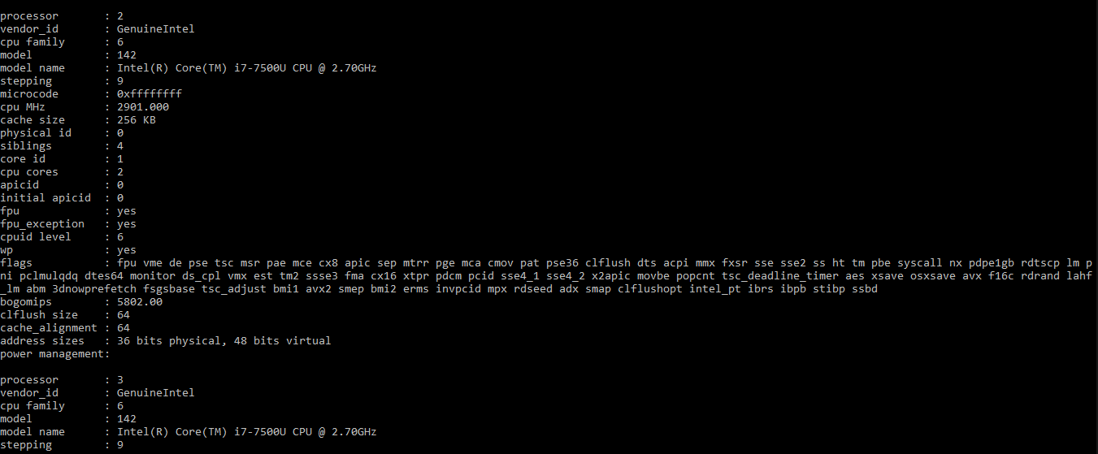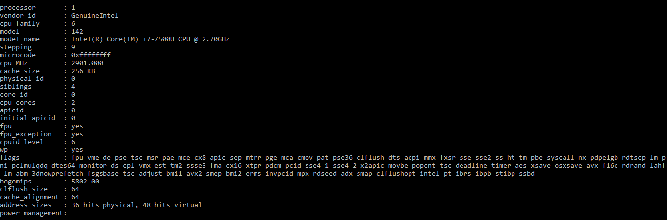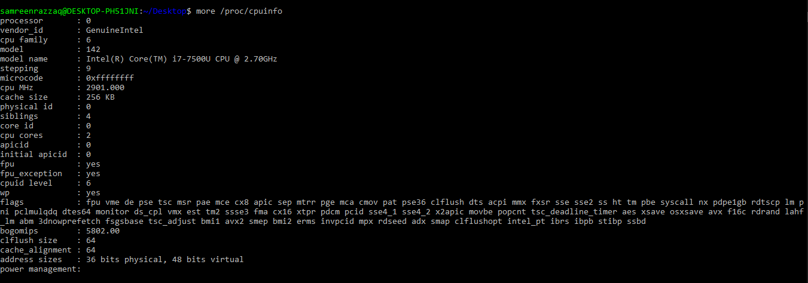(a) Run command more /proc/cpuinfo and explain the following terms: processor and cores. Use the command lscpu to verify your definitions.

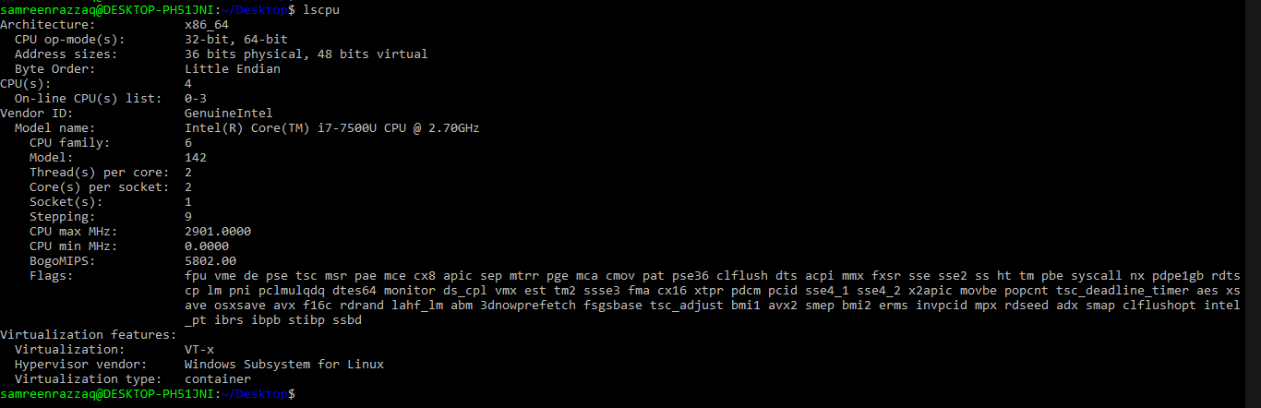 **lscpu:**

(b) How many cores does your machine have?



(c) How many processors does your machine have?



(d) What is the frequency of each processor?



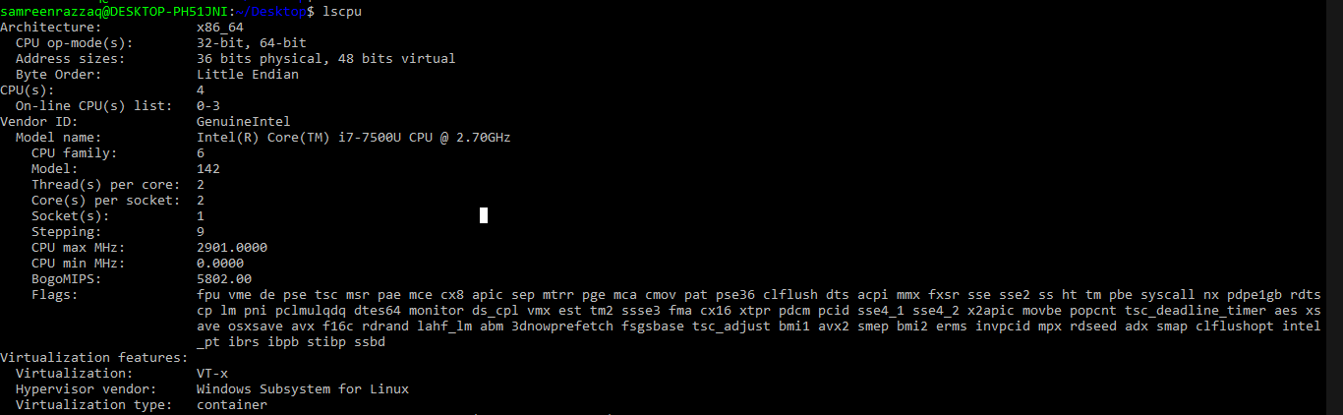(e) What is the architecture of your CPU?

(f) How much physical memory does your system have?

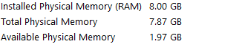

(g) How much of this memory is free?



(h) What is total number of number of forks and context switches since the system booted up?

Total number of forks (process creation):

Total number of context switches:

**Lab Tasks:**

In this lab, we'll see how these process states change as a program runs, and thus learn a little bit better how these things work.

To run the program and get its options, do this:

prompt> ./process-run.py -h

If this doesn't work, type "python" before the command, like this:

prompt> python process-run.py -h

What you should see is this:

Usage: process-run.py [options]

1. 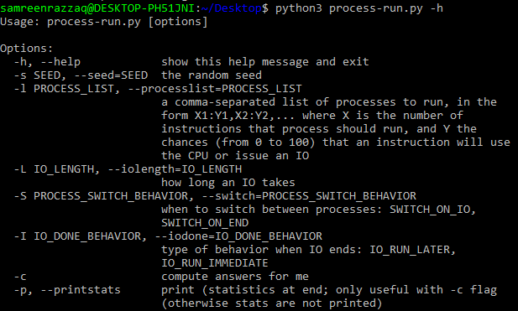**By putting -h:**
2. **By putting -l 5:100:**

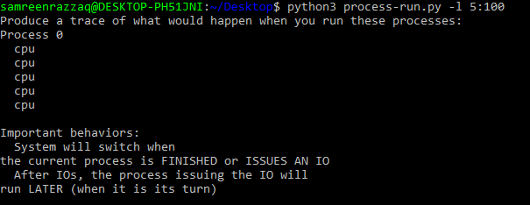

1. **By putting -l 5:100 -c:**

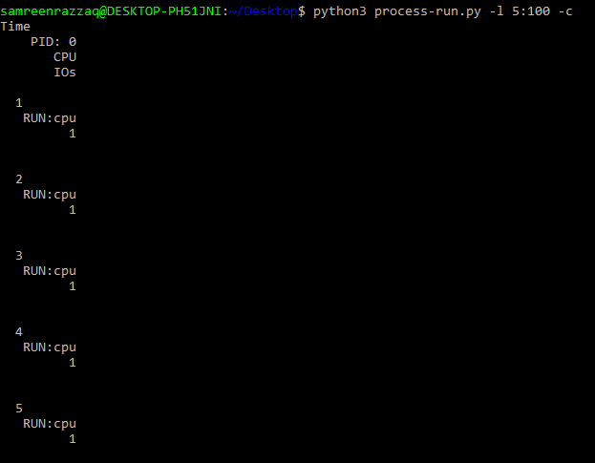

1. **By putting -l 5:100,5:100:**

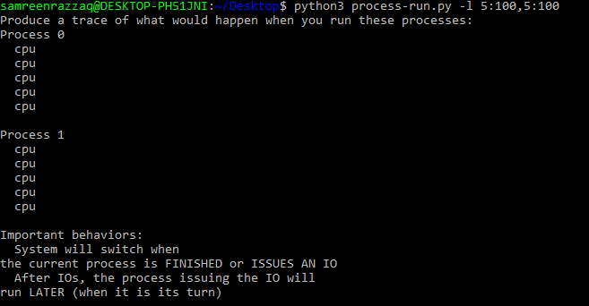

1. **By putting -l 5:100,5:100 -c:**

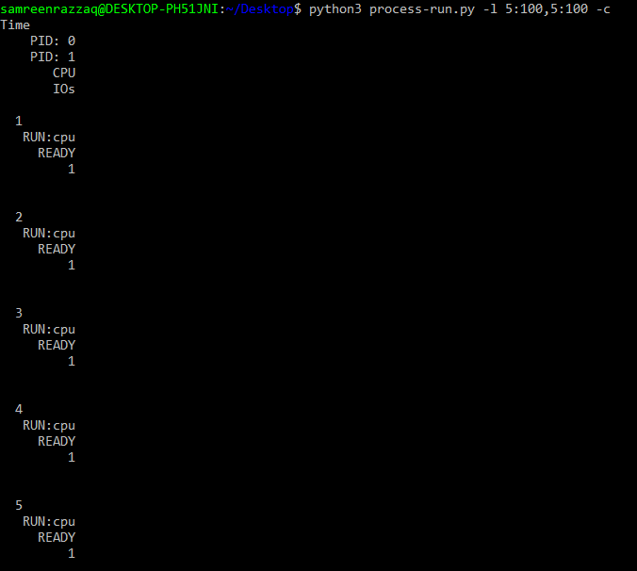

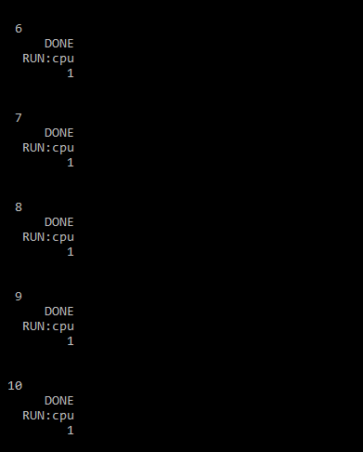

1. **By putting -l 3:0 -L 5:**

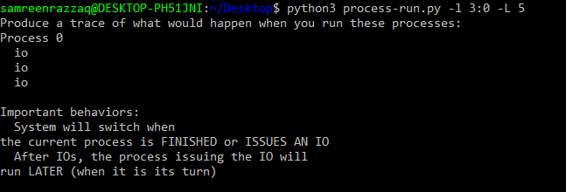

1. **By putting -l 3:0 -L 5 -c:**

