ST.XAVIER’S COLLEGE
(Affiliated to Tribhuvan University)
Maitighar , Kathmandu



Final Assignment

SUBMITTED BY :
Samrid Man Baniya
016BSCIT029

SUBMITTED TO :
Mr. Nitin Malla
(Lecturer)

Department of Computer Science and Information Technology

Q1. Discuss ACID Property of a database transaction with example.

Ans: A ​transaction is a single logical unit of work which accesses and possibly modifies the contents of a database. Transactions access data using read and write operations. In order to maintain consistency in a database, before and after the transaction, certain properties are followed. These are called ​ACID​properties.
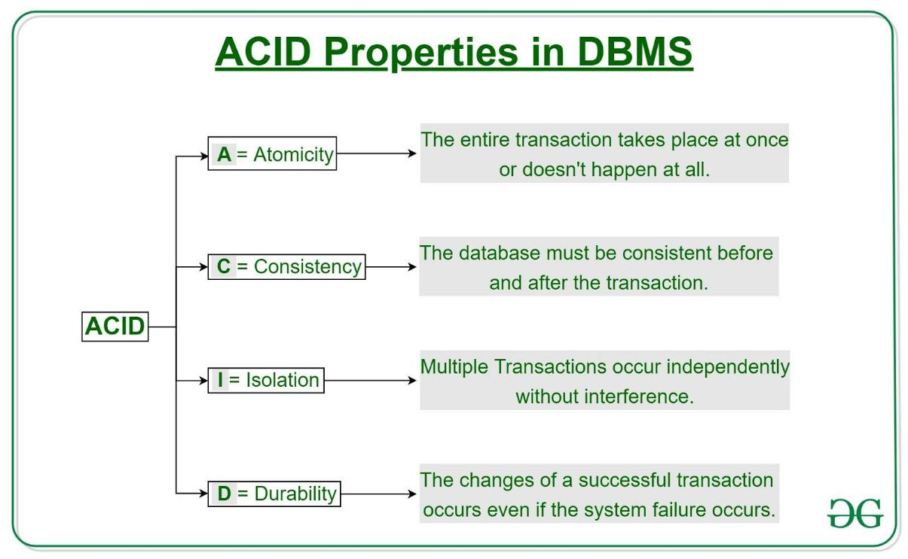

Atomicity

By this, we mean that either the entire transaction takes place at once or doesn’t happen at all. There is no midway i.e. transactions do not occur partially. Each transaction is considered as one unit and either runs to completion or is not executed at all. It involves the following two operations.

—​Abort​: If a transaction aborts, changes made to database are not visible.

—Commit​:​ If a transaction commits, changes made are visible.

Atomicity is also known as the ‘All or nothing rule’.

Consider the following transaction ​T consisting of ​T1 and ​T2​: Transfer of 100 from account X​to account ​Y​.
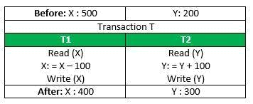

If the transaction fails after completion of ​T1 but before completion of ​T2​.( say, after write(X) but before ​write(Y)​), then amount has been deducted from ​X but not added to ​Y​. This results in an inconsistent database state. Therefore, the transaction must be executed in entirety in order to ensure correctness of database state.

​Consistency

This means that integrity constraints must be maintained so that the database is consistent before and after the transaction. It refers to the correctness of a database. Referring to the example above,

The total amount before and after the transaction must be maintained.

Total before​ T​occurs = 500​ + 200 = 700.​

Total after​ T occurs​= 400​ + 300 = 700.​

Therefore, database is ​consistent​.Inconsistency occurs in case ​T1 completes but ​T2 fails. As a result T is incomplete.

​Isolation

This property ensures that multiple transactions can occur concurrently without leading to the inconsistency of database state. Transactions occur independently without interference. Changes occurring in a particular transaction will not be visible to any other transaction until that particular change in that transaction is written to memory or has been committed. This property ensures that the execution of transactions concurrently will result in a state that is equivalent to a state achieved these were executed serially in some order.

Let ​X​= 500, ​Y​= 500.

Consider two transactions ​T​and ​T”.
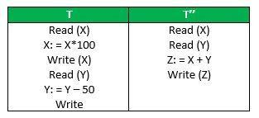
Suppose ​T has been executed till ​Read (Y) and then ​T’’ starts. As a result , interleaving of operations takes place due to which ​T’’ reads correct value of ​X but incorrect value of ​Y and sum computed by

T’’: (X+Y = 50, 000+500=50, 500)

is thus not consistent with the sum at end of transaction:

T: (X+Y = 50, 000 + 450 = 50, 450)​.

This results in database inconsistency, due to a loss of 50 units. Hence, transactions must take place in isolation and changes should be visible only after they have been made to the main memory.

Durability:

This property ensures that once the transaction has completed execution, the updates and modifications to the database are stored in and written to disk and they persist even if a system failure occurs. These updates now become permanent and are stored in non-volatile memory. The effects of the transaction, thus, are never lost.

Q2. How does a category or union type differ from a regular shared subclass? What is a category used for? Illustrate your answer with suitable examples.

Ans: ​A category has two or more superclasses that may represent distinct entity types, while other regular shared subclasses always have a single superclass. An entity which is the member of shared subclass must exist in all superclasses, but in case of category, a member entity can be a part of any one of superclass. Moreover, attribute inheritance works selectively in case of categories.

A category is used when we need arises for modeling a single superclass/subclass relationship with more than on superclass, where the superclasses represent different entity types. The subclass will represent a collection of objects that is a subset of distinct entity types. For example, a piece of land which can be owned by a person, a company or a bank. All of these entities are different types, but they will jointly form total set of the land owners.

Q3. What is the difference between persistent and transient objects? How persistence is handled in typical OO database systems?

Ans: The difference between persistent and transient objects is discuss below:-

Transient Objects:

Transient Objects are that has been just instantiated. Transient objects don't have representation and identifier value in the databases. The transient objects will be destroyed by the garbage collector if they don't have any use and reference in the database.
Persistent Objects:

Persistent Objects have representation in databases and identifiers. These objects are saved in the databases. Persistent objects are synchronized with that of the database.

The persistence in Object Oriented Databases is handled by creating Persistent Objects and Transient Objects. As stated above the persistent objects have representations in the databases.

Q4. What is the difference between structured and unstructured complex object? Differentiate identical versus equal objects with examples.

Ans: The difference between structured and unstructured complex object is given below:-

Structured Complex object:

Structured complex object is defined by repeated application of the type constructors provided by the OODBMS. Simply structured complex objects are constructed by using type constructors (set, atom, tuple etc.). Hence, the object structure is defined and known to the OODBMS. The OODBMS also defines methods or operations on it.

Two types of reference semantics ( ownership semantics and reference semantics ) exist between a complex object and its components at each level.

- Ownership semantics applies when the sub-objects of a complex object are encapsulated within the complex object and are hence considered part of the complex object. It is also called is-part-of or is-component-of relationship. e.g., “Arjun” atomic value owned by employee. Means that ‘Arjun’ is dependent on owner.

- Reference semantics applies when the components of the complex object are themselves independent objects but may be referenced from the complex object. It is also called is-associated-with relationship. e.g., Department referenced by the employee object.

Unstructured complex objects:

It is a data type provided by a DBMS and permits the storage and retrieval of large objects that are needed by the database application. These objects are unstructured in the sense that the DBMS does not know what their structure is, only the application programs that uses them can interpret their meaning. These objects are considered complex because they require large area of storage and are not part of the standard data types provided by traditional DBMSs.

The difference between​​identical versus equal objects with examples is given below:-

Identity object:

identity: a variable holds the ​same​instance as another variable. For example:
Integer a = new Integer(1); Integer b = a;

a is identical to b.

In Java, identity is tested with ==. For example, if( a == b ).

Equality object:

equality: two ​distinct​objects can be used interchangeably. they often have the same id. Integer c = new Integer(1); Integer d = new Integer(1); c is equal but not identical to d.

Of course, two identical variables are always equal.

Q5. Describe object Collection type, Set, List, Bag, Array and Dictionary.

Ans:​​Collection Type
A collection is an ordered group of elements of same type. The purpose of collection type is to support multiple values for one attribute [variable]. For example, other programming languages support the collection types array, lists, sets, bags, trees etc. To extend these features in database applications, PL/SQL provides the following collection types;

- Nested Tables

- VARRAYs (Varying arrays)

- Associative Arrays

Set

In mathematics, a set is nothing more than a collection of objects. Similarly, in databases, records within a table can be treated as objects in a set - i.e. the table becomes a set of records. The SET operator allows the tables of a database to be treated as objects in a set when performing a query.

In mathematics, the various operations on sets using mathematical operators, must act on at least two different sets to produce results. Naturally, when applied to databases, SET operations must work on two or more different database tables too.

The SET operators available for use on a database are identical to those available in mathematics. They include:

- INTERSECT

- UNION

- DIFFERENCE (implemented as EXCEPT in MS SQL, and MINUS in Oracle)

List

Lists are used to store a ​collection of different pieces of information in a ​sequence order of under a single variable name.A list can be used to implement a ​Python - Stack​. A list is mutable whereas a ​tuple​is not.

Bag

Database systems cope with the management of large groups of persistent data in a shared, reliable, effective, and efficient way. Within a database, a multiset (or bag) is a collection of elements of the same type that may contain duplicates.

Array

An array is a special variable that allows storing one or more values in a single variable e.g. – holding usernames or details in an Array.Array database management systems (array DBMSs) provide ​database services specifically for ​arrays (also called ​raster data​), that is: homogeneous collections of data items (often called ​pixels​,​voxels​,etc.), sitting on a regular grid of one, two, or more dimensions. Often arrays are used to represent sensor, simulation, image, or statistics data. Such arrays tend to be ​Big Data​, with single objects frequently ranging into Terabyte and soon Petabyte sizes; for example, today’s earth and space observation archives typically grow by Terabytes a day. Array databases aim at offering flexible, scalable storage and retrieval on this information category.

Dictionary

Data Dictionary consists of database metadata. It has records about objects in the database.

Data Dictionary consists of the following information −

- Name of the tables in the database

- Constraints of a table i.e. keys, relationships, etc.

- Columns of the tables that related to each other

- Owner of the table

- Last accessed information of the object

- Last updated information of the object

An example of Data Dictionary can be personal details of a student −

Example

<StudentPersonalDetails>

Student_ID | Student_Name | Student_Address | Student_City

The following is the data dictionary for the above fields −

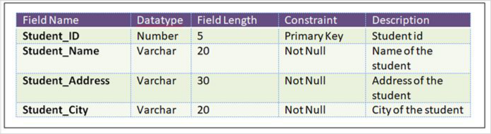

Types of Data Dictionary

Here are the two types of data dictionary −

- Active Data Dictionary

The DBMS software manages the active data dictionary automatically. The modification is an automatic task and most RDBMS has active data dictionary. It is also known as integrated data dictionary.

- Passive Data Dictionary

Managed by the users and is modified manually when the database structure change. Also known as non-integrated data dictionary.

Q6. Describe the main reasons for the potential advantage for distributed database. What additional functions does it have over centralized DBMS?

Ans: Distributed databases basically provide us the advantages of distributed computing to the database management domain. Basically, we can define a Distributed database as a collection of multiple interrelated databases distributed over a computer network and a distributed database management system as a software system that basically manages a distributed database while making the distribution transparent to the user.

Distributed database management basically proposed for the various reason from organizational decentralization and economical processing to greater autonomy. Some of these advantages are as follows:

1. Management of data with different level of transparency –

Ideally, a database should be distribution transparent in the sense of hiding the details of where each file is physically stored within the system. The following types of transparencies are basically possible in the distributed database system:

- Network transparency:

This basically refers to the freedom for the user from the operational details of the network. These are of two types Location and naming transparency.

- Replication transparencies:

It basically made user unaware of the existence of copies as we know that copies
of data may be stored at multiple sites for better availability performance and reliability.

  - Fragmentation transparency:

It basically made user unaware about the existence of fragments it may be the vertical fragment or horizontal fragmentation.

- Increased Reliability and availability –

Reliability is basically defined as the probability that a system is running at a certain time whereas Availability is defined as the probability that the system is continuously available during a time interval. When the data and DBMS software are distributed over several sites one site may fail while other sites continue to operate and we are not able to only access the data that exist at the failed site and this basically leads to improvement in reliability and availability.

3. Easier Expansion –

In a distributed environment expansion of the system in terms of adding more data, increasing database sizes, or adding more data, increasing database sizes or adding more processor is much easier.

4. Improved Performance –

We can achieve interquery and intraquery parallelism by executing multiple queries at different sites by breaking up a query into a number of subqueries that basically executes in parallel which basically leads to improvement in performance.

The additional functions does it have over centralized DBMS is described below:

- Increased reliability and availability – A distributed database system is robust to failure to some extent. Hence, it is reliable when compared to a Centralized database system.

- Local control – The data is distributed in such a way that every portion of it is local to some sites (servers). The site in which the portion of data is stored is the owner of the data.

- Modular growth (resilient) – Growth is easier. We do not need to interrupt any of the functioning sites to introduce (add) a new site. Hence, the expansion of the whole system is easier. Removal of site is also does not cause much problems.

- Lower communication costs (More Economical) ​– Data are distributed in such a way that they are available near to the location where they are needed more. This reduces the communication cost much more compared to a centralized system.

- Faster response – Most of the data are local and in close proximity to where they are needed. Hence, the requests can be answered quickly compared to a centralized system.

- Reflects the organizational structure – Normally, database is fragmented into various locations wherever we have controls.
- Secured management of distributed data – Various transparencies like network transparency, fragmentation transparency, and replication transparency are implemented to hide the actual implementation details of the whole distributed system. In such way, Distributed database provides security for data.

- Robust – The system is continued to work in case of failures. For example, replicated distributed database performs in spite of failure of other sites.

- Complied with ACID properties – Distributed transactions demands Atomicity, Consistency, Isolation, and Reliability.

- Improved performance and Parallelism​in executing transactions can be achieved.

Q7. Discuss how time is represented in temporal databases and compare the different time dimensions.

Ans: Databases that store information about states of the real world across time are called temporal databases. A temporal database stores data relating to time instances. It offers temporal data types and stores information relating to past, present and future time. Temporal databases could be uni-temporal, bi-temporal or tri-temporal.

More specifically the temporal aspects usually include ​valid time​, ​transaction time or decision time​.

- Valid time is the time period during which a fact is true in the real world.

- Transaction time is the time at which a fact was recorded in the database.

- Decision time is the time at which the decision was made about the fact.

Q8. What is data mining? Discuss data mining as a part of knowledge discovery process.

Ans: In simple words, data mining is defined as a process used to extract usable data from a larger set of any raw data. It implies analysing data patterns in large batches of data using one or more software. Data mining has applications in multiple fields, like science and research. As an application of data mining, businesses can learn more about their customers and develop more effective strategies related to various business functions and in turn leverage resources in a more optimal and insightful manner. This helps businesses be closer to their objective and make better decisions. Data mining involves effective data collection and warehousing as well as computer processing. For segmenting the data and evaluating the probability of future events, data mining uses sophisticated mathematical algorithms.

Data Mining also known as Knowledge Discovery in Databases, refers to the nontrivial extraction of implicit, previously unknown and potentially useful information from data stored in databases.

Steps Involved in KDD Process:
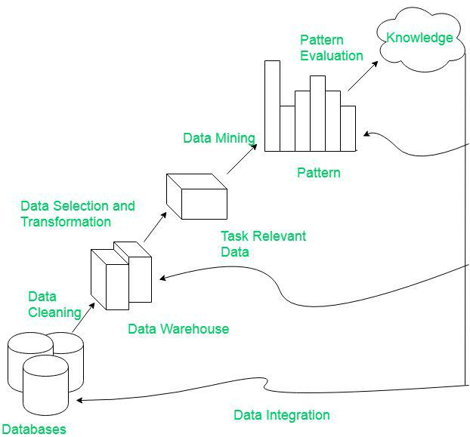

KDD process

  - Data Cleaning​: Data cleaning is defined as removal of noisy and irrelevant data from collection.

    - Cleaning in case of ​Missing values​.
    - Cleaning ​noisy​data, where noise is a random or variance error.

    - Cleaning with ​Data discrepancy detection and ​Data transformation tools​.

- Data Integration​: Data integration is defined as heterogeneous data from multiple sources combined in a common source(DataWarehouse).

    - Data integration using ​Data Migration tools​.
    - Data integration using ​Data Synchronization tools​.

    - Data integration using ​ETL​(Extract-Load-Transformation) process.
- Data Selection​: Data selection is defined as the process where data relevant to the analysis is decided and retrieved from the data collection.

  - Data selection using ​Neural network​.
  - Data selection using ​Decision Trees​.

  - Data selection using ​Naive bayes​.

  - Data selection using ​Clustering​,​Regression​,etc.

- Data Transformation​: Data Transformation is defined as the process of transforming data into appropriate form required by mining procedure.

Data Transformation is a two step process:

  - Data Mapping​: Assigning elements from source base to destination to capture transformations.
  - Code generation​: Creation of the actual transformation program.
- Data Mining​: Data mining is defined as clever techniques that are applied to extract patterns potentially useful.

  - Transforms task relevant data into ​patterns​.
  - Decides purpose of model using ​classification​or ​characterization​.

- Pattern Evaluation​: Pattern Evaluation is defined as as identifying strictly increasing patterns representing knowledge based on given measures.

  - Find ​interestingness score​of each pattern.
  - Uses ​summarization and ​Visualization to make data understandable by user.

- Knowledge representation​: Knowledge representation is defined as technique which utilizes visualization tools to represent data mining results.
  - Generate ​reports​.
  - Generate ​tables​.

  - Generate ​discriminant rules​,​classification rules​,​characterization rules​,etc.

Q9. Define Active database. Discuss some applications of active database.

Ans: ​An active database is a ​database that includes an ​event-driven architecture (often in the form of ​ECA rules​) which can respond to conditions both inside and outside the database. Possible uses include security monitoring, alerting, statistics gathering and authorization.

Some applications of active database are given below:

- Applications which depend on data monitoring activities such as CIM, Telecommunications Network management, Program trading, Medical and Financial Decision Support Systems can greatly benefit from integration with active database.
- Production control, eg: power plants.

- Maintenance tasks, eg: inventory control.

- Financial applications, eg: stock and bond trading.

- Telecommunication and network management.

- Air traffic control.
- Computer Integrated Manufacturing (CIM).

- Statistics gathering and authorization tools.

Q10. What is Mobile Database? Discuss the characteristics of Mobile Database.

Ans: Mobile databases are separate from the main database and can easily be transported to various places. Even though they are not connected to the main database, they can still communicate with the database to share and exchange data.

The characteristics of Mobile Database is discuss below:

- The mobile database includes the following components −

  - The main system database that stores all the data and is linked to the mobile database.

  - The mobile database that allows users to view information even while on the move. It shares information with the main database.

  - The device that uses the mobile database to access data. This device can be a mobile phone, laptop etc.

  - A communication link that allows the transfer of data between the mobile database and the main database.

- Some advantages of mobile databases are −

  - The data in a database can be accessed from anywhere using a mobile database. It provides wireless database access.

  - The database systems are synchronized using mobile databases and multiple users can access the data with seamless delivery process.

  - Mobile databases require very little support and maintenance.

  - The mobile database can be synchronized with multiple devices such as mobiles, computer devices, laptops etc.

- Some disadvantages of mobile databases are −

  - The mobile data is less secure than data that is stored in a conventional stationary database. This presents a security hazard.

  - The mobile unit that houses a mobile database may frequently lose power because of limited battery. This should not lead to loss of data in database.

