

Tribhuvan University
Faculty of Humanities and Social Science

A PROJECT PROPOSAL
ON
Hotel Booking System

Submitted to:
Department of Computer Application
Kathmandu Business Campus

In partial fulfillment of the requirements for the Bachelors in Computer Application

Submitted by:
Suman Thapa (6-2-1219-31-2023)
Samriddha Sindurakar(6-2-1219-15-2023)

Contents
1. Introduction 1
2. Problem Statements 1
3. Objectives 1
4. Methodology 1
4.1 Study of Existing System 2
4.2 Requirement Identification 2
4.3 Functional Requirements 2
4.4 Non-functional Requirements 2
4.5 Feasibility Study 2
4.6 High-Level System Design 3
Tools 5
6. Expected Outcome 5
6.1 Reference 5

Introduction
The Hotel Booking System is developed to simplify the process of searching, booking, and managing hotel rooms. It benefits customers by offering quick and reliable bookings, while helping hotels manage their reservations, room availability, and pricing. By making use of modern technology, the system improves both customer satisfaction and hotel efficiency.

Problem Statements
Currently, many hotel booking systems face issues such as complicated interfaces, lack of real-time updates, insecure payment methods, and limited customer support. These challenges create confusion for customers and extra workload for hotel staff.

Objectives
The Hotel Booking System will achieve the following objectives:
i.) Manage hotel room availability and reservations.
ii.) Provide customers with user-friendly booking and secure payments.
iii.) Help hotels analyze booking patterns and improve decision-making.

Methodology
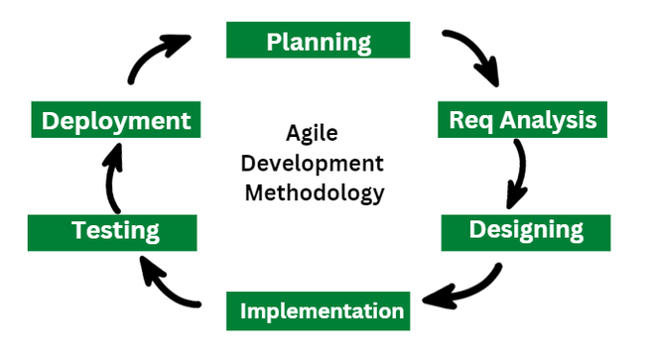
The Agile development model will be followed to design the system in iterative cycles. This allows continuous improvements based on feedback from hotel staff and customers.

Fig: Agile model

4.1 Study of Existing System
A review of existing platforms like Booking.com, Agoda, and Airbnb shows that while they offer useful features, they also have drawbacks such as complex navigation and high service charges. Our system aims to overcome these gaps by offering simplicity, affordability, and reliability.

4.2 Requirement Identification
Key requirements include:
i.) User Authentication (secure login and account management).
ii.) Room Management (availability, pricing, updates).
iii.) Booking Management (reservations, cancellations, invoices).
iv.) Payment Integration (safe online payments).

4.3 Functional Requirements
i.) Customer registration and login.
ii.) Hotel staff room management.
iii.) Secure booking and payment.
iv.) Booking history and tracking.

4.4 Non-functional Requirements
i.) High performance under heavy usage.
ii.) Strong security for user and hotel data.
iii.) Simple and accessible interface.

4.5 Feasibility Study
i.) Technical Feasibility: Can be built using HTML, CSS, JavaScript, PHP, and MySQL.
ii.) Operational Feasibility: Easy to use for both hotel staff and customers.
iii.) Economic Feasibility: Cost-effective compared to third-party booking systems.

4.6 High-Level System Design
The design will include system architecture and data flow to handle bookings and reservations.
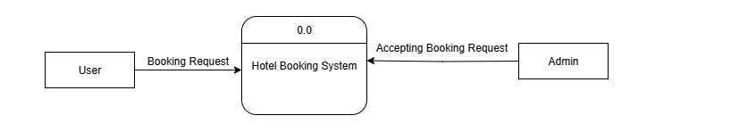
Fig: Level 0 DFD
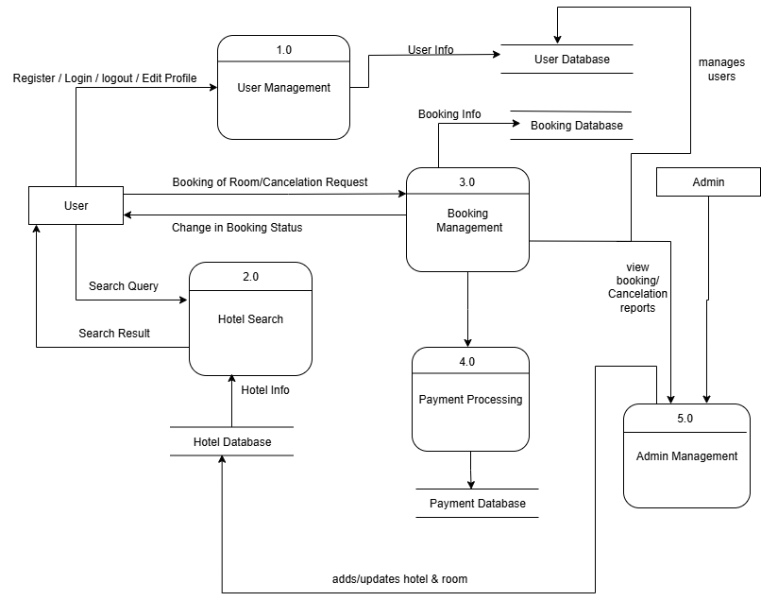

Fig: Level 1 DFD

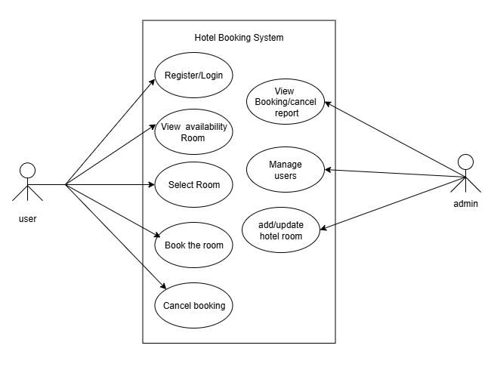
4.7 Use case Diagram
Figure: Use Case Diagram of Hotel Booking System

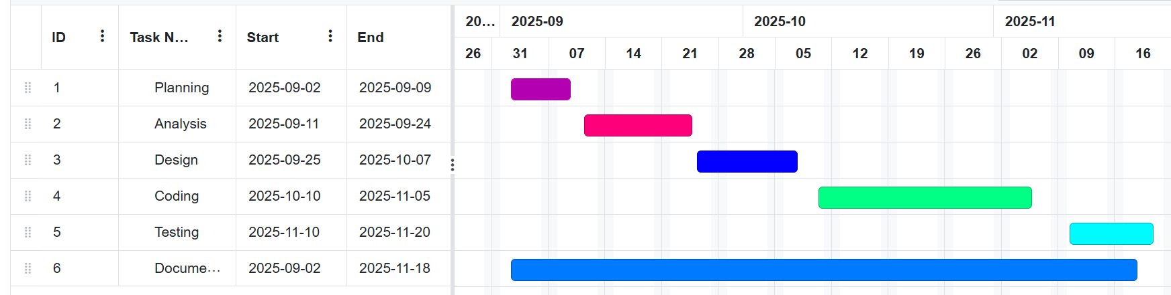
- Gantt chart

Tools
Front end: HTML, CSS, JavaScript
Back end: PHP, MySQL
Draw.io (for DFD diagrams)
Online gantt (For Gantt chart)
MS Word (for documentation)

6. Expected Outcome
i.) Customers can easily search and book rooms.
ii.) Hotels can manage availability and reservations efficiently.
iii.) Payments and booking records remain secure and reliable.

6.1 Reference
The references section includes research papers, articles, and online resources used for system design, development, and security implementation. Some of the key references are:

Books&ResearchPapers:
i)Sommerville,I.(2016). Software Engineering (10th Edition). Pearson.
ii) Tanenbaum, A. S., & Bos, H. (2015). Modern Operating Systems (4th Edition). Pearson.
iii)Elmasri, R., & Navathe, S. B. (2015). Fundamentals of Database Systems (7th Edition). Pearson.
Online Articles & Websites:
i)Booking.com Tech Blog. (n.d.). Scalable Hotel Reservation Systems. Retrieved from https://booking.com/tech
ii)Google Developers. (n.d.). Web Development Documentation. Retrieved from https://developers.google.com/web
iii)W3Schools. (n.d.). PHP and MySQL Tutorial. Retrieved from https://www.w3schools.com/php
iv) Firebase Documentation. (n.d.). Real-Time Database & Authentication. Retrieved from https://firebase.google.com/docs
Existing Systems & Case Studies:
i)Analysis of Online Hotel Reservation Systems: A Case Study on Booking.com and Expedia.
ii) Study on Secure Payment Integration in Hotel Booking Platforms.
iii) Comparative Study of Mobile-Based and Web-Based Hotel Booking Applications.

