

Tribhuvan University
Faculty of Humanities and Social Sciences

“A Hotel Booking System Website”

A PROJECT REPORT

Submitted to
Department of Bachelor in Computer Application
Kathmandu Business Campus

In partial fulfillment of the requirements for the Bachelors in Computer Application

Submitted by

Suman Thapa Samriddha Sindurakar
BCA 4th Semester BCA 4th Semester
University SN: 6-2-1219-31-2023 University SN: 6-2-1219-15-2023
Roll No:27 Roll No: 34

Under the Supervision of

Ankit Paudel



Tribhuvan University
Faculty of Humanities and Social Sciences

Kathmandu Business Campus
Bypass, Balaju

Supervisor’s Recommendation
I hereby recommend that this project prepared under my supervision by Suman Thapa (reg no:6-2-1219-31-2023) and Samriddha Sindurakar (reg no:6-2-1219-15-2023) entitled “HotelHub: Hotel Booking System Website” in the Partial Fulfillment of requirement for the degree of Bachelor in Computer Application is recommended for that final evaluation.

Ankit Paudel
Project Supervisor
BCA Department
Kathmandu Business Campus


Tribhuvan University
Faculty of Humanities and Social Sciences
Kathmandu College of Technology

LETTER OF APPROVAL

This is to certify that this project prepared by Suman Thapa and Samriddha Sindurakar entitled “HotelHub: Hotel Booking System Website” in partial fulfillment of the requirements for the degree of Bachelor in Computer Application has been evaluated. In our opinion it is satisfactory in the scope and quality as a project for the required degree.

Signature of supervisor  Ankit Paudel  Supervisor  BCA Department  Kathmandu Business Campus | Signature of HOD/Cordinator  Nixon Maharjan
Internal Examiner | External Examiner

ABSTRACT

The proposed system is a Hotel Booking Platform designed to simplify the process of searching, reserving, and managing hotel accommodations through a web-based application. It provides a user-friendly interface for customers to browse available rooms, check availability, compare prices, and make secure online reservations. At the same time, hotel administrators can efficiently manage room details, bookings, customer information, and payment records through a dedicated management panel.
The system incorporates key features such as user registration and authentication, room listing and management, real-time availability checking, booking and cancellation modules, secure payment integration, and automated confirmation notifications. Through detailed system analysis and design, essential functional and non-functional requirements were identified to develop a scalable, reliable, and high-performance solution.
Built using modern web technologies and industry best practices, the system architecture ensures data security, smooth performance, ease of maintenance, and future scalability. Overall, the Hotel Booking System provides an effective digital platform that enhances customer experience, improves hotel management efficiency, and reduces manual workload. With future improvements and additional modules, the system aims to adapt to evolving customer expectations and technological advancements in the online booking industry.
Keywords: Hotel booking, online reservation system, room availability, customer management, booking management, hotel administration, user interface, system analysis, system design, secure payment, scalability, reliability, performance, modern technologies, web application, automated notifications, continuous improvement.

ACKNOWLEDGEMENT

We would like to express our special thanks of gratitude to our supervisor Ankit Paudel who gave us the golden opportunity to do this wonderful project on the topic of ‘HotelHub: Hotel Booking System Website’, which also helped us in doing a lot of research and we came to know about so many new tools and technologies.

I would like to express my special gratitude and thanks to our BCA Program Coordinator Mrs. Stella Koirala for her support and help for our personnel development and mainly for the completion of this Project

I am highly indebted to Kathmandu Business Campus for their guidance and constant supervision as well as for providing necessary information regarding the Project and support in the completion.

We would also like to express my gratitude towards library and member of Kathmandu Business Campus for their kind co-operation and encouragement which help me in completion of this Project.

We would also like to thank our parents and friends who helped us a lot in finalizing this project within the limited time frame.

In the end, we would also like to thank Tribhuvan University for giving us this opportunity via the course of Computer Application to help us understand the project ethics at this early stage and helped us to evaluate my knowledge and expand it a little more.

Yours sincerely,
Suman Thapa
Samriddha Sindurakar
LIST OF ABBREVIATIONS

CRUD Create, Read, Update and Delete

CSS Cascading Style Sheet

DFD Data Flow Diagram

ERD Entity Relationship Diagram

HTML Hyper Text Markup Language

JS Java Script

MySQL Microsoft Server Structured Query Language

PHP Hypertext Preprocessor

TABLE OF CONTENTS
Contents
Supervisor’s recommendation ii
Letter of approval iii
Abstract iv
Acknowledgement v
List of abbreviations vi
List of figures ix
CHAPTER: 1 1
INTRODUCTION 1
1.1 Introduction 1
1.2 Problem Statement 2
1.3 Objectives 2
1.4 Scope and limitation 3
1.4.1 Scope 3
1.4.2 Limitation 3
1.5 Report Organization 3
CHAPTER: 2 5
BACKGROUND STUDY AND LITERATURE REVIEW 5
2.1 Study of existing systems 5
2.2 Literature review 6
CHAPTER: 3 7
SYSTEM ANALYSIS AND DESIGN 7
3.1 System Analysis 7
3.1.1 Requirement Identification 8
3.1.2 Feasibility Study 10
3.1.3 Data Modeling (ER-diagram) 12
3.1.4 Process Modeling (DFD) 12
3.2 System Design 14
3.2.1 Architectural Design 14
3.2.2 System flowchart 14
3.2.3 Database schema design 15
3.2.4 Interface Design (UI Interface) 17
CHAPTER: 4 18
IMPLEMENTATION 18
4.1 Implementation 18
4.1.1 Tools Used (CASE tools, Programming language, Database platforms) 18
4.1.2 Implementation Details of Modules 19
References 21

LIST OF FIGURES
Figure : Agile model for Hotel Booking System. 7
Figure : Use case diagram for Hotel BookingSystem. 9
Figure : Gantt chart for Hotel Booking System. 11
Figure : Entity Relationship diagram for Hotel Booking System. 12
Figure : level 0 DFD for Hotel Booking System 13
Figure : level 1 DFD for Hotel Booking System 13
Figure : Architecture Design of Hotel BookingSystem 14
Figure : System Flowchart of Hotel BookingSystem 15
Figure : Database Schema Design 16

CHAPTER 1

INTRODUCTION

Introduction
Introducing “Online Hotel Booking System”, an innovative and user-friendly web platform designed to simplify the process of finding and reserving hotel rooms. This system aims to provide a seamless and efficient experience for travelers searching for suitable accommodations and for hotel owners looking to manage their bookings effortlessly.
It is a simple, well-organized portal where users can explore available hotels that match their preferences and budget. It serves as a trusted platform where guests can browse room options, view detailed descriptions, compare facilities and prices, and book their stays directly through the website.
Our project is aimed at the general public—students, families, tourists, business travelers, and anyone looking for a reliable and accessible hotel booking service. Users can search for hotels by location, price, room type, amenities, or ratings, as well as read useful information shared by hotel owners. Hotel managers can list their rooms, update availability, manage reservations, and interact with guests in a convenient way.
We aim to provide a safe, easy-to-use environment where travelers can create profiles, store booking details, and reserve their preferred rooms, while hotel owners can efficiently connect with potential guests and manage their property information. It offers powerful search filters to help users quickly find rooms that match their needs and expectations.
In summary, It is a simple yet effective hotel booking system. With its user-friendly interface and straightforward design, it serves as the perfect platform for individuals to discover accommodations and for hotel owners to reach customers and manage bookings successfully.

Problem Statement
In today’s fast-growing travel and hospitality industry, travelers and hotel owners face significant challenges in connecting efficiently. With the rise of digital booking platforms, users now expect a smooth, and responsive experience when searching for accommodations. However, many existing booking systems lack streamlined navigation, accurate room availability updates, reliable communication tools, or proper management of bookings and customer information.
To address these challenges, our project focuses on developing a comprehensive Hotel Booking System that prioritizes user experience, efficient reservation workflows, and scalability. By targeting these key areas, the platform aims to bridge the existing gap between travelers and hotels, and trustworthy digital environment for accommodation booking.
Through intuitive design and innovative features, the system seeks to enhance user engagement, improve room-search accuracy, and support smooth interactions between guests and hotel management. Our goal is to create a platform that not only meets the current needs of both travelers and hotel owners.

Objectives

The objectives of this project are outlined below, focusing on improving the hotel-booking experience, and enhancing reservation efficiency.
• To provide a wide range of hotel options with the ability to easily compare rooms based on location, price, amenities, and room type.
• To offer mechanisms for user interaction, such as booking confirmation updates, guest–hotel communication, and review or feedback features, to enhance the overall accommodation experience.
• To provide efficient room and booking management tools for hotel owners, ensuring smooth listing, updating, and handling of room availability, pricing, and customer reservations.

Scope and limitation

Scope

The scope of our Hotel Booking System project includes the following key features:
- Online Hotel Listings
- Detailed Hotel Information
- User & Admin Dashboard
- Online Room Booking Functionality
- Booking Management

Limitation
However, the system has a few limitations:
- No Physical Verification of Rooms
- Cannot Judge Service Quality in Advance
- Possibility of Incorrect or Outdated Information

Report Organization
Introduction
The Hotel Booking System project aims to develop a user-friendly platform that connects hotel guests with hotels efficiently. It focuses on enhancing user experience, streamlining the booking process, ensuring system scalability and security, and adapting to evolving hospitality industry needs. Despite potential constraints such as data accuracy and room availability updates, the project strives to provide an effective solution that simplifies hotel reservations for both customers and hotel administrators.

Background Study and Literature Review
This chapter discusses the background of online hotel booking systems and reviews recent research related to hotel reservation platforms. It highlights the role of modern web technologies and intelligent systems in improving booking efficiency and customer satisfaction. The chapter also reviews key features of existing hotel booking platforms, providing useful insights and guidance for the design and development of the proposed Hotel Booking System.
System Analysis and Design
This chapter reviews recent trends in online hotel reservation systems, digital booking practices, and hotel management platforms. It examines features of popular hotel booking websites and explores best practices for system design, offering insights for the development of this project.

Implementation
This chapter explains the tools and technologies used to develop the Hotel Booking System and describes the implementation of its main modules, such as hotel and room management, user registration, room search, booking management, and payment processing.

CHAPTER 2

BACKGROUND STUDY AND LITERATURE REVIEW

Study of existing systems
In this section, an examination of existing hotel booking systems in Nepal provides insights into common practices, features, and challenges. By analyzing popular platforms such as Booking.com, Agora, and Nepal Hotel Online, valuable lessons can be learned to guide the development of our own hotel booking system.
Booking.com is one of the most widely used online hotel booking platforms, offering a variety of hotels and accommodations across regions. It provides features such as room availability checks, reviews, ratings, and secure online payments, making it convenient for users. However, challenges like outdated listings, limited local hotel coverage, and occasional discrepancies in booking confirmations indicate areas for improvement.
Agora emphasizes a user-friendly interface and extensive filtering options. Users can search for hotels by location, price, star rating, or amenities. Hotels benefit from tools to manage bookings and promotions efficiently. Yet, issues such as inconsistent room information, lack of localized customer support, and limited offline verification highlight the need for more accurate data and enhanced trust mechanisms.
Nepal Hotel Online focuses on providing local hotel listings and detailed information about room types, amenities, and nearby attractions. While it helps travelers find accommodations in Nepal, its limited interactive features, minimal booking analytics, and sometimes outdated content reduce overall user engagement and reliability.
By studying these Nepali hotel booking platforms, we can identify best practices, user expectations, and gaps in current systems. This analysis will help in designing a reliable, user-friendly, and efficient hotel booking system tailored to the needs of both customers and hotel administrators in Nepal.

2.2 Literature review
The literature review examines existing research and publications related to online hotel booking systems. Online hotel booking in Nepal has grown significantly with increased internet access and digital platform adoption. Studies show that users’ adoption of online booking systems is primarily influenced by perceived usefulness, ease of use, and trust in the platform. Poudel [1] explains that performance expectancy and facilitating conditions strongly affect users’ intention to use online hotel booking platforms in Nepal. Similarly, Dahal [2] highlights that trust and perceived value play a major role in encouraging Nepali users to rely on online hotel reservation systems.
The adoption of e-booking by hotels and guesthouses in Nepal is also increasing, especially in urban and tourist-heavy areas. Dhakal et al. [3] found that many hotels have a positive perception toward digital booking, but challenges such as staff readiness, data security, and system integration still affect full adoption. University and tourism-focused booking platforms are also emerging, helping local accommodations connect with travelers, although stronger integration with hospitality industry standards is still needed.
Earlier studies on internet-based hotel booking in Nepal show a growing trend of travelers shifting from traditional in-person reservations to online platforms. Sharma found that users in Kathmandu increasingly depend on platforms like Booking.com and Agoda for hotel information. Today, large commercial platforms such as Agoda dominate the Nepali online hotel booking market. However, the literature highlights gaps in mobile accessibility, rural hotel coverage, verification mechanisms, and intelligent room–customer matching systems.
Overall, the literature review serves as a foundation for understanding key concepts and trends in digital hotel booking, informing the design and development of our Hotel Booking System to ensure its alignment with industry standards, user expectations, and best practices.

CHAPTER 3

SYSTEM ANALYSIS AND DESIGN

System Analysis
The Hotel Booking System is developed using the Agile methodology, which focuses on iterative development, continuous feedback, and incremental improvements. Agile allows the development team to adapt quickly to changes and refine system features based on user input throughout the project lifecycle.
In Agile, the development process begins with gathering and analyzing user stories, which clearly define functional and non-functional requirements. These requirements are prioritized in the product backlog. The system is then designed and developed in multiple sprints, where each sprint delivers a working module of the system. After every sprint, the increment is reviewed and tested. Testing is performed continuously throughout each sprint. This iterative testing ensures higher quality output and reduces the risk of major failures. Once all key features such as hotel listing management, room booking, user authentication, and payment integration—are completed, integrated, and validated by stakeholders, the system moves into the deployment phase.
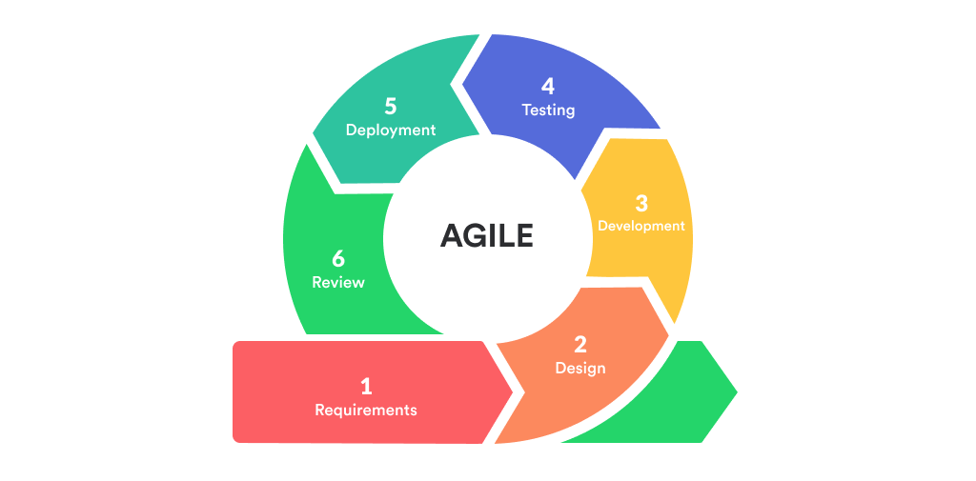
Fig 3.1: Agile Model

Requirement Identification
It is a critical step in the development of the Hotel Booking System. This process involves identifying both functional and non-functional requirements to ensure that the system effectively meets the needs of customers, hotel administrators, and system managers.
- Functional requirement
For Customers
- Users can register and log in to the system.
- Users can create and update their profiles, including personal details and preferences.
- Users can search hotels and rooms based on location, price, availability, and amenities.
- Users can make room reservations and view booking details.
For Hotels/Administrators
- Hotel staff or administrators can register and log in to the system.
- Hotels can add, update, or remove room listings, including details like type, price, amenities, and availability.
- Hotels can view and manage customer bookings.
- Hotels can view and manage customer bookings.
For Admin
- Admin can log in to the portal.
- Admin can manage users (job seekers and employers).
- Admin can manage job postings and monitor portal activity.
- Admin can generate reports and handle system-related tasks.

USECASE DIAGRAM
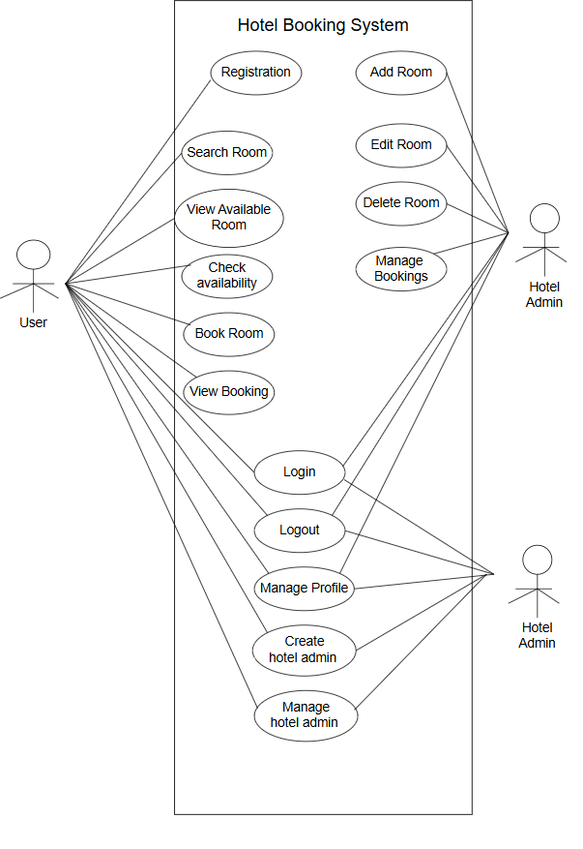
Fig 3.2: Use Case Diagram of Job Portal System

- Non-functional requirement
- Security
User passwords and sensitive information are securely stored using encryption and hashing techniques. The system also implements secure payment processing for hotel bookings.
- Performance
The system is optimized to provide fast response times for hotel searches, room bookings, profile updates, and payment transactions.
- Reliability
The system ensures consistent availability, accurate booking management, and dependable processing of user and hotel data.
- Usability
The platform features an intuitive and user-friendly interface for customers, hotel administrators, and system admins, making navigation and booking simple and efficient.

Feasibility Study
A feasibility study is a preliminary assessment conducted to determine whether a proposed project is practical, achievable, and economically viable. Its purpose is to identify potential risks, challenges, and opportunities associated with the project before development begins.
Before developing the Hotel Booking System, the following feasibility aspects were evaluated to ensure the system could be developed according to requirements and within the expected timeframe:
- Technical Feasibility
The system uses widely available technologies, programming languages, and database management tools. There are no major technological obstacles, as the required hardware and software resources are easily accessible. The system can be implemented using standard development tools, making it technically feasible.
- Operational Feasibility
The Hotel Booking System is designed with user-friendly interfaces and straightforward navigation. Customers, hotel administrators, and system admins can easily interact with the system without advanced technical knowledge. The system ensures smooth operations, ease of maintenance, and effective booking management.
- Schedule Feasibility
The project has a well-defined development plan and timeline. Each phase analysis, design, development, testing, and deployment can be completed within the allocated timeframe. With proper planning and Agile methodology, the system can be delivered on schedule without significant delays.
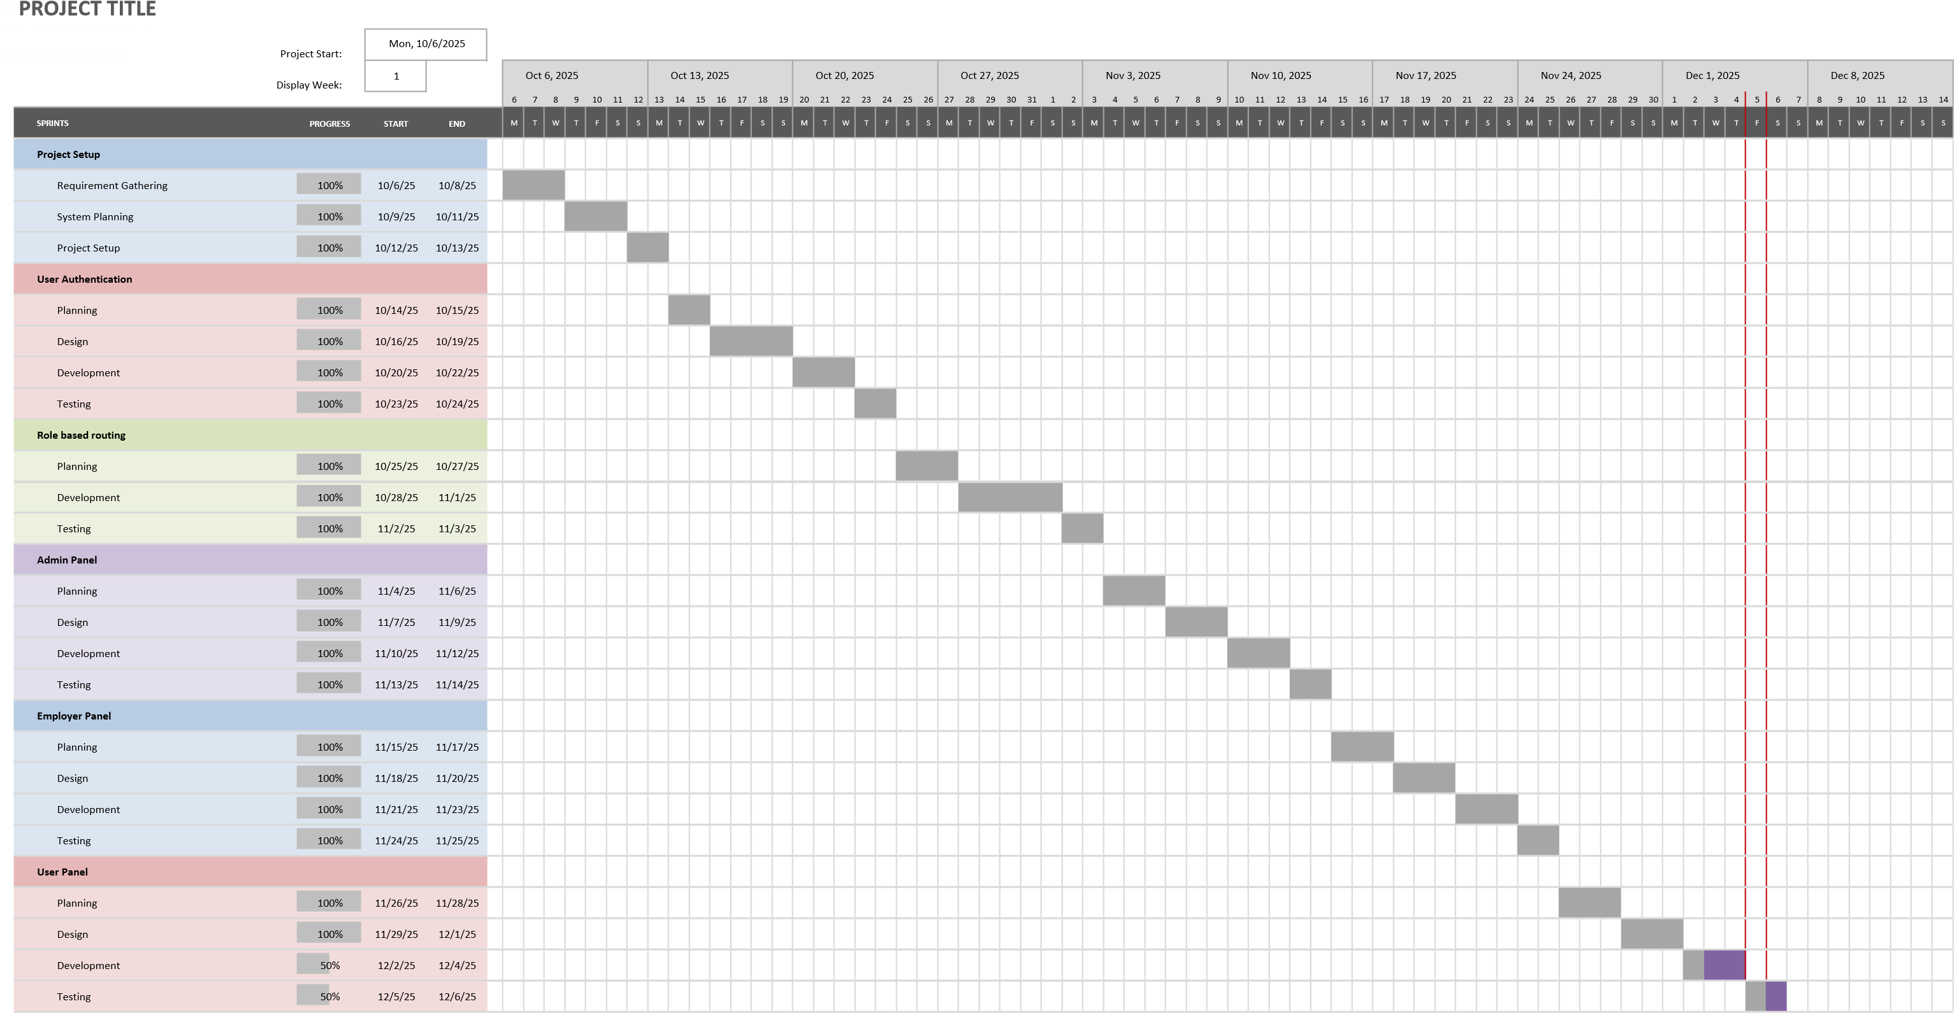
Fig 3.3: Gantt Chart for Hotel Booking System

Data Modeling (ER-diagram)
This Entity–Relationship (ER) diagram represents a Hotel Booking System involving users, hotels, rooms, and bookings. The users entity stores user information such as name, email, phone, password, and role, and each user can be associated with multiple bookings, forming a 1-to-many relationship. The hotels entity contains hotel details like hotel name, location, and the admin responsible (hotel_admin_id), and each hotel can have many rooms, also forming a 1-to-many relationship. The rooms entity includes attributes such as room number, type, price, and its associated hotel_id. The bookings entity links users, hotels, and rooms through foreign keys (user_id, hotel_id, room_id) and contains booking details such as check-in, check-out dates, number of rooms booked, total price, status, and payment status.

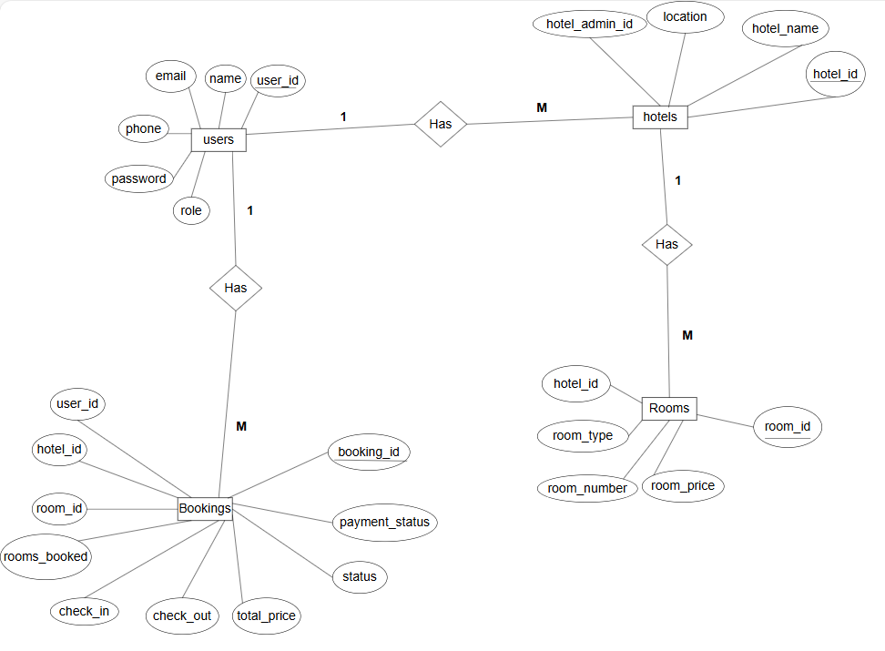

Fig 3.4: Entity-Relationship Diagram of Hotel Booking System

Process Modeling (DFD)
The Data Flow Diagram (DFD) of the Job Portal System consists of two levels: the context diagram and level one DFD. These diagrams help in visualizing the flow of data within the system and understanding its processes.
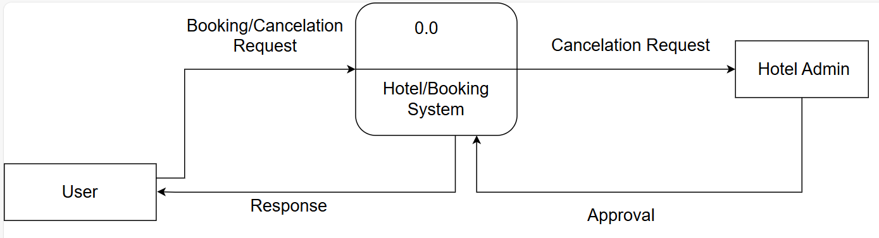
Fig 3.5: Level 0 DFD of Hotel Booking System

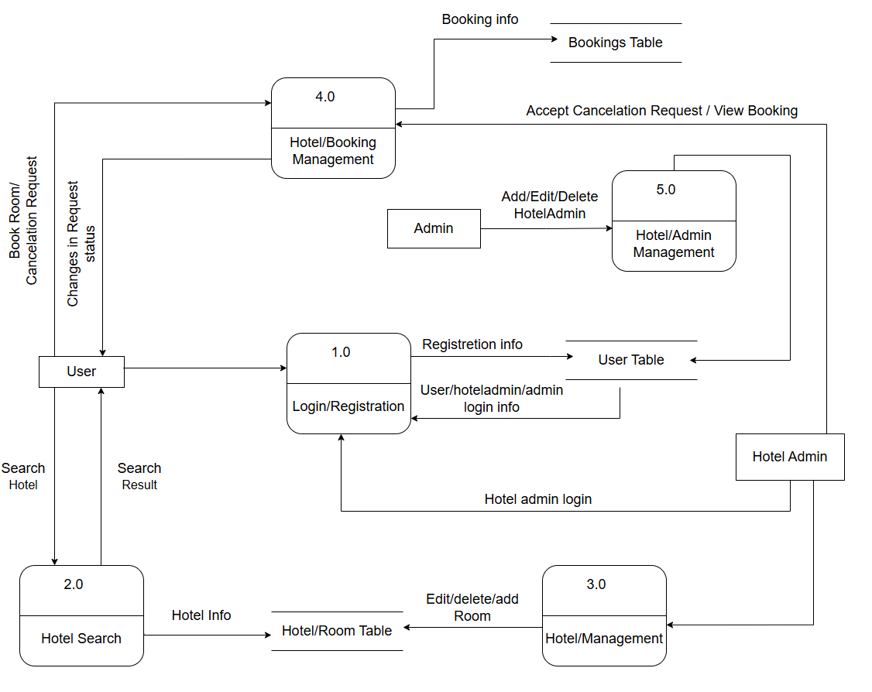
Fig 3.6: Level 1 DFD of Hotel Booking System

System Design
To realize the different functional requirement of the system in graphical form, different design diagram of the system has been prepared which are as follows:

Architectural Design
For this system, three tier architecture is used which includes user interface, web server and database. In architectural design, basic structure of the system is show.

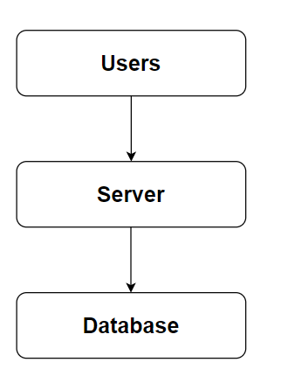

Figure 3.7: Architecture Design of Hotel Booking System

System flowchart
The flowchart for the Hotel Booking System begins with the start of the process. Users are first asked whether they already have an account. If they do, they proceed to the login page, where the system verifies their credentials. Upon successful login, users are directed to the dashboard, where they can browse available hotels, view room details, check prices, and explore hotel facilities. Users can then select a hotel, choose room types, and proceed to make a booking. After confirming the reservation details, users can make payment and receive a booking confirmation. Additionally, users have options to update their profile, view their booking history, or cancel existing bookings. Once they finish their tasks, they can logout, which ends the process.
For the admin, the process begins with login. The system validates the admin’s credentials, and upon successful authentication, the admin is redirected to the admin dashboard. From there, the admin can manage hotels, add or update room information, set room prices, and monitor hotel availability. The admin can also manage user accounts, view booking records, and generate reports as needed. After completing all required administrative tasks, the admin can logout, ending the process.

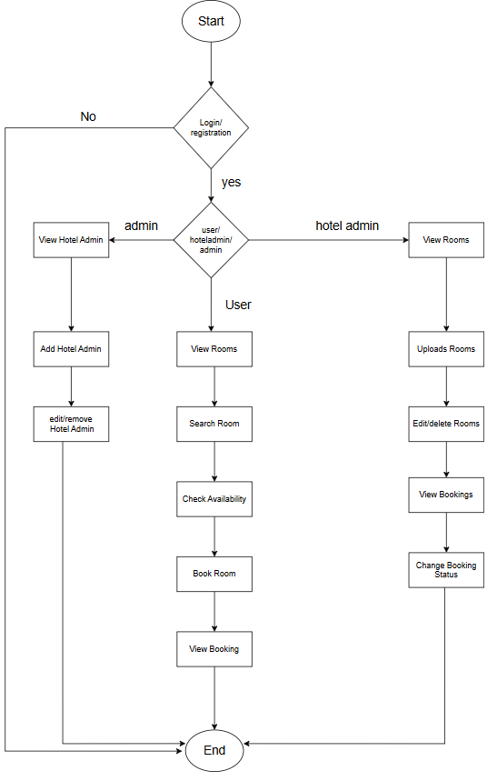
Fig 3.8: System Flow Diagram of Hotel Booking System

Database Schema Design
The figure below shows the database schema design of the Hotel Booking System. It represents the overall structure of the database and the relationships among the different tables used in the system. Each table contains a unique primary key, and when this key is referenced in another table, it functions as a foreign key. This relational structure ensures data consistency, supports smooth hotel and room management, and enables efficient processing of bookings, users, and payment-related information within the system.
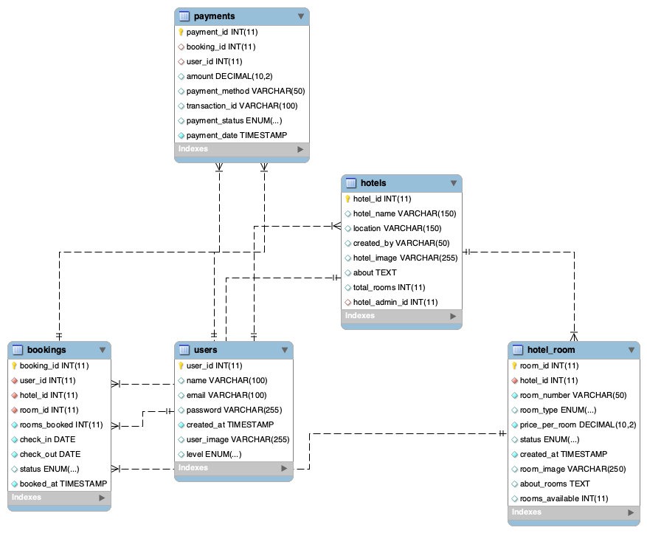

Fig 3.9: Database Schema Design of Hotel Booking System

Interface Design (UI Interface)
Interface design is used to plan and design how the Hotel Booking System will appear to users. This design provides a visual representation of the system, helping users understand how the platform will look, feel, and function. Once the interface design is finalized, the system development process begins based on these layouts.
The UI design includes pages such as the login page, registration page, user dashboard, hotel listing page, hotel details page, room selection page, booking form page, payment page, booking confirmation page, profile management page, and booking history page. For the admin, the design includes the admin login page, admin dashboard, hotel management page, room management page, booking management page, and user management page. These interface designs are included in the appendix section for reference.

CHAPTER 4

IMPLEMENTATION

Implememtation

Tools Used (CASE tools, Programming language, Database platforms)
Following are the tools and framework used for the accomplishment of this project:
- Front end
  - Html: HTML (Hyper Text Markup Language) was used to create and structure the web pages. This involved organizing content with various elements and tags to define sections, headings, links, and paragraphs, ensuring a clear and accessible structure for the website.

  - CSS: CSS, which stands for Cascading Style Sheets, was employed to style the web pages, controlling the presentation and appearance. I used CSS to define text colors, font styles, spacing between paragraphs, column sizes, and layout designs, resulting in a visually appealing and consistent user interface.

  - JavaScript: JavaScript was implemented to add interactivity and dynamic behavior to the website. We utilized JavaScript for client-side validation, creating dynamic, interactive, and responsive web pages, and adding special effects to enhance the user experience.

- Back end
- PHP: PHP was extensively utilized due to its versatility and powerful features. It was used to generate dynamic content on web pages based on user inputs, database queries, and other external data sources, ensuring personalized and relevant information delivery. PHP handled server-side scripting tasks such as connecting to the database, encrypting data, and validating user inputs.

- Server
    - APACHE SERVER: In our hotel booking system, Apache server is used to run PHP files and creating fast and dynamic web pages.

- Database
  - MYSQL: MySQL was used as the foundational database management system. It served crucial roles such as storing product information, managing customer data including profiles and purchase histories, processing and storing orders, and facilitating secure transactions
- Documentation Tools
    - MS Office: MS Office was utilized in our project for creating and editing documents, spreadsheets, and presentations essential for business operations, communication, and reporting.

    - Draw.io: Draw.io was used to create a variety of diagrams such as flowcharts, DFD, ER-diagram, and more, aiding in visualizing complex concepts, processes, and structures within our project.

Implementation Details of Modules
Different modules of the Hotel Booking System are described as below:
Admin module:
- Admin manage user module:
In this module, the admin can view all registered users, including customers and hotel owners (if applicable). The admin can activate, deactivate, or block accounts whenever necessary. This ensures a secure and well-managed environment.
- Admin manage Hotels and Room module:
This module allows the admin to add, edit, and delete hotel information. The admin can manage room categories, room availability, pricing, and hotel details such as location, facilities, and descriptions.
- Admin Booking management module:
The admin can view all bookings made by customers. They can update the booking status (e.g., confirmed, canceled, pending), manage payment records, and monitor overall activity in the system to ensure smooth operation.

User module:
- Hotel search and view module:
This module enables users to search for hotels based on location, price range, room type, available dates, and facilities. Users can view detailed hotel information, room photos, features, and pricing.
- Room Booking module:
Users can select a hotel, choose a room type, set check-in and check-out dates, and proceed with booking. The system checks availability and confirms the reservation. Users can also view their booking history and track the status of their reservations.
- Profile management module:
Users can update their personal information such as name, email, contact number, and address. They can also manage saved hotels, view past bookings, and update their password or account-related details.

Login module:
This module provides secure login functionality for both admins and users. Admins are redirected to the admin dashboard after successful login, while users are taken to their personal dashboard where they can search hotels and manage bookings.

Register module:
Users can register by providing basic information such as name, email, username, password, and contact details. After successful registration, they can log in using their credentials to access hotel search and booking features.

Testing
System testing is performed to ensure that the hotel management system functions correctly and meets user requirements. Different test cases are executed by providing various inputs and validating the system’s outputs. The system is tested repeatedly during the development phase to identify errors, improve performance, and ensure reliability. The testing process focuses on verifying major functionalities such as user navigation, room search, room booking, customer information management, payment processing, and system responses. The series of testing conducted are as follows:

Table 4.1: Test case for Hotel Management System
S.No. | Test Name | Input | Expected Output | Actual Output | Test Result
1 | Home Page Navigation | User navigates to home page | Home page is displayed | Home page displayed | Pass
2 | User Login | User enters valid username and password | User logged in successfully | User logged in successfully | Pass
3 | Room Search | User searches available rooms | Available rooms are displayed | Available rooms displayed | Pass
4 | Room Details View | User selects a room | Room details page is displayed | Room details page displayed | Pass
5 | Room Booking Form | User clicks “Book Now” | Booking form is displayed | Booking form displayed | Pass
6 | Customer Information Entry | User enters personal details | Information saved correctly | Information saved correctly | Pass
7 | Date Selection | User selects check-in and check-out dates | Selected dates accepted | Dates accepted | Pass
8 | Booking Submission | User clicks “Confirm Booking” | Booking submitted successfully | Booking submitted successfully | Pass
9 | Payment Processing | User enters payment details | Payment processed successfully | Payment processed successfully | Pass
10 | Booking Confirmation | Booking completed | Confirmation message displayed | Confirmation message displayed | Pass
11 | Admin Login | Admin enters valid credentials | Admin dashboard displayed | Admin dashboard displayed | Pass
12 | Booking Management | Admin views bookings | New booking appears in dashboard | New booking visible | Pass

CHAPTER 5

CONCLUSION AND FUTURE RECOMMENDATIONS

5.1 Lesson Learnt / Outcome
Every project provides valuable learning opportunities and practical experience in different aspects of system development. Through the successful completion of this project, we gained significant knowledge and skills related to problem solving, teamwork, communication, documentation, and time management. The development of the Hotel Management System helped us understand both technical and managerial challenges involved in real-world software projects.
Teamwork
Since this was a team-based project, it taught us the importance of collaboration and coordination among team members. We learned how to divide tasks effectively, work together toward common goals, and support each other while resolving issues and errors that occurred during the development of the hotel management system.
Problem-Solving Skills
This project enhanced our ability to identify, analyze, and solve different technical and logical problems. We learned how to debug errors, manage database-related issues, and apply appropriate solutions to ensure the smooth functioning of the hotel management system.
Writing and Documentation Skills
We gained experience in preparing project proposals and technical documentation. Additionally, we learned to use various modeling and design tools such as use case diagrams, schema diagrams, data flow diagrams (DFD), and entity-relationship (ER) diagrams, which helped us better understand and document the system requirements and structure.

Time Management
One of the most important lessons learned was effective time management. We understood the importance of prioritizing system components based on their complexity and significance. Proper planning and scheduling helped us complete different modules of the hotel management system within the given timeframe.

5.2 Conclusion
The Hotel Management System has been successfully developed in accordance with the predefined objectives of the project. The system fulfills all the requirements that were set during the planning and design phases. It provides a reliable and efficient platform for managing hotel operations such as room booking, customer information, room availability, and booking records in a simple and effective manner.
The system offers a user-friendly and smooth interface that can be easily used by both hotel staff and customers. The overall design emphasizes simplicity, usability, and efficiency, making the system suitable for real-world use and future improvements.

5.3 Future Recommendations
The hotel management system can be further improved by refining its design and development process and by preparing more structured documentation before implementation. Future updates should be based on user feedback to better meet the needs of both hotel management and customers. In addition, system performance such as page load time and server response speed can be optimized to ensure smoother and faster access.
Some future recommendations for the hotel management system are:
- Introduce multiple user roles such as administrator, receptionist, and customer with role-specific permissions.
- Implement a secure password recovery and reset feature for users.
- Add online payment integration for room booking.
- Provide advanced room search and filtering options based on room type, price range, and availability.
- Include automated billing and invoice generation for customers.
- Add a customer feedback and rating system to improve hotel services.

References
[1] B. R. Poudel, “Online Recruitment: A Cognitive Perspective of Job Seekers in Nepal,” Journal of Business and Social Sciences (JBSS), 2018.
[2] S. Dahal, Digital Trust and Online Service Adoption in Nepal, Kathmandu: Academic Press, 2020.
[3] K. Dhakal, P. Baczar and N. Devkota, “Institutional perception of e-recruitment adoption in Nepal: Evidence from structural equation modeling,” Economics & Sociology, vol. 16, no. 3, 2023.
[4] R. Sharma, Use of Internet in Job Search among Jobseekers in Kathmandu: A Case Study of Jobseekers Registered at JobsNepal.com, M.A. Thesis, Tribhuvan University, 2009.

