Game Design Document

Fill up the Following document

1. Write the title of your project.

The Golden Egg

1. What is the goal of the game?

The player has to help the bird to find it’s lost golden egg.

1. Write a brief story of your game?

In a forest were many birds the most beautiful was an Ostrich.

Everyone praised her but there were some vultures who didn’t liked her at all.

So they stole her most precious Golden Egg and now the Ostrich is upset. Now we have to help her save her golden egg.

1. Which are the playing characters of this game?

* Playing characters are the ones which respond to the user based on the input from the user
* Cars, monkeys, dinos, wizards etc, are the playing characters in the game.

|  |  |  |
| --- | --- | --- |
| Number | Character Name | What can this character do? |
| 1 | The Boy | Helping to find the golden egg. If you are a boy you will get a boy character. |
| 2 | The Girl | Helping to find the golden egg. If you are a girl you will get a girl character. |
| 3 |  |  |
| 4 |  |  |
| 5 |  |  |
| 6 |  |  |
| 7 |  |  |
| 8 |  |  |

1. Which are the Non Playing Characters of this game?

* Non Playing characters are the ones which don't have an action or a behaviour when the user interacts with the game.
* Hurdles, stones, bananas, coins, etc are non playing characters in the game.

|  |  |  |
| --- | --- | --- |
| Number | Character Name | What can this character do? |
| 1 | Stones | They are obstacles in the user’s way. |
| 2 | Cactus | They are obstacles in the user’s way. |
| 3 | Puddle | They are obstacles in the user’s way. |
| 4 | Dustbin | They are obstacles in the user’s way. |
| 5 | Ladder | They will help the user to climb up. |
| 6 | Coins | They will be adding points for the user. |
| 7 | Lives | There will be three lives, if you touch any obstacle then you lose one life and when all the three lives are lost then you lose. |
| 8 |  |  |

Draw your imagination of this game. What does this game look like?

* Draw the game either on your computer or on paper,
* Add images of scenes of the game to show each of the playing and non-playing characters at least once.

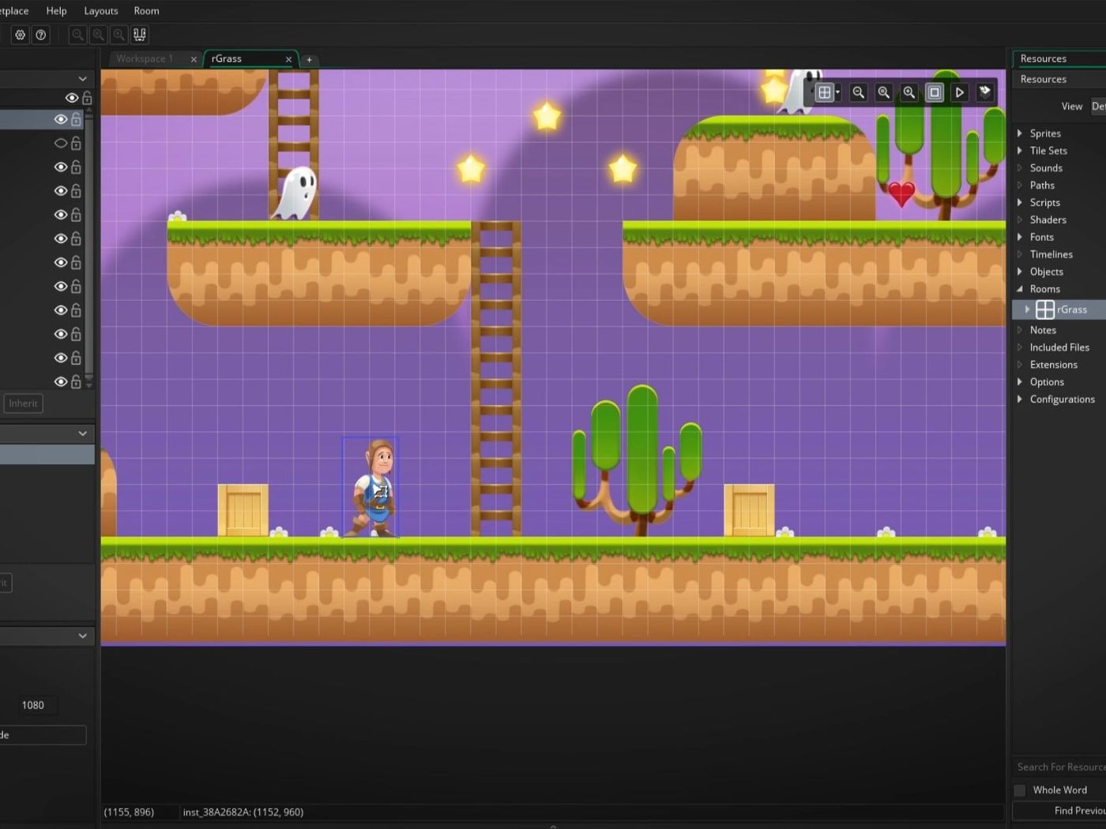 My game will look something like this.

How do you plan to make your game engaging?

I will be adding nice in background. And it will be getting harder after some period of time.