**Project title: “*Smart* *Hospital Appointment & Patient Management”***

* **Industry**- Healthcare
* **Project Type**- B2C Salesforce CRM Implementation
* **Target Users**- Patients, Receptionists, Doctors, Hospital Administrators

**➤Problem Statement:**

Hospitals receive hundreds of appointment requests daily from walk-ins, phone calls, and online portals. However:

* Appointment booking and confirmation are manual & time-consuming.
* Doctors’ schedules are not centralized, leading to double-booking.
* Patient history and past consultations are scattered across files.
* Administrators lack real-time insights into patient flow and doctor utilization.

👉 To address this, the hospital wants to implement a Salesforce CRM that can:

* Automate appointment booking & confirmation
* Manage doctor schedules efficiently
* Track patient medical history and previous visits
* Enable real-time dashboards for hospital management

**➤Objectives of the Project:**

The goal of the project is to build a Salesforce-based Hospital Appointment & Patient Management System to:

1. Provide a centralized platform for **patient registration and appointment booking**.
2. Enable doctors to **view and manage their schedules**.
3. Send **automated reminders** (email/SMS) to patients before appointments.
4. Maintain patient records and past visit history.
5. Generate **reports and dashboards** for hospital administrators (appointments per doctor, missed appointments, patient trends).

**➤Stakeholder Analysis:**

| **Stakeholder** | **Role/Need** |
| --- | --- |
| **Patients :** | Book appointments easily, receive reminders, access records. |
| **Doctors :** | View/manage their schedules, track patient history, reduce no-shows. |
| **Receptionists :** | Book appointments on behalf of patients, manage doctor availability, handle cancellations. |
| **Hospital Admins :** | Monitor hospital performance, view reports, enforce security and data policies. |

**➤Use Cases:**

**🔹 Appointment Management**

* Patients can request appointments via **website/portal/phone**
* Receptionist books appointment in Salesforce
* Auto confirmation sent via **SMS/Email**

**🔹 Doctor Schedule Management**

* Doctors’ availability managed centrally
* Avoid double-booking with real-time calendar view

**🔹 Patient Records & History**

* Store patient details (basic info, past consultations, prescriptions)
* View history before each appointment

**🔹 Consultation & Follow-ups**

* Doctor updates consultation notes
* Schedule follow-up visits with automated reminders

**🔹 Billing & Payments**

* Record consultation fees, lab charges, and payments
* Generate invoices linked to patient records

**🔹 Reporting & Analytics**

* Daily/Monthly appointment reports
* Doctor utilization tracking
* Patient flow & revenue trends

**➤Business Process Mapping**

**Current (Manual) Process:**

* Patient calls or walks in → Receptionist manually checks doctor’s availability → Appointment written in register → Patient often forgets timing → Doctor has no automated daily schedule → Admins struggle to analyze patient load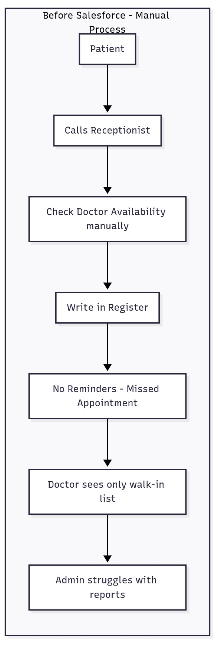

**Proposed (Salesforce) Process:**

1. Patient requests appointment (via receptionist or portal).
2. Salesforce checks doctor availability.
3. Appointment booked → Status = “Scheduled”.
4. Automated **email/SMS confirmation** sent.



1. 24 hours before → Automated reminder.
2. Doctor sees daily schedule in Salesforce.
3. After consultation → Appointment marked as **Completed**.
4. Hospital Admin generates reports for decision-making.

**➤AppExchange Exploration:**

Before reinventing, explore AppExchange solutions:

* Salesforce Health Cloud – enterprise-grade patient management.
* DocuSign – for digital patient consent forms.
* Twilio Integration – for SMS reminders.
* FormAssembly – for patient intake forms.