Input & Output
1. Log Today's Mood
Test Case Name: Add Single Mood Entry
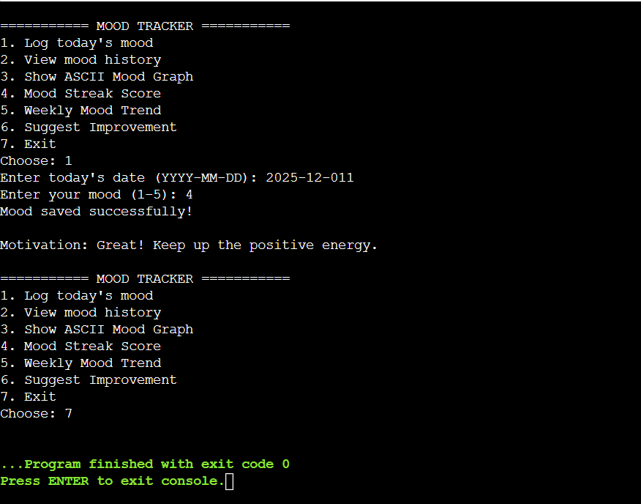

2. View Mood History
Test Case Name: Show Mood History
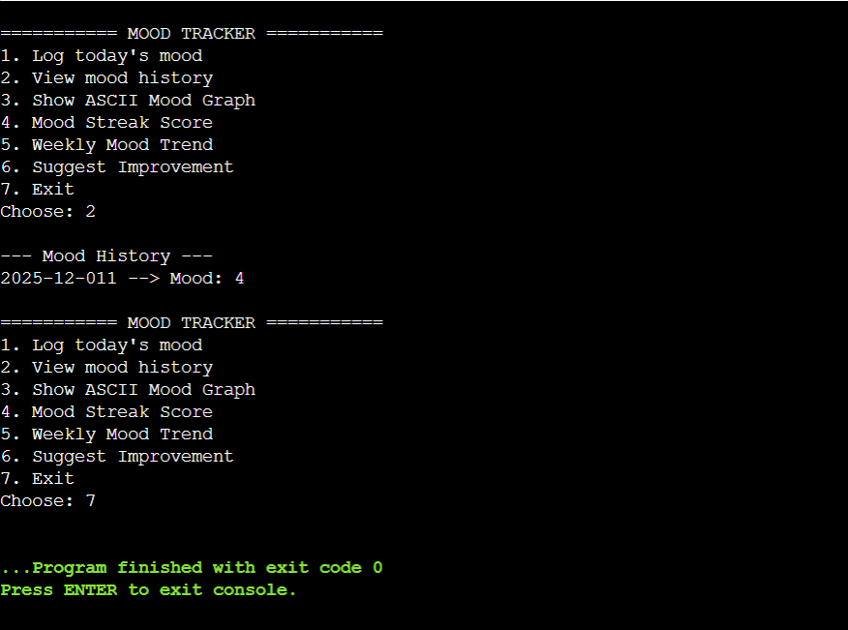

3. Show ASCII Mood Graph
Test Case Name: Display ASCII Graph
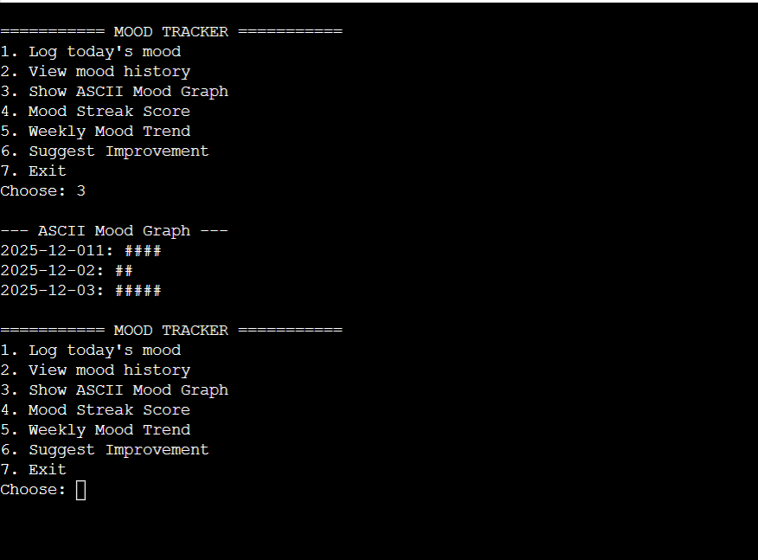

4. Mood Streak Score
Test Case Name: Calculate Mood Streak
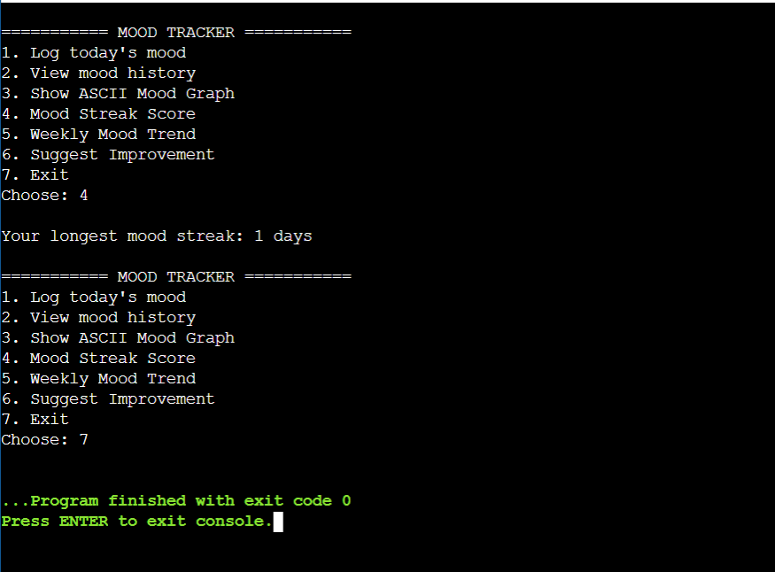

5.Suggest Improvement
Test Case Name: Suggest Based on Last Mood
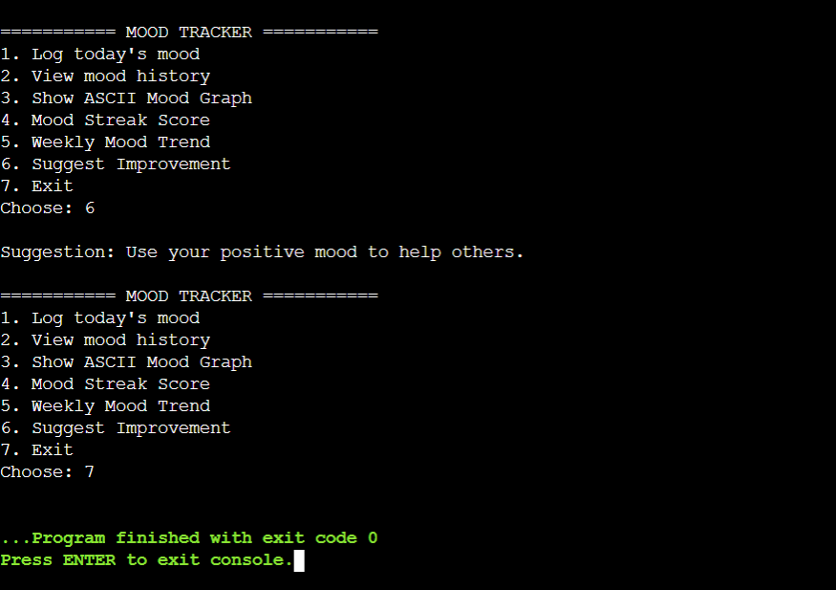

6. Invalid Choice
Test Case Name: Invalid Choice