Mood
Monitoring
System

Course: Programming in C
Submitted by: Samridhi 590027568 B-53
Submitted to: Dr. Mohammad Ahsan

Abstract
The Mood Tracker is a C-based console application designed to help users record and monitor their daily moods. Users can log their mood for each day, view historical records, and analyze trends. The project demonstrates practical use of arrays, structures, and file handling in C programming. This tool aims to assist individuals in understanding their emotional patterns over time.

Problem Definition
People often struggle to track their emotional well-being consistently. Manual tracking is prone to forgetfulness or error. The Mood Tracker solves this problem by providing a simple programmatic solution to record, store, and visualize moods over time in an organized manner.
Objectives:
- Record daily mood entries.
- Store multiple mood entries for historical tracking.
- Display mood history clearly.
- Identify patterns or trends in user moods over time.

System Design
Algorithms

1. Main Menu (main())
Purpose: Provide a menu-driven interface for all features.
Algorithm:
- Start program.
- Loop until exit:
a. Display 7 menu options:
  - Log today's mood
  - View mood history
  - Show ASCII mood graph
  - Mood streak score
  - Weekly mood trend
  - Suggest improvement
  - Exit
b. Read user choice.
c. Call the corresponding function or print "Invalid choice!".
- Exit program.

2. Log Today's Mood (addMoodEntry())
Purpose: Save a new mood entry and display motivation.
Algorithm:
- Open mood_logs.txt in append mode.
- Prompt user for date (YYYY-MM-DD) and mood (1–5).
- Validate mood: if invalid, print error and return.
- Write date and mood to file.
- Close file.
- Display a motivational message based on mood.
- Return to main menu.

3. View Mood History (showMoodHistory())
Purpose: Display all previously logged moods.
Algorithm:
- Load logs from file into array.
- If no logs, print "No logs found" and return.
- Loop through array: print each date and mood.
- Return to main menu.

4. Show ASCII Mood Graph (displayAsciiGraph())
Purpose: Visually display moods using #.
Algorithm:
- Load logs from file into array.
- If no logs, print "No logs found" and return.
- For each log:
a. Print date.
b. Print # repeated by mood value.
- Return to main menu.

5. Mood Streak Score (calculateMoodStreak())
Purpose: Calculate longest streak of the same mood.
Algorithm:
- Load logs from file into array.
- If no logs, print "No logs found" and return.
- Initialize streakCount = 1, longestStreak = 1.
- Loop through logs from second entry:
a. If current mood equals previous, increment streakCount.
b. Else, reset streakCount = 1.
c. Update longestStreak if streakCount > longestStreak.
- Print "Your longest mood streak: X days".
- Return to main menu.

6. Weekly Mood Trend (showWeeklyTrend())
Purpose: Display moods of last 7 days.
Algorithm:
- Load logs from file into array.
- If no logs, print "No logs found" and return.
- Calculate start index: start = max(0, totalLogs - 7).
- Loop from start to last entry:
a. Print date.
b. Print # repeated by mood value.
- Return to main menu.

7. Suggest Improvement (suggestImprovement())
Purpose: Provide suggestion based on last mood entry.
Algorithm:
- Load logs from file into array.
- If no logs, print "No logs found" and return.
- Get last mood value.
- Print suggestion according to mood:
  - 1 → Talk or journal
  - 2 → Go for a walk / listen to music
  - 3 → Try a new hobby
  - 4 → Continue positive habits
  - 5 → Spread positivity
- Return to main menu.

Flowchart
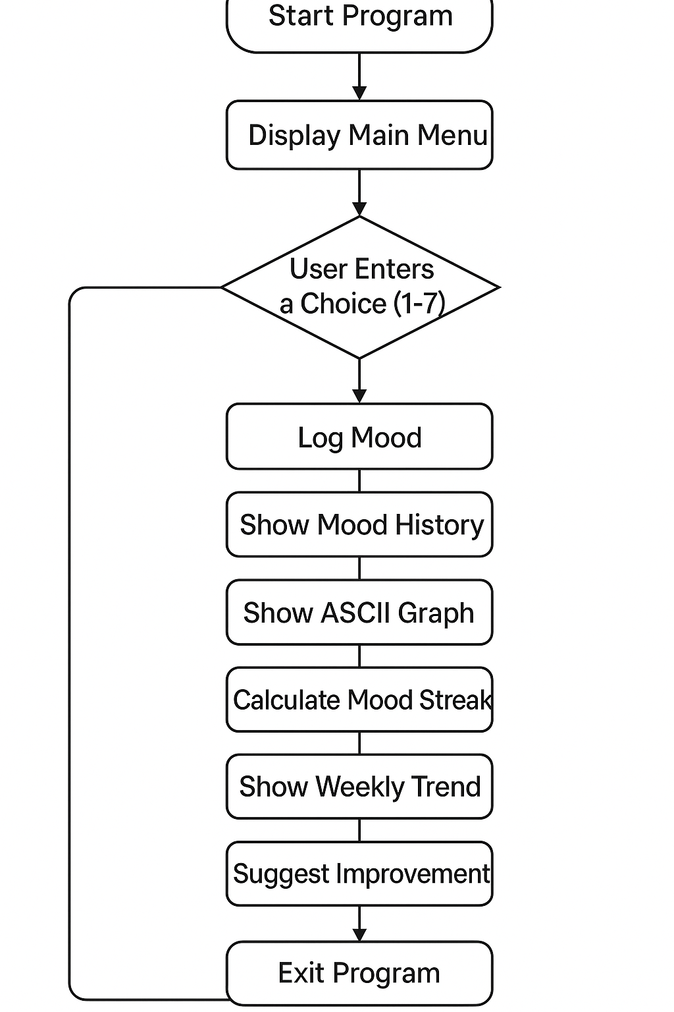
Implementation Details
- Technologies Used
- C Programming Language – to write the Mood Tracker program.
- GCC Compiler – to compile and run the C code.

- Important Code Snippets
  - Structure and File Declaration
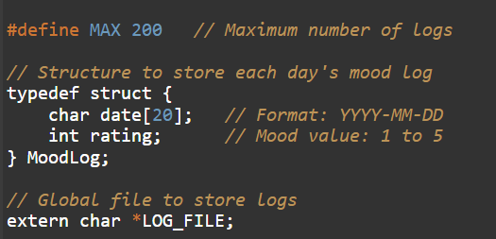
  - Add Mood Entry with Validation & Motivation
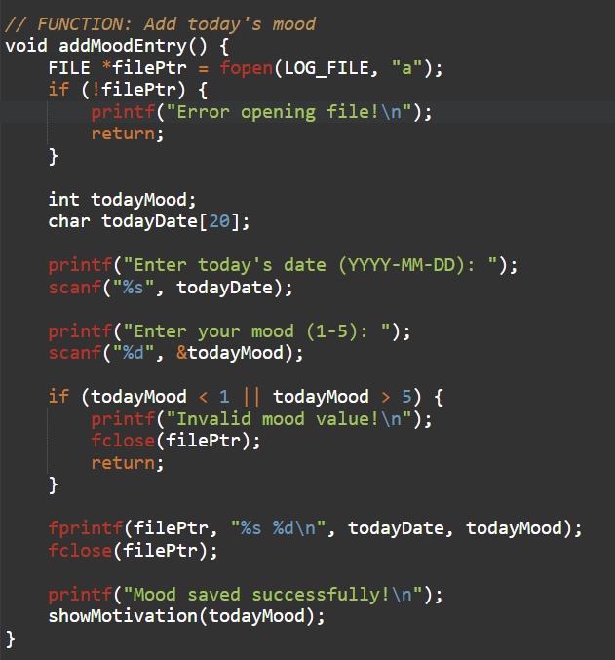
  - Display ASCII Mood Graph
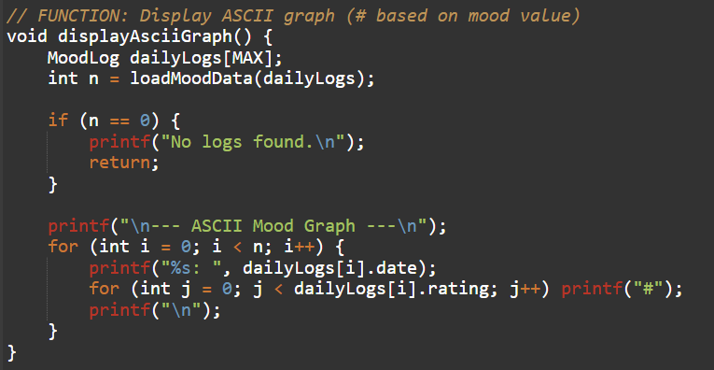

- Calculate Longest Mood Streak
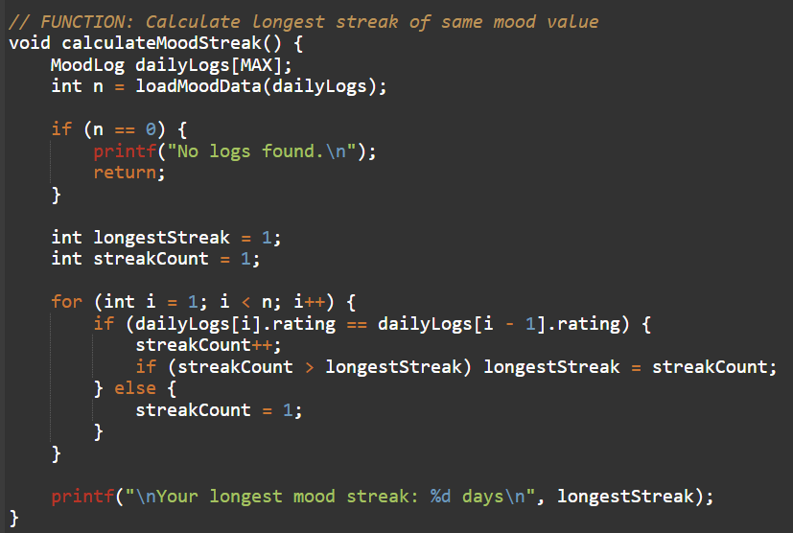
- Suggest Improvement
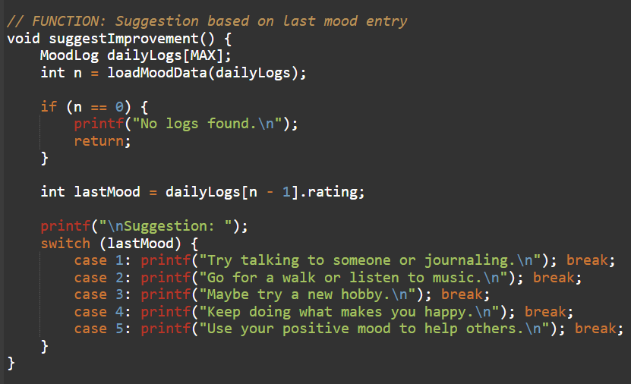

Testing and results
1. Log Today's Mood
Test Case Name: Add Single Mood Entry
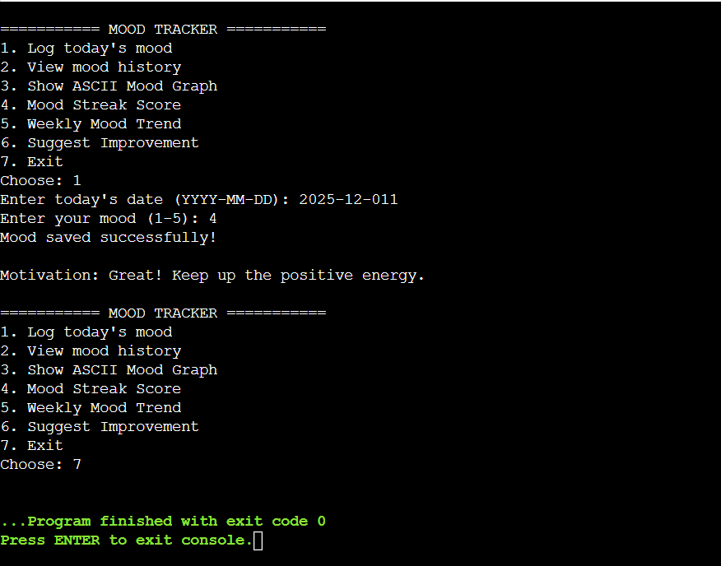

2. View Mood History
Test Case Name: Show Mood History
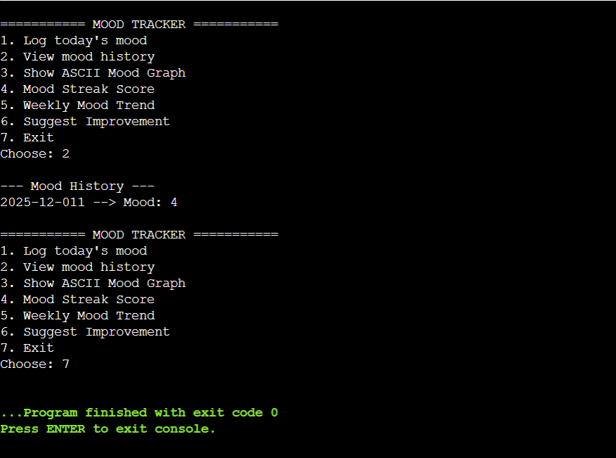

3. Show ASCII Mood Graph
Test Case Name: Display ASCII Graph
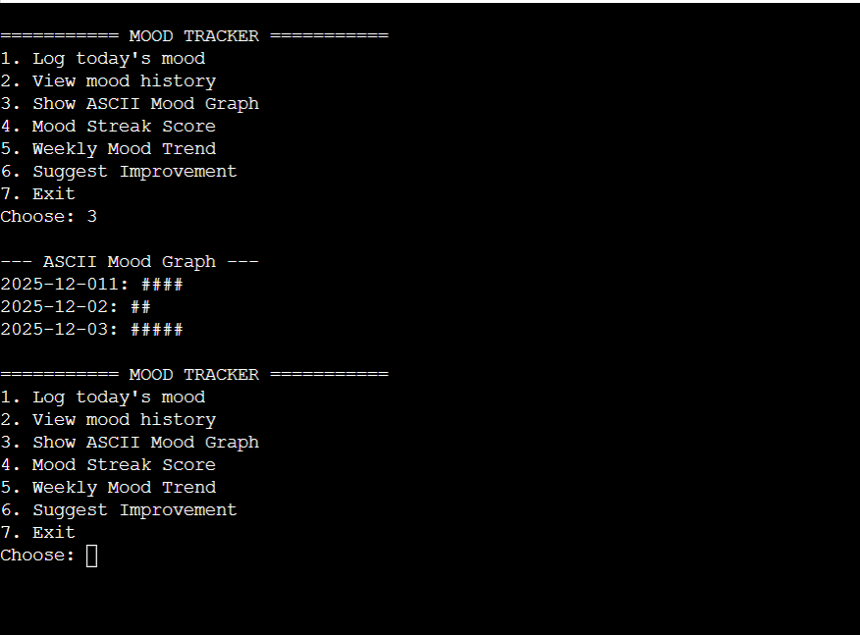

4. Mood Streak Score
Test Case Name: Calculate Mood Streak
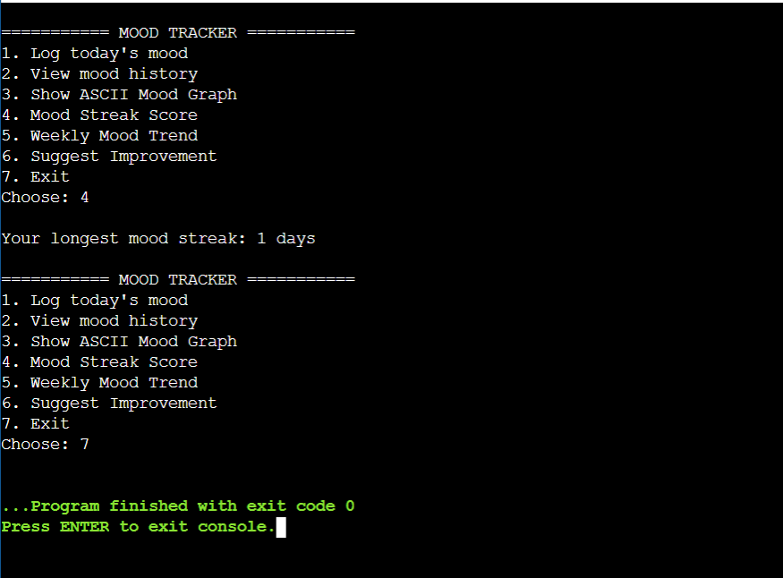

5.Suggest Improvement
Test Case Name: Suggest Based on Last Mood
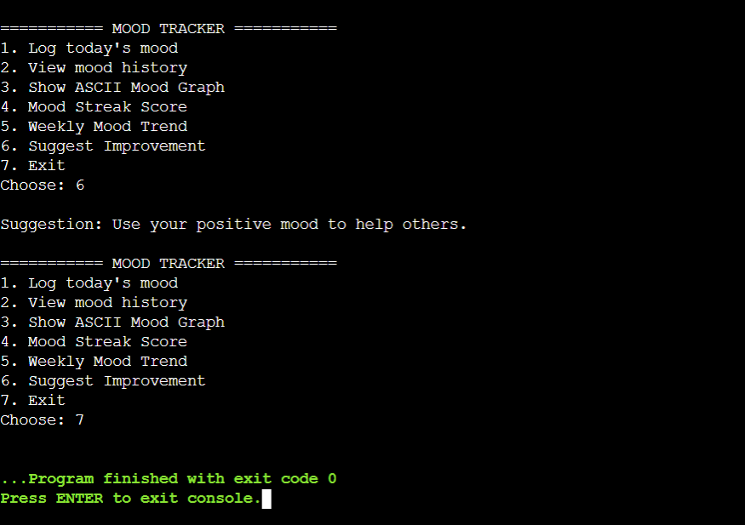

6. Invalid Choice
Test Case Name: Invalid Choice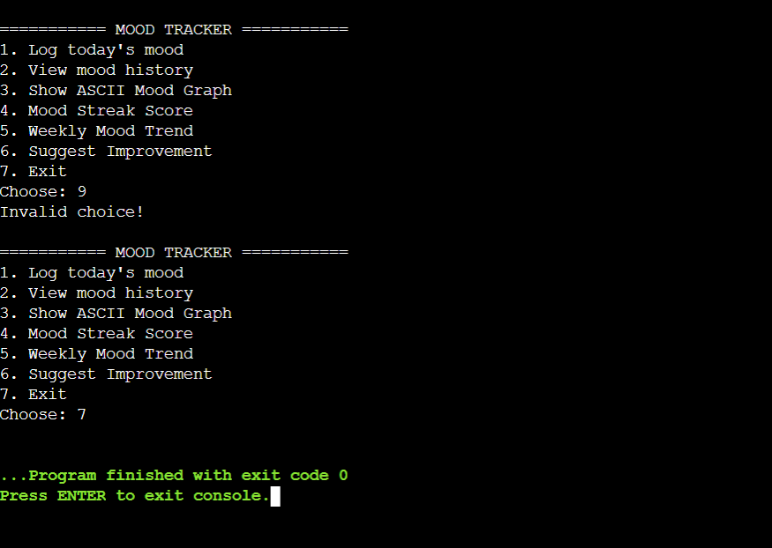

Conclusion

The Mood Tracker effectively allows users to log daily moods, track trends, and receive motivational suggestions. By using file handling, arrays, and structs, it provides persistent storage and efficient in-memory management. Features like ASCII mood graphs, weekly trends, and mood streak calculations help users visualize emotional patterns and maintain awareness of their mental well-being.

Future Work
- Enhanced Analytics: Calculate average mood, identify mood patterns over months.
- Better Visualization: Add graphical charts instead of ASCII representation.
- GUI Version: Build a user-friendly interface using libraries like GTK or Qt.
- Mobile/Web Version: Make the tracker accessible online for easier use.
- Advanced Suggestions: Integrate tips based on trends or AI-driven insights for mood improvement.

References
- Let Us C – Yashavant Kanetkar.
- GeeksforGeeks – https://www.geeksforgeeks.org
- Stack Overflow – https://stackoverflow.com/questions/tagged/c
- CProgramming.com – https://www.cprogramming.com/tutorial/c/lesson1.html
- “Data Structures in C” – TutorialsPoint: https://www.tutorialspoint.com/data_structures_algorithms/index.htm

