**University Admission System**

**Abstract**

University wants to computerize its admission process for higher education courses.

**1. Major Objective:**

Basic objectives are to extend their reach to geographically scattered students, reducing time in activities, centralized data handling and paperless admission with reduced manpower.

University Admission Management System is a web-based application built with the aim of computerizing the admission procedure in universities and colleges. The system proposed here incorporates handling and management of multi-departmental and multi-divisional system that includes various daily activities in the system.

This project is developed for the purpose of computerization of admission procedure in universities to reduce the time and manpower required in manual admission process. UAMS is developed using Java programming language with HTML/CSS used for user interface, JavaScript for client-side scripting and MS Access for the system database.

The key feature of the system is outlined below:

* Paperless admission with computerized process
* Reduced time in activities with reduced manpower
* Economy
* Operational efficiency
* Effective integration with other institutions
  1. **Existing System**

The existing admission management system in universities is generally pen-paper based. Even though some use somewhat computerized system, it is not very effective as the system takes a lot of time and manpower in performing various tasks.

Also, there is no centralized data handling system, so the overall admission procedure becomes very lengthy and tedious as the huge amount of paperwork is very difficult to handle.

* 1. **Proposed System**

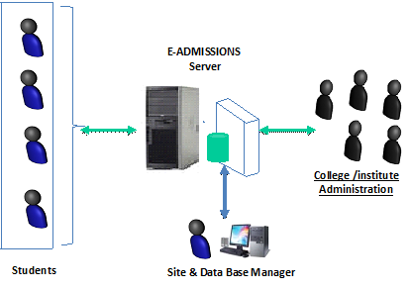

Outline Sketch of the **U.A.S**.

The Proposed system is a browser which is completely related to internet browsing. The web enabled information management system designed to automate the entire operations of a modern. Being a web-based system, it enables multi-departmental and multi-divisional handling with a centralized system for effective and efficient database management.

1. **Key Components:**

2.1. Administrator

2.2. Student User

* 1. MAC(Member Of Admission Committee)

1. **Modules Overview:**

**3.1. Administrator:** Admin of the system has full access and rights to manage the system. They handle all the accounts of students and faculty members. From the back end, admin’s can prepare and submit student reports, college reports, and daily reports of activities in the system.

**3.2. Members Of Committee(MAC):** Members Of committee(MAC) is responsible for keeping in track all the applications(including accepting and rejecting applications) for a particular program and sending the conclusive information to Administrator.

**3.3. Applicant:** Unlike the admin module, the access to students is restricted to only some sub-modules and functions. Users can see the college list, take hall ticket through online, and view reports prepared by the administrators.

1. **Software Requirements**

Operating System                     :                 Windows XP/2003 or Linux/Solaris

User Interface                          :                 HTML, CSS

Client-side Scripting                 :                JavaScript

Programming Language          :                 Java

Web Applications                     :                 JDBC, JNDI, Servlets, JSP

IDE/Workbench                        :                 Eclipse with MyEclipse Plug-in

Database                                  :                 Access

Server Deployment                   :                 RetHat JBoss AS

1. **Hardware Requirements**

Processor                                 :                  Pentium IV

Hard Disk                                :                  40GB

RAM                                        :                 256MB

1. **Conclusion:**

A computerized system provides flexibility, effectiveness and efficiency, plus it proves to be economical in the long run. The proposed university admission management system integrates all the features of a web-based system. As per user requirements, new features and modules can be added to the system.