Name- Samridhi Keshri

S/O Mr. RANJEET KUMAR

Ganesh cinema road, Mirganj Bihar

Pin: 140413

Cell: 8102499964

**PERSONAL DETAILS:**

~**DATE OF BIRTH**: 8TH FEB 2004

~ **MOTHER’S NAME** : Mrs. SHWETA KESHRI

~**FATHER’S NAME**: Mr. RANJEET KUMAR

~ **LANGUAGES KNOWN** : ENGLISH, HINDI

**EDUCATIONAL BACKGROUND :**

~ **B.E CSE –** CHANDIGARH UNIVERSITY, GHAURAN

~**12th standard** – DAV PUBLIC SCHOOL, (THAWE), BIHAR

( 2020-2021)

~ **10TH Standard-** DAV PUBLIC SCHOOL,(THAWE) ,BIHAR

(2018-2019)

**PROFESSIONAL EXPERIENCE:**

CURRENTLY PURSUING - B.E CSE (2021-2025) FROM CHANDIGARH UNIVERSITY

I have joined specialization course of web development

**JOB PROFILE: (INTERNSHIP)**

1. **HOMEPHLIC VIGRO COMPANY**  – WORKED IN SALING
2. **UINTY COMPANY**  - WORKED AS HR

**PROFESSIONAL SKILLS:**

Languages Known-

C, C++, JAVA, JAVASCRIPT, HTML, CSS

I have expert knowledge of frontend web development and basic of Backend. I have made frontend websites also.

**PROJECTS-**

Created a Joke generator website

Link- <https://replit.com/@Samrke/Joke>

Created a website that will show all the coding contests list to participate in date and time wise

Link- <https://replit.com/@Samrke/Contest>

**PARTICIPATION-**

Participated in Hack-a-Thon 2022 Chandigarh Police

And ServiceNow Code to Win contest in 2023

**CERTIFICATES-**

**Authentication server using Mongodb and Nodejs**

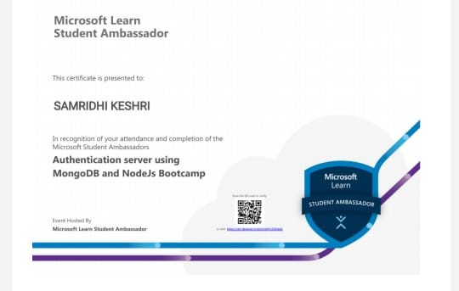

**LINKEDLN ACCOUNT-**

<https://www.linkedin.com/in/samridhi-keshri-365986241>

**INTERPERSONAL SKILLS:**

Communication skills

Moral values

Leadership qualities

Strong integrity

Determination

Loyal

**PERSONAL INTERESTS**

CODING

BADMINTON

SINGING

READING NOVELS