DESIGN AND DEVELOPMENT OF A PERSONAL CALORIE, STEP AND METABOLIC ENERGY TRACKER FOR SOUTH INDIAN DIET
A PROJECT REPORT
Submitted by
SAM BLESSON S
(Roll No. 2023111073)
in partial fulfillment for the award of the degree
of
BACHELOR OF ENGINEERING
IN
MECHANICAL ENGINEERING
COLLEGE OF ENGINEERING GUINDY
ANNA UNIVERSITY : CHENNAI 600 025
OCTOBER 2026

ABSTRACT
Maintaining a healthy body weight depends on balancing the energy taken in through food with the energy spent by the body. Existing calorie counters are built largely around Western foods, often need accounts and connectivity, and rarely treat the energy burned during rest and sleep as a continuous process. This project presents Tracker, a personal, offline-capable application that records daily food intake, steps walked and exercise, and computes the net energy balance. A preloaded database of more than sixty Tamil Nadu and South Indian dishes, grouped into categories, can be extended by the user. Basal metabolic rate is calculated with the Mifflin–St Jeor equation and converted into a live, non-editable counter that accumulates idle and sleep energy second by second. Energy spent in walking is estimated from step count and body weight, and planned activities use energy-per-minute rates. The tool also reports body mass index, total daily energy expenditure, a goal-based calorie target and reminders. It is built with HTML, CSS and JavaScript, stores data locally, supports light and dark themes, and is packaged as a progressive web application that can be converted to an Android package. A worked example shows that its results agree with hand calculations using standard equations.

CHAPTER 1

INTRODUCTION

1.1 GENERAL
Body weight is governed by a simple physical principle: the energy that enters the body through food must be balanced against the energy that leaves it as heat and work. The rising prevalence of overweight, obesity and lifestyle disorders makes it important for individuals to monitor this balance daily (WHO, 2000). From a mechanical engineering viewpoint, the human body is an open thermodynamic system, and the first law of thermodynamics must hold for it at every instant.
Most calorie counters are built around Western foods, need accounts and internet access, and show only exercise energy, although more than half of the daily energy is spent at rest. This project develops a private, offline application, named Tracker, for a traditional Tamil Nadu diet. It records food, steps and exercise, accumulates resting and sleep energy automatically, and reports the daily energy balance.

1.2 OBJECTIVES
The objectives of the project are as follows.
1. To build a categorised food database of South Indian dishes that the user can extend permanently.
2. To calculate BMR, TDEE and BMI from a user profile using standard equations.
3. To convert steps and exercise into energy expenditure.
4. To model idle and sleep expenditure as a live, non-editable counter derived from BMR.
5. To provide reminders, light and dark themes, and packaging as an installable mobile application.

1.3 SCOPE AND LIMITATIONS
The application is intended for one healthy adult for personal awareness. Steps are entered by the user, food values are typical estimates per home serving, and the tool is not a medical device.

1.4 NEED FOR THE PROJECT
Traditional Tamil Nadu meals are built around rice, millets, lentils, vegetables, coconut and tempering in oil, and one plate often combines several preparations such as rice, sambar, a poriyal and a side dish. General calorie counters seldom list these dishes under the names and serving sizes familiar at home, so the user must either guess a Western equivalent or type in values by hand every time. Both habits introduce error and discourage regular logging. A tool that begins with a database of local dishes, and lets the user add any missing item, removes this barrier.
A second need arises from the way expenditure is shown. Most applications display only the energy of logged exercise, which gives the impression that the body burns very little unless a workout is recorded. In reality the energy spent in resting and sleeping is the largest part of the day, and a tracker that ignores it gives a misleading picture of the balance. A third need is privacy. Many commercial applications require an account, a continuous internet connection or a subscription, and keep personal data on remote servers. An application that keeps all data on the device is preferable for an individual who wants awareness of their energy balance without sharing health information.

1.5 METHODOLOGY
The work was carried out in the following stages.
1. Study of the literature on energy expenditure, predictive equations for basal metabolic rate, pedometer-based activity classification and Indian food composition data.
2. Selection of the equations to be used for BMR, TDEE, BMI, walking energy and exercise energy, and derivation of the resting energy counter from the daily BMR.
3. Compilation of a database of Tamil Nadu and South Indian dishes with typical energy values per household serving.
4. Preparation of the functional and non-functional requirements, and design of the architecture, data storage and user interface.
5. Implementation of the application in HTML, CSS and JavaScript and packaging as a progressive web application.
6. Verification of the computed results against hand calculations and against other published equations.

1.6 ORGANISATION OF THE REPORT
Chapter 2 reviews the literature on energy expenditure, activity classification, food data and existing applications. Chapter 3 presents the theoretical background, including the thermodynamic view of the body and all equations used. Chapter 4 describes the requirements, architecture, data organisation and processing of the application. Chapter 5 explains the implementation of each module, the installable packaging and the verification procedure. Chapter 6 reports the results for the test case and for additional profiles, compares the equations used with others, and discusses the limitations. Chapter 7 gives the conclusion, the contributions and the future scope.
CHAPTER 2

LITERATURE REVIEW

2.1 ENERGY EXPENDITURE AND BMR
Daily energy expenditure has three parts: basal metabolism, the thermic effect of food and physical activity. Kleiber (1932) showed that metabolic rate scales with body mass to about the power three-quarters, and Weir (1949) gave the standard relation for converting measured gas exchange into energy. Because laboratory methods need equipment, predictive equations are used instead. Harris and Benedict (1918) published an early regression for basal metabolism, and Mifflin et al. (1990) later developed an equation reported to predict resting expenditure more accurately in healthy adults. It is adopted here because it needs only weight, height, age and sex.

2.2 STEPS, ACTIVITY AND FOOD DATA
Tudor-Locke and Bassett (2004) classified daily activity by pedometer steps, with fewer than about 5,000 steps indicating a sedentary day. Ainsworth et al. (2011) compiled metabolic equivalent (MET) values for activities, from which the per-minute rates used here were chosen. Food energy values for Indian foods are published by the National Institute of Nutrition (Gopalan et al., 1989; Longvah et al., 2017); the database here stores typical energy per household serving.

2.3 ENERGY BALANCE AND RESEARCH GAP
Wishnofsky (1958) estimated that about 7,700 kcal corresponds to one kilogram of body weight, but Hall et al. (2011) showed that the rule overstates long-term change, so it is used here only as a short-term guide. Asian populations also carry higher risk at lower BMI values (WHO Expert Consultation, 2004). The gap addressed is a private, offline tool with an extendable South Indian food database and a live resting energy counter.

2.4 EXISTING CALORIE-TRACKING APPLICATIONS
Calorie-tracking applications generally share a common structure: a large food database that is either licensed or contributed by users, a barcode scanner, an exercise log and a summary of daily calories. Their strengths are the size of the database and the link to wearable devices. For the present purpose they have three weaknesses. First, entries for regional dishes are often contributed by users, vary widely in value and may be duplicated with conflicting energy figures. Second, the energy spent at rest is usually folded into a single daily allowance and is not shown as a quantity that grows through the day, so the user cannot see how much energy has already been spent at a given hour. Third, most of them need an account and a network connection, and personal data is stored on remote servers. These observations describe the general design of such applications and are not the result of a formal comparison of particular products.

2.5 THERMIC EFFECT OF FOOD AND NON-EXERCISE ACTIVITY
Besides basal metabolism and exercise, two other components affect the daily total. Westerterp (2004) reviewed diet-induced thermogenesis, the energy used to digest, absorb and store food, and reported that it amounts to roughly ten percent of the energy intake on a mixed diet. Levine (2002) described non-exercise activity thermogenesis, the energy of standing, walking about and fidgeting, and showed that it differs greatly between individuals. Because both are hard to measure without laboratory equipment, the FAO, WHO and UNU (2004) express the total expenditure of a population as a multiple of the basal rate, called the physical activity level, which is also the approach followed in Table 3.1. The thermic effect of food and non-exercise activity are therefore absorbed into the activity factor in this project and are not modelled separately.

2.6 CHOICE OF PREDICTIVE EQUATION
Frankenfield, Roth-Yousey and Compher (2005) reviewed the accuracy of several predictive equations for resting metabolic rate in healthy adults and found that the Mifflin–St Jeor equation predicted the measured value within ten percent for a greater share of individuals than the other equations compared. This supports the choice made here. The equation was developed on a sample from the United States, and its accuracy for Indian adults of different body composition is less well documented, a point that is returned to in the discussion of limitations. The Indian Council of Medical Research and the National Institute of Nutrition (2020) have also published nutrient requirements for Indians, which may be used by a user as a reference when setting a personal goal.

2.7 SUMMARY OF THE REVIEW
The literature shows that the energy balance can be estimated with simple, well-tested equations, that step counts and metabolic equivalents give a practical estimate of activity energy, and that national food composition tables exist for Indian foods. It also shows that the 7,700 kcal rule and the standard BMI cut-offs are approximations. What is missing is a single, private and offline tool that combines these equations with a database of South Indian dishes that the user can extend, and that displays the resting energy as a live quantity. The remaining chapters describe the design of such a tool.
CHAPTER 3

THEORETICAL BACKGROUND

3.1 ENERGY BALANCE
The daily change in stored energy is the difference between intake and total expenditure:
ΔE = E_{in} − E_{out} (3.1)
where E_{out} is the sum of idle and sleep energy, walking energy and exercise energy.

3.2 BMR AND TDEE
BMR is calculated by the Mifflin–St Jeor equation, with W in kg, H in cm and A in years (Mifflin et al., 1990):
BMR = 10 W + 6.25 H − 5 A + 5 (male) (3.2)
BMR = 10 W + 6.25 H − 5 A − 161 (female) (3.3)
Total daily energy expenditure is the BMR multiplied by a physical activity level (PAL) from Table 3.1:
TDEE = BMR × PAL (3.4)
Table 3.1 Physical activity factors used for TDEE
Activity level | Description | PAL
Sedentary | Desk job, little exercise | 1.200
Lightly active | Exercise 1–3 days per week | 1.375
Moderately active | Exercise 3–5 days per week | 1.550
Very active | Exercise 6–7 days per week | 1.725
Extra active | Physical job plus training | 1.900

3.3 BODY MASS INDEX
BMI is the weight divided by the square of the height in metres:
BMI = W / (H / 100)² (3.5)
The WHO ranges are used: below 18.5 underweight, 18.5 to 24.9 normal, 25.0 to 29.9 overweight and 30 or above obese (WHO, 2000).

3.4 IDLE AND SLEEP ENERGY
The resting rate in kcal per second and the energy accumulated t seconds after midnight are:
r = BMR / 86400 (3.6)
E_{idle}(t) = r × t (3.7)
The program computes this from the system clock, so it cannot be edited and grows linearly to the full BMR at midnight. Adding BMR to gross activity energy slightly overstates total expenditure, a simplification accepted here for clarity.

3.5 WALKING ENERGY
Energy for N steps by a person of weight W, with stride length L taken as a fraction of height, is:
E_{steps} = N × W × 0.00045 (3.8)
L = 0.415 H / 100, d = N L / 1000 (3.9)
For 70 kg this gives about 31.5 kcal per 1000 steps. Here L is in metres and d is the distance in km. Figure 3.1 shows the variation for three body weights.
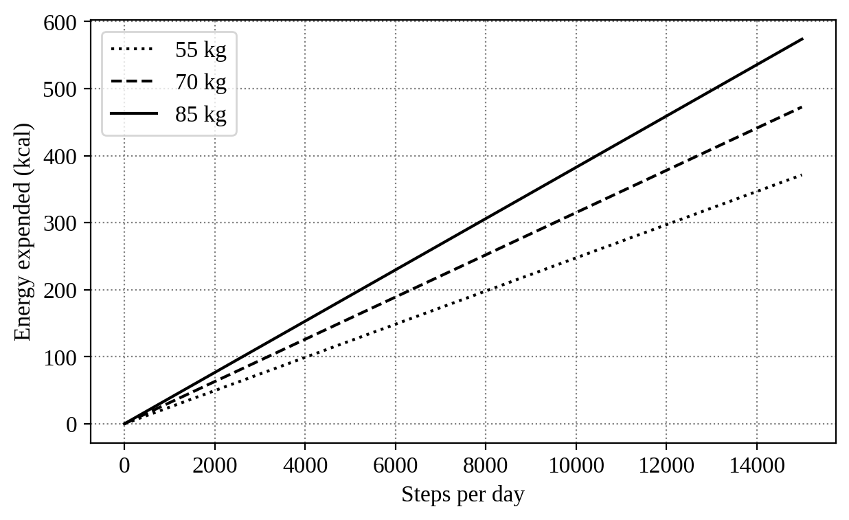
Figure 3.1 Energy expended in walking versus steps per day

3.6 CALORIE TARGET
The daily target is the TDEE for maintenance, TDEE minus 500 kcal for loss and TDEE plus 500 kcal for gain. At 7,700 kcal per kilogram, a 500 kcal deficit means about 15 days per kilogram.

3.7 THERMODYNAMIC VIEW OF THE HUMAN BODY
The human body exchanges matter and energy with its surroundings and is therefore an open system. In rate form the first law of thermodynamics for the body can be written as:
dE / dt = P_{in} − (P_{heat} + P_{work}) (3.10)
where dE/dt is the rate of change of stored energy, P_{in} is the rate at which chemical energy enters with food, P_{heat} is the rate at which heat is released to the surroundings and P_{work} is the rate of external mechanical work. Muscle converts chemical energy into mechanical work with an efficiency of only about 20 to 25 percent, defined as the ratio of the mechanical work W_{mech} to the chemical energy E_{chem} consumed:
η = W_{mech} / E_{chem} (3.11)
so that most of the energy used by working muscle appears as heat. External work is small even in vigorous exercise, and almost all of the energy expenditure leaves the body as heat in the end. This is the reason why the application treats expenditure as the total energy consumed and not as the mechanical work done. At rest the heat released equals the basal rate, which is the energy needed to keep the heart, lungs, brain and other organs working.
Kleiber (1932) found that the basal rate of mammals scales with body mass to the power three-quarters. Expressed for humans in the usual form:
BMR ≈ 70 M^{0.75} (kcal/day, M in kg) (3.12)
For the 68 kg test subject this gives about 1658 kcal per day, which is within one percent of the 1648 kcal per day given by the Mifflin–St Jeor equation. The agreement of two independent approaches gives confidence in the value used by the resting energy counter.

3.8 ENERGY OF PHYSICAL ACTIVITIES
The energy of an activity is found from its metabolic equivalent, MET, which is the ratio of the working metabolic rate to the resting rate. By convention one MET is taken as about 1 kcal per kilogram of body weight per hour, so that for a body weight W in kg and a duration t in minutes:
E_{act} = MET × W × t / 60 (3.13)
Brisk walking has a value of about 4.4 MET (Ainsworth et al., 2011), and for the 68 kg subject walking for 30 minutes gives 4.4 × 68 × 30 / 60 = 150 kcal, the value used in Table 6.1. The rates in Table 5.1 follow from the same relation. The walking energy of Equation 3.8 can be checked against it. For a person of 170 cm the stride length is 0.7055 m, so one kilometre needs about 1417 steps, and at 0.00045 kcal per step per kilogram this is about 0.64 kcal per kilogram per kilometre, which is of the order commonly quoted for walking at a moderate speed.

3.9 SENSITIVITY OF BMR TO THE PROFILE
Because Equation 3.2 is linear, the effect of a change in each input can be read from its coefficient. An additional kilogram of weight adds 10 kcal per day, an additional centimetre of height adds 6.25 kcal per day, an additional year of age removes 5 kcal per day, and the difference between the male and female equations is 166 kcal per day. Table 3.2 shows the effect of a change in each input on the BMR of the test subject.
Table 3.2 Effect of changes in the profile on the BMR of the test subject (1648 kcal/day)
Change in input | Coefficient | Change in BMR | Percent
Weight +5 kg | 10 kcal/kg | +50 kcal/day | +3.0
Height +5 cm | 6.25 kcal/cm | +31 kcal/day | +1.9
Age +5 years | −5 kcal/year | −25 kcal/day | −1.5
Female instead of male | −166 kcal | −166 kcal/day | −10.1

Weight is therefore the most influential input among those that a user can change, and an error of a few kilograms in the entered weight has a small but noticeable effect on all derived quantities.

3.10 TDEE AND CALORIE TARGET FOR EACH ACTIVITY LEVEL
The activity factor has a larger effect than any single profile input. Table 3.3 and Figure 3.2 apply the factors of Table 3.1 to the BMR of 1648 kcal per day and show the resulting TDEE and the calorie targets for loss and gain. Moving from the sedentary to the extra active level raises the TDEE by about 1150 kcal per day, which shows why the correct choice of level is important.
Table 3.3 TDEE and calorie targets for the test subject at each activity level (kcal/day)
Activity level | PAL | TDEE (maintain) | Loss target | Gain target
Sedentary | 1.200 | 1978 | 1478 | 2478
Lightly active | 1.375 | 2266 | 1766 | 2766
Moderately active | 1.550 | 2554 | 2054 | 3054
Very active | 1.725 | 2843 | 2343 | 3343
Extra active | 1.900 | 3131 | 2631 | 3631

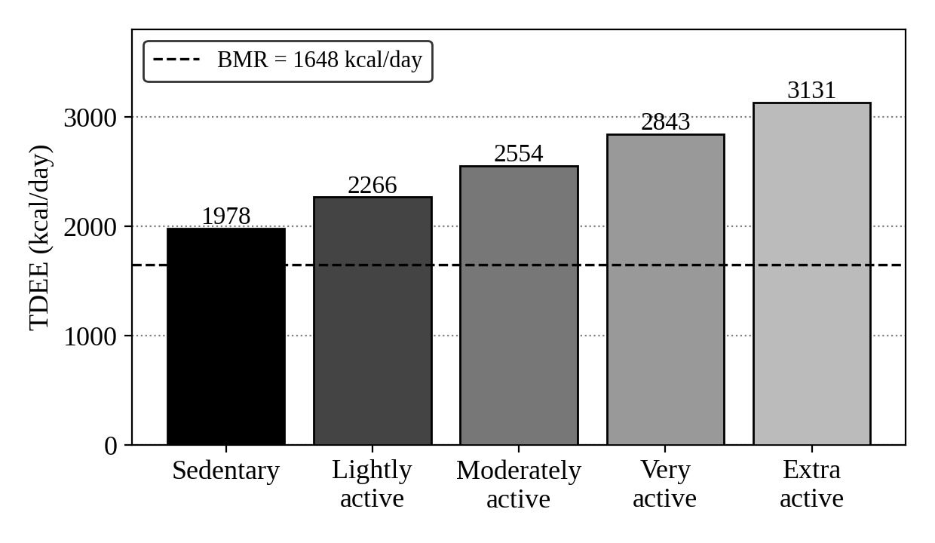
Figure 3.2 TDEE of the test subject at each activity level

3.11 ASSUMPTIONS OF THE MODEL
The model rests on a few simplifying assumptions, which are stated here so that the results can be interpreted correctly.
1. Body weight, height and age remain constant during one day, so that the BMR is constant and the idle energy grows linearly with time.
2. The energy of walking is proportional to the number of steps and does not depend on walking speed or gradient.
3. Each food has a typical energy value per household serving, and the user logs the number of servings eaten.
4. The thermic effect of food and non-exercise activity are contained in the activity factor and the idle counter and are not counted again.
5. The conversion of 7,700 kcal per kilogram is used only as a short-term guide to the rate of change of weight.
CHAPTER 4

SYSTEM DESIGN

4.1 REQUIREMENTS
The functional requirements are listed in Table 4.1. The application must also work offline, keep data on the device and suit a phone screen.
Table 4.1 Functional requirements of the application
ID | Requirement
FR1 | Store a profile and calculate BMR, TDEE, BMI and calorie target
FR2 | Provide a categorised food database and log food by servings
FR3 | Allow new foods to be added permanently
FR4 | Record steps and exercise and convert them to energy
FR5 | Accumulate idle and sleep energy automatically
FR6 | Show intake, expenditure and net energy for any date
FR7 | Provide reminders and light and dark themes

4.2 ARCHITECTURE AND DATA
The application is a single-page client-side program. As shown in Figure 4.1, the interface connects six modules to a local key-value store, in which each record kind has its own key and each date has its own log.
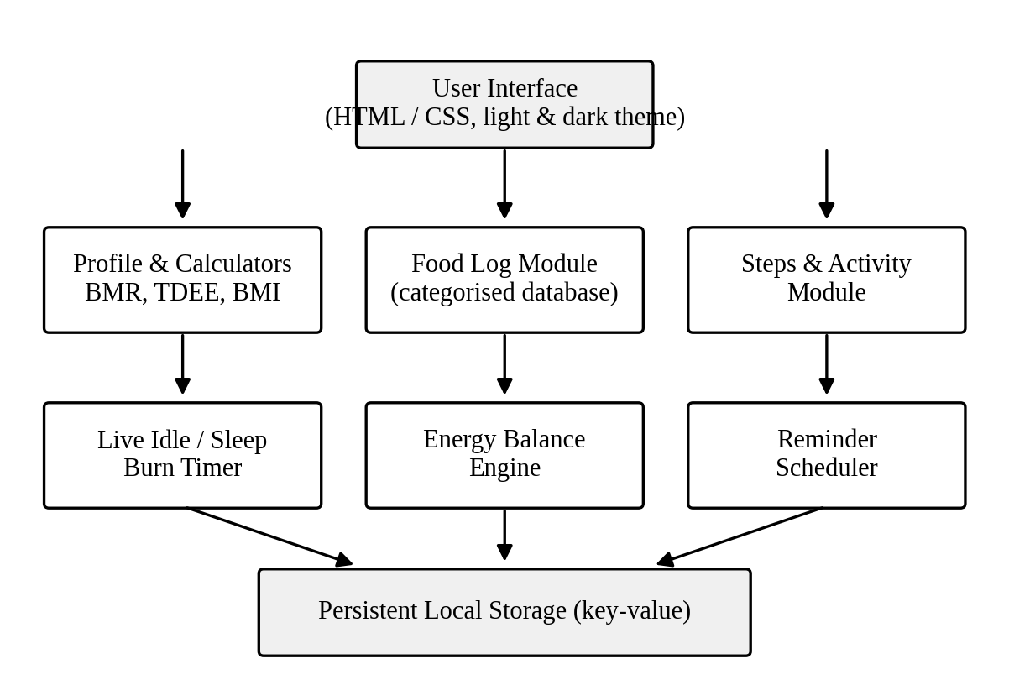
Figure 4.1 System architecture of Tracker
Inputs are validated, converted to numbers, stored locally and displayed on the dashboard, which also refreshes every second so that the idle counter advances in real time (Figure 4.2).
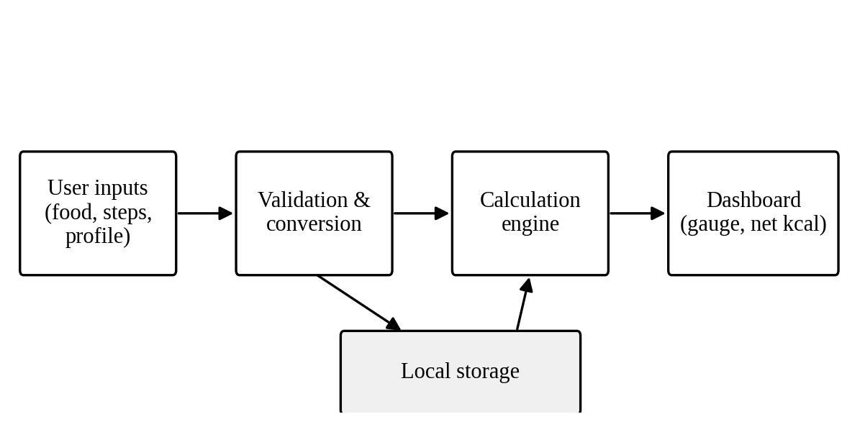
Figure 4.2 Data flow diagram of Tracker
The built-in database holds 62 Tamil Nadu and South Indian dishes in nine categories (breakfast, rice, curry, side, non-veg, snack, dessert, drink and fruit), including fried rice and noodles. Each record has a name, serving, energy per serving and category. Dishes added by the user are saved separately and merged at run time.

4.3 USER INTERFACE AND TECHNOLOGY
The interface has five tabs: Dashboard, Food Log, Steps and Activity, Profile, and Reminders. It uses a minimalist palette with a switchable dark theme. The program is written in HTML, CSS and JavaScript without any framework, so that it runs in a browser and can be installed as a progressive web application (Mozilla Developer Network, n.d.).

4.4 NON-FUNCTIONAL REQUIREMENTS
Besides the functions of Table 4.1, the application has to satisfy the qualities listed in Table 4.2. These qualities decided the choice of technology and the way data is stored.
Table 4.2 Non-functional requirements of the application
ID | Quality | Requirement
NFR1 | Offline use | All functions work without an internet connection after the first load
NFR2 | Privacy | Personal data is kept on the device and is never sent to a server
NFR3 | Responsiveness | The idle counter refreshes every second without noticeable delay
NFR4 | Usability | Common actions such as logging a dish need only one or two taps on a phone screen
NFR5 | Portability | The same code runs in a desktop browser and on a phone, and can be installed
NFR6 | Extensibility | Foods can be added and kept permanently without changing the program

4.5 DESIGN DECISIONS
Three decisions shaped the design. The first is to make the application offline-first. The program and its data are stored on the device, so that the application starts quickly and works in places with poor connectivity, which is common during travel. The second is to avoid a server and user accounts altogether. This removes the cost of hosting and the risk of leaking personal data, and it keeps the application simple to use. The third is to avoid a software framework. A plain HTML, CSS and JavaScript program is small, runs in every modern browser, can be read and modified by a student, and has no dependency that may become unavailable.
The price of these decisions is that data does not move automatically between devices, and that background tasks such as reminders are limited while the page is closed. Both are listed as limitations in Chapter 6 and as future work in Chapter 7.

4.6 ORGANISATION OF STORED DATA
The data is held in the local storage of the browser as a key-value store. Each kind of record has its own key, and each date has its own log, so that a record can be read or changed without loading the rest. Table 4.3 lists the kinds of record and their contents.
Table 4.3 Kinds of record held in local storage
Record | Contents
Profile | Sex, age, height, weight, activity level and goal, with the derived BMR, TDEE, BMI and calorie target
User-added foods | Name, serving, energy per serving and category of each dish added by the user
Daily log | One record per date holding the foods eaten, the steps and the activities logged
Reminders | Time and message of each reminder and whether it is switched on
Theme | The selected light or dark theme

The built-in dishes are part of the program and are not copied into storage. At start-up the built-in list and the user-added list are merged, so that updating the built-in list in a later version does not disturb the user’s own entries.

4.7 FOOD CATEGORIES
The nine categories of the database follow the way meals are arranged in a South Indian household. Breakfast items such as idli, dosa and pongal form one group, and rice dishes such as sambar rice, curd rice and fried rice form another. Curries and side dishes are held separately, since a plate usually combines a rice item with one or more of them. Non-vegetarian dishes, snacks, desserts, drinks and fruits make up the rest. The grouping lets the user find a dish by browsing a short list and not by typing, which suits a phone screen, and a search box is provided for the cases where the name is known.

4.8 PROCESSING OF A DAY’S DATA
The dashboard is computed from the stored records in the following sequence each time the page is refreshed.
1. Read the profile and the log of the selected date from storage.
2. Add the energy of all foods logged to obtain the intake, using the number of servings and the energy per serving.
3. Convert the steps to walking energy by Equation 3.8 and add the energy of the logged activities to obtain the exercise energy.
4. Read the system clock, find the seconds elapsed since midnight and multiply by the resting rate of Equation 3.6 to obtain the idle energy. For a past date the full BMR is used.
5. Obtain the total expenditure as the sum of idle, walking and exercise energy, and the net energy as intake minus total expenditure.
6. Compare the intake with the calorie target to draw the gauge, and display all values.
CHAPTER 5

IMPLEMENTATION

5.1 PROFILE, FOOD AND STEPS MODULES
The profile form recalculates BMR, TDEE, BMI and the calorie target on saving. Foods are shown in labelled category groups, and tapping a dish logs a serving, with search and an add-new-food form. Steps are converted by Equations 3.8 and 3.9, and other activities are logged by type and minutes using the rates in Table 5.1.
Table 5.1 Energy rates used for manual activity logging
Activity | Rate (kcal/min) | Equivalent MET (68 kg)
Brisk walk | 5.0 | 4.4
Jogging | 10.0 | 8.8
Cycling | 8.0 | 7.1
Yoga | 3.0 | 2.6
Gym / weights | 6.0 | 5.3
Swimming | 9.0 | 7.9
Household work | 3.5 | 3.1

5.2 LIVE IDLE AND SLEEP BURN
A timer runs every second, reads the clock, multiplies the seconds since midnight by r from Equation 3.6 and updates the display. There is no input field, so the value rises continuously through waking and sleeping hours, as in Figure 5.1.
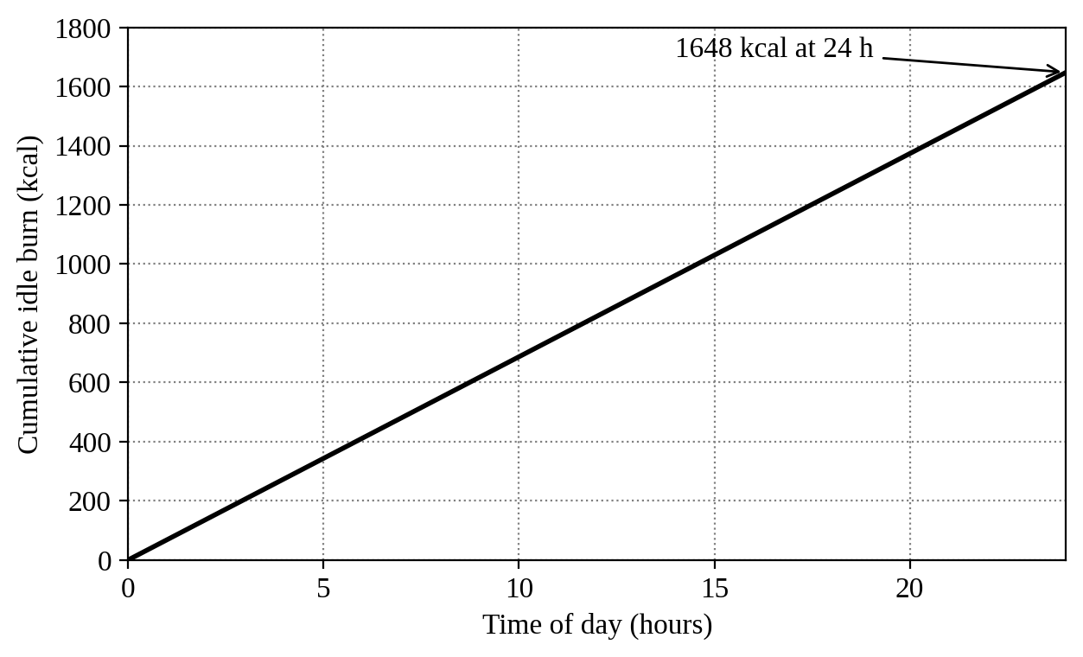
Figure 5.1 Idle and sleep energy during a day (BMR = 1648 kcal)

5.3 DASHBOARD, REMINDERS AND PACKAGING
The dashboard shows net energy as intake minus the sum of idle, walking and exercise energy, and a gauge of intake against the target. Reminders are checked every 20 seconds and fire a message, a tone and, if permitted, a browser notification while the page is open. A manifest, a service worker and icons make the application installable, and it can then be wrapped as an Android package (APK) by a free packaging service.

5.4 INPUT VALIDATION AND ERROR HANDLING
Every value entered by the user is read as text and has to be converted to a number before it is used. The program checks that the profile fields, servings, steps and minutes are present, numeric and within reasonable limits, and it refuses values that are negative or empty. A short message tells the user what is wrong, and the stored data is left unchanged when an entry is rejected. This prevents a mistyped value from corrupting the totals of the day or the derived quantities of the profile. Reading from storage is also guarded, so that a missing or damaged record is replaced by default values and the application still starts.

5.5 EXTENDING THE FOOD DATABASE
A dish that is not in the built-in list can be added through a form that asks for the name, the serving description, the energy per serving and the category. The new record is validated, saved in the list of user-added foods and shown at once in its category group. Because the list is saved in local storage it is present when the application is opened again, and it is merged with the built-in dishes at start-up as described in Section 4.6. The user can then log the new dish exactly like any other, with a single tap.

5.6 PROGRESSIVE WEB APPLICATION PACKAGING
A progressive web application is an ordinary web page that adds a manifest file and a service worker, so that a browser can install it and run it like a native application (Mozilla Developer Network, n.d.). The manifest gives the name, the icons, the colours and the start page of the application. The service worker is a script that the browser runs in the background. When the application is first opened it stores the program files in a cache, and on later visits it serves them from the cache, so that the application opens without a network connection.
Once the files are cached the application can be added to the home screen of a phone. It then opens in its own window without the address bar of the browser. For distribution as an Android package, the installed web application is wrapped by a free packaging service that generates an APK file without any change to the source code. The same code therefore serves the desktop browser, the installed web application and the Android package.

5.7 VERIFICATION PROCEDURE
The application was checked in two ways. The calculations were verified by comparing the displayed values with hand calculations from the equations of Chapter 3, as reported in Chapter 6. The behaviour of the application was checked against the test cases listed in Table 5.2. Each case states an action and the behaviour that is expected, so that the checks can be repeated after any later change to the program.
Table 5.2 Test cases and expected behaviour
ID | Action | Expected behaviour
T1 | Save the test profile | BMR 1648, TDEE 2266, BMI 23.5 and target 1766 kcal
T2 | Log foods totalling 1840 kcal | Intake of 1840 kcal on the dashboard
T3 | Enter 8000 steps | 245 kcal and a distance of 5.64 km
T4 | Log 30 min of brisk walking | Exercise energy of 150 kcal
T5 | Read the idle counter at 06:00 and 12:00 | 412 kcal and 824 kcal
T6 | Add a new dish and reload the page | The dish remains in its category
T7 | Open the application without a network | All functions work
T8 | Switch the theme and reload | The selected theme is kept
T9 | Enter an empty or negative value | The entry is rejected and totals are unchanged

CHAPTER 6

RESULTS AND DISCUSSION

6.1 TEST CASE AND RESULTS
The test profile was a male of age 20 years, 170 cm and 68 kg, lightly active, with weight loss as the goal. He walked 8000 steps, did 30 minutes of brisk walking and ate foods from the database totalling 1840 kcal. The application results matched hand calculations, as shown in Table 6.1.
Table 6.1 Computed results for the test case
Quantity | Calculation | Result
BMR | 10(68) + 6.25(170) − 5(20) + 5 | 1648 kcal/day
TDEE | 1648 × 1.375 | 2266 kcal/day
BMI | 68 / (1.70)² | 23.5 (normal)
Calorie target | 2266 − 500 | 1766 kcal/day
Steps energy | 8000 × 68 × 0.00045 | 245 kcal
Distance | 8000 × 0.415 × 1.70 / 1000 | 5.64 km
Exercise energy | 5 kcal/min × 30 min | 150 kcal
Idle and sleep (full day) | Equation 3.7 at t = 86400 s | 1648 kcal
Total burned | 1648 + 245 + 150 | 2043 kcal
Net energy | 1840 − 2043 | −203 kcal

At 06:00 the idle counter showed 412 kcal and at 12:00 it showed 824 kcal, one quarter and one half of the daily BMR. Figure 6.1 compares the energy components of the day.
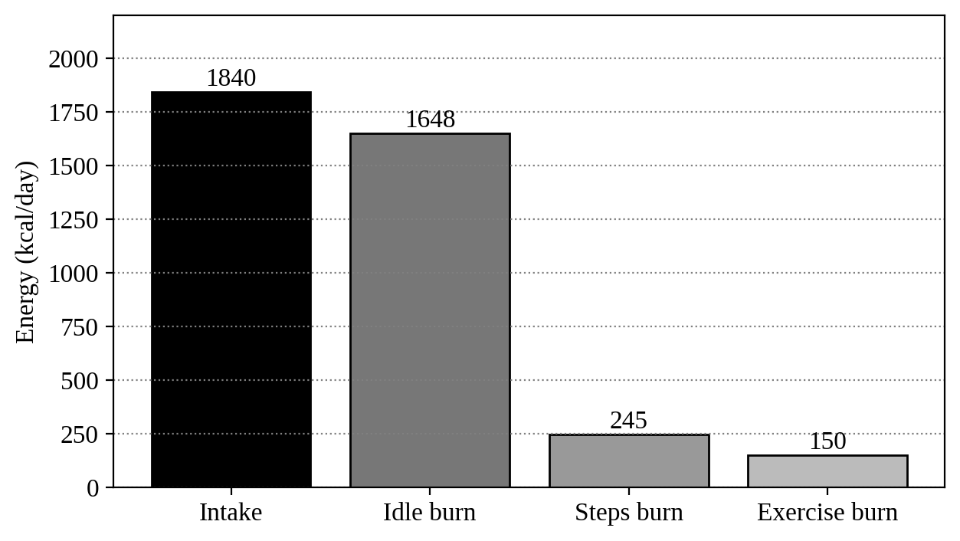
Figure 6.1 Energy intake and expenditure for the test day

6.2 DISCUSSION AND LIMITATIONS
The test day shows a deficit of 203 kcal, and the idle component is 81 percent of the total expenditure, which shows how much of the day’s energy is spent at rest. The limitations are that steps are entered manually, food values are typical estimates, adding BMR to gross activity energy slightly overstates expenditure, the standard BMI ranges are used instead of Asian cut-offs, reminders work only while the page is open, and the 7,700 kcal rule is a short-term approximation.

6.3 ADDITIONAL PROFILES
To check that the equations behave correctly for other users, two more profiles were calculated by hand in addition to the test case, which is called Profile A. Profile B is a woman of 25 years, 160 cm and 55 kg who is sedentary and wishes to maintain her weight. Profile C is a man of 45 years, 175 cm and 90 kg who is lightly active and wishes to lose weight. The results are given in Table 6.2.
Table 6.2 Computed results for three profiles
Quantity | Profile A | Profile B | Profile C
Sex, age | Male, 20 y | Female, 25 y | Male, 45 y
Height, weight | 170 cm, 68 kg | 160 cm, 55 kg | 175 cm, 90 kg
Activity level | Lightly active | Sedentary | Lightly active
BMR (kcal/day) | 1648 | 1264 | 1774
TDEE (kcal/day) | 2266 | 1517 | 2439
BMI | 23.5 (normal) | 21.5 (normal) | 29.4 (overweight)
Goal | Loss | Maintain | Loss
Calorie target (kcal/day) | 1766 | 1517 | 1939

For Profile B, 6000 steps give 6000 × 55 × 0.00045 = 149 kcal, and with a stride of 0.664 m the distance is 3.98 km. If this profile were to select weight loss, the fixed deduction of 500 kcal would give a target of 1017 kcal per day, which is well below the 1200 kcal per day that is often quoted as a minimum for unsupervised dieting. This shows that a lower limit on the target is a useful addition, and it is included in the future scope. Profile C has a BMI of 29.4, close to the obesity threshold, and its target of 1939 kcal per day would take about 15 days per kilogram if the deficit of 500 kcal per day were met.

6.4 COMPARISON WITH OTHER EQUATIONS
The BMR of the test subject was also found with two other relations. The original Harris and Benedict (1918) equation for men gives BMR = 66.473 + 13.7516 W + 5.0033 H − 6.755 A, and Kleiber’s relation is Equation 3.12. The results are compared in Table 6.3.
Table 6.3 BMR of the test subject by three methods
Method | BMR (kcal/day) | Difference
Mifflin–St Jeor (used here) | 1648 | Reference
Harris–Benedict (1918) | 1717 | +4.2%
Kleiber, 70 M^0.75 | 1658 | +0.6%

The Harris–Benedict value is about four percent higher, which agrees with the finding of Frankenfield et al. (2005) that this older equation tends to give higher values than Mifflin–St Jeor. The Kleiber value is close to the value used. The three methods lie within a band of about 70 kcal per day, which is small compared with the daily total, so the choice of equation does not change the conclusions drawn from the energy balance.

6.5 EFFECT OF THE NUMBER OF STEPS
The same day was recalculated for different step counts with the intake, the idle energy and the exercise energy kept constant. Table 6.4 and Figure 6.2 show that each additional 2000 steps lowers the net energy by about 61 kcal. The last column gives the number of days needed to lose 1 kg at that daily deficit, using 7,700 kcal per kilogram. It is a rough guide only, because the rule overstates long-term change (Hall et al., 2011).
Table 6.4 Net energy of the test day for different step counts
Steps per day | Steps energy (kcal) | Net energy (kcal) | Days per kg
4,000 | 122 | −80 | 96
6,000 | 184 | −142 | 54
8,000 | 245 | −203 | 38
10,000 | 306 | −264 | 29
12,000 | 367 | −325 | 24

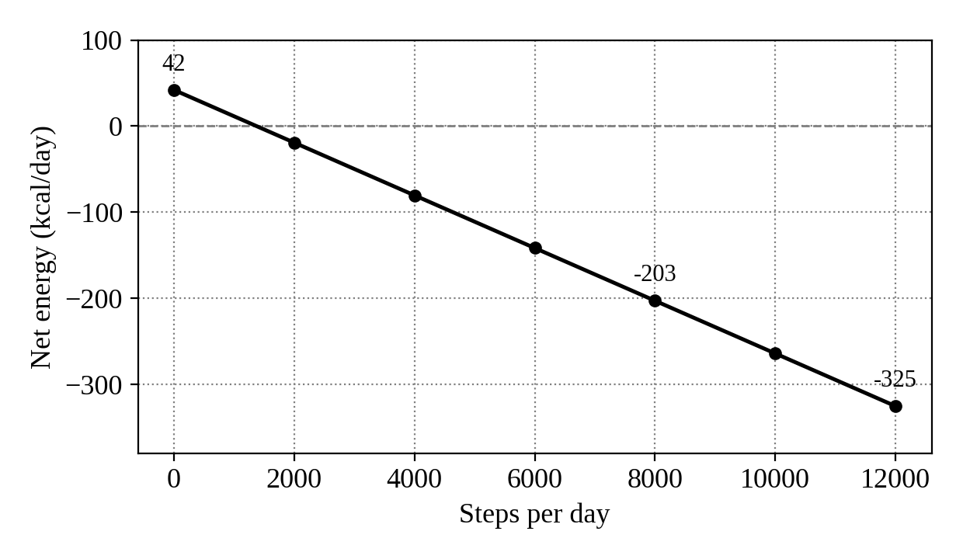
Figure 6.2 Net energy of the test day versus steps per day
On the classification of Tudor-Locke and Bassett (2004), the 8000 steps of the test case fall in the somewhat active range of 7,500 to 9,999 steps per day. The table shows that the benefit of walking is real but modest in energy terms, since even 12,000 steps remove only about 367 kcal. The resting energy, which is 81 percent of the expenditure of the test day, remains the dominant term. Steps and exercise account for about 12 percent and 7 percent of the total respectively.

6.6 INTERPRETATION OF BMI
The test subject has a BMI of 23.5, which is normal on the WHO ranges used in the application. The WHO Expert Consultation (2004) proposed lower action points of 23.0 and 27.5 for Asian populations because the risk of disease starts at lower values. On those points the same BMI would fall in the band of moderate risk. The application therefore reports the standard category, and the user should treat a value close to the upper end of the normal range with some care. Adding the Asian cut-offs as an option is simple, since only the comparison values of the BMI check need to change.
CHAPTER 7

CONCLUSION AND FUTURE SCOPE

7.1 CONCLUSION
A personal, offline calorie, step and energy balance tracker was designed, implemented and tested. It combines a categorised database of 62 South Indian dishes that the user can extend, standard equations for BMR, TDEE and BMI, a step and exercise energy model and a live, non-editable idle and sleep counter. Its results agreed with hand calculations, and it can be installed on a phone and converted to an Android package.

7.2 KEY CONTRIBUTIONS
The main contributions of the project are as follows.
1. A categorised database of 62 Tamil Nadu and South Indian dishes that can be extended by the user and is kept permanently on the device.
2. A single offline application that calculates BMR, TDEE, BMI and a goal-based calorie target from standard equations.
3. A live and non-editable counter of idle and sleep energy derived from the BMR, which makes the resting component of the day visible.
4. A walking and exercise energy model based on the step count, the body weight and metabolic equivalents.
5. A verification of the results against hand calculations, additional profiles and two other methods of estimating the BMR.

7.3 FUTURE SCOPE
Future work can add automatic step counting from phone sensors, heart-rate input from a wearable, protein, carbohydrate and fat values, trend charts with export, background reminders through a native Android wrapper and Asian BMI cut-offs.
The calculations in Chapter 6 point to three further improvements. A lower limit should be placed on the calorie target so that the fixed deduction cannot give an unsafe value. An option for Asian BMI action points should be added. The weight entered in the profile should be updated from time to time, since the BMR and the walking energy both depend on it.

7.4 RESPONSIBLE USE
The application is meant for awareness and not for treatment. The values it shows are estimates based on population equations and typical food energy, and they may differ from the true values for an individual. A person with a medical condition, a person who is pregnant, and anyone who intends to change the diet substantially should seek the advice of a doctor or a qualified dietitian. Since all data remains on the device, the user is in full control of personal information, which is an advantage of the design.

REFERENCES
1. Ainsworth, B.E., Haskell, W.L., Herrmann, S.D. et al. (2011) ‘Compendium of Physical Activities: a second update of codes and MET values’, Medicine & Science in Sports & Exercise, Vol.43, No.8, pp.1575–1581.
2. FAO/WHO/UNU (2004) ‘Human energy requirements: report of a joint FAO/WHO/UNU expert consultation’, Food and Nutrition Technical Report Series 1, Food and Agriculture Organization, Rome.
3. Frankenfield, D., Roth-Yousey, L. and Compher, C. (2005) ‘Comparison of predictive equations for resting metabolic rate in healthy nonobese and obese adults: a systematic review’, Journal of the American Dietetic Association, Vol.105, No.5, pp.775–789.
4. Gopalan, C., Rama Sastri, B.V. and Balasubramanian, S.C. (1989) ‘Nutritive Value of Indian Foods’, National Institute of Nutrition, Indian Council of Medical Research, Hyderabad.
5. Hall, K.D., Sacks, G., Chandramohan, D., Chow, C.C., Wang, Y.C., Gortmaker, S.L. and Swinburn, B.A. (2011) ‘Quantification of the effect of energy imbalance on bodyweight’, The Lancet, Vol.378, No.9793, pp.826–837.
6. Harris, J.A. and Benedict, F.G. (1918) ‘A biometric study of human basal metabolism’, Proceedings of the National Academy of Sciences, Vol.4, No.12, pp.370–373.
7. ICMR-NIN (2020) ‘Nutrient Requirements for Indians: Recommended Dietary Allowances and Estimated Average Requirements’, National Institute of Nutrition, Indian Council of Medical Research, Hyderabad.
8. Kleiber, M. (1932) ‘Body size and metabolism’, Hilgardia, Vol.6, No.11, pp.315–353.
9. Levine, J.A. (2002) ‘Non-exercise activity thermogenesis (NEAT)’, Best Practice & Research Clinical Endocrinology & Metabolism, Vol.16, No.4, pp.679–702.
10. Longvah, T., Ananthan, R., Bhaskarachary, K. and Venkaiah, K. (2017) ‘Indian Food Composition Tables’, National Institute of Nutrition, Indian Council of Medical Research, Hyderabad.
11. Mifflin, M.D., St Jeor, S.T., Hill, L.A., Scott, B.J., Daugherty, S.A. and Koh, Y.O. (1990) ‘A new predictive equation for resting energy expenditure in healthy individuals’, American Journal of Clinical Nutrition, Vol.51, No.2, pp.241–247.
12. Mozilla Developer Network (n.d.) ‘Progressive web apps’, https://developer.mozilla.org/en-US/docs/Web/Progressive_web_apps.
13. Tudor-Locke, C. and Bassett, D.R. (2004) ‘How many steps/day are enough? Preliminary pedometer indices for public health’, Sports Medicine, Vol.34, No.1, pp.1–8.
14. Weir, J.B. de V. (1949) ‘New methods for calculating metabolic rate with special reference to protein metabolism’, Journal of Physiology, Vol.109, pp.1–9.
15. Westerterp, K.R. (2004) ‘Diet induced thermogenesis’, Nutrition & Metabolism, Vol.1, Article 5.
16. WHO (2000) ‘Obesity: preventing and managing the global epidemic’, WHO Technical Report Series 894, World Health Organization, Geneva.
17. WHO Expert Consultation (2004) ‘Appropriate body-mass index for Asian populations and its implications for policy and intervention strategies’, The Lancet, Vol.363, No.9403, pp.157–163.
18. Wishnofsky, M. (1958) ‘Caloric equivalents of gained or lost weight’, American Journal of Clinical Nutrition, Vol.6, No.5, pp.542–546.

