Experiment 2
Static Structural Analysis of a Simply Supported Beam
Name Sam Blesson S | Reg. No. 2023111073
Date 25-08-2026 | Software ANSYS 2024 R1

Aim
To perform static structural analysis of a simply supported beam with a point load at the centre and a distributed load at its top surface, and to check the variation in results while using a fine mesh.

Software Required
ANSYS Workbench (Student / Academic Version) — ANSYS 2024 R1

Problem Statement
Analyse the deformation and stress distribution of a simply supported beam subjected to an external load using ANSYS Workbench.

Theory
Static structural analysis is used to determine the stresses, strains, and deformation caused by applied loads that do not vary with time. For a simply supported beam, both ends are restrained against transverse (vertical and lateral) displacement but are free to rotate; the maximum deflection and maximum bending stress occur at the centre of the span.

Procedure
- Open ANSYS Workbench.
- Drag and drop a Static Structural system into the Project Schematic.
- Double-click Geometry and create a rectangular beam using SpaceClaim.
- Set beam dimensions: Length = 200 mm, Width = 20 mm, Height = 20 mm.
- Close and save the geometry.
- Open Model and assign Structural Steel as the material.
- Generate the mesh using default settings.
- Apply the simply supported condition at the ends of the beam (Displacement constraint: Dy = 0, Dz = 0, horizontal direction free).
- Apply a Force of 2000 N downward at the top surface.
- Solve the model.
- Insert Total Deformation and Equivalent (von-Mises) Stress and note the results.
- Change to a 2000 N point load at the centre, re-solve, and measure the maximum deformation and von-Mises stress.
- Change to a fine mesh, repeat the analysis, and record the results for both load cases.

Note on Boundary Condition Implementation
Applying the horizontal (axial) direction as free at both ends simultaneously leaves the model with no restraint against rigid-body translation along the beam axis, which ANSYS flags as an under-constrained (singular) model. To resolve this while preserving the simply supported condition, one end was modelled as a pin (Dx = 0, Dy = 0, Dz = 0) and the other as a roller (Dx = 0, Dy = 0, Dz = Free) — the standard FEA implementation of a simply supported beam, satisfying the intended free-rotation, no-moment-restraint condition while keeping the solution well-posed.

Results
The maximum deformation and maximum bending stress occur at the centre of the beam for both load types, as expected for a simply supported beam. Each load case (UDL and point load) was solved twice — once with the default mesh (~10 mm element size) and once with a fine mesh (2 mm element size) — to study result convergence with mesh refinement.

Case 1: Uniformly Distributed Load (2000 N over top surface)
Default Mesh (~10 mm)
Maximum Total Deformation: 0.033796 mm
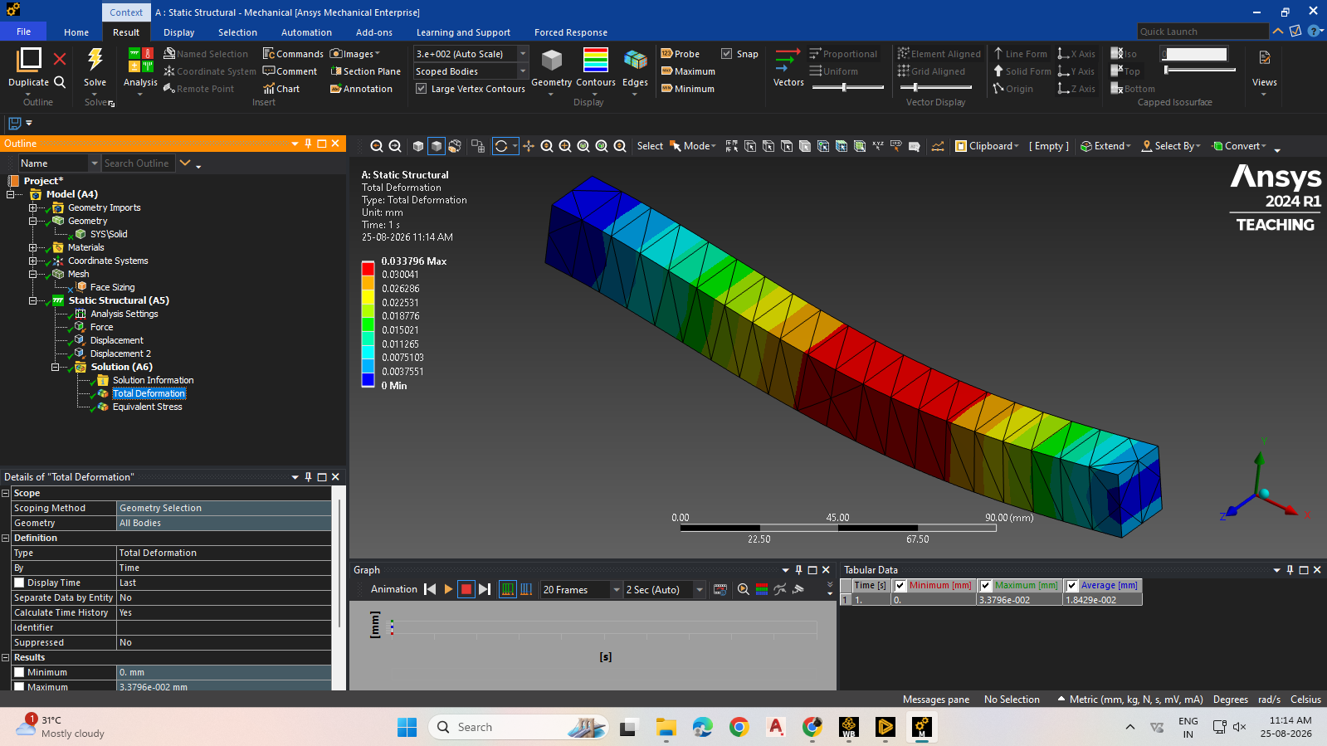
Fig. 1 — Total Deformation, UDL, Default Mesh
Maximum von-Mises Stress: 29.935 MPa
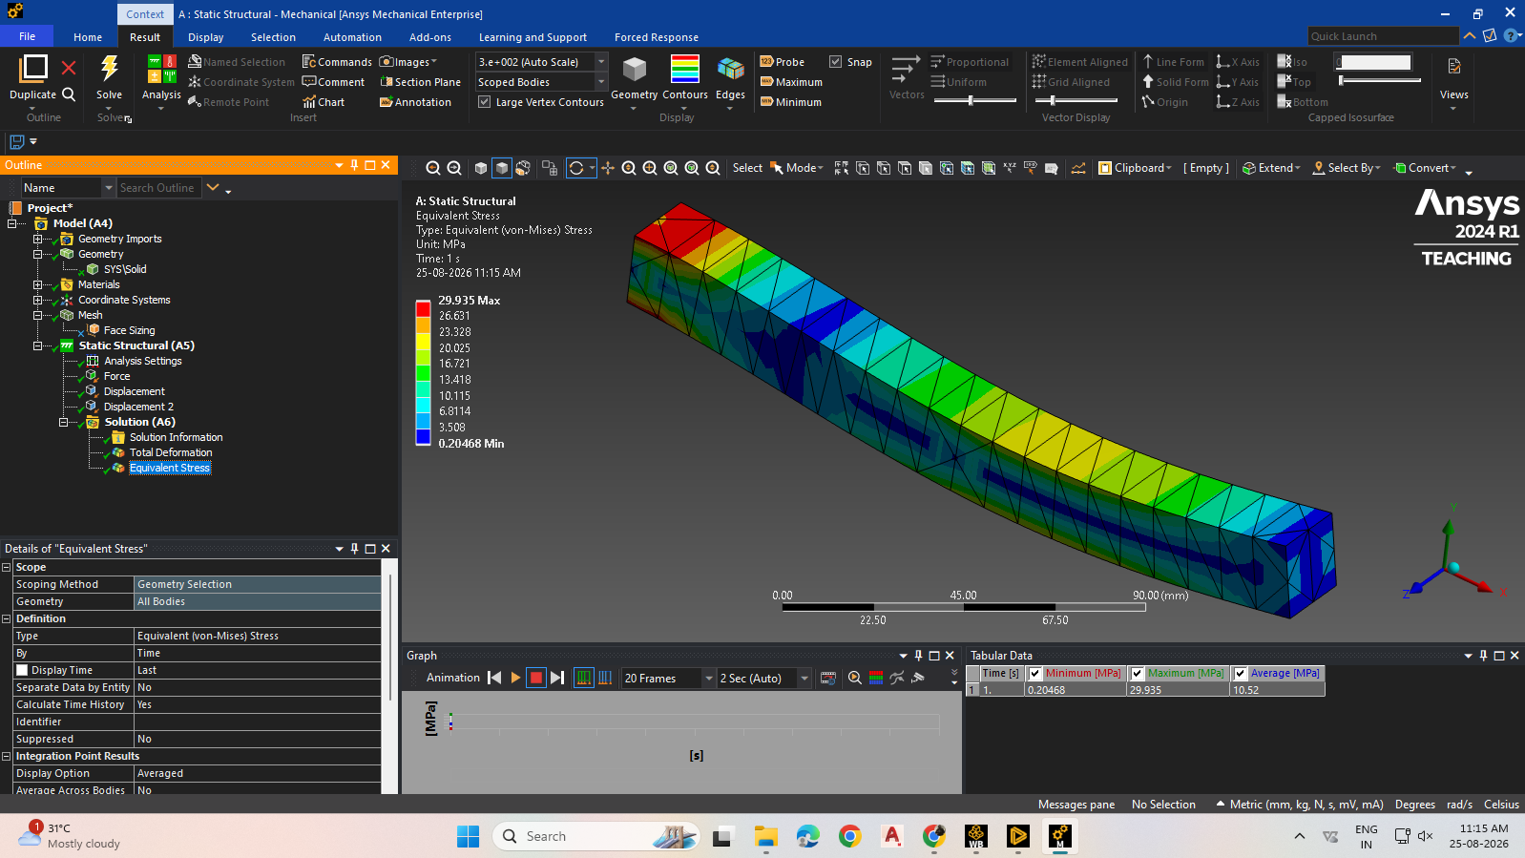
Fig. 2 — Equivalent (von-Mises) Stress, UDL, Default Mesh
Fine Mesh (2 mm)
Maximum Total Deformation: 0.034475 mm
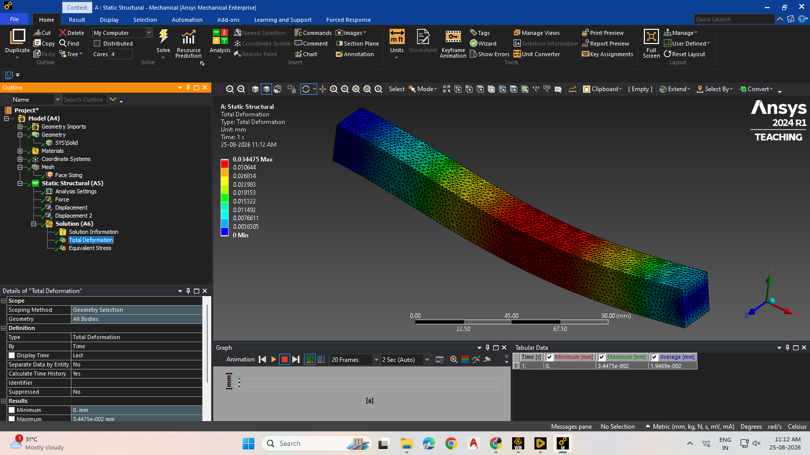
Fig. 3 — Total Deformation, UDL, Fine Mesh
Maximum von-Mises Stress: 54.121 MPa
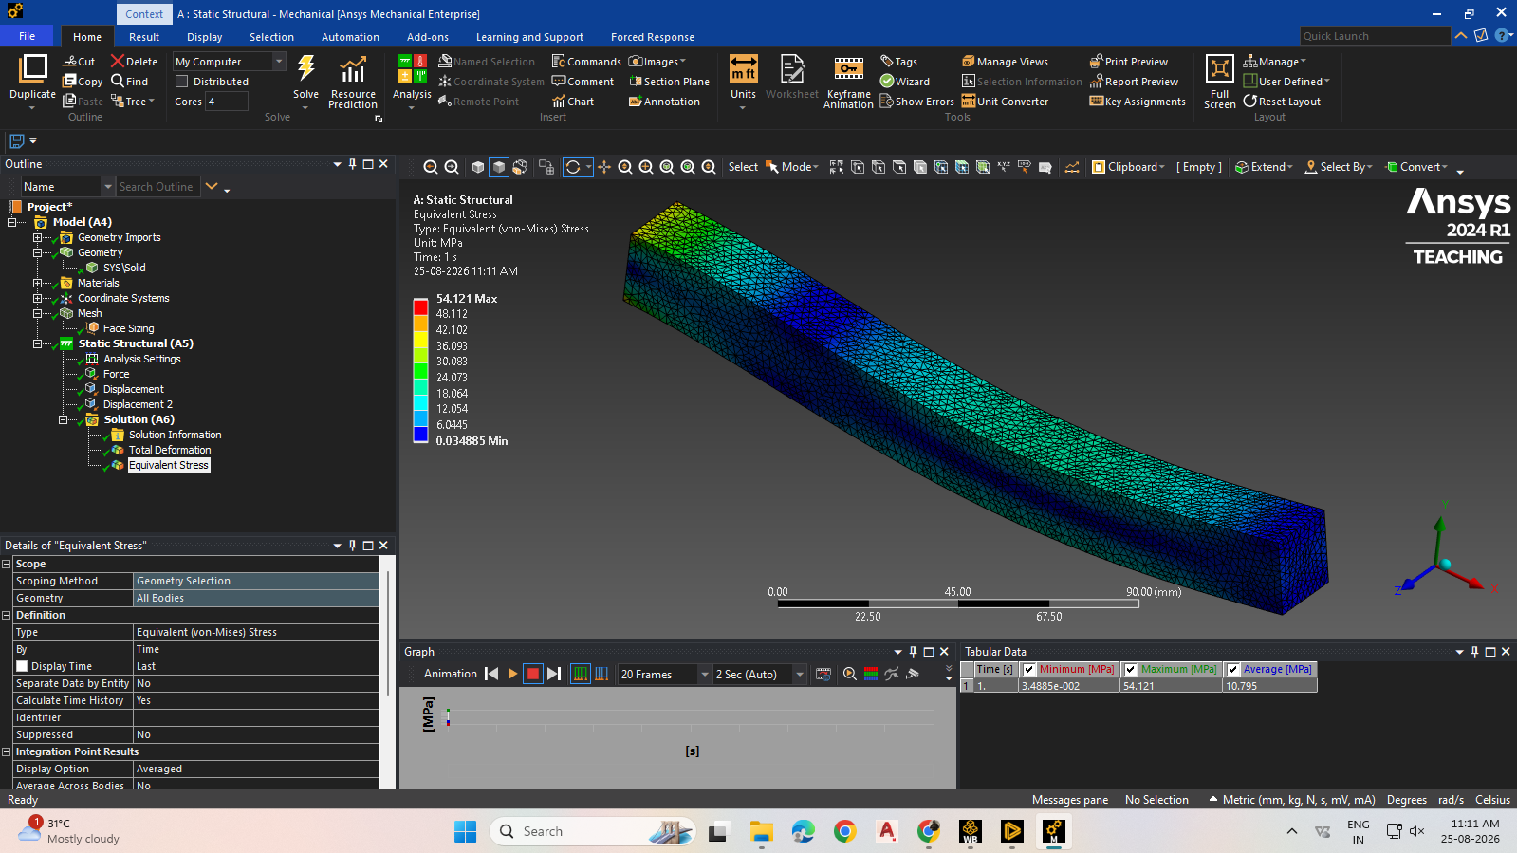
Fig. 4 — Equivalent (von-Mises) Stress, UDL, Fine Mesh

Case 2: Point Load (2000 N at centre)
Default Mesh (~10 mm)
Maximum Total Deformation: 0.058621 mm
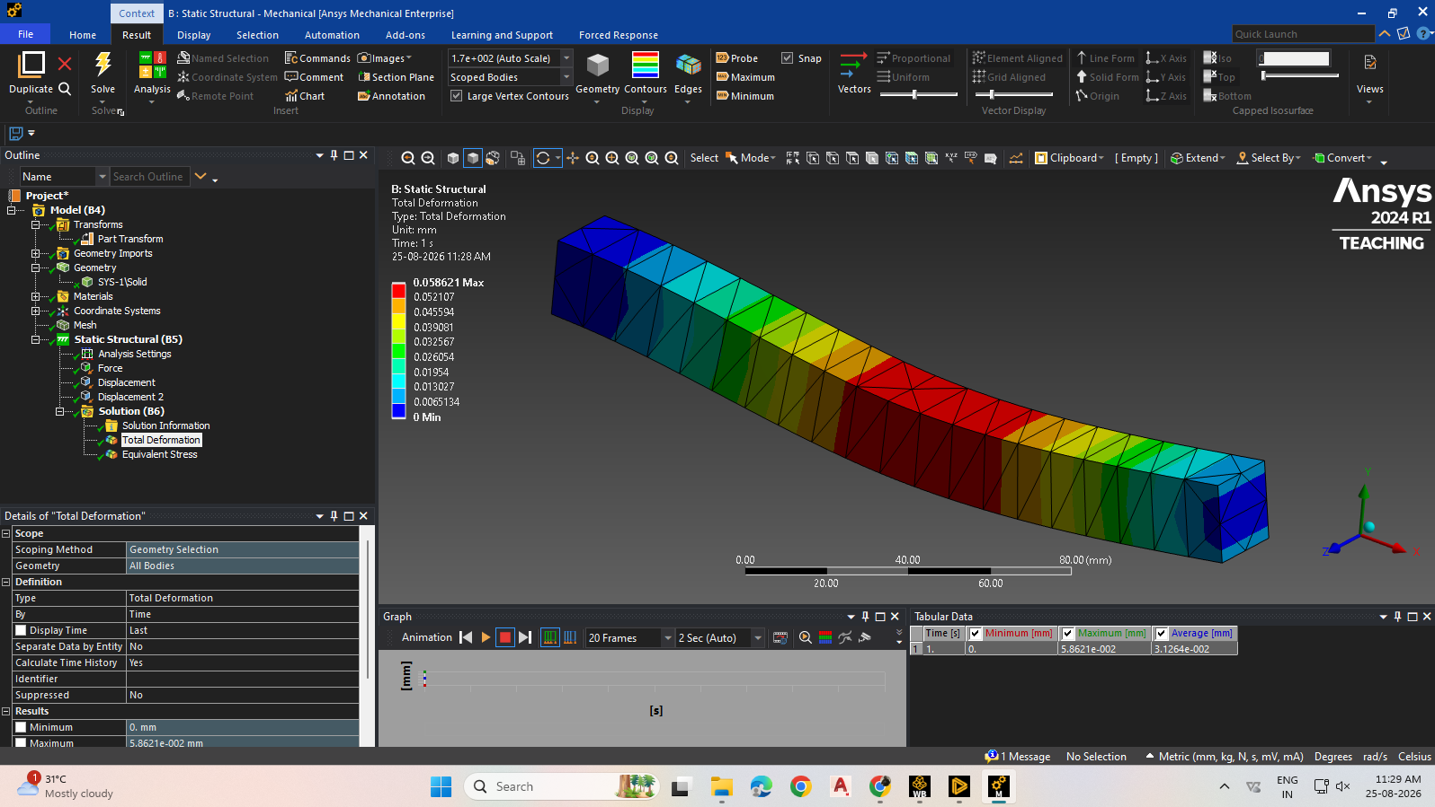
Fig. 5 — Total Deformation, Point Load, Default Mesh
Maximum von-Mises Stress: 47.642 MPa
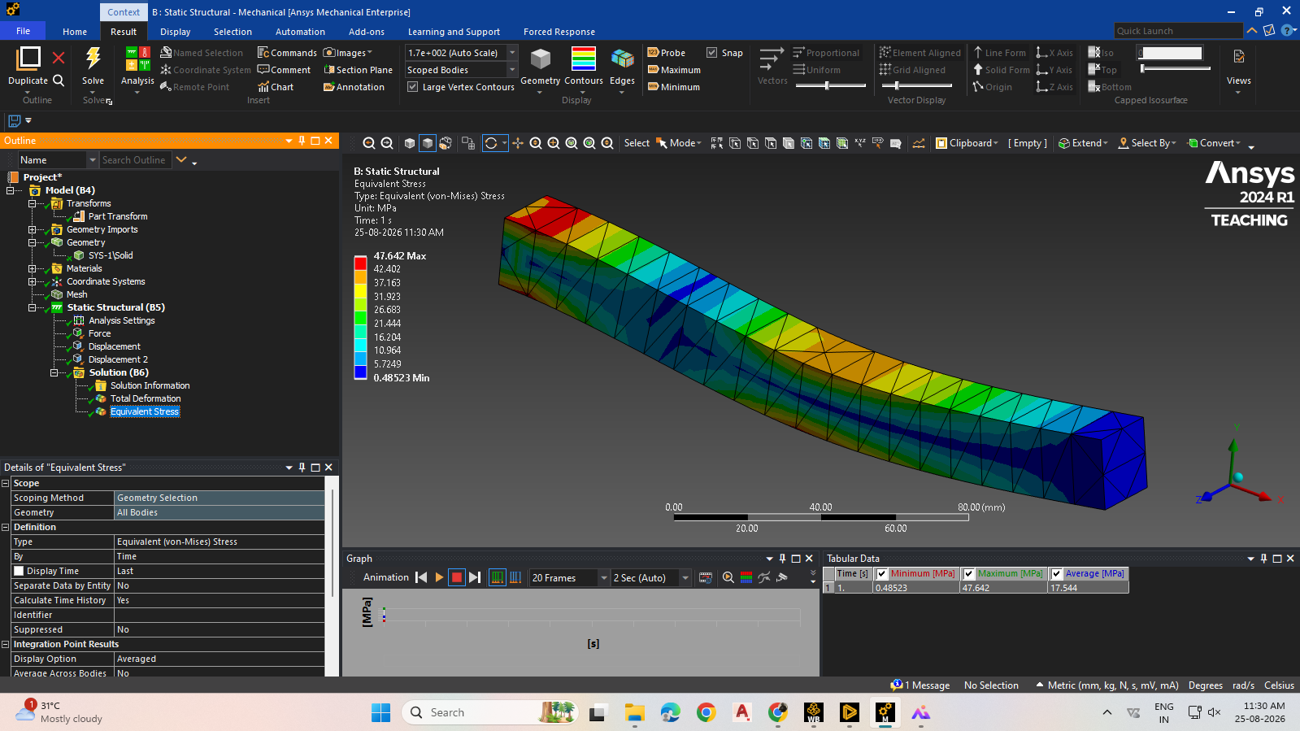
Fig. 6 — Equivalent (von-Mises) Stress, Point Load, Default Mesh
Fine Mesh (2 mm)
Maximum Total Deformation: 0.070456 mm
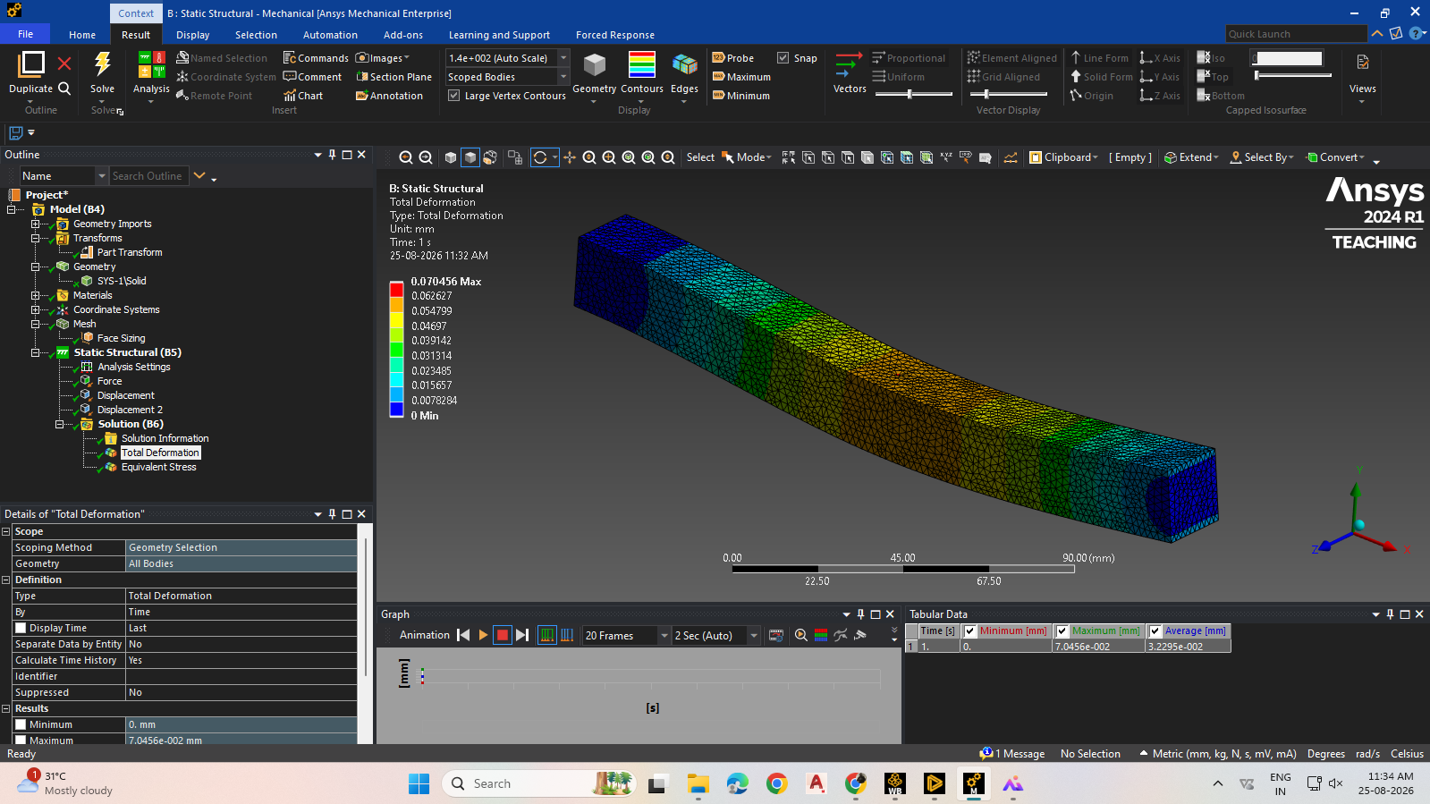
Fig. 7 — Total Deformation, Point Load, Fine Mesh
Maximum von-Mises Stress: 922.89 MPa
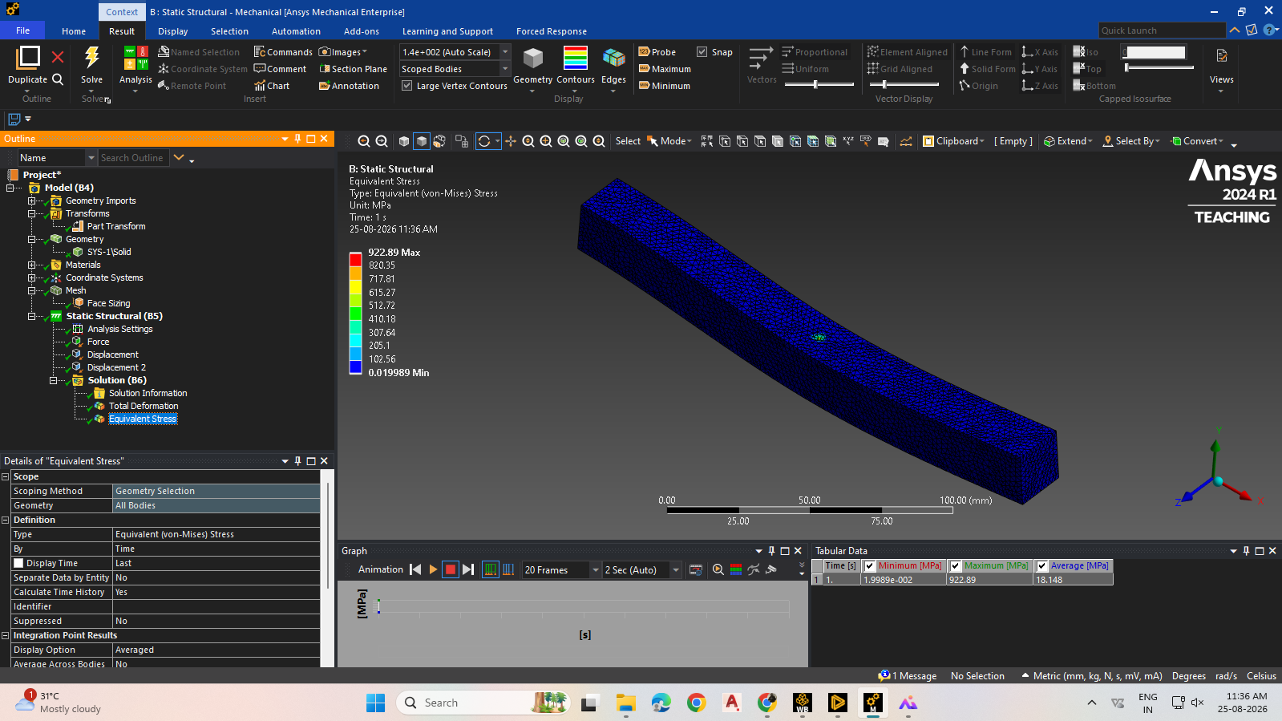
Fig. 8 — Equivalent (von-Mises) Stress, Point Load, Fine Mesh

Summary of Results
Load Case | Mesh | Max. Total Deformation | Max. von-Mises Stress
UDL (2000 N) | Default (~10 mm) | 0.033796 mm | 29.935 MPa
UDL (2000 N) | Fine (2 mm) | 0.034475 mm | 54.121 MPa
Point Load (2000 N) | Default (~10 mm) | 0.058621 mm | 47.642 MPa
Point Load (2000 N) | Fine (2 mm) | 0.070456 mm | 922.89 MPa

Conclusion
Static structural analysis of a simply supported beam was successfully performed for both a uniformly distributed load and a centre point load, and the deformation and stress distributions were visualised for each.
A mesh refinement study showed that results for the distributed load case converge well with mesh refinement, while the point load case exhibits a stress singularity at the load location, with the computed peak stress increasing sharply as the mesh is refined.
This demonstrates the importance of load application method when interpreting local stress results from a finite element model.

