WEEK-4

B.SAM ROHITH

AV.SC.U4CSE24031

CSESEC-A

**Aim: (i)** Create the java program for the books by using the constructor and display its details using methods

**Class Diagram:**

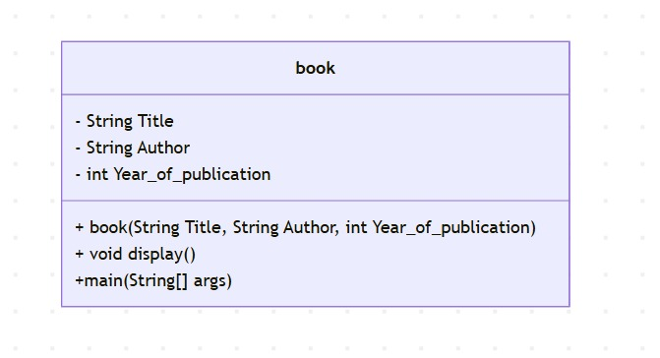

**Procedure:**

**Code:**

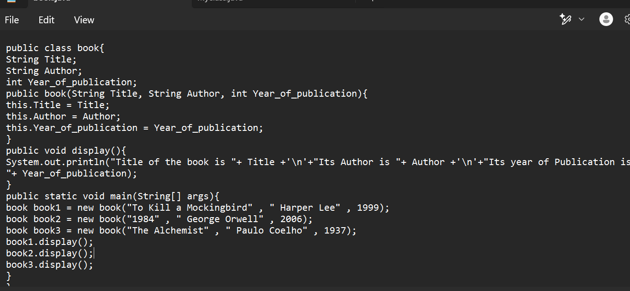

**Output:**

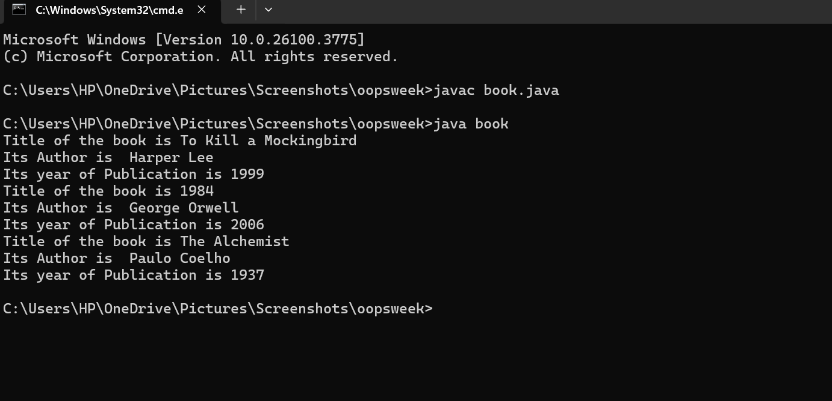

**Explanation or Important points :**

* We created a book class with different attributes. By using the constructor we pass the details of the book and the display method for the showing the details.

**Errors:**

|  |  |  |  |  |
| --- | --- | --- | --- | --- |
| **Error Type** | |  | | --- | | **Incorrect Code** |  |  | | --- | |  | | **Corrected Code** |
| **Class Name Capitalization** | public class book | public class Book (Java follows PascalCase for class names) |
| **Constructor Name Mismatch** | new book(...) | new Book(...) (Constructor name must match class name) |

**Aim: (ii)** Program to explain the final and the static variables.

**Class Diagram:**

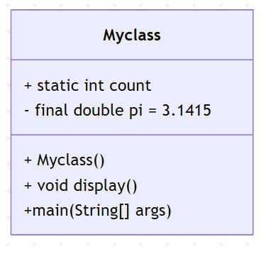

**Procedure:**

**Code:**

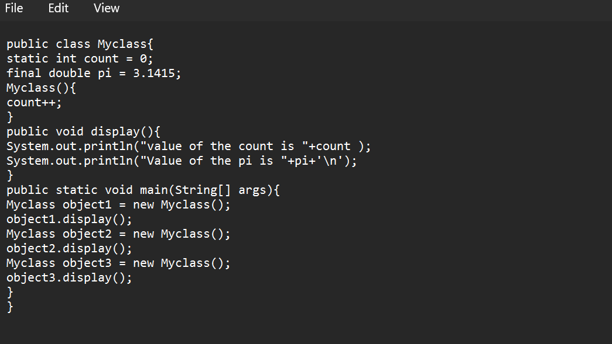

**Output:**

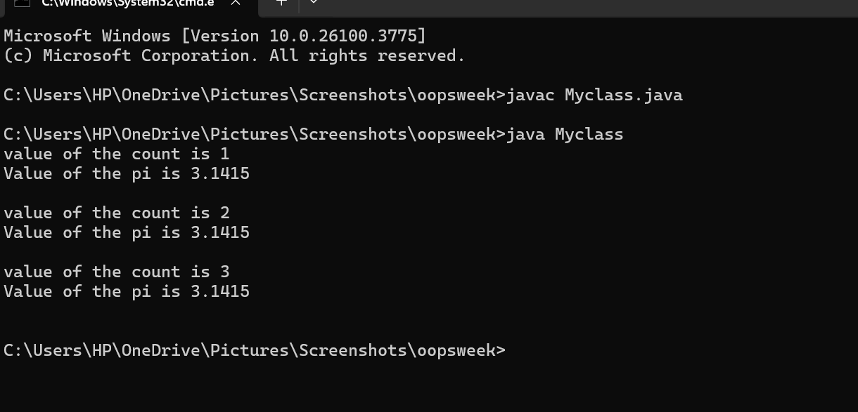

**Explanation or Important points :**

* Here we used the final and static variable.
* For final it is constant over the file , static is chages in all places if it is changed. By using those keywords we printed the output.

**Error:**

|  |  |  |
| --- | --- | --- |
| **Error Type** | **Incorrect Code** | **Corrected Code** |
| **Attempt to Modify final Variable** | pi = 3.14; (if added inside the constructor or method) | Remove this line (final variables cannot be reassigned) |
| **Incorrect Class Name** | public class Myclass | public class MyClass (Java follows PascalCase for class names) |

**WEEK-5**

**Aim: (i) Create the java program for calculator using multi-level inheritance.**

**Class Diagram:**

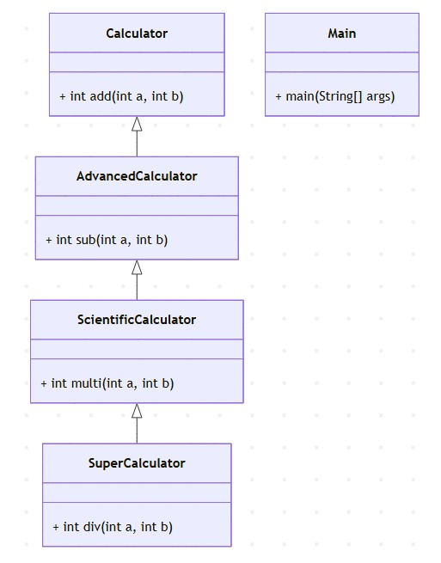

**Procedure:**

**Code:**

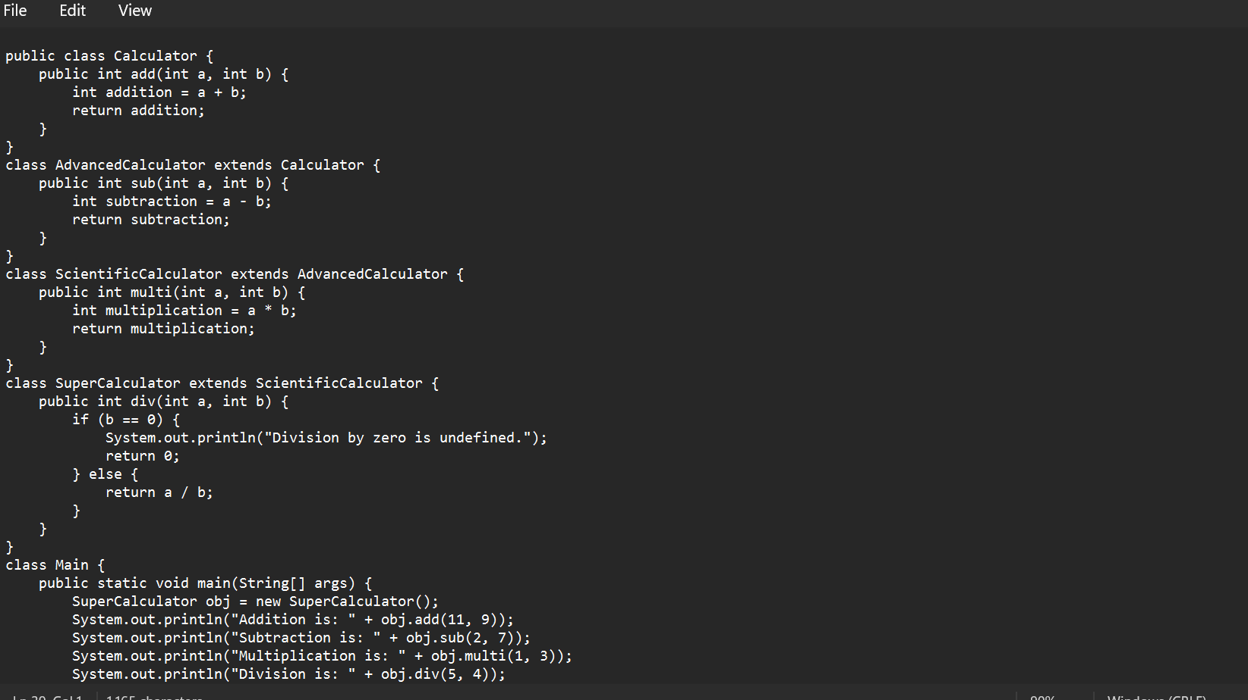

**Output:**

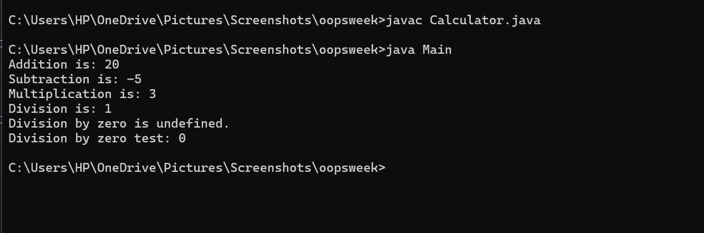

**Explanation or Important points :**

* By using the inheritance concept we are extending all the classes and creating the objects for the superCalculator and accessing all methods from it.
* That by using this we decrease the code by inheritance concept.

**Error:**

|  |  |  |
| --- | --- | --- |
| **Error Type** | **Incorrect Code** | **Corrected Code** |
| **Invalid file name** | Given calculator as the file name | For public class file should be class name |

**i**

**Aim: (ii)** A vehicle rental company wants a system to manage details of vehicles available for rent, including cars, bikes, and trucks. Each vehicle should store basic information such as brand and speed. Cars must include an additional property for the number of doors, while bikes should indicate whether they have gears. The system should also provide a function to display the details of each vehicle and indicate when a vehicle is starting.

**Class Diagram:**

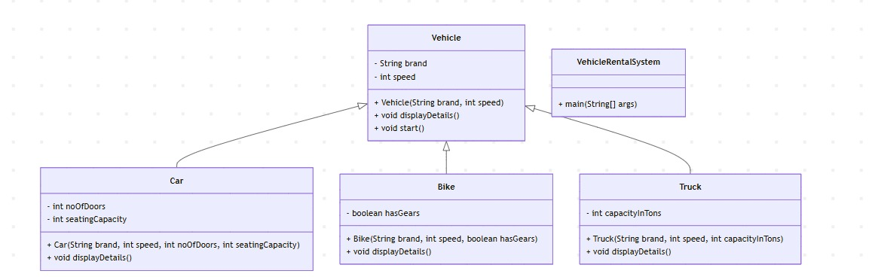

**Procedure:**

Code

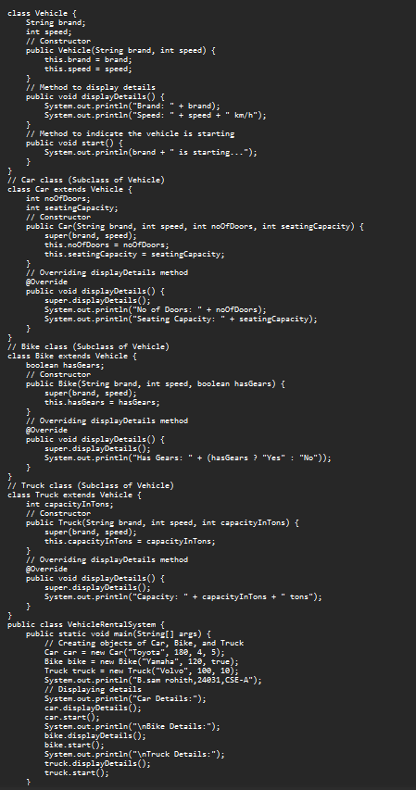

**Output:**

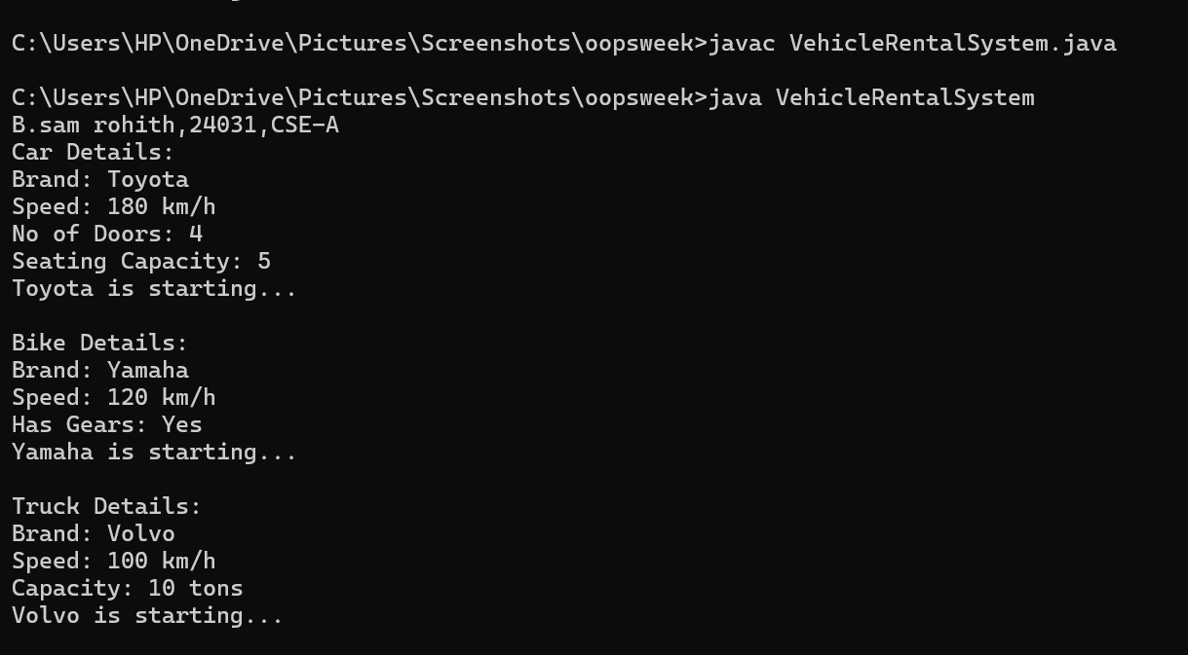

**Explanation or Important points :**

* Here I have created a class named vehicle and it consists of subclasses car
* Bike and truck and I have used hiracy inheritance and the main class consists of attributies brand and speed and I created a constructor using these attributies
* I have created a new class main and I have created objects named car ,bike and truck and I have called all the methods which I have written in the classes and I have displayed the desired output.

**Error:**

|  |  |  |
| --- | --- | --- |
| **Error Type** | **Incorrect Code** | **Corrected Code** |
| **Syntax Error** | Missing comma between constructor parameters | public Transport(String model, int maxSpeed) |

**Week-6:**

**Aim:** (i) Write a java program to create a vehicle class with a method display info . Overisde this method in car subclass to provide specific information.

**Class Diagram:**

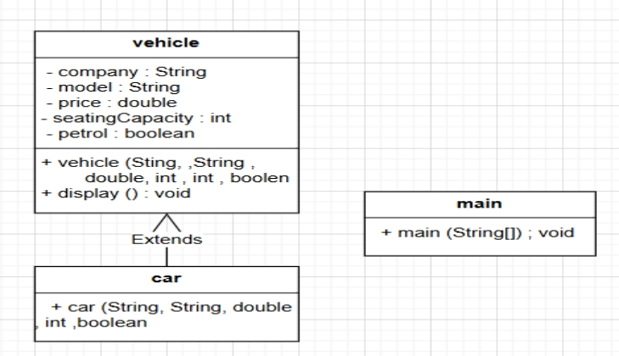

**Procedure:**

**Code:**

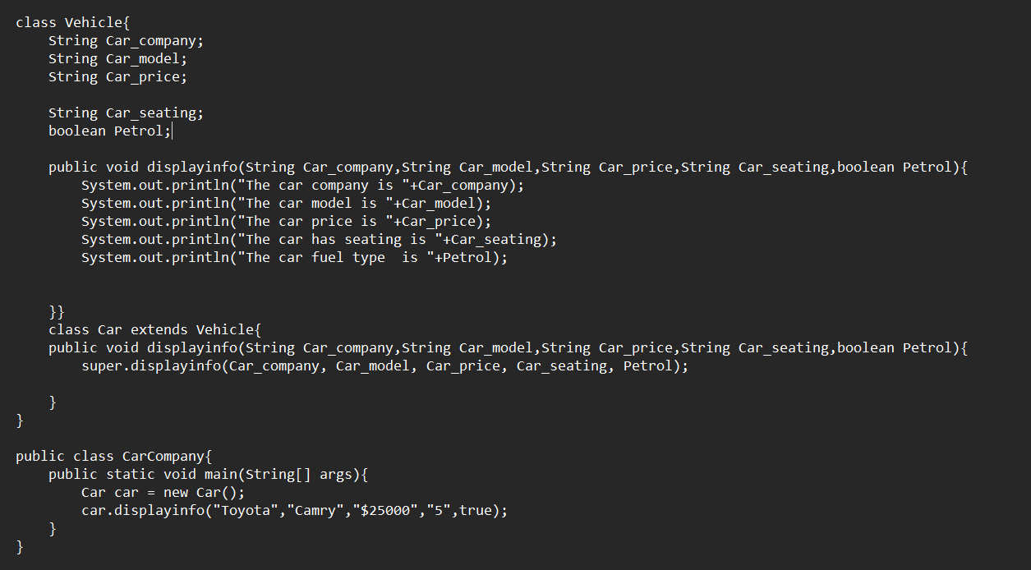

**Output:**

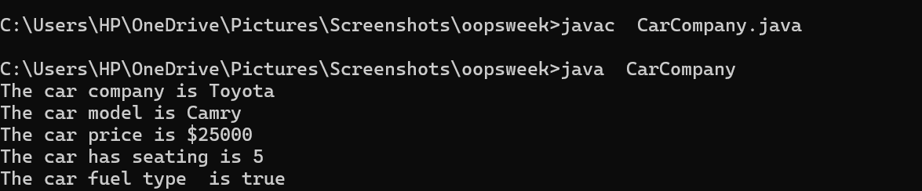

**Explanation or Important points :**

* We taken the vehicle class and then it is extended to the car class .
* Then we prepared the objects to the car class and then we perform the display method.

**Error:**

|  |  |  |
| --- | --- | --- |
| **Error Type** | **Incorrect Code** | **Corrected Code** |
| **i.Unused variable** | Declared instance variable in vehicle class | Use this.Car_company = Car_company; to set instance variable |
| **ii. Reductant method override** | The car class just calls super.displayinfo(..) without adding any new behaviour | Either remove the override if it is not needed or add a custom behavior |

**Aim:** (ii)A college is developing an automated admission system that verifies students eligibility for undergraduate (UG) and postgraduate (PG) programs. Each program has different eligibility for UG and PG program qualifications.UG admission requires a minimum of 60% and PG requires a minimum of 70%.

**Class Diagram:**

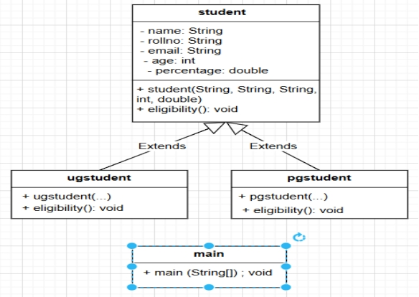

**Procedure:**

**Code:**

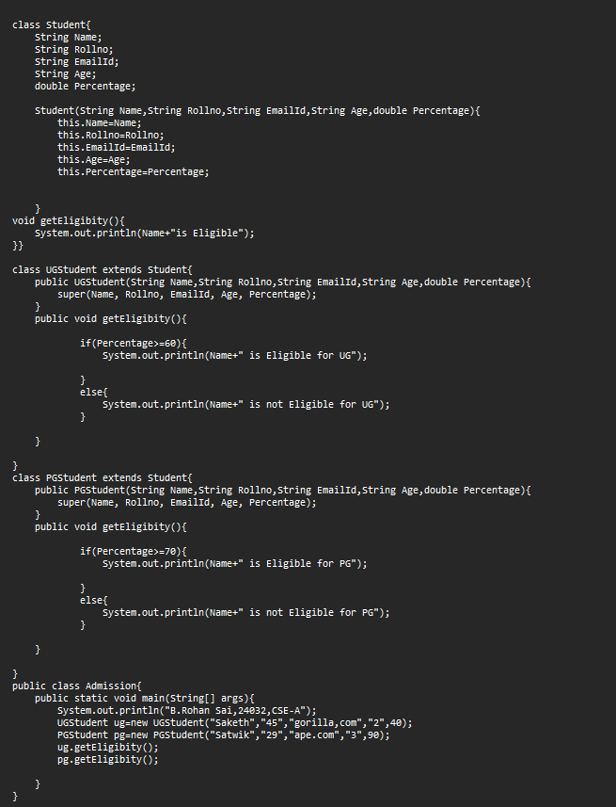

**Output:**

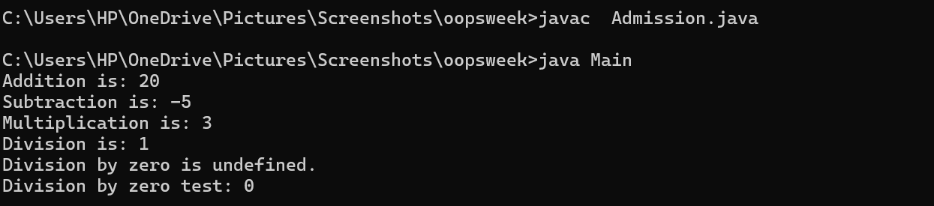

**Explanation or Important points :**

* In this the Student class is create then for the upper-graduation another class is created and the input of student details and if the percentage is greater then 60% he is eligible for this college.
* Similarly for the post-graduation the percentage is greater then the 70% then they are eligibile for this college.

**Error :**

|  |  |  |
| --- | --- | --- |
| **Error Type** | **Incorrect Code** | **Corrected Code** |
| **i. Logical error** | Age is declared as a string, but it represents a number | int age; |
| **ii. Data validation error** | Email string uses a comma instead of a dot | **“**gorgilla.com**”** |

**Aim:** (iii)Create a calculator class with overloaded methods to perform addition

i. Add two integers.

ii. Add two doubles.

iii. Add three integers.

**Class diagram:**

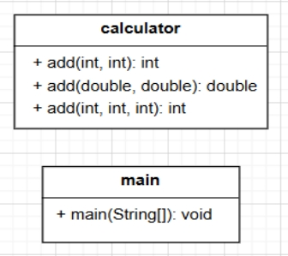

**Procedure:**

**Code:**

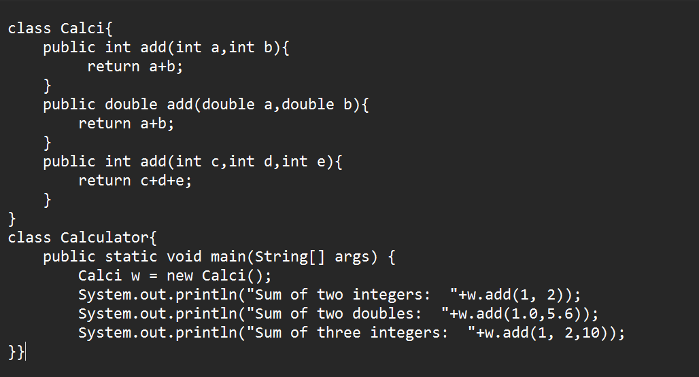

**Output:**

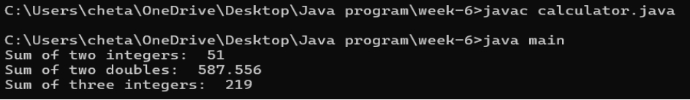

**Explanation or Important points :**

* Here we added the two numbers with different data types overloading concept is used here.
* Used the same method with different parameters. Then printed the result.

**Errors:**

|  |  |  |
| --- | --- | --- |
| **Error type** | **Incorrect error** | **Corrected error** |
| **Java naming convention violation** | class name Calci is not standerd | class calculator |

**Aim:** (iv)Create a shape class with a method-calculated area that is overloaded for different shapes. Ex square, rectangle…Then create a subclass circle that overrides the Calculated Area() method for a circle.

**Class diagram:**

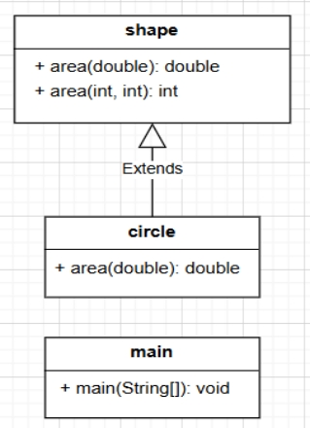**s**

**Procedure:**

**Code:**

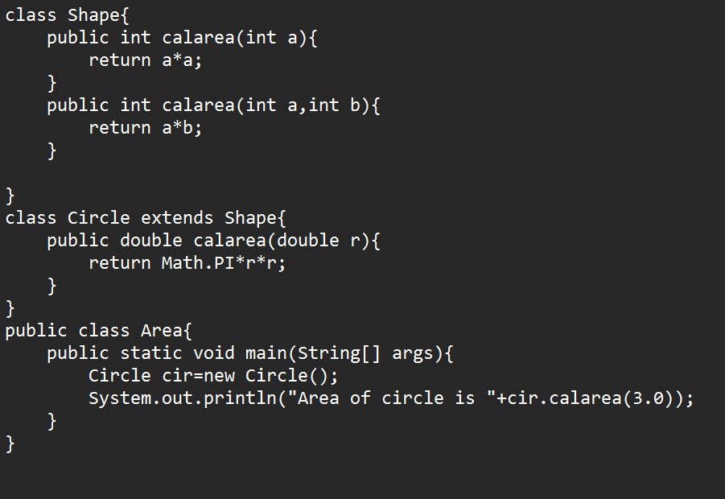

**Explanation or Important points :**

* Here the shape class is used for calculating the area.
* That the circle is extended from the shape class and the same method area of overloading to find the area of the circle.

**Output:**

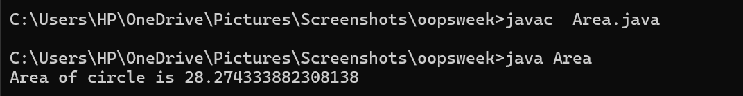**Errors:**

|  |  |  |
| --- | --- | --- |
| **Error Type** | **Incorrect Error** | **Corrected Error** |
| **Syntax Error** | Forget to end the print statement with ; | Ended the statement with ; |