**Week-2:**

**B.SAM ROHITH**

**AV.SC.U4CSE24031**

**Aim: Program to calculate the area of the rectangle.**

**Procedure:**

**Code:**

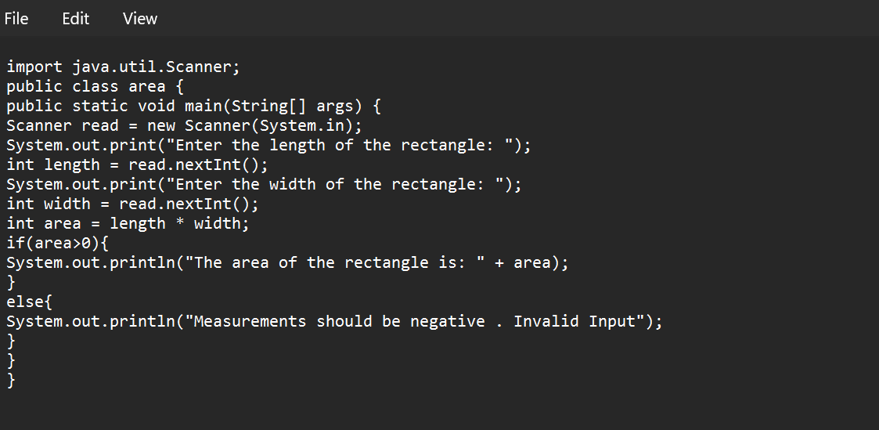

**Output:**

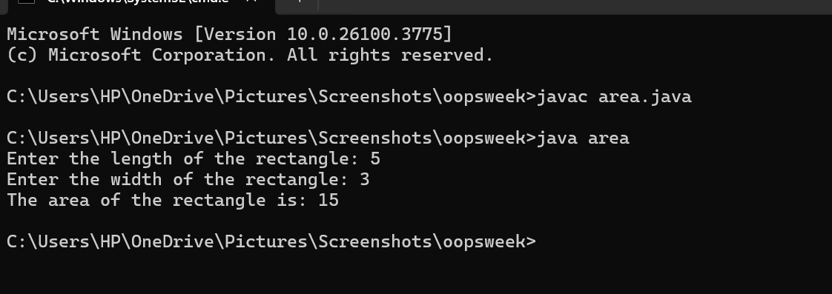

**Errors:**

|  |  |  |
| --- | --- | --- |
| **Error Type** | **Description** | **Correction** |
| **Syntax Error** | **Unclosed string literal(“ missing)** | **Ensure all strings are properly enclosed in double quotes (")** |
| **Runtime Error** | **Dividing by zero when calculating an aspect ratio** | **Check for zero before division (if (width != 0) { ... })** |

**Aim: Program to convert the temperature in celsius to Fahrenheit.**

**Procedure:**

**Code:**

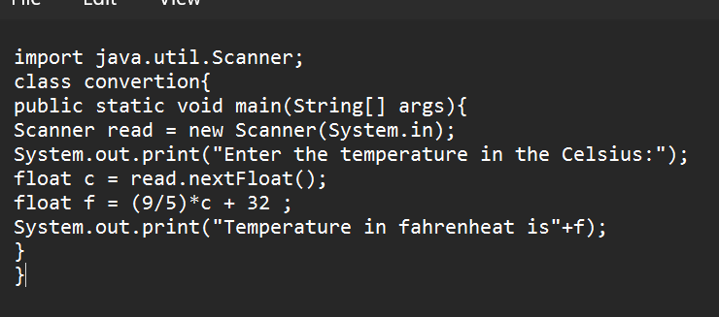**Output:**

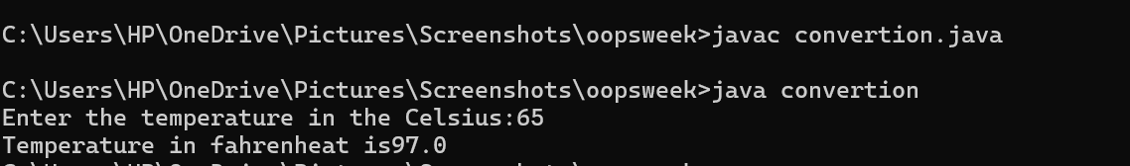**Error:**

|  |  |  |
| --- | --- | --- |
| **Error Type** | **Description** | **Correction** |
| **Syntax Error** | **Forgot to write ; (semicolon)** | **Ensure every statement ends with a semicolon (;)** |
| **Runtime Error** | **Dividing by zero when calculating an aspect ratio** | **Check for zero before division (if (width != 0) { ... })** |
| **Variable Declaration Error** | **Wrong variable declaration** | **Use correct data types and proper syntax** |

**Aim: The program will calculate the simple interest.**

**Procedure:**

**Code:**

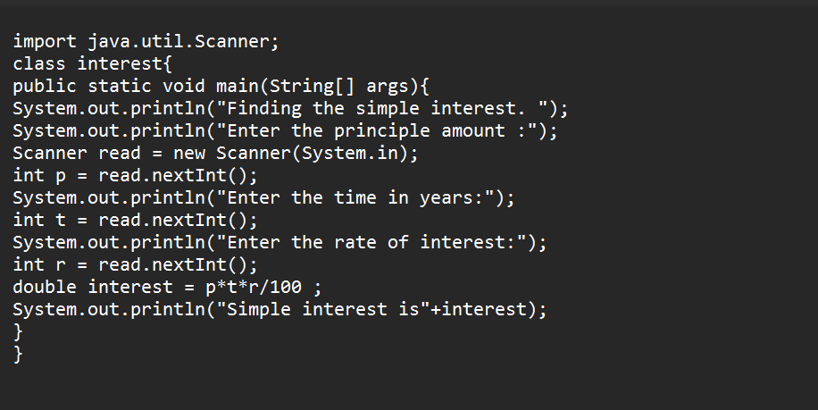**Output:**

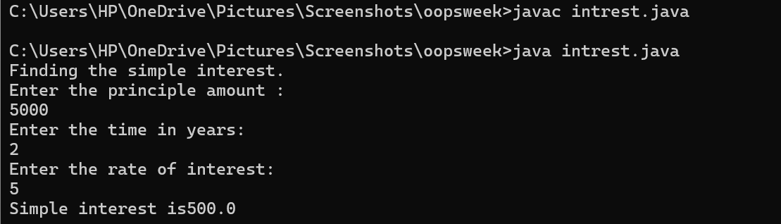**Error:**

|  |  |  |  |  |  |
| --- | --- | --- | --- | --- | --- |
|  | |  | |  | |
|  | |  | |  | |
|  | |  | |  | |
| **Error Type** | **Description** | | **Correction** | |
| **Syntax Error** | **Missing semicolon (;) after System.out.println()** | | **Add ; at the end of System.out.println() statements** | |
| **Data Type Error** | **int used instead of double for time (t)** | | **Change int t = read.nextInt(); to double t = read.nextDouble();** | |
| **Type Mismatch** | **int r = read.nextDouble(); (assigning double to int)** | | **Change int r to double r for correct data type** | |

**Aim: Program to find the largest of three numbers using the ternary operators.**

**Procedure:**

**Code:**

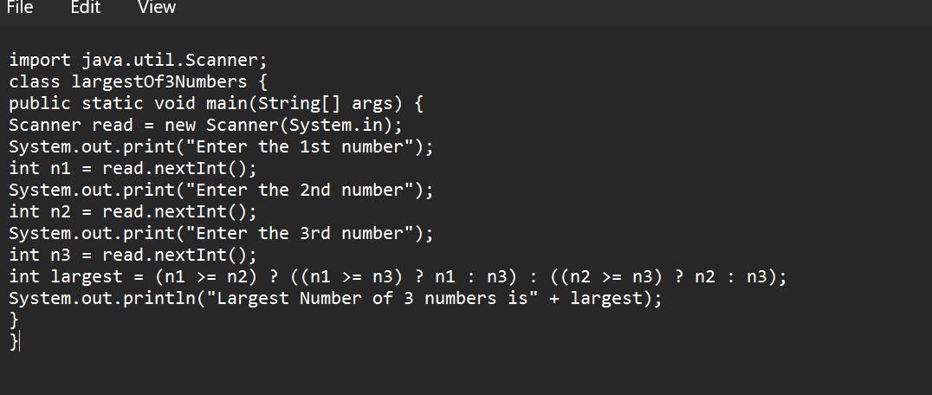

**Output:**

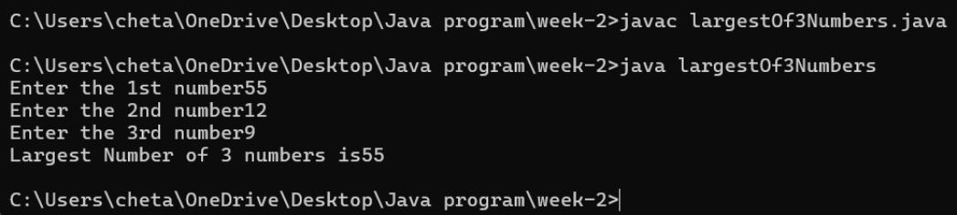

**Error:**

|  |  |  |
| --- | --- | --- |
| **Error Type** | **Description** | **Correction** |
| **Syntax Error** | **Missing space in output: "Largest Number of 3 numbers is" + largest** | **Change to "Largest Number of 3 numbers is " + largest (add space before largest)** |
| **Logical Error** | **No read.close(); to free resources** | **Add read.close(); at the end of the program** |
| **Input Handling Issue** | **No prompt for invalid input (e.g., non-integer values)** | **Add input validation using if (read.hasNextInt()) before reading values** |

**Aim: Program to find the factorial of the number.**

**Program:**

**Code:**

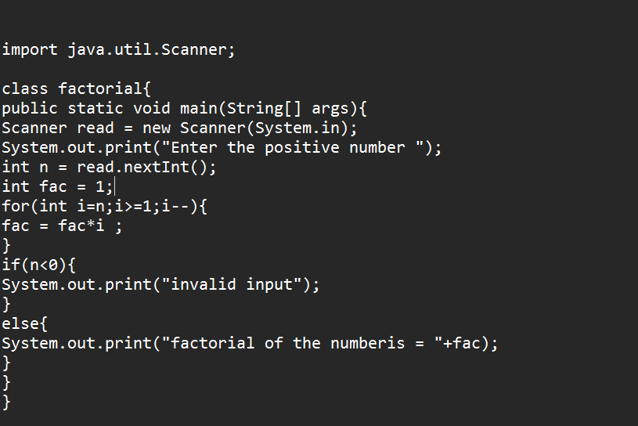**Output:**

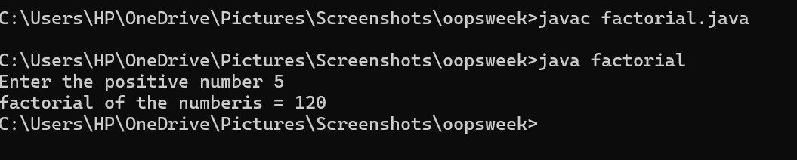**Error:**

|  |  |  |
| --- | --- | --- |
| **Error Type** | **Description** | **Correction** |
| **Syntax Error** | **do keyword mistakenly placed before for loop** | **Remove do before for(int i=n; i>=1; i--)** |
| **Logical Error** | **if(n<0) check comes after the factorial calculation** | **Move if(n<0) check before the loop to prevent calculation** |
| **Resource Leak** | **Scanner not closed** | **Add read.close(); at the end of the program** |