Object Oriented Programming

23CSE111



Department of Computer Science and Engineering

Amrita School of Engineering

Amrita Vishwa Vidyapeetham, Amaravathi Campus

Verified BY : NAME: B. Sam Rohith

ROLL : AV.SC.U4CSE24031

|  |  |  |  |  |
| --- | --- | --- | --- | --- |
| Week | Questions | Page No | Date | Sign |
| 1 | i. Download and install Java software  ii. Write a java program to print the message welcome to java programming  iii. Write a java program to print the name, roll no and section of the student |  |  |  |
| 2 | 1.to calculate the area of the rectangle  2.program to convert the temperature in Celsius to Fahrenheit  3.program to calculate the simple interest  4.program to find the largest of three numbers using the ternary operators  5.program to find the factorial of the number |  |  |  |
|  |  |  |  |  |
|  |  |  |  |  |
|  |  |  |  |  |

**Week-1:**

**Aim:** Download and install Java software

**Procedure:**

Step-1: Open any browser and search java download. Then open oracle website.

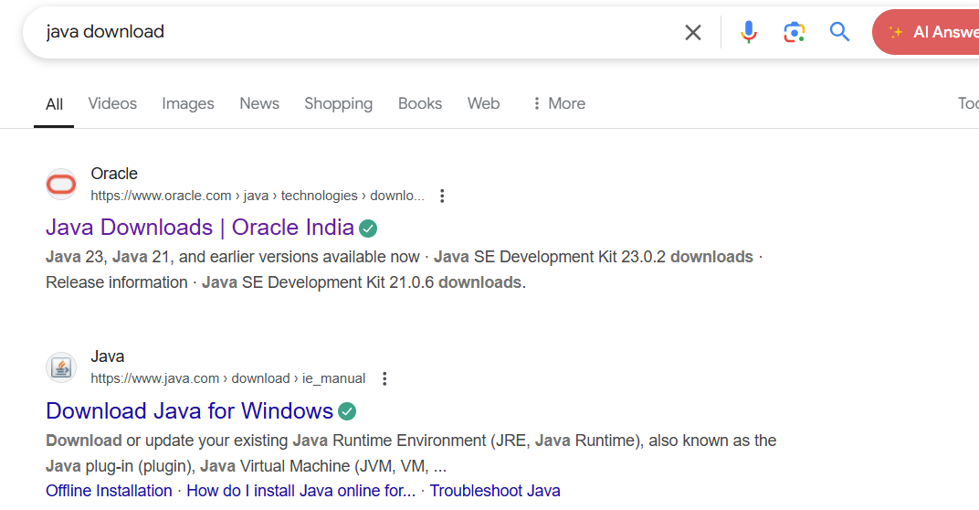

Step-2:It shows different java versions. In it download LTS version of your operating system. Download exe file

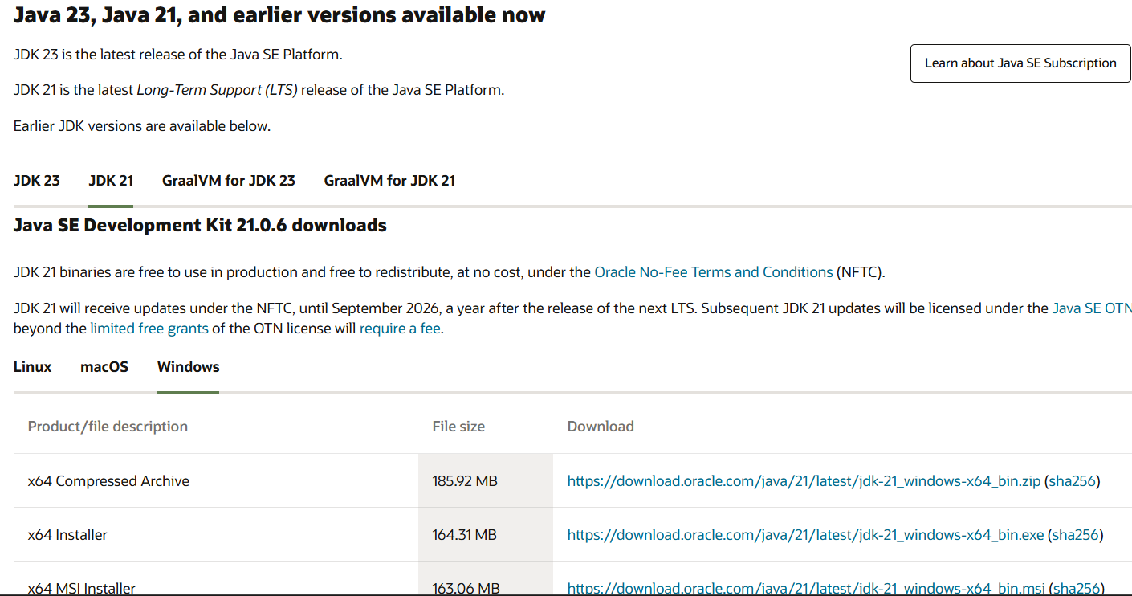

Step-3: Then open the downloaded file and allow all permissions and install it in the system.

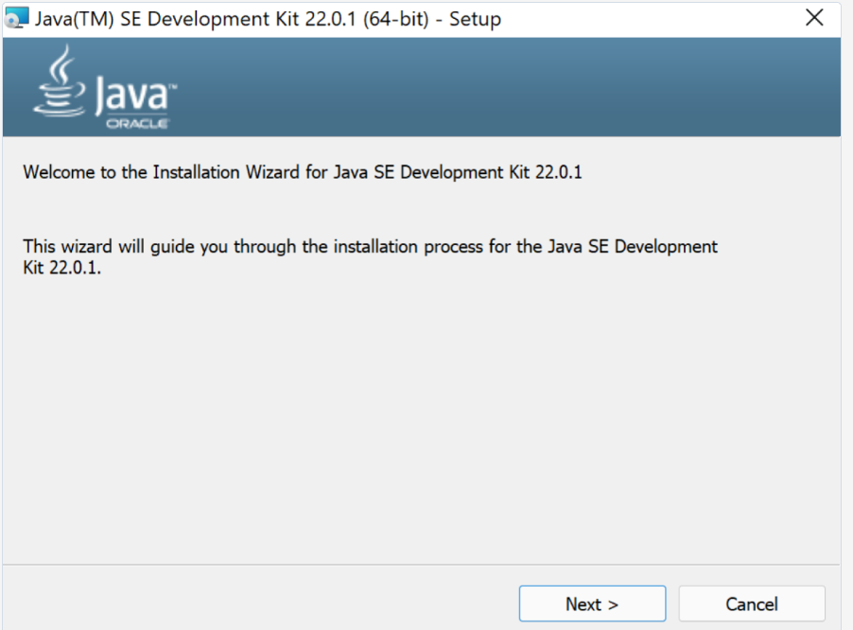

Step-4: Then open the files and go to the drive and enter into the program files.

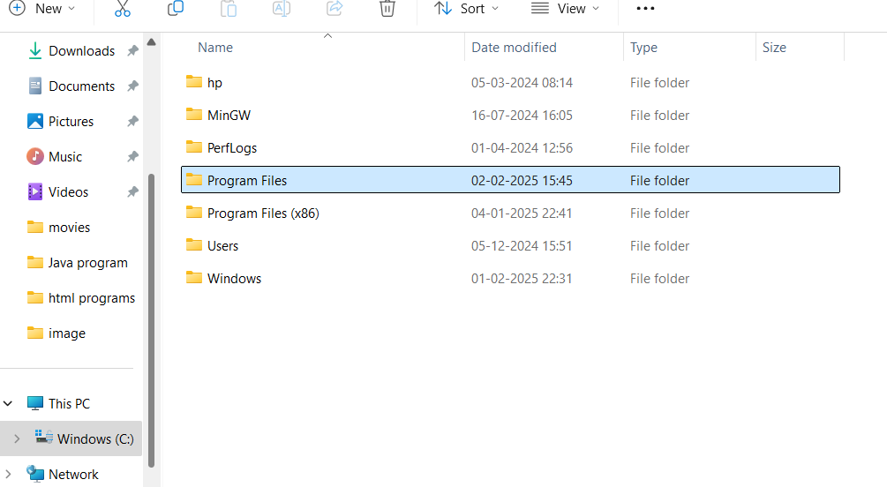

Step-5: Then open the program files and enter into the java, then open the jdk 21.

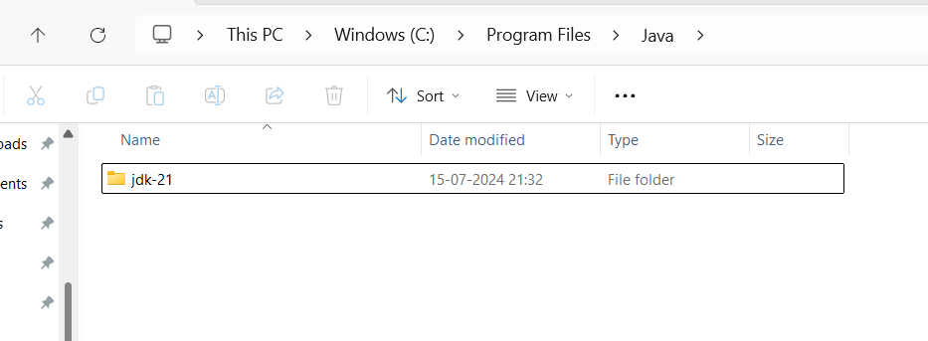

Step-6: Then enter into the bin. Then click on the on the bar to copy the path.

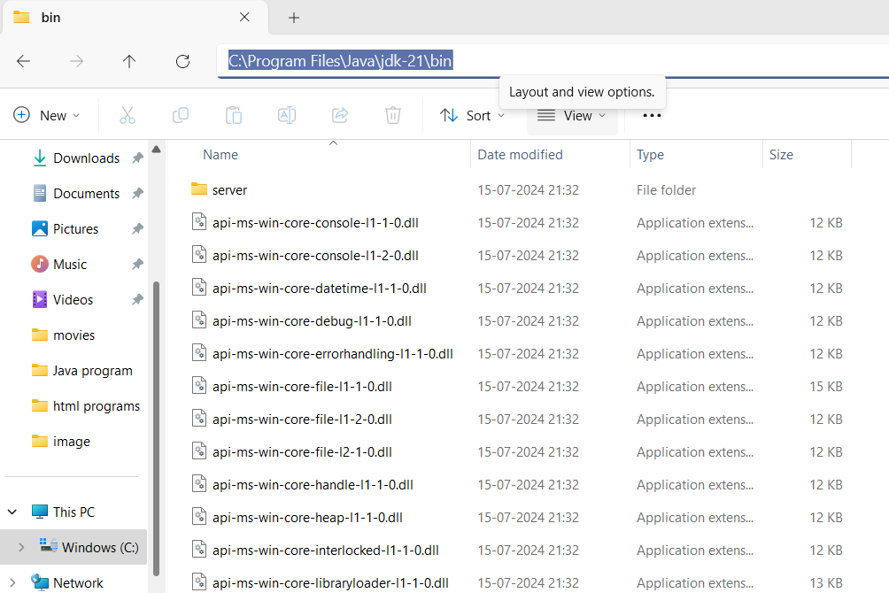

Step-7: Then right click on this PC and enter the properties, click on the advanced system settings, click on the environmental variables.

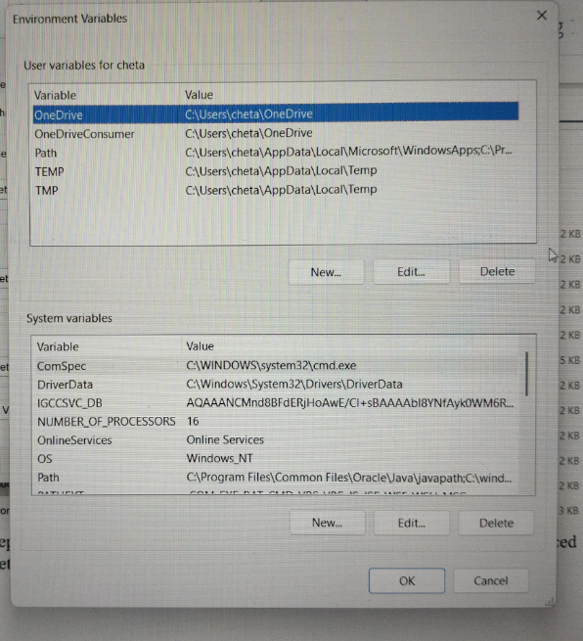

Step-8: Click on the new and paste the path and apply it. Then open the command prompt the enter java --version.

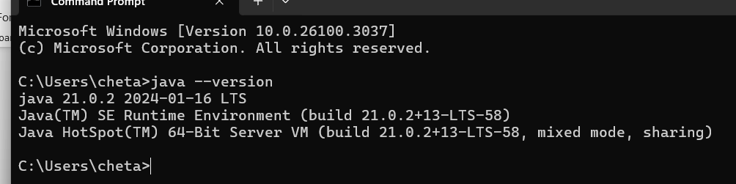

Hence java is installed.

**Aim:** Write a java program to print the message welcome to java programming

**Procedure:**

Step-1: To perform the first program open the new file in notepad and save it with name of the and .html.

Step 2: Write the program to print “Welcome to Java programming”.

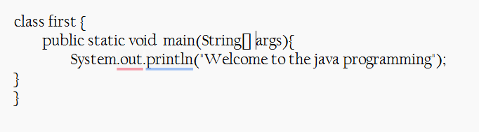

Step-3: Open the file in the files and delete the path and type cmd. Then type javac name.java and type java first. Then we get the output.

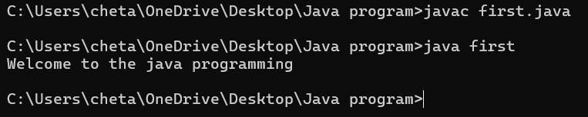

**Error:**

1. identifiers (forget to write the main)

2. syntax (s instant of S)

**Program : 3**

Aim:-write a java program that prints name, roll no, section of the student Input:-

class Studentdet{

public static void main(String[] args){

System.out.println("Name: B.SAM ROHITH”);

System.out.println("Class: CSE A");

System.out.println("Roll No: 24031");

}

}

**Output:-**

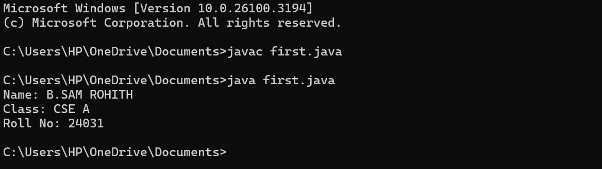

***WEEK-2***

Program-1:

Aim: to write a java program to find area of rectangle

Input:

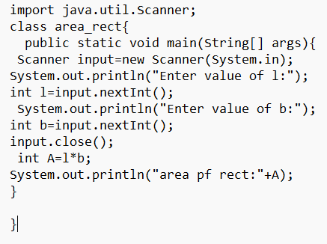

Output:

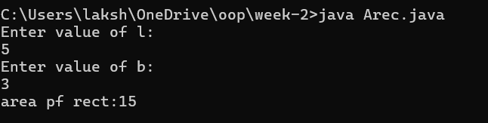

Error table:

|  |  |  |
| --- | --- | --- |
| Error | Error cause | Error rectification |
| error: ';' expected | ‘;’ is missed in the end of print statement | Placed ‘; ’ at the end of the statement |
| error:cannot find symbolScannerinput=new scanner(System.in); | Placed small s in place of capital S | Replaced capital s in place of small s to rectifiy the error |
| error: cannot find symbol  int b=input.nextstr(); | Placed str in place of int | Rectified by replacing int in place of int |

Program-2

Aim: write a java program to convert temp from celsius to farenheit

Input:

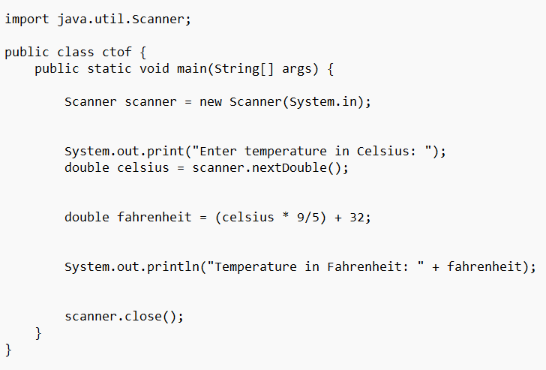

Output:

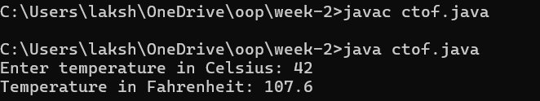

Error table:

|  |  |  |
| --- | --- | --- |
| Error | Error cause | Error rectification |
| error: ';' expected  public static void main(String[] args) | Forgot flower brace in the end | Rectified by replacing flower brace |
| error: ';' expected  scanner.close() | Forgot ‘;’ at the end the statement | Rectified by placing ’;’  it |
| error: incompatible types: possible lossy conversion from double to int  int celsius = scanner.nextDouble(); | Placed int in place of double | Rectified by replacing double |

Program-3:

Aim: write a java program to calculate simple interest

Input:

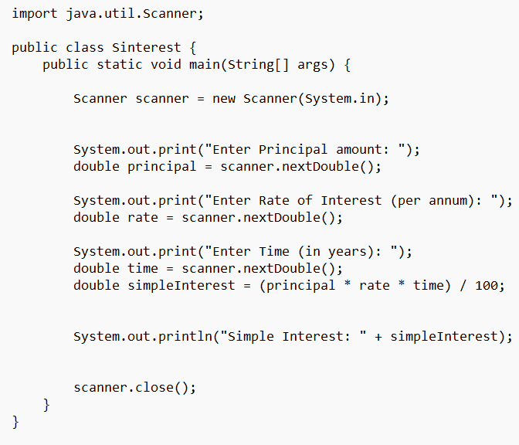

Output:

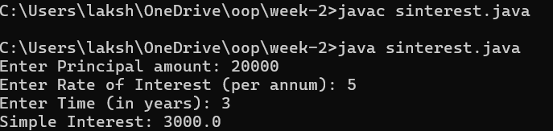

Error table:

|  |  |  |
| --- | --- | --- |
| Error | Error cause | Error rectification |
| error: class Sinterest is public, should be declared in a file named Sinterest.java  public class Sinterest {  ^ | Placed capital s I place of small ‘s’ | Replaced by placing small ‘s’ |

Program-4

Aim: write a java program to find the largest of 3 numbers using terenary operator

Input:

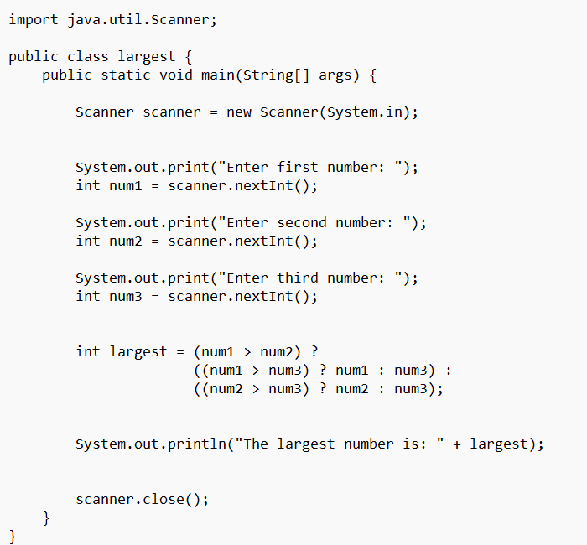

Output:

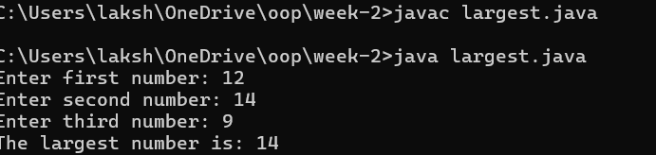

Error table:

|  |  |  |
| --- | --- | --- |
| Error | Error cause | Error rectification |
| error: reached end of file while parsing  ((num1 > num3) ? num1 : num3) | Missed ‘} ’ in the end of the program | Rectified by replacing it |
| error: illegal start of expression  }  ^ | Missed’}’in the starting | Rectified by replacing it |

Program-5

Aim: write a java program to find the factorial of a number

Input:

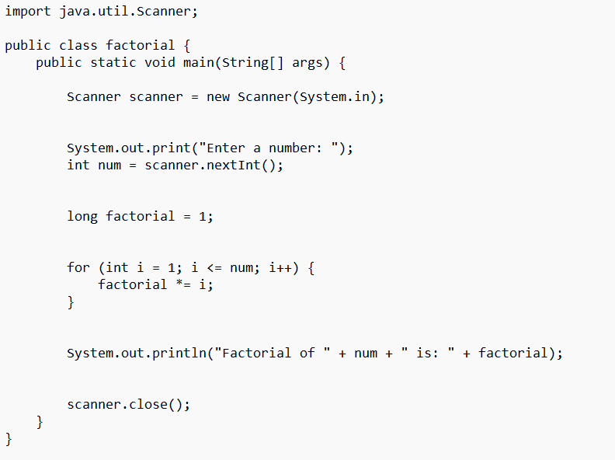

Output:

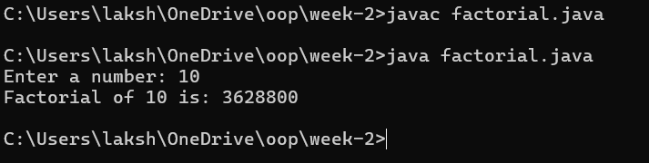

Error table:

|  |  |  |
| --- | --- | --- |
| Error | Error cause | Error rectification |
| error: unclosed string literal  System.out.print("Enter a number: );  ^ | Missed “ in the end | Rectified by replacing “ |