

Week - 03

**Name:** B. SAM ROHITH

**Section:** CSE – A

**Roll No**: AV.SC.U4CSE23031

**Subject:** Object Oriented Programming

**Date:**

**Aim:**

Q.) Create The java program.

1. Car

2. Bankaccount

**Q.1: Car**

**Procedure:**

1. Create a class with name Car.
2. Create 5 attributes named car_color,car_brand,car_model,fuel,mileage.
3. Create 3 methods named start(),stop(),service().
4. Create 3 objects named car_1,car_2,car_3.
5. Create a construer and assign the values through it and it should print “welcome to car garage”

**Program:**

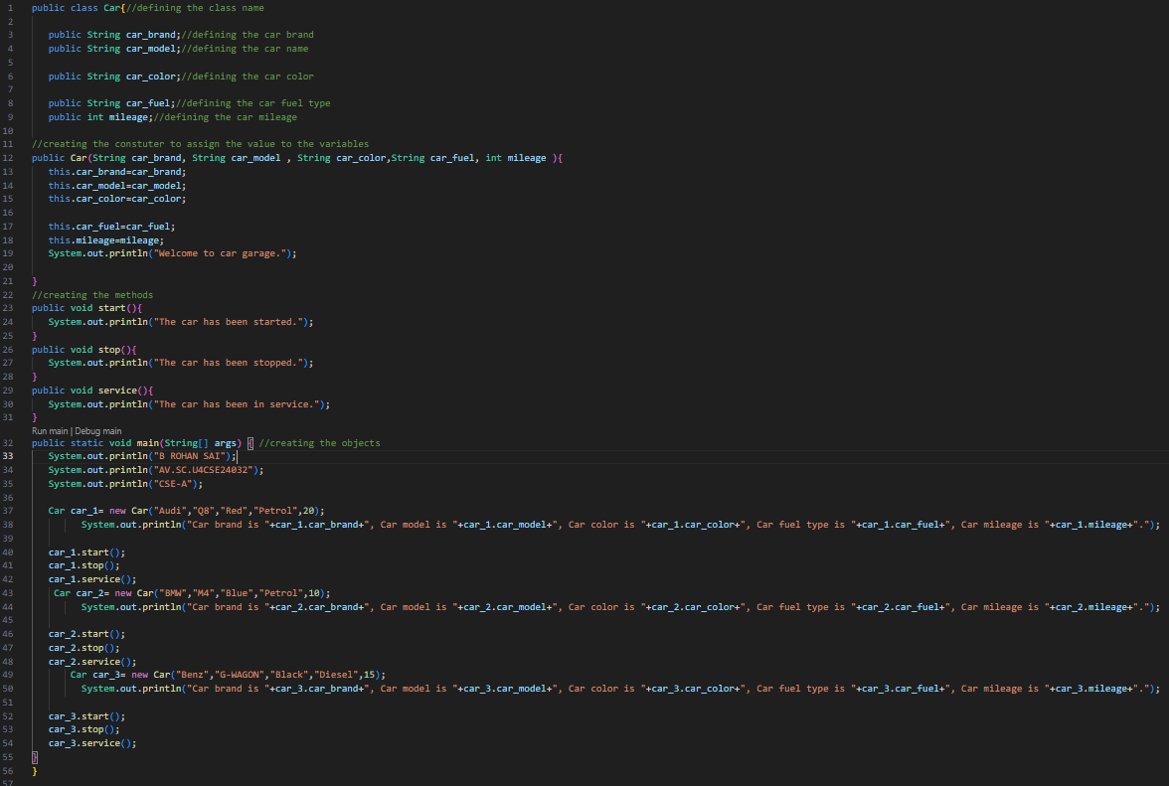

**OUTPUT:**

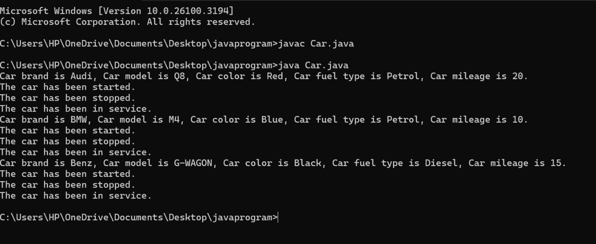**Errors:**

* Declaring the wrong class name.
* Declaring wrong construer name.
* Not using uppercase in the class name.
* Not using + symbol in the System.out.println(“”) to differentiate the data.
* Using wrong class name in the object.
* Declaring wrong data type for the variables.
* Not producing the class correctly.

**Class Diagram:**

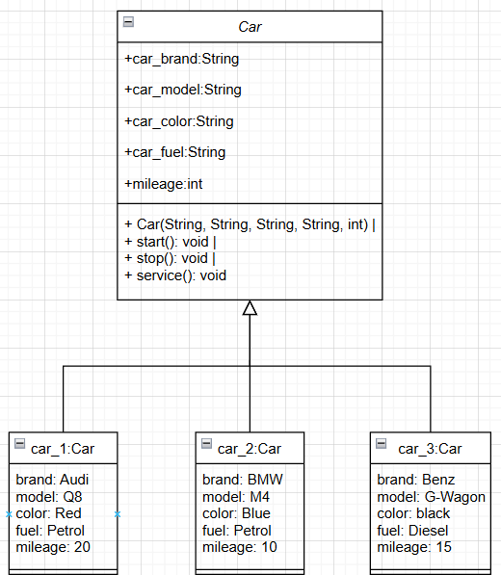

**Q.2: Bank Account**

**Procedure:**

1. Create a class with name Bankacc
2. Create 2 attributes named name,Balance,Accno.
3. Create 2 methods named withdrawal(int withdrawal),deposit(int deposit).
4. Create 2 objects named cus1,cus2.

5.Create a construer and assign the values through it and it should print “Welcome to the bank”.

**Errors:**

* Declaring the wrong class name.
* Declaring wrong construer name.
* Not using uppercase in the class name.
* Not using + symbol in the System.out.println(“”) to differentiate the data.
* Using wrong class name in the object.
* Declaring wrong data type for the variables.
* Not producing the class correctly.

**Program:**

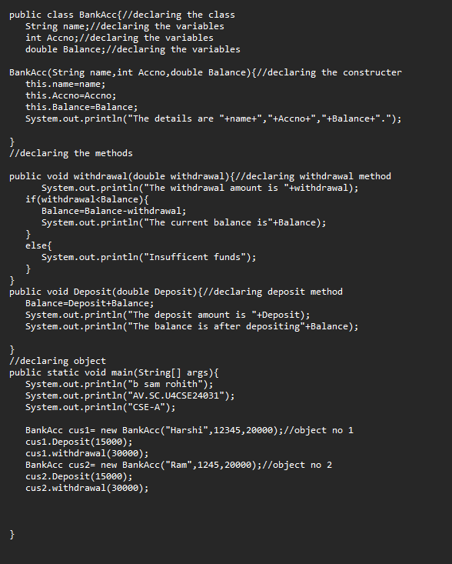

**Output:**

**Class Diagram:**

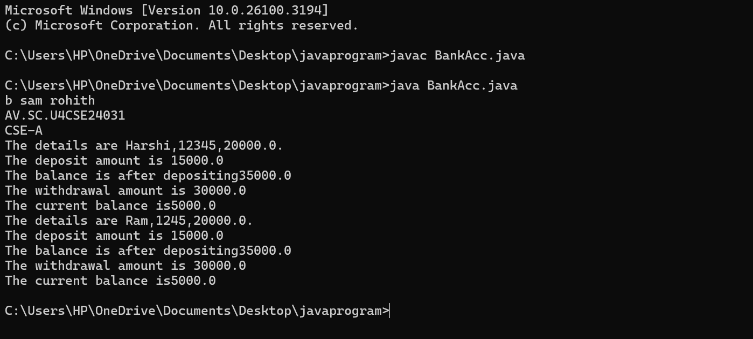

**Class Diagram:**

