**Design and development of aerial thermal imaging drone**

Samruddha Adsule- samruddha1881[@gmail.com](mailto:sonuadsule@gmail.com)

Ramrao Adik Institute of Technology, Mumbai University, Maharashtra, India

Abstract:

The pandemic has led to the huge loss of human Life into the World-wide and which it Presents Unprecedented Challenge to people health, foods System and Working People. There are two Disruptions are happened here first is economic and second is Social Disruption. pandemic is so devastating that tens of Millions of people are at Poverty, and Number of people are Undernourished, Because of Recent outbreak the Pneumonia that Caused by a New Coronavirus in China this make an extraordinary risk in world-wide General Health. Pneumonia type Diseases put human life in danger even after this pandemic. Because this type of Disease is spread very Fast. Because of this kind of Diseases can lead to spread such kind of the Viruses The reason behind the rapid spreading is lack of awareness and the screening of the huge crowd for the spread is a big challenge. Screening through infrared Guns/Thermometer is technically not possible as it also puts the person scanning to risk. Technically it's not possible to do the COVID test for everyone. So, in this Project we aim to Design a System which can capable of Detecting the Spreaders without Physical Screening or Human Interaction. the IoT based thermal scanning-based drone capable of scanning huge crowds and segregate the data based on the temperature, as well as the it detects the Gender of the Person and send that information the Drone.

Keywords: Screening, Drone, IOT, Pneumonia

1. **INTRODUCTION**

The pandemic has led to the huge loss of human Life into the World-wide and which it Presents Unprecedented Challenge to people health, foods System and Working People. There are two Disruptions are happened here first is economic and second is Social Disruption. pandemic is so devastating that tens of Millions of people are at Poverty, and Number of people are Undernourished, Because of Recent outbreak the Pneumonia that Caused by a New Coronavirus in China this make an extraordinary risk in world-wide General Health. Pneumonia type Diseases put human life in danger even after this pandemic.

The germs that motive pneumonia are contagious. this shows they may unfold from person to person. Both viral and bacterial pneumonia can unfold to others via inhalation of airborne droplets from a sneeze or cough. you will additionally get those types of pneumonia through getting into touch with surfaces or items which can be infected with pneumonia-inflicting microorganism or viruses. You can contract fungal pneumonia from the environment. However, it doesn’t unfold from person to person.

The symptoms of pneumonia are usually mild or life-threatening. These include a cough that makes mucus (phlegm), fever, sweating or chills, shortness of breath that occurs during normal activities or perhaps at rest, chest pain that gets worse when you breathe or cough, feeling tired or exhausted, loss of appetite, nausea or vomiting, headache. Human body has an average temperature of 37ºC to 37.2ºC (that is 97ºF to 99ºF), values below or above that range are not considered healthy and could be an indication of a possible health issue

Drone is an unmanned aircraft that can fly autonomously—that is, without a human in control. Although drones are used for various purposes, including entertainment, photography, advertising, and military, their two main functions are flight and navigation. For flight, drones are composed of energy sources such as batteries or fuel, rotors, propellers, and frames. A thermal imager (commonly known as TIC) can be a thermal imager used for firefighting. By converting infrared radiation into light, these cameras enable firefighters to identify hot spots through smoke, darkness, or heat infiltration obstacles. An infrared camera is a non-contact device that can capture infrared energy (heat) and convert it into a visual image. The temperature camera detects temperature by detecting and recording infrared radiation of different intensities. This light is invisible to the naked eye, but it is usually perceived as warm when it is strong enough. All objects emit a considerable amount of infrared radiation, which is a way of transferring heat.

In real time Detection of the Covid Symptoms help doctors to find out Patients because of continuous Monitoring of the screening Image

This Project Combines the Thermal Camera as for the Rendering Infrared as light, as the light Rendered as we are discussed the it is the Non-contact Device it Detect the Infrared Energy and it converts it into a Visual Image There is a Small Screen attached to it which Display the Results or the Readings in Real time. If it Detect some quite is Infrared show the Warning Case Temperature a Person outside the range is Detected.

**2) Methodology:**

This project we will develop using IOT, Python Programming

**2.1) Raspberry Pi4 in progress:**

Raspberry Pi can be a credit card-sized low-cost computer that can be plugged into a TV or a computer monitor and use a standard keyboard and mouse. This is a powerful compact device that allows people of all ages to learn computers and figure out how to write a program in languages such as Python. The latest version of Raspberry Pi was released in June 2019. It uses a quad-core Arm Cortex-A72 processor. At 1.5 GHz and 64-bit, it has three RAM options (2 GB, 4 GB, 8 GB), Gigabit Ethernet, integrated 802.11ac / n WLAN, and Bluetooth 5.

**2.2) IOT: The Internet of Things (IoT):**

refers to a system of interconnected objects that are connected to the Internet and are ready to collect and transmit data wirelessly without human intervention. Personal or business choices are endless. It usually monitors and controls the electrical, mechanical, and electronic systems used in numerous types of buildings (for example, private and public, residential, institutional or industrial) in home and building automation systems.)

**2.3)Thermal Camera Image Capture:**

Thermal imaging camera (commonly known as TIC) can be a thermal imaging camera used for firefighting. By converting infrared radiation into light, these cameras enable firefighters to identify hot spots through smoke, darkness, or heat infiltrating obstacles. An infrared camera is a non-contact device that captures infrared energy (heat) and converts it into a visual image. The temperature camera detects temperature by detecting and recording infrared radiation of different intensities. This light is invisible to the naked eye, but if it is strong enough, it is usually considered warm. All objects emit some strong infrared rays, which is a way of transferring heat. An infrared camera is a device that can detect infrared radiation without contact. Energy, or heat, is converted into a visual image.

**4) Algorithm Working:**

The Camera will use for the screening For People the Thermal camera which is used Model name is MLX90640. Camera will Read the data from the Thermal Camera module. Then that Data Which was read need to convert the temperature Readings. Based on the Readings. then that Conversion data need to transmit from ground station with Redundant Mediums, Then Image person need to detected via thermal and Action Camera, at that same time Gender of the Person is also Detected, and data send to the Drone Both cameras are Mounted on Drone

We are using Local Server to display all the readings and display the videos on the Web page Raspberry pi is run headless the Camera will move as s system Service.

A local server is established in conjunction with running the scripts, ready to receive the stream of JPEG-images. To expose the local server to the Internet, making it accessibly for other units, a free service called Serve is used. Serve has the feature of creating your own sub-domain (depending on availability) and will provide a static URL to reach the local server.

Working Steps:

● Read data from the Thermal Camera module MLX90640.

● Convert the data to temperature readings.

● Generate thermal videos based on the readings.

● Detect the person gender

● To transmit data to ground station with redundant mediums.

● To identify the detected person via image processing cross-referencing images from thermal camera and action camera (mounted on drone).

**5) Camera Working:**

When Drone flights are happening over the Suspected areas. Using the Thermal Camera High Temperature Body Detected, then Camera will capture the suspected Face with the Optical Camera. then that person’s GPS Location Specified and that Information will be shown on small display or the Notification will be sent to the Health Officer there can be Four type the Information can be sent Displaying Accurate GPS Location, captured thermal Image, Captured Optimal Image, Live Video Streaming. This is a way where the Thermal cameras and Optical cameras are worked.

**6) Convolutional Neural Network:**

Neural Network are now used in Number of Industries where the Decision Making is the Key Neural Network Understand association between huge amount of data, they solve the Problem of sales forecasting, Validation of the Data, regression Problems, Time Series Prediction as well. In the Convolution Neural Network There are Two types of Techniques are used , First Technique is Feed Forwarding Algorithm and Back-propagation Algorithm, In the Feed Forwarding Algorithm each Layer is Connected with the internal hidden layer, after that neural network randomly assign weights on it, after that in each layers there is a Activation Function , Activation Function Introduce Non-Linearity in the Network, The random number which is called as Bias will be added in the each layer, This Process happens at each layer and this how we get output in the layer, In the Back-Propagation technique we have to assign the target accuracy to the Output Layer we are getting a particular accuracy at the end of output if the accuracy didn’t match which is Assigned so the network back-propagates backwards reassign random weights to the neurons until get proper accuracy which is assign at the Output , We are not using Fully Connected Neural Networks because lot of number of weights are used ,In the convolutional Neural Network the Neuron not connected with every neuron on the layer , It will be Connected with the small part of the neurons If the Convolutional Neural Network technique is used to classify Images. We are using CNN For Face Recognition There are Number of Images which consist Different Images of the Faces , Face Recognition Algorithm consist the CNN but it much more difficult task t Handle More effectively at Different Faces consist Images Convolutional Neural Network Needed number of Pictures to Reference, We Got 1300 Pictures of Red Headed Men Online Pictures and 400 Images of My Team , The 1300 Red Headed Images consist of 15 different men which have age gap of 20 to 60 , and My Team Images consist the Images which more liked called as Selfie but in Different outfits and Different Locations, All faces are clear Visible in the Images.

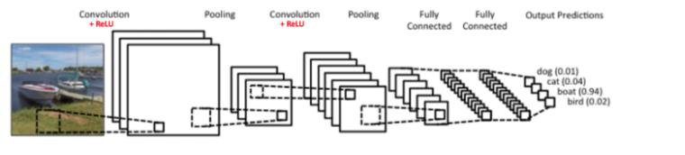 (1)

***2.6.1) Preprocessing:***

In the Preprocessing Part we going to read the images which is stored in the Folders. The CV2 Python library is used to read the Images, While reading the Images we are getting a Pixel values of the Images which is Stored into the folders, those Pixels values of the Individual Images are stored in the Python array, Here we have to give Particular Image size which we have to give so we can resize every images and store in to the Python array, Every Image size should be same that is the Motto Behind that, So we resize every Image accordingly after resizing the every images of both classes we have to create two array One array consist the Image Pixel values and other array consist the Number where the Image Belongs to it, and then we have to convert both array to the Numerical Python Array. We got Pixel values which are between 0 to 255 that’s why we divide the Each and every Pixel values array by 255, this is Done because the High Number of the Pixel value taken longer time to Process So we Normalized Pixel values.

***2.6.2) Activation Function:***

Activation Function is situation at end of Every Layer, Activation Function Brings Non-Linearity in the Output Process, there a Number of Activation function used in Deep Learning Techniques

1. Sigmoid

2. Tan-h

3. Relu

4. Leaky-Relu

5. SoftMax (Multiple Classes)

Sigmoid is used to solve binary Classification type of the Problem where we have to classify the Images in the Two Classes (ex. Cat, Dog). In the Tan-h activation Function all values are centered around the zero which is Shown in Figure while using the Tan-h activation Function there is Problem occurs called as vanishing Gradients:

1. We have to assign Random weights to Neurons

2. Check Output with Random Weight,

3. Calculate the Accuracy according to those Weights,

4. Find the weights Which gives minimum Error

After certain point we get the constant values there is no change in it, to counter that Problem we having the Relu Function.it is the Non-Linear Function which is Bend at zero, In Relu Negative Values are Map to Zero. Relu gives Maximum Accuracy. That’s Why Most of the Data Scientist use Relu Activation Functions, SoftMax is used in the last layer where we have Multi classes Problem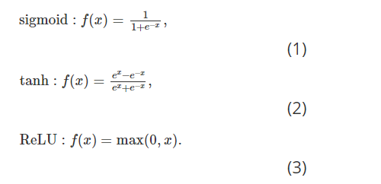

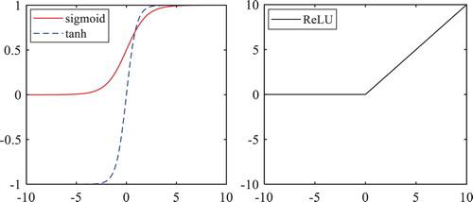 (2)

***2.6.3)Conv2D:***

In this Convolution 2D layer we can give Number of Filter that we can Provide as well give the Size of the Filter, in The Image Processing, there are three modes in the Convolution as follows Full, same and Valid which used according to their Need, Valid used where forward propagation is needed and Full mode is used in the Backward Propagation to find out Proper weight according to the Accuracy which is assign at the Output. In the Convolution Method Edge are become Zero, Convolution is nothing but Convert a Big image to Smaller One. filters are rotated applied on it, rotation about 180 degrees. Convolution applied should be turn around, Flipped and Down

***2.6.4) Operation:***

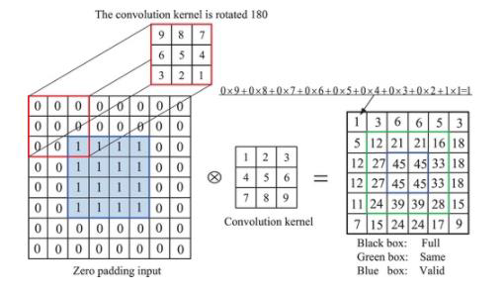 (3)

Convolution is technique means nothing but Mathematical Operation done on the image for Finding out Features in the Images. Ex. Let's say there is a cat or dog images so feature is nothing but the “Two Eyes”, “One Nose” Such features are extracted in this Layer.

***2.6.5) Pooling:***

These Layers are situated right after the Con2D layers, The Function of these layers are nothing but flatten image output of Con2D. it Reduces the Over-fitting Problem , The Major Operation of the Pooling Layer is to forward the output of Conv2D Important Pixel values, (Maximum Pixels Values) , Maximum Pixel values means Maximum Amount of Information Stored in it , There are three Types of reduction Processing of images available stochastic Pooling , Overlapping Pooling , Mean-Pooling and Max-Pooling

Mean Pooling extract average Pixel Values and Max-Pooling Extract Maximum Pooling Value, The Max-Pooling method applied according to the Filter size if Filter Size is (2,2) Maximum Pixel values will be Extracted from 4 values.

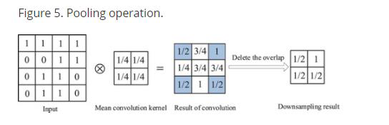 (4)

***2.6.6) CNN model for face recognition:***

In this paper, a model is developed I.e., a CNN model to upgrade the accuracy of facial image classification. The structure of the CNN model is alike to the classic LeNet-5 model, but they are dissimilar in some frameworks of the model, such as fully connected level, wide network, and input data. The developed CNN consists of

two folding layers (C1 and C2) and two grouping layers (S1 and S2). These layers are arranged alternately as C1-S1-C2-S2.

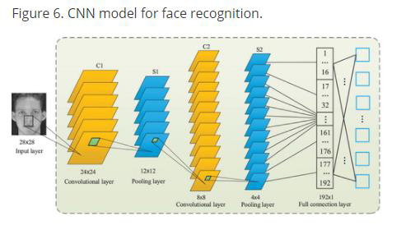 (5)

There is a single feature map on the input layer, which is made used to place the normalized facial image on the CNN model. C1 is the first convolutional layer containing 6 feature maps. Each neuron is convolved with a randomly generated 5x55x5 convolution kernel. S1 is the initial grouping layer and outputs 6 feature maps. Calculate depending on the output of the previous layer. Each element in the map I.e., feature map is assigned to the central convolution kernel of the correlate feature map of the C1 layer, and the perceptual fields of the elements do not overlap. C2 and S2 are the next convolutional layer and grouping layer, respectively. They have twelve feature maps and calculation steps, similar to the previous ones. An entirely coupled single-layer perceptron is positioned in the middle of the output layer and S2 layer. As mentioned in Figure 6, the concluding result is a 40-dimensional vector for facial recognition of 40 people, using the if sigmoid function to classify across multiple labels.

**3) Hardware components for Thermal Camera:**

1. Raspberry Pi 4 Computer Model B 4GB

2.Thermal Imaging Camera MLX90640 110 degree

3. Grove - 4 pin Female Jumper to Grove 4 pin Conversion Cable

4. Raspberry Pi 4 Official micro-HDMI to Standard HDMI Male Cable - 1m

5. Power Supply of Wall Adapter - Type-C 5VDC 3A

6. An SD Card (SanDisk Extreme Pro SD cards/Any supported)

**4) Hardware components for Drone:**

1.Action Camera

**5) Software Specifications:**

1. Pi4

2. Python Programming Language

**6)Technologies Used: -**

**6.1)Python:**

Python is a high-level, object-oriented interpreted programming language with dynamic semantics. Its integrated high-level data structure, unite with dynamic types and dynamic links, makes it interesting for rapid application development and the use of scripting languages or glue to link present components. Python's easy-to-learn and simple syntax highlights readability, thus reducing the cost of maintaining programs. Python supports modules and packages, which helps program modularity and code reuse. They are freely available to all major platforms in source code or binary format and can be redistributed for free. Programmers often fall in love with Python because it provides higher performance. Loops are very quick. Python programs debugging is easy-a wrong or incorrect input will never cause a segmentation fault. The peter catches errors and throws exceptions. If the program does not catch the exception, the interpreter outputs a stack trace. The source code level debugger allows you to inspect global and local variables, evaluate any expressions, set breakpoints, step through the code line by line, etc. The debugger is written in Python itself, which proves the introspection capabilities of Python. Alternatively, the fastest method to debug a program is usually to add some print statements to the source code-a quick edit-test-debug cycle makes this easy method productive.

**6.2)Flask:**

A Flask is Web Application Framework that is built with Flexibility and Speed in the Mind. Flask is Built in Python, which many data Scientist are familiar with. Flask takes care of the Environment and Project setup involved in web Applications

Allowing the Developer to focus on their application rather than thinking about HTTP, routing, dataset etc. Flask allow Data Scientist to create simple Single page Applications and one should Help or look into if they want to create Products for Consumers

Flask is a micro web framework which is written in Python programming language. It's labeled as a microframework as it doesn't need specific tools or libraries. It's no database abstraction layer, form validation, or the other components where former third-party libraries give similar functions. Though, Flask supports extensions which will add application characteristics as if they were achieved in Flask itself. Extensions exist for form validation, various open authentication technologies, object-relational mappers, upload handling, and a number of other common framework related tools

Flask was invented by Armin Ronacher of Pocoo, a world group of Python enthusiasts set up in 2004. As stated by Ronacher, the thought was originally an April Fool's joke that was favoured sufficient to form into significant application.

When Georg Brandl and Ronacher built a bulletin board system written in Python, the Pocoo projects Werkzeuge and Jinja were developed. Flask has set off well liked among Python enthusiasts. As of October 2020, it's second most stars on GitHub among Python web-development frameworks, only slightly behind Django, and was voted the foremost favoured web framework within the Python Developers Survey 2018

These are some Important features of the Flask:

**6.2.1)**. it is a Development Server

**6.2.2)**. Debugger

**6.2.3)**.RESTful request dispatching

**6.2.4)**.Unicode Based

**6.2.5)**.Flask have googled app engine Compatibility

**7) Testing:**

Software testing technique are traditionally split into white box testing and black box testing. Such two methods are used to describe the viewpoints taken by test engineers when developing test cases.

*Black box testing:* In black box testing, the software is regarded as a black box in the absence of internal implementation knowledge. Black box testing procedure include: uniformly separation, threshold analysis, all paired testing, fuzz testing, model-driven testing, traceability matrix, scan testing, and specification-based testing.

***7.1) Specification-based testing:***

Specification-based testing is designed to experiment the functionality of the software in accordance with relevant need. Therefore, when the tester inputs data, he can only see the output of the test object. This test level usually needs the tester to have full access to the test case, and then the tester can clearly check whether the output value (or behavior) of a given input is "equal to" or "not equal to" the expected value in the test case. Norm-based testing is obligatory to prevent certain risks, but it is not enough.

***8) Advantages and disadvantages:***

Black box testers are not "bound" by the code, and their perception is simple: the code must contain errors. According to the "ask and get" principle, black box testers can find errors that programmers cannot find. Then again, black box testing is described as "walking in a dark maze in the absence of a flashlight" as the tester does not recognize how the software to be tested is actually built. When (1) testers write many test cases to test things that can be tested with a single test case and/or (2) some areas of the backend are not tried-out at all.

Hence, black box testing has the edge of "an unaffiliated opinion," on the one hand, and the disadvantage of "blind exploring," on the other.

***9) White box testing:***

In white box testing, testers can access internal data structures and algorithms, including the code that implements them.

***9.1)Types of white box testing are:***

The types of existing white box testing are as follows

● Testing API (application programming interface): Use public and private APIs to test your application.

● Code coverage: Create tests that meet certain code coverage standards (for example, test designers can create tests so that all statements in the program are executed at least once).

● Testing methods with mutations.

● Static testing: The white box testing contains all static tests.

***9.2)Evaluation of code completeness:***

The white box testing method can also be used to assess the integrity of the test suite generated by the black box testing method. This allows the software development team to check the rarely tested parts of the system and ensure that the most important functional points are evaluated. Two common forms of code coverage are:

● Function coverage, which reports the executed functions.

● Statement coverage, which represents the number of rows run to complete the test.

Both return code coverage metrics measured in percentages.

***9.3)Integration testing:***

Integration testing is a type of software testing, designed to test the interface between components based on software design. Software components can be iteratively integrated or integrated together ("Big Bang"). The first option is generally considered the best option because it allows you to troubleshoot the interface faster.

***9.4)Acceptance testing:***

Acceptance testing can mean one of two things:

1. A smoke test is used as an acceptance test prior to introducing a new build to the main testing process, i.e. Before integration or regression.

2. Acceptance testing performed by the customer, often in their lab environment on their own HW, is known as user acceptance testing (UAT).

**10) Flow chart of Camera:**

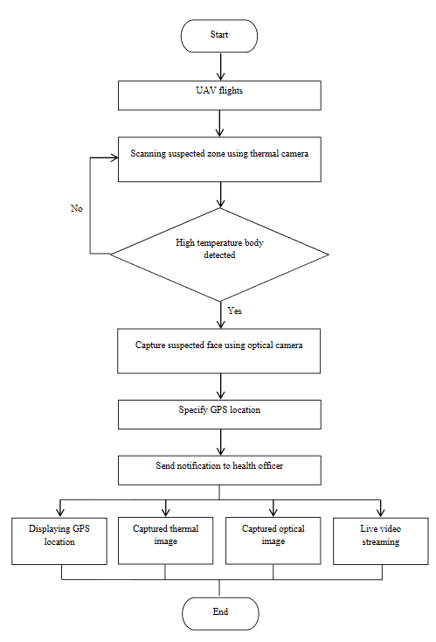 (6)

0-Level

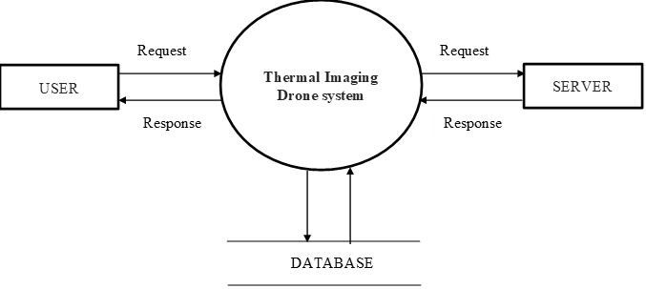 (7)

Diagram 1:

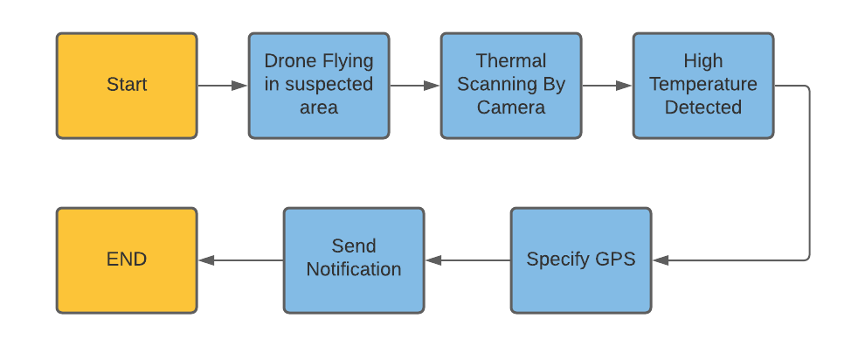 (8)

Level 2 Diagram:

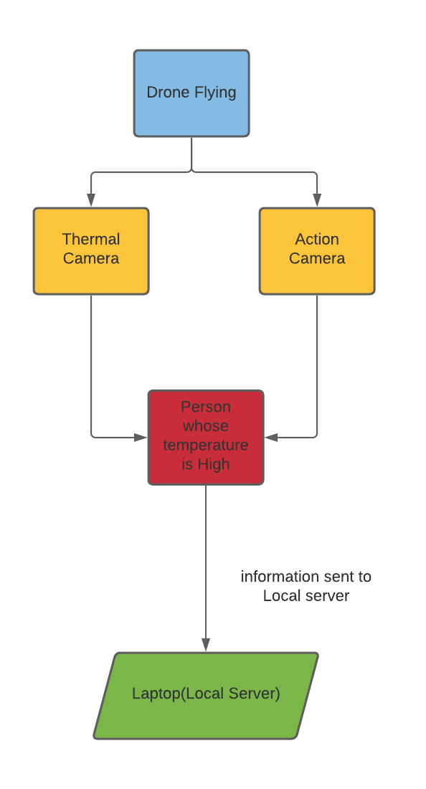 (9)

**11) Conclusion:**

The innovative real-time coronavirus early detection and monitoring system was developed using unmanned aerial vehicles (UAV) or drones with integrated thermal imaging cameras. The proposed system can determine the temperature of the earth's surface from the height above the ground. The drone can also seend the measured data to the server for displaying in the smartphone application. The spread of the coronavirus is the latest major issue that has emerged worldwide and requires the attention and awareness of many people. Early detection of coronavirus symptoms is an effective way to prevent the spread of coronavirus. Since hyperthermia (high temperature) is one of the most common symptoms in humans, a real-time screening process monitoring system is needed to automatically display thermal images of human body temperature. The diagnostic testing process will take less time and less human interaction, which may lesser the cause of coronavirus to spread more quickly. It can be concluded that remote sensing and detection technologies provide a variety of methods for detecting, scanning and monitoring coronaviruses, with excellent safety and potential, and can meet the needs of the healthcare system.

**12) References**

[1] P. Dollar, C. Wojek, B. Schiele, and P. Perona, “Pedestrian detection: ´ An evaluation of the state of the art,” in IEEE Transactions on Pattern Analysis and Machine Intelligence (PAMI), 2011.

[2] M. Enzweiler and D. Gavrila, “Monocular pedestrian detection: Survey and experiments,” in IEEE Transactions on Pattern Analysis and Machine Intelligence (PAMI), 2009.

[3] M. Andriluka, S. Roth, and B. Schiele, “People-tracking-by-detection and people-detection-by-tracking,” in Proceedings of the IEEE Conference on Computer Vision and Pattern Recognition (CVPR), 2008.

[4] P. Viola and M. Jones, “Rapid object detection using a boosted cascade of simple features,” in Proceedings of the IEEE Conference on Computer Vision and Pattern Recognition (CVPR), 2001.

[5] N. Dalal and B. Triggs, “Histograms of oriented gradients for human detection,” in International Conference on Computer Vision & Pattern Recognition, 2005.

[6] K. McManus, “Airborne thermography and ground geophysical investigation for detecting shallow ground disturbance under vegetation,” Ph.D.dissertation, Durham University, Durham, U.K., 2004.

[7] D. Allinson, “Evaluation of aerial thermography to discriminate loft insulation in residential housing,” Ph.D. dissertation, University of Nottingham, Nottingham, U.K., 2007. [8] S.

Axelsson, “Thermal modeling for the estimation of energy losses from municipal heating networks using infrared thermography,” IEEE Trans. Geosci. Remote Sens., vol. 26, no. 5, pp. 686–692, Sep. 1988.

[9] Anne-Mareike Chu, et.al. (2016), Exploring the Use of Thermal Imagery for the Promotion of Residential Energy Efficiency. Report prepared for the City of Vancouver. Availabe at: http://calp2016.sites.olt.ubc.ca/files/2016/05/Thermal-ImagingReport.pdf

[10] Zhang, Junjie, et al. “Thermal infrared inspection of roof insulation using unmanned aerial vehicles,” The International Archives of Photogrammetry, Remote Sensing and Spatial Information Sciences 40.1 (2015): 381.

[11] Nex, F., & Remondino, F. (2013). UAV for 3D mapping applications: a review. Applied Geomatics, 6, 1-15