Project - High Level Design
on
  - Real Estate System – DevOps Enabled Deployment using IaC
  - Course Name:

Institution Name: Medicaps University – Datagami Skill Based Course

Student Name(s) & Enrolment Number(s):
Sr no | Student Name | Enrolment Number
1 | Samruddhi Muley | EN22CS304056
2 | Payal Singh | EN22CS301701
3 | Aarti Bamanke | EN22EE301001
4 | Akshat Joshi | EN22CS304006
5 | Punit Pawar | EN22CS303038
6 | Shubhi Dubey | EN22CS304061

Group Name: Group 01D11
Project Number: DO-27
Industry Mentor Name: Mr. Vaibhav
University Mentor Name: Prof. Shyam Patel
Academic Year: 2026

Table of Contents
- Introduction.
  - Scope of the document.
  - Intended Audience
  - System overview.
- System Design.
  - Application Design
  - Process Flow.
  - Information Flow.
  - Components Design
  - Key Design Considerations
  - API Catalogue.
- Data Design.
  - Data Model
  - Data Access Mechanism
  - Data Retention Policies
  - Data Migration
- Interfaces
- State and Session Management
- Caching
- Non-Functional Requirements
  - Security Aspects
  - Performance Aspects
- References

1. Introduction
The Real Estate DevOps System is a containerized web application built using Flask that enables users to browse property listings and view detailed property information. The system is designed following DevOps principles with automated infrastructure provisioning using Infrastructure as Code (IaC) tools such as Terraform, containerization using Docker, and orchestration using Kubernetes.
The primary objective of this system is to demonstrate automated, scalable, and repeatable infrastructure deployment while maintaining application portability and reliability.
1.1 Scope of the Document
This document defines architectural boundaries, deployment strategy, and operational workflows. It outlines high-level interactions between system components without detailing internal implementation logic.
It also serves as a baseline document for future enhancements, including database scaling, security improvements, and monitoring integration.
This document provides a high-level design of:
- Application architecture
- Infrastructure architecture
- Deployment workflow
- Data design
- API structure
- Security and performance considerations
- DevOps automation process
This document does not include low-level code implementation details.

1.2 Intended Audience
The document assumes that readers have basic knowledge of:
- Cloud computing concepts
- DevOps practices
- Containerization technologies
- Web application architecture
This document is intended for:
- DevOps Engineers
- Cloud Architects

- Backend Developers
- System Administrators
- Technical Reviewers
- Project Evaluators

1.3 System Overview
The system follows a modular design approach where infrastructure, application, and deployment layers are logically separated. This separation allows independent scaling, maintenance, and upgrades without affecting other layers.
The architecture is cloud-ready and can be extended to multi-region deployments.
The system consists of:

- A Flask-based backend application
- HTML/CSS/Jinja2 frontend
- SQLite database
- Docker containerization
- Infrastructure provisioning using Terraform
- CI/CD pipeline using GitHub Actions or Jenkins
- Kubernetes for container orchestration (planned/implemented)
The system enables automated infrastructure setup and application deployment without manual configuration.

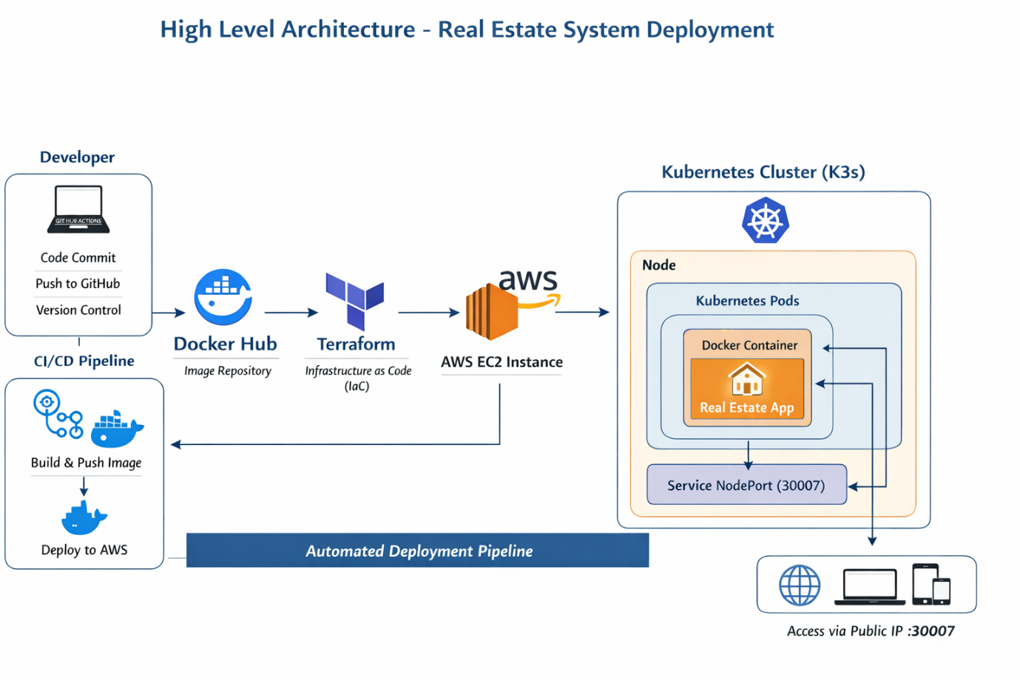

2. System Design

2.1 Application Design
The application follows a layered architecture:
Presentation Layer-
HTML, CSS frontend
Flask templates
Application Layer-
Flask backend logic
API endpoints
Request handling
Infrastructure Layer-
Docker container
Kubernetes deployment
AWS EC2 hosting
The application follows a request-response lifecycle:
- Client sends HTTP request
- Flask route handles request
- Database queried via ORM
- Template renders response
- Response returned to client

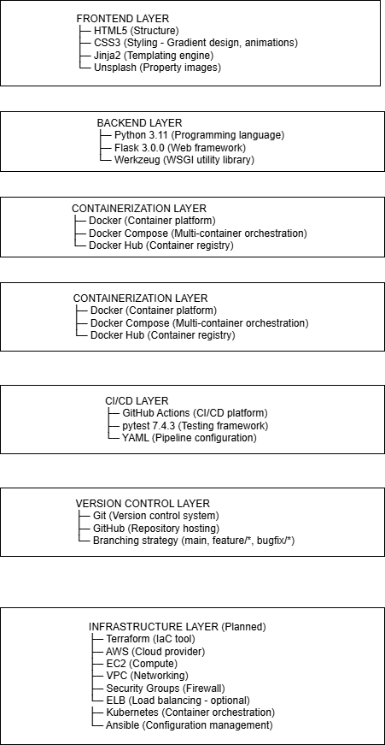

2.2 Process Flow
The deployment pipeline ensures zero manual intervention after code push. Automated testing and image building reduce the risk of broken deployments.
The runtime process ensures stateless behaviour to support horizontal scaling in Kubernetes environments.
User Flow:
1. User opens browser
2. Sends HTTP request to EC2 Public IP
3. Kubernetes service forwards request to container

4. Flask application processes request
5. Response displayed in browser
CI/CD Flow:
- Code pushed to Git repository
- Pipeline triggers automatically
- Docker image built
- Image pushed to registry
- Terraform provisions infrastructure
- Kubernetes deploys updated container

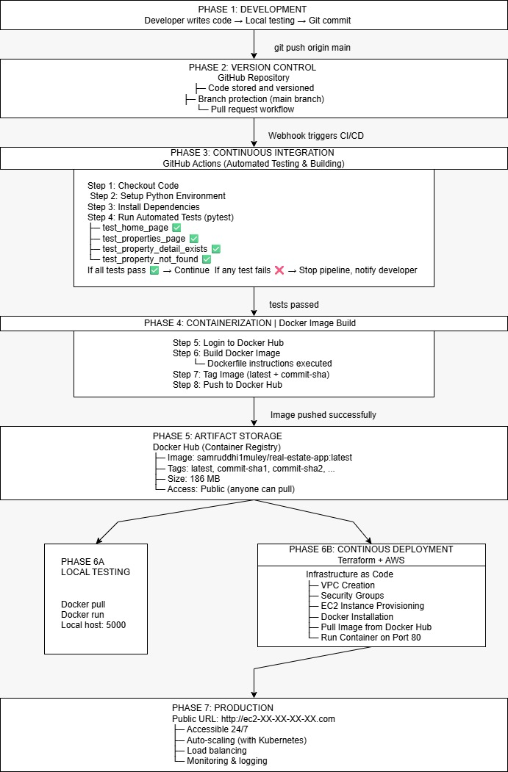
Complete devops workflow

2.3 Information Flow
Information flow is unidirectional in request-response format, ensuring clarity in data processing.
User Browser
↓
AWS EC2 Public IP
↓
Kubernetes Service
↓

Kubernetes Pod
↓
Docker Container
↓
Flask Application
↓
HTML Response
2.4 Components Design
Major Components:
- GitHub Repository
Stores source code
Stores Terraform configuration
- GitHub Actions
CI/CD pipeline
Builds Docker image
Pushes image to Docker Hub
- Docker
Containerizes application

- Docker Hub
Stores Docker image
- Terraform
Provisions infrastructure
Creates EC2 instance
Configures networking
- AWS EC2
Hosts Kubernetes cluster
- Kubernetes (K3s)
Orchestrates containers
Manages pods and services

2.5 Key Design Considerations
- Infrastructure automation using Terraform
- Container portability using Docker
- Scalability using Kubernetes
- Automated deployment using CI/CD
- Cloud-based hosting for high availability
- Security via controlled acce
2.6 API Catalogue
All APIs are designed to follow RESTful standards and proper HTTP methods.
Future enhancements may include:
- POST APIs for adding properties
- PUT APIs for updating properties
- DELETE APIs for administrative control
- Authentication endpoints
API versioning strategy can be introduced for backward compatibility.

Endpoint | Method | Description
/ | GET | Home page
/properties | GET | List all properties
/property/<id> | GET | View property details
/static/* | GET | Serve static assets
All APIs follow RESTful design principles and return HTML responses.

3. Data Design

3.1 Data Model
- Data includes:
- Property ID
- Property Name
- Location
- Price
- Description
Data is stored in SQLite database.
3.2 Data Access Mechanism
Data is accessed using:
- Flask backend logic
- SQL queries
- ORM abstraction layer where applicable
Database interactions are handled securely through the backend application.

  - Data Retention Policies
- Data is stored on the EC2 instance.
- Backups can be created using AWS snapshots.
- Data is retained until manually deleted or infrastructure is destroyed.
- Future implementations may include automated backup strategies.

3.4 Data Migration
Terraform enables recreation of infrastructure without affecting application source code.

Database migration can be handled using scripts or migration tools during upgrades.
4. Interfaces
External Interfaces:
- Web Browser
- AWS EC2
- Docker Hub
- GitHub
Internal Interfaces:
- Kubernetes Service to Pod
- Pod to Docker Container
- Container to Flask Application

  - State and Session Management
The application follows a stateless architecture.
Each request is processed independently.
No persistent session storage is currently implemented.
Kubernetes ensures container restart and high availability without affecting system stability.

6. Caching
Currently, no caching mechanism is implemented.
Future improvements may include:
- Redis-based application caching

- CDN caching for static assets

7. Non-Functional Requirements

7.1 Security Aspects
- AWS Security Groups restrict external access.
- SSH access is controlled via key pairs.
- Docker provides container-level isolation.
- Kubernetes ensures pod-level isolation.
- IAM roles control access to AWS resources.

7.2 Performance Aspects
- Kubernetes enables horizontal scalability.
- Docker ensures fast application startup.
- Terraform enables quick infrastructure provisioning.
- Cloud deployment ensures better availability and reliability.

8. References
- AWS Documentation
- Terraform Documentation
- Docker Documentation
- Kubernetes Documentation
- Flask Documentation
- GitHub Actions Documentation

