- Problem Definition
The rapid increase in road accidents due to negligence and lack of safety measures has become a serious concern. One of the major causes includes drivers not wearing helmets and instances of driver drowsiness, which significantly increase the risk of fatal accidents. Traditional monitoring methods rely heavily on manual supervision, which is inefficient and prone to human error. Therefore, there is a need for an automated, real-time system that can accurately detect such violations.
The problem is to design and develop a deep learning-based detection system using YOLO (You Only Look Once) that can identify whether a person is wearing a helmet or if a driver is in a drowsy state. The system should process live video streams or images and provide instant detection results with high accuracy. Additionally, it should minimize false positives and work effectively under different environmental conditions such as varying light and angles.
.
- Existing System
- Manual Monitoring
- Traffic police check helmet usage manually
- Time-consuming and inefficient
- Limited coverage in crowded areas
- CCTV-Based Systems
- Cameras installed at traffic signals
- Require human supervision

- Need for Computerization
- Automation of Detection : Reduces dependency on manual monitoring by automatically identifying violations like no helmet or drowsiness.
- Improved Accuracy :Computerized systems using AI/ML provide more precise and reliable results compared to traditional methods.
- Real-Time Processing : Enables instant detection and alerts, helping in quick action and accident prevention.
- Continuous Monitoring : Works 24/7 without fatigue, ensuring constant surveillance of drivers and traffic conditions.
- Reduced Human Effort : Minimizes the need for manual supervision, saving time and resources.
- Enhanced Road Safety :Helps in reducing accidents by ensuring timely detection and enforcement of safety rules.

- Scope of Proposed System
The proposed system aims to provide a real-time, automated solution for detecting helmet usage and driver drowsiness using YOLO-based deep learning models. It can be deployed on roads, highways, traffic signals, and inside vehicles, integrating seamlessly with existing CCTV or webcam setups. The system offers high accuracy and fast detection, ensuring timely alerts to prevent accidents. It is scalable, allowing monitoring across multiple locations and cameras, and can store detection data for future analysis and reporting. Additionally, the system can be enhanced in the future to detect other traffic violations such as seatbelt usage or mobile phone usage, making it a comprehensive tool for improving road safety.

- Objectives
The primary objective of the proposed system is to automate the monitoring of road safety by detecting helmet usage and driver drowsiness in real time. By leveraging YOLO-based deep learning models, the system aims to provide accurate and reliable detection under different lighting and environmental conditions. It seeks to enhance road safety by generating instant alerts for risky behavior, thereby reducing the chances of accidents. Additionally, the system will record detection data for analysis and reporting, allowing authorities to monitor trends and make informed decisions. Designed to be scalable and flexible, it can be deployed across multiple locations and integrated with existing CCTV or webcam setups. In the future, the system can be extended to detect other traffic violations, such as seatbelt or mobile phone usage, making it a comprehensive tool for improving overall traffic safety.

- Requirement Gathering
Requirement gathering is the process of collecting and documenting the needs of stakeholders to ensure the system meets its intended objectives. For the helmet and driver drowsiness detection system, this involves understanding the expectations of traffic authorities, developers, and safety experts. The system must be able to detect helmet usage and driver drowsiness in real time, generate alerts for violations, and store data for analysis and reporting. It should be compatible with existing CCTV or webcam setups and provide a user-friendly interface for monitoring. Additionally, the system must deliver high accuracy, fast processing, scalability across multiple locations, and reliable performance under varying environmental conditions, while ensuring the security and privacy of the recorded data. Proper requirement gathering ensures that the system is effective, efficient, and aligned with stakeholder needs.

- Platform Details (H/W & S/W with versions)
- Hardware Platform
- Processor: Intel Core i5 or higher / AMD Ryzen 5 or higher
- RAM: Minimum 8 GB
- Storage: At least 10–20 GB free space
- Webcam :for live detection
- GPU :optional, for faster processing and training
- Display :Monitor with minimum 720p resolution

- Software Platform
  - Operating System: Windows 10/11 (64-bit) or Ubuntu 20.04/22.04
  - Python: Version 3.9 or higher
  - Libraries/Frameworks:
    - PyTorch 2.0+ (for YOLO model implementation)
    - OpenCV 4.5+ (for image/video processing)
    - NumPy 1.21+ (for numerical operations)
    - Pandas 1.3+ (for data storage/analysis)
    - Matplotlib / Seaborn (for visualization)
  - IDE/Editor: VS Code, PyCharm, or Jupyter Notebook
  - YOLO Model: Pretrained YOLOv5/YOLOv8 .pt weights

- Analysis Specification (Object Oriented Approach)
The proposed helmet and driver drowsiness detection system is designed using an object-oriented approach to ensure modularity, reusability, and easy maintenance. The system is divided into several classes, each with a specific responsibility. The Camera/Input class handles capturing live video feeds, while the Preprocessing class prepares frames for analysis through resizing, normalization, and noise reduction. The YOLO Detection class loads the pretrained model and detects helmets or signs of drowsiness, returning bounding boxes, class labels, and confidence scores. The Alert/Notification class generates visual or audio alerts upon detecting violations, and the Data Storage/Logging class manages recording of detection results for analysis. Additionally, the Interface/Display class handles real-time visualization of results, and the Utility/Helper class provides reusable functions for tasks such as model loading and frame conversion. This object-oriented structure ensures that each component has a single responsibility, interacts through well-defined interfaces, and allows the system to be easily extended, tested, and maintained.

- Design Specification
The design specification defines the structure and implementation of the helmet detection system, following a modular approach for efficiency and maintainability.
- Input Module: Captures live video feed from a webcam or CCTV camera.
- Preprocessing Module: Resizes, normalizes, and enhances frames to improve detection accuracy.
- Detection Module: Uses a pretrained YOLO model to identify helmets, providing bounding boxes, class labels, and confidence scores.
- Alert Module: Generates real-time notifications through visual indicators or audio alarms when a person is detected without a helmet.
- Data Logging Module: Records detection timestamps, and images for monitoring and analysis.
- Display Module: Shows the live video feed with detection results in an intuitive interface.
This modular design ensures fast, accurate, and scalable helmet detection, with the ability to integrate future enhancements or additional safety features.

- Data Dictionary / Diagram
- Data Dictionary:
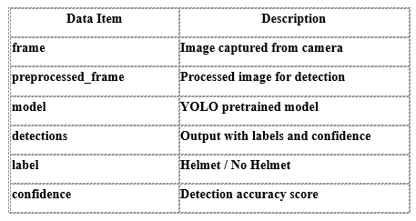
- Flowchart:

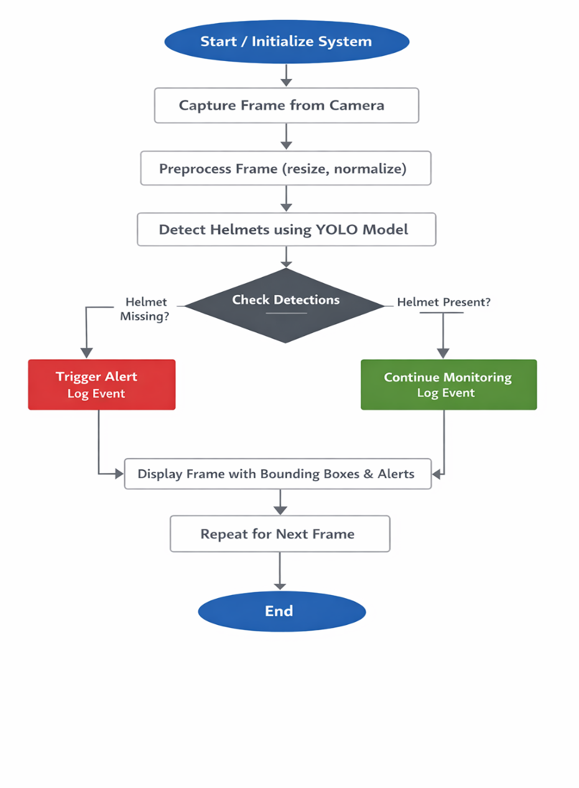

- Use Case Diagram

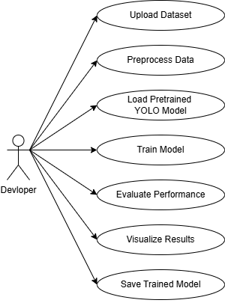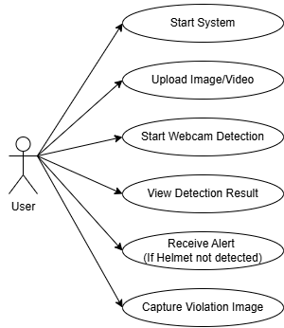
- Implementation Strategies
- Requirement Analysis
  - Gather functional and non-functional requirements from stakeholders.
  - Define system objectives, input/output data, and performance expectations.
- System Design
  - Use an object-oriented modular design for clarity and reusability.
  - Define classes for video capture, preprocessing, detection, alerting, and data logging.
- Model Selection & Integration
  - Use a pretrained YOLO model for helmet detection to avoid long training times.
  - Integrate the model with Python using frameworks like PyTorch and OpenCV.
- Data Handling & Preprocessing
  - Capture video frames from webcam or CCTV.
  - Resize, normalize, and enhance frames for better model performance.
- Detection & Alert Mechanism
  - Apply YOLO to detect helmets in each frame.
  - Trigger alerts (audio/visual) if a helmet is missing and log events.
- Visualization & Reporting
  - Display processed frames with bounding boxes and labels.
  - Store logs for analysis and monitoring compliance.
- Testing & Optimization
  - Test the system under different lighting and environmental conditions.
  - Optimize model parameters and preprocessing for real-time performance.
This step-by-step strategy ensures that the helmet detection system is accurate, real-time, and reliable while being easy to maintain and extend in the future.

- Input / Output Screens (Screenshots)

UI :

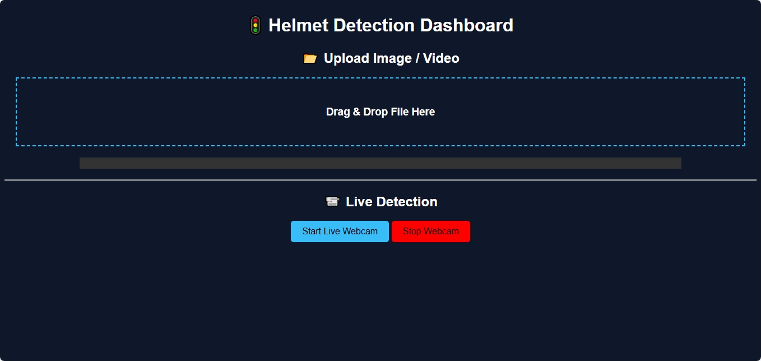

Input :

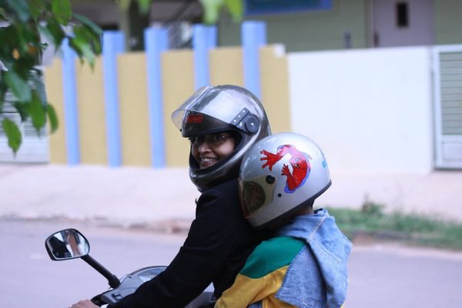
Output :

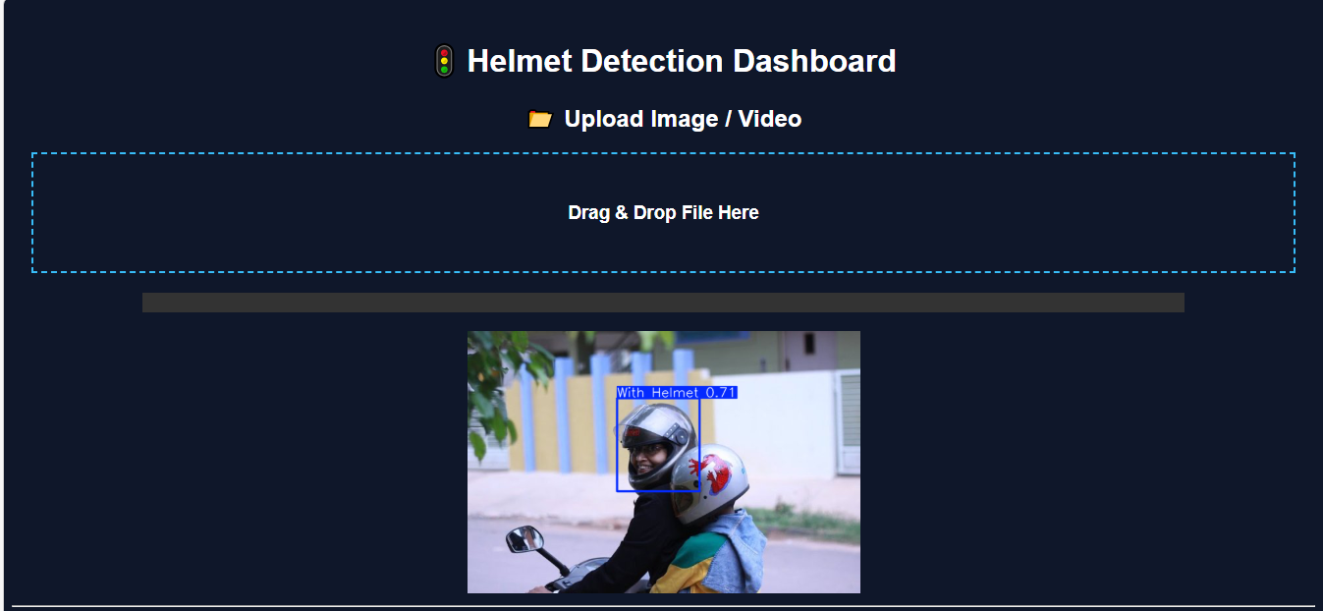

Input :

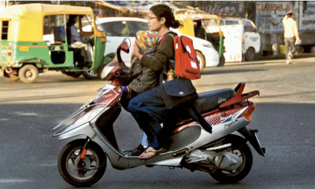

Output :

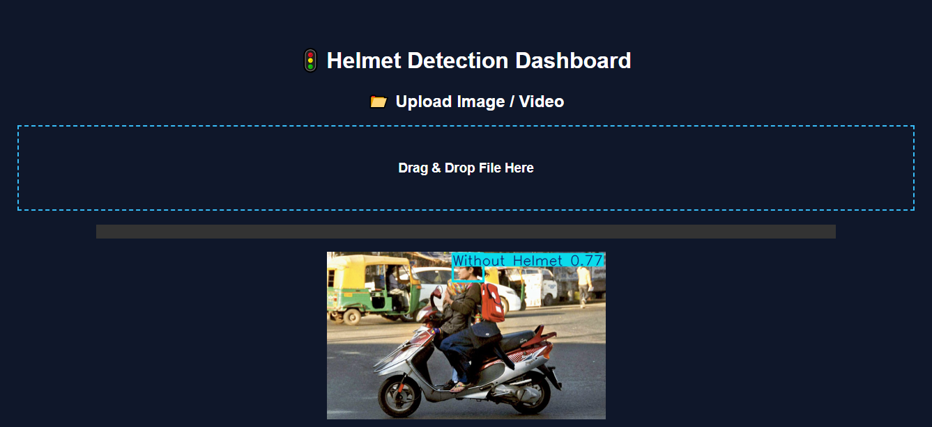

- Decision Tools (if any)
The proposed system uses a YOLO-based deep learning model as the primary decision tool for helmet detection. The model analyzes each video frame and makes decisions by classifying objects as “Helmet” or “No Helmet” based on learned features.
Additionally, a threshold-based decision mechanism is applied using confidence scores generated by the model. If the confidence value exceeds a predefined threshold, the detection is considered valid. Based on this decision, the system triggers alerts for violations and logs the events.
Thus, the combination of deep learning (YOLO) and rule-based thresholding ensures accurate and reliable decision-making in real time.

- Testing Strategies
- Unit Testing : Each module (camera input, preprocessing, detection, alert system) is tested individually to ensure it works correctly.
- Integration Testing : All modules are combined and tested together to verify smooth interaction and data flow between components.
- Functional Testing : Checks whether the system correctly detects “Helmet” and “No Helmet” cases as per requirements.
- Performance Testing : Evaluates system speed and efficiency to ensure real-time detection without delays.
- Accuracy Testing : Tests the model using different datasets and conditions (lighting, angles, occlusion) to measure detection accuracy.
- Stress Testing : Analyzes system performance under heavy load or continuous video streaming.
- User Testing : Ensures the system is user-friendly and meets practical usability requirements.

- Limitations and Drawbacks
- Dependence on Lighting Conditions : Detection accuracy may decrease in low light, shadows, or poor weather conditions.
- Camera Quality Dependency : Low-resolution or blurred video input can affect detection performance.
- Occlusion Issues : Helmets may not be detected properly if partially covered or blocked.
- Model Limitations : Pretrained models may not generalize well to all real-world scenarios without further training.
- Hardware Requirements : Requires a good GPU for efficient real-time processing, which may increase cost.
- Limited Scope : Focuses only on helmet detection and does not cover other traffic violations.

- Conclusion
The proposed helmet detection system using YOLO provides an efficient and automated solution for monitoring road safety. By leveraging deep learning techniques, the system is capable of detecting helmet usage in real time with good accuracy. It reduces the dependency on manual monitoring and helps in identifying violations quickly.
Overall, the system is reliable, scalable, and can be integrated with existing surveillance infrastructure. It plays a significant role in improving traffic rule enforcement and reducing road accidents, while also offering scope for future enhancements.

- Future Enhancements
- Detection of Multiple Violations : Extend the system to detect other violations such as seatbelt usage, mobile phone usage, and triple riding.
- Improved Model Accuracy : Train the model with larger and more diverse datasets to enhance detection performance under all conditions.
- Real-Time Notification System : Integrate SMS, email, or mobile app alerts for instant notification to authorities.
- Edge Device Deployment : Deploy the system on edge devices like Raspberry Pi or Jetson Nano for portable and cost-effective solutions.
- Automatic Number Plate Recognition (ANPR) : Combine with number plate detection to identify and penalize violators automatically.
- Dashboard and Analytics : Develop a dashboard to visualize reports, trends, and statistics for better decision-making.

- User Manual
- Step 1: System Setup
Install required software (Python, OpenCV, PyTorch) and load the pretrained YOLO model. Connect the webcam or CCTV camera properly.
- Step 2: Running the Application
Execute the main program file to start the helmet detection system. The camera feed will open automatically.
- Step 3: Monitoring
Observe the live video feed where detected objects are highlighted with bounding boxes and labels (Helmet / No Helmet).
- Step 4: Alerts Handling
If a person without a helmet is detected, the system will generate an alert (visual/audio). Take appropriate action if required.
- Step 5: Data Storage
Detection results and logs are automatically stored for future reference and analysis.
- Step 6: System Shutdown
Close the application window or stop the program safely to end the process.
- Step 7: Troubleshooting
Ensure camera connection, correct installation of libraries, and proper model file path if the system does not run correctly.

- References & Bibliography
- Scikit-learn Documentation. [Online]. Available: https://scikit-learn.org
- Flask Documentation. [Online]. Available: https://flask.palletsprojects.com
- NumPy Documentation. [Online]. Available: https://numpy.org
- Pandas Documentation. [Online]. Available: https://pandas.pydata.org
- Kaggle. [Online]. Available: https://www.kaggle.com
- GitHub. [Online]. Available: https://github.com

