**Machine Vision System**

**Practical 1**

**Image Processing & Video Processing in OpenCV using Python**

In this Practical, we’ll learn step-by-step how to open an image by using the OpenCV (Open Source Computer Vision) library.

**1] Installations:**

First search cmd on your windows search bar to open command prompt on your windows and type *python –version.* if python is already available on your windows you will see the version that is present, if not available it will say *Python was not found;* Then you can simply install Python from Microsoft Store or Google.

After you’ve successfully installed Python on your system we have to install OpenCV and some important libraries that are used for Image/Video Processing. For this write a command *pip install opencv-contrib-python* on your terminal and it will install Opencv and all other prerequisites libraries like Numpy.

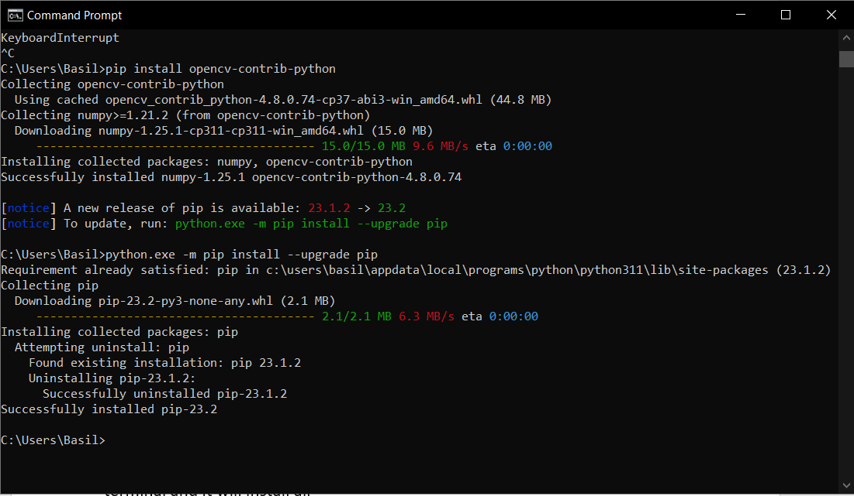

Now, we have to install a CAER package that helps speed up the workflow. For this write a command *pip install caer* and the package will start installing. This package has a set of utility functions and helper functions that will help us speed up the workflow.

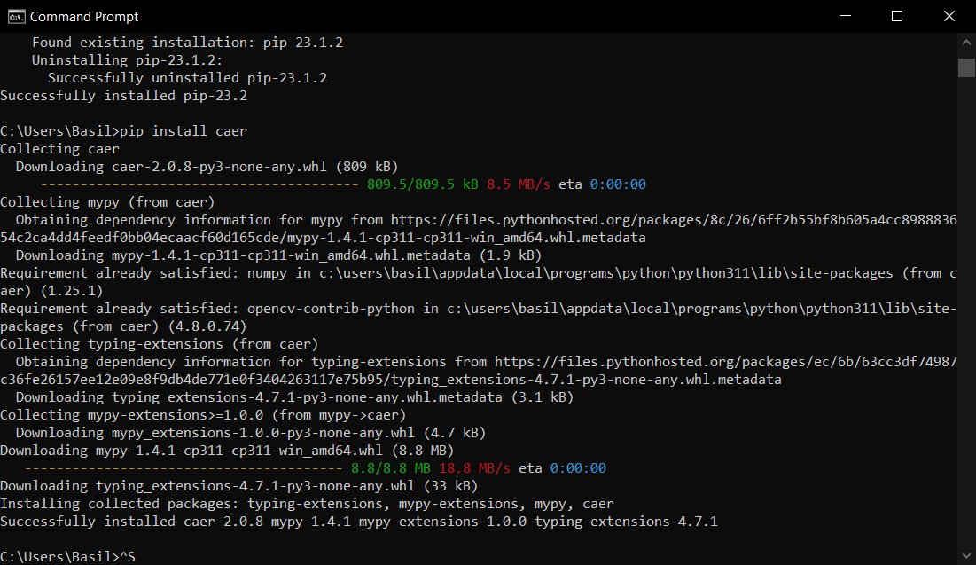

Lastly, install Visual Studio code from the Microsoft Store or Google, and a python extension in it, in which you will be able to write the code for image and video processing.

Also, create a folder on your desktop named "Cv_(Roll No.)" Then create two more folders in it named "Photos" & Videos" and add some photos and videos to the respective folders. Then right click on your main Cv folder and click on Open with Code.

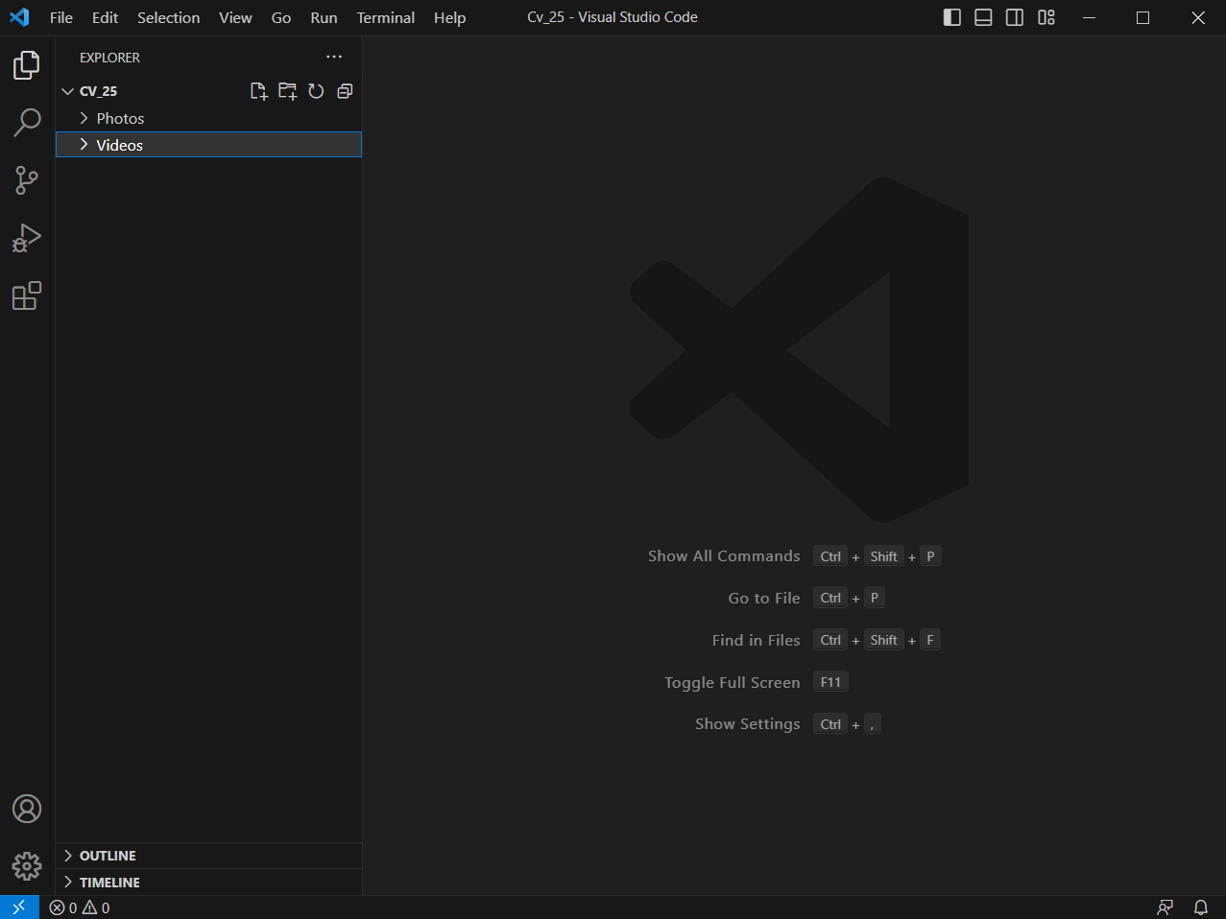

**1] Reading Images:**

Create a file with .py extension named as *Img_processing.py* and then write the code for reading the image.

**Code:**

import cv2 as cv

img = cv.imread('Photos/(file_name).jpg')

cv.imshow('(Image)', img)

cv.waitKey(0)

**Output:**

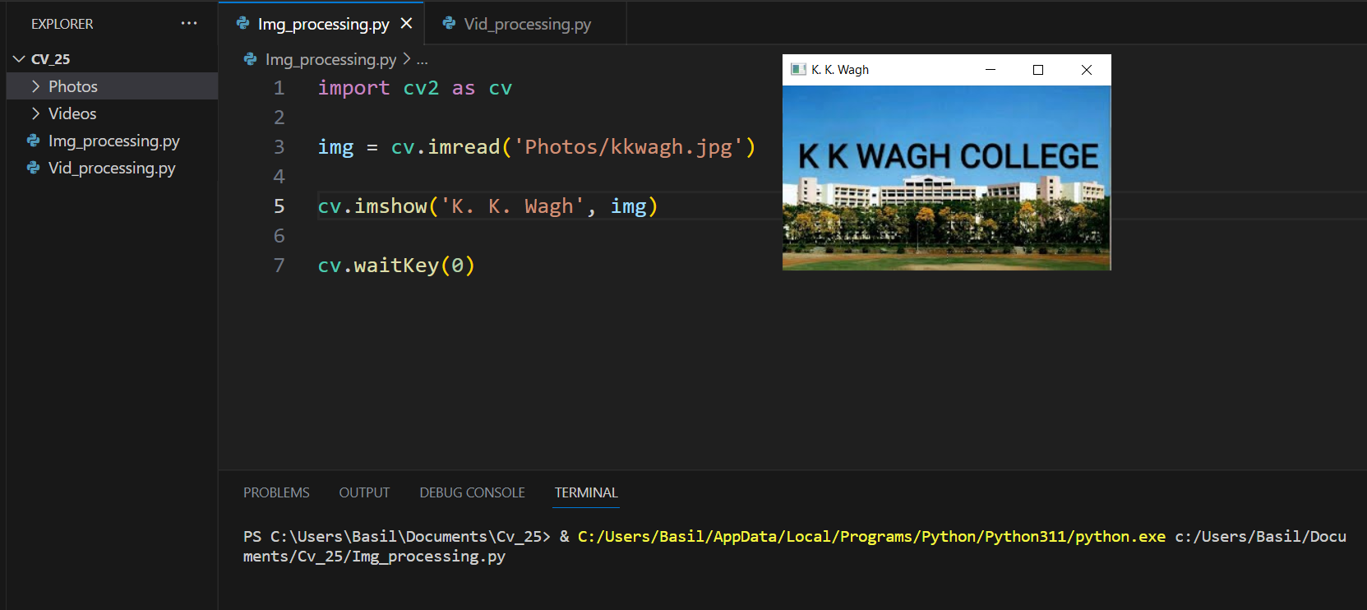

**1] Reading Video:**

Create another file with .py extension named as Vid*_processing.py* and then write the code for reading the video.

**Code:**

import cv2 as cv

capture = cv.VideoCapture('Videos/(file_name).mp4')

while True:

    isTrue, frame = capture.read()

    if isTrue:

        cv.imshow('(Video)', frame)

        if cv.waitKey(20) & 0xFF==ord('d'):

            break

    else:

        break

capture.release()

cv.destroyAllWindows()

**Output:**

