**Machine Vision System Practical 2**

**Pause Video at a frame & Passcode encrypted Image**

**in OpenCV using Python**

In this Practical, we will learn

1. How to pause a video at a particular frame using waitKey() and a while loop.

&

1. How to Encrypt your image with a passcode using ifelse method.

**1] Pause Video at a frame:**

* **Importing OpenCV (cv2 as cv):**

The code starts by importing the OpenCV library, which is used for computer vision tasks, including reading and processing videos.

* **Opening the Video File:**

The video file is opened using the cv.VideoCapture() function. It takes the path to the video file as an argument and returns a VideoCapture object, which is used to read frames from the video.

* **Main Program:**

In order to pause a video at a frame defined by the user, we must first collect their input regarding the number of frames and store it in a variable called "frames" using the input method. Then we create a while loop with the iterations set as ‘frames’. Based on the user's specification of the frame at which the video is to be paused, our loop repeats that number of times. With the help of "cv2.imshow," we then simply display each frame during this loop. The final step is to record and display the last frame that was provided.

* **Releasing Resources and Closing Windows:**

Once the loop is exited the VideoCapture object is released using capture.release() to free up system resources. Then, all OpenCV windows are closed using cv.destroyAllWindows().

**Flow Chart:**

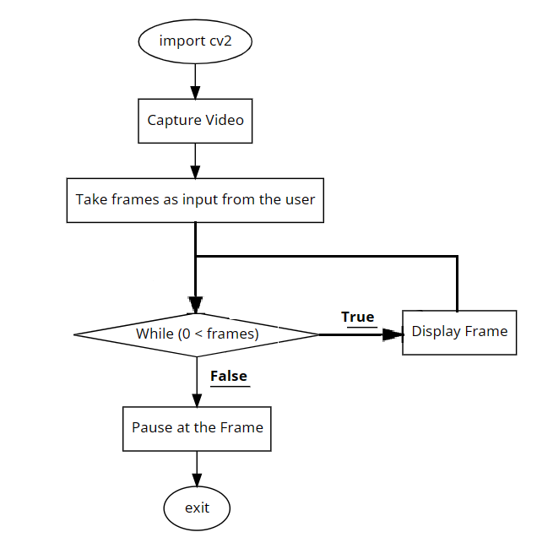

**Code:**

import cv2 as cv

capture=cv.VideoCapture('Videos/MachineVision.mp4')

pause_frame = int(input("Number of frame: "))

frame_count = 0

while frame_count < pause_frame:

    ret, frame = capture.read()

    cv.imshow('MVS', frame)

    cv.waitKey(20)

    frame_count += 1

capture.set(1, pause_frame)

while True:

    ch = 0xFF & cv.waitKey(1)

    if ch == 27:

        break

capture.release()

cv.destroyAllWindows()

**Output:**

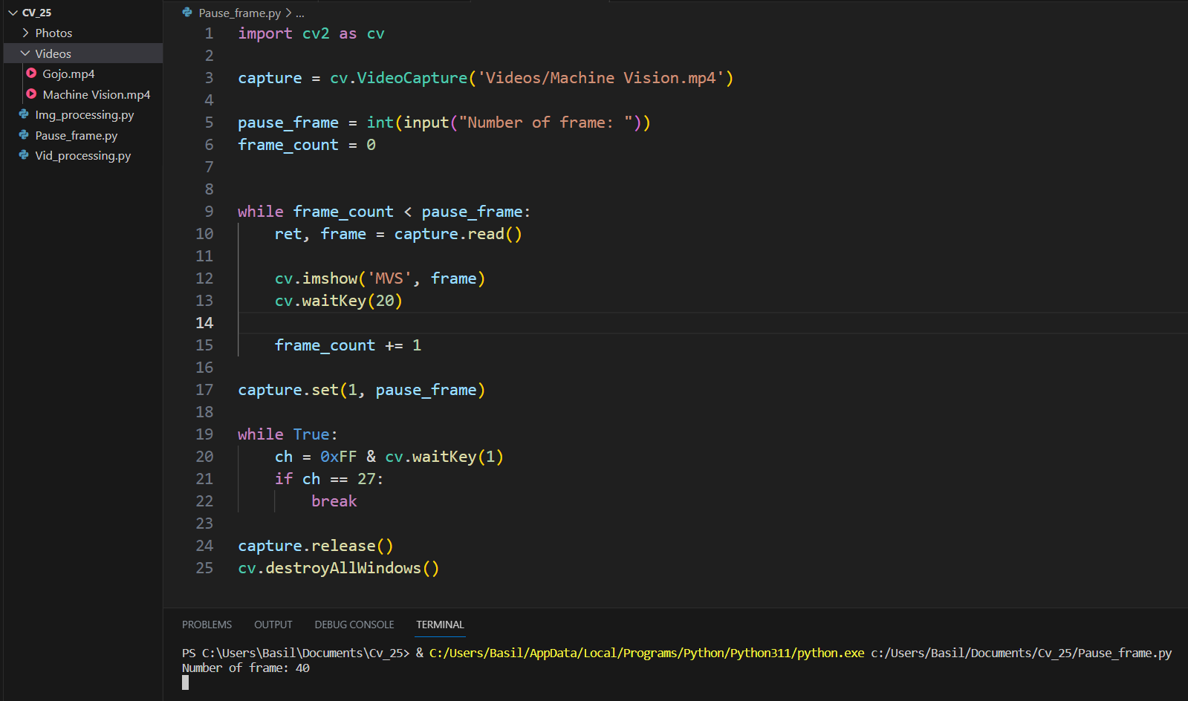

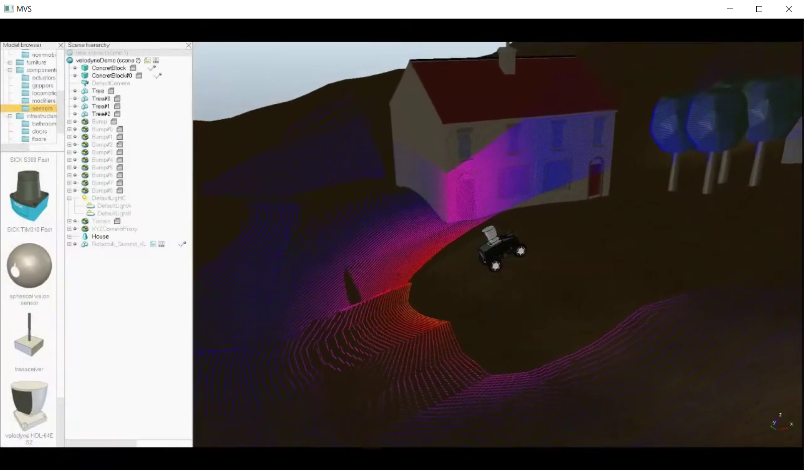

**1] Passcode Encrypted Image:**

* **Importing OpenCV (cv2 as cv):**

The code starts by importing the OpenCV library, which is used for computer vision tasks, including reading and processing videos.

* **Main Program**

Here we need to encrypt our image with a passcode so we use ifelse type loop. If the user has given the correct passcode we show the image else, we print The Passcode is incorrect.

**Flow Chart:**

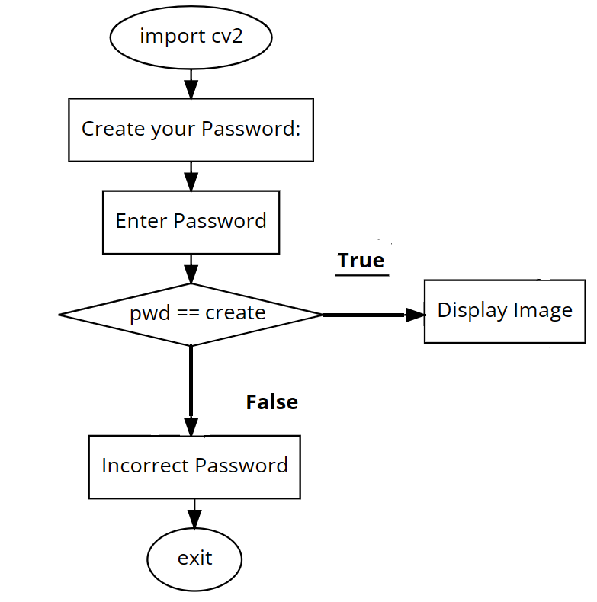

**Code:**

import cv2 as cv

create = int(input("Create your Password:"))

pwd = int(input("Password:"))

if pwd == create:

    img = cv.imread('Photos/kkwagh.jpg')

    cv.imshow('K. K. Wagh', img)

    cv.waitKey(0)

else:

    print("Passcode is incorrect")

    exit()

**Output:**

