- Create the database in MySQL as per the ER diagram.
- Select the database using the appropriate SQL command.
- Create all tables (users, students, courses, videos) with:
- Correct data types
- Primary keys
- Foreign keys
- Relationships exactly as shown in the ER diagram

Users Table:
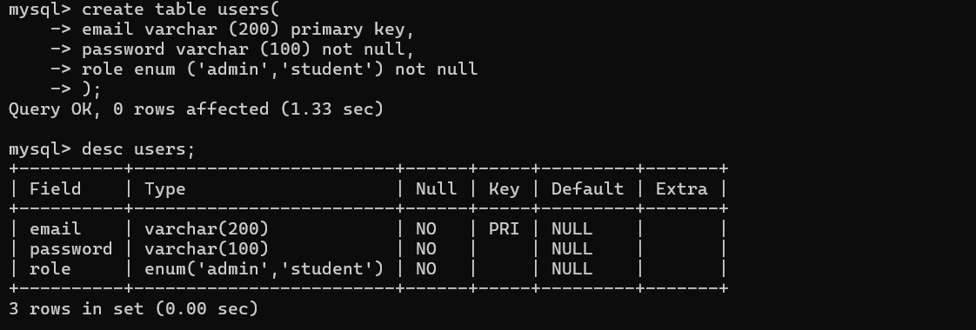

Courses Table:
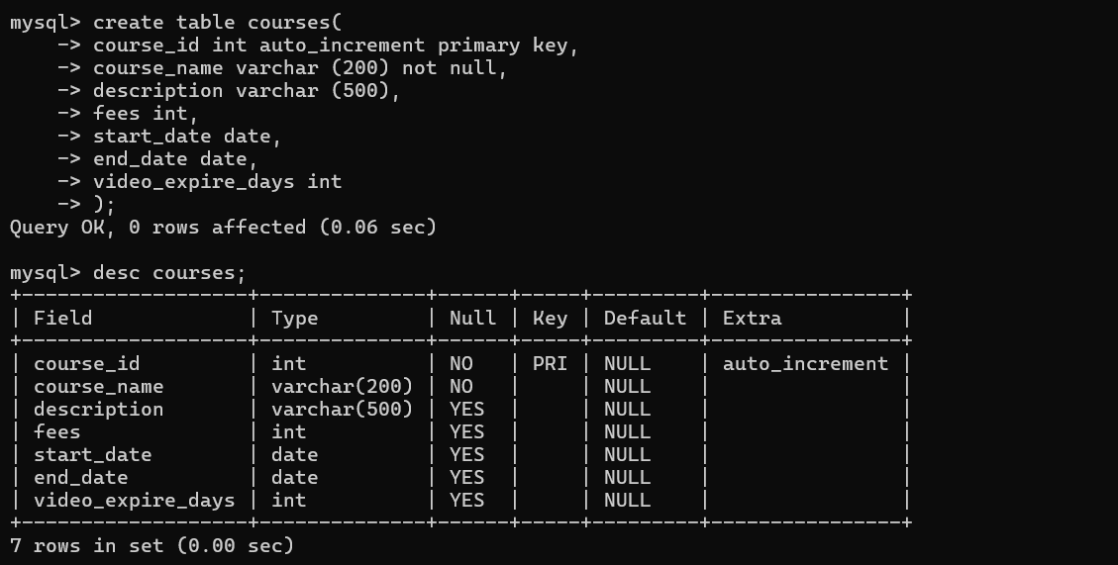

Student Table:
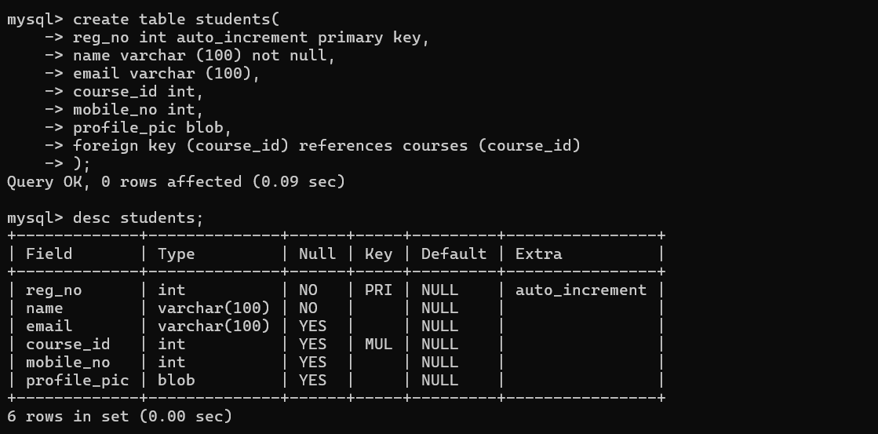
Videos Table:
