Question 1:
Verify that Git is correctly installed on your system and record the version displayed
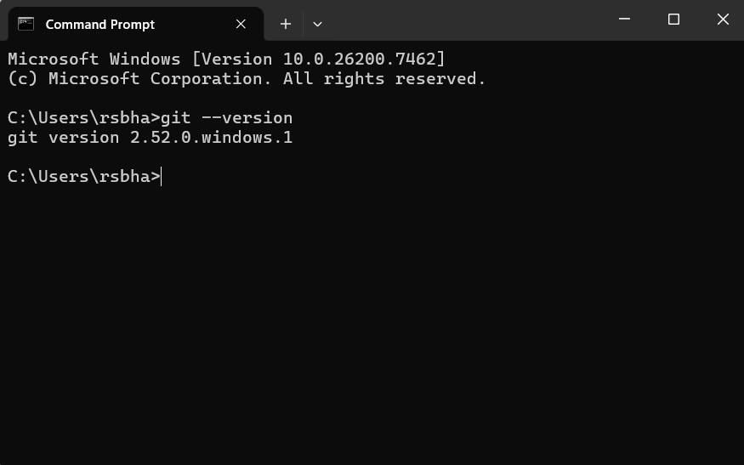
Question 2:
Configure Git with your global username and email ID, and verify that the configuration has been applied successfully

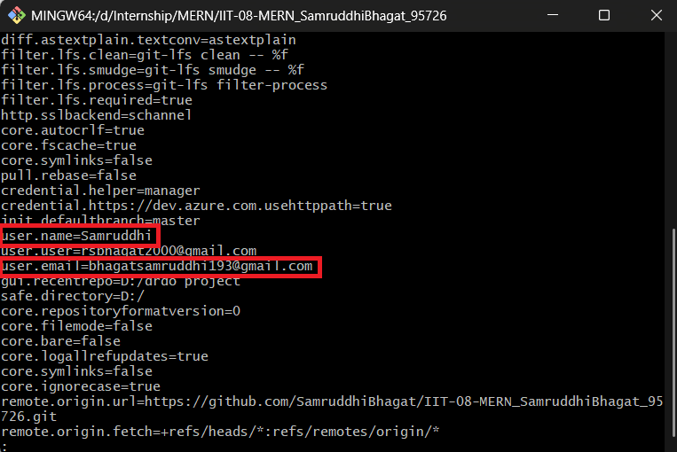
Question 3
Create a new local Git repository named git-assignment and initialize version control in it.
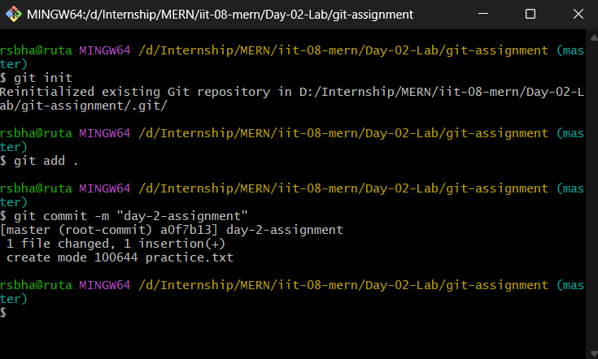
Question 4
Create a README.md file inside the repository, add relevant project information, and commit the file to the repository.
Question 5
Modify the existing README.md file and create a new file named index.html. Track the changes and commit them with an appropriate commit message.
Question 6
Display the commit history of the repository and identify the commit hash, author, and commit message

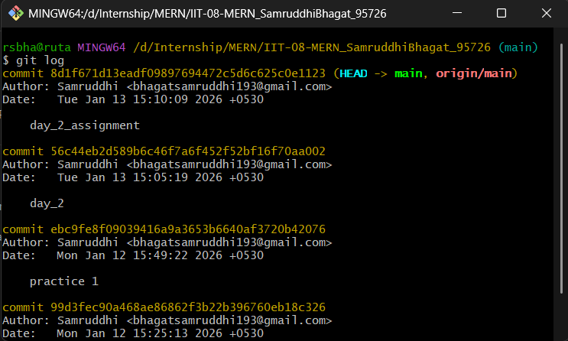
Question 7
Create a new branch named feature-branch, switch to it, add a new file named feature.txt, and commit the changes.
Question 8
Switch back to the main branch and merge the feature-branch into it. Ensure the merge is completed successfully.
Question 9
Create a new remote repository on GitHub named git-assignment and push the complete local repository to GitHub
(combine)
