Program 1:-

#include<iostream.h>
class ABC
{
int a;
int b;
public:
int c;
void inputdata()
{
std::cout << "\n Enter two number";
std::cin >> a >> b ;
}
void display ()
{
std::cout << "\n a ="<<a;
std::cout << "\n b ="<<b;
std::cout << "\n c ="<<c;
}
};
int main()
{
ABC p;
p.c = 20;
p.inputdata ();
p.display();

ABC k;
k.c=100;
k.inputdata();
k.display();
}

Output:-

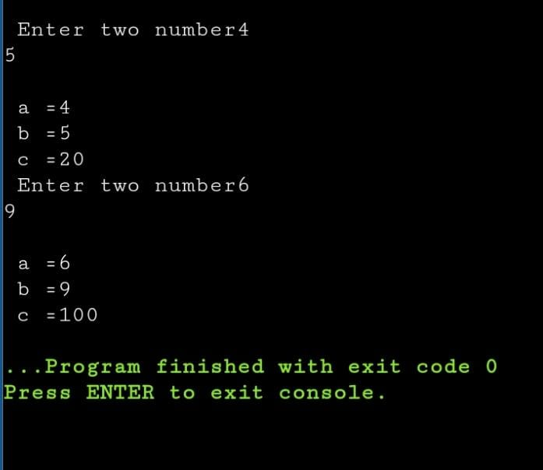

Program 2:-

#include <iostream.h>
class ABC
{
int x;
static int count;
public:
void getdata(int a);
void display();
};
int ABC::count = 0;
void ABC::getdata(int a)
{
x = a;
count ++;
}
void ABC::display()
{
std::cout << "\n x=" << x;
std::cout << "\n count=" << count;
}
int main()
{
ABC P;
P.getdata(10);
P.display();
ABC T;
T.getdata(10);
T.getdata(10);
T.display();
std::cout << "\n\n 2nd object";
ABC K;
K.getdata(9);
K.display();
P.display();
T.display();
K.display();
return 0;
}

Output:-

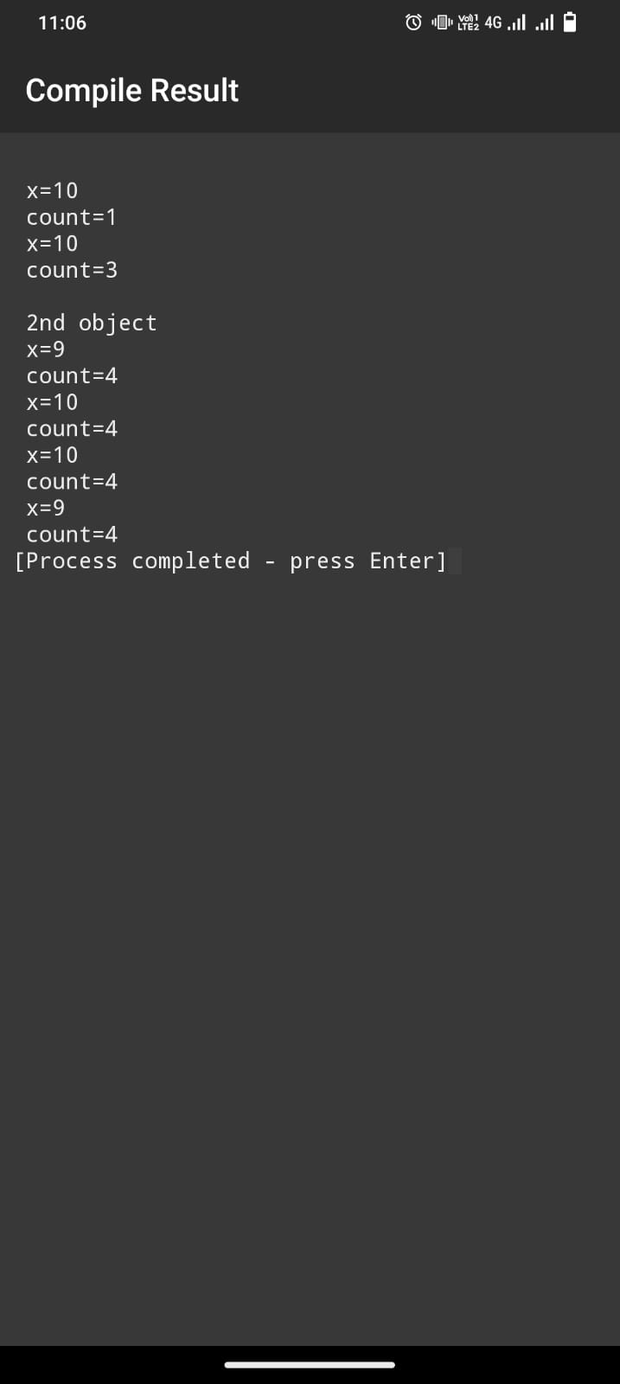

Program 3:-

#include <iostream.h>
class ABC {
int x;
static int count;
public:
void getdata(int a);
static void putdata();
void display();
};
int ABC::count = 0;
void ABC::getdata(int a) {
x = a;
count++;
}
void ABC::display() {
std::cout << "x=" << x;
}
void ABC::putdata() {
std::cout << "\n count=" << count;
}
int main() {
ABC p, q, r;
p.getdata(10);
q.getdata(20);
r.getdata(30);
p.display();
p.putdata();
q.display();
q.putdata();
r.display();
r.putdata();
return 0;
}

Output:-

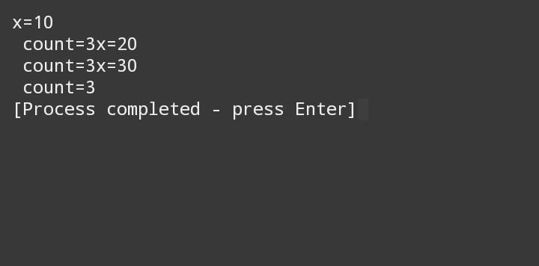

Program 4:-

#include <iostream.h>
class xyz;
class ABC {
int a;
public:
void get_a() {
std::cout << "\nEnter a number: ";
std::cin >> a;
}
friend void cal(ABC, xyz);
};
class xyz {
int x;
public:
void get_x() {
std::cout << "\nEnter a number: ";
std::cin >> x;
}
friend void cal(ABC, xyz);
};
void cal(ABC T, xyz P) {
std::cout << "\nSum = " << T.a + P.x;
}
int main() {
ABC K;
xyz R;
K.get_a();
R.get_x();
cal(K, R);
}

Output:-

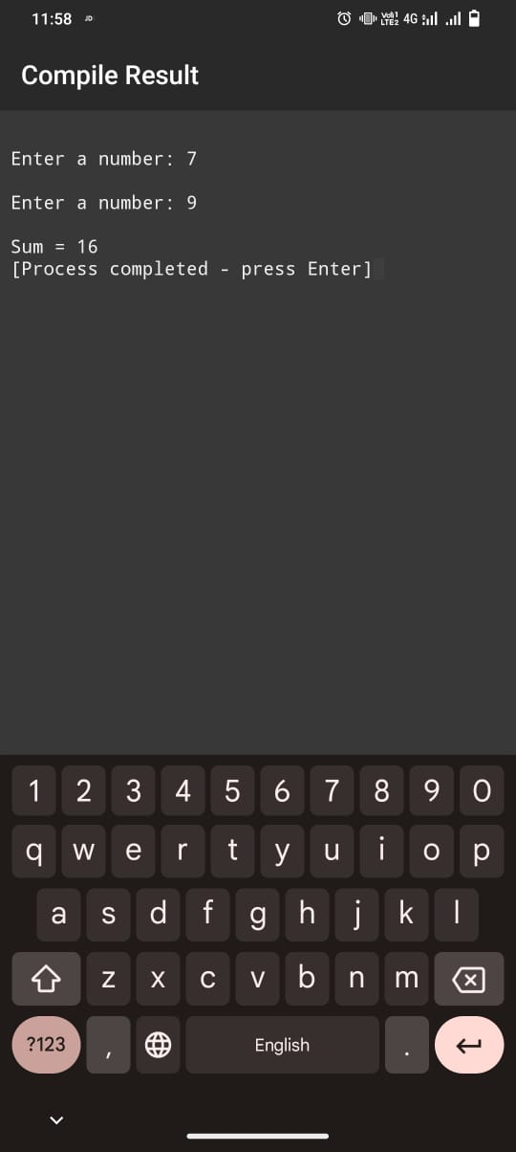

Program 5:-
#include <iostream.h>
class Time {
private:
int HH;
int MM;
int SS;

public:
void get_data() {
std::cout << "\nEnter HH:MM:SS: ";
std::cin >> HH >> MM >> SS;
}

void display() {
std::cout << "HH: " << HH << " ";
std::cout << "MM: " << MM << " ";
std::cout << "SS: " << SS << std::endl;
}
friend Time cal(Time, Time);
};
Time cal(Time p, Time q) {
Time R;
R.MM = p.MM + q.MM;
R.HH = p.HH + q.HH + (R.MM / 60);
R.MM = (R.MM % 60);
R.SS = p.SS + q.SS;
R.MM = R.MM + (R.SS / 60);
R.SS = (R.SS % 60);
return R;
}
int main() {
Time T1, T2, T3;
T1.get_data();
T2.get_data();
T3 = cal(T1, T2);

std::cout << "Time T2: ";
T2.display();

std::cout << "Time T3: ";
T3.display();

return 0;
}

Output :-

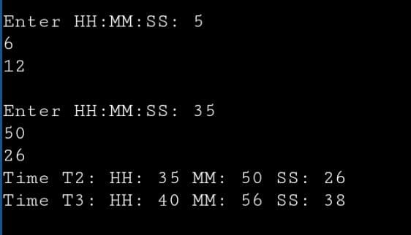

Program 6:-

#include <iostream.h>
class ABC
{
int a;
int b;
public:
ABC()
{
a = 0;
b = 30;
}
void show()
{
std::cout << "\n a=" << a;
std::cout << "\n b=" << b;
}
};
int main()
{
ABC P;
std::cout << "\n 1st object";
P.show();
ABC K;
std::cout << "\n 2nd object";
K.show();
}

Output:-

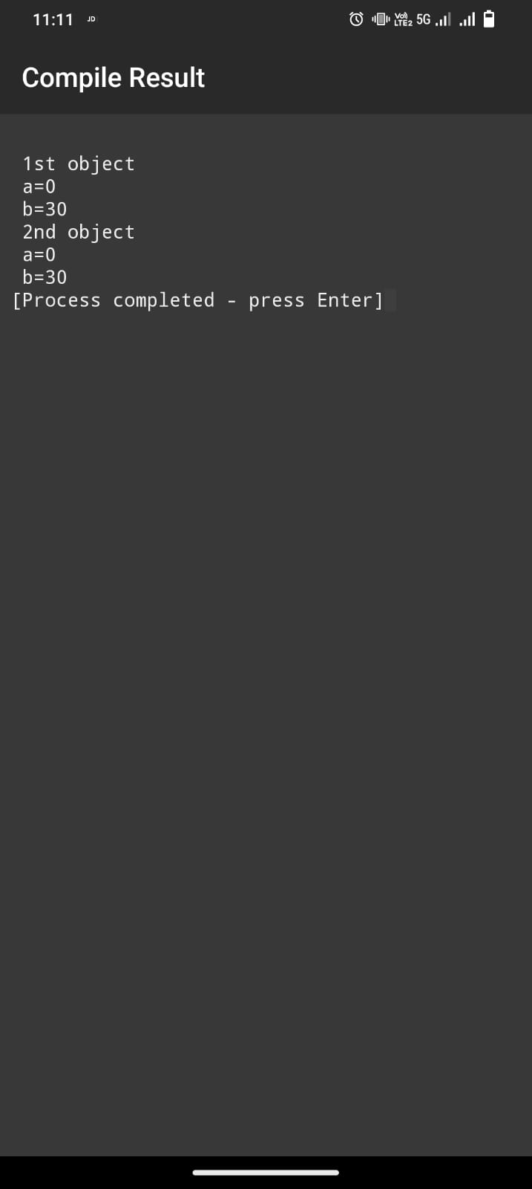

Program7:-
#include <iostream.h>
class ABC {
int a;
int b;
public:
ABC(int x, int y) {
a = x;
b = y;
}
void show() {
std::cout << "\na: " << a << "\nb: " << b << std::endl;
}
};
int main() {
ABC P(10, 20);
std::cout << "\n1st object";
P.show();
ABC K(30, 40);
std::cout << "\n2nd object";
K.show();
return 0;
}

Output:-

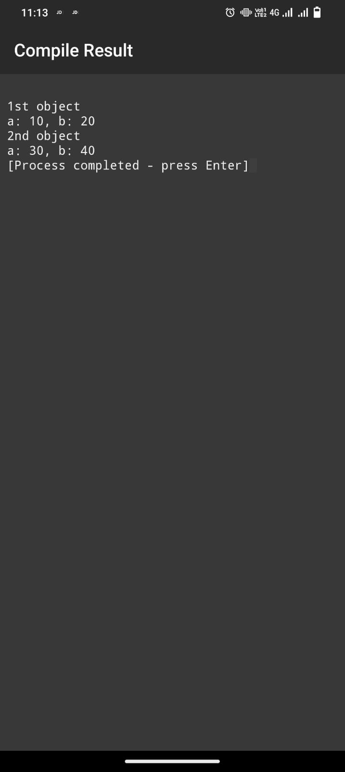

Program 8:-
#include <iostream.h>
class B
{
int x;
public:
void getval()
{
std::cout << "\nEnter a number: ";
std::cin >> x;
}
void showval()
{
std::cout << "\nx=" << x;
}
};
class P : private B
{
int y;
public:
void get_y()
{
getval();
std::cout << "\nEnter value of y: ";
std::cin >> y;
}

void put_y()
{
showval();
std::cout << "\ny=" << y;
}
};
int main()
{
P p;
p.get_y();
p.put_y();
}

Output:-

