Holy-wood Academy, Kolhapur.

**SANJEEVAN ENGINEERING AND TECHNOLOGY INSTITUTE.**

*Sanjeevan Knowledge City, Somwar Peth, Panhala, Kolhapur - 416201*

**Department of Computer Science and Engineering**

**A**

**PROJECT REPORT**

**ON**

**“*SuperMarket Billing System*”**

**Submitted in the partial fulfillment of the requirements for the award of degree of**

**T.Y.B.Tech**

**IN**

**COMPUTER SCIENCE AND ENGINEERING**

**Of**

**SUBMITTED BY**

Project Group ID:11

|  |  |  |  |
| --- | --- | --- | --- |
| **Sr. No** | **Student Name** | **Roll No.** | **PRN** |
| 1 | Digvijay Namdev Kambale | 47 | 2063151242011 |
| 2 | Samruddhi Sudhir Sasavade | 48 | 2063151242030 |
| 3 | Trupti Tanaji Sutar | 49 | 2063151242052 |
| 4 | Karan Kundalik Barale | 50 | 2163151242552 |
|  |  |  |  |

**UNDER THE GUIDANCE OF**

Prof. S.S.Kumbhar

*Department of Computer Science & Engineering*

*Sanjeevan Engineering and Technology Institute, Panhala*

**Academic Year: 2022-2023**

Holy-wood Academy, Kolhapur.

**SANJEEVAN ENGINEERING AND TECHNOLOGY INSTITUTE.**

*Sanjeevan Knowledge City, Somwar Peth, Panhala, Kolhapur - 416201*

**Department of Computer Science and Engineering**

## Certificate

This is to certify that Project entitled **“Super Market Billing System”** is a bonafied Project work carried out by:

|  |  |  |  |
| --- | --- | --- | --- |
| **Sr. No** | **Student Name** | **Roll No.** | **PRN** |
| 1 | Digvijay Namdev Kambale | 47 | 2063151242011 |
| 2 | Samruddhi Sudhir Sasavade | 48 | 2063151242030 |
| 3 | Trupti Tanaji Sutar | 49 | 2063151242052 |
| 4 | Karan Kundalik Barale | 50 | 2163151242552 |
|  |  |  |  |

in partial fulfillment of the requirements for the award of ***T.Y.B.Tech in Computer Science and Engineering*** by **Dr. Babasaheb Ambedkar Technological University, Lonere** for the academic year 2022-23. It is certified that all the corrections / suggestions indicated for internal assessment have been incorporated in the report deposited in the departmental library. The project report has been approved as it satisfies the academic requirements in respect of Mini Project work prescribed for the said Degree.

**Guide HOD Principal**

**Prof. S.S.Kumbhar Prof. R. S. Nejkar Dr. S. N. Jain**

**Name of the Examiners: External Viva Signature with Date**

**1**

**2.**

**Declaration**

We here by declare that this project work entitled “Supermarket Billing System” has been prepared by us during the year 2022 - 23 under the guidance of Prof S. S. Kumbhar , Department of Computer Science, Sanjeevan Engineering and Technology Institute, Panhala in the partial fulfilment of the T.Y. B.Tech . We also declare that this project is the outcome of our effort, that it has not been submitted to any other university for the award of any degree.

**ACKNOWLEDGEMENT**

It gives me an immense pleasure to present a report on the successful completion of our mini project work on **“Super Market Billing System”** We express our deep sense of gratitude to our guide **“Asst. prof. S.S.Kumbhar”** for his valuable guidance rendered in all phases of seminar. We are thankful of his wholehearted assistance, advice and expert guidance towards making my seminar success.

My special thanks to respected Principal and Head of the Department for their keep interest, encourage and excellent support.

|  |  |  |  |
| --- | --- | --- | --- |
| **Sr. No** | **Student Name** | **Roll No.** | **PRN** |
| 1 | Digvijay Namdev Kambale | 47 | 2063151242011 |
| 2 | Samruddhi Sudhir Sasavade | 48 | 2063151242030 |
| 3 | Trupti Tanaji Sutar | 49 | 2063151242052 |
| 4 | Karan Kundalik Barale | 50 | 2163151242552 |

**ABSTRACT**

This article is mainly about the supermarket inventory information system environment, function, the language used, the design of the program and other aspects of the content. It is mainly allow users to understand the system, so that they can use the system effectively, and allow the system to play its roles. The system uses computer management information technology, the establishment of the database, the supermarket inventory process to conduct a detailed analysis, to achieve the supermarket purchase and sales. The system mainly includes the following major modules: Key In the invoices: Shipping, Warehousing, List of finished products; Query: Query on shipping and warehousing, Query on finished products list; Sales: Sales Costs Sales Refunds/Returns; Print Report: Warehouse Report, Outbound Report; Finished Product List Report: Sales Refund Report Return/Return Report.

These includes billing system, the banking industry , customers paying system , as well as an online interface for the billing system for the paperless billing system. Paperless billing is most helpful for businesses that send recuring bills to customer. Paperless bills are an option for delivering bills. Bills could be presented as electric documents, such as pdf , or on websites. This gives the customer the ability to review bills before sending payments. Alternatally , customers can also set up atomatated payments in order to pay without even touching a button. We can shop and create bills by using the moblie application. Paperless bills of a benefits to both the seller as well as the customer. The supermarket billing system is built to help supermarkets calculate and display bills and serve the customer in a faster and efficient manner.

In present days people are facing problem in shopping, this Supermarket Billing

System project in C++ is a simple console application built without use of graphics. This

project will help us to understand basically two things- use of stream class and file handling in

C++ language. This project is simple to understand, and the source code has been presented in

an understandable manner. To make software fast in processing with the good user interface

so that user can manage and change it, this should be used for long time without error and

maintenance.

This project is a traditional supermarket billing system with some added functionality.

This system is built for fast data processing and bill generation for supermarket customers. The

billing system consists of C++ and file handling concepts. The billing database is a vast

collection of product name, price and other product specific data. A product when billed is

searched from the database and its price is added to the bill based upon the product quantity.

The system also contains discounted price while billing. The supermarket billing system is built

to help supermarkets calculate and display bills and serve the customer in a faster and efficient

manner.

In present days people are facing problem in shopping, this Supermarket Billing

System project in C++ is a simple console application built without use of graphics. This

project will help us to understand basically two things- use of stream class and file handling in

C++ language. This project is simple to understand, and the source code has been presented in

an understandable manner. To make software fast in processing with the good user interface

so that user can manage and change it, this should be used for long time without error and

maintenance.

This project is a traditional supermarket billing system with some added functionality.

This system is built for fast data processing and bill generation for supermarket customers. The

billing system consists of C++ and file handling concepts. The billing database is a vast

collection of product name, price and other product specific data. A product when billed is

searched from the database and its price is added to the bill based upon the product quantity.

The system also contains discounted price while billing. The supermarket billing system is built

to help supermarkets calculate and display bills and serve the customer in a faster and efficient

manner.

In present days people are facing problem in shopping, this Supermarket Billing

System project in C++ is a simple console application built without use of graphics. This

project will help us to understand basically two things- use of stream class and file handling in

C++ language. This project is simple to understand, and the source code has been presented in

an understandable manner. To make software fast in processing with the good user interface

so that user can manage and change it, this should be used for long time without error and

maintenance.

This project is a traditional supermarket billing system with some added functionality.

This system is built for fast data processing and bill generation for supermarket customers. The

billing system consists of C++ and file handling concepts. The billing database is a vast

collection of product name, price and other product specific data. A product when billed is

searched from the database and its price is added to the bill based upon the product quantity.

The system also contains discounted price while billing. The supermarket billing system is built

to help supermarkets calculate and display bills and serve the customer in a faster and efficient

manner.

In present days people are facing problem in shopping, this Supermarket Billing

System project in C++ is a simple console application built without use of graphics. This

project will help us to understand basically two things- use of stream class and file handling in

C++ language. This project is simple to understand, and the source code has been presented in

an understandable manner. To make software fast in processing with the good user interface

so that user can manage and change it, this should be used for long time without error and

maintenance.

This project is a traditional supermarket billing system with some added functionality.

This system is built for fast data processing and bill generation for supermarket customers. The

billing system consists of C++ and file handling concepts. The billing database is a vast

collection of product name, price and other product specific data. A product when billed is

searched from the database and its price is added to the bill based upon the product quantity.

The system also contains discounted price while billing. The supermarket billing system is built

to help supermarkets calculate and display bills and serve the customer in a faster and efficient

manner.

In present days people are facing problem in shopping, this Supermarket Billing

System project in C++ is a simple console application built without use of graphics. This

project will help us to understand basically two things- use of stream class and file handling in

C++ language. This project is simple to understand, and the source code has been presented in

an understandable manner. To make software fast in processing with the good user interface

so that user can manage and change it, this should be used for long time without error and

maintenance.

This project is a traditional supermarket billing system with some added functionality.

This system is built for fast data processing and bill generation for supermarket customers. The

billing system consists of C++ and file handling concepts. The billing database is a vast

collection of product name, price and other product specific data. A product when billed is

searched from the database and its price is added to the bill based upon the product quantity.

The system also contains discounted price while billing. The supermarket billing system is built

to help supermarkets calculate and display bills and serve the customer in a faster and efficient

manner.

**INDEX**

|  |  |  |
| --- | --- | --- |
| **CHAPTER**  **NO** | **CONTENT** | **PAGE**  **NO** |
| **1** | **Introduction** | 7 |
| **2** | **Problem Statement**  2.1 Literature Survey  2.2 Problem Definition  2.3 Objective  2.4 Scope of study | 8-10 |
| **3** | **System Design and Requirement Specification Analysis** 3.1 System Architecture  3.2 Use Case Diagrams  3.3 Data Flow Diagram  3.4 System Requirements | 11-13 |
| **4** | **Implementation**  4.1 Implementation Modules Description  4.2 Software Platforms, Languages & Tools Used  4.3 Algorithms Used | 14-15 |
| **5** | **Testing** | 16 |
| **6** | **Snapshots** | 17-19 |
| **7** | **Conclusion & Future Work** | 20 |
|  | **References** | 21 |

**1.Introduction**

This project is based on the sales transaction and billing of items in a supermarket. The first activity is based on adding the items to the system along with the rate which are present in the supermarket and the name of the items which the supermarket will agree to sell. This authority is given only to admin (administrator). Any modifications to be done in the item name and the rate can be done only by admin. He also has the right to delete any item. As the customer buys the products and comes to the billing counter, the user is supposed to enter the item name he purchased and the quantity of the item he had purchased. This is not a huge a task.

This study is to produce software which manages the sales activity done in a supermarket, maintaining the stock details, maintaining the records of the sales done for a particular month/year. The users will consume less time in calculation and the sales activity will be completed within a fraction of seconds whereas manual system will make the user to write it down which is a long procedure and so paper work will be reduced and the user can spend more time on the monitoring the supermarket. The project will be user friendly and easy to use.

**1.1 Account Configuration:**

* **Employee:** When a new employee joins the company, his record is saved in the database.
* Items**:** Here the Admin can add any new items present in the supermarket. He also has the right to modify or delete it from the database.
* **Registration:** As soon as the employee joins the company, the admin provides unique username and password to him.
* **Vendor Order:** If the stock is not available, the supermarket orders and buys from a prescribed vendor. The amount will be paid by deducting the total amount acquired in the sales activity.
* **Stock entry:** The items bought from the vendor will be entered here and this will be added to the stock.
* **Indent Report:** This provides the report of the items sold for a particular month/year and also gives the total amount acquired.
* **Vendor Report:** This provides theveport of the items bought from a vendor for particular month year and also gives the total amount spent.
* **Display:** A user can view information regarding hems present in the supermarket.

**2 .Proble statement**

**2.1 Literature Survey:**

* **Design and implementation of supermarket billing system, Yixin Lu, Aimin Du:** This project is based on sales transactions and billing of items in a supermarket. This study is to produce software which manages the sales activity done in a supermarket, maintaining the stock details, maintaining the records of the sales done for a particular month/year.
* **Smart supermarket billing system using python, Prof. S. R. Patil:** This study is to produce software which manages sales activity done in a supermarket. In this survey all billing cosepts are explained as well as by using the python programming cosepts are explained in this paper.
* **Management Information System, Honglei Bian** : This supermarket management system has realized the transmission and control of large goods. In this paper.In this paper inform the information of the small and medium sized supermarket management techaniques and management system

**2.2 Problem Defination:**

Being a Computer Technology student we had to go into the business department to learn some basic sales and supermarket management topics to increase our intellectual understanding on the project at hand it was really tasking Building a standard Supermarket management system was not an easy task looking at the problems of existing manual system.

The factors for these difficulties are:

* **Time Consumption:** Manual systems are time consuming, as the business owner must keep track of Supermarket sales on a daily basis, while updating the system manually at the end of the day.
* **Poor Communication:** A manual Supermarket system requires employees and managers to write down cach time an item is removed from the Supermarket. If one employee forgets to mention that the last coffee product has been removed from the Supermarket, a manager expects the item to still be available for a customer during a sale. Compared with a technical Supermarket system, a manual Supermarket system does not help the communication in the workplace.
* **Physical Counts:** A manual Supermarket system does not provide any number, as all numbers from the Supermarket are gained through physical Supermarket counts. One of the difficulties of running a manual Supermarket system is that physical Supermarket counts must be performed frequently to cool the items in the Supermarket. This is time consuming and can cost the business money, if employees must come in to help out outside of business hours.
* **Daily Purchases:** Keeping track of daily purchases is another difficult controlling measure with manual Supermarket systems. A manaal Supermarket system requires the employees to write down the items sold during a single work day. This can be a difficult task, as one employee may lose the list of items sold or another may forget to write down a sale.
* **Ordering Supplies:** A manual Supermarket system does not update at the end of the day with updated Supermarket

**2.3 Objective**

The main objective of the project is to make software fat in processing and it should be used or a long time without error and maintenance. Provides a convinent solution of billing pattern and make an easy to use environment for users and customers,

* **Automation-** The application automates each and every activity of the manual system and increases its throughput. Thus, the response time of the system is very less and it works very fast.
* **Accuracy-** The application provides the user a quick response with very accurate information regarding the bill calculation and customer detail etc. any details or system in an accurate manner, as when required.
* **User Friendly-** The application Supermarket Billing System has a very usre friendly interface. Thus, the users will fully very easy to work on it. The application provide accuracy along with a pleasant interface. Make the present manual system more interactive, speedy and user friendly.
* **Availability-**All the Billing details stored permanently in the database admin can see the data, whatever needed.
* **Maintain Cost-** Reduce the cost of maintenance. It is standalone application so no reqire of cost for maintain it.

**2.4 Scoop of the study**

Scope is more at certain area where billing is required and it also avoid the fake dealers. Easy to maintain in future prospect. It provides quick way of operation by capturing the manual process and automating them. This project is helpful to computerize the item transaction, sales activity record keeping wich is very huge task and maintaining the stock .

This project will help the admin to

* Calculate the bill.
* Give the bill to the customer.
* Store how many products are sold.
* Store products and their prices and with other information.
* See the rates of discounts on the products.

**3. System Design and Requirement Specification Analysis**

**3.1 System Architecture**

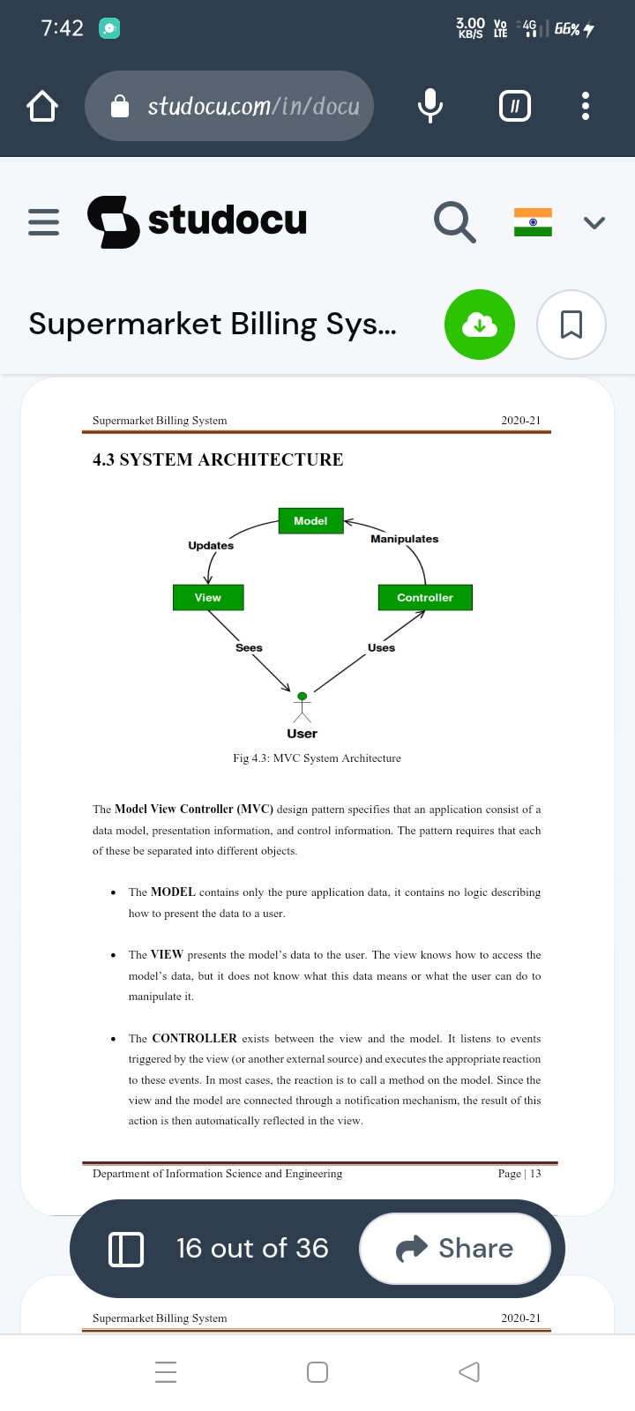

Fig 1: MCV System Architechuire

The Model View Controller(MCV) design patterns specifies that an application consist of a data model, presentation information, and control information. The pattern requires that each of these be separated into different objects.

* The **Model** contains only the pure appkication data, it contains no logic describing how to present the data to a user
* The **VIEW** presents the model’s data to the user. The view knows how to access the model’s data, but it does not know what this data means or what the user can do to manipulate it.
* The **CONTROLLER** exists between the view and the model. It listens to events triggered by the view(or another external source) and executes the appropriate reaction to these events. In most case, the reaction is to call a method on the model. Since the View and the model are connected through a notification mechanism, the result of this action is then automatically reflected in the view.

**3.2 Use Case Diagrams:**

Use case diagram is a graph of actors ,a hard and fast istances enclosed by means of a deviceboundary, conversation associations among the actor and the use case. The use case diagram describes how a gadget interacts with out of doors actors; each use case represents a bit of functionality that a machine provides to its users. The use instances are used at some point of the evaluation phase of a task to pick out and partition systemcapability. They separate the device into actor and use case.Actors represent roles which might be played by using person of the system. Those users may be people, different computer systems, portions of hardware, or may =be other software strutures.

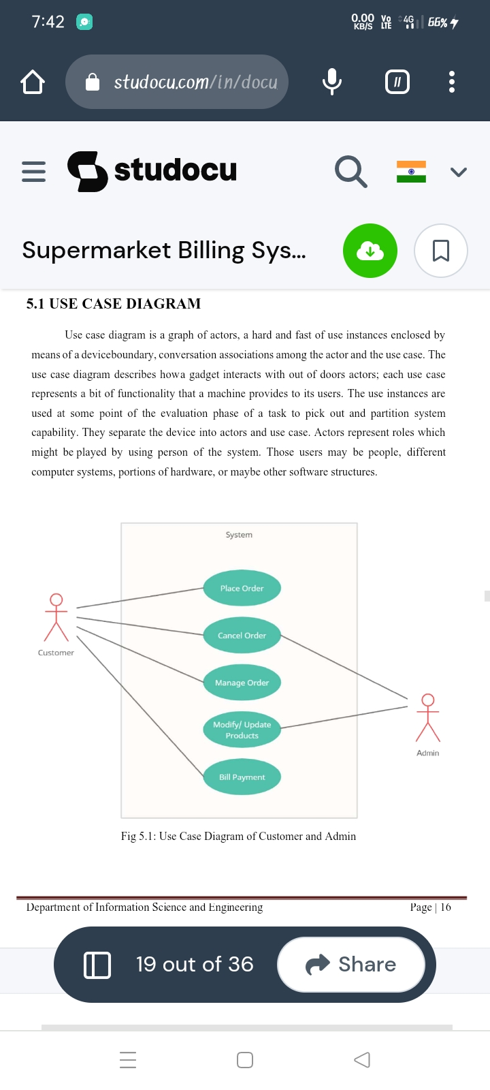

Fig 2: Use Case Diagram for customer and admin

**3.3 Data flow Diagram**

data flow diagram(DFD) maps out the flow of information for any process or system to show data inputs, outputs, storage points and routes between each destination

**3.3.1 Low Level Data Flow Diagram**

The Low Level Data Flow Diagram (DFD) is the basic overview of the of the Supermarket Billing System or process being analysed or modelled. It is designed to be an at a glance view of payment, products, rate of discount showing the system as a single high- level process, with its relationship to external entities of inventory, custyomer and purchasing.

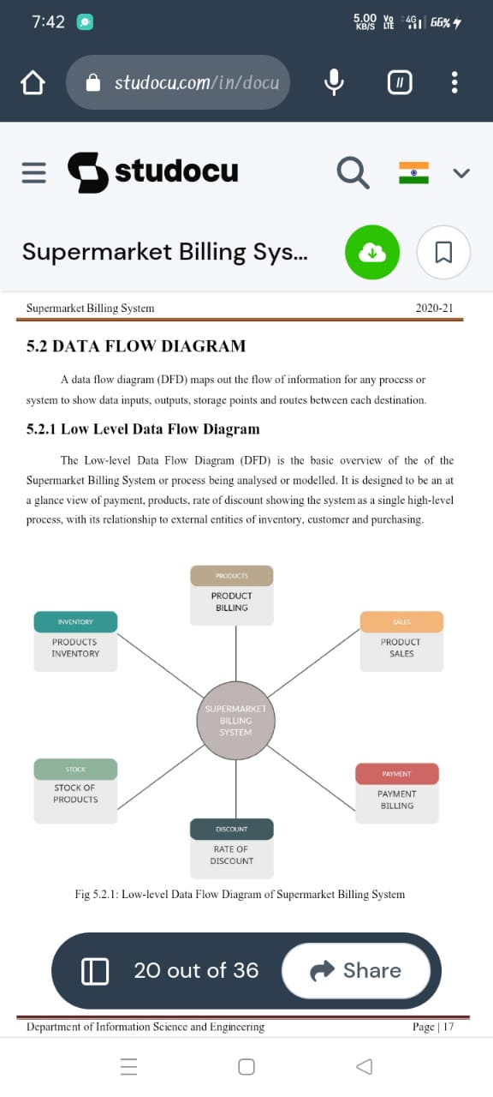

Fig 3: Low level data flow diagram of supermarket billing system

**4. Implementation**

**4.1 Implementation Modules Description**

This Project is based on the sales transaction and billing of items in a supermarket. The first activitry is based on adding the items to the system along with the rate which are presemt in the supermarket and the name of the items which the supermarket will agree to sell. The models provide four basic types of functionality , that is , create, read, update, and delete the resources. This is oftenreferred to as CRUD by computer scientists. A model should have the ability to perform all these foue functions in order to be complete. If an action cannot be described by one of these four operations, then it should be contained in a model of its own. The CRUD paradigm is commonly used to construct web applications, as it provides a memorable framework for reminding developers of how to construct complete, usable models.

We use python to build the functionality of the application and graphics user interface(GUI). We make use of different libraries of python, like TKinter, asyncio, turtle to build the application.

**4.2 Software Platforms, Languages & Tools Used**

This Section Describe the software and hardware requirements of the system

* **Operating System:-**Window 11 used as the operating system as it is stable and supports more features and is more user friendly.
* **Programming Language:-** Python is used to write the whole code.
* **Software:-** VS code.

**VS Code:-**

Visual Studio Code is a free source code editor that fully supports Python and useful features such as real-time collaboration. Professor Dodds also utilizes the built-in terminal heavily in his class as an introduction to running programs from the command line and navigating around their machine all within Visual Studio Code. He appreciates how "the built-in terminal panel does not try to automate too much (which, if it did, would deprive newcomers of the experience of the information-flow that's going on)." "Visual Studio Code is the best balance of authenticity and accessibility... Visual Studio Code doesn't feel 'fake', it's what real software developers use. Plus, Visual Studio Code works on every OS!" VS Code runs on Windows, macOS, Linux, and even Chromebooks.

**4.2.1 Python**

The language of select for this project was Python. This was a straightforward call for many reasons.

* Python as a language has a vast community behind it. Any problems which may be faced is simply resolved with visit to Stack Overflow. Python is the foremost standard language on the positioning that makes it is very straight answer to any question.
* Python is an abundance of powerful tools ready for scientific computing Packages. The packages like NumPy, Pandas and sklearn area unit freely available and well documented. These Packages will intensely scale back, and variation the code necessary to write a given program. This makes repetition fast.
* Python is a language as forgiving and permits for the program that appear as if pseudo code. This can be helpful once pseudo code give in tutorial papers should be required and verified. Using python this step is sometimes fairly trivial.

However, Python is not without its errors. The python is dynamically written language and packages are area unit infamous for Duck writing. This may be frustrating once a package technique returns one thing that, for instance, looks like an array instead of being an actual array. Plus, the standard Python documentation did not clearly state the return type of a method, this can’t lead without a lot of trials and error testing otherwise happen in a powerfully written language. This is a problem that produces learning to use a replacement Python package or library more difficult than it otherwise may be.

**4.2.2.Python Libraries:**

* **Tkinte**r: This framework provides Python users with a simple way to create GUI elements using the widgets found in the Tk toolkit.
* **NumPy:** NumPy can be used to perform a wide variety of mathematical operations on arrays.
* **Pandas:** Pandas offers various data structure and operations for manipulating numerical data and time series.
* **Matplotlib:** Matplotlib is a cross-platform, data visualization and graphical plotting library for Python and its numerical extension NumPy.
* **Sklearn:** It provides a selection of efficient tools for machine learning and statistical modeling including classification, regression, clustering and dimensionality reduction via a consistence interface in Python.
* **Yahoo_fin:** Yahoo_fin is a Python 3 package designed to scrape historical stock price data, as well as to provide current information on market caps, dividend yields, and which stocks comprise the major exchanges.
* **Yfinance**: The yfinance is one of the famous modules in Python, which is used to collect online data, and with it, we can collect the financial data of Yahoo.
* **Datetime:** Python Datetime module supplies classes to work with date and time. These classes provide a number of functions to deal with dates, times and time intervals

**5.Testing:s**

**Test Case:**

Test cases for supermarket billing system:

* To check whether all the product name is displaying or not.
* To check whether all the product price is entered.
* To check when the user enters the first letter of the product name itself it must display the products list starting with that letter.
* To check whether the product cannot entered without quantity.
* To check when the user gives the quantity immediately it must multiply with cost price and must display the result.
* To check whether at last it must display the total cost of bill.
* To check each product must show its cost price.

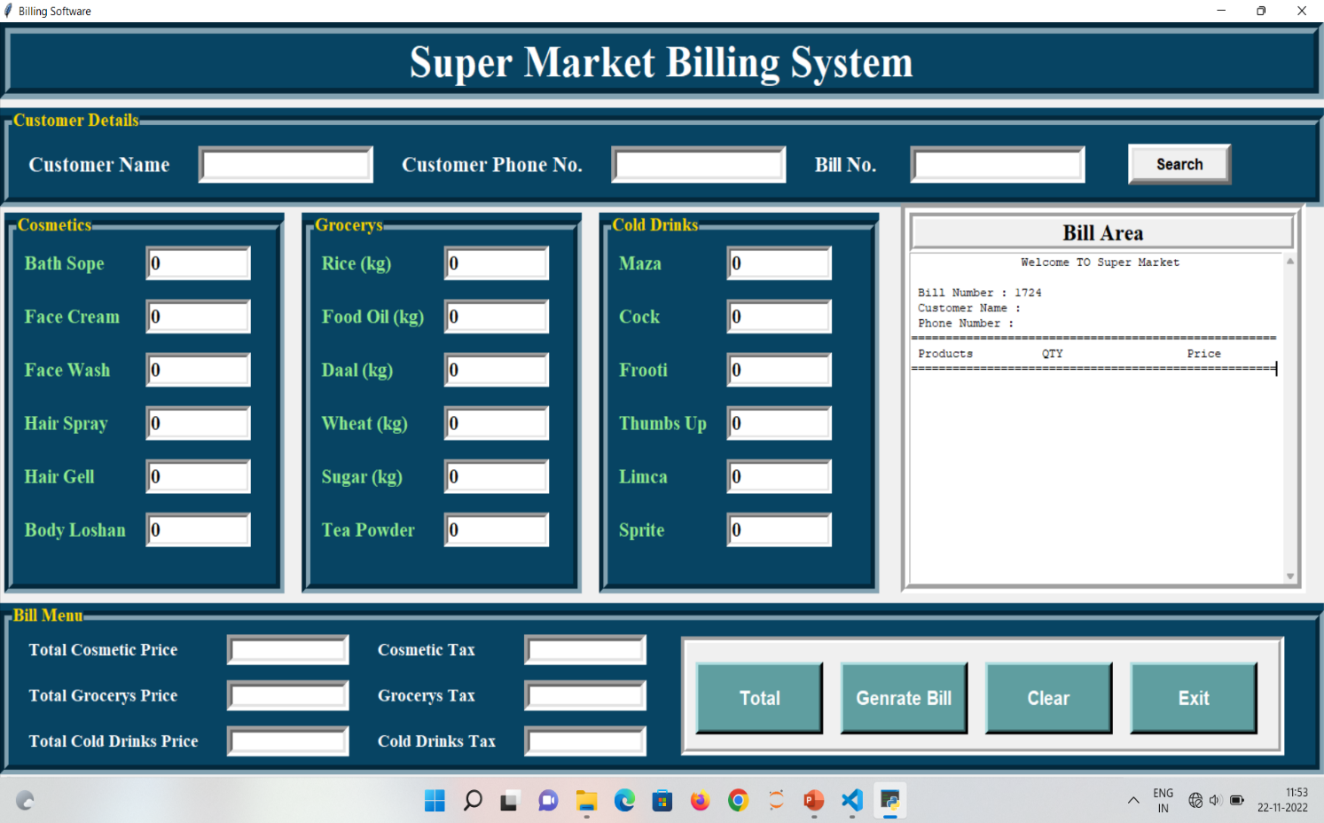**6. Snapshoots**

img 1 : Home Page

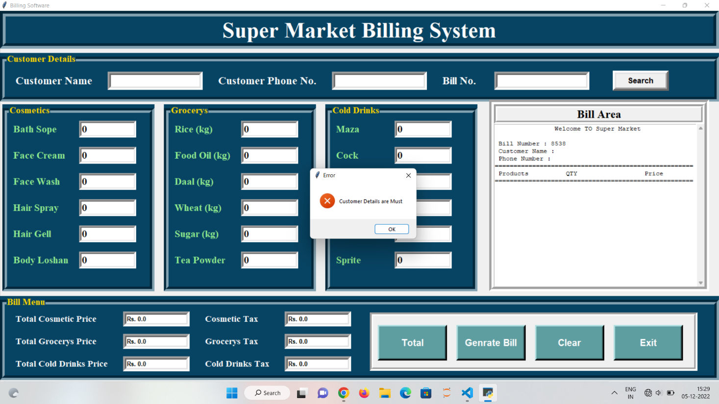

img 2 : Customer Details are Must

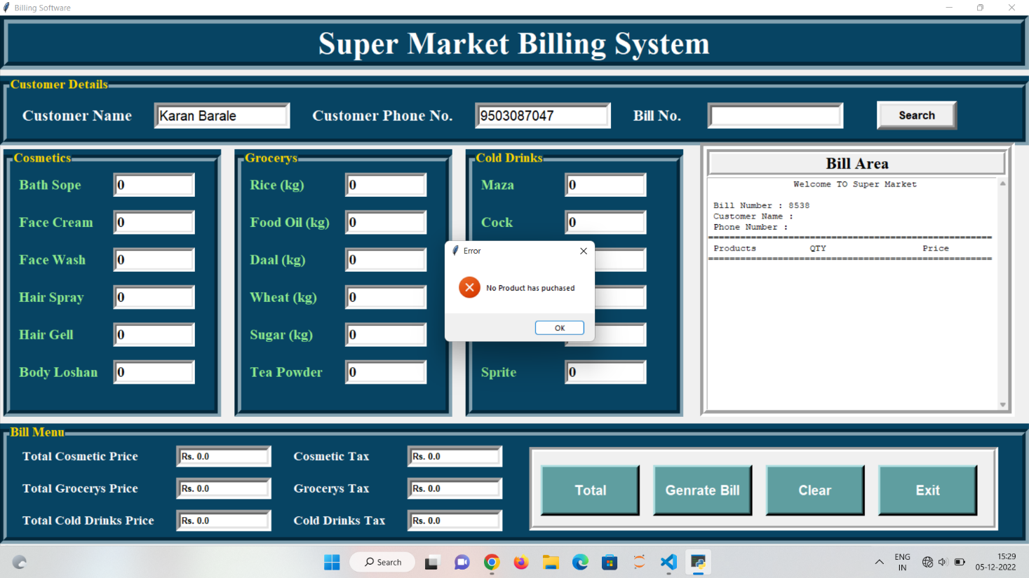

3 : No products has puechased

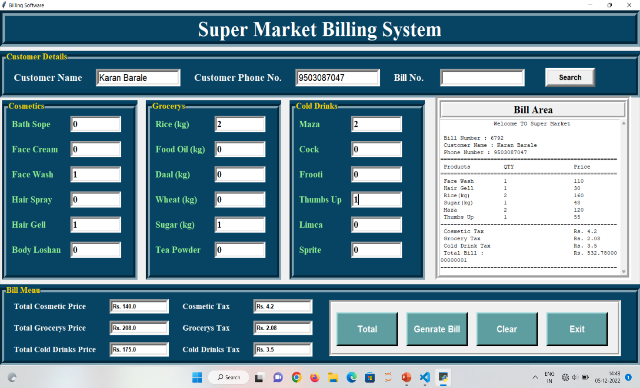

img 4 : Generate Bill Page

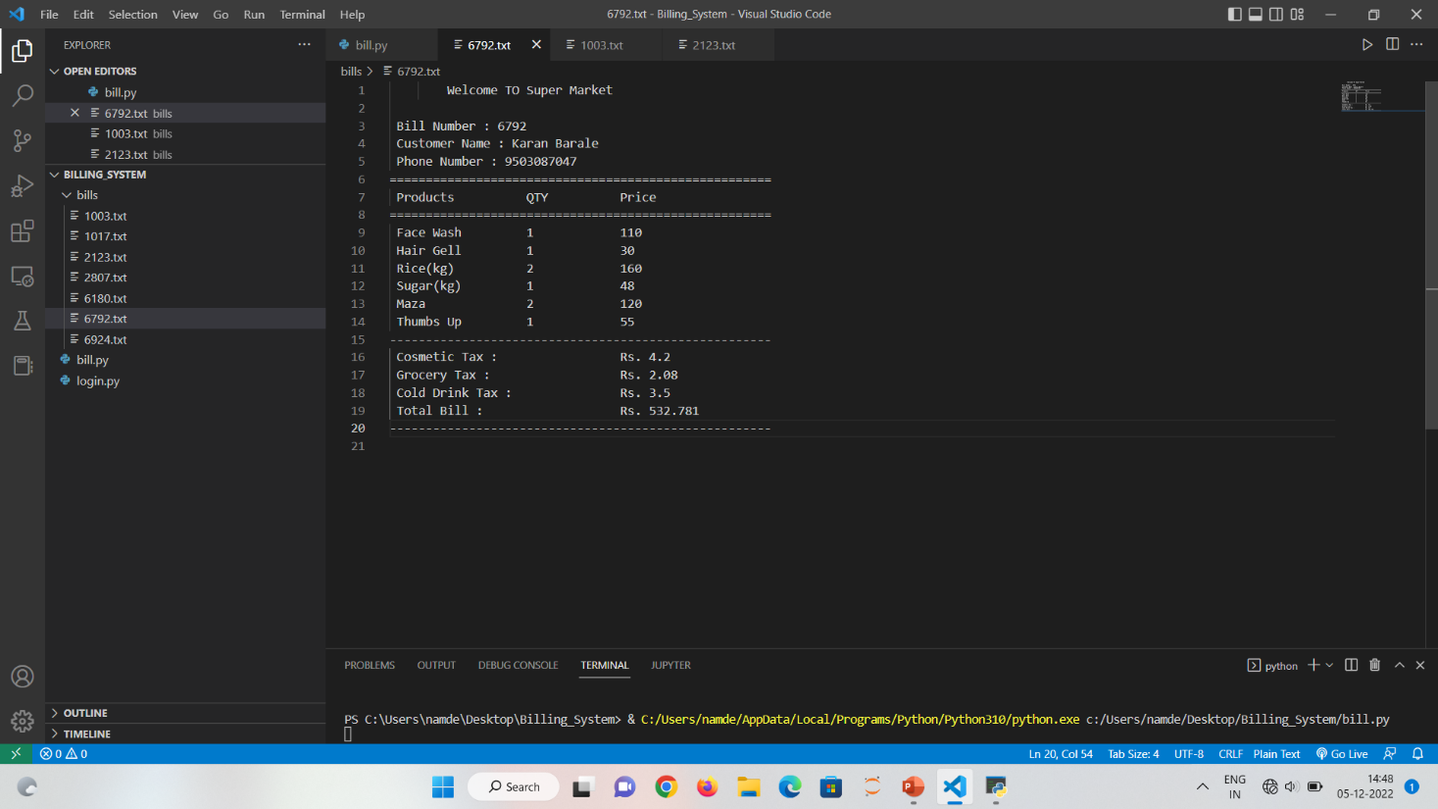

img 5: Save Bill Page

**7. Conclusion and Future Work**

Supermarket Management System has to do with making appropriate effort to stop the rising problem to all manual supermarket operation in order to enhance the operation of such supermarket. In this project, the software or system that can be used to aid all supermarkets that is still operating manually have been successfully developed. The software can be implementing in all types of supermarket as mentioned in the second chapter. The software has a large memory of storing all the goods in the supermarket and also keeping record it is highly effective and accurate.

We have Demonstrated a method which makes the billing of goods in efficient, eaiser and fast way. Existing system makes use of hardware barcode scanners on billing counters results in a long queie. Many reserchers proposed methods to overcome this problem but there is a lack of efficiency and realistic in their work so we have proposed better method along with simulation and hardware results so as to check the behaviour in our approach in the real world. Althogh we have observed good results .

**References:**

[1]sha shixuan, wang shan. introduction to the database system. beijing: university education press, 1985.60-65

[2] smart supermarket billing system using python. international journal of advance scientific research & engineering april 2021 .

[3]Management information system, Lanzhou university press, 2001.70-80