Manufacturing Machine
Failure-Type Prediction
Multi-class classification of machine failure modes on the UCI AI4I 2020 Predictive Maintenance Dataset
Final Project Report — Machine Learning
Submitted by: Chanakya
September 2026
All results in this report were produced by the accompanying code and can be reproduced with “python run_pipeline.py”.

Abstract
Predictive maintenance aims to detect developing machine failures from operating data before they stop production. This project goes beyond predicting whether a machine fails and predicts which failure mode occurs — tool wear (TWF), heat dissipation (HDF), power (PWF) or overstrain (OSF) failure — or that no failure occurs. Using the UCI AI4I 2020 Predictive Maintenance Dataset (10,000 records), a five-class target was constructed from the dataset's failure flags; 50 records (0.5%) with contradictory, unknown or multiple failure labels were excluded and logged. Three physically motivated features — process–air temperature difference, mechanical power, and tool-wear × torque strain — raised the mean cross-validated Macro F1 of two reference models from 0.684 to 0.791.
A most-frequent-class baseline, Logistic Regression, Random Forest, XGBoost, CatBoost and a stacking ensemble were tuned with stratified 5-fold cross-validation on the training split using Macro F1, the primary metric for this heavily imbalanced problem (96.9% of records are "No Failure"). XGBoost achieved the highest cross-validated Macro F1 (0.7956 ± 0.0294) and was selected by this pre-defined rule. On the untouched test set it reached Macro F1 0.7750, accuracy 0.9894 and macro One-vs-Rest ROC-AUC 0.9873. HDF, OSF and PWF were predicted with F1 between 0.866 and 0.937; tool-wear failure remained hard to predict (F1 0.142) because its records overlap almost completely with non-failing records at the same tool wear. SHAP analysis showed each failure mode is driven by its physically expected quantity. The selected pipeline was saved with Joblib and deployed as a validated Streamlit application.
Keywords: predictive maintenance, multi-class classification, class imbalance, Macro F1, Random Forest, XGBoost, CatBoost, stacking, SHAP, Streamlit.

Table of Contents

If page numbers are not shown, right-click the table and choose Update Field.

1. Introduction
Machining equipment degrades through tool wear, thermal load and mechanical stress. Unplanned failures stop production, scrap workpieces and damage tools; purely time-based maintenance, on the other hand, replaces parts that still have useful life. Predictive maintenance uses sensor data to decide when intervention is actually needed.
Most introductory work on the AI4I 2020 dataset treats the problem as binary: failure or no failure. That answer is only partly actionable, because each failure mode calls for a different response. This project therefore frames the task as multi-class classification of the failure mode, and follows a complete, leakage-free machine-learning workflow from data understanding to a deployed application.

2. Problem Statement
Given one machine's operating snapshot — product quality variant and five sensor readings — predict which failure mode, if any, the snapshot corresponds to.
Formal objective. Let X = (Type, T_air, T_process, rotational speed, torque, tool wear) and Y ∈ {No Failure, TWF, HDF, PWF, OSF}. Learn Failure Type = f(X) from labelled training pairs, choosing f to maximise the macro-averaged F1-score on data not used for training. The model also outputs P(Y = k | X) for every class k.
Table 1. Why the failure type matters: each mode implies a different action.
Failure mode | Code | Typical maintenance response
Tool Wear Failure | TWF | Replace the tool
Heat Dissipation Failure | HDF | Check cooling, reduce thermal load
Power Failure | PWF | Move the speed–torque operating point
Overstrain Failure | OSF | Reduce load relative to tool wear and product grade

Classification type: supervised, multi-class (five classes), heavily imbalanced. Primary metric: Macro F1.

3. Objectives
- Construct a valid multi-class target from the raw failure flags without silently discarding data.
- Build a reproducible, leakage-free preprocessing and feature-engineering pipeline shared by training and deployment.
- Test whether physically motivated engineered features improve classification.
- Train and tune a baseline, Random Forest (bagging), XGBoost (boosting), CatBoost (advanced boosting) and a stacking ensemble with stratified cross-validation.
- Evaluate every model on an untouched test set with Macro F1, per-class metrics, confusion matrices and One-vs-Rest ROC-AUC.
- Explain misclassifications and interpret the final model with permutation importance and SHAP.
- Deploy the final pipeline in a Streamlit application with input validation, and cover the code with automated tests.
Success criteria (set before modelling; no numeric targets were fixed in advance): every failure class is reported separately; the model clearly beats the baseline on Macro F1; test performance is consistent with cross-validation; and the saved pipeline reproduces its in-memory predictions inside the app.

4. Dataset Description
The AI4I 2020 Predictive Maintenance Dataset (UCI Machine Learning Repository, id 601) is a synthetic dataset designed to reflect real milling-machine data [1, 2]. The file used here has SHA-256 checksum dc6630cd9b1f0f85…; it contains 10,000 rows and 14 columns, no missing values, no duplicate rows, and no duplicate feature vectors.
Table 2. Feature dictionary and inclusion decision.
Column | Role | Type | Used as model input
UDI | Row identifier (1…10000) | int | No — no physical meaning
Product ID | Serial number, unique per row | text | No — cannot generalise; first letter = Type
Type | Quality variant L / M / H | categorical | Yes
Air temperature [K] | Sensor | float | Yes
Process temperature [K] | Sensor | float | Yes
Rotational speed [rpm] | Sensor | int | Yes
Torque [Nm] | Sensor | float | Yes
Tool wear [min] | Sensor | int | Yes
Machine failure | Binary failure indicator | 0/1 | No — summarises the target (leakage)
TWF, HDF, PWF, OSF, RNF | Failure-mode flags | 0/1 | No — used only to build the target

Table 3. Statistical summary of the numerical features (all 10,000 rows).
Feature | Mean | Std | Min | 25% | Median | 75% | Max | Skew
Air temperature [K] | 300.005 | 2.0 | 295.3 | 298.3 | 300.1 | 301.5 | 304.5 | 0.114
Process temperature [K] | 310.006 | 1.484 | 305.7 | 308.8 | 310.1 | 311.1 | 313.8 | 0.015
Rotational speed [rpm] | 1538.776 | 179.284 | 1168.0 | 1423.0 | 1503.0 | 1612.0 | 2886.0 | 1.993
Torque [Nm] | 39.987 | 9.969 | 3.8 | 33.2 | 40.1 | 46.8 | 76.6 | -0.01
Tool wear [min] | 107.951 | 63.654 | 0.0 | 53.0 | 108.0 | 162.0 | 253.0 | 0.027

Target construction. The file has no single failure-type column: failures are recorded as a binary Machine failure flag plus five mode flags that can overlap. A five-class target was built from the four predictable modes. Random failure (RNF) is not a target class, because the dataset documentation describes it as independent of the process parameters and 18 of its 19 records contradict Machine failure = 0. Records that cannot be mapped to exactly one class were excluded and each is logged with its reason.
Table 4. Records excluded during target construction (0.5% of the data).
Excluded because | Rows
Multiple failure modes: no single class | 23
Contradictory labels: RNF=1 but Machine failure=0 | 18
Failure type unknown: Machine failure=1 with no mode flag | 9

Table 5. Final five-class target distribution (9,950 records).
Class | Records | Share (%)
No Failure | 9643 | 96.91
TWF | 43 | 0.43
HDF | 106 | 1.07
PWF | 80 | 0.8
OSF | 78 | 0.78

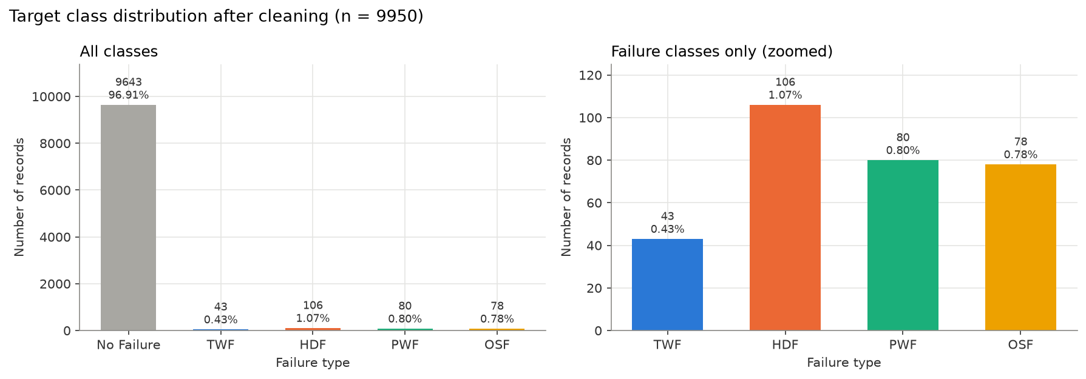
Figure 1. Target class distribution after cleaning; the right panel zooms in on the four failure classes.

5. Literature and Background
Dataset. Matzka [1] introduced AI4I 2020 as a benchmark for explainable predictive maintenance. Its failure modes are generated from physical conditions — tool wear, heat dissipation, power and overstrain — which makes it well suited to testing whether a model recovers physically sensible rules.
Bagging. A Random Forest [3] trains many decorrelated decision trees on bootstrap samples with random feature subsets and averages their votes, reducing variance without greatly increasing bias.
Boosting. Gradient boosting builds trees sequentially, each correcting the errors of the ensemble so far. XGBoost [4] adds regularisation, second-order optimisation and efficient histogram-based split finding.
Advanced boosting. CatBoost [5] uses ordered boosting, which computes each example's gradient from a model that has not seen that example, reducing the prediction shift that causes overfitting in standard boosting; it also grows symmetric (oblivious) trees that act as a strong regulariser and are fast to evaluate.
Stacking. Stacked generalisation [6] trains a meta-learner on the predictions of several base models. Using out-of-fold predictions prevents the meta-learner from learning on predictions that were made for rows the base models were trained on.
Imbalanced evaluation. When one class dominates, accuracy rewards ignoring the minority classes. Macro F1 — the unweighted mean of per-class F1 — gives each class equal weight and is therefore the standard choice for imbalanced multi-class problems. Interpretation. SHAP [7] attributes each prediction to its input features using Shapley values; TreeSHAP computes them exactly for tree ensembles.

6. Methodology
The workflow was designed so that no information from the test set influences any decision. The raw data were cleaned row by row (no cross-row statistics), then split once into a stratified 80% training and 20% test set with random_state = 42. Every later decision — feature-set choice, hyperparameters and final-model selection — used stratified 5-fold cross-validation on the training split only. The test set was read once, in the final evaluation.
- Stage 2–3: load and inspect the data; build the target; validity, duplicate and outlier checks.
- Stage 4: exploratory data analysis (descriptive only).
- Stage 5–6: stratified split; compare feature sets with 5-fold CV on the training split.
- Stage 7–12: baseline, Random Forest, XGBoost, CatBoost and stacking, each tuned with StratifiedKFold(5, shuffle=True, random_state=42) and scoring = f1_macro.
- Stage 13–17: evaluate all tuned models on the test set; select the final model by the pre-defined rule; interpret it; save it.
- Stage 18–19: Streamlit deployment and automated tests.
Feature engineering and preprocessing are steps inside a single scikit-learn Pipeline (FeatureEngineer → ColumnTransformer → classifier), so they are refitted within each cross-validation fold and are saved together with the model for deployment.
Final-model selection rule (fixed in advance): the model with the highest mean cross-validated Macro F1 on the training split. Test scores are reported for every model but are not used for selection.

7. Data Preprocessing

7.1 Missing values, duplicates and invalid values
There are no missing values and no duplicate rows (also none when identifiers are ignored), so no imputation or de-duplication was needed. Loose physical plausibility checks (e.g. temperatures between 250 and 450 K, non-negative torque and tool wear, process temperature above air temperature, Type ∈ {L, M, H}) found no invalid values. The minimum process–air temperature difference is 7.6 K.

7.2 Data types and encoding
Numerical sensor columns are cast to float. Type is one-hot encoded with a fixed category list [L, M, H], so the encoded columns are identical in training, cross-validation and the app; an unknown type raises an error rather than being silently encoded as all zeros. The target is encoded to fixed integer codes (No Failure = 0, TWF = 1, HDF = 2, PWF = 3, OSF = 4), required by XGBoost, and decoded back to names for reports and the app.

7.3 Scaling
Tree-based models split on thresholds, so their predictions are unchanged by any monotonic rescaling of a feature; scaling is therefore not applied for Random Forest, XGBoost or CatBoost. Standardisation is applied only for Logistic Regression, whose coefficients and regularisation depend on feature scale. The scaler is fitted inside each CV fold, never on the test set.

7.4 Outliers
Table 6. IQR outlier investigation (nothing removed).
Feature | IQR lower | IQR upper | Outliers | Failure rate in outliers (%) | Overall failure rate (%)
Air temperature [K] | 293.5 | 306.3 | 0 | — | 3.39
Process temperature [K] | 305.35 | 314.55 | 0 | — | 3.39
Rotational speed [rpm] | 1139.5 | 1895.5 | 418 | 8.4 | 3.39
Torque [Nm] | 12.8 | 67.2 | 69 | 89.9 | 3.39
Tool wear [min] | -110.5 | 325.5 | 0 | — | 3.39

Only rotational speed and torque have IQR outliers. They are not errors: high-rpm records always pair with low torque (speed and torque correlate at −0.88), and torque outliers are failures in 89.9% of cases compared with 3.39% overall. Removing them would delete exactly the operating conditions that produce failures, so all outliers were kept.

8. Exploratory Data Analysis
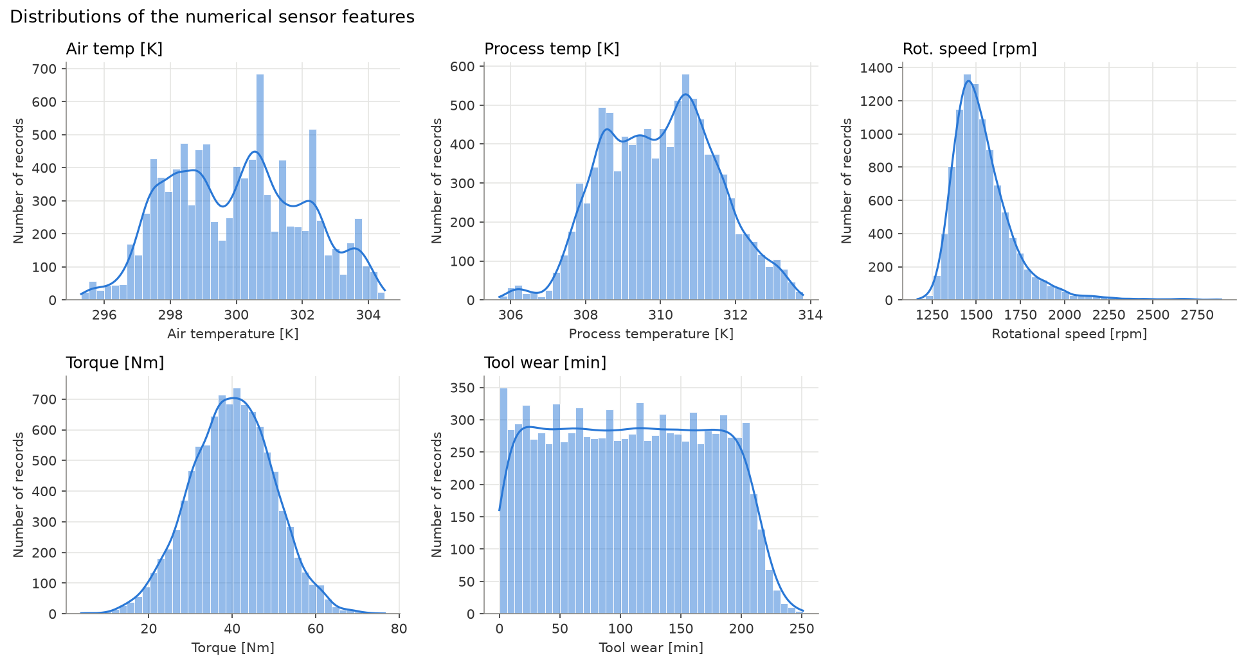
Figure 2. Distributions of the five numerical features.
Temperatures are roughly symmetric, tool wear is close to uniform between 0 and ~250 min, torque is bell-shaped, and rotational speed is right-skewed (skew 1.99) with a long high-rpm tail.
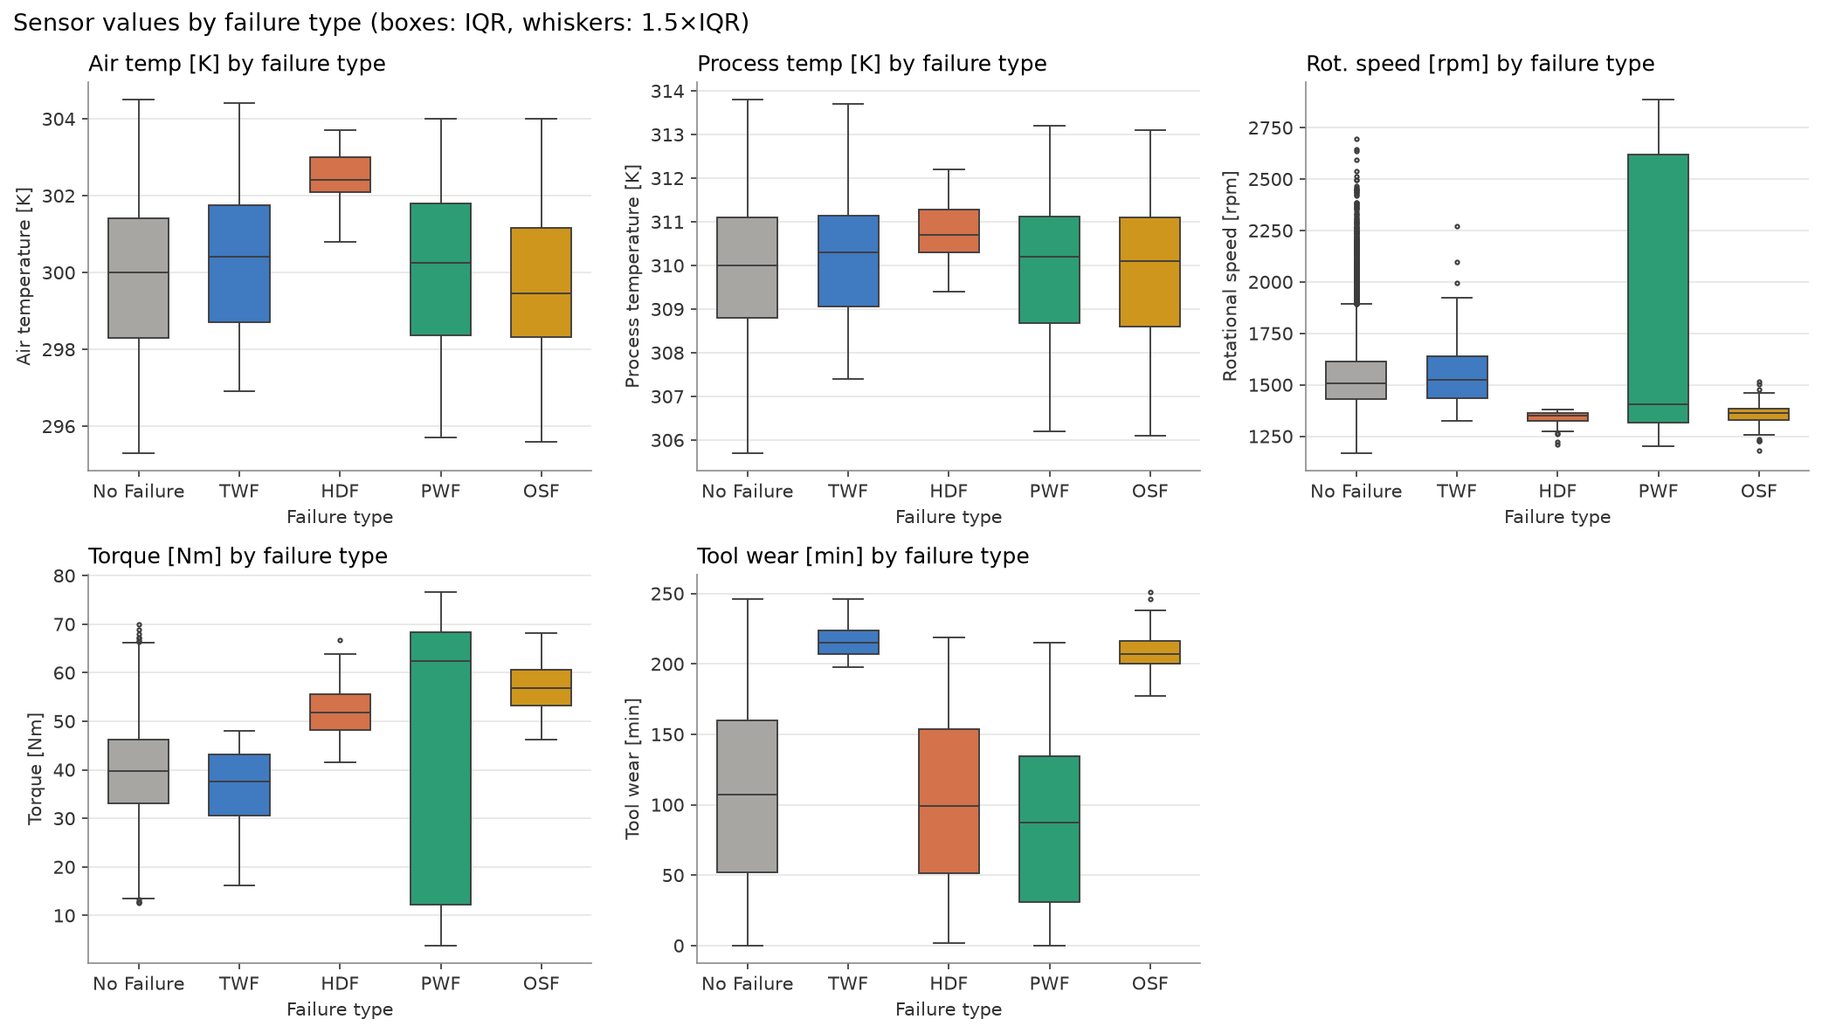
Figure 3. Sensor values by failure type.
Each failure mode occupies a distinct region: TWF and OSF occur only at high tool wear; HDF at high air temperature and low speed; PWF at both extremes of torque and speed. No Failure spans the whole range and overlaps TWF on every single feature.
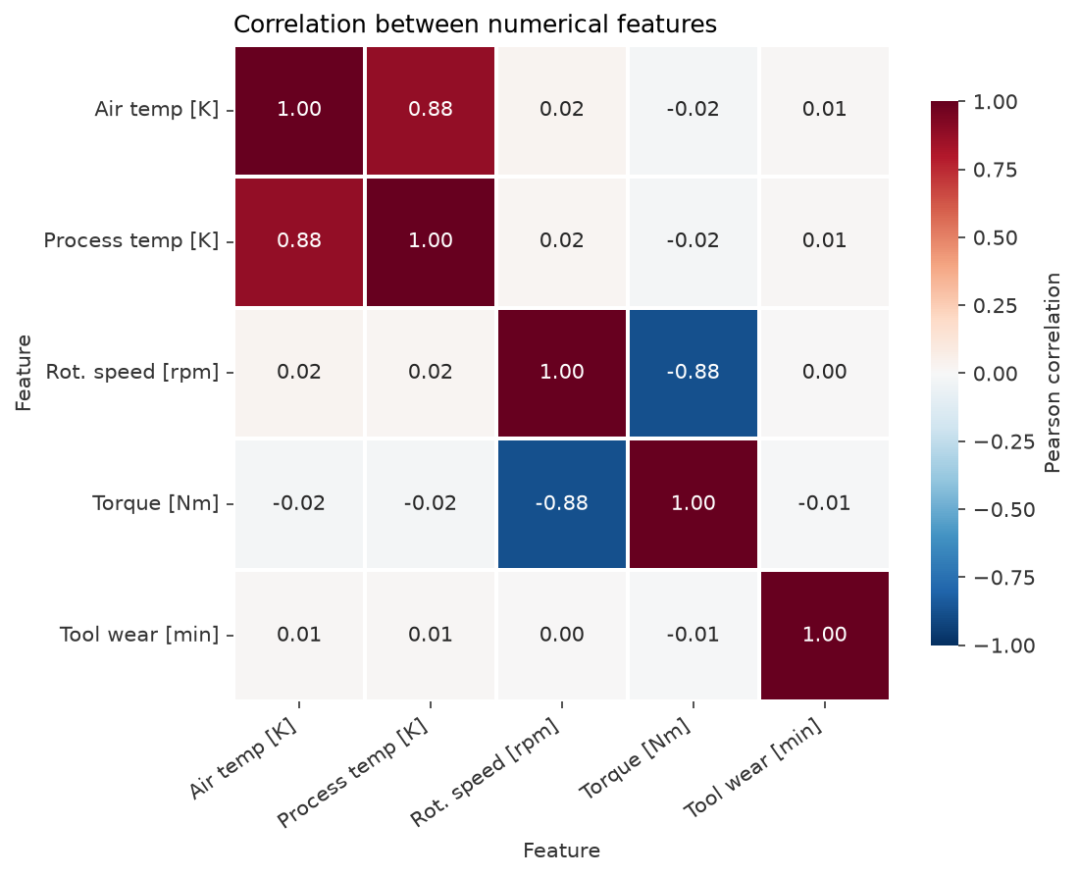
Figure 4. Pearson correlation between the numerical features.
Two strong pairs exist — air vs process temperature (+0.88) and rotational speed vs torque (−0.88); all other correlations are close to zero. Tree ensembles tolerate such correlation, but it is revisited during feature selection.
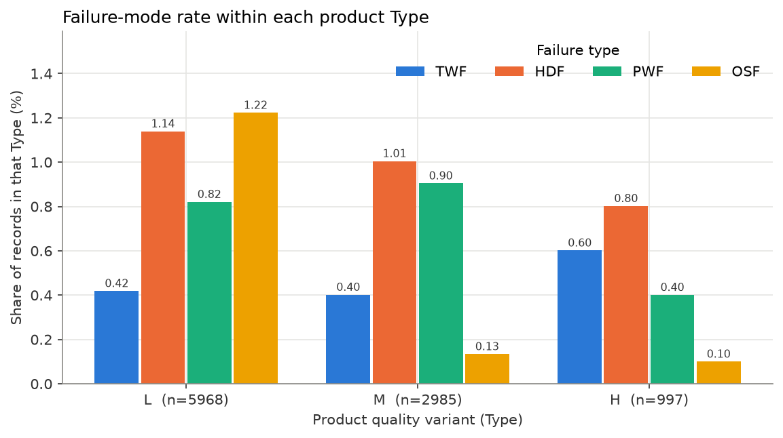
Figure 5. Rate of each failure mode within each product quality variant.
OSF is about ten times more frequent for L-type products (1.22%) than for M (0.13%) or H (0.10%), so Type is informative for OSF even though it matters little elsewhere.
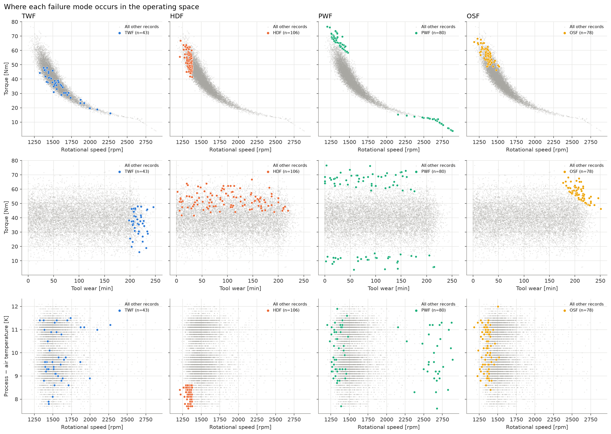
Figure 6. Where each failure mode lies in the operating space (each mode highlighted against all other records).
This figure motivates the engineered features: HDF sits at the smallest process–air temperature gaps and below ~1380 rpm; PWF sits at both ends of the speed–torque curve, i.e. at extreme mechanical power; OSF needs high tool wear and high torque; TWF appears only at tool wear of roughly 200–246 min and otherwise overlaps No Failure, so it is expected to be the hardest class.

9. Feature Engineering and Feature Selection
Table 7. Engineered features. All are computed inside the pipeline by the stateless FeatureEngineer transformer.
Feature | Formula | Reason and expected relationship
Temp difference [K] | Process temp − Air temp | Heat leaves the process through the air; a small gap means poor dissipation, expected to indicate HDF.
Power [W] | Torque × rpm × 2π / 60 | Mechanical power; PWF is expected at both very low and very high power, which one feature captures instead of two interacting ones.
Strain [min·Nm] | Tool wear × Torque | Load on an already-worn tool; OSF is expected where both are high.

Table 8. Median engineered-feature values by class (training split).
Class | Temp difference [K] | Power [W] | Strain [min·Nm]
No Failure | 9.9 | 6239.01 | 3933.6
TWF | 9.6 | 5948.42 | 7752.65
HDF | 8.3 | 7218.74 | 5045.6
PWF | 9.7 | 9037.44 | 1632.4
OSF | 10.15 | 8058.18 | 11575.15

The medians confirm the expected relationships: HDF has the lowest temperature difference, PWF the highest median power, and OSF by far the highest strain.
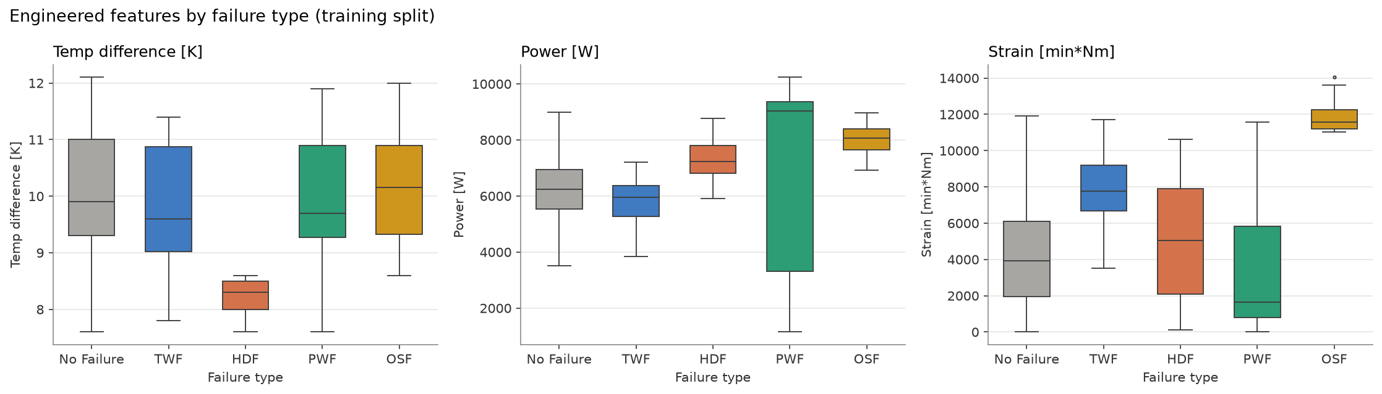
Figure 7. Engineered features by failure type (training split).
Feature selection. Three candidate feature sets were compared with 5-fold stratified CV on the training split, using two model families (class-balanced Random Forest and XGBoost with default hyperparameters) so the choice would not depend on one model or on tuning. The pre-defined rule was the highest Macro F1 averaged over both models. Mutual information (a filter method) was also computed for reference.
Table 9. Feature-set comparison (5-fold stratified CV, training split only).
Feature set | Model | Inputs | CV Macro F1 | Std
original | Random Forest | 6 | 0.6420 | 0.0452
original | XGBoost | 6 | 0.7252 | 0.0233
original + engineered | Random Forest | 9 | 0.7821 | 0.0214
original + engineered | XGBoost | 9 | 0.8000 | 0.0261
engineered, raw temperatures dropped | Random Forest | 7 | 0.7896 | 0.0211
engineered, raw temperatures dropped | XGBoost | 7 | 0.7887 | 0.0247

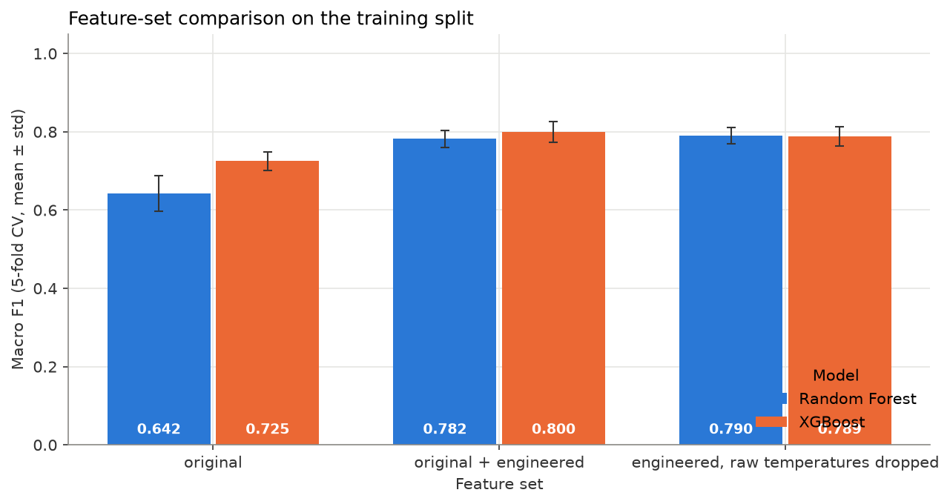
Figure 8. Original vs engineered vs reduced feature sets.
Adding the engineered features raised the mean CV Macro F1 from 0.684 to 0.791. Dropping the two raw temperatures afterwards (testing redundancy with the temperature difference) gave 0.789 — no improvement — so the full set of 6 raw inputs plus 3 engineered features (11 model columns after one-hot encoding) was selected. The engineered features are correlated with their source columns (power–torque 0.98, strain–tool wear 0.90), which is acceptable for tree ensembles and is taken into account when interpreting importance.

10. Train-Test Split and Baseline Model
Table 10. Stratified 80/20 split (random_state = 42); class proportions are preserved.
Class | Train | Train % | Test | Test %
No Failure | 7715 | 96.92 | 1928 | 96.88
TWF | 34 | 0.43 | 9 | 0.45
HDF | 85 | 1.07 | 21 | 1.06
PWF | 64 | 0.8 | 16 | 0.8
OSF | 62 | 0.78 | 16 | 0.8
Total | 7960 | 100.0 | 1990 | 100.0

Why Macro F1. A model that always predicts No Failure scores 96.9% accuracy yet detects no failures at all. Macro F1 averages the F1-score of the five classes with equal weight, so each rare failure mode counts as much as No Failure; weighted F1 and accuracy are reported alongside it but not used for selection.
The DummyClassifier (most frequent) confirms this: CV Macro F1 0.1969 ± 0.0000, test accuracy 0.9688, test Macro F1 0.1968. Its constant probabilities give a ROC-AUC of exactly 0.5 — a valid value meaning no ranking ability, not a missing one. Logistic Regression on standardised inputs (GridSearchCV over C and class_weight) reached CV Macro F1 0.7084 ± 0.0419 and test Macro F1 0.6455; it detects OSF well but misses every TWF case, because the failure regions are not linearly separable.
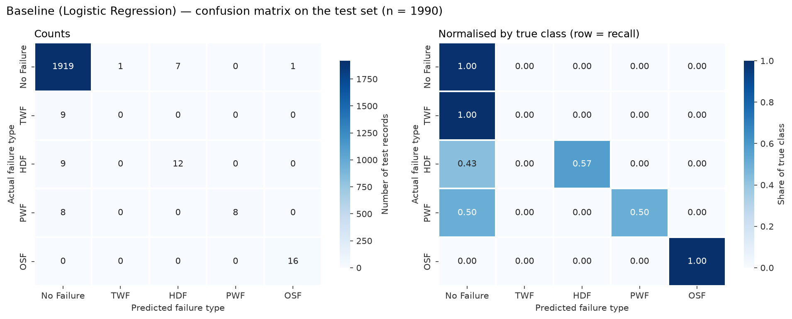
Figure 9. Logistic Regression baseline — confusion matrix on the test set.

11. Random Forest (Bagging)
An initial Random Forest with library defaults (300 trees) reached CV Macro F1 0.7842 ± 0.0094 but a training Macro F1 of 1.000, i.e. it memorised the training data. RandomizedSearchCV (30 candidates × 5 folds) tuned n_estimators, max_depth, min_samples_split, min_samples_leaf, max_features and class_weight. Best parameters: class_weight = balanced, max_depth = 12, max_features = 0.5000, min_samples_leaf = 1, min_samples_split = 4, n_estimators = 300.
Tuned CV Macro F1: 0.7909 ± 0.0129. Limiting depth to 12 cut the train–CV gap from 0.216 to 0.025, a much better-generalising model. Class balancing makes the forest aggressive on rare classes: on the test set it recalls 7 of 9 TWF cases but raises 85 false alarms.
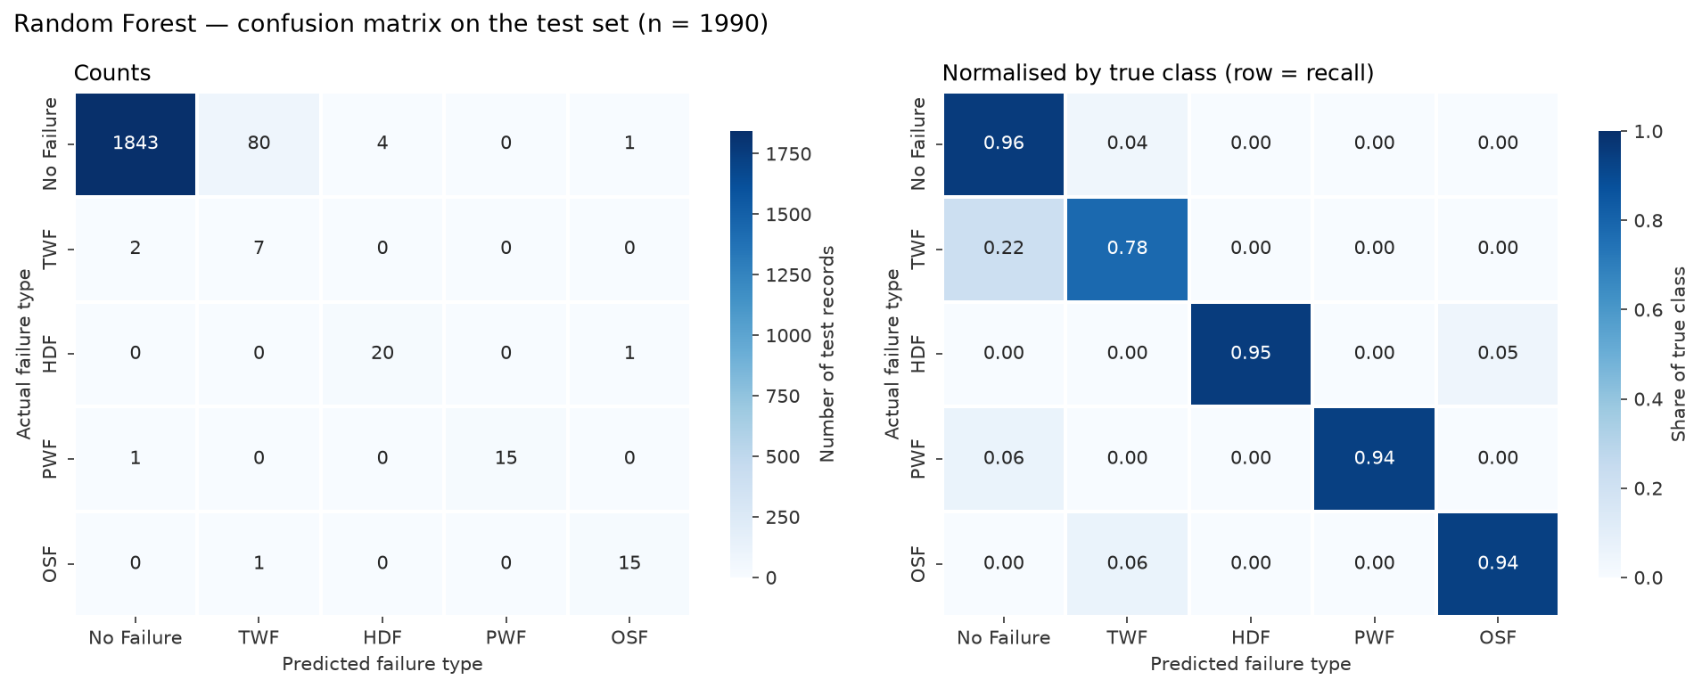
Figure 10. Random Forest — confusion matrix on the test set.

12. XGBoost (Boosting)
XGBoost was configured for multi-class classification with objective = multi:softprob (softmax probabilities over the five classes) and eval_metric = mlogloss. Because XGBoost has no class_weight option for multi-class problems, a small wrapper (XGBClassifierCW) converts a class_weight setting into balanced per-sample weights inside fit(), so weighting could be tuned like any other hyperparameter and still works inside CV and stacking; its effect was verified to equal explicitly passing balanced sample weights.
RandomizedSearchCV (30 candidates) tuned n_estimators, max_depth, learning_rate, subsample, colsample_bytree, min_child_weight and class weighting. Best parameters: class_weight = balanced, colsample_bytree = 0.8253, learning_rate = 0.0568, max_depth = 4, min_child_weight = 1, n_estimators = 489, subsample = 0.6964. CV Macro F1 improved from 0.7620 ± 0.0251 (defaults) to 0.7956 ± 0.0294, the highest of all models. Its training score (0.994) is far above its CV score — boosting fits the training rows almost perfectly — but the CV score, which is what generalisation depends on, is the best, and the test result (0.7750) is consistent with it.
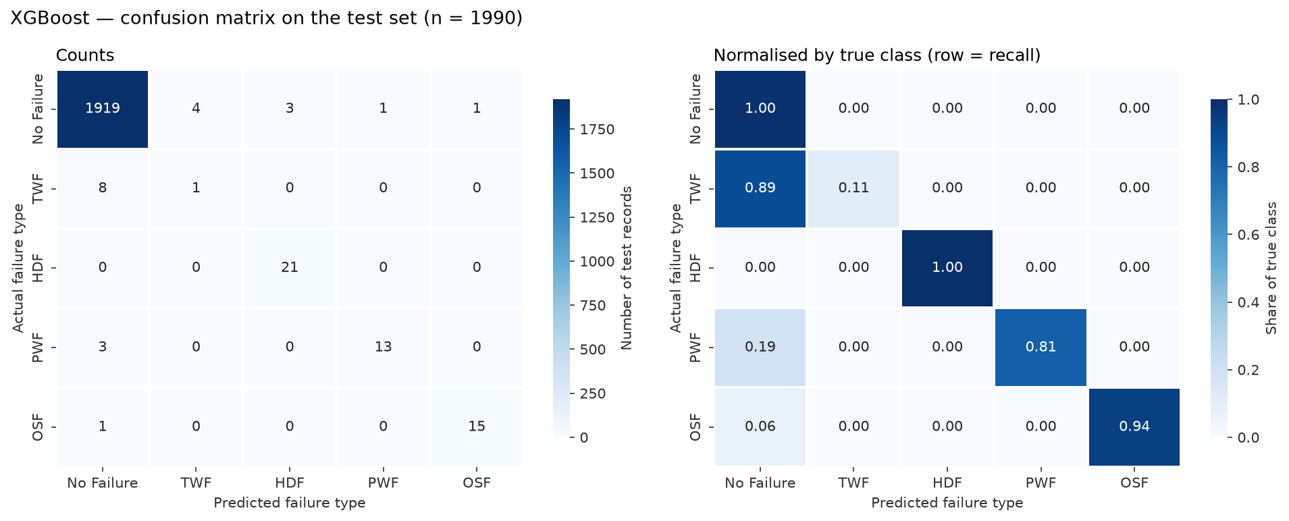
Figure 11. XGBoost — confusion matrix on the test set.

13. CatBoost (Advanced Boosting)
CatBoost was tuned over iterations, depth, learning_rate, l2_leaf_reg, loss_function (MultiClass vs MultiClassOneVsAll) and auto_class_weights (None, Balanced, SqrtBalanced) with RandomizedSearchCV (20 candidates). Best parameters: auto_class_weights = SqrtBalanced, depth = 8, iterations = 466, l2_leaf_reg = 1.0310, learning_rate = 0.2565, loss_function = MultiClassOneVsAll. CV Macro F1 rose from 0.7551 ± 0.0104 to 0.7766 ± 0.0304, below both Random Forest and XGBoost. CatBoost's main advantage — native handling of high-cardinality categorical features — has little to act on here, since the only categorical input has three levels.
Two implementation issues were found and fixed rather than worked around: CatBoost requires the string "None" (not Python None) for no class weighting — the first run silently failed those candidates, so the search was re-run with failures set to raise errors; and CatBoost returns multi-class predictions as an (n, 1) column, which a small subclass flattens. With the MultiClassOneVsAll loss, class probabilities are independent and need not sum to 1; One-vs-Rest ROC-AUC was therefore computed class by class, which is identical to scikit-learn's multi-class computation for models whose probabilities do sum to 1 (verified).
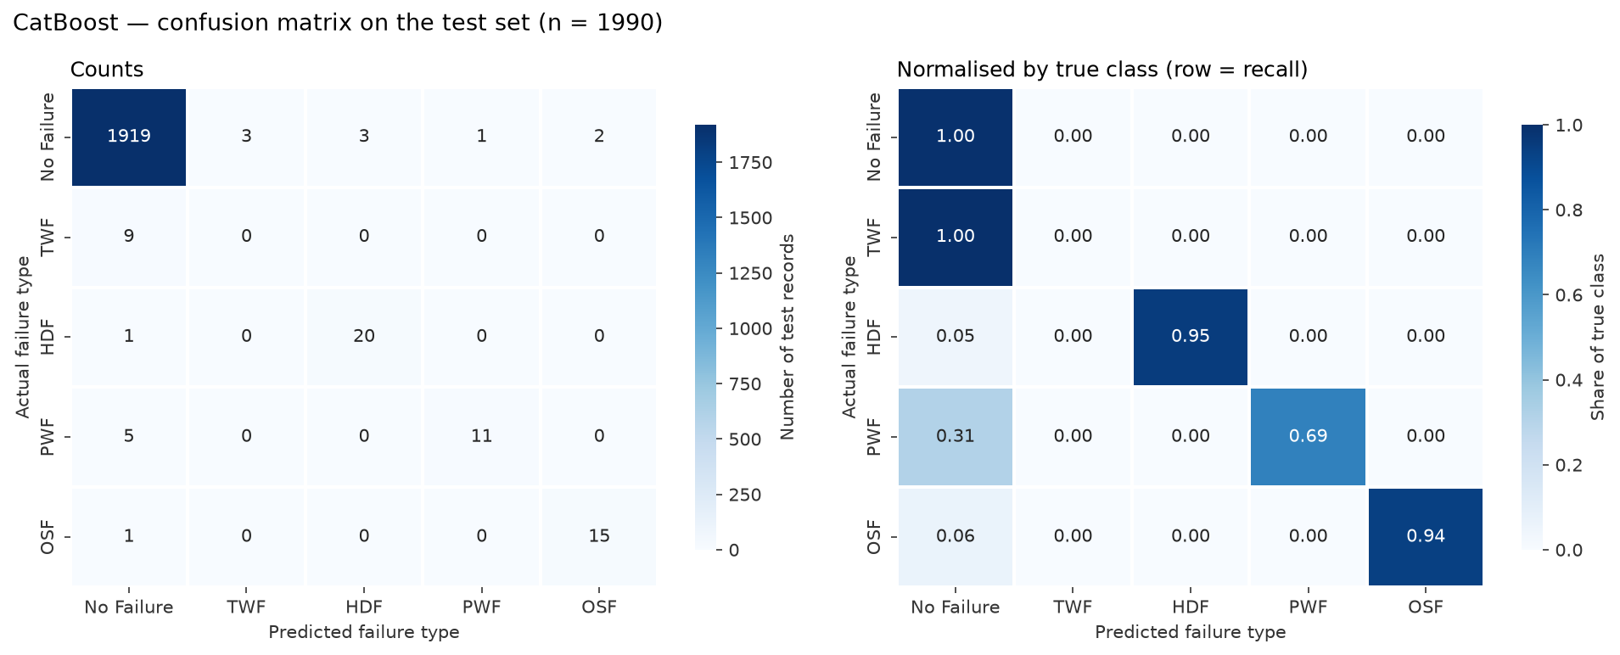
Figure 12. CatBoost — confusion matrix on the test set.

14. Stacking Ensemble
The stacking ensemble combines the three tuned tree ensembles (Random Forest, XGBoost, CatBoost). A class-balanced multinomial Logistic Regression meta-learner is trained on their out-of-fold predicted probabilities, produced by an inner stratified 5-fold CV inside StackingClassifier, so no base-learner prediction used for training the meta-learner comes from a model that saw that row. GridSearchCV tuned the meta-learner's regularisation C.
Stacking reached CV Macro F1 0.7881 ± 0.0101 — the most stable across folds (lowest std) but not higher than XGBoost. On the test set it has the highest Macro F1 (0.8021) and recall (0.9669), because the balanced meta-learner flags rare classes aggressively: it catches 8 of 9 TWF cases but raises 105 false alarms, almost all as TWF. Stacking therefore did not simply dominate the individual models; it shifted the precision–recall trade-off.
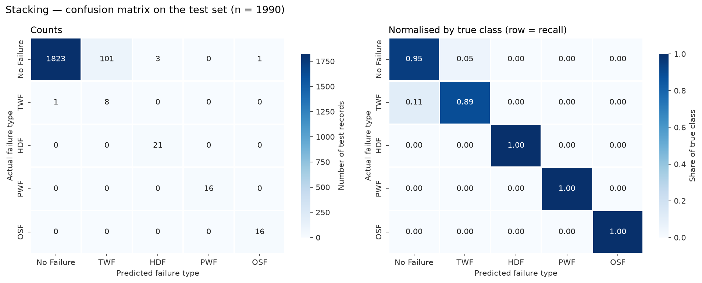
Figure 13. Stacking ensemble — confusion matrix on the test set.

15. Hyperparameter Tuning
RandomizedSearchCV was used for the large search spaces of the three tree ensembles (30, 30 and 20 candidates) and GridSearchCV for the small final grids (Logistic Regression: 10 candidates; stacking meta-learner: 3). All searches used StratifiedKFold(n_splits=5, shuffle=True, random_state=42), scoring = f1_macro and refit on the full training split. Search spaces were kept modest, as the brief requested, because the training machine had 2 CPU cores. Mean training scores were recorded to expose overfitting.
Table 11. Tuning summary (training split only).
Model | Search | Candidates | CV Macro F1 (mean ± std) | Train Macro F1 | Train − CV
Baseline (Dummy, most frequent) | none (fixed strategy) | 1 | 0.1969 ± 0.0000 | 0.1969 | +0.0000
Baseline (Logistic Regression) | GridSearchCV | 10 | 0.7084 ± 0.0419 | 0.7143 | +0.0060
Random Forest | RandomizedSearchCV | 30 | 0.7909 ± 0.0129 | 0.8157 | +0.0248
XGBoost | RandomizedSearchCV | 30 | 0.7956 ± 0.0294 | 0.9936 | +0.1980
CatBoost | RandomizedSearchCV | 20 | 0.7766 ± 0.0304 | 1.0000 | +0.2234
Stacking | GridSearchCV | 3 | 0.7881 ± 0.0101 | 0.8103 | +0.0222

Table 12. Effect of tuning on the three tree ensembles.
Model | Initial CV Macro F1 | Tuned CV Macro F1 | Improvement
Random Forest | 0.7842 ± 0.0094 | 0.7909 ± 0.0129 | +0.0067
XGBoost | 0.7620 ± 0.0251 | 0.7956 ± 0.0294 | +0.0336
CatBoost | 0.7551 ± 0.0104 | 0.7766 ± 0.0304 | +0.0215

The best parameters for every model are stored in reports/tuning/tuning_summary.csv. Note that a best cross-validation score is slightly optimistic, being the maximum over many candidates; this is why the held-out test set is kept for a final unbiased check.

16. Cross-Validation
Every model — initial and tuned — was scored on exactly the same five stratified folds, so fold-wise results are directly comparable.
Table 13. Fold-wise CV Macro F1 on the training split.
Model | Fold 1 | Fold 2 | Fold 3 | Fold 4 | Fold 5 | Mean | Std
Random Forest (initial) | 0.7720 | 0.7779 | 0.7831 | 0.7995 | 0.7883 | 0.7842 | 0.0094
XGBoost (initial) | 0.7708 | 0.7153 | 0.7676 | 0.7911 | 0.7651 | 0.7620 | 0.0251
CatBoost (initial) | 0.7636 | 0.7534 | 0.7413 | 0.7698 | 0.7476 | 0.7551 | 0.0104
Baseline (Dummy, most frequent) | 0.1969 | 0.1969 | 0.1969 | 0.1969 | 0.1969 | 0.1969 | 0.0000
Baseline (Logistic Regression) | 0.7867 | 0.6784 | 0.7176 | 0.6818 | 0.6772 | 0.7084 | 0.0419
Random Forest | 0.7870 | 0.7801 | 0.7980 | 0.8122 | 0.7770 | 0.7909 | 0.0129
XGBoost | 0.8210 | 0.7978 | 0.7823 | 0.8295 | 0.7472 | 0.7956 | 0.0294
CatBoost | 0.8062 | 0.7423 | 0.7813 | 0.8122 | 0.7411 | 0.7766 | 0.0304
Stacking | 0.7778 | 0.8016 | 0.7778 | 0.7984 | 0.7848 | 0.7881 | 0.0101

Fold-to-fold variation is substantial for the boosting models (XGBoost ranges from 0.747 to 0.830), mainly because each validation fold contains only about 7 TWF records, so a single TWF record changes that class's F1 considerably. The differences between Random Forest, Stacking and XGBoost are within about one standard deviation, which is taken into account when discussing the result.

17. Model Evaluation
All tuned models were evaluated once on the untouched test set (1,990 records). One-vs-Rest ROC-AUC uses predicted probabilities; macro averages give each class equal weight, weighted averages weight by class support.
Table 14. Test-set results for every model (CV column: training split).
Model | CV Macro F1 | Accuracy | Prec. (macro) | Recall (macro) | F1 (macro) | F1 (wtd) | AUC (macro) | AUC (wtd)
Baseline (Dummy, most frequent) | 0.1969 ± 0.0000 | 0.9688 | 0.1938 | 0.2000 | 0.1968 | 0.9535 | 0.5000 | 0.5000
Baseline (Logistic Regression) | 0.7084 ± 0.0419 | 0.9824 | 0.7119 | 0.6134 | 0.6455 | 0.9796 | 0.9890 | 0.9842
Random Forest | 0.7909 ± 0.0129 | 0.9548 | 0.7587 | 0.9122 | 0.7773 | 0.9714 | 0.9908 | 0.9878
XGBoost | 0.7956 ± 0.0294 | 0.9894 | 0.7870 | 0.7713 | 0.7750 | 0.9886 | 0.9873 | 0.9837
CatBoost | 0.7766 ± 0.0304 | 0.9874 | 0.7321 | 0.7145 | 0.7195 | 0.9858 | 0.9878 | 0.9868
Stacking | 0.7881 ± 0.0101 | 0.9467 | 0.7778 | 0.9669 | 0.8021 | 0.9678 | 0.9913 | 0.9908
Best Model (XGBoost) | 0.7956 ± 0.0294 | 0.9894 | 0.7870 | 0.7713 | 0.7750 | 0.9886 | 0.9873 | 0.9837

Table 15. Per-class F1 on the test set for every model.
Model | No Failure | TWF | HDF | PWF | OSF
Baseline (Dummy, most frequent) | 0.984 | 0.000 | 0.000 | 0.000 | 0.000
Baseline (Logistic Regression) | 0.991 | 0.000 | 0.600 | 0.667 | 0.970
Random Forest | 0.977 | 0.144 | 0.889 | 0.968 | 0.909
XGBoost | 0.995 | 0.143 | 0.933 | 0.867 | 0.938
CatBoost | 0.994 | 0.000 | 0.909 | 0.786 | 0.909
Stacking | 0.972 | 0.136 | 0.933 | 1.000 | 0.970

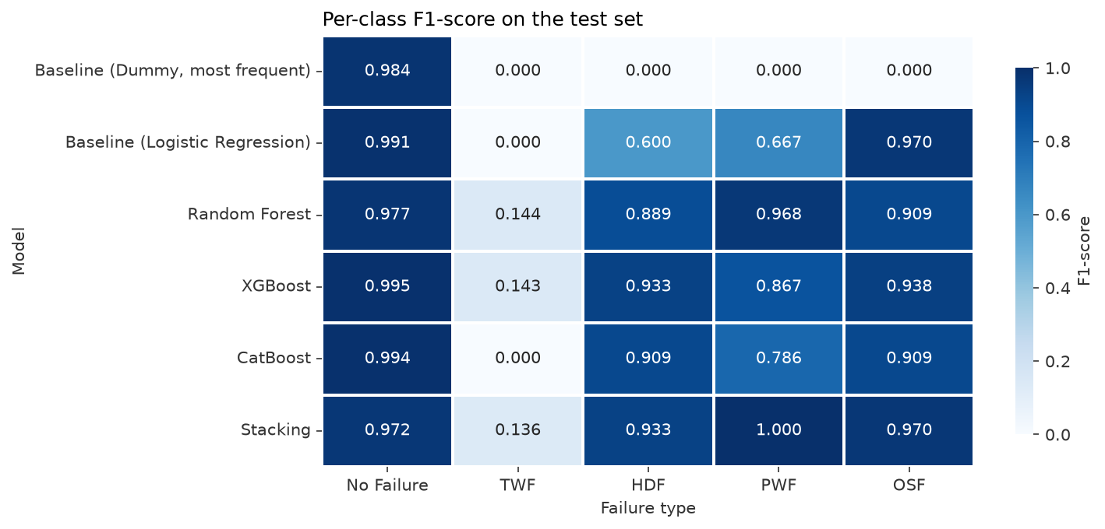
Figure 14. Per-class test F1 for every model.
Easiest classes: No Failure (F1 0.97–0.99 for every trained model) and HDF, OSF and PWF (F1 0.79–1.00 for the tree ensembles), whose occurrence is tied to clear physical thresholds. Hardest and lowest-F1 class: TWF, which no model predicts with F1 above 0.15. Most underrepresented: TWF (43 records, 9 in the test set), followed by OSF and PWF (16 test records each).
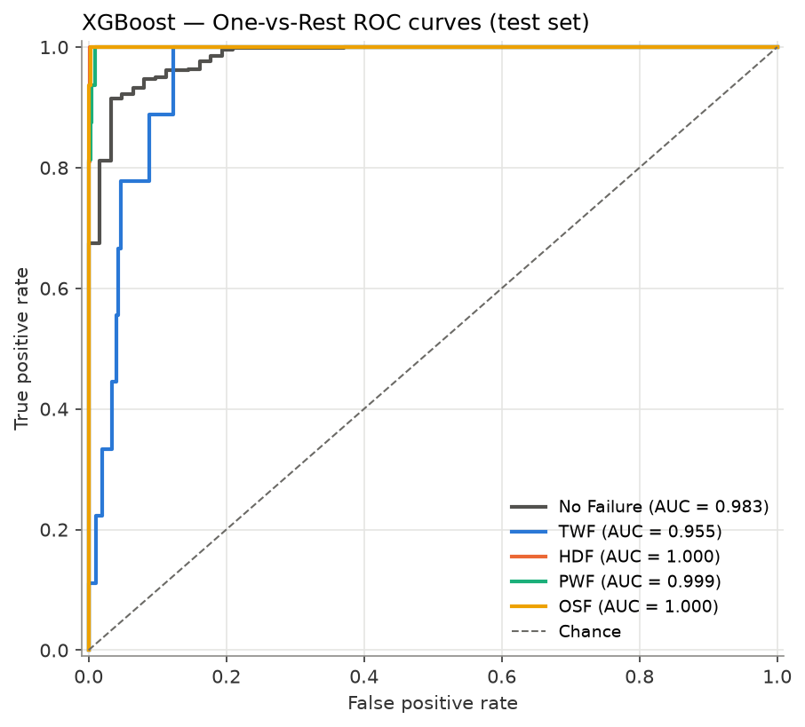
Figure 15. One-vs-Rest ROC curves of the final model (XGBoost).
ROC-AUC is high for every trained model (≥ 0.987) and, for this problem, not very discriminating: it measures ranking across all thresholds, whereas F1 measures decisions at the chosen threshold — which is where the rare classes are won or lost.

18. Confusion Matrix Analysis
Figure 16. Final model (XGBoost): raw and row-normalised confusion matrices.
Table 16. Confusion pairs of the final model (Actual → Predicted), most frequent first.
Actual | Predicted | Count | % of actual class
TWF | No Failure | 8 | 88.9
No Failure | TWF | 4 | 0.2
No Failure | HDF | 3 | 0.2
PWF | No Failure | 3 | 18.8
No Failure | PWF | 1 | 0.1
No Failure | OSF | 1 | 0.1
OSF | No Failure | 1 | 6.2

The final model misclassifies 21 of 1,990 test records. The dominant confusion is TWF → No Failure (8 of 9 TWF records). Failure classes are never confused with each other — every error is between a failure class and No Failure — so when the model does raise a failure, the failure type is reliable.
Table 17. Error trade-off between models on the test set.
Model | False alarms (No Failure → failure) | Missed failures (failure → No Failure) | TWF caught (of 9)
XGBoost | 9 | 12 | 1
Random Forest | 85 | 3 | 7
Stacking | 105 | 1 | 8
CatBoost | 9 | 16 | 0

This table shows the practical difference behind the headline scores: XGBoost raises 9 false alarms and misses 12 failures, while Stacking raises 105 false alarms and misses 1. Stacking's higher test Macro F1 comes almost entirely from TWF, bought with more than a hundred false TWF alarms.

19. Misclassification Analysis
Each misclassified test record (saved with its features, engineered features and predicted probabilities in reports/misclassification_analysis.csv) was compared with correctly classified records and with the class boundaries observed in the training data.
Table 18. Where each failure class begins in the training data.
Class | Evidence (training split) | Value | Detail
TWF | share of training rows with tool wear 198-246 min that are TWF | 4.8 | {'No Failure': 614, 'OSF': 48, 'TWF': 34, 'HDF': 5, 'PWF': 2}
HDF | max temp difference / max rpm of HDF rows | 8.6 K / 1379 rpm | No Failure rows with temp diff <= 8.6 K and rpm < 1380: 0
PWF | PWF power (low-group max / high-group min) vs No Failure power range | 3477 W / 9020 W | No Failure: 3515-8990 W
OSF | Type L: min OSF strain vs max No Failure strain | 11019 | n OSF=59; No Failure max 10994
OSF | Type M: min OSF strain vs max No Failure strain | 12482 | n OSF=3; No Failure max 11920
OSF | Type H: min OSF strain vs max No Failure strain | no OSF rows | n OSF=0; No Failure max 11873

- TWF → No Failure (8). TWF occurs only at tool wear ≈ 198–246 min, but in that band only 4.8% of training records are TWF; the rest are mostly No Failure with overlapping temperature, speed and torque. No available feature separates them, which is consistent with the dataset documentation describing tool replacement or failure at a randomly chosen wear time. The misclassified TWF records have high tool wear (median 207.5 min) and otherwise ordinary operating values. This is insufficient distinguishing information combined with class imbalance, not a modelling error that tuning could fix.
- PWF → No Failure (3). In training, No Failure power ranges up to 8,990 W while high-power PWF starts at 9,020 W. The three missed PWF records have powers of 9,010–9,014 W, i.e. inside this 30 W gap where the model had no training examples, so the learned threshold fell just above them.
- OSF → No Failure (1) and No Failure → OSF (1). For L-type products the classes meet between 10,994 and 11,019 min·Nm of strain; the missed OSF record has 11,003. The false OSF alarm is an M-type record with strain 11,239, above the L-type boundary but below the lowest M-type OSF value (12,482); with only 3 M-type OSF records in training, the model has not learned that the threshold depends on the product type.
- No Failure → HDF (3). These records have a temperature difference of exactly 8.6 K and speed 1,340–1,356 rpm, sitting on the edge of the HDF region (all training HDF records have difference ≤ 8.6 K and speed < 1,380 rpm; no No Failure record lies inside it).
In summary, apart from TWF, errors are boundary cases where a record lies within a few units of a sharp decision threshold, with very few training examples near that threshold. Overlapping feature distributions, class imbalance and rare classes explain the errors; there is no evidence of label noise in the remaining data.

20. Feature Importance and Interpretation
Two complementary views were used for the final XGBoost model. Permutation importance shuffles one raw input column at a time on the test set and measures the drop in Macro F1 (engineered features are recomputed from the shuffled column inside the pipeline), so it reflects each operator-controlled input. Native importance is XGBoost's gain-based importance over the 11 model columns.
Table 19. Permutation importance (test set).
Raw input | Macro F1 drop (mean) | Std (10 repeats)
Torque [Nm] | 0.3760 | 0.0124
Rotational speed [rpm] | 0.3417 | 0.0179
Tool wear [min] | 0.2169 | 0.0223
Air temperature [K] | 0.1882 | 0.0085
Process temperature [K] | 0.1564 | 0.0102
Type | 0.0449 | 0.0154

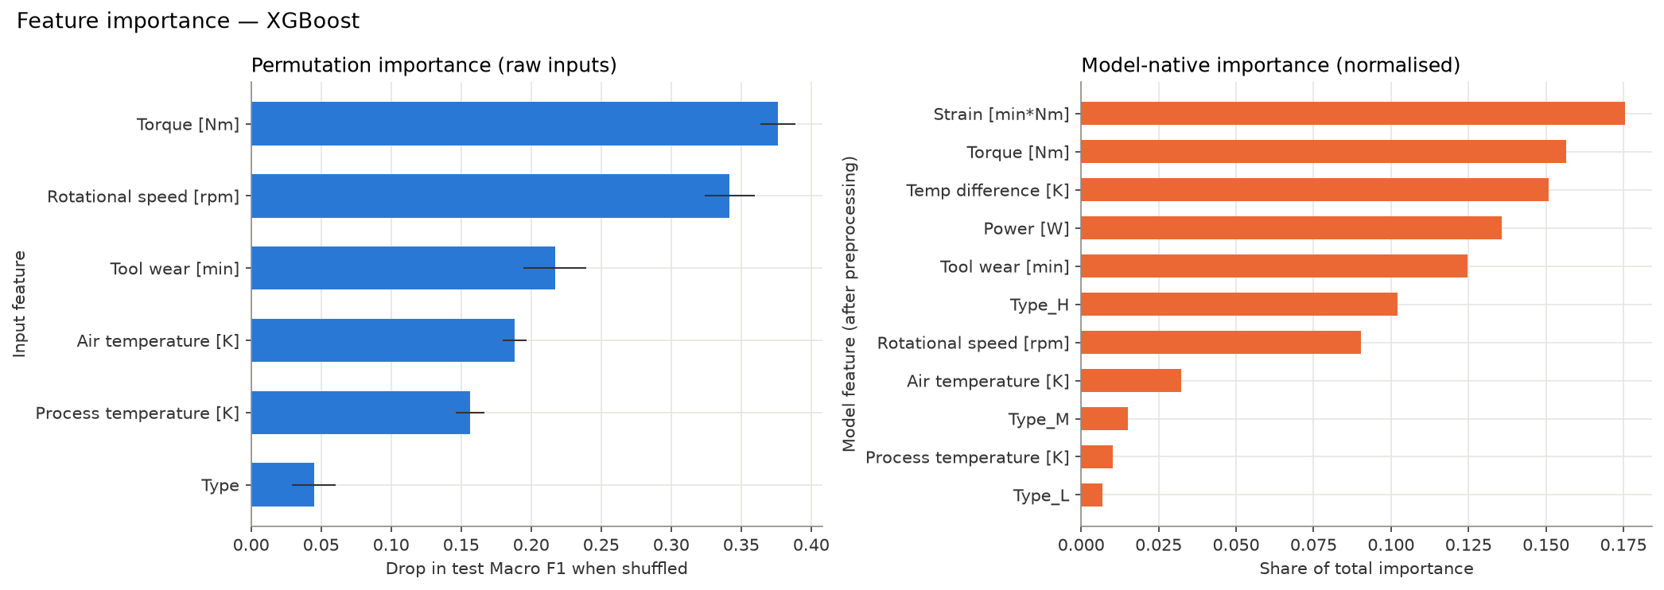
Figure 17. Permutation importance of raw inputs (left) and XGBoost native importance (right).
Torque and rotational speed are the most important raw inputs (each also feeds Power and, for torque, Strain), followed by tool wear. Type matters least overall, though SHAP shows it matters for OSF. Among model columns, the three engineered features are among the five most important, which confirms the Stage 5 result.
Table 20. Mean |SHAP value| per class (XGBoost, test set; log-odds units).
Feature | No Failure | TWF | HDF | PWF | OSF
Strain [min*Nm] | 0.744 | 1.386 | 0.065 | 0.306 | 4.254
Power [W] | 1.137 | 0.949 | 0.133 | 3.879 | 0.564
Tool wear [min] | 1.469 | 3.745 | 0.381 | 0.276 | 0.316
Rotational speed [rpm] | 1.402 | 0.761 | 2.373 | 0.607 | 0.118
Temp difference [K] | 0.683 | 0.606 | 3.145 | 0.234 | 0.022
Torque [Nm] | 1.007 | 0.585 | 0.250 | 0.967 | 0.293
Air temperature [K] | 0.524 | 0.603 | 0.737 | 0.121 | 0.019
Type_L | 0.037 | 0.108 | 0.388 | 0.009 | 1.022
Process temperature [K] | 0.535 | 0.580 | 0.171 | 0.102 | 0.024
Type_M | 0.049 | 0.054 | 0.102 | 0.002 | 0.128
Type_H | 0.008 | 0.059 | 0.003 | 0.002 | 0.095

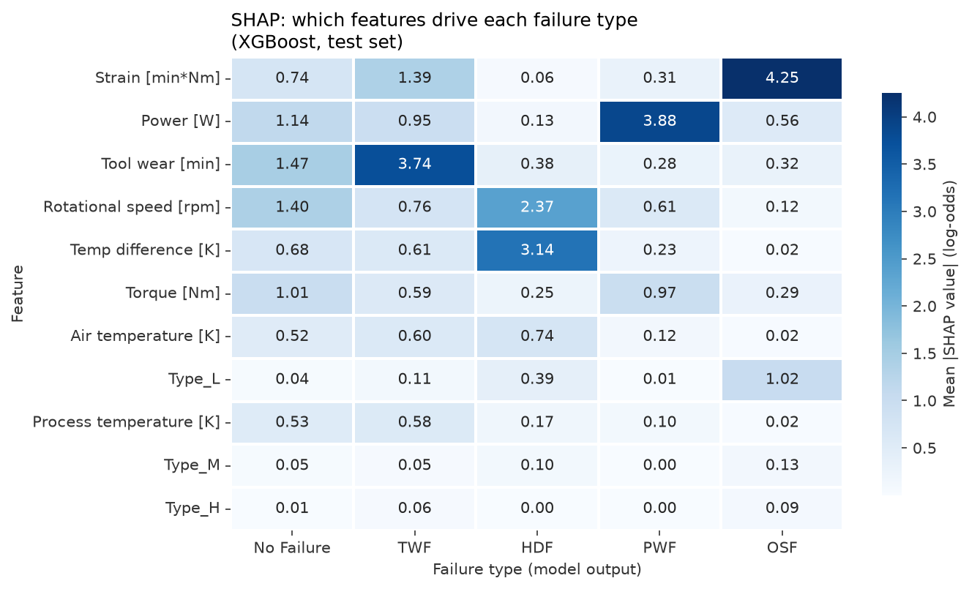
Figure 18. Which features drive each failure type (mean |SHAP|).
SHAP links every failure class to the physically expected driver: Strain [min·Nm] for OSF, Power [W] for PWF, Temp difference [K] (with rotational speed) for HDF, and Tool wear [min] for TWF; Type L is also important for OSF, consistent with OSF being most frequent for L-type products. The beeswarm plots show the directions: low temperature difference raises HDF, extreme (very low or very high) power raises PWF, high strain raises OSF.
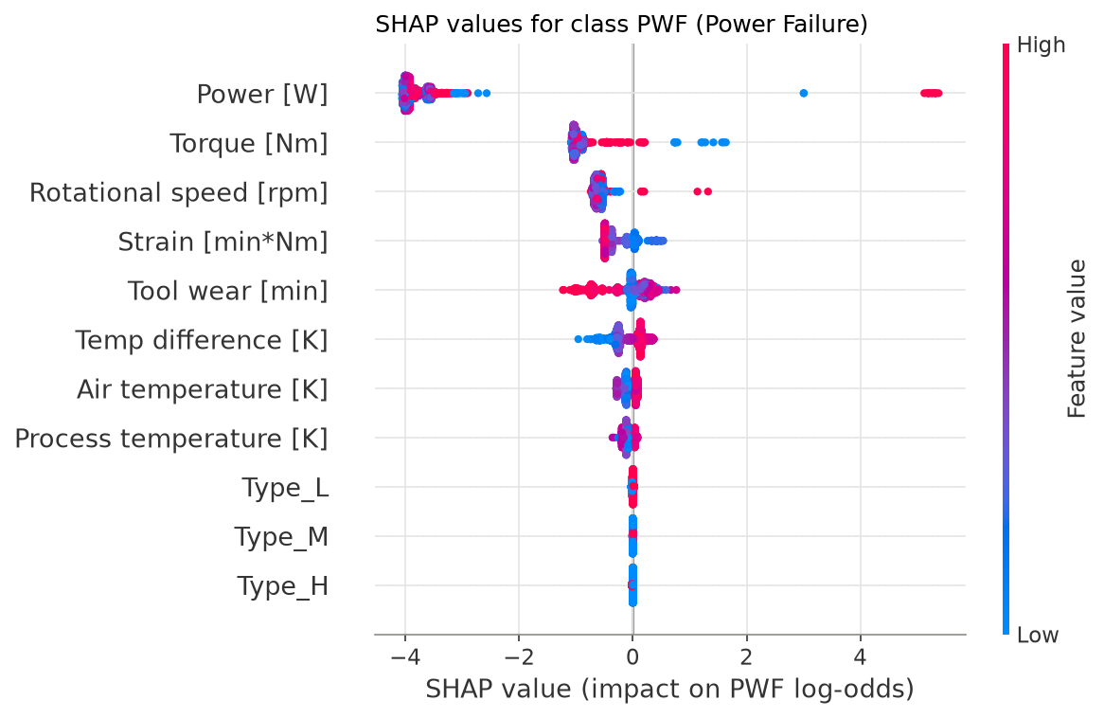
Figure 19. SHAP values for PWF: both very low and very high power push towards Power Failure.
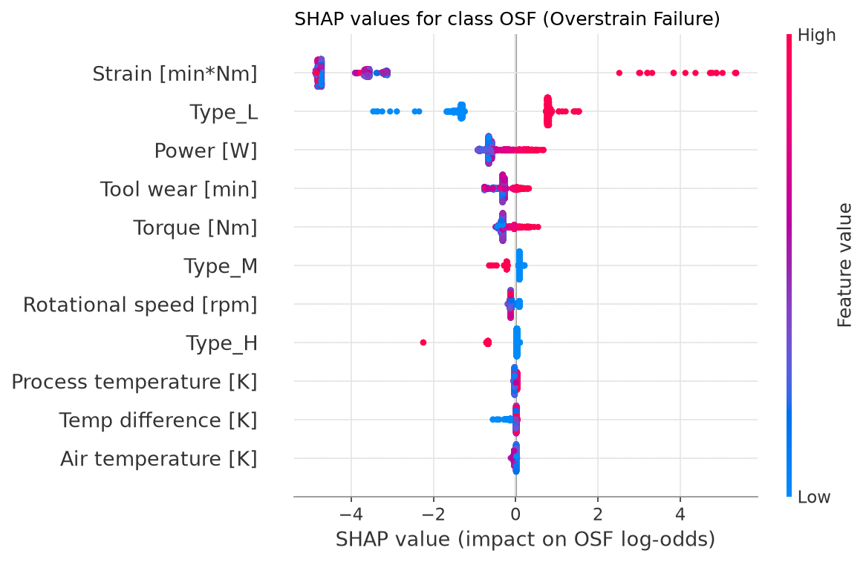
Figure 20. SHAP values for OSF: high strain dominates.
These findings make engineering sense: they match how heat, power and load failures arise physically. They describe what the model relies on, not causation — a feature can be important because it is correlated with the true cause, and the synthetic data were generated from similar physical rules.

21. Model Comparison
Table 21. Final comparison. CV Score = 5-fold CV Macro F1 on the training split; all other columns are test-set, macro-averaged; ROC-AUC is One-vs-Rest.
Model | CV Score | Accuracy | Precision | Recall | F1 | ROC-AUC
Baseline (Dummy, most frequent) | 0.1969 ± 0.0000 | 0.9688 | 0.1938 | 0.2000 | 0.1968 | 0.5000
Baseline (Logistic Regression) | 0.7084 ± 0.0419 | 0.9824 | 0.7119 | 0.6134 | 0.6455 | 0.9890
Random Forest | 0.7909 ± 0.0129 | 0.9548 | 0.7587 | 0.9122 | 0.7773 | 0.9908
XGBoost | 0.7956 ± 0.0294 | 0.9894 | 0.7870 | 0.7713 | 0.7750 | 0.9873
CatBoost | 0.7766 ± 0.0304 | 0.9874 | 0.7321 | 0.7145 | 0.7195 | 0.9878
Stacking | 0.7881 ± 0.0101 | 0.9467 | 0.7778 | 0.9669 | 0.8021 | 0.9913
Best Model (XGBoost) | 0.7956 ± 0.0294 | 0.9894 | 0.7870 | 0.7713 | 0.7750 | 0.9873

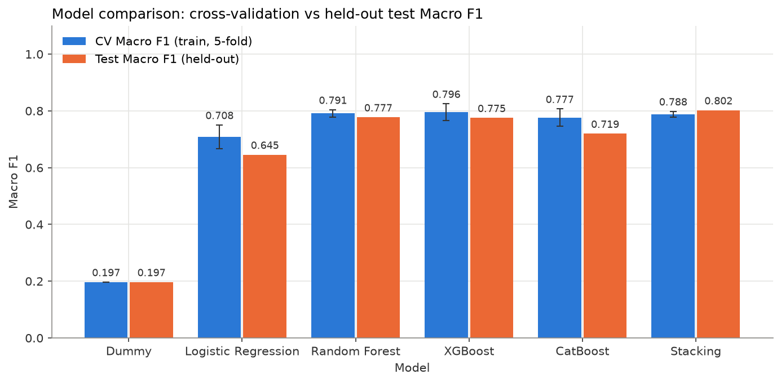
Figure 21. Cross-validation vs held-out test Macro F1 for every model.
Every trained model beats the dummy baseline by a wide margin, and every tree ensemble beats Logistic Regression. The three strongest approaches — XGBoost, Random Forest and Stacking — are close on cross-validation (0.788–0.796) and differ mainly in how they trade false alarms against missed failures. CatBoost is the weakest ensemble here. CV and test Macro F1 agree within about one CV standard deviation for XGBoost and Random Forest; Stacking's test score is slightly above its CV score, and CatBoost's somewhat below.

22. Final Model Selection
Applying the rule fixed before evaluation — highest mean CV Macro F1 — selects XGBoost (0.7956 ± 0.0294). On the test set it achieves Macro F1 0.7750, weighted F1 0.9886, accuracy 0.9894, macro precision 0.7870, macro recall 0.7713 and macro OvR ROC-AUC 0.9873.
Stacking has a higher test Macro F1. Choosing it because of that would use the test set for selection and make its reported score optimistic, so the pre-defined rule was kept. The choice is also defensible on practical grounds: XGBoost is a single model that is faster to train and serve and easier to interpret, it has the highest accuracy and precision, and it raises about a tenth as many false alarms. If missed failures were judged far more costly than false alarms, Stacking or Random Forest would be the better operating point; that is a business decision, discussed under Future Scope.
Final pipeline. The tuned XGBoost pipeline, refitted on the full training split (7960 records), was saved with Joblib as models/final_model.joblib: FeatureEngineer → ColumnTransformer → XGBClassifierCW. The fitted feature-engineering + preprocessing steps were also saved separately (models/preprocessing_pipeline.joblib), and model_metadata.json records classes, metrics, training ranges, library versions and the dataset checksum. Reloading the file reproduces the in-memory predictions and probabilities exactly.

23. Deployment using Streamlit
The Streamlit application (app.py) loads the saved pipeline once (cached) and collects the six raw inputs. It never re-implements preprocessing: inputs become a one-row DataFrame that passes through the same saved FeatureEngineer and ColumnTransformer used in training.
- Inputs: product quality variant (L/M/H) and the five sensor values, pre-filled with training medians and annotated with the training range.
- Validation: missing or non-numeric values, non-finite values, physically implausible values and process temperature not exceeding air temperature are rejected with a clear message; values outside the training range produce a warning that the prediction is an extrapolation.
- Output: the predicted failure type with its description and confidence, a probability chart and table for all five classes, and the derived quantities computed by the pipeline.
- Error handling: a missing or unloadable model file, or a failed prediction, is reported in the interface instead of crashing.
- Model information: a sidebar shows the model, how it was selected, and its CV and test scores.
Run: “streamlit run app.py” from the project root.

24. Screenshots of the Application
The screenshots below were captured from the running application with a headless browser; the inputs of the two predictions are real records from the test set that the model classifies correctly.
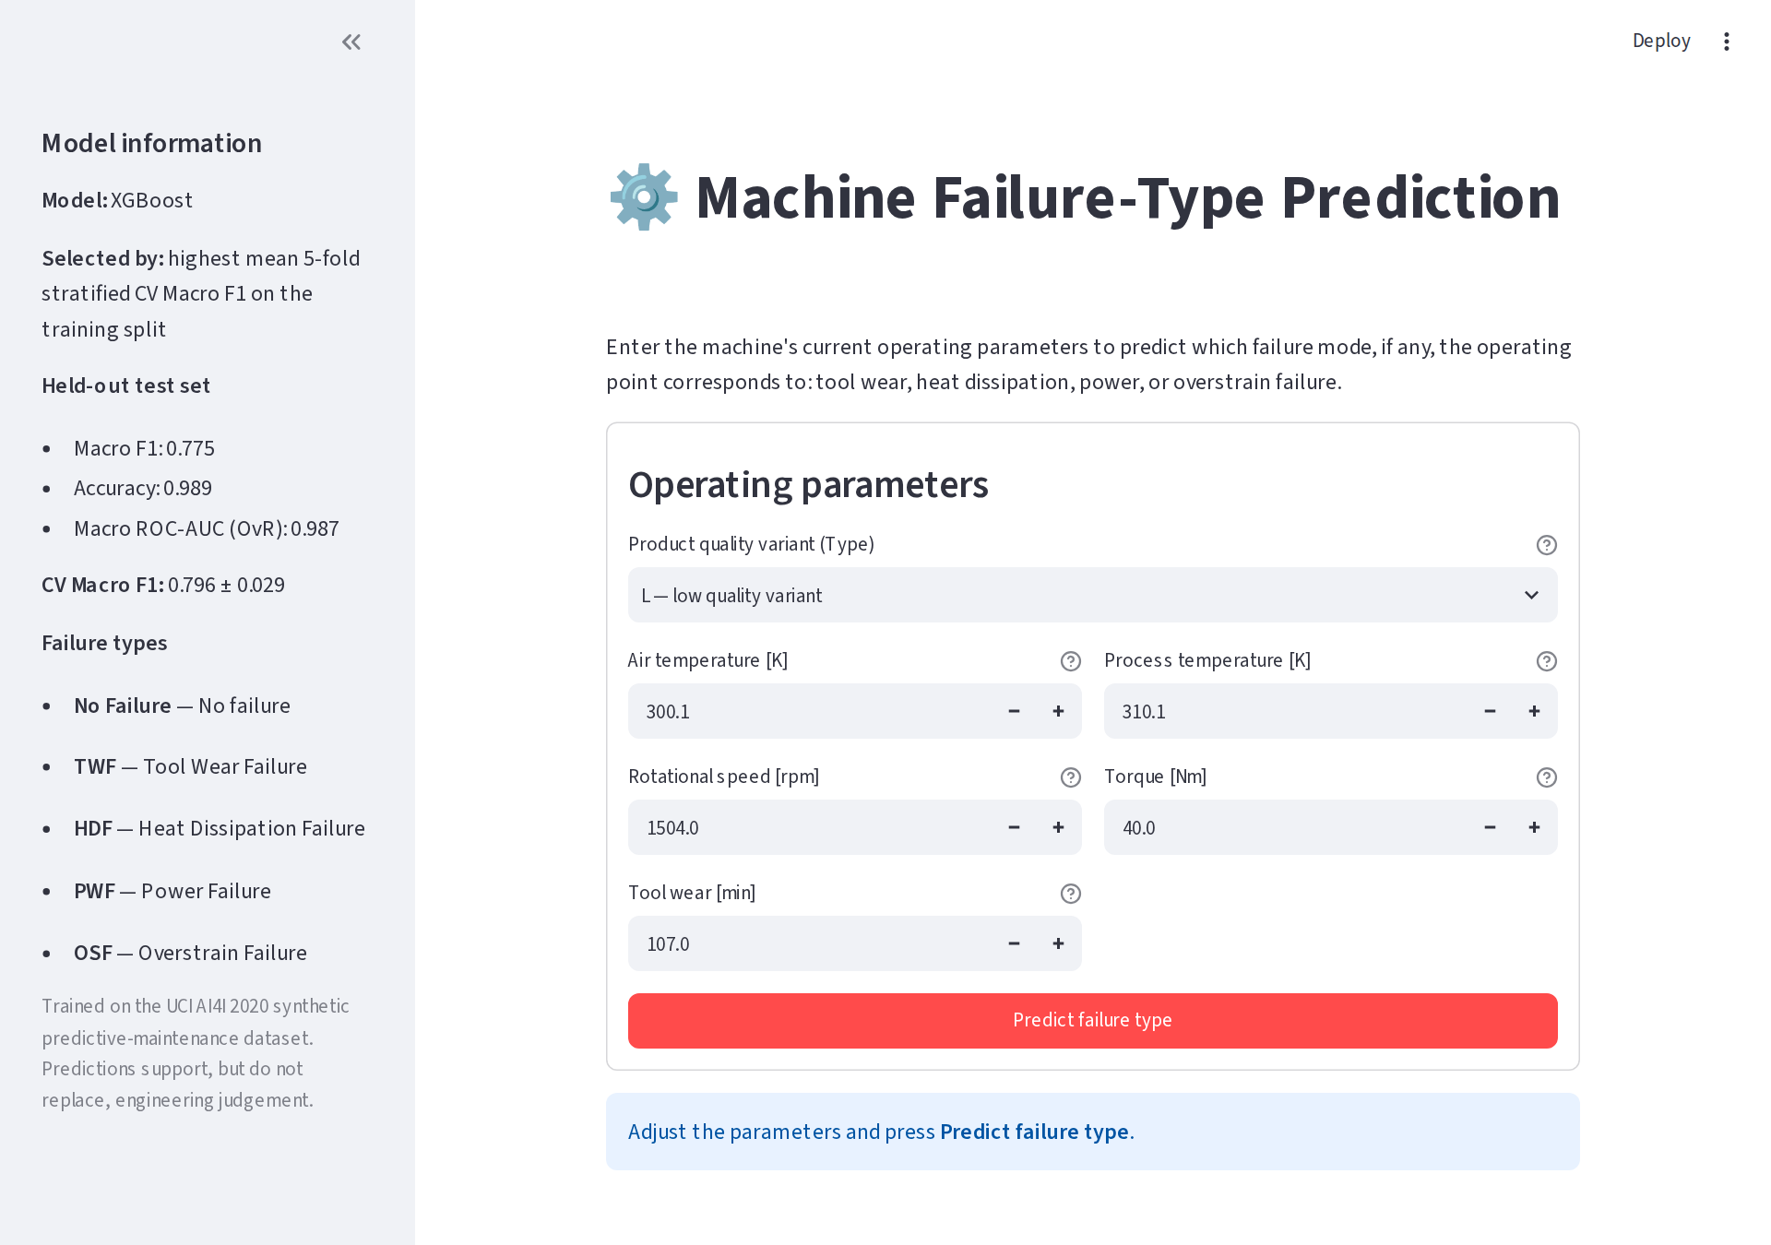
Figure 22. Input form with model information in the sidebar.
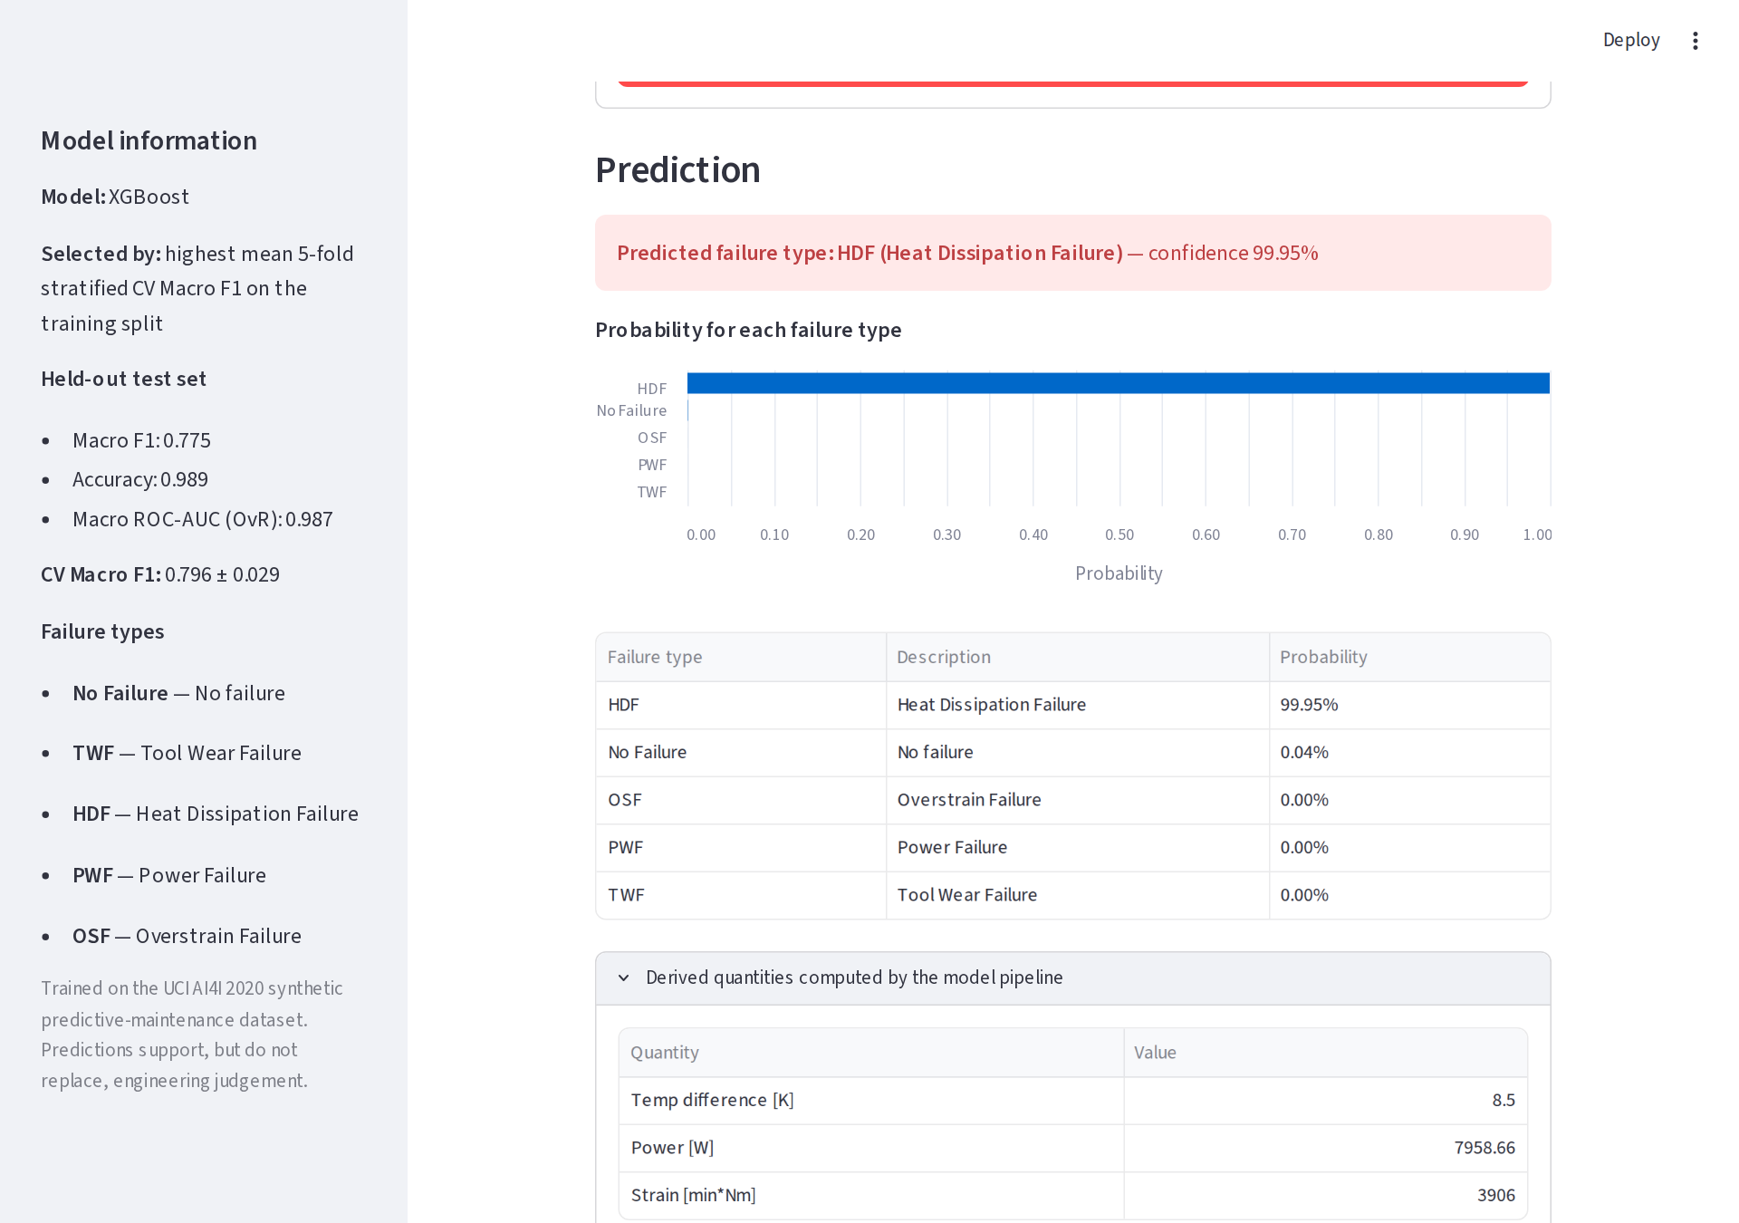
Figure 23. Prediction for a test-set HDF record: Heat Dissipation Failure, with class probabilities and derived quantities.
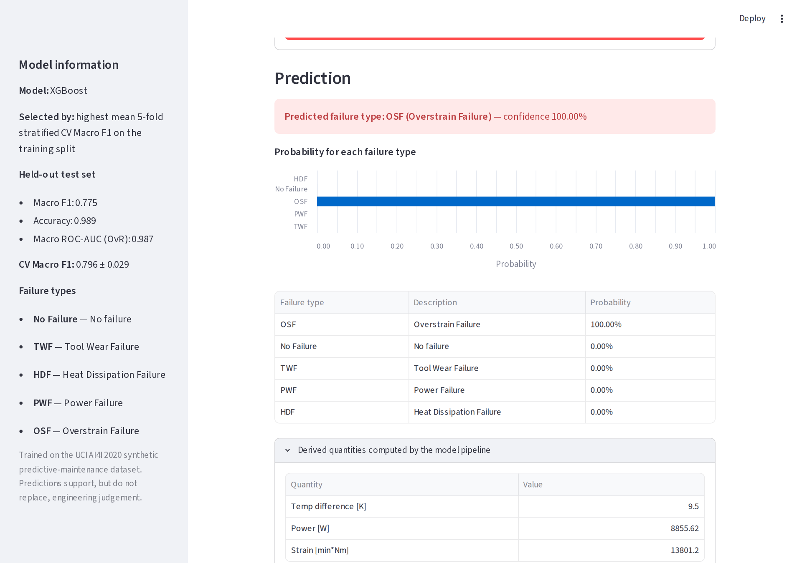
Figure 24. Prediction for a test-set OSF record: Overstrain Failure.
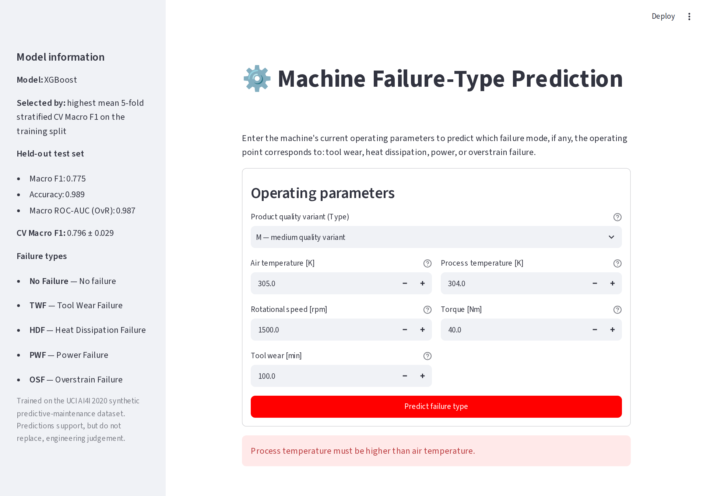
Figure 25. Input validation: process temperature below air temperature is rejected.

25. Results
- A five-class target was built transparently; 50 of 10,000 records (0.5%) were excluded with a logged reason.
- Engineered physical features raised mean CV Macro F1 from 0.684 to 0.791.
- The final model, XGBoost, reached CV Macro F1 0.7956 ± 0.0294 and test Macro F1 0.7750, accuracy 0.9894, macro OvR ROC-AUC 0.9873 — against a dummy baseline Macro F1 of 0.197.
- HDF (F1 0.933), OSF (0.937) and PWF (0.866) are predicted reliably; TWF is not (0.142). Excluding TWF, Macro F1 is 0.933.
- Failure classes are never confused with each other; all 21 test errors are between a failure class and No Failure.
- Stacking and Random Forest trade many more false alarms (105 and 85) for fewer missed failures (1 and 3).
- SHAP ties each failure class to its physical driver: strain → OSF, power → PWF, temperature difference → HDF, tool wear → TWF.
- The complete pipeline is deployed in a validated Streamlit app and covered by 36 automated tests, all passing.

26. Limitations
- Synthetic data. Failures in AI4I 2020 are generated from rule-like conditions, which is why the tree models find sharp boundaries. Performance on real machines, with sensor noise and gradual degradation, would likely be lower.
- Tool-wear failure is not predictable from these inputs. Its records are indistinguishable from No Failure records at the same tool wear.
- Small minority classes. The test set holds 9–21 records per failure class, so per-class metrics are uncertain: one record changes TWF recall by 11 percentage points.
- Close model scores. CV differences among XGBoost, Random Forest and Stacking are within about one standard deviation; the best CV scores are slightly optimistic because they are maxima over many candidates.
- Scope of the target. 23 records with simultaneous failure modes and the random-failure mode are outside the single-label formulation.
- Point-in-time snapshots. There is no time dimension, so the model classifies the current state and cannot forecast time to failure.
- Default decision threshold. Predictions use the most probable class; no cost-sensitive threshold was tuned, because the relative costs of false alarms and missed failures were not specified.

27. Future Scope
- Cost-sensitive thresholds per class, chosen on validation data from the real cost of false alarms versus missed failures — the principled way to choose between the XGBoost and Stacking operating points.
- A multi-label formulation to predict simultaneous failure modes instead of excluding them.
- Validation on real shop-floor data, and time-series features (e.g. tool-wear rate, temperature trends) to enable remaining-useful-life estimation.
- Probability calibration and drift monitoring for a production deployment; containerised deployment of the Streamlit app.
- Nested cross-validation for an unbiased estimate of the tuned models' performance.

28. Conclusion
This project built a complete, reproducible machine-learning system that predicts the failure mode of a milling machine from six operating parameters. Careful target construction, a strictly separated test set, physically motivated feature engineering and Macro-F1-driven model selection produced an XGBoost model with test Macro F1 0.7750 and accuracy 0.9894, which identifies heat-dissipation, power and overstrain failures reliably and whose decisions align with the underlying physics.
The analysis was equally informative about what the data cannot support: tool-wear failure is essentially unpredictable from these inputs, and the choice between the best models is a choice between false alarms and missed failures rather than a single winner. The final pipeline is deployed as a validated Streamlit application and backed by automated tests, making the work suitable both as an academic submission and as a starting point for a real predictive-maintenance tool.

References
[1] S. Matzka, "Explainable Artificial Intelligence for Predictive Maintenance Applications," in Proc. Third International Conference on Artificial Intelligence for Industries (AI4I), 2020.
[2] UCI Machine Learning Repository, "AI4I 2020 Predictive Maintenance Dataset" (id 601). https://archive.ics.uci.edu/dataset/601/ai4i+2020+predictive+maintenance+dataset
[3] L. Breiman, "Random Forests," Machine Learning, vol. 45, pp. 5–32, 2001.
[4] T. Chen and C. Guestrin, "XGBoost: A Scalable Tree Boosting System," in Proc. 22nd ACM SIGKDD, 2016.
[5] L. Prokhorenkova, G. Gusev, A. Vorobev, A. V. Dorogush and A. Gulin, "CatBoost: unbiased boosting with categorical features," in Advances in Neural Information Processing Systems 31, 2018.
[6] D. H. Wolpert, "Stacked Generalization," Neural Networks, vol. 5, no. 2, pp. 241–259, 1992.
[7] S. M. Lundberg and S.-I. Lee, "A Unified Approach to Interpreting Model Predictions," in Advances in Neural Information Processing Systems 30, 2017.
[8] F. Pedregosa et al., "Scikit-learn: Machine Learning in Python," Journal of Machine Learning Research, vol. 12, pp. 2825–2830, 2011.
Software: Python 3.11.15; scikit-learn 1.9.1, XGBoost 3.2.0, CatBoost 1.2.10, pandas 3.0.6, NumPy 2.4.6, SHAP 0.51.0, Streamlit 1.64.0, Joblib 1.6.0.

