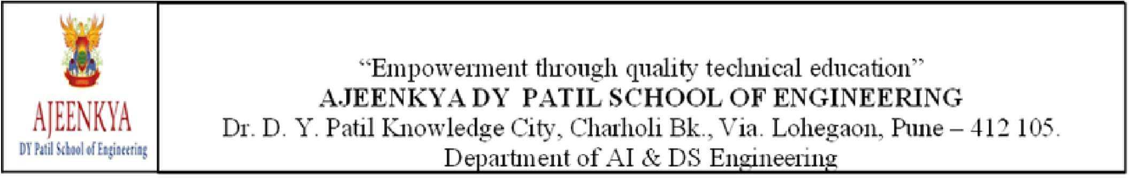

Stress Relief :Yoga & Meditation

Samruddhi Kotwal
B-27

Introduction:
The Stress Relief: Yoga and Meditation audit course is designed to equip students with essential soft skills that complement academic knowledge and prepare them for real-world challenges. In today’s fast-paced world, stress has become an almost unavoidable part of daily life. Whether it stems from work, relationships, or personal challenges, unmanaged stress can take a toll on both mental and physical health. Fortunately, ancient practices like yoga and meditation offer powerful tools for managing stress and promoting overall well-being. Yoga is a holistic discipline that combines physical postures, controlled breathing, and mindfulness to enhance flexibility, strength, and inner peace. Regular yoga practice not only improves physical health but also calms the nervous system and reduces stress levels. Meditation, on the other hand, is the practice of focused attention and mental clarity. By helping individuals become more aware of their thoughts and emotions, meditation cultivates a sense of inner calm, resilience, and emotional balance. Together, yoga and meditation form a synergistic approach to stress relief, encouraging a healthier, more centered, and peaceful way of living. Whether practiced individually or together, they offer accessible methods for reducing stress and enhancing the quality of life.
Course Summary:
The Stress Relief: Yoga and Meditation this course offers a comprehensive introduction to the powerful practices of yoga and meditation as effective tools for stress relief and mental wellbeing. Designed for beginners and those seeking to deepen their understanding, the course blends theory with practice to help participants develop a holistic approach to managing stress. is designed to help individuals manage stress naturally through the ancient and proven practices of yoga and meditation. Whether you're new to these practices or looking to deepen your routine, this course provides practical, accessible techniques to bring balance and peace into your everyday life. Throughout the course, you will understand: The science behind stress and its effects on the body and mind.

1.Foundational yoga postures (asanas) aimed at relaxation and tension release

2.Breathing techniques (pranayama) to calm the nervous system

3.Guided meditation and mindfulness practices for mental clarity and emotional balance

4.Techniques for incorporating yoga and meditation into daily life.

By the end of this course, you'll gain not only theoretical knowledge but also real-life tools to reduce stress, increase inner peace, and improve your physical and mental resilience. It’s more than just a class — it’s a pathway to a more mindful, balanced life.

Conclusion:
The Stress Relief: Yoga and Meditation audit course has been a transformative learning experience that went beyond traditional academic subjects. Here we gained a strong foundation in using yoga and meditation as practical, effective tools for managing stress and improving overall well-being. You’ve explored the physical, mental, and emotional benefits of these ancient practices and learned how to apply them in your daily life. By incorporating simple yoga postures, mindful breathing, and regular meditation into your routine, you now have the ability to respond to stress with calm, clarity, and balance. Remember, stress is a part of life—but how you handle it can make all the difference. This journey is just the beginning. With continued practice, your connection to inner peace will grow stronger, empowering you to live with greater awareness, resilience, and joy. Carry these tools with you, and let them guide you toward a healthier, more centered life.

