

**Laboratory Practice II (310258)**

# (2019 Pattern) Practical Assignments

# Part-I:Artificial Intelligence

**Part – IICloud Computing**



# LP II Cloud Computing

**Assignment No**: 1

**Aim**: Case study on Amazon EC2 to learn about Amazon EC2,Amazon Elastic Compute Cloud is a central

part of Amazon.com's cloud computing platform, Amazon Web Services. How EC2 allows users torrent virtual computers on which to run their own computer applications.

# Objectives:

1. To learn Amazon Web Services.
2. To case study the Amazon EC2.

# Software Requirements:

Windows 10 and above

# Hardware Requirements:

Pentium IV system with latest configuration

# Theory:

**Amazon Elastic Compute Cloud (EC2)**

**Elastic IP addresses** allow you to allocate a static IP address and programmatically assign it to an instance. You can enable monitoring on an Amazon EC2 instance using Amazon CloudWatch2 in order to gain visibility into resource utilization, operational performance and overall demand patterns (including metrics such as CPU utilization, disk reads and writes, and network traffic). You can create Auto

feature3 to automatically scale your capacity on certain conditions based on m

Amazon CloudWatch collects. You can also distribute incoming traffic by creating an elastic load balancer using the Elastic Load Balancing4 service. Amazon Elastic Block Storage (EBS)5 volumes provide network

Point-in-time consistent snapshots of EBS volumes can be created and stored on Amazon Simple Storage Service (Amazon S3)6.

Amazon S3 is highly durable and distributed data store. With a simple web services interface, you can store and retr

at any time, from anywhere on the web using standard HTTP verbs. Copies of objects can be distributed and cached at 14 edge locations around the world by creating a distribution using Amazon CloudFront7 service

content). Amazon SimpleDB8 is a web service that provides the core functionality of a database- real-time lookup and simple querying of structured data



complexity. You can organize the dataset into domains and can run queries across all of the Auto-scaling Group using the Auto network-attached persistent storage to Amazon

EC2 instances. retrieve large amounts of data as objects in buckets (containers) udFront7 – a web service for content delivery (static or streaming

– without the operational

plexity. performance,Auto-scaling metric that n even data stored in a particular domain.

Domains are collections of items that are described by attribute-value pairs.

**Amazon Relational Database Service9 (Amazon RDS)** provides an easy way to setup, operate and scale a relational database in the cloud. You can launch a DB Instance and get access to a full-featured MySQL database and not worry about common database administration tasks like backups, patch management etc.

Amazon Simple Queue Service (Amazon SQS)10 is a reliable, highly scalable, hosted distributed queue for storing messages as they travel between computers and application components.

**Amazon Simple Notifications Service (Amazon SNS)** provides a simple way to notify applications or people from the cloud by creating Topics and using a publish-subscribe protocol.

**Amazon Elastic MapReduce** provides a hosted Hadoop framework running on the webscale infrastructure of Amazon Elastic Compute Cloud (Amazon EC2) and Amazon Simple Storage Service (Amazon S3) and allows you to create customized JobFlows. JobFlow is a sequence of MapReduce steps.

**Amazon Virtual Private Cloud (Amazon VPC)** allows you to extend your corporate network into a private cloud contained within AWS. Amazon VPC uses IPSec tunnel mode that enables you to create a secure connection between a gateway in your data center and a gateway in AWS.

**Amazon Route53** is a highly scalable DNS service that allows you manage your DNS records by creating a HostedZone for every domain you would like to manage.

**AWS Identity and Access Management (IAM)** enable you to create multiple Users with unique security credentials and manage the permissions for each of these Users within your AWS Account. IAM is natively integrated into AWS Services. No service APIs have changed to support IAM, and exiting applications and tools built on top of the AWS service APIs will continue to work when using IAM.

AWS also offers various payment and billing services that leverages Amazon’s payment infrastructure. All AWS infrastructure services offer utility-style pricing that require no longterm commitments or contracts. For example, you pay by the hour for Amazon EC2 instance

usage and pay by the gigabyte for storage and data transfer in the case of Amazon S3. More information about each of these services and their pay-as-you-go pricing is available on the

You are free to use the programming model, language, or operating system

(Windows, OpenSolaris or any flavor of Linux) of your choice.

You are free to pick and choose the AWS products that best satisfy your requirements—you can use any of the services individually or in any combination. Because AWS provides resizable (storage, bandwidth and computing) resources, you are free to consume as much or as little and only pay for what you consume.

You are free to use the system management tools you’ve used in the past and extend your datacenter into the cloud.

# Launching an EC2 instance

* 1. **Sign in to the preview version of the** [**AWS Management Console**](http://console.aws.amazon.com/)
  2. Open the Amazon EC2 console by choosing **EC2** under Compute.
  3. From the EC2 Console, click **Launch Instance**.

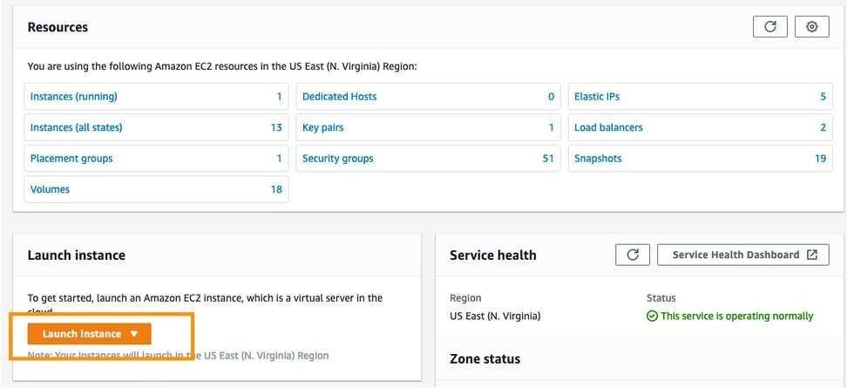

The **Choose an Amazon Machine Image (AMI)** page displays a list of basic configurations called Amazon Machine Images (AMIs) that serve as templates for your instance. Select the HVM edition of the **Amazon Linux 2 AMI**.

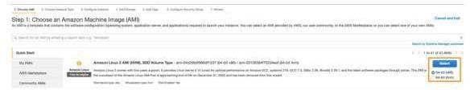

On the **Choose an Instance Type page**, choose **c5d.xlarge** as the hardware configuration of your instance and **Review and Launch**.



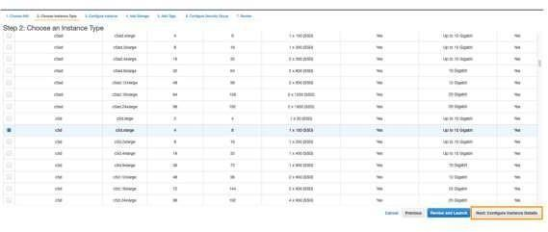

On Instances details, make sure the Auto-assign Public IP is **Enable** and you selected Enclave as **Enable**. Click on **Next: Add Storage**

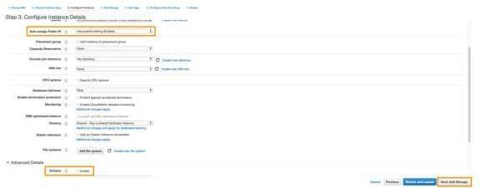

Review the configurations and click **next: Add Tages**The **ephemeral0** is the Instance Storage based on NVMe SSD.

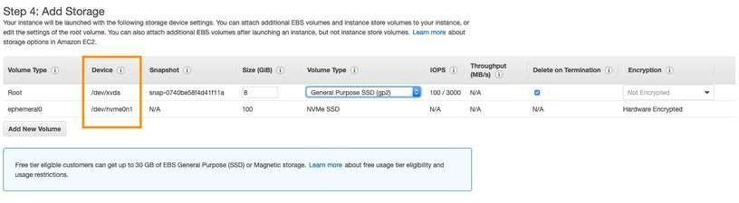

A tag consists of a case-sensitive key-value pair. For example, you could define a tag with key = Name and value = Webserver. Add a tag and click **Next: Configure Security Group**



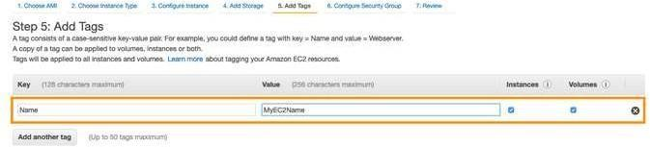

A security group is a set of firewall rules that control the traffic for your instance. On this page, you can add rules to allow specific traffic to reach your instance. For example, if you want to set up a web server and allow Internet traffic to reach your instance, add rules that allow unrestricted access to the HTTP and HTTPS ports. Give the Security group a name and Description. Select source as **My IP** to avoid expose SSH port 22 to the world. **Click Review and Launch**.

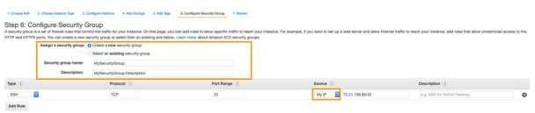

Review Instance Launch and click **Launch**

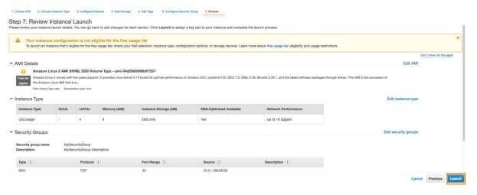

In the **Select an existing key pair or create a new key pair** dialog box, choose **Create a new key pair**, enter a name for the key pair, and then choose **Download Key Pair**. This is the only chance for you to save the private key file, so be sure to download it. Save the private key file in a safe place. You can use C:\user\yourusername.ssh\myfirstkey.pem if you are on a Windows machine, and

~/.ssh/myfirstkey.pem if you are on a Mac or Linux machine. You need to provide the name of your key pair when you launch an instance, and the corresponding private key each time you connect to the



instance.

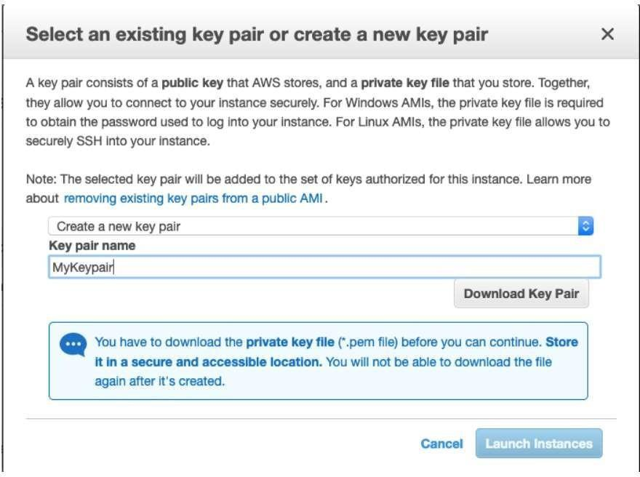

A confirmation page lets you know that your instance is launching. Choose **View Instances** to close the confirmation page and return to the console.

On the Instances page, you can view the status of your instance. It takes a short time for an instance to launch. When you launch an instance, its initial state is pending. After the instance starts, its state changes to running, and it receives a public DNS name.

# Conclusion

Performed case study of Amazon web services: Amazon EC2.



# Assignment No: 2

**Aim**: Case study on Microsoft azure to learn about Microsoft Azure is a cloud computing platform and infrastructure, created by Microsoft, forbuilding, deploying and managing applications and services through a global network of Microsoft-managed datacenters. How it work, different services provided by it.

# Objectives:

1. To learn Microsoft Azure Cloud computing platform.
2. To case study the Microsoft Azure cloud services.

# Software Requirements:

Windows 10

# Hardware Requirements:

Pentium IV system with latest configuration

# Theory:

**Execution Environment**

The Windows Azure execution environment consists of a platform for applications and services hosted within one or more roles. The types of roles you can implement in Windows Azure are:

* **Azure Compute (Web and Worker Roles)**. A Windows Azure application consists of one or more hosted roles running within the Azure data centers. Typically there will be at least one Web role that is exposed for access by users of the application. The application may contain additional roles, including Worker roles that are typically used to perform background processing and support tasks for Web roles. For more detailed information see

―Overview of Creating a Hosted Service for Windows Azure‖ a[thttp://technet.microsoft.com/](http://technet.microsoft.com/en-au/library/gg432976.aspx)e[n-au/library/gg432976.aspx](http://technet.microsoft.com/en-au/library/gg432976.aspx) and ―Building an Application that Runs in a Hosted Service‖ at [http://technet.microsoft.com/en-au/library/hh180152.aspx.](http://technet.microsoft.com/en-au/library/hh180152.aspx)

* **Virtual Machine (VM role)**. This role allows you to host your own custom instance of the Windows Server 2008 R2 Enterprise or Windows Server 2008 R2 Standard operating system within a Windows Azure data center. For more detailed information see ―Creating Applications by Using a VM Role in Windows Azure‖ a[thttp://technet.microsoft.com/](http://technet.microsoft.com/enau/)e[nau/](http://technet.microsoft.com/enau/) library/gg465398.aspx.



# Data Management

Windows Azure, SQL Azure, and the associated services provide opportunities for storing and managing data in a range of ways. The following data management services and features are available:

* **Azure Storage:** This provides four core services for persistent and durable data storage in

the cloud. The services support a REST interface that can be accessed from within Azurehosted or on-premises (remote) applications. For information about the REST API, see

―Windows Azure Storage Services REST API Reference‖ a[thttp://msdn.mi](http://msdn.microsoft.com/enus/)c[rosoft.com/enus/](http://msdn.microsoft.com/enus/) library/dd179355.aspx. The four storage services are:

* **The Azure Table Service** provides a table-structured storage mechanism based on the familiar rows and columns format, and supports queries for managing the data. It is primarily aimed at scenarios where large volumes of data must be stored, while being easy to access and update. For more detailed information see ―Table Service Concepts‖ a[t http://msdn.microsoft.com/en-us/library/dd179463.aspx](http://msdn.microsoft.com/en-us/library/dd179463.aspx) and ―Table Service API‖ at <http://msdn.microsoft.com/en-us/library/dd179423.aspx>.
* **The Binary Large Object (BLOB) Service** provides a series of containers aimed at storing text or binary data. It provides both Block BLOB containers for streaming data, and Page BLOB containers for random read/write operations. For more detailed information see ―Understanding Block Blobs and Page Blobs‖ a[thttp://msdn.microsoft.com/](http://msdn.microsoft.com/en-us/library/ee691964.aspx)e[n-us/library/ee691964.aspx](http://msdn.microsoft.com/en-us/library/ee691964.aspx) and ―Blob Service API‖ at <http://msdn.microsoft.com/en-us/library/dd135733.aspx>.
* **The Queue Service** provides a mechanism for reliable, persistent messaging between role instances, such as between a Web role and a Worker role. For more detailed information see ―Queue Service Concepts‖ a[t http://msdn.microsoft.com/enus/](http://msdn.microsoft.com/enus/) library/dd179353.aspx and ―Queue Service API‖ a[thttp://](http://msdn.microsoft.com/enus/)m[sdn.microsoft.com/enus/](http://msdn.microsoft.com/enus/) library/dd179363.aspx.
* Windows Azure Drives provide a mechanism for applications to mount a single volume NTFS VHD as a Page BLOB, and upload and download VHDs via the BLOB. For more detailed information see ―Windows Azure Drive‖ (PDF) at <http://go.microsoft.com/?linkid=9710117>.
* **SQL Azure Database:** This is a highly available and scalable cloud database service built on SQL Server technologies, and supports the familiar T-SQL based relational database model. It can be used with applications hosted in Windows Azure, and with other applications running on-premises or hosted elsewhere. For more detailed information see

―SQL Azure Database‖ at <http://msdn.microsoft.com/en-us/library/ee336279.aspx>.

* **Data Synchronization:** SQL Azure Data Sync is a cloud-based data synchronization service built on Microsoft Sync Framework technologies. It provides bi-directional data synchronization and data management capabilities allowing data to be easily shared between multiple SQL Azure databases and between on-premises and SQL Azure databases. For

more detailed information see ―Microsoft Sync Framework Developer Center‖ at [http://msdn.microsoft.com/en-us/sync.](http://msdn.microsoft.com/en-us/sync)

* **Caching:** This service provides a distributed, in-memory, low latency and high throughput application cache service that requires no installation or management, and dynamically increases and decreases the cache size automatically as required. It can be used to cache application data, ASP.NET session state information, and for ASP.NET page output caching. For more detailed information see ―Caching Service (Windows Azure AppFabric)‖ at [http://msdn.microsoft.com/en-us/library/gg278356.aspx.](http://msdn.microsoft.com/en-us/library/gg278356.aspx)

# Networking Services

Windows Azure provides several networking services that you can take advantage of to maximize

performance, implement authentication, and improve manageability of your hosted applications. These services include the following:

* **Content Delivery Network (CDN).** The CDN allows you to cache publicly available static data for applications at strategic locations that are closer (in network delivery terms) to end users. The CDN uses a number of data centers at many locations around the world, which store the data in BLOB storage that has anonymous access. These do not need to be locations where the application is actually running. For more detailed information see ―Delivering High-Bandwidth Content with the Windows Azure CDN‖ a[thttp://msdn.mi](http://msdn.microsoft.com/enus/)c[rosoft.com/enus/](http://msdn.microsoft.com/enus/) library/ee795176.aspx.
* **Virtual Network Connect.** This service allows you to configure roles of an application running in Windows Azure and computers on your on-premises network so that they appear to be on the same network. It uses a software agent running on the on-premises computer to establish an IPsec-protected connection to the Windows Azure roles in the cloud, and provides the capability to administer, manage, monitor, and debug the roles directly. For more detailed information see ―Connecting Local Computers to Windows Azure Roles‖ at <http://msdn.microsoft.com/en-us/library/gg433122.aspx>.
* **Virtual Network Traffic Manager.** This is a service that allows you to set up request redirection and load balancing based on three different methods. Typically you will use Traffic Manager to maximize performance by redirecting requests from users to the instance in the closest data center using the Performance method. Alternative load balancing methods available are Failover and Round Robin. For more detailed information see ―Windows Azure Traffic Manager‖ a[t http://msdn.microsoft.com/enus/](http://msdn.microsoft.com/enus/) WAZPlatformTrainingCourse_WindowsAzureTrafficManager.
* **Access Control.** This is a standards-based service for identity and access control that makes use of a range of identity providers (IdPs) that can authenticate users. ACS acts as a Security Token Service (STS), or token issuer, and makes it easier to take advantage of federation authentication techniques where user identity is validated in a realm or domain other than that in which the application resides. An example is controlling user access based on an identity verified by an identity provider such as Windows Live ID or Google. For more detailed information see ―Access Control Service 2.0‖ at <http://msdn.microsoft.com/en> us/library/gg429786.aspx and ―Claims Based Identity & Access Control Guide‖ at <http://claimsid.codeplex.com/>.



* **Service Bus.** This provides a secure messaging and data flow capability for distributed and hybrid applications, such as communication between Windows Azure hosted applications and on-premises applications and services, without requiring complex firewall and security infrastructures. It can use a range of communication and messaging protocols and patterns to provide delivery assurance, reliable messaging; can scale to accommodate varying loads; and can be integrated with on-premises BizTalk Server artifacts. For more detailed information see ―AppFabric Service Bus‖ at <http://msdn.microsoft.com/en-us/library/ee732537.aspx>

# Conclusion

Performed case study of Microsoft Azure Cloud computing platform and services.



# Assignment No: 3

**Aim**: Assignment to install and configure Google App Engine.

# Objectives:

1. To learn basics of Google App Engine.
2. To install and configure Google App Engine.

# Software Requirements:

Windows 10

# Hardware Requirements:

Pentium IV system with latest configuration

# Theory:

Google App Engine is Google's platform as a service offering that allows developers and businesses to build and run applications using Google's advanced infrastructure. These applications are required to be written in one of a few supported languages, namely: Java, Python, PHP and Go. It also requires the use of Google query language and that the database used is Google Big Table.

Applications must abide by these standards, so applications either must be developed with GAE in mind or else modified to meet the requirements. GAE is a platform, so it provides all of the required elements to run and host Web applications, be it on mobile or Web. Without this all-in feature, developers would have to source their own servers, database software and the APIs that would make all of them work properly together, not to mention the entire configuration that must be done. GAE takes this burden off the developers so they can concentrate on the app front end and functionality, driving better user experience.

Advantages of GAE include:

* Readily available servers with no configuration requirement
* Power scaling function all the way down to "free" when resource usage is minimal
* Automated cloud computing tools



1. Make sure you have python installed in your ubuntu system. run the command ―*python - V”* and most probably you will get ―Python 2.7.6‖ or above.
2. Crul https://sdk.cloud.google.com and use bash to run the commands by typing this command curl https://sdk.cloud.google.com | bash
3. Whenever you get to choose directories just hit enter, ―YEAH IT WILL BE FINE‖.
4. Follow the instructions in the installation process.
5. Then run gcloud init
6. Follow the installation instructions as they are very straight forward.
7. Choose the account you want to use for google app engine.
8. Choose the project with numeric choice (don’t use textual, you might make mistake). If you do not already have a google app engine project create a app engine project by following this link. https://console.cloud.google.com/start
9. Enable google api by pressing Y in the command line prompt.

***Now as we have finished installing appengine, now it’s time to create and upload an app. In this case we will be taking example of a “HELLO WORLD” app in python.***

1. As we already have made sure that we have python installed in our system, It will be easier for us to clone existing code and deploy it rather than creating our own so we will use python-docs-sample. Run the command ―git clone https://github.com/GoogleCloudPlatform/python-docs-samples‖.
2. cd to hello world sample by typing the command ― cd python-docssamples/ appengine/standard/hello_world‖.
3. Then run the command ―dev_appserver.py app.yml‖. It will run and give you the url of default and admin. If you go to the link of default you see the text hello world like this.

This is how you run the python app in your local server. But what we have to do is hosting the app in google app engine. To do so Now let’s follow the following instructions.

1. Run the command *Ctrl + C .*
2. Being in the same working directory hello-world runt he command

*gcloud app deploy*

1. Select the project you want to deploy the app , press Y and enter to continue. after that you will get the console output ―Deployed service[default] to [Your web url for appengine] ‖
2. If you copy and paste the url, you will see the hello world in the browser too. Web output

Now you have successfully uploaded your web app into app engine.

# Conclusion

Hence we learnt to install and configure Google App Engine.



# Assignment No: 4

**Aim: Creating an Application in SalesForce.com using Apex programmingLanguage**

# Objectives:

1. To learn Sales Force Cloud
2. To study Apex programmingLanguage

# Software Requirements:

Windows 10

# Hardware Requirements:

Pentium IV system with latest configuration

# Theory:

**WhatisApex?**

Apex is a proprietary language developed by the Salesforce.com. As per the official definition, Apex is a strongly typed, object-oriented programming language that allows developers to execute the flow and transaction control statements on the Force.com platform server in conjunction with calls to the Force.com API.

It has a Java-like syntax and acts like database stored procedures. It enables the developers to add business logic to most system events, including button clicks, related record updates, and Visual force

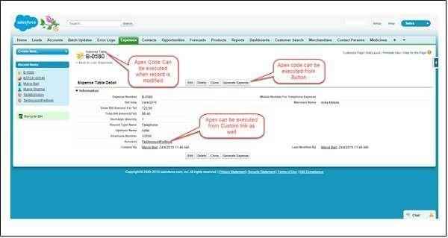



**pages. Apex** code can be initiated by Web service requests and from triggers on objects. Apex is included in Performance Edition, Unlimited Edition, Enterprise Edition, and Developer Edition.

# Featuresof ApexasaLanguage

Let us now discuss the features of Apex as a Language −

* Integrated

Apex has built in support for DML operations like INSERT, UPDATE, DELETE and also DML Exception handling. It has support for inline SOQL and SOSL query handling which returns the set of sObject records. We will study the sObject, SOQL, SOSL in detail in future chapters.

* Java like syntax and easy to use

Apex is easy to use as it uses the syntax like Java. For example, variable declaration, loop syntax and conditional statements.

* Strongly Integrated With Data

Apex is data focused and designed to execute multiple queries and DML statements together. It issues multiple transaction statements on Database.

* Strongly Typed

Apex is a strongly typed language. It uses direct reference to schema objects like sObject and any invalid reference quickly fails if it is deleted or if is of wrong data type.

* Multitenant Environment

Apex runs in a multitenant environment. Consequently, the Apex runtime engine is designed to guard closely against runaway code, preventing it from monopolizing sharedresources. Any code that violates limits fails with easy-to-understand error messages.

* Upgrades Automatically

Apex is upgraded as part of Salesforce releases. We don't have to upgrade it manually.

* Easy Testing

Apex provides built-in support for unit test creation and execution, including test results that indicate how much code is covered, and which parts of your code can be more efficient.

# WhenShouldDeveloperChooseApex?

Apex should be used when we are not able to implement the complex business functionality using the pre-built and existing out of the box functionalities. Below are the cases where we need to use apex over Salesforce configuration.



# Apex Applications

We can use Apex when we want to −

Create Web services with integrating other systems. Create email services for email blast or email setup.

Perform complex validation over multiple objects at the same time and also custom validation implementation.

Create complex business processes that are not supported by existing workflowfunctionality or flows.

Create custom transactional logic (logic that occurs over the entire transaction, not justwith a single record or object) like using the Database methods for updating the records.

Perform some logic when a record is modified or modify the related object's record whenthere is some event which has caused the trigger to fire.

# Working Structure of Apex

As shown in the diagram below (Reference: Salesforce Developer Documentation), Apex runsentirely on demand Force.com Platform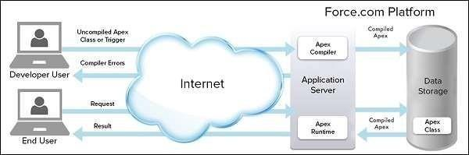

# Flowof Actions

There are two sequence of actions when the developer saves the code and when an end user performs some action which invokes the Apex code as shown below −

# Developer Action

When a developer writes and saves Apex code to the platform, the platform application server first compiles the code into a set of instructions that can be understood by the Apex runtime interpreter, and then saves those instructions as metadata.

# End User Action



When an end-user triggers the execution of Apex, by clicking a button or accessing a Visualforce page, the platform application server retrieves the compiled instructions from the metadata and sends them through the runtime interpreter before returning the result. The end-user observes no differences in execution time as compared to the standard application platform request.

Since Apex is the proprietary language of Salesforce.com, it does not support some features which a general programming language does. Following are a few features which Apex doesnot support −

It cannot show the elements in User Interface.

You cannot change the standard SFDC provided functionality and also it is not possibleto prevent the standard functionality execution.

You cannot change the standard SFDC provided functionality and also it is not possibleto prevent the standard functionality execution.

Creating multiple threads is also not possible as we can do it in other languages.

# Understandingthe ApexSyntax

Apex code typically contains many things that we might be familiar with from otherprogramming languages.

# Variable Declaration

As strongly typed language, you must declare every variable with data type in Apex. As seen inthe code below (screenshot below), lstAcc is declared with data type as List of Accounts.

# SOQL Query

This will be used to fetch the data from Salesforce database. The query shown in screenshot below is fetching data from Account object.

# Loop Statement

This loop statement is used for iterating over a list or iterating over a piece of code for a specified number of times. In the code shown in the screenshot below, iteration will be same as the number of records we have.

# Flow Control Statement

The If statement is used for flow control in this code. Based on certain condition, it is decided whether to go for execution or to stop the execution of the particular piece of code. For example, in the code shown below, it is checking whether the list is empty or it containsrecords.

# DML Statement

Performs the records insert, update, upsert, delete operation on the records in database. For example, the code given below helps in updating Accounts with new field value.

# Apex Code Development Tools

In all the editions, we can use any of the following three tools to develop the code −

Force.com Developer Console Force.com IDE

Code Editor in the Salesforce User Interface

**Conclusion:** Hence we learnt to create an Application in SalesForce.com using Apex programming Language



# Assignment No: 5

**Aim: Design and develop custom Application (Mini Project) using Salesforce Cloud.**

# Theory:

**Objectives**:

1. To design application custom Application.
2. To develop application using sales force cloud

# Software Requirements:

Windows 10

# Hardware Requirements:

Pentium IV system with latest configuration

# Introduction

**Salesforce.com Inc.** is an American cloud-based software company headquartered in [San](https://en.wikipedia.org/wiki/San_Francisco) [Francisco,](https://en.wikipedia.org/wiki/San_Francisco) [California.](https://en.wikipedia.org/wiki/California) Though the bulk of its revenue comes from a [customer relationship management](https://en.wikipedia.org/wiki/Customer_relationship_management) (CRM) product, Salesforce also sells a complementary suite of enterprise applications focused on customer service, marketing automation, analytics and application development.

Salesforce is the primary enterprise offering within the Salesforce platform. It provides companies with an interface for case management and [task management](https://en.wikipedia.org/wiki/Task_management), and a system for automatically routing and escalating important events. The Salesforce customer portal provides customers the ability to track their own cases, includes a social networking [plug-in](https://en.wikipedia.org/wiki/Plug-in_(computing)) that enables the user to join the conversation about their company on [social networking websites](https://en.wikipedia.org/wiki/Social_networking_website), provides analytical tools and other services including email alert, Google search, and access to customers' entitlement and contracts.

# Lightning Platform

Lightning Platform (also known as Force.com) is a [platform as a service](https://en.wikipedia.org/wiki/Platform_as_a_service) (PaaS) that allows developers to create add-on applications that integrate into the main Salesforce.com application. These third- party applications are hosted on Salesforce.com's infrastructure.

Force.com applications are built using declarative tools, backed by Lightning and Apex (a



proprietary [Java](https://en.wikipedia.org/wiki/Java_(programming_language))-like programming language for Force.com) and Lightning and Visual force (a framework that includes an XML syntax typically used to generate [HTML](https://en.wikipedia.org/wiki/HTML)). The Force.com platform typically receives three complete releases a year. As the platform is provided as a service to its developers, every single development instance also receives all these updates.

# Community Cloud

Community Cloud provides Salesforce customers the ability to create online web properties for external collaboration, customer service, channel sales, and other custom portals in their instance of Salesforce. Tightly integrated to Sales Cloud, Service Cloud, and App Cloud, Community Cloud can be quickly customized to provide a wide variety of web properties

# Salesforce Sales Cloud

Salesforce Sales Cloud is a customer relationship management ([CRM](https://searchcrm.techtarget.com/definition/CRM)) platform designed to support sales, marketing and customer support in both business-to-business ([B2B](https://searchcio.techtarget.com/definition/B2B)) and business-to-customer ([B2C](https://searchcio.techtarget.com/definition/B2C)) contexts. Sales Cloud is a fully customizable product that brings all the customer information together in an integrated platform that incorporates marketing, [lead generation](https://whatis.techtarget.com/definition/lead-generation), sales, customer service and [business analytics](https://searchbusinessanalytics.techtarget.com/definition/business-analytics-BA) and provides access to thousands of applications through the AppExchange. The platform is provided as Software as a Service ([SaaS](https://searchcloudcomputing.techtarget.com/definition/Software-as-a-Service)) for browser-based access; a [mobile app](https://whatis.techtarget.com/definition/mobile-app) is also available. A real- time social feed for collaboration allows users to share information or ask questions of the user community.[Salesforce.com](https://searchsalesforce.techtarget.com/definition/Salesforce%20Sales%20Cloud%20is%20a%20customer%20relationship%20management%20(CRM)%20platform%20designed%20to%20support%20sales%2C%20marketing%20and%20customer%20support%20in%20both%20business-to-business%20(B2B)%20and%20business-to-customer%20(B2C)%20contexts) offers five versions of Sales Cloud on a per-user, per month basis, from lowest to highest: Group, Professional, Enterprise, Unlimited and Performance. The company offers three levels of support contracts: Standard Success Plan, Premier Success Plan and Premier+ Success Plan.

# Create Custom Apps for Salesforce Classic

Create custom apps to give your Salesforce Classic users’ access to everything they need all in one place.

If you're new to custom apps, we recommend using [Lightning Platform quick start](https://help.salesforce.com/articleView?id=dev_quick_create.htm&type=5) to create an app. With this tool, you can generate a basic working app in just one step.

If you’ve already created the objects, tabs, and fields you need for your app, follow these steps. With this option, you create an app label and logo, add items to the app, and assign the appto profiles.

* 1. From Setup, enter Apps in the Quick Find box, then select **Apps**.



* 1. Click **New**.
  2. If the Salesforce console is available, select whether you want to define a custom app or a Salesforce console.
  3. Give the app a name and description.

An app name can have a maximum of 40 characters, including spaces.

* 1. Optionally, brand your app by giving it a custom logo.
  2. Select which items to include in the app.
  3. Optionally, set the default landing tab for your new app using the **Default Landing Tab** drop-down menu below the list of selected tabs. This determines the first tab a user sees when logging into this app.
  4. Choose which profiles the app will be visible to.
  5. Check the Default box to set the app as that profile’s default app, meaning that new users with the profile see this app the first time they log in. Profiles with limits are excluded from this list.
  6. Click **Save**

# What is the difference between custom application and console application in sales force?

A custom application is a collection of tabs, objects etc that function together to solve a particular problem.

A console application uses a specific Salesforce UI - the console. Console applications are intended to enhance productivity by allowing everything to be done from a single, tabbed, screen**.**

**Conclusion:** Hence we learnt to design and develop custom Application (Mini Project) using Sales force Cloud



**Mini-Project :** Setup your own cloud for Software as a Service (SaaS) over the existing

LAN in your laboratory. In this assignment you have to write your own code for cloud controller using open source technologies to implement **with HDFS**. Implement the basic operations may be like to divide the file in segments/blocks and upload/ download file on/from cloud in encrypted form.

[**https://www.tecmint.com/openstack-installation-guide-rhel-centos/**](https://www.tecmint.com/openstack-installation-guide-rhel-centos/)

**To set static IP address**

[**http://www.mustbegeek.com/configure-static-ip-address-in-centos/**](http://www.mustbegeek.com/configure-static-ip-address-in-centos/)

<https://www.tecmint.com/create-deploy-and-launch-virtual-machines-in-openstack/>

<https://www.tecmint.com/openstack-networking-guide/>

