TASK 1 code:

import java.util.Scanner;

public class GuessTheNumber {

public static void main(String[] args) {

Scanner scanner = new Scanner(System.in);

playGame(scanner);

scanner.close();

}

public static void playGame(Scanner scanner) {

System.out.println("Welcome to the Guess the Number game!");

boolean playAgain = true;

int totalAttempts = 0;

int totalRounds = 0;

int bestScore = Integer.MAX_VALUE;

while (playAgain) {

totalRounds++;

int randomNumber = generateRandomNumber(1, 100);

int attempts = 0;

boolean guessedCorrectly = false;

System.out.println("\nRound " + totalRounds);

System.out.println("Guess a number between 1 and 100:");

while (!guessedCorrectly) {

int guess = scanner.nextInt();

attempts++;

if (guess == randomNumber) {

System.out.println("Congratulations! You guessed the number " + randomNumber + " correctly in " + attempts + " attempts.");

guessedCorrectly = true;

} else if (guess < randomNumber) {

System.out.println("Too low! Try again:");

} else {

System.out.println("Too high! Try again:");

}

}

totalAttempts += attempts;

if (attempts < bestScore) {

bestScore = attempts;

}

System.out.println("Do you want to play again? (yes/no):");

String playAgainInput = scanner.next();

if (!playAgainInput.equalsIgnoreCase("yes")) {

playAgain = false;

}

}

System.out.println("\nGame Over!");

System.out.println("Total rounds played: " + totalRounds);

System.out.println("Total attempts: " + totalAttempts);

System.out.println("Best score: " + (bestScore == Integer.MAX_VALUE ? "N/A" : bestScore));

}

public static int generateRandomNumber(int min, int max) {

return (int) (Math.random() * (max - min + 1) + min);

}

}

Output:

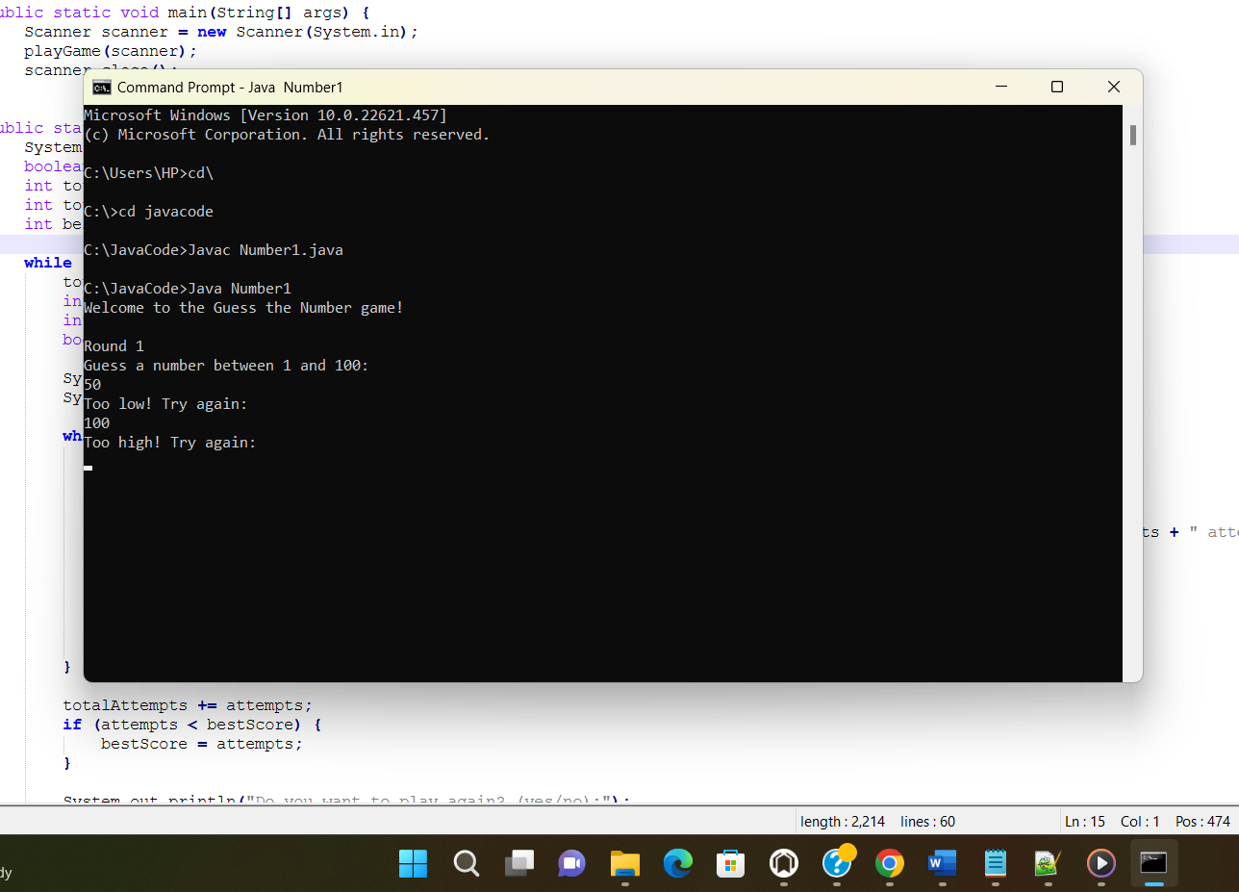

Task 2 code:

import java.util.Scanner;

public class GradeCalculator {

public static void main(String[] args) {

Scanner scanner = new Scanner(System.in);

System.out.print("Enter the number of subjects: ");

int numSubjects = scanner.nextInt();

int[] marks = new int[numSubjects];

int totalMarks = 0;

// Input marks for each subject

for (int i = 0; i < numSubjects; i++) {

System.out.print("Enter marks obtained in subject " + (i + 1) + ": ");

marks[i] = scanner.nextInt();

totalMarks += marks[i];

}

// Calculate average percentage

double averagePercentage = (double) totalMarks / numSubjects;

// Grade Calculation

char grade;

if (averagePercentage >= 90) {

grade = 'A';

} else if (averagePercentage >= 80) {

grade = 'B';

} else if (averagePercentage >= 70) {

grade = 'C';

} else if (averagePercentage >= 60) {

grade = 'D';

} else if (averagePercentage >= 50) {

grade = 'E';

} else {

grade = 'F';

}

// Display Results

System.out.println("\nResults:");

System.out.println("Total Marks Obtained: " + totalMarks);

System.out.println("Average Percentage: " + averagePercentage + "%");

System.out.println("Grade: " + grade);

scanner.close();

}

}

OTPUT:

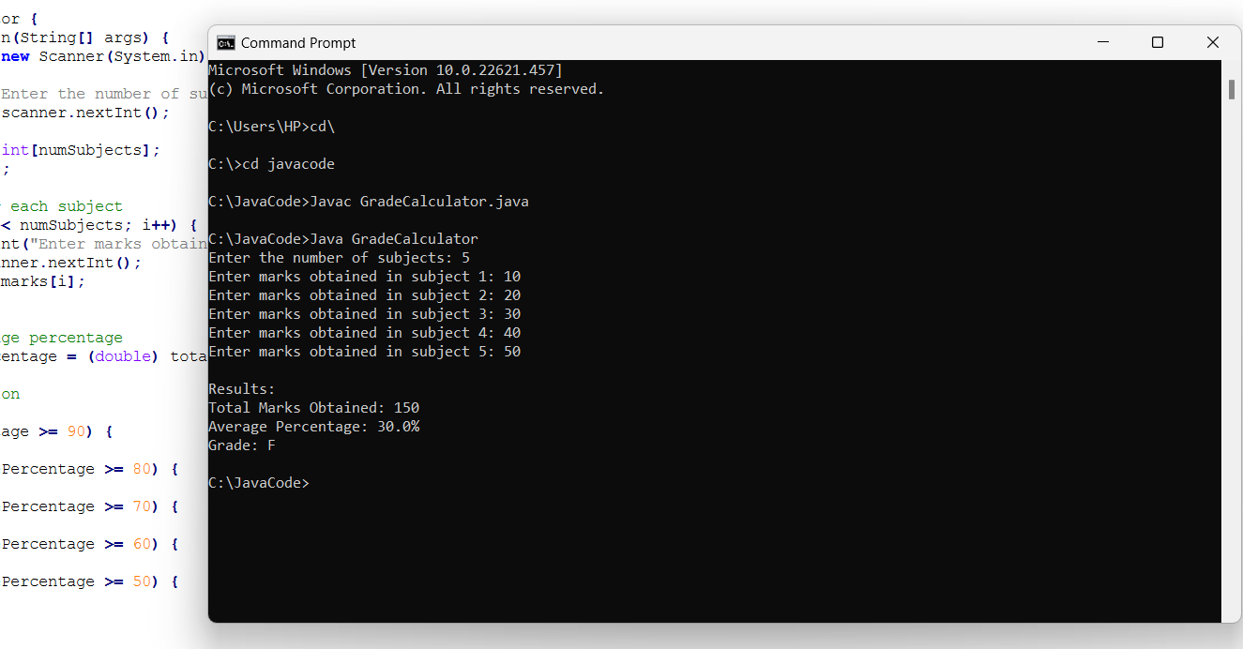

Task 3 code:

import java.util.Scanner;

class BankAccount {

private double balance;

public BankAccount(double initialBalance) {

this.balance = initialBalance;

}

public double getBalance() {

return balance;

}

public void deposit(double amount) {

balance += amount;

}

public boolean withdraw(double amount) {

if (amount <= balance) {

balance -= amount;

return true;

}

return false;

}

}

class ATM {

private BankAccount account;

public ATM(BankAccount account) {

this.account = account;

}

public void withdraw(double amount) {

if (account.withdraw(amount)) {

System.out.println("Withdrawal successful. Current balance: " + account.getBalance());

} else {

System.out.println("Insufficient funds. Withdrawal failed.");

}

}

public void deposit(double amount) {

account.deposit(amount);

System.out.println("Deposit successful. Current balance: " + account.getBalance());

}

public void checkBalance() {

System.out.println("Current balance: " + account.getBalance());

}

public static void main(String[] args) {

Scanner scanner = new Scanner(System.in);

System.out.print("Enter initial balance: ");

double initialBalance = scanner.nextDouble();

BankAccount bankAccount = new BankAccount(initialBalance);

ATM atm = new ATM(bankAccount);

boolean running = true;

while (running) {

System.out.println("\nOptions:");

System.out.println("1. Withdraw");

System.out.println("2. Deposit");

System.out.println("3. Check Balance");

System.out.println("4. Exit");

System.out.print("Enter your choice: ");

int choice = scanner.nextInt();

switch (choice) {

case 1:

System.out.print("Enter amount to withdraw: ");

double withdrawAmount = scanner.nextDouble();

atm.withdraw(withdrawAmount);

break;

case 2:

System.out.print("Enter amount to deposit: ");

double depositAmount = scanner.nextDouble();

atm.deposit(depositAmount);

break;

case 3:

atm.checkBalance();

break;

case 4:

running = false;

break;

default:

System.out.println("Invalid choice. Please try again.");

}

}

scanner.close();

System.out.println("Thank you for using the ATM.");

}

}

Output:

