
Mukesh Patel School of Technology Management and Engineering

Word Jungle
Course: Artificial Intelligence
By

Name | Pranav Mantri, Avni Gupta, Samruddhi Jain, Shruti Mishra
Roll No | E238, E252, E245, E243
SAP ID | 70552300039, 70552300054, 70552300047, 70552300045

Bachelor of Technology Computer Science
Third Year, Semester VI
Faculty: Prof. Kiran Salunke
AY 2025-26

1. Abstract
Word Jungle is a learning game, where players have to use artificial intelligence to solve word ladder puzzles. The player starts with a word and must finish with a word in the game by adding or removing a single letter to the word until they arrive at a transition word that is a word in the dictionary. The game applies multiple classical algorithms in search and a genetic algorithm, which enables the game to solve a puzzle and generate hints among other features.

2. Objectives
- Create a complete word-ladder game, connecting Next.js front-end and FastAPI backend.
- Incorporate several AI algorithms for solving puzzles in order not to stick to only one particular approach.
- Provide players with hints and comments when necessary, as well as let them know if they are very close to an optimum solution.
- Implement a comparing option, which will allow comparing how different AI algorithms solve the same puzzle.
- Maintain performance efficiency in all stages of operation by utilizing set data structures when working with dictionaries.

3. Technology Stack
Frontend: Next.js + TypeScript
Backend: FastAPI (Python)
AI/Solver Layer: Bidirectional BFS, A* Algorithm, Genetic Algorithm
Data Layer: Core dictionary + external word list file

4. System Architecture
The project is made up of four parts. The solver engine, dictionary, backend and the frontend. Every section has its task and they are all able to communicate with each other.
The Frontend UI is the one that the player views and interacts with. Where the player types in words and tracks moves, asks to get hints and sees the comparison view of the algorithm. The Frontend UI does not perform any work per se. It simply sends the requests to the backend. Receives back what it gives out.
The important decisions are made in the Backend API. Checks if the requests that they receive are okay and apply the appropriate level of difficulty, select the algorithm and returns a clean answer. With all this logic under one roof, it implies that everything will work the way regardless of how the frontend is utilized.
The three artificial intelligence methods reside in the Solver Engine. Bidirectional BFS, A* and the Genetic Algorithm. The Solver Engine works based on the request of the backend. It decides the next hint, step or to make comparison data in all three algorithms, figures out the entire solution path computes.
The Dictionary Layer maintains a record of all the words which may be used in solving and checking. It takes a list of already present words and adds those of an external file. Then it severs the words depending on the nature of the words and the level of difficulty selected. This preserves the words of the puzzle and at the same time allows the pool of words to increase. The Dictionary Layer ensures that the project has the words that it requires to operate. The Dictionary Layer will be significant to the project since it assists the Solver Engine and the Backend API in their work. The Dictionary Layer and the other parts are utilized to create a fun and challenging game, to the player, in the project. Main API routes used in this architecture are:
- GET /health
The easiest check is a ping-like program that verifies that the server is online and accepting requests - handy in the development and deployment phases.
- POST /validate-word
Determines if a word that is submitted is in the dictionary. This is what the frontend refers to as a moment when a player makes a move such that bad words are immediately captured before any other action occurs.
- POST /solve
Executes the selected algorithm (Bidirectional BFS, A, or Genetic) to derive a solution path to navigate between start and target. Provides the entire path and the number of steps the frontend can use to inform the user of how well the AI solved it.
- POST /hint
Provides the following suggested word on the path to the target. It is supposed to help point the player in the right direction but not to take over, the player still has to type in the word.
- GET /difficulties
Sends back the list of possible difficulty options so that the frontend does not need to hardcode the list on the client side, but dynamically populates the list.
- POST /compare
Compares all three algorithms to the same puzzle simultaneously and gives a breakdown of the metrics used - the number of steps made, the time taken in milliseconds, the number of nodes visited, was the result optimal and was the result consistent. This powers the comparison table in the UI.

5. AI Concepts Used
5.1 State-Space Search
In this model, a word is a node in a graph and a valid one-letter change between two words constitutes an edge between them.

5.2 Bidirectional BFS
Rather than searching only one end, in this method two simultaneous searches are started one starting with the starting word and the other with the target and halts when they intersect in the middle. It is a good one to find the shortest distance in unweighted graph and never produces different results.

5.3 A* Search (Heuristic AI)
A* considers every candidate based on f(n) = g(n) + h(n) with the heuristic h(n) being the Hamming distance between the current word and the target. This can guide the search to more promising states instead of searching in a random fashion and it is also guaranteed to find the best solution as long as the heuristic does not overestimate.

5.4 Genetic Algorithm (Evolutionary AI)
This methodology keeps a set of candidate solution paths and mutates them with the help of a fitness function, tournament selection, crossover, and mutation. It is non-deterministic in its nature, i.e. the results may change each time it is run, but it is fast at reaching sensible solutions even when those solutions are not necessarily the best.

5.5 Constraint-Based Filtering
Word length is tied directly to difficulty:
Easy = 4 letters
Medium = 5 letters
Hard = 6 letters

6. Runtime Flow (What Happens After What)
6.1 Start Level
1) The player selects the level, the degree of difficulty and the algorithm to employ.
2) POST /solve request is sent by the frontend.
3) The word list is filtered by the backend to suit the difficulty of choice and the algorithm is run.
4) The response contains a solution path and a number of steps.
5) The frontend displays the number of steps that the AI required and this provides the player with an objective to achieve.

6.2 Player Move Submission
1) The frontend verifies that the word has the correct length and the difference in it is one letter.
2) The word is given by the dictionary to be true.
3) The move counter is incremented and the game determines whether the player has won or lost all the attempts.

6.3 Hint Request
1) The player hits the Hint button.
2) POST /hint is called by the frontend and it receives the target and current word.
3) The backend solves a step with the current position and extracts the following step.
4) That is a word that is in the hint box - the player is yet to type it in.

6.4 Algorithm Comparison (On-Demand)
1) The player clicks the comparison view.
2) POST /comparing is called by the frontend.
3) Each of the three algorithms is run on the current puzzle and recorded with their metrics.
4) The results are presented in a table with Steps, Time(ms), Nodes, Optimal and Consistent columns.
7. Dictionary Management
The entire word set is constructed by combining two sources:
1)CORE_WORDS - a hard-coded list of terms necessary to the puzzle that can not be removed.
2)Extended vocabulary retrieved in words_alpha.txt
All are transformed to uppercase and sliced into 4, 5 or 6 length words.
By doing so the game-important vocabulary is never left out, and the larger dictionary can be substituted or added with minimal effort.
8. Comparison Metrics Meaning
Steps: the number of word changes needed to get from the start to the target.
Time(ms): how long the algorithm actually took to run, in milliseconds.
Nodes: the total number of words the algorithm examined during its search.
Optimal: whether the path length matches the best result seen across all three methods for that puzzle.
Consistent: whether the algorithm produces the same answer every time. The Genetic Algorithm is flagged as non-consistent here because of its built-in randomness.

9. Results
The project shows us that AI doesn't have to stay in the realm of theory as it can make real decisions about how to play a game in a working system environment.
- Shortest-path search that always gives the same answer (Bidirectional BFS, A*) A* is more smart than other algorithms as its heuristic-based search doesn't look around for no reason.

- Genetic Algorithm, which is an evolutionary optimization method that gives up consistency in favor of speed. Every choice made in the game went through a live API call. A built-in comparison tool that makes it easy to see and feel the trade-offs between different approaches

10.Interface

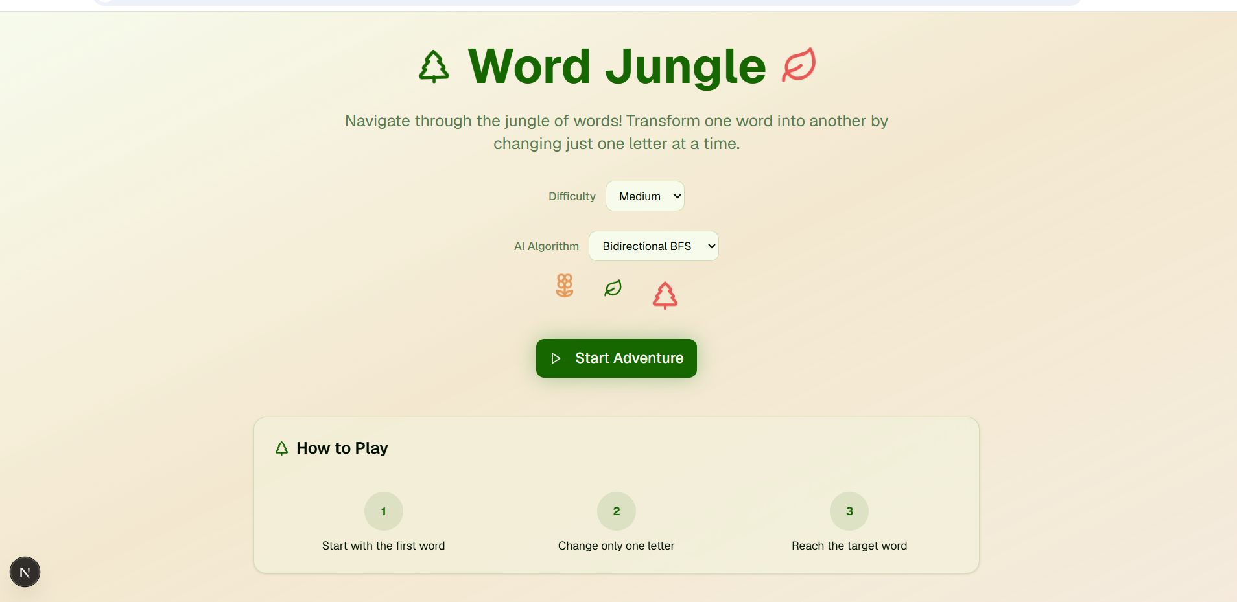
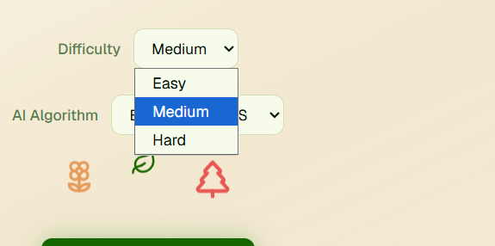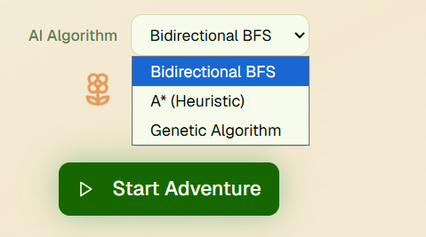

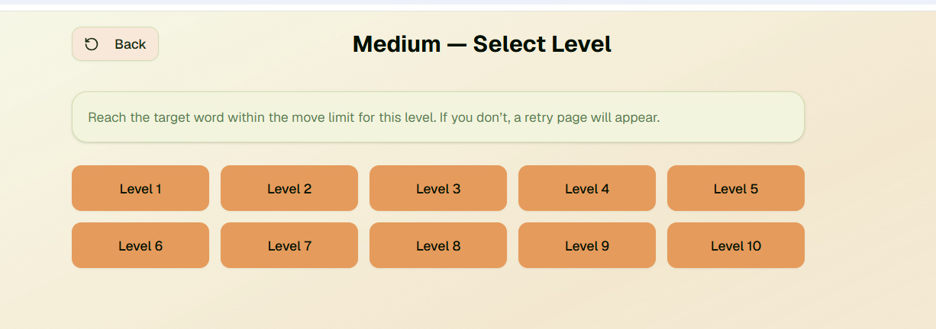
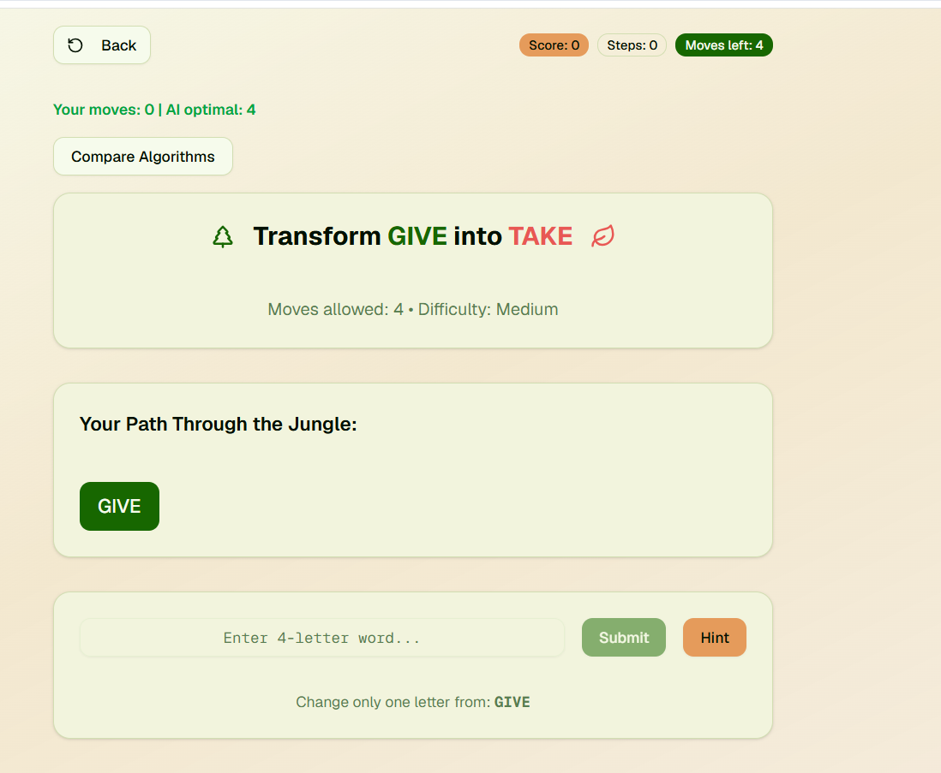
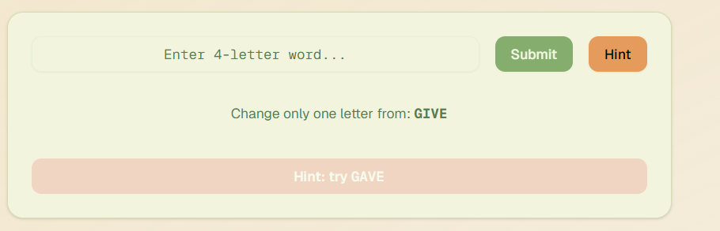
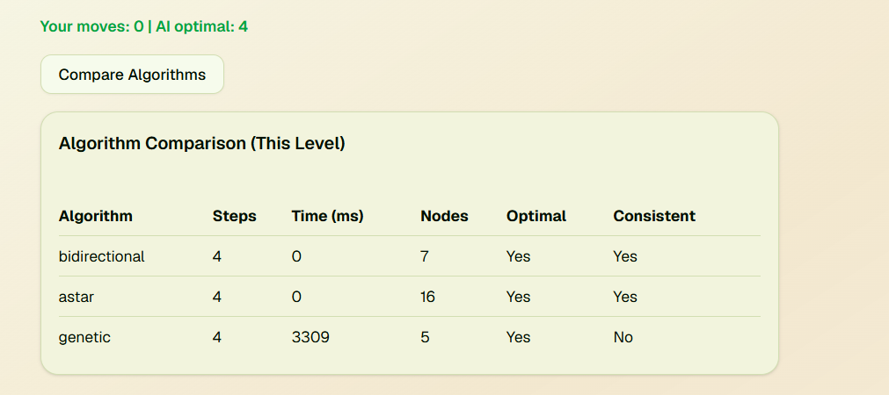
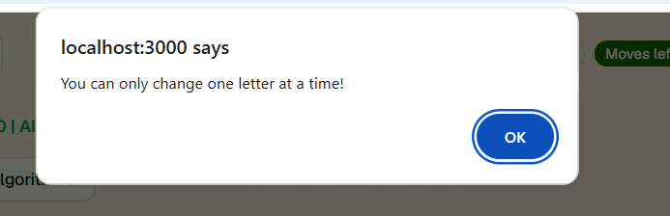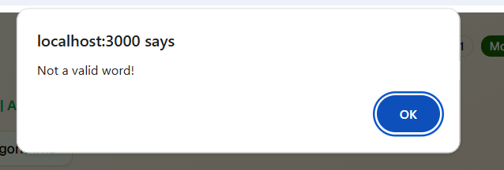

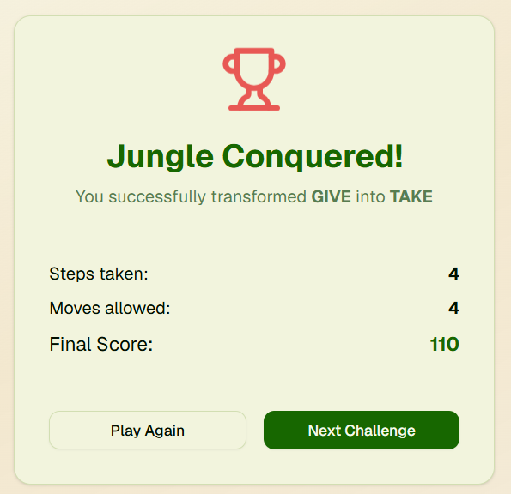

11. Future Scope
- Use the average of the Genetic Algorithm results over multiple runs to get more reliable results rather than depending on a single solution.
- Let players export the comparison table as a CSV or PDF for offline review or academic use.
- Build a every-level benchmark dashboard so performance between algorithms can be tracked across different puzzles through trends
- Introduce adaptive difficulty that adjusts based on how well a particular player is actually performing, rather than relying on fixed word-length categories.

References
Carroll, L. (1879). Word Ladders — a game for two or more players. Vanity Fair.
Russell, S. & Norvig, P. (2020). Artificial Intelligence: A Modern Approach, 4th ed. Pearson. (Uninformed search strategies, Ch. 3)
Jurafsky, D. & Martin, J. H. (2023). Speech and Language Processing, 3rd ed. (draft). Stanford University. https://web.stanford.edu/~jurafsky/slp3/
Yannakakis, G. N. & Togelius, J. (2018). Artificial Intelligence and Games. Springer. https://gameaibook.org

