SOFTWARE ENGINEERING LAB 2
Agile Planning, Estimation & Sprint Execution using Jira
Project: Incident Escalation & On-Call Rotation
Project Key: IEOC
Jira Project/Workspace: samrudh0045.atlassian.net
Jira Board: IEOC Board

1. Epics & User Stories
Epics:
- Incident Alert Management
- Incident Escalation & Handling
- On-Call & Incident Management
User Stories: 6 stories, 21 total Story Points
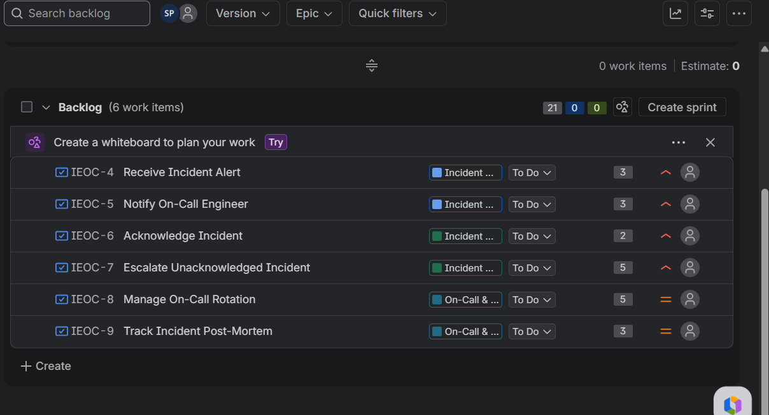

2. Sprint 1
8 Story Points — 3 stories completed
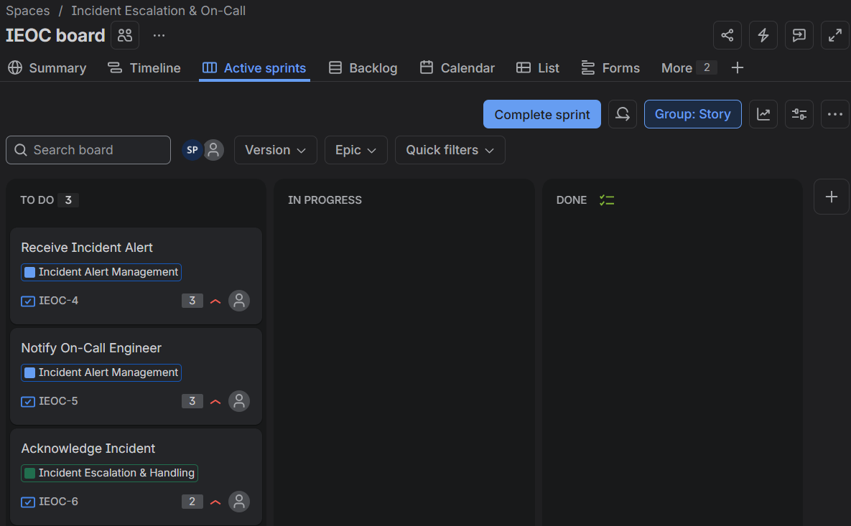
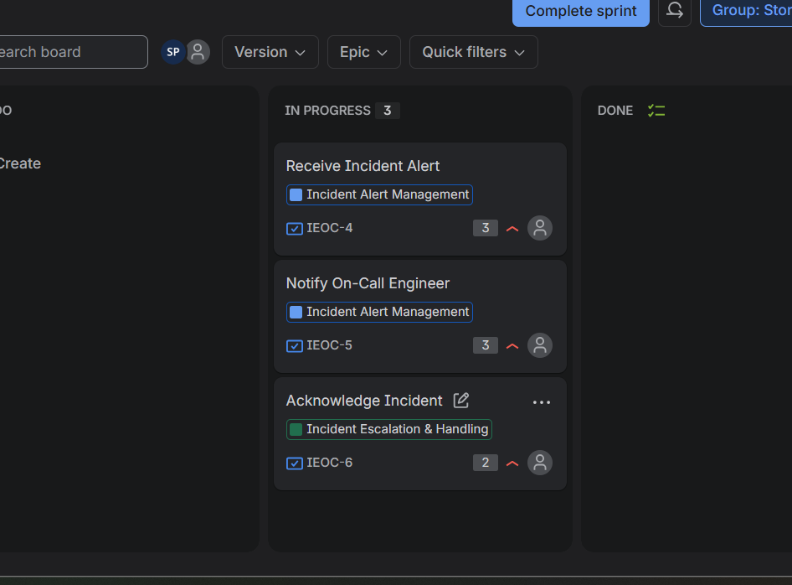
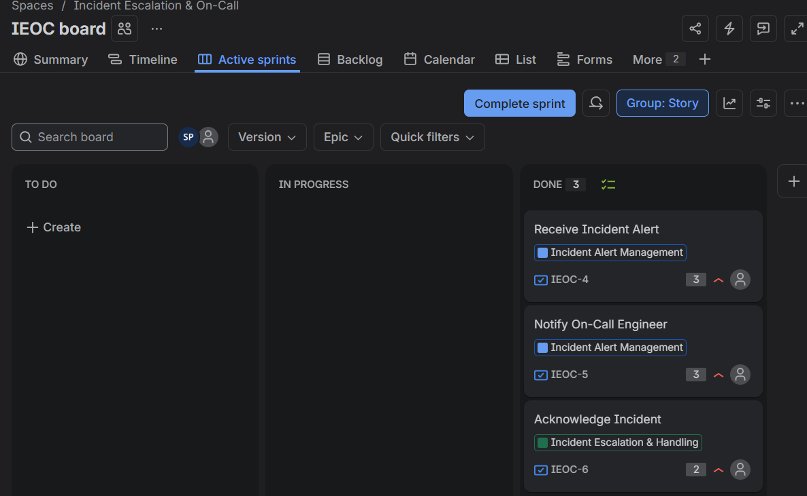
3. Sprint 2
13 Story Points — 3 stories completed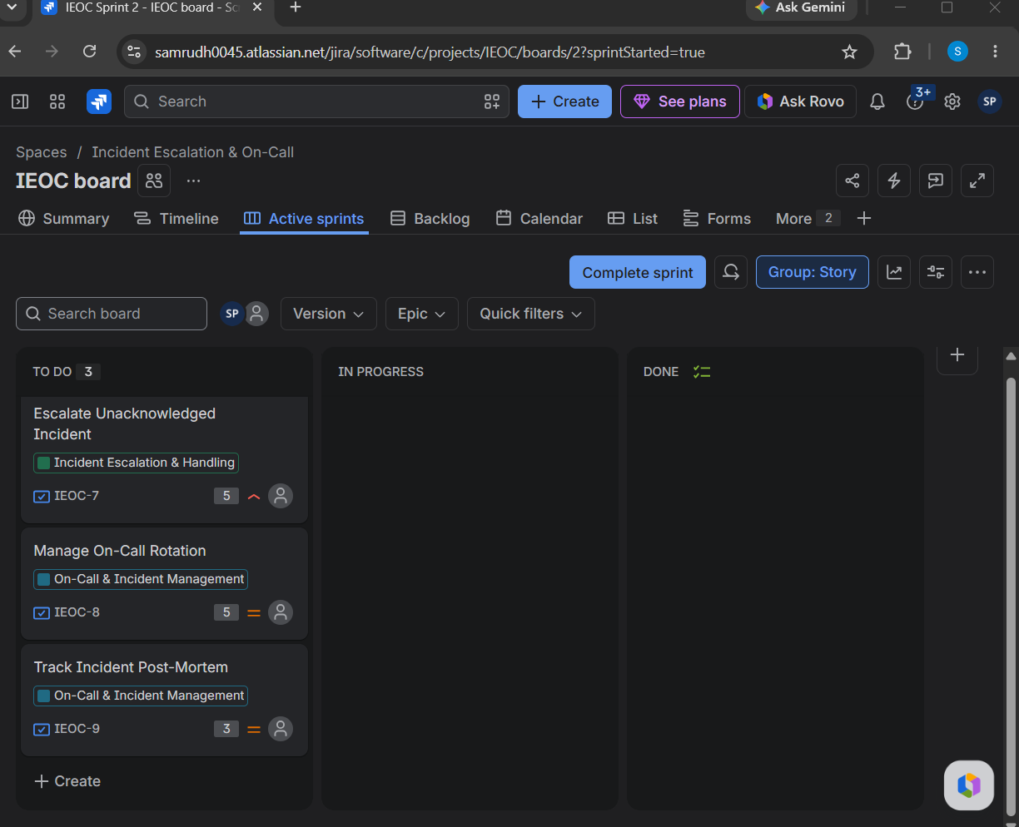
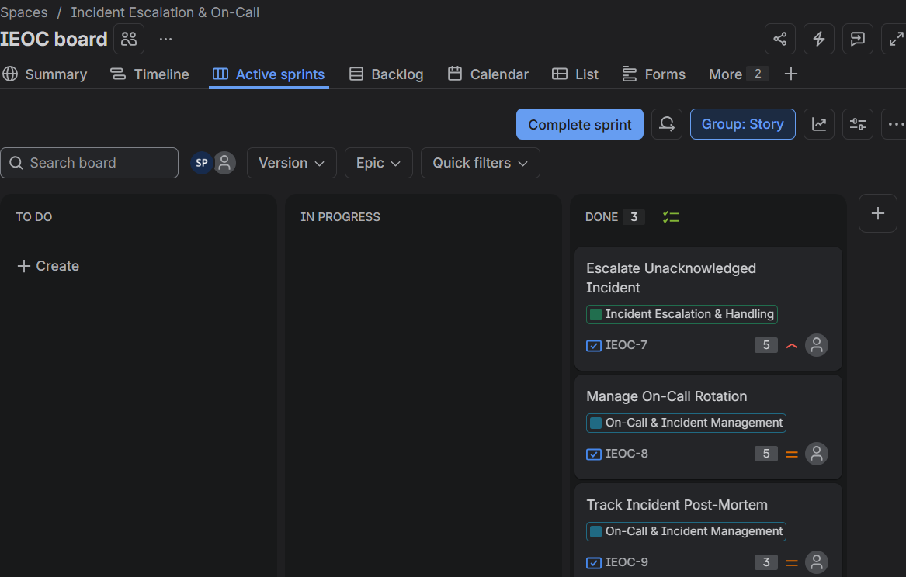
4. Burndown Chart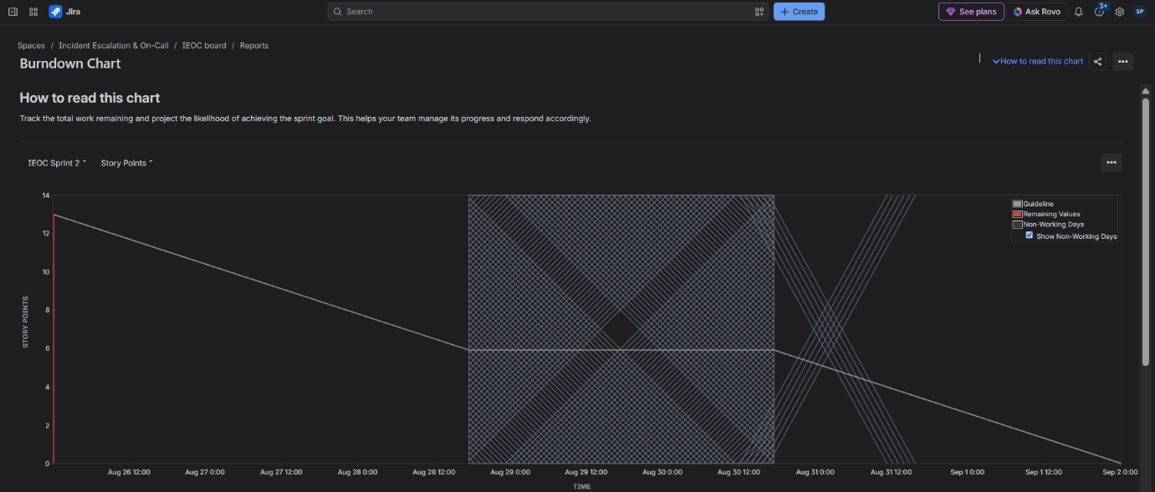
5. Reflection
1. Estimation:
Estimates reasonably reflected the effort required.
2. Prioritization:
High-priority incident and escalation work was handled first.
3. Sprint:
Both sprints followed the planned scope and were completed successfully.
4. Burndown:
The chart showed remaining work and sprint progress over time.
Jira Link
https://samrudh0045.atlassian.net

