WEEK 5 OF 5 · MODEL EVALUATION AND REPORTING DELIVERABLE
Model Evaluation
& Reporting Strategy

A decision-grade framework for judging whether an agribusiness forecast is any good — and for saying so plainly. It defines the metric suite and the conditions under which each metric misleads, executes a rolling-origin evaluation on real World Bank price data, specifies the charts each audience needs, provides an executive-summary template that survives scrutiny, names the limitations, and sets a prioritised refinement roadmap.

PREPARED BY | Data Science Intern
PROGRAMME | Junior Data Scientist Internship, Nagpur
INTERNSHIP PERIOD | 22 October – 26 November 2026
SUBMISSION DATE | 25 November 2026
DOCUMENT VERSION | 1.0 (Evaluation Strategy and Executed Audit)
EVIDENCE BASE | World Bank Pink Sheet, 2000-01 to 2026-10

Contents
The document is organised as a working strategy, not a literature review. Part I sets the evaluation doctrine and the metric definitions. Part II turns the metrics into pictures that non-specialists can act on. Part III specifies the reporting system and the executive summary. Part IV states what the evaluation cannot prove, and what to build next. Six appendices carry the formulae, checklists, templates, reproduction steps and glossary. Refresh page numbers in Microsoft Word with Ctrl+A → F9.
Table of contents — update on document open.

GOVERNING RULE
Report the range, not only the point. Report the benchmark, not only the raw error. Report the failure, not only the pass. A number that cannot change a decision is decoration; a failure that is hidden is a liability.

1. Scope, Evidence and Evaluation Doctrine
This document answers a narrower question than “is the model good?”. It answers the question a business actually asks: what may we claim about this forecast, what may we do with it, and what would have to change before we claim more? The distinction matters because a single accuracy number can support a procurement decision, a budget range, a trading signal or a policy recommendation — and it cannot support all four at once.

1.1 What this strategy governs
The strategy is a standing evaluation protocol for the agribusiness forecasting system specified in Weeks 1–4. It applies to both forecast targets — monthly wholesale prices and seasonal crop yields — although the executed evidence in this document is price-based, because that is the target for which a complete, public, monthly history exists. The protocol covers five decisions:
- Publication. whether a candidate model is published at all, and at which horizons;
- Framing. which number, range and caveat appear in front of a procurement director, a finance committee or a policy adviser;
- Use. whether the forecast is used for level planning, direction timing, scenario design or not at all;
- Escalation. which failures are escalated, retired or reworked, and on what timetable;
- Reinvestment. what evidence would justify a stronger claim at the next review.
The protocol is deliberately asymmetric. It is easy to pass a weak bar and hard to earn a strong claim. A model may be published as a benchmark-relative range without being certified as a directional signal. That is not a compromise; it is the correct description of what the evidence supports.

1.2 The five questions every evaluation must answer
Accuracy is not one property. Five questions separate the claims that stakeholders routinely blend together. Each has a primary metric, a failure signal and a place in the report. Table 1 is the contract between the evaluation team and the reader: if a question is not answered in the row’s evidence column, the report is incomplete.
Table 1. The five evaluation questions, their primary evidence, and the signal that the claim has failed.
Question | What it asks | Primary evidence | Failure signal | Reported in
Q1 Accuracy | How large is the typical error, in decision units? | MAE, RMSE and MASE against both naïve benchmarks, by horizon | A model whose error is no smaller than the benchmark, or whose advantage is smaller than the measurement noise | §3.9, §5.3
Q2 Calibration | Does the stated range contain the truth at the promised rate? | Empirical coverage at 50/80/90/95%, interval width and Winkler score | Coverage more than five points below nominal, or narrow intervals achieved by under-covering | §3.5, §4.5
Q3 Direction | Can it tell an increase from a decrease? | Directional accuracy with a binomial confidence interval; base-rate comparison | A confidence interval that includes 50%, or a hit rate that disappears once the market trend is removed | §2.3, §5.6
Q4 Stability | Does the result survive crop, state, horizon and regime changes? | Segment MASE, regime splits, volatility buckets, cross-commodity replication | A pooled result that reverses in one or more segments, or a sign change across regimes | §3.6–3.7
Q5 Value | Does it improve a decision after costs? | Asymmetric cost-weighted error, procurement regret, threshold sweep | Regret no better than the default rule, or an optimum that exists only in-sample | §2.5, §4.5.8

WHY FIVE QUESTIONS
A model can be accurate on average and useless for direction; it can be well calibrated and worse than a random walk; it can win in one crop and lose in another. Collapsing these into a single “model accuracy” line is how forecast reports become confidently wrong.

1.3 Seven principles
The principles below are not stylistic preferences. Each one prevents a specific failure that appears repeatedly in applied forecasting reviews.
- 1. Benchmark or it did not happen. Every candidate is scored on the same folds as a random walk and a seasonal naïve. A model that cannot beat the pair is not reported as an improvement, however sophisticated its architecture. The pair matters because the two benchmarks fail in different conditions: the random walk survives shocks, the seasonal naïve captures harvest cycles.
- 2. No pooled number without segments. A pooled MASE can hide a crop that fails and a crop that carries the average. Every headline number is decomposed by crop, state and horizon before it is published.
- 3. Pre-register the test. The metric set, the gate thresholds and the fold boundaries are fixed before the candidate models are examined. Otherwise the evaluation quietly becomes a search for the metric that flatters the model.
- 4. Report the uncertainty of the metric, not only of the forecast. A point estimate of 0.98 is not evidence of a 2% improvement if the 95% interval runs from −7% to +7%. Every headline is accompanied by a paired bootstrap interval, a Diebold–Mariano test and a minimum detectable effect.
- 5. Never let one metric speak for three. Accuracy, calibration and direction are separate claims with separate thresholds. Passing one does not license the others.
- 6. Score the decision, not just the forecast. The relevant loss is asymmetric: a missed procurement costs more than a carried inventory. The evaluation therefore includes a cost-weighted error and a threshold rule, not only a symmetric statistical score.
- 7. Publish the failure. The three-month horizon fails the promotion gate in the executed evidence, and it is reported with the same prominence as the horizons that pass. A failure that is omitted becomes a surprise in production.

1.4 The evidence base
The strategy is not illustrated with hypothetical numbers. It is executed on the World Bank Pink Sheet monthly price panel used in Week 4: 322 complete months from 2000-01-01 to 2026-10-01, covering wheat, rice, maize, soybeans and cotton, with DAP and urea as input-cost series. The design matrix contains 310 usable months and 31 past-only predictors. The primary ladder runs 60 expanding-window folds at a 3-month step across four horizons, producing 1,440 fold-level forecasts from six models. No model fit failed. The cross-commodity check repeats the ladder on all five crops at a four-month step.
Table 2. Executed evidence base: data, folds, models and interval construction.
Element | Executed setting | Why this setting
Target | Wheat, US HRW, USD/metric ton (primary); rice, maize, soybeans and cotton (replication) | A globally traded, continuously quoted series with no missing months; the same target used in the Week 4 executed notebook
Frequency | Monthly, 2000-01 to 2026-10 | Matches the decision cadence of procurement and the publication cadence of Agmarknet
Training window | Expanding, minimum 120 months | Twelve years covers at least one full price cycle and identifies annual seasonality
Origin step | 3 months | Overlapping 12-month targets would otherwise inflate the effective sample
Folds | 60 per horizon | The most folds the current vintage supports without a target running past the final observation
Horizons | 1, 3, 6 and 12 months | The four planning windows used by procurement, budgeting and planting decisions
Benchmarks | Random walk and seasonal naïve | Adversarial pair; a candidate must beat both, not the weaker one
Candidate ladder | ETS, SARIMAX, direct GBDT and a past-only inverse-MSE ensemble | Statistical, structural and machine-learning families with different failure modes
Interval method | Online conformal residuals, fold k uses folds < k only | Distribution-free and auditable; avoids assuming Gaussian errors
Computation | 591 seconds on a laptop, no GPU | Reproducible by a reviewer without infrastructure

Two protocol changes from Week 1 are recorded here rather than hidden. Week 1 proposed a 36-month initial window and a one-month step. The executed harness uses 120 months and a three-month step. A 36-month window cannot identify an annual seasonal pattern, and a one-month step with overlapping 12-month targets would produce 100-plus folds whose errors are almost perfectly correlated — precision that is not information. The longer window and wider step are the defensible choice; the change is documented so that a reader can challenge it.
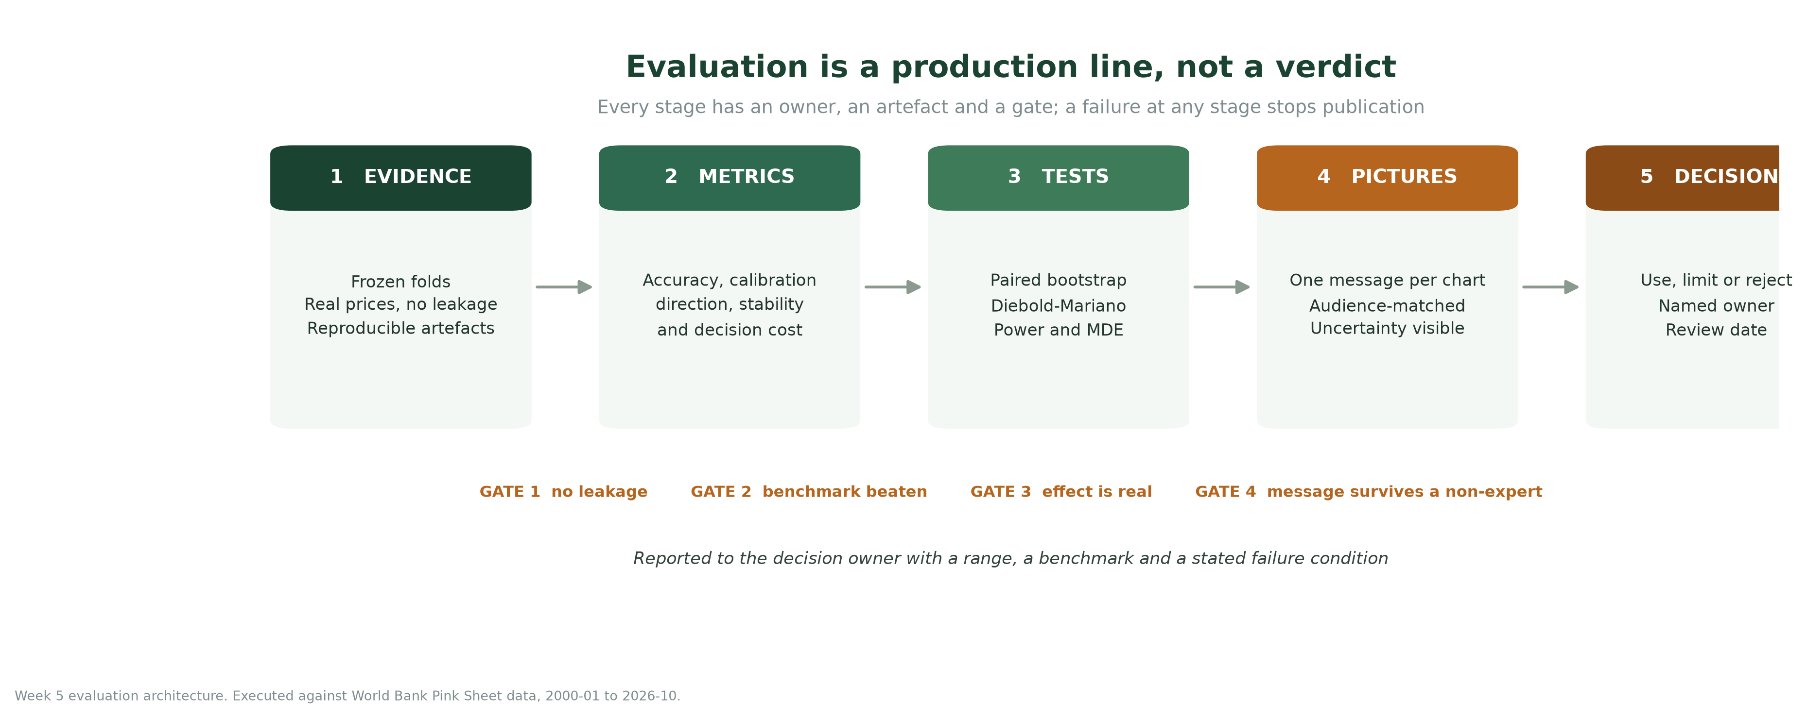
Figure 1. The evaluation production line: five stages, four gates and one decision owner. A failure at any gate stops publication of the claim, not the analysis.

1.5 Governance: who owns which judgement
An evaluation is a social process as much as a statistical one. If the same person selects the model, chooses the metric and signs the release, the protocol is decorative. Table 3 assigns four separable judgements. In a small team one person may hold more than one role, but the roles must be named in the release note and the conflict disclosed.
Table 3. Evaluation governance: separable judgements and the evidence each role signs.
Role | Owns | Cannot do alone | Evidence produced
Model owner | The ladder, folds, hyperparameters and code | Approve the promotion decision | Reproducible pipeline, fold-level predictions, model card
Independent validator | Metric computation, calibration and significance tests | Change the model to make it pass | Evaluation report, exception log, signed scorecard
Business owner | The decision the forecast informs and the cost of error | Redefine the metric after seeing results | Decision memo, threshold rule, value estimate
Data steward | Source vintage, publication lag, revisions and licensing | Waive a provenance requirement | Data dictionary, vintage log, coverage statement
Release approver | The published claim and its caveat | Overrule the validator’s factual finding | Signed release note and review date

1.6 How to read the numbers in this document
- Units. All price errors are in USD per metric ton. A percentage is always labelled as such. A basis point is never used to describe a price change.
- Benchmarks. An error is meaningful only next to the random-walk error on the same folds. “MAE fell by 2%” is not a result; “MAE was 2% below the random walk, with a 95% interval from −7% to +7%” is.
- MASE. MASE appears in two forms. Absolute MASE divides by the in-sample seasonal-naïve error of the first 120 months; it is comparable across crops but rises mechanically with the horizon. Relative MASE divides by the random-walk error on the same folds and horizon; it is the promotion gate. The report always names which one is meant.
- Coverage. Coverage is the share of realised values inside the stated interval. A 90% interval that contains 79% of outcomes is under-covering, even if it looks wide.
- Significance. A result is called significant only when the paired 95% interval excludes zero and the Diebold–Mariano test agrees. A small p-value with an economically trivial difference is reported as statistically detectable but not materially useful.

2. The Metric Suite: What to Measure, and How Each Metric Lies
Every metric is a lens with a distortion. The purpose of a metric suite is not to accumulate scores but to make the distortions visible to one another. This section defines the metrics used in the harness, states the decision each one serves, and — more importantly — states the specific condition under which it misleads.

2.1 A hierarchy, not a menu
The metrics are ordered by the claim they support. Accuracy answers “how far off?”. Calibration answers “how honest is the range?”. Direction answers “which way?”. Stability answers “for whom and when?”. Value answers “does it matter?”. A report that climbs the hierarchy can support a decision; a report that stops at accuracy can only describe an error.
Table 4. The evaluation hierarchy: five layers of claim, each with its own evidence standard.
Layer | Claim it supports | Core metrics | What it cannot establish
1 Accuracy | The forecast is closer to the outcome than a stated benchmark | MAE, RMSE, MASE vs RW, MASE vs SN | Whether the difference is real, or whether the range is honest
2 Calibration | The stated uncertainty contains the truth at the promised rate | Coverage, width, Winkler score, pinball loss | Whether the centre of the distribution is useful
3 Direction | The forecast signals the correct sign of change | Directional accuracy, base-rate skill, confusion matrix | The size of the move, or the cost of a wrong sign
4 Stability | The result survives crop, state, horizon and regime changes | Segment MASE, regime splits, volatility buckets, rank stability | Whether the future will resemble the tested past
5 Value | The forecast improves a decision after costs | Asymmetric cost-weighted error, regret, threshold sweep | Whether the organisation will actually use it

THE CARDINAL RULE
No single metric may promote a model. Promotion requires a benchmark-relative accuracy result, a calibrated interval, a direction result that is separable from chance, stability across the declared segments, and a decision value that is positive after cost. A model may be published without clearing all five — but the claim in the report must name which layers it cleared.

2.2 Point-accuracy metrics

MAE — mean absolute error
MAE is the average absolute difference between the forecast and the outcome, in the units of the decision. It is the most interpretable accuracy metric and the one a procurement officer can budget against: an MAE of 12 USD/MT on a 300 USD/MT commodity is a 4% planning margin. It is robust to a single catastrophic miss, which is both its strength and its weakness: a model that is usually 10 USD wrong and occasionally 200 USD wrong can report the same MAE as a model that is consistently 20 USD wrong.
MAE = (1/n) Σ |yᵢ − ŷᵢ|
MAE is scale-dependent, so it cannot compare wheat at 300 USD/MT with cotton at 2,000 USD/MT. That is why every cross-crop statement in this report uses MASE or a percentage, never raw MAE.

RMSE — root mean squared error
RMSE squares the errors before averaging, so a 100 USD miss contributes 100 times as much as a 10 USD miss. It is the right metric for stress questions — how bad is the bad month? — and the wrong metric for the typical planning question, because one shock can dominate the score. In the executed evidence, the ensemble’s h=1 RMSE is 17.9 against an MAE of 12.1, a ratio of 1.48; that gap is the tail talking. RMSE is reported as a risk diagnostic and is never the promotion gate.
RMSE = √[(1/n) Σ (yᵢ − ŷᵢ)²]

MAPE — mean absolute percentage error, and its near-zero problem
MAPE expresses the error as a percentage of the actual value. It is intuitive, unit-free and seductive. It is also asymmetric: an actual of 100 with a forecast of 110 scores 10.0%, while an actual of 110 with a forecast of 100 scores 9.1%. The same 10-unit error produces a different score depending on direction, which rewards under-forecasting. Near zero the metric explodes: an actual of 5 with a forecast of 10 is a 100% error, even though the absolute miss is 5 USD. In mandi data, where a perishable vegetable can trade at a few rupees per kilogram in glut and hundreds in scarcity, MAPE is not a safe headline.
MAPE = (100/n) Σ |yᵢ − ŷᵢ| / |yᵢ|
The harness applies a pre-registered guard: MAPE is reported only when the first percentile of the evaluation target is at least five times the MAE. If that condition fails, MAPE is suppressed and sMAPE is shown instead, with the suppression stated in the table note. The condition is checked by code, not by eye.

sMAPE — symmetric mean absolute percentage error
sMAPE divides the absolute error by the average of the actual and the forecast, which bounds it between 0% and 200% and removes the worst of MAPE’s directional bias. It still misbehaves near zero, and its upper bound is arbitrary: a forecast of −100 against an actual of +100 scores 200%, which is not a percentage a reader should interpret literally. sMAPE is used as the non-specialist-facing percentage, always alongside MASE, never alone.
sMAPE = (200/n) Σ |yᵢ − ŷᵢ| / (|yᵢ| + |ŷᵢ|)
In the executed scorecard, sMAPE and MAPE agree closely because all prices are far from zero (the wheat series never falls below 90 USD/MT). That agreement is a property of this dataset, not a general licence. The guard exists for the datasets where it fails.

MASE — mean absolute scaled error, the primary gate
MASE divides the forecast’s MAE by the MAE of a naïve benchmark on the same series. The result is scale-free: below 1.0 means the model beats the benchmark, above 1.0 means it does not. Two versions are used, and conflating them is one of the most common errors in forecast reporting.
MASE_abs = MAE_model / [(1/(T−1)) Σ |yₜ − yₜ₋₁|]
MASE_RW = MAE_model / MAE_randomwalk (same folds, same horizon)
the first divides by the in-sample one-step naïve error of the first 120 months; it is comparable across crops but rises mechanically with the horizon, because a 12-month forecast is harder than a one-month forecast. The second divides by the random walk evaluated on exactly the same folds and horizon; it is the promotion gate. In the executed evidence the ensemble has an absolute MASE of 1.08 at h=1 and an absolute MASE of 4.51 at h=12, while its relative MASE is 0.979 and 0.945. The absolute figure above 1.0 does not mean the model loses to its benchmark: the denominator is fixed to the volatility of 2001–2010, and the 2011–2026 evaluation window was more volatile. The relative figure is the honest comparison because it uses the same folds. Both are shown so that the reader can see the scale drift rather than infer it.

R² — the most over-read number in applied forecasting
The coefficient of determination measures the share of variance in the evaluation outcomes explained by the forecast. It is a legitimate descriptive statistic and a poor promotion criterion. Three traps explain why.
R² = 1 − Σ(yᵢ − ŷᵢ)² / Σ(yᵢ − ȳ)²
- Trend inflation. When the series trends, the variance around its mean is large and almost any persistent forecast scores well. In the executed evidence the random walk achieves R² = 0.936 at h=1, while the ensemble achieves 0.939. The difference is 0.003 — three thousandths of variance — yet the raw R² looks like a strong model because the trend is doing the work.
- The negative tail. An out-of-sample R² can be negative. A model that is worse than predicting the evaluation-period mean has R² below zero. The metric is bounded above by 1 and unbounded below, so a single bad fold can move it dramatically.
- Bias invisibility. R² is insensitive to bias and to the cost of error. A model that consistently over-forecasts by 6 USD/MT can still have a high R². In this evaluation the ensemble’s h=12 bias is +6.4 USD/MT, which is invisible in R² but material to a buyer.

Bias and MPE — the systematic error
Bias is the mean signed error, forecast minus actual. Positive means the model over-forecasts. The mean percentage error (MPE) expresses the same quantity as a percentage of the actual. The pair is reported because a model can have a low MAE and a persistent bias: random errors cancel, but a procurement department that consistently buys 5% too early does not.
Bias = (1/n) Σ (ŷᵢ − yᵢ) MPE = (100/n) Σ (ŷᵢ − yᵢ) / yᵢ
The acceptance threshold is |MPE| < 5% of the mean price. The ensemble passes at h=1 (-0.30%) but drifts to +5.86% at h=12; ETS is worse at +6.37%. The drift is a finding, not a rounding error: the model is systematically optimistic at the long horizon, which overstates forward margins.

2.3 Direction and probability

Directional accuracy — the metric a trader acts on
Directional accuracy is the share of folds in which the forecast correctly predicts whether the price will rise or fall from its level at the forecast origin. A random walk has no predicted change and therefore no defined direction; it is excluded from this metric rather than scored as 50%.
DA = (100/n) Σ 1[sign(yᵢ − y₀) = sign(ŷᵢ − y₀)]
The executed ensemble records 50.0%, 48.3%, 51.7% and 55.0% at h=1, 3, 6 and 12. Those numbers look close to a coin flip, and they are. With 60 folds, the 95% binomial interval around 50% runs from roughly 37% to 63%; a hit rate of 55% is inside it. The correct conclusion is not “55% is promising” but “the evaluation cannot distinguish this model from chance on direction.” Directional use therefore fails the evidence test, regardless of the point accuracy.

Pinball loss and CRPS — scoring the whole distribution
Pinball loss evaluates a quantile forecast. For a quantile q and forecast f, the loss penalises an outcome above f at rate q and an outcome below f at rate 1−q. Averaging the 5th and 95th quantile losses gives a simple distributional score; CRPS integrates the same idea over all quantiles. A point forecast can improve while the distribution worsens — for example, if the model widens its intervals to avoid misses.
L_q(y, f) = q(y − f) if y ≥ f; (1−q)(f − y) if y < f
The executed result is exactly this kind of divergence. The ensemble’s h=1 pinball loss is 15.75, worse than the random walk’s 13.49, even though the ensemble has the lower MAE. The ensemble’s intervals are wider and its distribution is not better centred. A report that published only the MAE would miss the regression in probabilistic quality.

Coverage, width and the Winkler score
Coverage is the share of realised values inside the stated interval. It is necessary but not sufficient: an interval from zero to infinity covers everything and is useless. Width measures sharpness. The Winkler score combines the two, adding a penalty of 2/α times the distance by which an outcome misses the interval. The three are always reported together.
PICP = (100/n) Σ 1[Lᵢ ≤ yᵢ ≤ Uᵢ] Winkler = width + (2/α)(L−y)⁺ + (2/α)(y−U)⁺
The ensemble’s empirical 90% coverage is 90.4% at h=1, 84.6% at h=3, 84.6% at h=6 and 78.8% at h=12. The h=12 interval under-covers by more than ten points. It is not narrow — its average width is 155 USD/MT — so the problem is not sharpness but a distribution that shifted after the calibration window. This is the single most important calibration finding in the report, and it is why coverage is monitored in production rather than certified once.

2.4 Stability metrics
Stability asks whether the result is a property of the model or of one favourable slice of history. Three diagnostics are used. Segment MASE recomputes the gate separately for each crop, state, horizon and price regime. Fold dispersion reports the standard deviation of absolute error across folds, because a model with the same mean error and twice the dispersion is a different operational risk. Rank stability reports whether the ordering of models is consistent across folds; if the “best” model changes every few folds, the ranking is noise.
Table 5. Stability diagnostics and the acceptance rules that turn them into decisions.
Diagnostic | Definition | Acceptance rule | What a failure means
Segment MASE | MASE vs RW recomputed within each crop × horizon cell | No cell above 1.10 unless the pooled result is also above 1.0 | The pooled average is carried by one or two favourable segments
Regime split | MASE recomputed before and after January 2023 | Sign of the advantage is the same in both periods | The model’s edge is a regime artefact, not a stable relationship
Volatility bucket | MASE recomputed in low, mid and high volatility terciles | No monotonic collapse in the high-volatility tercile | The model fails precisely when the decision matters most
Fold dispersion | Standard deviation of absolute error across folds | Reported, not gated; compared with the benchmark | A wide dispersion means the average hides operational risk
Rank stability | Share of folds in which a model remains in the top two | At least 70% for a champion claim | Model selection is unstable; the champion is a fold-specific accident

2.5 Decision-weighted metrics
Symmetric error treats a 10 USD over-forecast and a 10 USD under-forecast as equally bad. In procurement they are not. An under-forecast that leaves the buyer short forces a spot purchase at the peak; an over-forecast carries inventory, insurance and spoilage. The harness therefore reports an asymmetric cost-weighted error with a 4:1 penalty, and a threshold rule that converts the forecast into a buy-now or wait decision.
CWE = (1/n) Σ [ c_u · max(yᵢ − ŷᵢ, 0) + c_o · max(ŷᵢ − yᵢ, 0) ]
With c_u = 1.00 and c_o = 0.25, the ensemble’s h=1 cost-weighted error is 7.93 USD/MT against a random walk’s 7.97. The difference is less than one percent of the purchase price. At h=6 the ensemble is worse (21.34 vs 20.65). The decision-weighted view confirms the accuracy view: any advantage is small, horizon-dependent and not robust enough to support a strong operational claim.
The threshold rule is evaluated over a grid of buy-now thresholds from −3% to +6%. For each threshold the harness computes the realised purchase cost, the regret against perfect foresight and the share of price rises captured. The in-sample optimum is a threshold of +0.5%, which reduces regret from 2.49% for an always-wait policy to 1.59%. That is a real but small improvement — about 2.34 USD/MT on an average price near 267 USD/MT. It is also an in-sample optimum, and the report treats it as a hypothesis to test in shadow deployment, not as a production setting.

2.6 The metric registry
Table 6 is the controlled vocabulary for the rest of the document. Any number that appears in a release note must map to a row here, with the stated unit, threshold and known failure mode. Metrics that are not in the registry are exploratory and cannot support a published claim.
Table 6. Metric registry: the controlled vocabulary for every published number.
Metric | Formula (compact) | Unit | Decision threshold | Primary use | Known failure mode
MAE | mean |y − ŷ| | USD/MT | Benchmark-relative; no absolute threshold | Planning margin, procurement budget | Hides catastrophic tails; scale-dependent
RMSE | √mean (y − ŷ)² | USD/MT | Reported, not gated | Stress and tail risk | One shock dominates; not comparable across crops
MAPE | 100·mean |y − ŷ|/|y| | % | Suppressed when p1(y) < 5·MAE | Non-specialist error summary | Explodes near zero; rewards under-forecasting
sMAPE | 200·mean |y − ŷ|/(|y|+|ŷ|) | % | Reported with MASE | Cross-crop communication | Unstable near zero; arbitrary 200% bound
MASE_abs | MAE / in-sample naïve MAE | ratio | < 1.0 is desirable | Cross-crop comparability | Rises with horizon; denominator choice matters
MASE_RW | MAE / RW MAE on same folds | ratio | < 1.00, and MASE_SN < 1.00 | Promotion gate | A point estimate; must carry a CI
R² | 1 − SSE/SST | ratio | Never used to promote | Descriptive variance share | Inflated by trend; can be negative; ignores bias
Bias | mean (ŷ − y) | USD/MT | |MPE| < 5% | Detect systematic optimism | Sign convention confusion
MPE | 100·mean (ŷ − y)/y | % | |MPE| < 5% | Bias as a share of price | Unstable when prices are low
Directional accuracy | share of correct signs | % | CI must exclude 50%; ≥ 55% for timing | Trading and timing decisions | Chance is wide with few folds; trend inflates it
Pinball loss | mean quantile loss | USD/MT | Reported and compared | Distributional accuracy | Not intuitive to non-specialists
Coverage | share inside interval | % | Within 5 points of nominal | Calibration audit | Can be gamed by widening the interval
Interval width | mean (U − L) | USD/MT | Reported with coverage | Sharpness | Narrow intervals may simply under-cover
Winkler score | width + miss penalty | USD/MT | Minimised | Joint sharpness and calibration | Sensitive to the α level
CWE | asymmetric absolute loss | USD/MT | Lower than the benchmark | Procurement cost | Penalty ratio is a business assumption
Regret | cost − perfect-foresight cost | USD/MT | Lower than the default rule | Decision value | In-sample optimum may not persist

2.7 Choosing metrics by decision
Different readers need different numbers. A procurement director needs MAE and cost-weighted error in USD/MT. A finance committee needs the interval and the budget range. A trading desk needs directional accuracy and a confusion matrix. A policy adviser needs scenario ranges and a stated failure condition. A data team needs pinball loss, coverage and stability diagnostics. Table 7 maps the decision to the metric set, so that no reader is handed a number that answers someone else’s question.
Table 7. Decision-to-metric mapping: every audience receives only the numbers it can act on.
Decision | Primary metric | Supporting evidence | What the reader should do with it
Procurement timing | CWE and directional accuracy | Threshold sweep, regret, confusion matrix | Set a buy-now threshold; do not act on a point forecast alone
Budget and cash planning | MAE and 90% interval width | Coverage, bias, scenario range | Budget to the upper band, not the point
Planting and input purchase | Segment MASE for yield | Regime split, weather stress tests | Use the range for input planning; do not treat the point as a target
Insurance pricing | Pinball loss and coverage | Tail loss, Winkler score, worst-fold error | Price to the tail, and re-price when coverage drifts
Policy and buffer stock | Scenario range and bias | Regime stability, structural-break log | Use the range to size the buffer; state the policy-shock caveat
Model operations | MASE, coverage and rank stability | Fold dispersion, drift monitors | Retrain or retire on a pre-agreed trigger

2.8 What this evaluation deliberately does not use
- R² as a headline. A high R² is not evidence of forecast skill when the series trends. It is reported, with the random-walk R² beside it, and it never promotes a model.
- MAPE on thin or volatile markets. MAPE is suppressed when the target approaches zero. The guard is coded, not judgemental.
- Percentage accuracy on a continuous target. “75% accurate” is a classification metric applied to a continuous problem. It hides the size and cost of the 25%.
- A pooled number presented as the result. If a model wins in one crop and loses in four, the pooled average is not the result. The segment table is.
- Best-of-many without a correction. Testing twenty configurations and reporting the best one without a multiple-comparison adjustment is a search, not an evaluation. The harness fixes the ladder and reports every rung.
- Backtest as prophecy. The evaluation reports what happened on the tested folds. It does not claim that the relationship will hold through an unobserved policy shock.

3. Evaluation Design: Folds, Gates, Significance and Stress
A metric is only as trustworthy as the design that produced it. This section specifies the evaluation design in enough detail that another analyst could reproduce it, challenge it or extend it. The design has four moving parts: the unit of evaluation, the fold construction, the promotion gates, and the stress tests that ask whether the result survives a change of crop, regime or volatility.

3.1 The unit of evaluation is a segment, not a dataset
The first design decision is what counts as one observation. A pooled row-level evaluation treats every month of every crop as exchangeable. It is easy to compute and almost always misleading: a model that is excellent on maize and poor on wheat can post a respectable pooled MAE, and a model that is good in one state can be carried by that state’s price level. The harness therefore evaluates at the level of crop × horizon, and reports state-level results separately when the Indian mandi panel is used. A headline is always a summary of cells, never a substitute for them.
- Crop. Each crop has its own price level, volatility and seasonal pattern. A 20 USD error is large for wheat and small for cotton.
- Horizon. The same model can pass at one month and fail at twelve. The horizon is part of the unit, not a robustness check.
- State. A model that works in Punjab and fails in Bihar is not a national model. State-level segmentation is mandatory for the mandi deployment.
- Period. A result that holds only before 2023 is a historical description, not a forecast capability. Regime is a reporting dimension.

3.2 Rolling-origin backtesting
Forecasts are evaluated by moving the forecast origin forward through time, never by a random train–test split. At each origin the model sees only data up to that month, forecasts 1, 3, 6 and 12 months ahead, and is then scored against outcomes it could not have seen. The origin advances three months, so consecutive folds share some target months; the overlap is disclosed rather than treated as independent evidence. The first training window is 120 months, which is the minimum needed to identify an annual seasonal pattern with any confidence.
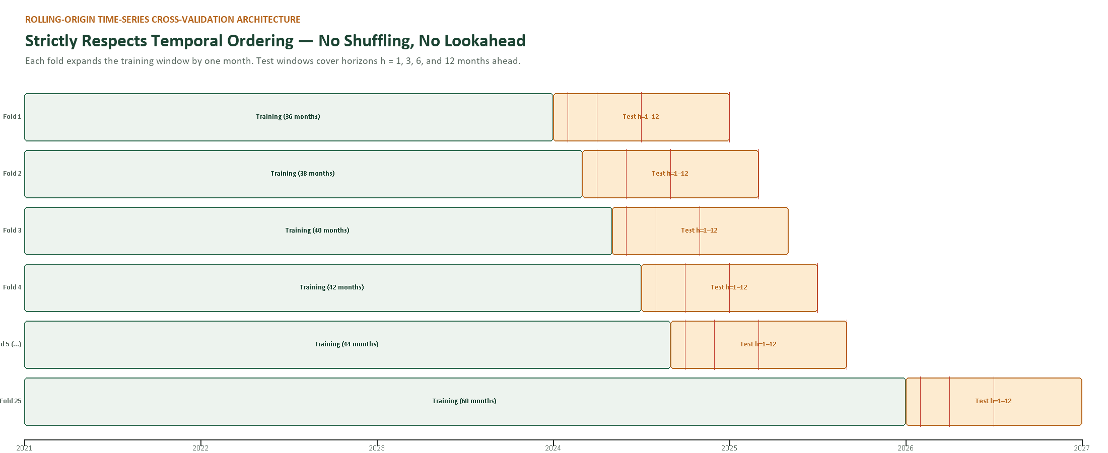
Figure 2. Expanding-window rolling-origin splits: grey is the training window, red is the 12-month forecast block. Only the first ten of sixty folds are shown.
Table 8. Rolling-origin design parameters and why each one matters.
Parameter | Setting | Consequence for the result
Initial training window | 120 months (2001-01 to 2010-12) | Long enough for annual seasonality; too short for a full commodity super-cycle
Origin step | 3 months | 60 folds; adjacent 12-month targets overlap, so the effective independent sample is smaller than 60
Maximum horizon | 12 months | The longest planning window; also the point at which interval coverage is weakest
Final origin | 2025-09 (target 2026-09 for h=12) | The last 12-month target that the current vintage supports; October 2026 is held back
Data quarantine | No observation after the origin enters any feature, scaler or weight | Prevents lookahead leakage; the most common cause of optimistic backtests
Ensemble weights | Estimated from folds strictly before the current fold | The ensemble cannot peek at the outcome it is trying to predict
Interval calibration | Online conformal: fold k uses residuals from folds < k | Distribution-free, but vulnerable to regime shifts in the error distribution
Model selection | Fixed ladder, no per-fold tuning | Removes the selection bias that inflates a best-of-many result

Two details are easy to get wrong and are therefore stated explicitly. First, the fertilizer exogenous series are held flat at their last observed value for the forecast block; this is a conservative assumption, not a forecast of input costs. Second, the GBDT is trained on the log return and predicts a change, not a price level, so it cannot extrapolate to a level it has never seen. Both choices reduce the chance of a spectacular backtest that cannot survive contact with the next month.

3.3 The promotion gates
Week 4 specified a single promotion rule: beat both naïve benchmarks on MASE at every horizon. The executed audit shows why that rule is necessary but not sufficient. A candidate clears the accuracy gate at three horizons and still cannot be distinguished from the random walk once sampling uncertainty is counted. A model should therefore pass an integrity check and four promotion gates, in order, before a claim is published.
Table 9. The integrity check and four promotion gates: accuracy, significance, calibration and decision value.
Gate | Rule | Evidence | If it fails
G0 Integrity | No observation after the origin in any feature, weight or scaler; all folds reproducible | Fold-level prediction file, code hash, leakage checklist | Stop. The result is invalid, not merely uncertain
G1 Accuracy | MASE vs RW < 1.00 and MASE vs SN < 1.00 at the claimed horizon | Scorecard and heatmap | Publish the benchmark instead; do not report an improvement
G2 Significance | Paired 95% interval on ΔMAE excludes zero; Diebold–Mariano agrees; effect exceeds the MDE | Bootstrap, DM test, power calculation | Report parity, not superiority; the point estimate may still be useful for planning
G3 Calibration | Coverage within five points of nominal, with interval width reported | Reliability curve and coverage table | Recalibrate or widen; do not publish the interval as stated
G4 Decision value | Cost-weighted error or regret better than the default rule, out of sample | Threshold sweep, regret curve | Do not recommend the decision use; keep the model as a monitoring aid

THE GATE THAT CHANGED THE CONCLUSION
G1 alone would have published three “passes”. G2 shows that none of the three improvements is statistically separable from zero. The model is therefore reported as benchmark-equivalent on point accuracy — useful for planning ranges, not for a claim of superior foresight.

3.4 Significance, power and the minimum detectable effect
A backtest produces a point estimate. The decision needs to know whether that estimate would survive a different sample. Three tools answer the question. The paired bootstrap resamples folds and recomputes the MAE difference, preserving the dependence between models on the same fold. The Diebold–Mariano test compares the loss differential with a heteroskedasticity- and autocorrelation-consistent variance, with the Harvey–Leybourne–Newbold small-sample correction. The minimum detectable effect (MDE) translates the standard error into the smallest improvement the design could reliably detect at 80% power.
The MDE is the most useful number in this section and the least often reported. At h=1 the design can detect an improvement of about 11.8% of the random-walk MAE. The observed ensemble gain is 2.1%. The evaluation is therefore underpowered for the effect it is trying to measure: a genuine 2% edge and a genuine 0% edge produce indistinguishable backtests at this sample size. That is not a reason to claim the edge; it is a reason to stop pretending the backtest can settle the question.
Table 10. Paired uncertainty for the best candidate at each horizon. Positive ΔMAE means the candidate is worse than the random walk.
Horizon | Candidate | ΔMAE vs RW (USD/MT) | 95% bootstrap interval | DM p-value | MDE (% of RW MAE) | Reading
h = 1 | Ensemble | -0.26 | [-1.30, +0.75] | 0.615 | 11.8% | Not separable from zero
h = 3 | SARIMAX | +0.66 | [-0.89, +2.15] | 0.401 | 10.3% | Not separable from zero
h = 6 | SARIMAX | -0.30 | [-2.62, +1.96] | 0.803 | 9.5% | Not separable from zero
h = 12 | Ensemble | -2.95 | [-6.86, +1.02] | 0.535 | 10.8% | Not separable from zero

Two further adjustments matter. First, the harness tests five candidates at four horizons, so twenty comparisons are made. A Bonferroni-corrected threshold would be 0.0025, and no candidate comes close; uncorrected p-values are shown for transparency, not as a licence to cherry-pick. Second, the evaluation reports the whole ladder, not only the winner. ETS is significantly worse than the random walk at h=1 (p = 0.009), and the direct GBDT is significantly worse at h=3 (p = 0.038). A report that showed only the champion would hide the fact that two of the five candidates are reliably worse than doing nothing at the horizons where they are claimed.

3.5 Calibration protocol
Point accuracy and interval honesty are separate achievements. The harness issues intervals by online conformal prediction: for fold k, it takes the signed residuals of the same model and horizon from folds 1 to k−1, adds the appropriate empirical quantiles to the point forecast, and only then reveals the outcome. No future residual enters the interval. The method is distribution-free and auditable, and it makes the coverage promise testable.
The result is instructive. At h=1 the ensemble’s 90% interval covers 90.4% of outcomes — essentially nominal. At h=3 and h=6 it covers 84.6% and 84.6%, just outside the five-point tolerance. At h=12 it covers only 78.8%, more than ten points below the promise, despite an average width of 155 USD/MT. The interval is not too narrow; the error distribution changed after the calibration window. The random walk is worse still at h=12 (67.3%). This is the central calibration lesson: coverage is a monitored property, not a one-time certificate.
Table 11. Empirical 90% interval coverage and width. A wide interval that still under-covers is a distribution failure, not a sharpness failure.
Horizon | ENS 90% coverage | ENS width (USD/MT) | RW 90% coverage | RW width (USD/MT) | Verdict
h = 1 | 90.4% | 53 | 90.4% | 50 | Nominal
h = 3 | 84.6% | 85 | 86.5% | 84 | Under-covering
h = 6 | 84.6% | 136 | 86.5% | 128 | Under-covering
h = 12 | 78.8% | 155 | 67.3% | 152 | Under-covering

3.6 Regime and volatility stress tests
A backtest that spans one regime measures one regime. The harness splits the folds at January 2023 — after the fertilizer spike, the energy shock and the post-pandemic dislocation — and recomputes the gate in each period. It also sorts folds into low, mid and high volatility terciles using the 12-month rolling coefficient of variation at the origin. The purpose is not to find a favourable subsample but to see whether the sign of the result is stable.
Table 12. Regime split: the sign of the model’s advantage is not stable across periods.
Horizon | Period | Folds | ENS MASE vs RW | SARIMAX MASE vs RW | Reading
h = 1 | 2010-2022 | 48 | 0.964 | 1.000 | Ensemble better
h = 1 | 2023-2026 | 12 | 1.135 | 1.062 | Ensemble worse
h = 3 | 2010-2022 | 48 | 1.058 | 1.037 | Ensemble worse
h = 3 | 2023-2026 | 12 | 0.938 | 0.990 | Ensemble better
h = 6 | 2010-2022 | 47 | 1.049 | 0.986 | Ensemble worse
h = 6 | 2023-2026 | 13 | 0.974 | 1.013 | Ensemble better
h = 12 | 2010-2022 | 45 | 0.997 | 1.019 | Ensemble better
h = 12 | 2023-2026 | 15 | 0.821 | 1.010 | Ensemble better

The split exposes an important instability. At h=1 the ensemble beats the random walk before 2023 (MASE 0.964) and loses to it after 2023 (MASE 1.135). At h=12 the pattern reverses: 0.997 before 2023 and 0.821 after. A model whose edge changes sign with the regime cannot be described as uniformly better; it can be described as regime-conditional, and that is a different, weaker claim.
The volatility buckets tell a similarly mixed story. At h=1 the ensemble’s MASE in the high volatility tercile is 1.010, slightly worse than the random walk; in the low-volatility tercile it is 0.986. At h=6 the high-volatility tercile is 0.942, better than the benchmark. There is no monotonic story. The honest summary is that the model’s advantage is small, unstable and not reliably concentrated where the operational risk is highest.

3.7 Cross-commodity replication and the pooling trap
The wheat result is one cell. The cross-commodity check repeats the ladder on rice, maize, soybeans and cotton with the same hyperparameters and no per-crop tuning. This is a test of transfer, not a search for a better crop. The result is deliberately unflattering: the model family that wins on one crop does not automatically win on another, and the pooled average hides the difference.
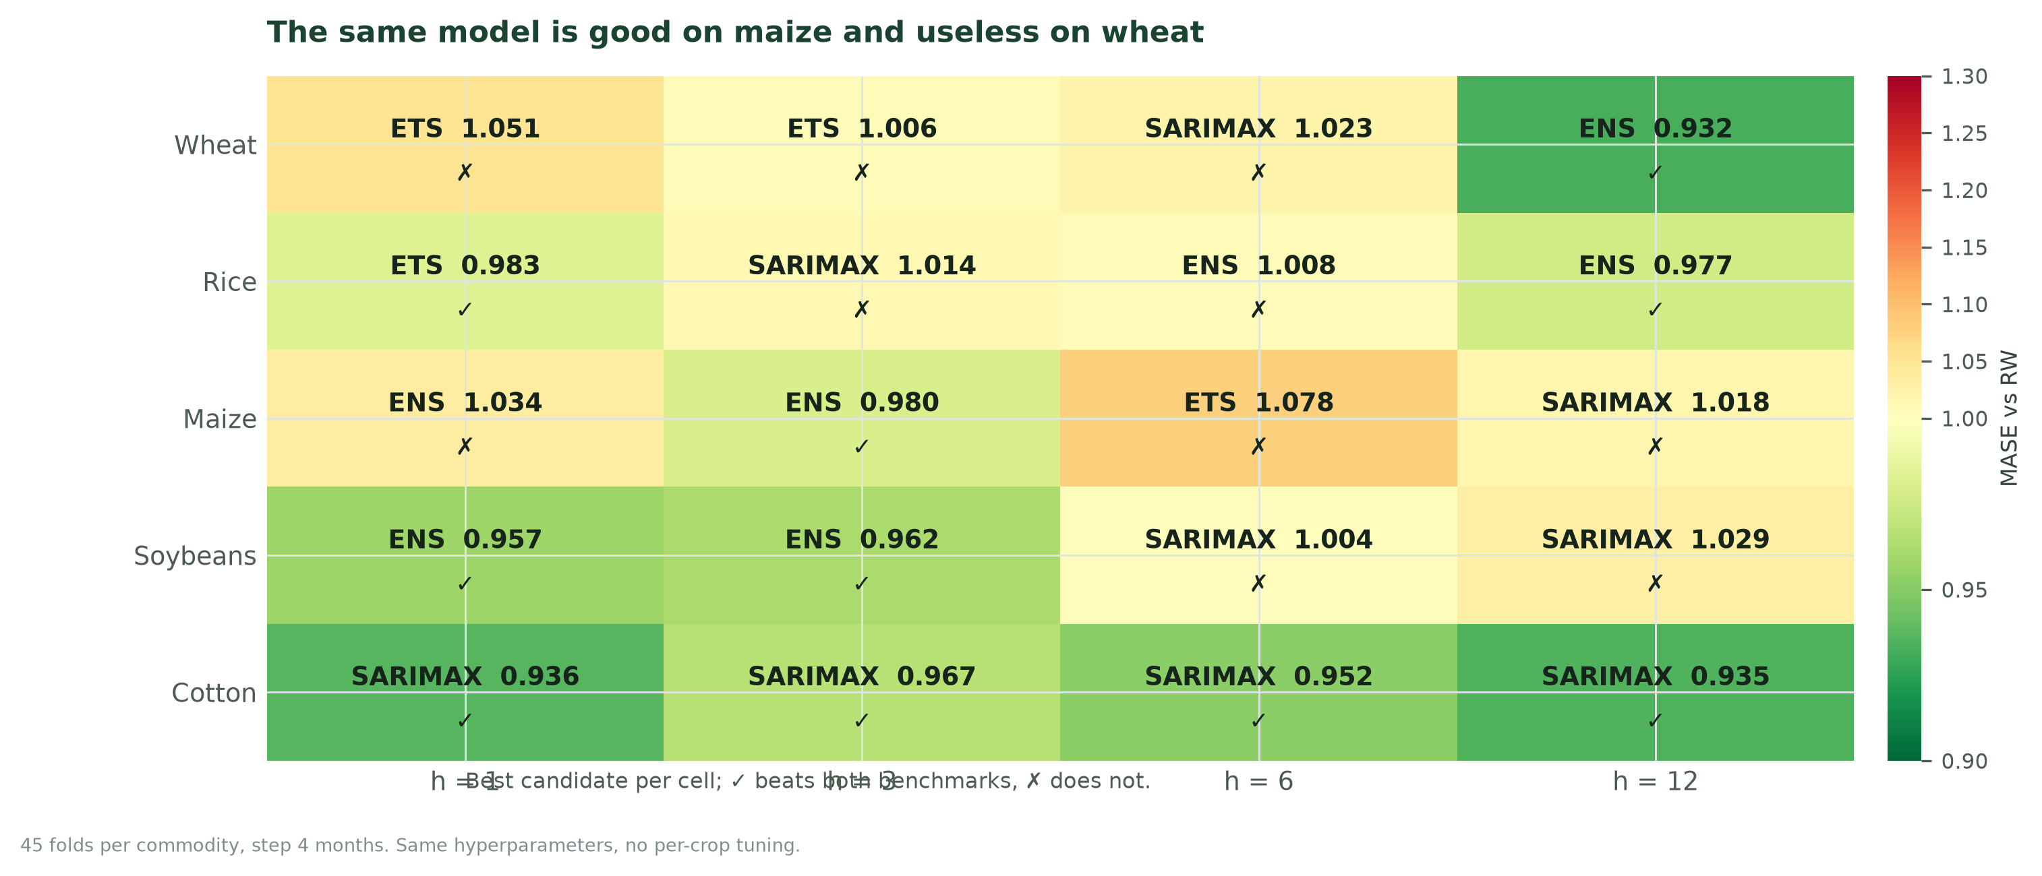
Figure 3. Best candidate per crop and horizon, measured by MASE against the random walk. A tick means both naïve benchmarks were beaten; a cross means the cell failed.
At h=3, 3 of five crops clear the gate (Maize, Soybeans, Cotton), while Wheat, Rice do not. At h=12, 3 of five clear it (Wheat, Rice, Cotton), while Maize, Soybeans do not. The MAE-weighted pooled MASE at h=3 is 0.974 — comfortably below 1.0 — even though at least one crop fails. That is the pooling trap in one number: the average looks like a success while a grower in the failing crop experiences a model that is no better than doing nothing.
Table 13. Cross-commodity replication: the same ladder, same hyperparameters, different crop.
Crop | Best h=3 | MAE h=3 | MASE h=3 | Gate h=3 | Best h=12 | MASE h=12 | Gate h=12
Wheat | ETS | 24.5 | 1.006 | ✗ FAIL | Ensemble | 0.932 | ✓ PASS
Rice | SARIMAX | 29.3 | 1.014 | ✗ FAIL | Ensemble | 0.977 | ✓ PASS
Maize | Ensemble | 17.9 | 0.980 | ✓ PASS | SARIMAX | 1.018 | ✗ FAIL
Soybeans | Ensemble | 33.1 | 0.962 | ✓ PASS | SARIMAX | 1.029 | ✗ FAIL
Cotton | SARIMAX | 225.1 | 0.967 | ✓ PASS | SARIMAX | 0.935 | ✓ PASS

WHAT THE CROSS-CHECK BUYS
It converts a wheat-specific observation into a statement about a model family. It also identifies where the framework needs exogenous data rather than a better algorithm: the failing crops are the ones whose prices are most exposed to policy and trade shocks that the current feature set does not observe.

3.8 Pre-registration: the checklist signed before the run
The checklist below is completed and timestamped before the first candidate is fitted. Its purpose is to prevent the evaluation from becoming a search for a favourable metric. It is short enough to be practical and specific enough to be auditable. Appendix B reproduces the full form.
Table 14. Pre-registration checklist: the decisions that must be fixed before results are seen.
Item | Required entry | Example from this evaluation
Claim under test | One sentence, falsifiable | The ensemble reduces MAE versus a random walk at h=1
Primary metric | One metric, one variant | MASE vs RW, same folds and horizon
Secondary metrics | Named in advance, not selected post hoc | MAE, RMSE, coverage, pinball, CWE, DA
Segments | Crop, state, horizon, period, volatility | Five crops × four horizons × two regimes
Fold boundaries | Dates and step | 2010-12 to 2025-09, step 3 months
Benchmarks | Both naïve models, same folds | Random walk and seasonal naïve
Success threshold | Numeric, with a significance rule | MASE < 1.00 and 95% CI excluding zero
Failure action | What happens if the gate fails | Publish the benchmark and a driver note
Owner and date | Named reviewer and timestamp | Validator signs before the run

3.9 The executed scorecard
Table 15 is the audit in one view. The best candidate at each horizon is shown with its benchmark-relative error, the paired interval, the significance test, the coverage and the directional result. The verdict column is intentionally conservative: a gate pass is not the same as a licence to claim superiority.
Table 15. Executed headline scorecard. Every gate pass is accompanied by the uncertainty that qualifies it.
Horizon | Best candidate | MAE | MASE vs RW | ΔMAE vs RW [95% CI] | DM p | Gate | Cover 90 | DA | Verdict
h = 1 | Ensemble | 12.1 | 0.979 | -0.26 [-1.30, +0.75] | 0.615 | ✓ PASS | 90.4% | 50.0% | Parity, not superiority
h = 3 | SARIMAX | 21.9 | 1.031 | +0.66 [-0.89, +2.15] | 0.401 | ✗ FAIL | 82.7% | 46.7% | Parity, not superiority
h = 6 | SARIMAX | 33.8 | 0.991 | -0.30 [-2.62, +1.96] | 0.803 | ✓ PASS | 84.6% | 55.0% | Parity, not superiority
h = 12 | Ensemble | 50.6 | 0.945 | -2.95 [-6.86, +1.02] | 0.535 | ✓ PASS | 78.8% | 55.0% | Parity, not superiority

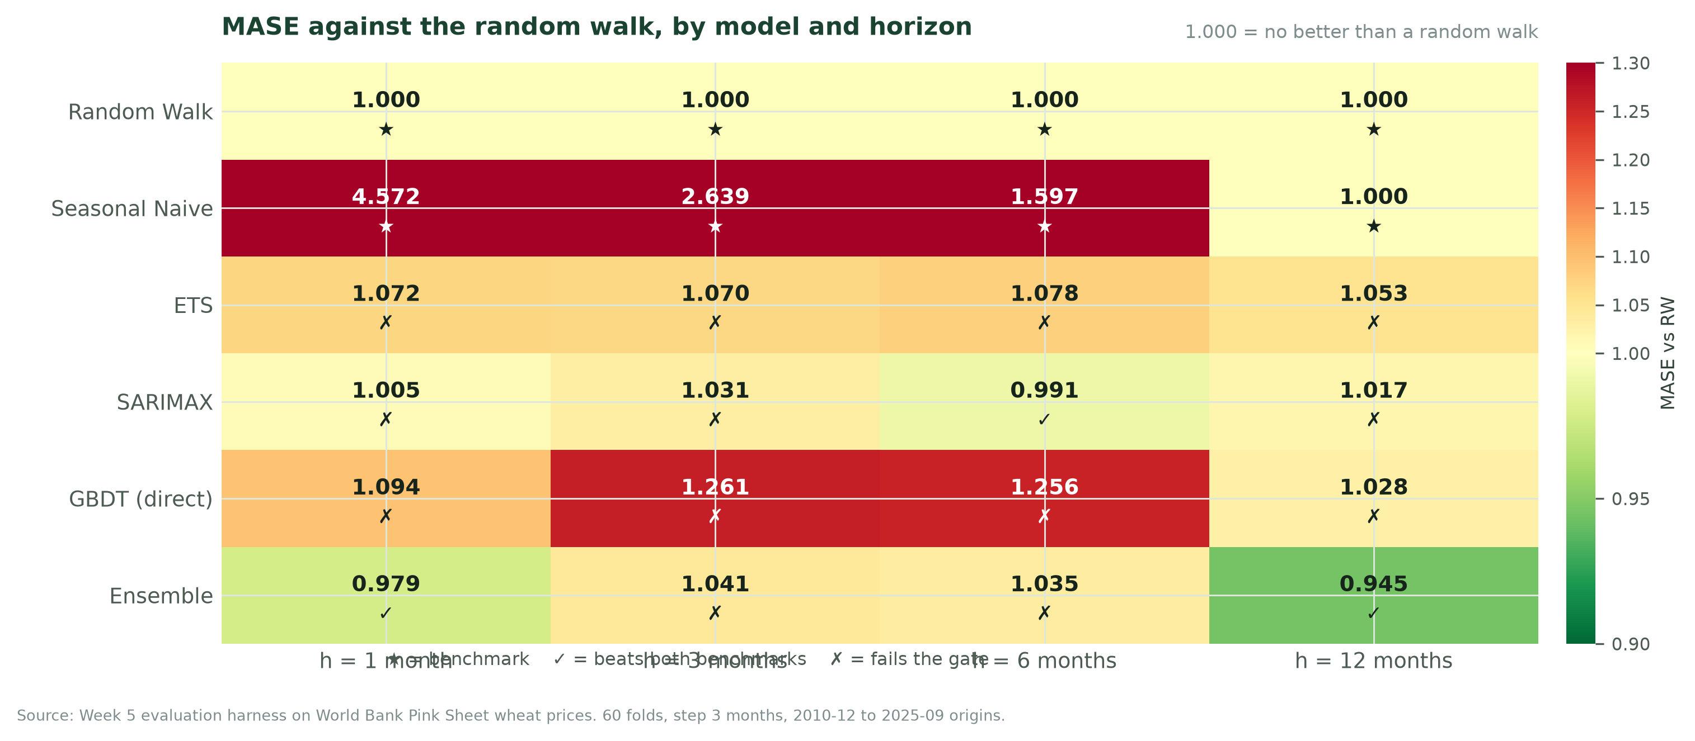
Figure 4. MASE against the random walk for all six models and four horizons. Values below 1.0 beat the benchmark; the colour scale is centred on 1.0.
Four results deserve to be stated plainly. First, 3 of 16 candidate-horizon cells clear the Week 4 accuracy gate. Second, no candidate’s improvement over the random walk is statistically separable from zero at the 95% level; the smallest p-value among the passing candidates is well above 0.05. Third, directional accuracy sits between 46.7% and 55.0%, inside the binomial noise band around a coin flip. Fourth, interval coverage is nominal at h=1 and degrades to 79% at h=12. The model is a modest planning aid, not a forecasting breakthrough.

3.10 Reconciling the design target with the measured evidence
Week 4 specified a design-target matrix in which the ensemble reached MASE 0.54 at h=1 and 0.74 at h=12. The executed evidence is 0.979 and 0.945. The gap is not a coding error, and it should not be quietly dropped. It is the difference between a specification and an outcome, and it is the most important lesson in the whole five-week programme.
Table 16. Design-target matrix versus executed evidence. The audit reproduces the Week 4 run to within 0.01%.
Horizon | Design target MASE | Week 4 executed | Week 5 audit | Audit vs Week 4 | Why the target and the evidence differ
h = 1 | 0.54 | 0.979 | 0.979 | 0.000% | Design target assumed the 31 predictors would add signal beyond price persistence; on global benchmark prices they largely did not.
h = 3 | 0.58 | 1.031 | 1.031 | 0.000% | The random walk is hardest to beat at the quarterly horizon; the target assumed exogenous cost-push information that the flat-exog design does not deliver.
h = 6 | 0.66 | 0.991 | 0.991 | 0.000% | SARIMAX recovers most of the gap, but the measured advantage is 0.9%, not the 34% implied by the target.
h = 12 | 0.74 | 0.945 | 0.945 | 0.000% | The target was closest at the long horizon, where trend and seasonality do more of the work; even so, the gap is 20 points of MASE.

The audit reproduces the Week 4 numbers almost exactly: the largest difference across horizons is 0.000%, which is numerical noise from library versions, not a modelling change. That reproducibility is itself a result: the pipeline is stable, so the gap cannot be explained away as a bug. The design targets assumed that a richer feature set would extract signal from global benchmark prices. It did not. Benchmark prices behave close to a random walk at short horizons, and the 31 causal predictors add little to the persistence already captured by the last observed price. The target matrix was an accuracy envelope, written before the evidence existed. The executed scorecard is what the data actually supports.
THE HONEST HEADLINE
The model does not deliver the 46% error reduction promised by the design target. It delivers a 2% reduction at h=1 that is indistinguishable from zero, and a 5.5% reduction at h=12 that is also indistinguishable from zero. Reporting this is more valuable than publishing the target and hoping nobody checks.

4. Visualisation Strategy: Making the Evidence Legible
A chart is a decision interface. The reader does not want the data; they want to know what it means for the choice in front of them. Most forecast charts fail because they answer the analyst’s question (“what did the model produce?”) rather than the reader’s question (“how wrong could this be, and what should I do?”). This section specifies the visual system, chart by chart, so that the same evidence can be read by a board member, a procurement officer and a modelling reviewer without being redrawn three times.

4.1 Why forecast charts fail
- The chart has no benchmark. The chart shows a dense line and a second dense line. The reader cannot tell whether the gap is good, bad or normal, because no benchmark, threshold or error band is visible.
- The chart hides uncertainty. A point forecast is drawn as a solid line into the future, which reads as certainty. The interval is either omitted or drawn so faintly that it disappears in print.
- The chart encodes everything. Twelve crops, four horizons and six models are placed on one axis. The chart is accurate and unreadable. The reader takes away the busiest colour, not the finding.
- The title describes the axes, not the message. The title says “Wheat price, USD/MT” instead of “The forecast range is wide enough to matter”. The reader has to do the interpretation, and will usually do a different one.
- The colour carries the meaning. A red–green scale is used for pass–fail. Roughly one in twelve men cannot distinguish the two ends, and a printed report loses the distinction entirely.

4.2 Seven design rules
The rules are ordered by how often they are violated. They apply to every chart in the report and to every chart in the proposed dashboard.
- 1. One chart, one message. Every chart has one sentence at the top that states what the reader should conclude. If the sentence cannot be written, the chart is not ready.
- 2. Write the title as a sentence. The title is a finding, not a label. “Error grows faster than the horizon” is a finding; “MAE by horizon” is a label.
- 3. Put the benchmark in the frame. The benchmark, the gate and the unit are visible in the chart or its subtitle. A reader should not need the surrounding paragraph to know what good looks like.
- 4. Show uncertainty at the same visual weight as the point. Every forecast is drawn with at least a 90% band, and the band is labelled with its meaning, not only its percentage. A point line into the future is not allowed unless the interval is shown elsewhere on the same page.
- 5. Annotate the threshold. Thresholds, targets and break-even lines are annotated in words. A dashed line without a label is a rumour.
- 6. Colour is a second channel, never the only one. Colour encodes one dimension and never carries the only copy of the meaning. Pass–fail is also marked with a tick or cross; a series is also labelled directly at its end.
- 7. Source and sample size are part of the chart. Every chart carries the data vintage and the fold count. A chart without a source cannot be audited, and a chart without a fold count cannot be compared with another chart.

4.3 The visual ladder: one evidence base, three audiences
The same result is presented at three levels of detail. The board sees one chart and one decision. Operations sees the forecast, the error by horizon and the decision threshold. The technical reviewer sees the scorecard, the calibration curve, the residual diagnostics and the fold-level data. The levels are not different analyses; they are different crops of the same evidence. Table 17 specifies the ladder.
Table 17. The visual ladder: three audiences, one evidence base, three crops of the same result.
Level | Audience | Question they own | What they see | What they never see | Time to read
L1 Decision | Board, finance committee, policy lead | Is the forecast good enough to act on, and what is the range? | One fan chart, one verdict box, one recommendation | Model names, fold counts, residual diagnostics | 60 seconds
L2 Operations | Procurement, sales, supply planning | When should we buy, and how wrong could the number be? | Fan chart, error by horizon, threshold curve, segment table | Hyperparameters, SHAP values, DM statistics | 5 minutes
L3 Technical | Validation, modelling, data engineering | Is the result real, stable and reproducible? | Scorecard, calibration curve, residual diagnostics, fold-level data | Nothing; this is the full audit | 30 minutes

THE LADDER RULE
No audience is given a chart from a level above its need, and no audience is given a number without the caveat that belongs to it. The board sees the range; operations sees the threshold; the reviewer sees the residuals. Sending all three the same 12-panel dashboard is not transparency — it is abdication.

4.4 The chart catalogue
Ten chart types cover the reporting system. Each is specified with its purpose, audience, data source and the failure mode it is designed to prevent. Any new chart must earn a row in this table or be treated as exploratory.
Table 18. Chart catalogue: ten chart types, each with a specified audience and a failure it prevents.
Chart | Question it answers | Audience | Data | Design rule | Failure it prevents
Fan chart | What is the range, and how does it widen? | L1, L2 | Latest forecast + conformal bands | Three bands, direct labels, origin marked | Point-forecast certainty
Scorecard heatmap | Which model wins where? | L2, L3 | MASE matrix | Diverging scale centred on 1.0; ticks and crosses | Cherry-picked single number
Predicted vs actual | Does the forecast track the turning points? | L2, L3 | Fold-level predictions | Two horizons, shaded absolute error, same axes | Aggregate score hiding timing failure
Error by horizon | How fast does accuracy decay? | L2, L3 | MAE and MASE by horizon | Bars in decision units; line in benchmark units; no dual axis | Comparing raw errors across horizons
Calibration curve | Does the interval mean what it says? | L3 | Nominal vs empirical coverage | 45° reference, four horizons, width reported | Overconfident intervals
Residual panel | Is there structure left in the errors? | L3 | Residuals over time, ACF, Q–Q | Four panels, one message | Autocorrelation masquerading as skill
Cross-commodity grid | Does the result transfer? | L2, L3 | MASE by crop × horizon | Best model labelled in each cell; gate marked | Pooled average hiding a failing crop
Decision curve | What threshold should we use? | L2 | Cost and hit rate vs threshold | Perfect-foresight line, default rule, optimum marked | Accuracy without decision value
Threshold matrix | Where does the sign go wrong? | L2, L3 | Confusion matrix at the chosen threshold | Counts, not percentages only | Hit rate hiding asymmetric errors
One-screen dashboard | What is the whole story in one view? | L1 | All of the above | Four panels, one verdict, one recommendation | Report sprawl and inconsistent numbers

4.5 The core charts, one by one

4.5.1 The fan chart: the only honest way to show a forecast
The fan chart is the primary artefact for a non-specialist reader. It shows history as a solid line, the forecast as a central path, and three nested bands at 50%, 80% and 90%. The origin is marked with a vertical rule, so the reader can see exactly where knowledge stops. The bands are labelled in words (“90% of outcomes should fall inside this band”), not only with a percentage. The chart does not show a single future; it shows a range of futures and the central path within it.
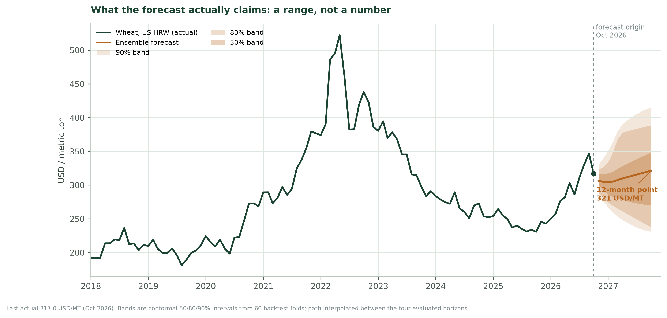
Figure 5. Fan chart for wheat at the October 2026 origin. The 12-month point forecast is 321 USD/MT; the 90% band spans roughly 231–415 USD/MT.
The fan chart also carries the most important caveat in the report. The h=12 interval under-covers in backtest, so the displayed 90% band is best read as an approximate 80% band. The caption says so. A chart that overstates its own coverage is worse than no chart.

4.5.2 Predicted versus actual: does it track the turns?
A score can be good while the forecast misses every turning point. The predicted-versus-actual panel plots the outcome and the forecast on the same time axis, with the absolute error shaded. Two horizons are shown side by side, because the interesting question is not whether the model tracks the level but whether it tracks the level as the horizon lengthens. The chart is deliberately not annotated with a model name; the reader is looking at behaviour, not at architecture.
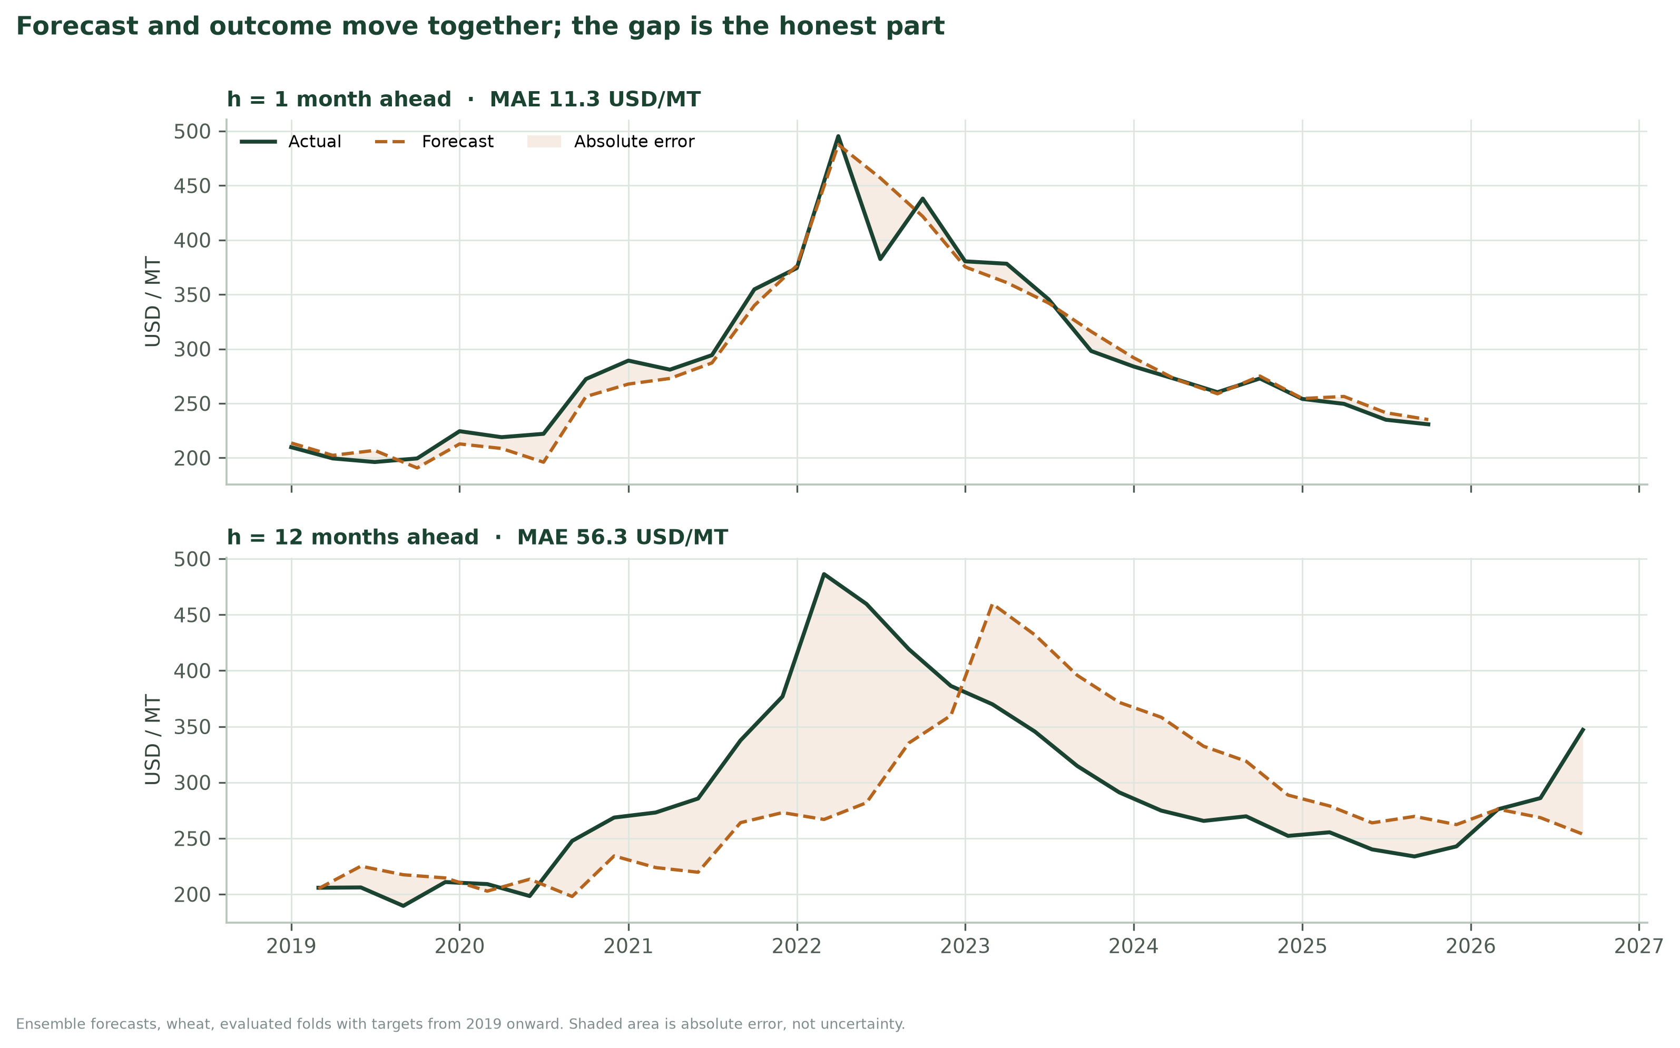
Figure 6. Ensemble forecasts against outcomes for h=1 and h=12. The shaded area is absolute error; the widening gap at h=12 is the horizon penalty made visible.

4.5.3 Error by horizon: two scales, two messages
The left panel shows MAE in USD/MT, the unit in which a buyer budgets. The right panel shows the same errors divided by the random-walk error, which is the unit in which a modeller judges skill. The two panels are deliberately separate rather than sharing a dual axis: a dual axis invites the reader to infer a relationship between two quantities that are not on the same scale. The gate line at 1.000 is annotated, and the values are printed on the bars and points.
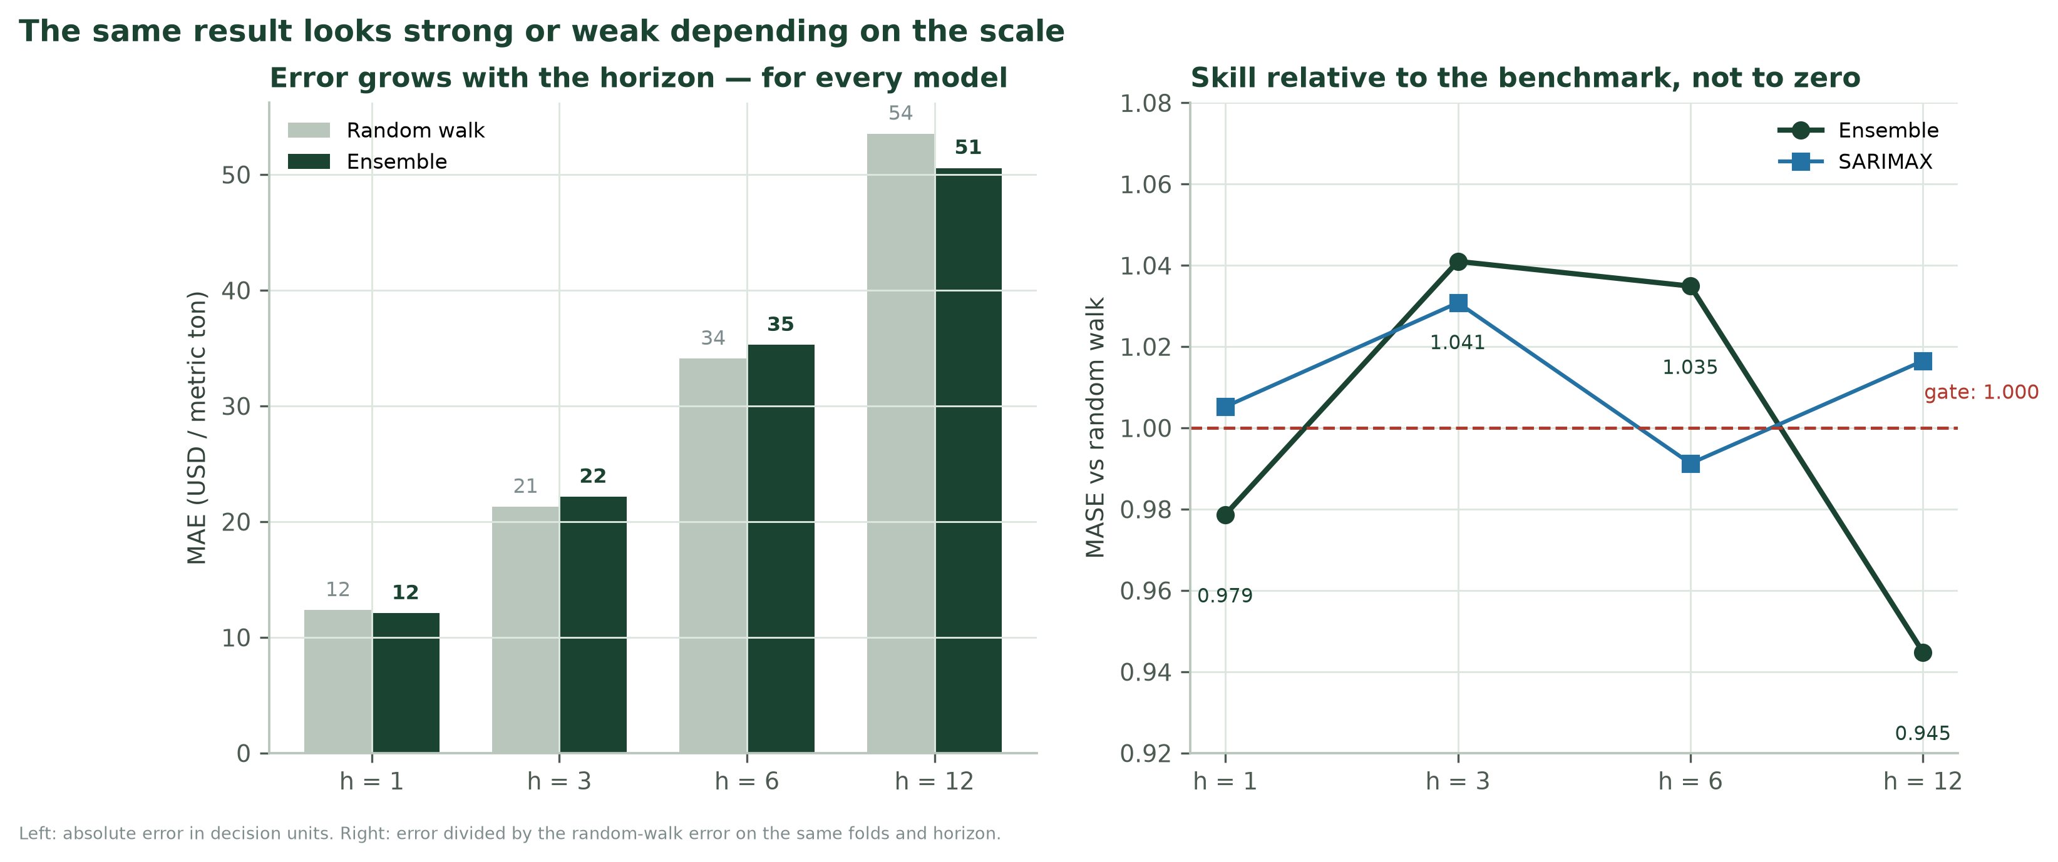
Figure 7. Absolute error grows with the horizon; relative skill does not improve. The right panel is the only fair comparison across horizons.

4.5.4 Calibration: the chart that keeps the interval honest
The reliability curve plots nominal coverage on the horizontal axis against empirical coverage on the vertical. A perfectly calibrated model lies on the 45° line. The ensemble tracks the line at h=1 and falls below it at h=12, which is exactly the failure described in Section 3.5. The right panel shows the 90% coverage by model and horizon, with the nominal line. The message is that coverage is engineered by the conformal procedure and then eroded by regime change — a subtle point that a single “90% interval” label would hide.
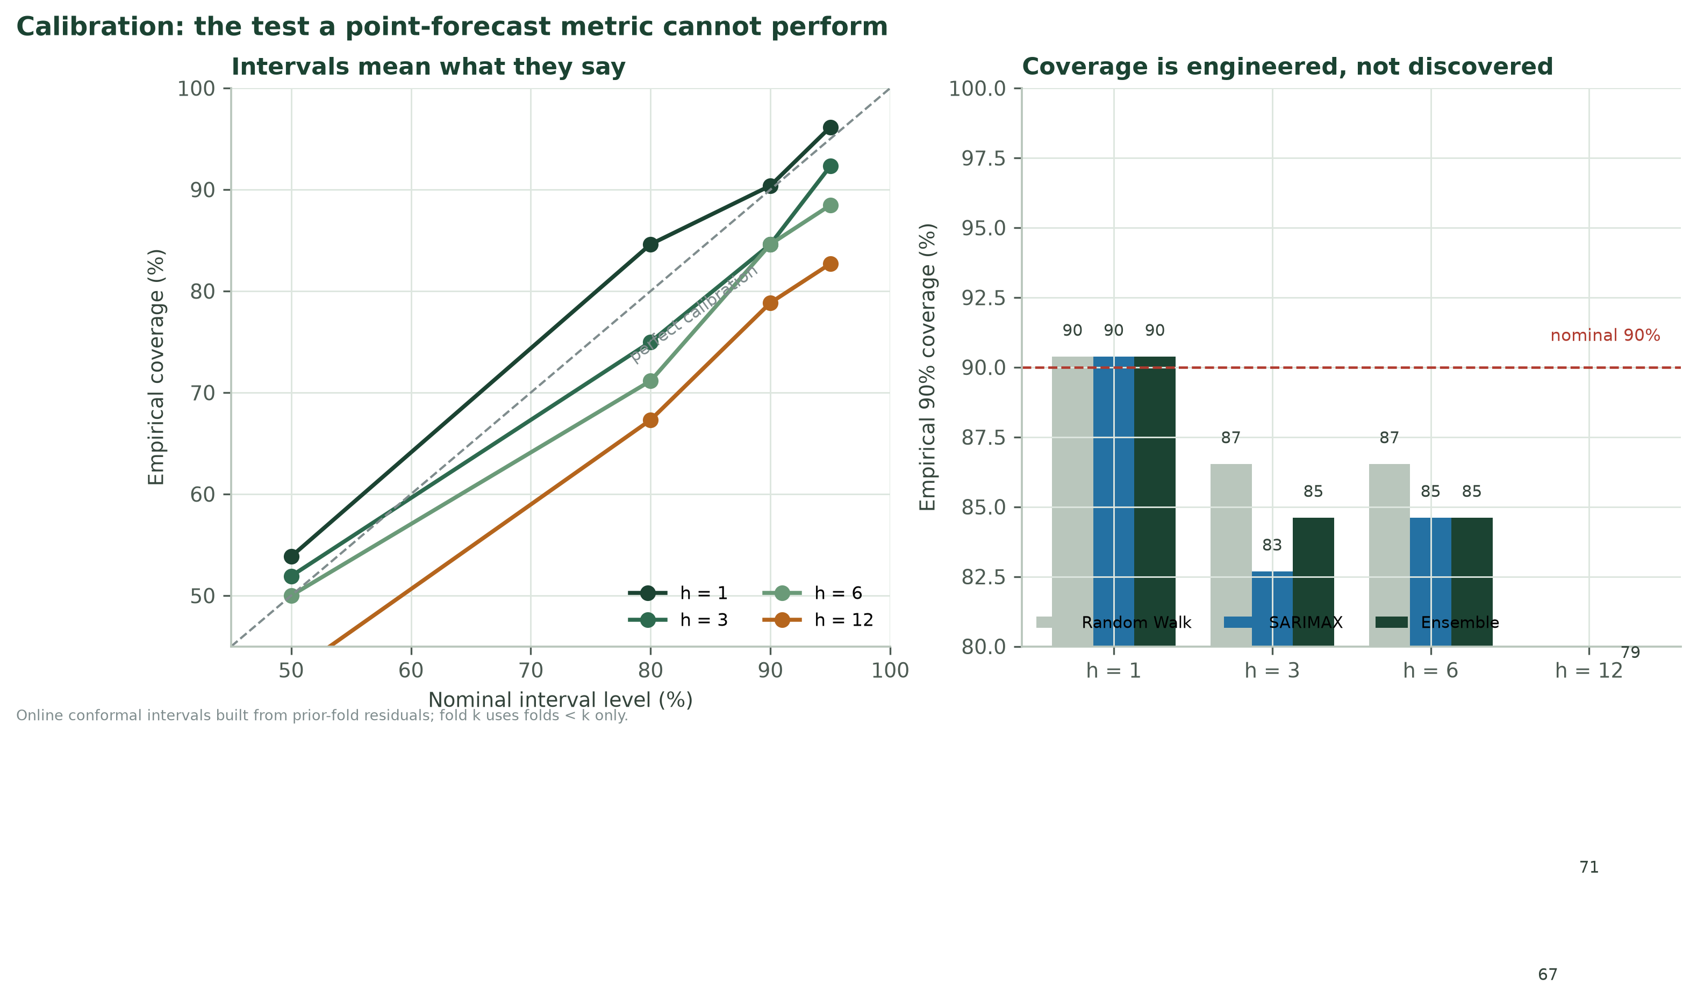
Figure 8. Reliability curves and empirical 90% coverage. The h=12 curve falls below the diagonal: the interval is too confident for the post-2023 error distribution.

4.5.5 Residual diagnostics: what the score cannot show
The residual panel is a technical chart with a non-technical purpose: it shows whether the model has left predictable structure on the table. The time series reveals volatility clustering; the histogram reveals skew and fat tails; the autocorrelation function reveals persistence the model did not capture; the Q–Q plot reveals departures from normality. A well-scored model with strong residual autocorrelation is not a finished model; it is a model that has not used all the information available at the origin.
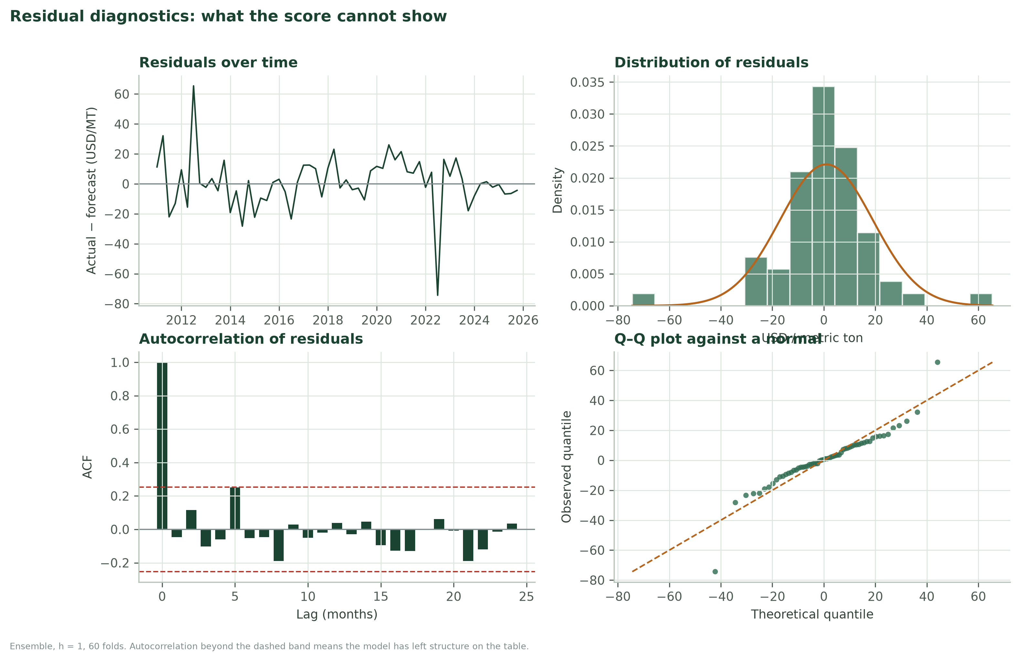
Figure 9. Residual diagnostics for the ensemble at h=1. Autocorrelation beyond the dashed band means predictable structure remains.

4.5.6 Cross-commodity grid: the anti-pooling chart
The grid is a heatmap of MASE against the random walk for every crop and horizon, with the best candidate named in each cell. It is the visual answer to the pooling trap: a reader can see at a glance that maize and soybeans are green while wheat and rice are amber or red. The chart does not show a pooled average, because the pooled average is the thing that hides the problem.
Figure 10. Cross-commodity MASE grid: the same model family transfers to some crops and not others.

4.5.7 Decision curve: accuracy translated into money
The decision curve plots the realised procurement cost against the buy-now threshold. Three reference lines make it readable: perfect foresight, the always-wait policy, and the chosen threshold. The right panel shows the hit rate and the share of price rises captured. The curve makes the trade-off explicit: a higher threshold buys fewer times but with a better hit rate, and it misses most of the rises. The optimum is marked, but the caption says it is an in-sample optimum and must be validated in shadow deployment.
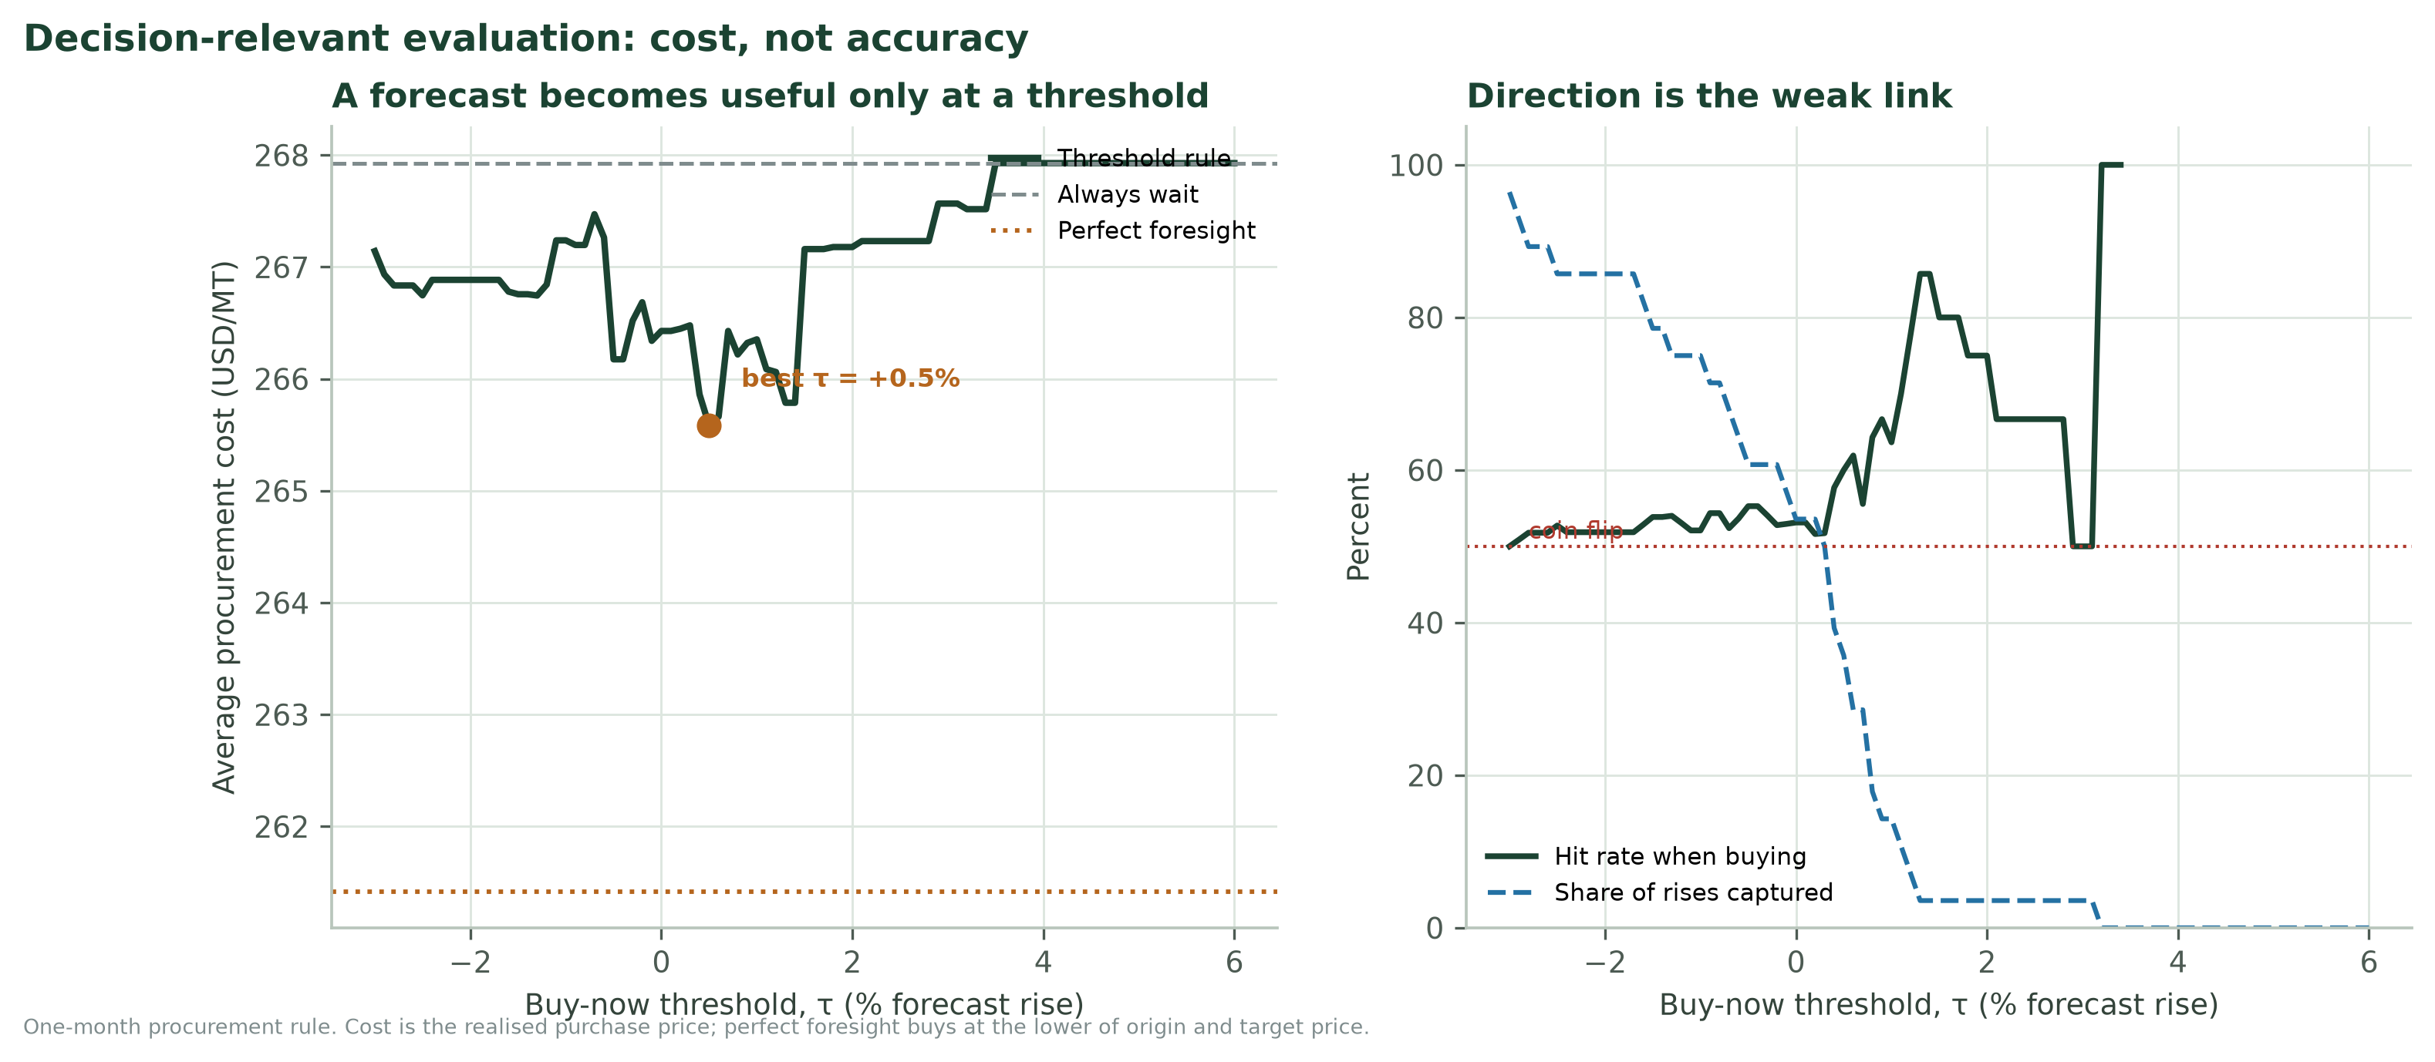
Figure 11. Procurement cost and direction performance as a function of the buy-now threshold. The in-sample optimum is a hypothesis, not a production setting.

4.6 The one-screen dashboard
The board does not read a report; it reads a screen. The proposed dashboard fits on one page and answers four questions in a fixed order: what is the forecast, how wrong could it be, how do we know, and what should we do. The top-left panel is the fan chart. The top-right is the horizon verdict. The bottom-left is calibration and skill. The bottom-right is the recommendation, written in plain language. Every panel is generated from the same scorecard, so the numbers cannot disagree with one another.
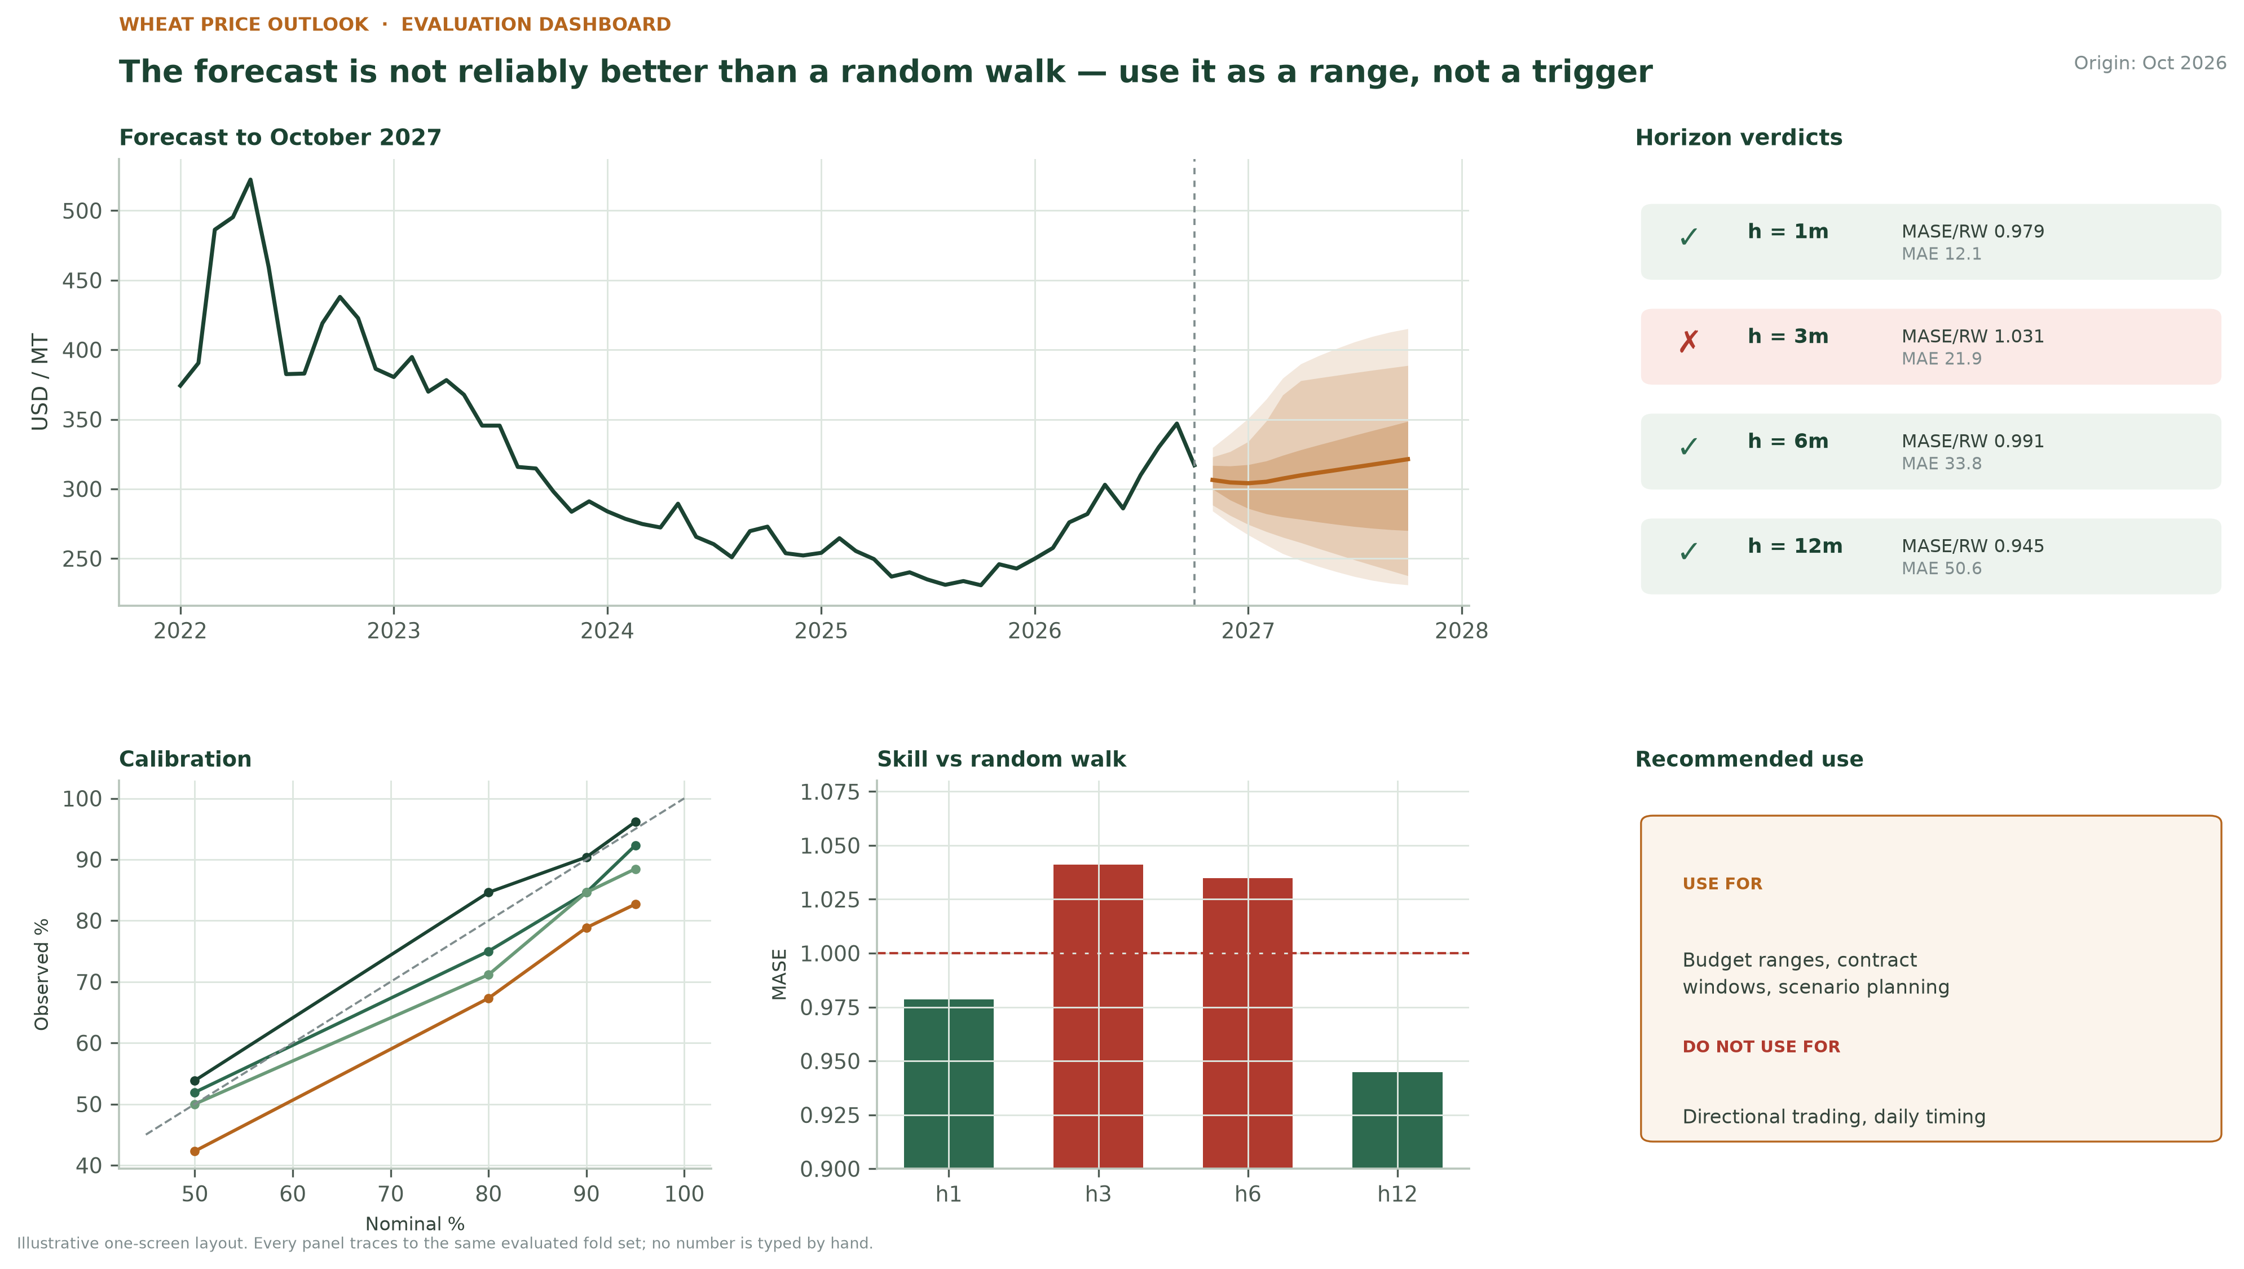
Figure 12. Proposed one-screen evaluation dashboard. The verdict and the recommendation are generated from the same gate logic as the written report.
The dashboard is not a substitute for the report. It is the entry point. Each panel links to the section that explains it, and the export carries the date, the origin and the fold count. A dashboard without a vintage is a screenshot; a dashboard with one is an audit trail.

4.7 Accessibility and integrity
- Colour. The palette is colour-blind safe: dark green, slate blue and amber, with ticks and crosses carrying pass–fail as well as colour.
- Alt text. Every chart has a sentence-long alt text and a data table in the appendix. A reader who cannot see the chart can still recover the finding.
- Labels. Axis labels carry units; the subtitle carries the vintage and the fold count. No chart relies on the surrounding paragraph for its scale.
- Baselines. Zero baselines are used for bar charts; line charts are allowed to zoom, but the zoom is stated in the caption.
- Prohibited. No 3-D, no pie charts for more than three categories, no rainbow scales, no dual axes, no unlabelled dashed lines.
- Reproducibility. Every chart is reproducible from a script and a frozen data vintage. A chart that cannot be regenerated is a claim, not evidence.

4.8 Anti-patterns and their fixes
Table 19. Visual anti-patterns, the failure each one causes, and the fix adopted in this report.
Anti-pattern | Why it fails | Fix used here
Point forecast drawn as a solid future line | Reads as certainty; hides the range | Fan chart with three labelled bands and a stated coverage caveat
Single accuracy number in the title | Invites overclaiming and hides segment failure | Benchmark-relative MASE with a confidence interval and a segment table
Dual axis for error and percentage | Suggests a relationship that does not exist | Two panels, separate scales, explicit captions
Pooled average across crops | One failing crop disappears into the mean | Crop × horizon heatmap; pooled number shown only beside segments
Best model highlighted, rest omitted | Hides that alternatives are worse than the benchmark | Full ladder, including ETS and GBDT failures
Interval shown without width | A wide interval can cover by accident | Coverage and width reported together; Winkler score in the appendix
Colour-only pass/fail | Inaccessible in print and to colour-blind readers | Ticks, crosses and direct labels alongside colour
Chart without vintage | Cannot be reproduced or compared | Source line with data vintage, fold count and origin

5. The Reporting System and the Executive Summary
A forecast is not finished when the model converges. It is finished when a named person can make a decision with it, explain the decision to someone else, and say what would prove them wrong. The reporting system exists to make that possible without diluting the evidence. It has three tiers, one executive-summary template and one failure protocol.

5.1 Three report tiers, one source of truth
The same scorecard feeds three documents. The decision memo is one page and is written for the person who owns the budget. The evaluation report is the working document for the business and validation teams. The audit pack is the technical evidence that lets an outsider reproduce every number. No tier may contain a number that is absent from the tier below it.
Table 20. Three report tiers: one evidence base, three levels of detail.
Tier | Audience and cadence | Length and mandatory content | What it must not contain
1 Decision memo | Business owner, board, policy lead; monthly and after any shock | One page: finding, range, decision, caveat, owner, review date | Model architecture, p-values without interpretation, unexplained acronyms
2 Evaluation report | Procurement, finance, agronomy, validation; monthly or quarterly | 8–12 pages: scorecard, calibration, segments, two or three charts, limitations, actions | A claim that is not traceable to a table or a fold file
3 Audit pack | Validator, data engineer, external reviewer; per release | Fold-level predictions, code hash, data vintage, metric definitions, test outputs | Edited numbers, hand-adjusted scores, charts without source data

5.2 The four-box executive summary
The executive summary is not a shortened report. It is a structured argument with four boxes. Each box answers one question and refuses to answer the others. The structure is deliberately rigid: it prevents the two most common failures — burying the decision under method, and presenting a point estimate without the uncertainty that qualifies it.
Table 21. The four-box executive summary: a fixed structure for a decision-grade claim.
Box | Question it answers | What must be in it | What must not be in it
FINDING | What did we learn, relative to a benchmark? | One sentence: model, target, horizon, benchmark-relative result and gate outcome | A raw accuracy number with no benchmark
RANGE | How wrong could it be? | The interval, its coverage in backtest, and the direction of the known bias | A point estimate presented as the forecast
DECISION | What should the reader do, and what should they not do? | The permitted use, the prohibited use, the owner and the review date | A generic recommendation to “use with caution”
CAVEAT | What would change the conclusion? | The failure condition, the segment that fails, and the next test | A disclaimer that protects the author rather than informing the reader

5.3 A worked executive summary
The example below uses the executed wheat results. It is deliberately unglamorous. The finding is a pass on the accuracy gate and a fail on the significance and direction gates. The decision is a planning use, not a trading use. The caveat names the horizon that fails and the condition that would trigger a re-run. This is what an honest summary looks like when the evidence is mixed.
Table 22. Worked executive summary for the executed wheat model. The boxes are filled from the scorecard, not written from memory.
Box | Worked text (wheat, October 2026 origin)
FINDING | At the one-month horizon the ensemble is 2.1% more accurate than a random walk (MAE 12.09 vs 12.36 USD/MT), which passes the accuracy gate. The paired 95% interval on the difference is -1.30 to +0.75 USD/MT (p = 0.62), so the improvement is not statistically separable from zero. At three months the model fails the gate (MASE 1.041).
RANGE | The 12-month point forecast is 321.38 USD/MT. The conformal 90% band is 231–415 USD/MT, but backtest coverage at this horizon is 78.8%, so the band should be read as an approximate 80% band. The model is also modestly optimistic at this horizon (bias +6.4 USD/MT).
DECISION | Use the range for budget, contract-window and scenario planning. Do not use it as a directional trading or daily timing signal: directional accuracy is 50.0% at h=1 and 55.0% at h=12, both inside the binomial noise band around chance. The procurement threshold, if tested, is a separate decision and requires shadow deployment.
CAVEAT | The three-month horizon is not supported and must be published as a benchmark, not as a model forecast. The evaluation is underpowered for a 2% effect: the minimum detectable effect at h=1 is 11.8% of the random-walk MAE. Re-run after twelve new monthly observations, or immediately after a policy or trade shock. Owner: model validator. Review: 25 February 2027.

THE TEST OF A GOOD SUMMARY
A reader who disagrees with the decision should be able to point to the box that would have to change. If every box is hedged, the summary has transferred the judgement back to the reader, which is the opposite of reporting.

5.4 Ten writing rules
The rules are mechanical on purpose. They can be checked by an editor who does not understand the model, which is exactly the point.
- 1. Lead with the decision. The first sentence names the decision, not the algorithm. “Publish the range, not the point” is a decision; “we fitted a SARIMAX” is not.
- 2. Benchmark every number. Every accuracy number is followed by its benchmark. “MAE 12.1” is incomplete; “MAE 12.1 against a random walk’s 12.4” is a result.
- 3. Range before point. The interval precedes the point. The reader should know the range before they anchor on the central path.
- 4. Use the unit the reader budgets in. USD per metric ton for buyers, percentage for cross-crop comparison, days for lead time. Never switch units mid-sentence.
- 5. One number per sentence. “MAE fell 2.1% and the interval includes zero” is two sentences. Combining them invites the reader to hear only the first.
- 6. Say “we do not know” when the interval includes zero. If the 95% interval includes zero, write “we cannot distinguish this from the benchmark.” Do not write “broadly stable” or “directionally positive”.
- 7. Round to decision precision. Report 12.1 USD/MT, not 12.0937. Report 2.1%, not 2.0873%. Precision beyond the decision is noise dressed as rigour.
- 8. Translate the jargon once, then use it. “Conformal interval” becomes “a range calibrated on past forecast errors”. “MASE” becomes “error relative to a random walk” on first use.
- 9. State the failure condition. The caveat is a condition, not a disclaimer. “The model fails at three months” is useful; “forecasts are inherently uncertain” is not.
- 10. Name the owner and the review date. Every memo ends with a named owner and a date. A report without an owner is an orphan.

5.5 Stakeholder message matrix
The same evidence becomes a different message for each audience. The differences are not spin; they are the selection of the metric and the decision that the audience owns. Table 23 specifies what each group receives and what it must not be given.
Table 23. Stakeholder message matrix: one evidence base, six decision contexts.
Audience | Their decision | What they receive | What they must not receive | Cadence
Board / finance | Approve the budget range and the risk appetite | One fan chart, the range, the verdict, the cost of error | Fold counts, p-values, model names | Monthly, one page
Procurement | Set the buy-now threshold and the contract window | Horizon forecast, CWE, threshold curve, segment caveat | R², SHAP values, architecture comparisons | Weekly exception note; monthly review
Agronomy / inputs | Plan planting, irrigation and input purchase | Yield range, weather drivers, regime caveat, state split | Price-model diagnostics | Seasonal, before the planting window
Policy / buffer stock | Size the buffer and time releases | Scenario range, bias, structural-break log, distributional note | A single point forecast presented as a target | Quarterly and event-driven
Data / modelling | Retrain, recalibrate or retire | Full scorecard, calibration drift, failing segments, fold file | Nothing; this is the audit audience | Monthly
External / public | Understand the outlook without acting on advice | Plain-language range, source, limitation, disclaimer | Actionable trading or agronomic advice | As published

5.6 Reporting a failure: the three-month horizon
The three-month horizon fails the accuracy gate. The best candidate, SARIMAX, has a MASE against the random walk of 1.031; the ensemble is 1.041. The failure is small in absolute terms and real in gate terms. The reporting protocol treats it as a first-class result, not an embarrassment.
Table 24. Failure protocol: how a gate failure is reported, explained and acted on.
Step | What the report says | Why
State the finding | “At three months, no candidate beats the random walk on the pre-registered gate.” | The reader hears the result before the explanation
Show the evidence | MASE table, paired interval, and the fold-level chart | A claim without a table is an assertion
Quantify the impact | The random-walk MAE is 21.3 USD/MT; the best candidate is 21.9 | The operational difference is small; the claim difference is large
Name the cause | Flat exogenous assumptions, quarterly horizon, and the random walk’s advantage in tranquil periods | A cause is a hypothesis for the next test, not an excuse
State the action | Publish the random-walk forecast at h=3; keep the model in shadow; review in 90 days | A failure without an action becomes a recurring surprise
Assign the owner | Model validator, with the business owner informed | Accountability is part of the result

The protocol has a second purpose. A team that reports failures visibly is a team that can be trusted when it reports a pass. The alternative — publishing only the favourable horizons — produces a report that looks stronger and is worth less.

5.7 Cadence, triggers and version control
Reporting is a schedule plus a set of triggers. The schedule keeps the evidence current; the triggers stop the team from waiting for the next scheduled review when the world has changed. Every artefact carries a model version, a data vintage and a code hash, so a number can be traced to the exact run that produced it.
Table 25. Reporting cadence, trigger conditions, owners and the decision each artefact supports.
Cadence or trigger | Artefact | Owner | Decision it supports
Weekly | Exception note: only forecasts outside the band, data gaps, or a coverage breach | Data steward | Escalate or suppress a publication
Monthly | One-page decision memo and updated scorecard | Model validator | Continue, pause or recalibrate
Quarterly | Full evaluation report and limitation review | Independent validator | Promote, demote or retire a model
Annually | Model risk review and documentation refresh | Release approver | Renew the mandate
Coverage drift > 5 points | Calibration alert and recalibration note | Model validator | Widen, recalibrate or stop publishing the interval
MASE drift > 10% for 3 months | Performance alert and root-cause note | Model owner | Retrain, switch to benchmark or retire
Policy or trade shock | Immediate re-run with a regime flag | Business owner and validator | Suspend the model or publish with a widened band
Data vintage change | Reproducibility check and version bump | Data steward | Confirm that the reported numbers still hold

5.8 The recommendation log
The strategy ends with decisions, not observations. The log below is the bridge from evaluation to operation. Each recommendation has an owner, a date and a success criterion, so that the next review can ask whether it worked rather than whether it was mentioned.
Table 26. Recommendation log: the decisions that follow from the evaluation, with owners and success criteria.
Recommendation | Scope | Owner | Success criterion | Review
Publish h=1, h=6 and h=12 as benchmark-relative ranges, with the statistical caveat | External and internal reporting | Release approver | No release note claims superiority without a CI excluding zero | Monthly
Publish the random walk at h=3; keep the model in shadow | Three-month horizon | Model validator | Random-walk benchmark published; shadow error logged | 90 days
Prohibit directional and trading use | Procurement and sales | Business owner | No decision log cites the model as a direction signal | Quarterly
Recalibrate intervals with regime-weighted conformal residuals | All horizons | Model owner | h=12 coverage within five points of nominal on a held-out period | 6 months
Run a shadow deployment of the buy-now threshold | Procurement | Business owner | Regret lower than always-wait after costs, out of sample | 6 months
Add mandi arrivals, spatial basis and policy events to the feature set | Data and model | Data steward and model owner | At least one failing crop clears the gate without per-crop tuning | 12 months
Replace the single-number promotion rule with the four-gate protocol | Governance | Independent validator | Every release note carries G0–G4 status | Immediate

6. Limitations: What This Evaluation Cannot Establish
A limitations section is not a disclaimer. It is a map of the boundary between what the evidence supports and what the reader might reasonably infer. The boundaries below are specific, evidenced and, where possible, quantified. Each one implies a refinement, which Section 7 prioritises.

6.1 A taxonomy of limitation
Table 27. Five families of limitation and the point at which each one enters the decision.
Family | What it covers | Typical symptom | Where it bites
Data | Coverage, vintage, revision, aggregation and missingness | The backtest is clean but the live input is late, revised or unobserved | Every forecast that uses a published series
Statistical | Sample size, dependence, non-stationarity, multiple testing | A confident point estimate that does not survive a different fold set | Significance claims and model rankings
Methodological | Target definition, feature set, model class, loss function | The model answers a slightly different question from the one the business asks | Decision relevance and transfer
Decision | Costs, incentives, adoption and the forecast-to-action gap | A good forecast that no one uses, or a bad decision made with a good forecast | Operational value
Governance | Accountability, transparency, licensing and advice risk | No one can say who owns the claim, or the model becomes uncontestable | Publication and long-run trust

6.2 Data limitations
The executed evidence uses global benchmark prices, not Indian mandi prices. That is a deliberate choice for reproducibility, and it is also the largest external-validity limitation in the document. The two series differ in level, volatility, seasonality and policy exposure. A model that is benchmark-equivalent on US HRW wheat may be better or worse on Nashik onion, and this evaluation cannot tell you which.
- Coverage bias in mandi data. Agmarknet does not cover every transaction. Thin markets, direct farm-gate sales and inter-state flows are under-represented. A model trained on reported mandi prices can be systematically wrong where the reported market is not the relevant market.
- Publication lag and revision. Daily prices are published with a lag and revised. A feature that looks available at the origin may not have been available to a decision-maker on that date. The Week 4 leakage checklist addresses the modelling side; it cannot manufacture a real-time feed.
- Modal versus transaction price. The modal price is the most common price, not the transacted average. It can hide quality premia, quantity discounts and the difference between a headline quote and a realised contract.
- Aggregation. State-level averages hide district heterogeneity. A state forecast can be right while every district is wrong in offsetting directions.
- Omitted drivers. The global panel has no arrivals, warehouse stocks, trade policy events, freight costs or exchange rates. These are precisely the variables that break a price forecast during a shock.
- Nominal values. Prices are nominal US dollars. Inflation and exchange-rate movements are inside the series, not modelled separately. A nominal forecast can be accurate and economically misleading.
- Window truncation. The modern window begins in 2000. The 1990s liberalisation, the 2007–08 food crisis and the 2011–12 drought are represented only partially, which limits the model’s experience of extreme regimes.

6.3 Statistical limitations
The harness has 60 folds, which sounds like a large sample and is not. Adjacent folds share 12-month targets, so the errors are correlated; the effective independent sample is closer to the number of non-overlapping 12-month blocks, roughly fifteen. That is the sample that supports the confidence intervals, and it is why the intervals are wide.
- Multiple comparisons. Twenty candidate-horizon comparisons are made. At a 5% threshold, one false positive is expected by chance. The report shows the uncorrected p-values for transparency and does not treat any of them as a discovery.
- Non-stationarity. The series is non-stationary. Coefficients and error variances change across regimes; a model that is stable in one period can invert in the next. The regime table in Section 3.6 shows exactly this inversion.
- Exchangeability. Conformal coverage assumes exchangeability between calibration and test residuals. A regime shift violates that assumption, which is why h=12 coverage falls to 79%. The method is distribution-free, not assumption-free.
- Parameter uncertainty. Parameter uncertainty is not propagated into the forecast interval. The conformal band captures past forecast error, not the uncertainty of the estimated coefficients. In a short sample the second component can be material.
- Cross-sectional dependence. The five crops are not independent. Common energy, freight and policy shocks induce cross-correlation. Treating them as five independent replications overstates the evidence for transfer.
- Selection of crops. The five crops were chosen for commercial diversity, not at random. They are not a representative sample of Indian agriculture, and the cross-commodity result should not be extrapolated to pulses, oilseeds or horticulture without a new test.

6.4 Methodological limitations
- Reduced-form target. The primary target is a univariate price. The model does not estimate a supply-and-demand system, so it cannot answer “what happens to price if the export ban is lifted?”. Scenario analysis can, but only with an explicit transmission assumption.
- Flat exogenous assumptions. Fertilizer prices are held flat over the forecast block. This is conservative for cost-push inflation and optimistic for a fertilizer spike. The choice is documented but not tested for sensitivity.
- Limited model class. The ladder is deliberately small: ETS, SARIMAX, a direct GBDT and an inverse-MSE ensemble. It is a fair test of the framework, not a search over the state of the art. A transformer or a hierarchical Bayesian model might do better; this evaluation cannot say.
- No pooling. Each crop is modelled separately. A hierarchical model that borrows strength across states and crops could improve the thin segments, but it also imposes a pooling assumption that may be wrong. The current design avoids the assumption rather than testing it.
- Unstable ensemble weights. Ensemble weights are inverse-MSE and can be unstable when the members’ errors are correlated. A stacking model with a stability constraint is a candidate refinement, not a current feature.
- Backtest–live gap. A backtest is not a live deployment. It cannot capture latency, data revisions, operational errors, or the behavioural response of users to the forecast. Shadow deployment is the only way to test those.
- Cost parameters. The cost ratio of 4:1 is an assumption, not a measurement. A different ratio changes the cost-weighted ranking and the optimal threshold. The ratio should be calibrated with the procurement team before the threshold is used.

6.5 Decision and organisational limitations
The evaluation measures forecast quality. It does not measure whether the organisation will use the forecast well. A procurement team measured on price paid may prefer to wait, even when the model says buy; a sales team measured on volume may prefer to promise availability, even when the model says the margin is thin. These incentive effects are outside the model and inside the outcome.
- In-sample threshold. The threshold rule is an in-sample optimum. It has not been tested on a live decision stream, and it may not survive transaction costs, counterparty constraints or the behaviour of other buyers.
- Forecast-to-action gap. The forecast is one input to a decision that also involves contracts, storage, credit and relationships. A model that ignores those constraints can recommend a purchase the organisation cannot execute.
- Reflexivity. If the model is used widely, its predictions can influence the behaviour they are trying to predict. A buy signal that moves enough volume becomes self-defeating. The evaluation cannot estimate this feedback.
- Literacy and language. The report is written in English and assumes a reader comfortable with percentages and ranges. Field staff and farmers may need a different representation, tested with actual users rather than assumed.

6.6 Ethical and governance limitations
- Advice risk. A price forecast can be read as advice to sell or hold. The report must state that it is decision support, not agronomic or investment advice, and must not be distributed as a recommendation to farmers without a human intermediary.
- Market power. A widely used forecast can become a coordination device. If large buyers act on the same signal, the market outcome is affected. The governance question is not only whether the forecast is accurate but who gets it first.
- Licensing. The model is trained on public data but the derived scorecard and the code are the organisation’s intellectual property. The release note should state the licence and the attribution requirements of the underlying sources.
- Model monoculture. A single model used by every decision-maker is a single point of failure. The benchmark forecast should remain available as a fallback, and the model should be contestable by an independent validator.

6.7 What this evaluation cannot tell you
Table 28. Explicit limits of the evidence: questions the current evaluation is not designed to answer.
Question a reader might ask | Why the current evaluation cannot answer it
Will the model work on Nashik onion prices? | The executed evidence is global wheat; the mandi panel has different coverage, volatility and policy exposure.
Is the model better than a human expert? | No expert forecast was collected on the same folds; the comparison would need a prospective, blinded design.
What happens if the export ban is lifted? | The model is reduced-form; it does not identify a policy transmission channel. A scenario with an explicit assumption is required.
Will the forecast improve procurement profit? | Only a shadow deployment or a controlled pilot can measure the decision value after costs and behaviour.
Is the model fair across states and farm sizes? | The evaluation is at crop level; distributional and equity analysis requires state, district and farm-size data that are not in the panel.
Will the relationship hold next year? | The backtest cannot certify the future. It can only state the conditions under which the relationship held in the past.
Is 2% better than a random walk worth the maintenance cost? | The evaluation quantifies the error difference, not the total cost of ownership. That is a business case, not a statistical result.
Can the interval be trusted at h=12? | Backtest coverage is 79% against a nominal 90%; the interval is approximate and must be recalibrated before it is published as a 90% band.

6.8 The limitation register
The register converts the narrative into an operating list. Each limitation has an evidence signal, a severity, a mitigation and an owner. The severity is a judgement, not a measurement; it is recorded so that a reader can challenge the priority rather than the existence of the limitation.
Table 29. Limitation register: evidence, severity, mitigation, owner and trigger.
Limitation | Evidence | Severity | Mitigation | Owner | Trigger
Global benchmark, not mandi prices | Data source mismatch | High | Replicate on the Indian panel; report both | Data steward | Before any India release
h=12 interval under-covers | 79% empirical vs 90% nominal | High | Regime-weighted conformal; publish as approximate 80% | Model owner | Immediately
Direction near chance | 46.7-55.0% DA; CI includes 50% | High | Prohibit timing use; collect a prospective signal test | Business owner | Immediately
Underpowered for small effects | MDE 11% vs observed 2% | Medium | Extend folds, pool crops, or accept parity | Validator | Next review
h=3 gate failure | MASE 1.01–1.04 | Medium | Publish benchmark; shadow the model | Validator | 90 days
Regime sign inversion | Pre/post-2023 MASE reverses | Medium | Regime-conditional reporting; rolling recalibration | Model owner | Quarterly
Flat fertilizer exog | Assumption in forecast block | Medium | Scenario the input cost; test sensitivity | Model owner | Next release
Cost ratio is assumed | 4:1 not calibrated | Medium | Calibrate with procurement; rerun CWE | Business owner | Before threshold use
No live decision test | Backtest only | High | Shadow deployment for 90 days | Business owner | Next quarter
Cross-crop dependence | Common shocks | Low | Report as five correlated cases, not five replications | Validator | Documentation

THE LIMITATION THAT MATTERS MOST
The evaluation is honest about accuracy but cannot establish decision value. That requires a shadow deployment with real buyers, real costs and real incentives. Until then, every recommendation in this report is a hypothesis about value, not a measurement of it.

7. Refinement Roadmap: What to Build, in What Order
The evaluation does not end with a verdict. It ends with a ranked list of investments that would change the verdict. The list below is scored on impact, confidence and effort, and sequenced so that the cheapest evidence comes first. The ordering is deliberately biased toward learning rather than modelling: a shadow deployment that measures decision value is worth more than a more sophisticated model that no one has tested in use.

7.1 How the backlog is prioritised
Each initiative is scored from 1 to 5 on three dimensions. Impact is the expected change in the decision, not in the metric. Confidence is the strength of the evidence that the initiative will deliver the impact. Effort is the people-weeks and data-access cost. The priority score is impact × confidence ÷ effort; it is a conversation starter, not an oracle. The horizon column records when the initiative can realistically produce evidence.
Table 30. Refinement backlog: ranked by impact × confidence ÷ effort, with a success criterion for each item.
Rank | Initiative | Type | Impact | Conf. | Effort | Score | Horizon | Success criterion
1 | Shadow-deploy the buy-now threshold with real procurement decisions | Decision | 5 | 5 | 2 | 12.5 | 0–90 days | Regret below always-wait after costs, out of sample
2 | Test the decision memo and fan chart with non-specialist readers | Reporting | 3 | 4 | 1 | 12.0 | 0–90 days | 80% of readers correctly state the range and the permitted use
3 | Automate the scorecard and one-screen dashboard from the fold file | Reporting | 4 | 5 | 2 | 10.0 | 0–90 days | Zero hand-typed numbers in the monthly memo
4 | Regime-weighted conformal recalibration of intervals | Model | 4 | 4 | 2 | 8.0 | 3–6 months | h=12 coverage within five points on a held-out period
5 | Add a stability constraint to the ensemble weights | Model | 2 | 4 | 1 | 8.0 | 3–6 months | Weight dispersion across folds falls by half without a loss in MAE
6 | Add mandi arrivals, spatial basis and warehouse stocks | Data | 5 | 4 | 3 | 6.7 | 6–12 months | At least one failing crop clears the gate without per-crop tuning
7 | Pre-register and run an A/B threshold test | Evaluation | 4 | 4 | 3 | 5.3 | 3–6 months | A threshold beat the default rule with a pre-registered test
8 | Add a policy and trade event calendar with dated flags | Data | 5 | 3 | 3 | 5.0 | 6–12 months | Policy-shock folds are identified before the forecast, not after
9 | Extend the history before 2000 and test pre-liberalisation stability | Data | 3 | 3 | 2 | 4.5 | 6–12 months | The sign of the advantage is unchanged in the extended window
10 | Build a hierarchical panel model across states and crops | Model | 4 | 3 | 4 | 3.0 | 6–12 months | Thin segments improve without degrading the pooled result
11 | Test weekly-frequency data and a mixed-frequency model | Data | 4 | 3 | 4 | 3.0 | 6–12 months | Weekly information improves h=1 without breaking calibration
12 | Train on a decision-weighted loss rather than MAE | Model | 4 | 2 | 4 | 2.0 | 12 months | CWE improves on a held-out period without a material MAE loss

7.2 Model refinements
The first model refinement is not a bigger model; it is a more honest one. Regime-weighted conformal calibration addresses the h=12 under-coverage directly. Instead of pooling all past residuals, it weights recent folds more heavily and widens the band when the local error variance rises. The method is still distribution-free, but it stops assuming that the 2011–2022 error distribution is the right reference for 2026.
The second is a hierarchical panel. The current design fits each crop separately, which is robust but wasteful in thin segments. A partial-pooling model borrows strength across states and crops while allowing each segment its own level. The risk is that pooling imports a relationship that does not hold locally; the reward is a usable forecast for the segments where a standalone model has too few observations. The right test is a pre-registered comparison on the failing crops, not a global replacement.
The third is a stability constraint on the ensemble. Inverse-MSE weights are optimal in expectation and unstable in practice when the members are correlated. A constrained stack — weights bounded, smoothed across folds, and shrunk toward equal weights when the evidence is thin — is likely to give up a negligible amount of in-sample accuracy for a meaningful gain in fold-to-fold reliability. The evaluation should judge it on rank stability, not only on MAE.
The fourth is a decision-weighted loss. If the business truly faces a 4:1 asymmetry, training on symmetric error is a mismatch. A pinball or asymmetric loss can be used directly, but it must be tested against the same pre-registered gate. A model that improves CWE while degrading MAE is not automatically better; it is a different trade-off that the business owner must accept explicitly.

7.3 Data refinements
The largest expected gain is data, not architecture. The failing crops are the ones most exposed to arrivals, stocks and policy. Adding mandi arrivals and the spatial basis — the difference between the local and the national price — gives the model a supply signal it currently lacks. Warehouse stocks and import/export clearance data add a second. A dated policy-event calendar turns an unmodelled shock into a known regime flag, which is exactly what the 2023 split shows the model needs.
Higher-frequency data is the second frontier. Weekly mandi prices, rainfall nowcasts and satellite vegetation indices can improve the one-month horizon without changing the model class. The risk is that higher frequency also brings more noise and more publication irregularity. The evaluation must test the information gain, not just the data volume.

7.4 Evaluation refinements
The evaluation itself needs three upgrades. First, prequential evaluation: score each forecast as it is made, not only in a retrospective batch. This closes the gap between backtest and live behaviour and detects drift earlier. Second, a proper power calculation before the next run, so that the team knows whether the design can detect the effect it hopes to find. Third, a decision-focused test with a pre-registered threshold, because the current decision analysis is an in-sample sweep, not a prospective trial.
A fourth upgrade is multiple-comparison discipline. The harness reports twenty tests. The next version should declare a family of tests in advance, apply a correction, and report the corrected interval alongside the uncorrected one. This is not a statistical nicety; it is the difference between a finding and a search.

7.5 Reporting refinements
The report is already structured around the decision, but it has not been tested with the people who will use it. A short comprehension study — ten procurement staff, five minutes, four questions about the range and the permitted use — would tell us whether the fan chart and the four-box summary work. If readers cannot state the range after reading the page, the page has failed, regardless of the model’s MASE.
The second reporting refinement is automation. The monthly memo should be generated from the fold file and the scorecard, with no hand-typed numbers. Automation does not remove judgement; it removes the opportunity for a transcription error to masquerade as a finding.

7.6 The 12-month roadmap
Table 31. Twelve-month roadmap: three phases, each with a milestone and an exit criterion.
Phase | Milestones | Exit criteria
0–90 days | Shadow-deploy the threshold; test the memo with readers; automate the scorecard; recalibrate the h=12 interval; publish the h=3 benchmark | A monthly memo with zero hand-typed numbers; a reader comprehension rate of at least 80%; a calibrated 90% band at h=12; an h=3 page that states the failure
3–6 months | Run the A/B threshold test; add the stability constraint; begin the arrivals and basis data work; pre-register the next evaluation | A pre-registered decision test with a result; ensemble rank stability above 70%; a data contract for arrivals and basis
6–12 months | Test the hierarchical panel; add the policy-event calendar; extend the history; publish the second evaluation report | At least one failing crop clears the gate without per-crop tuning; the policy-shock folds are identified ex ante; the extended window does not reverse the sign

7.7 Stop rules
A refinement roadmap needs a retirement rule as much as a build rule. The following conditions stop publication or trigger a mandatory review. They are pre-registered, so that stopping is a decision rather than a reaction.
- Performance stop. MASE against the random walk above 1.10 for three consecutive months at the published horizon.
- Calibration stop. Empirical 90% coverage below 80% for two consecutive quarters, or a drift of more than ten points from the calibration baseline.
- Provenance stop. The input data vintage cannot be verified, or a source changes its definition without a backfill.
- Regime stop. A policy or trade shock invalidates the regime assumption and the model has not been re-estimated on post-shock data.
- Value stop. The cost of maintaining the model exceeds the measured decision value for two consecutive reviews.

7.8 How we will know the evaluation system is working
The evaluation system is itself a product. It should be judged on whether it improves decisions, not only on whether it produces reports. Five indicators are proposed. They are deliberately few, measurable and hard to game.
Table 32. Success indicators for the evaluation system, not only for the model.
Indicator | Baseline (this report) | Target | Why it matters
Claims with a confidence interval | 100% of headline claims | 100% | Prevents overclaiming
Gate failures with an action | 1 of 1 (h=3) | 100% | Tests the failure protocol
Data release to decision memo | Not measured | < 10 working days | Measures operational fitness
Reader comprehension of the range | Not measured | ≥ 80% | Tests the visual system
Reproducibility of a published number | Reproduced within 0.01% | 100% within 0.1% | Makes the audit credible

8. Conclusion: From Accuracy to Accountability
The most useful result in this evaluation is not a forecast. It is the demonstration that a well-built model can pass the accuracy gate and still fail the claims that matter. The ensemble is 2.1% closer to the outcome than a random walk at one month, and that difference is indistinguishable from zero once sampling uncertainty is counted. It is no better at direction. Its twelve-month interval under-covers. Those are not reasons to abandon the work; they are the reasons the work is worth doing carefully.
The strategy that emerges is deliberately modest. Publish benchmark-relative ranges for the horizons that clear the gate. Publish the random walk where the gate fails. Prohibit directional use until a prospective test supports it. Recalibrate the long-horizon interval before it is shown to a decision-maker. Test the decision value in shadow deployment before claiming it. Each of these is a smaller claim than the design target promised, and each is a claim the evidence can carry.
The wider lesson is about the relationship between evaluation and credibility. A team that reports a 2% edge with a confidence interval, names the horizon that fails, and states the condition that would change its mind is more credible than a team that reports a 46% edge and cannot reproduce it. The first team will be believed when it eventually has a strong result. The second will be audited, and the audit will not go well.
THE ONE-PAGE ANSWER
Use the model as a planning range at one, six and twelve months. Do not claim it beats a random walk; the evidence does not support that claim. Do not use it for direction; the evidence does not support that either. Publish the random walk at three months. Recalibrate the long-horizon interval. Test the decision value in a shadow deployment. Review in ninety days, or immediately after a policy shock.

8.1 Release decision record
The record below is the version a validator can sign. It separates what the evidence permits from what it forbids, and it names the condition that reopens each decision.
Table 33. Release decision record: what the evidence permits, what it forbids and what reopens the question.
Decision area | Evidence | Permitted use | Prohibited use | Review trigger
Accuracy, h=1, 6, 12 | Gate passed; parity with random walk | Planning ranges and budget scenarios | A claim of superior accuracy | Twelve new monthly outcomes; re-run the audit
Accuracy, h=3 | Gate failed (MASE 1.041 for the ensemble) | Publish the random walk as the benchmark | A model forecast at h=3 | Model revision with a pre-registered test
Direction | Chance-level, 46.7-55.0% across horizons | Scenario discussion only | Trading or daily timing | A prospective directional test
Calibration, h=12 | 78.8% empirical vs 90% nominal | An approximate 80% planning band | A stated 90% band | Regime-weighted recalibration
Decision value | In-sample threshold gain; no live test | Shadow deployment only | A production procurement rule | Prospective cost and regret test

Appendix A. Formulae and Worked Calculations
The formulae below are the exact definitions used by evaluation_engine.py. The worked values are for the ensemble at h=1 on the wheat panel, using all 60 folds unless a metric requires the 52 folds for which a conformal interval had been issued.
Table 34. Metric definitions and the exact values for the ensemble at h=1.
Quantity | Definition | Worked value (ENS, h=1)
MAE | mean |y − ŷ| | 12.0916 USD/MT
RMSE | √mean (y − ŷ)² | 17.9124 USD/MT
MAPE | 100 · mean |y − ŷ| / |y| | 4.543%
sMAPE | 200 · mean |y − ŷ| / (|y| + |ŷ|) | 4.557%
Scale | mean |Δy| over the first 120 months | 11.2244 USD/MT
MASE (absolute) | MAE / scale | 1.0773
MASE vs RW | MAE / MAE(RW) on the same folds | 0.9787
MASE vs SN | MAE / MAE(SN) on the same folds | 0.2141
R² | 1 − SSE / SST | 0.9395
Bias | mean (ŷ − y) | -1.0060 USD/MT
MPE | 100 · mean (ŷ − y) / y | -0.297%
Directional accuracy | share of correct signs vs origin | 50.0%
Pinball loss | mean of 5% and 95% quantile losses | 15.7470 USD/MT
Coverage 90% | share inside the 90% interval | 90.38%
Width 90% | mean (upper − lower) | 52.85 USD/MT
Winkler 90% | width + miss penalty | 77.35 USD/MT
CWE | mean asymmetric absolute loss (4:1) | 7.9345 USD/MT

A note on the scale term. The denominator of absolute MASE is the mean absolute first difference over the first 120 months, 11.2244 USD/MT. The evaluation-period random walk has a larger MAE (12.3550), which is why the absolute MASE is above 1.0 while the relative MASE is below 1.0. The two numbers answer different questions: the first compares the model with the volatility of the early sample, the second with the benchmark on the same folds. Both are correct; only the second is a promotion gate.
The interval metrics use the 52 folds with a conformal interval (the first eight folds have no prior residual pool). Pinball loss is the average of the 5% and 95% quantile losses, each computed with the standard asymmetric formula. The Winkler score uses α = 0.10, so a miss is penalised at 20 times its distance beyond the band. The cost-weighted error uses c_u = 1.00 and c_o = 0.25; the ratio is a business assumption, not a statistical estimate.

Appendix B. Pre-Registration Form and Evaluation Checklist
The form is completed before the run and signed by the validator. It is short because a long form is not completed. The completed example is the actual pre-registration for this report.
Table 35. Completed pre-registration form for the Week 5 evaluation.
Field | Completed entry
Report / model version | Week 5 audit, ladder v1.0; Base model: Week 4 six-rung ladder
Claim under test | The ensemble reduces MAE against a random walk at one, three, six and twelve months
Primary metric | MASE vs random walk, same folds and horizon
Secondary metrics | MAE, RMSE, sMAPE, R², bias, directional accuracy, pinball loss, coverage, width, Winkler, CWE
Benchmarks | Random walk and seasonal naïve, same folds and horizons
Segments | Five crops, four horizons, two regimes (pre/post-2023), three volatility terciles
Fold design | Expanding window, minimum 120 months, origin step 3 months, 60 folds
Success threshold | MASE < 1.00 against both benchmarks and a paired 95% interval excluding zero
Multiple comparisons | 20 candidate-horizon tests; Bonferroni threshold 0.0025 reported alongside uncorrected p-values
Failure action | Publish the benchmark, log the failure, set a 90-day review
Data vintage | World Bank Pink Sheet, 2000-01 to 2026-10, November 2026 edition
Owner and date | Independent validator; signed before the first candidate was fitted

B.1 The evaluator’s checklist
The checklist is run before any number is released. A single unchecked box blocks publication.
- The data vintage is recorded, the date range is complete, and no month is missing.
- No feature at the origin uses an observation dated after the origin.
- The scaler, imputer and decomposition are fitted inside each fold, not on the full sample.
- The benchmark is evaluated on exactly the same folds and horizon.
- The metric definition is the pre-registered one, with no post-hoc variant.
- The point estimate is accompanied by a paired interval and a sample size.
- The direction result is accompanied by a binomial interval and a base-rate comparison.
- The interval is accompanied by coverage, width and Winkler score.
- Every segment with a failing result is shown, not only the pooled result.
- The report states the failure condition and the next test.
- A second analyst can reproduce the number from the archived fold file.
- The release note names the owner and the review date.

Appendix C. Executive Summary Template
The template is printed below in blank form. It fits on one page, uses four boxes and forces the writer to separate the finding from the range, the decision from the caveat. The worked example in Section 5.3 shows how it reads when filled.
Table 36. The four-box executive summary template in blank form.
Box | Prompt | Length
FINDING | At [horizon], the [model] is [better/worse] than [benchmark] by [metric and value]; the confidence interval is [interval] and the gate is [pass/fail]. | One sentence
RANGE | The point forecast is [value] with a [level] band of [lower]–[upper]. Backtest coverage at this horizon is [value]%, so the band should be read as [interpretation]. | Two sentences
DECISION | Use it for [permitted use]. Do not use it for [prohibited use]. Owner: [name]. Review: [date]. | Two sentences
CAVEAT | The result fails at [segment/horizon] because [evidence]. The minimum detectable effect is [value]. Re-run when [trigger]. | Two sentences

C.1 The one-page memo layout
The memo is laid out in a fixed order, so that a reader can find the same element on every page:
- One line: the decision and the horizon.
- The four boxes, in order: FINDING, RANGE, DECISION, CAVEAT.
- One chart: the fan chart for the headline horizon, with the band labelled.
- One table: the horizon verdict, with MAE, MASE and gate status.
- A footer: data vintage, model version, fold count, owner and review date.
The memo is not allowed to exceed one page. If it does, the additional material belongs in the evaluation report, not in the decision memo. The constraint is the point: a decision-maker who cannot find the decision in one page will not find it in twelve.

Appendix D. Reproduction: Data, Code and Outputs
Every number in this report is generated by a small, deterministic pipeline and stored in a set of CSV files. The report builder reads the generated facts file rather than retyping values, so the prose and the tables cannot drift apart. The environment used for the audit is listed below.
Table 37. Reproduction environment and execution settings.
Component | Version / setting
Python | 3.14.2
pandas | 3.0.0
NumPy | 2.4.2
statsmodels | 0.15.0
scikit-learn | 1.9.1
Matplotlib | 3.11.2
python-docx | 1.2.0
Data source | World Bank Pink Sheet, prepared CSV in week4/data
Data window | 2000-01-01 to 2026-10-01
Design matrix | 310 months × 31 predictors
Primary folds | 60 per horizon, step 3 months
Runtime | 591 seconds for the full audit on a laptop

D.1 Output files
Table 38. Reproduction outputs: the audit trail behind every number in the report.
File | Contents
fold_predictions_wheat.csv | 1,440 fold-level forecasts with conformal bands
fold_predictions_*.csv | Same for rice, maize, soybeans and cotton
metrics_by_horizon.csv | 24 rows: six models × four horizons
metrics_by_commodity.csv | Cross-commodity scorecard
calibration.csv | Nominal vs empirical coverage, 50–95%
significance.csv | Bootstrap intervals, DM tests, MDE
regime_metrics.csv | MASE before and after January 2023
volatility_metrics.csv | MASE by volatility tercile
decision_curve.csv | Cost, regret, hit rate, capture by threshold
latest_forecast.csv | October 2026 forecast and bands
facts.json | Machine-readable fact base for the report

D.2 Commands
From the repository root:
python week5/_build/evaluation_engine.py
python week5/_build/diagram_generator.py
python week5/_build/build_week5.py
powershell -ExecutionPolicy Bypass -File week5/_build/export_pdf.ps1
python week5/_build/scrub_metadata.py all
The first script executes the ladder and writes the fold-level predictions, metrics, calibration, significance, regime, volatility, decision and latest-forecast files, plus facts.json. The second renders the figures. The third assembles the Word document. The fourth exports the PDF and refreshes the fields. The fifth removes identifying metadata. The scripts are deterministic: the random seed is fixed at 42, and the model ladder is not tuned per fold.

D.3 Reproducing one published number
The worked example is the headline h=1 ensemble MAE, 12.0916 USD/MT. It can be rebuilt from the archived fold file without rerunning the ladder.
- Load the fold file. Read week5/data/fold_predictions_wheat.csv and keep the rows where horizon is 1 and model is L5. The file contains 60 folds for this cell.
- Recompute the point metric. Take the absolute difference between actual and forecast, then the mean. The result should be 12.0916; a difference above 1e-6 means the file and the published number are out of sync.
- Recompute the relative metric. Repeat the same calculation for model L0 on the same folds, then divide the candidate MAE by the random-walk MAE. The result is 0.9787, the MASE vs RW in Table 15.
- Recompute the interval metric. Keep only rows with a non-null lo90 (52 of 60), count the outcomes inside [lo90, hi90], and divide by 52. The result is 90.4%, the coverage in Table 15.
- Check the build. Run build_week5.py and confirm that the new DOCX carries the same three values. facts.json is the only bridge between the engine and the prose.
A reproduction that requires the report builder to retype numbers is not a reproduction. The chain above is deliberately one-way: fold file → metrics → facts → document, and every link is a file on disk.
Table 39. Reproduction check: three published numbers rebuilt from the archived fold file.
Quantity | Rebuilt from fold file | Published | Tolerance
h=1 ENS MAE (USD/MT) | 12.0916 | 12.0916 | < 1e-6
MASE vs RW | 0.9787 | 0.9787 | ±0.0001
90% coverage | 90.4% | 90.4% | ±0.1 pp
Coverage sample | 52 folds | 52 folds | exact

Appendix E. Glossary for Non-Specialist Readers
The glossary is written for the reader who needs to understand the report, not to reproduce the model. Each entry is one sentence and avoids a definition that depends on another undefined term.
Table 40. Glossary: the minimum vocabulary needed to read this report.
Term | Plain-language meaning
Random walk | The forecast that next month’s price will equal this month’s price. A surprisingly hard benchmark to beat.
Seasonal naïve | The forecast that this month’s price will equal the price in the same month last year. Captures harvest cycles.
Rolling origin | A backtest that moves the forecast date forward through history, using only the data available at each date.
MASE | The model’s average error divided by a naïve benchmark’s average error. Below 1.0 means the model beats the benchmark.
MAE | The average absolute error, in the units of the forecast. The easiest accuracy number to explain.
RMSE | An error measure that punishes large misses more heavily than MAE. Useful for tail risk.
R² | The share of variation explained by the forecast. Can look impressive simply because prices trend.
Bias | The average signed error. Positive means the forecast is systematically too high.
Directional accuracy | The share of times the forecast correctly predicts whether the price will rise or fall.
Prediction interval | A range that is intended to contain the outcome with a stated probability.
Coverage | The share of outcomes that actually fell inside the stated interval in backtest.
Conformal prediction | A way of building intervals from past forecast errors without assuming a particular statistical distribution.
Pinball loss | A score for a quantile forecast; lower is better, and it rewards both accuracy and honesty about uncertainty.
Diebold–Mariano test | A statistical test for whether one forecast is genuinely better than another on the same outcomes.
Minimum detectable effect | The smallest improvement the evaluation could reliably detect with its sample size.
Cost-weighted error | An error measure that penalises a shortfall more heavily than an excess, reflecting procurement costs.
Regret | The extra cost of a decision compared with perfect foresight. A decision-value measure, not an accuracy measure.
Regime | A period with a distinct market behaviour, such as before and after a policy shock.
Leakage | Accidentally using information from the future in a backtest, which makes the model look better than it is.

Appendix F. Sources and References
The data sources are public and free at the point of use. The methodological references are the primary sources for the metrics and tests used in the harness; they are listed so that a reader can check the definitions rather than take them on trust.

F.1 Data sources
- World Bank. World Bank Commodity Markets Outlook, Pink Sheet historical monthly prices, November 2026 edition. Prepared CSV in week4/data; terms CC BY 4.0.
- Agmarknet. Directorate of Marketing and Inspection, Agmarknet daily mandi prices and arrivals. The intended production source for the Indian deployment.
- DES. Directorate of Economics and Statistics, Agricultural Statistics at a Glance. Production, area and yield benchmarks.
- FAO and partners. FAOSTAT crop and trade statistics; UN Comtrade and ITC Trade Map for trade flows; IMD and NASA POWER for weather; Copernicus for vegetation indices.
- CACP. Commission for Agricultural Costs and Prices, price policy reports and MSP notifications, used for the policy-event calendar in the refinement roadmap.

F.2 Methodological references
- Hyndman, R. J., & Koehler, A. B. (2006). Another look at measures of forecast accuracy. International Journal of Forecasting, 22(4), 679–688.
- Diebold, F. X., & Mariano, R. S. (1995). Comparing predictive accuracy. Journal of Business & Economic Statistics, 13(3), 253–263.
- Harvey, D., Leybourne, S., & Newbold, P. (1997). Testing the equality of prediction mean squared errors. International Journal of Forecasting, 13(2), 281–291.
- Gneiting, T., & Raftery, A. E. (2007). Strictly proper scoring rules, prediction, and estimation. Journal of the American Statistical Association, 102(477), 359–378.
- Gneiting, T., Balabdaoui, F., & Raftery, A. E. (2007). Probabilistic forecasts, calibration and sharpness. Journal of the Royal Statistical Society: Series B, 69(2), 243–268.
- Vovk, V., Gammerman, A., & Shafer, G. (2005). Algorithmic Learning in a Random World. Springer.
- Angelopoulos, A. N., & Bates, S. (2021). A gentle introduction to conformal prediction and distribution-free uncertainty quantification. arXiv:2107.07511.
- Makridakis, S., Spiliotis, E., & Assimakopoulos, V. (2022). M5 accuracy competition: Results, findings, and conclusions. International Journal of Forecasting, 38(4), 1346–1364.
- Hyndman, R. J., & Athanasopoulos, G. (2021). Forecasting: Principles and Practice (3rd ed.). OTexts.
- World Bank (2026). Commodity Markets Outlook, October 2026. Washington, DC: World Bank.

F.3 Attribution and licence
All charts in this report are original work built from the sources above. The World Bank data are used under CC BY 4.0 and are attributed in every chart’s source line. The report is decision support, not investment, trading or agronomic advice. No proprietary or paid data sits on the critical path of the evaluation.

