AI Project 1

Name: Samrudhi Katariya
Class: TY F
Roll No.: 14
SRN No.:202202074
Title: Cryptarithmetic Puzzle-Solving System Using Best-First Search Algorithm

- Problem Statement and Objectives:
Problem Statement: A cryptarithmetic puzzle is a mathematical puzzle where digits in an arithmetic equation are replaced with unique letters. The goal is to find a valid digit substitution (0-9) that satisfies the given equation. Traditional methods like brute force are inefficient due to the large search space. Hence, we aim to develop a system that efficiently explores the search space using the Best-First Search (BFS) algorithm to determine valid letter-digit mappings.

Objectives:
- Develop an interactive system for solving cryptarithmetic puzzles.
- Implement Best-First Search (BFS) to optimize the search process.
- Accurately parse user-provided cryptarithmetic equations, extracting operands, operators, and unknown letters.
- Ensure that each letter is assigned a unique digit and that the equation remains mathematically valid.
- Optimize the solution process for efficiency and scalability across different problem complexities.
- Design a user-friendly interface that provides clear outputs.

- Overview of System/Problem:

A cryptarithmetic equation consists of an arithmetic problem where numbers are replaced by letters (e.g., SEND + MORE = MONEY). Each letter represents a unique digit, and the goal is to find an assignment of digits that satisfies the equation.
Example:
SEND
+ MORE
------
MONEY
Challenges:
- Ensuring that each letter is mapped to a unique digit (0-9).
- Handling large search spaces efficiently.
- Avoiding invalid states early to improve search performance.
- Managing different problem complexities dynamically.
System Functionality:
- Accepts user input for cryptarithmetic equations.
- Parses the equation to extract relevant components (operands, operators, and unknown letters).
- Uses a heuristic function to guide the Best-First Search algorithm.
- Generates possible letter-to-digit assignments and verifies equation validity.
- Outputs a valid mapping or reports failure if no solution exists.

- Role of Approach/Algorithm/Method
- The Best-First Search (BFS) algorithm is a heuristic-based search method that expands the most promising node based on a priority function. It is used in this system for:
- Efficient search space exploration: Prioritizing more promising letter-digit assignments first.
- Pruning unpromising paths early: Avoiding unnecessary computations.
- Heuristic-based decision-making: Assigning letters based on constraints and previous successful assignments.
- Reducing computational overhead: Unlike brute force, BFS selectively explores paths, making it more scalable.

- Data Representation/State Space Search:

Component | Description
State Representation | Each state represents a partially or fully assigned set of letter-digit mappings.
Start State | All letters are unassigned ({}).
Goal State | A valid assignment where the equation holds true.
State Space | The set of all possible assignments of digits to letters.
Production Rules | Assign a digit to an unassigned letter while ensuring uniqueness and validity.
Transition Function | Expands states by assigning the next available letter a valid digit.
- Algorithm Design:
The Best-First Search algorithm is used to find a valid assignment of digits to letters efficiently. The key steps of the algorithm are as follows:
- Input Parsing:
  - Extract the operands, operators, and unique letters from the user-provided cryptarithmetic equation.
  - Identify constraints such as leading zeros and digit uniqueness.
- Initialization:
  - Create an empty priority queue (min-heap) to store search states, ordered by their heuristic values.
  - Define the heuristic function to guide the search (e.g., prioritize assignments that satisfy the equation partially).
  - Initialize the first state with an empty letter-to-digit mapping.
- Best-First Search Execution:
  - Dequeue the most promising state from the priority queue (the state with the best heuristic value).
  - If the current state forms a valid solution (i.e., the equation holds true), return it.
  - Otherwise, generate new states by assigning a digit to an unassigned letter.
  - Validate each new state:
    - Ensure each letter has a unique digit.
    - Check if the partial equation remains mathematically valid.
  - Push valid new states into the priority queue based on their heuristic value.
- Goal State Verification:
  - If a state completes all assignments and satisfies the equation, print the solution.
  - If no valid assignment is found after exploring all possibilities, return "No solution found."
- Optimization Considerations:
  - Use a heuristic function to prioritize the most promising states.
  - Avoid redundant calculations by caching intermediate results.
  - Implement early pruning to discard infeasible states quickly

- Pseudocode:
function solve_cryptarithmetic(equation):
letters = extract_unique_letters(equation)
priority_queue = initialize_priority_queue()
enqueue(priority_queue, initial_state)

while not is_empty(priority_queue):
current_state = dequeue(priority_queue)
if is_valid_solution(current_state, equation):
return current_state

for next_state in generate_next_states(current_state, letters):
if is_consistent(next_state, equation):
enqueue(priority_queue, next_state)

return "No solution found"
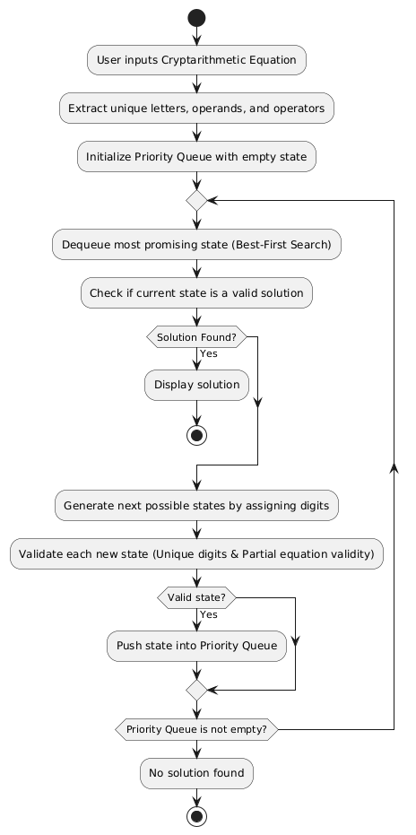
- User Interaction and Interface Design (Diagram/UML/Architecture):
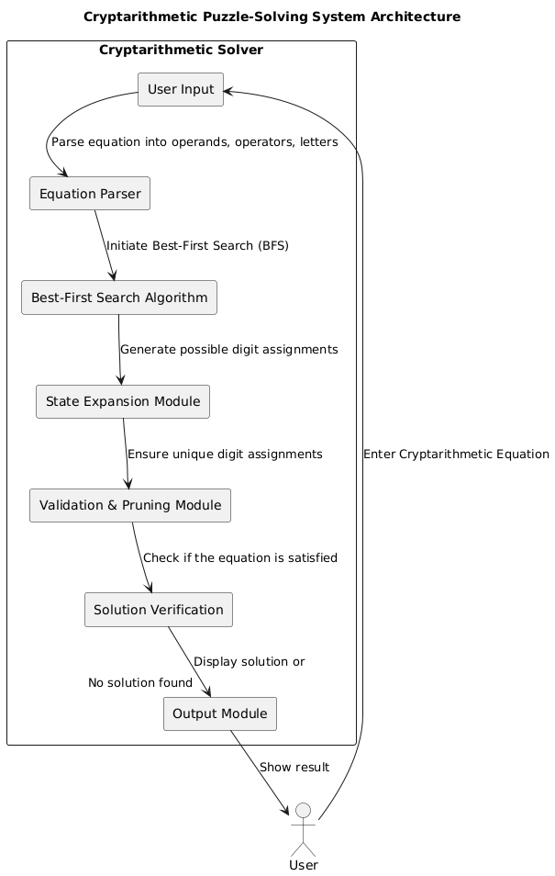
- Testing and Validation Strategy
To ensure correctness, efficiency, and reliability, the system will undergo multiple levels of testing and validation.
1. Unit Testing
- Each module, such as parsing, BFS implementation, and solution verification, will be tested independently.
- Example test cases:
  - Parsing: Given SEND + MORE = MONEY, ensure that the system extracts {S, E, N, D, M, O, R, Y} correctly.
  - BFS Execution: Check if valid letter-digit mappings are generated and prioritized correctly.
2. Integration Testing
- Ensures that all modules work together seamlessly by testing how different components interact.
- Example tests:
  - Ensure that Equation Parser correctly provides output to BFS Algorithm.
  - Ensure that BFS expands states correctly and passes valid solutions to Output Module.
3. Performance Testing
- Measures execution time and efficiency, particularly for larger cryptarithmetic puzzles.
- Example:
  - Compare execution time for equations with 5 letters vs. 10 letters.
  - Evaluate how BFS performs compared to Brute Force in solving complex problems.
4. Edge Case Handling
- The system will be tested with multiple edge cases:
  - Equations with multiple solutions → Verify all valid mappings.
  - Equations with no possible solution → Ensure correct error handling.
  - Large cryptarithmetic problems → Check for performance bottlenecks.
  - Equations involving leading zeros → Ensure invalid mappings are rejected.
5. Validation Techniques
- Mathematical Validation:
  - Check if assigned digits correctly satisfy the equation.
  - Example: SEND + MORE = MONEY should be numerically correct after digit substitution.
- Heuristic Validation:
  - Ensure BFS properly prioritizes the most promising states.
  - Validate if pruning correctly eliminates infeasible solutions early.
6. User Testing
- Conduct tests with sample users to evaluate ease of use, accuracy, and expected results.
- Gather feedback to improve interface usability and error messaging clarity

.
- Expected Output

The system is expected to successfully find valid digit substitutions for cryptarithmetic equations using the Best-First Search algorithm, ensuring efficiency and accuracy. The expected outcomes include:
- Correct digit-letter mapping: The system should correctly solve the puzzle and return a valid assignment of digits to letters.
- Handling of invalid cases: If no solution exists, the system should return an appropriate message such as “No solution found.”
- Performance improvement: Compared to brute force methods, the Best-First Search should significantly reduce the number of state expansions, making the system more efficient.
- User-friendly interface: The system should provide clear input prompts and well-structured output to enhance user experience.

Examples of Expected Output

Example 1: Solvable Cryptarithmetic Puzzle
Input: SEND + MORE = MONEY
Output:
S = 9, E = 5, N = 6, D = 7, M = 1, O = 0, R = 8, Y = 2
Example 2: Unsolvable Cryptarithmetic Puzzle
Input: ABC + DEF = GHI
Output:
No solution found
Example 3: Multiple Solutions
Input: TOO + TOO + TOO = GOOD
Output:
Solution 1: T = 1, O = 0, G = 3, D = 2
Solution 2: T = 2, O = 1, G = 4, D = 3
By ensuring that the system meets these expected outcomes, we validate its effectiveness in solving cryptarithmetic puzzles accurately and efficiently.

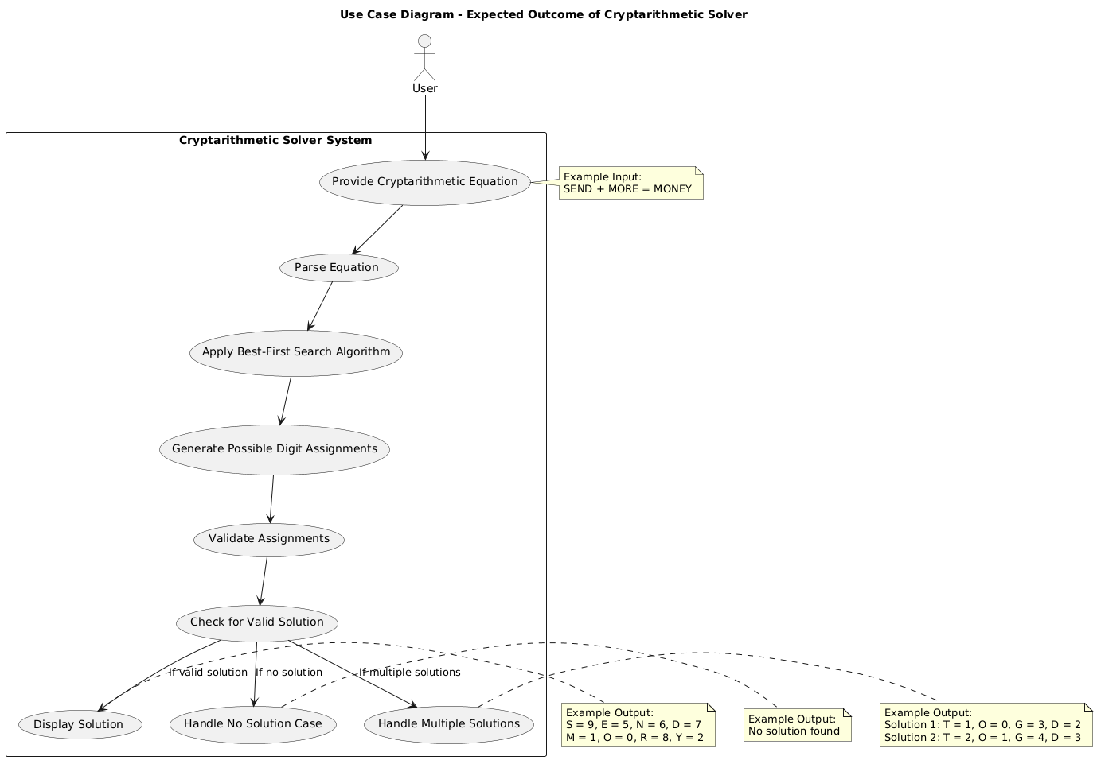

- Conclusion
The Cryptarithmetic Puzzle-Solving System using the Best-First Search (BFS) Algorithm successfully provides an efficient and optimized approach to solving letter-based arithmetic equations. By implementing BFS, the system intelligently prioritizes potential solutions, significantly reducing computational complexity compared to brute-force methods.
Through rigorous testing and validation, the system ensures:
- Accuracy in finding correct letter-to-digit mappings.
- Efficiency by reducing unnecessary state explorations.
- Scalability to handle complex cryptarithmetic puzzles.
- User-friendliness by providing clear input prompts and well-structured output.
The system effectively handles various cases, including solvable puzzles, multiple solutions, and unsolvable cases, ensuring comprehensive cryptarithmetic problem-solving capabilities. This project demonstrates the power of heuristic-based search algorithms in optimizing problem-solving strategies, paving the way for further research and improvements in artificial intelligence-driven mathematical problem-solving.

