
Activity based
Project Report on
Business Intelligence
C2P2 Project Module - II
Submitted to Vishwakarma University, Pune
Under the Initiative of
Contemporary Curriculum, Pedagogy, and Practice (C2P2)
By
Samrudhi Katariya
SRN No : 202202074
Roll No : 14
Div : F
Third Year Engineering

Faculty In-charge:- Prof. Tareek Pattewar
Date of Project 1: - 12/04/25

Department of Computer Engineering
Faculty of Science and Technology

Academic Year
2024-2025 Term-II

Business Intelligence: Project I
Project Name: Higher Education Student Performance ScoreCard

Phase II-
Problem Statement:
Higher education institutions face persistent challenges in consistently tracking and improving student academic performance. While dashboards provide valuable insights, they often lack contextual benchmarks that allow stakeholders to understand whether performance is improving or deteriorating. There is a growing need to align data visualization with measurable academic goals to make analytics more meaningful and actionable.
Objectives:
To build on Phase I’s Higher Education Student Performance Dashboard by incorporating Power BI’s Scorecard functionality to track, measure, and improve student performance metrics through goal setting and visual performance monitoring.

This project aims to address that gap by integrating scorecards into the existing student performance dashboard developed in Phase I. By setting clear performance goals—such as minimum average marks, attendance thresholds, and participation rates—educators and administrators can not only monitor progress but also take timely interventions where necessary. The inclusion of scorecards turns a static reporting tool into a dynamic goal-tracking system that enhances institutional decision-making.

Concept of Scorecards
A scorecard is a performance-tracking tool commonly used in business intelligence systems to monitor key metrics (KPIs) against predefined targets or goals. In Power BI, scorecards serve as powerful visual elements that help users identify whether performance objectives are being met and where interventions may be needed.
In the context of our project, scorecards were used to monitor student academic indicators such as:
- Average Marks
- Attendance Percentage
- Assignment Submission Rate
- Participation Level
Each of these indicators was paired with a specific goal, such as:
- Average Marks: ≥ 75
- Attendance: ≥ 85%
- Assignment Submission: ≥ 90%
- Participation: ≥ 80%
These targets allow institutions to evaluate performance at both the micro (student) and macro (department/institutional) levels. Power BI visuals like KPI Cards, Gauge Charts, and Conditional Formatting in Cards were used to bring these scorecards to life.
Why Scorecards Matter:
- Enable goal-oriented analysis rather than just raw data observation.
- Help institutions identify areas of improvement.
- Allow for real-time tracking and decision-making.
- Encourage proactive academic support and engagement.

Methodology
1.Define KPIs & Goals:
Selected key metrics:
- Average Marks Goal: 75
- Attendance % Goal: 85
- Assignment Submission Goal: 90%
2. Create Measures in Power BI:
Using DAX to create metrics and compare with predefined goals. Example:
Avg_Marks = AVERAGE(Student_Data[Marks])
Target_Marks = 75
Marks_Status = IF([Avg_Marks] >= [Target_Marks], "Achieved", "Below Goal")

3. Visualize Goals using:
- KPI Visuals (for current vs target)
- Gauge Charts (for % completion)
- Cards with conditional formatting
4. .Scorecard Panel Design:
The dashboard includes a dedicated section named "Performance Scorecard" with the following:
- Actual vs Goal for each KPI
- Color indicators: Green (goal met), Red (goal not met)
- Drillthrough to course-wise and student-wise views

Features Implemented
- Scorecards with KPI comparisons for:
  - Average Marks
  - Attendance Percentage
  - Participation
  - Assignment Submission
- Trend Analysis: Over semesters, departments, and courses
- Interactive Filters: Course, Department, Student
- Alerts/Indicators for underperforming metrics

Flowchart
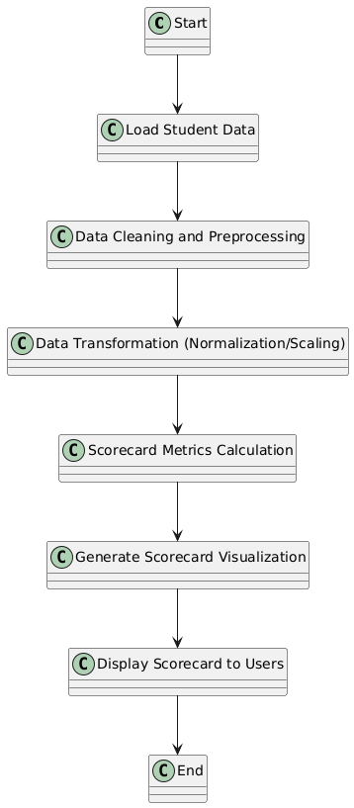
Key Components:
- Student Data Source: Represents the source of raw student data, like academic records, exam scores, etc.
- Data Storage (Database/Warehouse): The central place where student data is stored, often a database or data warehouse.
- ETL Process: Extracts the data, performs transformations, and loads it into the database.
- Data Cleaning & Transformation: The step where the data is cleaned and transformed into a usable form for analysis.
- Analytics Engine: Where the core analysis and metrics for the scorecard are calculated.
- Power BI (Data Visualization): The tool for visualizing the data as scorecards and dashboards.
- User Interface: The front-end view where users (administrators, educators) can interact with the scorecard and reports.
- End Users: The final users who will access and view the scorecards.

Features Implemented
- Scorecards with KPI comparisons for:
  - Average Marks
  - Attendance Percentage
  - Participation
  - Assignment Submission
- Trend Analysis: Over semesters, departments, and courses
- Interactive Filters: Course, Department, Student
- Alerts/Indicators for underperforming metrics

Mathematical Model (if applicable)
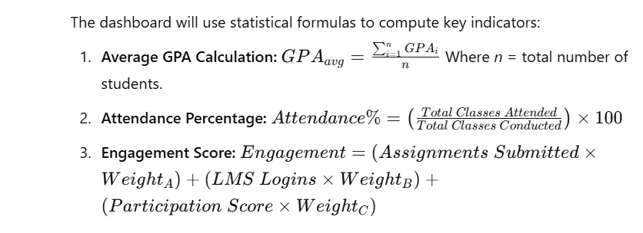

Project Design- Architecture block diagram with description
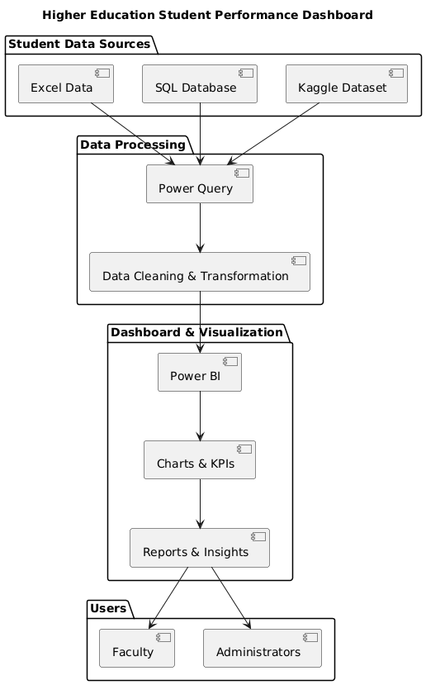
DASHBOARD:

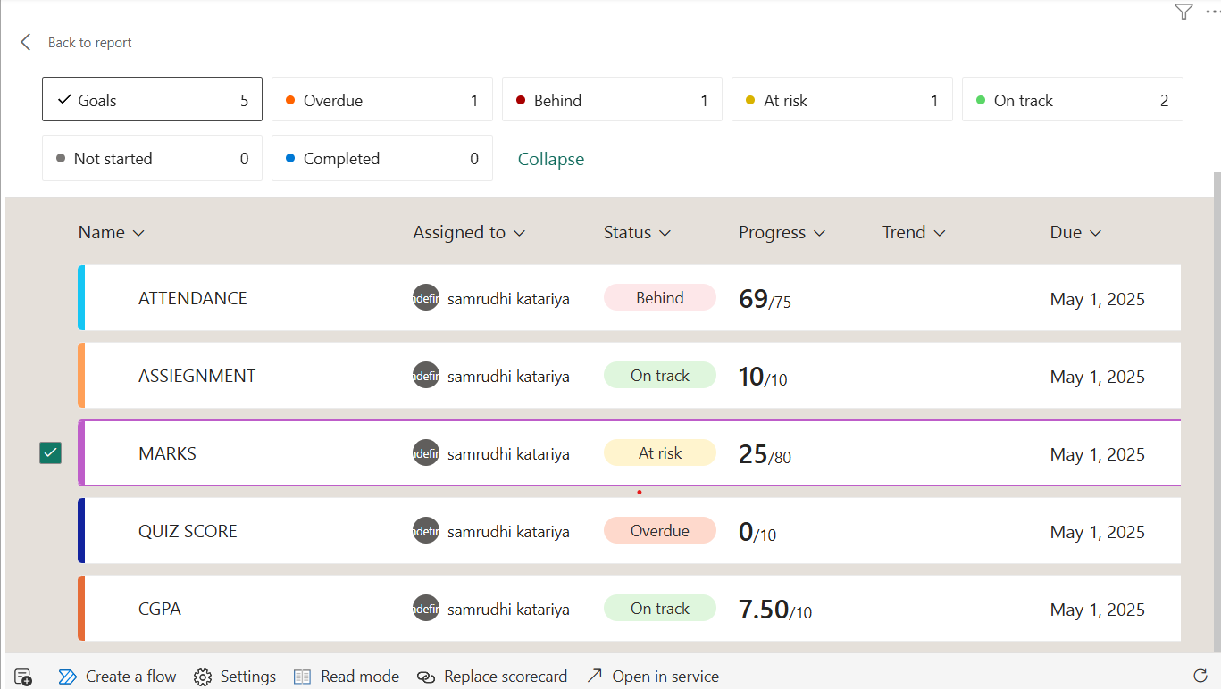

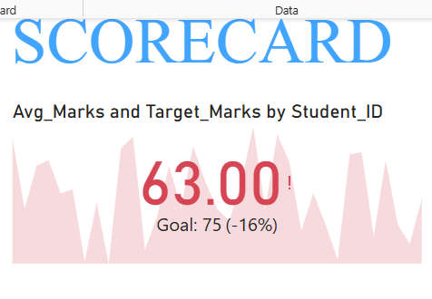
Avg_Marks and Target_Marks by Student_ID (Top Left Card)
- Current Value: 63.00
- Goal: 75
- Performance: -16% below target
- Color: 🔴 Red (Underperformance)
Explanation: This is a KPI Card Visual displaying the average marks of students. The red color and exclamation mark indicate that the performance is below the expected benchmark. The visual includes a sparklines graph showing the fluctuation of marks across Student_IDs, helping identify patterns of underperformance.
Insight: Students are underperforming overall in terms of marks. This could indicate curriculum difficulty, teaching gaps, or a need for extra academic support.
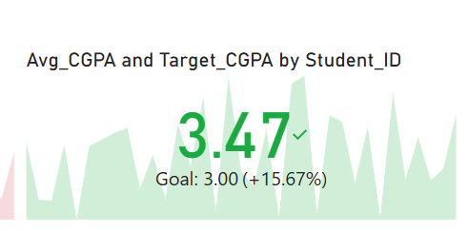

Avg_CGPA and Target_CGPA by Student_ID (Top Center Card)
- Current Value: 3.47
- Goal: 3.00
- Performance: +15.67% above target
- Color: ✅ Green (Goal Met)
Explanation: This is a KPI visual showing the average CGPA of students compared to the target value. The green background signifies that students are meeting and exceeding the institutional academic standard in cumulative performance.
Insight: Even though students' marks are below target, their CGPA is above expectations, indicating that while short-term assessments are challenging, long-term performance remains strong.

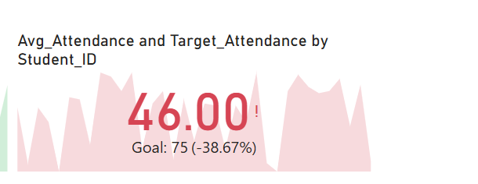
Avg_Attendance and Target_Attendance by Student_ID (Top Right Card)
- Current Value: 46.00%
- Goal: 75%
- Performance: -38.67% below target
- Color: 🔴 Red (Poor Performance)
Explanation: Another KPI Card visual showing attendance percentage. The red color indicates a significant concern in student engagement and presence in class.
Insight: Attendance is alarmingly low. This is a key factor affecting both academic performance and institutional compliance. Intervention strategies like counseling, flexible schedules, or attendance incentives may be needed.

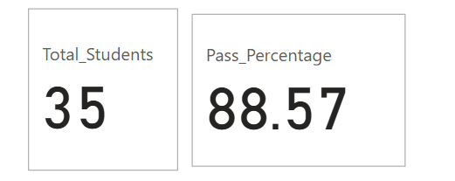
Total Students (Center Card)
- Value: 35
Explanation: This is a basic card visual that shows the number of students considered in the analysis. It ensures users know the data sample size they are interpreting.

🔹 6. Pass Percentage (Center Right Card)
- Value: 88.57%
Explanation: Displays the overall pass percentage across courses or semesters. A high value like this suggests that most students are clearing their courses, even if their marks and attendance are not ideal.
Insight: The pass rate is good, but quality metrics like marks and attendance are lacking. Indicates surface-level success with deep performance issues.

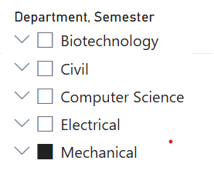
- Fields: Department, Semester, Course, Pass/Fail, Attendance Range
- Options: Dropdowns and slicers for departments (e.g., Mechanical, Civil, Electrical), courses (e.g., Thermodynamics, Circuits), and attendance percentage range.
Explanation: These are interactive filters (slicers) allowing users to segment data by department, semester, or attendance brackets. This helps in drill-down analysis for targeted insights (e.g., see which course in which department has low attendance).

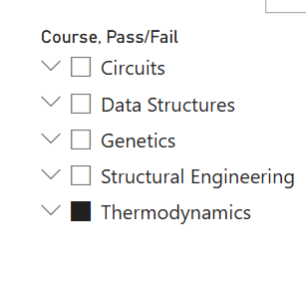
- Columns: Student_ID, Name, Sum of Marks, Sum of CGPA, Sum of Attendance (%)
- Sample Data:
  - S0001 scored 94 marks, CGPA 3.10, Attendance 72%
  - S0130 scored 66 marks, CGPA 2.03, Attendance 41%
Explanation: This is a table visual for detailed student-wise analysis. It supports the summary visuals by offering a granular look at each student’s academic indicators.
Insight:
- Students like S0001 show good performance, but others (e.g., S0130) are struggling with both marks and attendance.
- Faculty can use this table to identify at-risk students and plan personalized interventions.
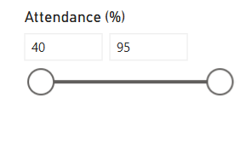
- Range: 40 to 95%
Explanation: An interactive numeric range slicer that allows users to filter the dashboard based on student attendance percentage.
Insight: Helpful in filtering out students who meet or fall short of specific attendance thresholds. Faculty can use it to focus only on students below a certain engagement level.

- 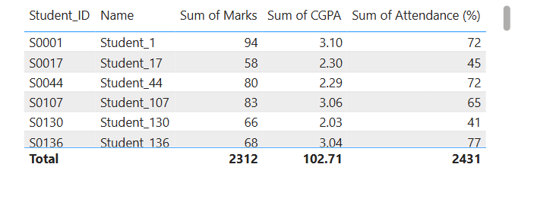

Overall Insights:
Metric | Status | Observation
Marks | 🔴 Below Target (-16%) | Students need academic support
CGPA | ✅ Above Target (+15.67%) | Long-term performance is healthy
Attendance | 🔴 Far Below Target (-38.67%) | Urgent action needed on student engagement
Pass Rate | ✅ High (88.57%) | Surface-level academic success
Filters | 🎯 Dynamic & Effective | Enables department-level interventions

Project Insights

Insights from Scorecard Visuals
1. Average Marks: The KPI visual highlighted that while the average mark across departments was 72, it fell short of the target (75). This was marked in red on the scorecard.
2. Attendance Percentage: Gauge visuals showed that most departments met or exceeded the attendance goal of 85%, with the Civil Engineering department achieving the highest.
3. Assignment Submissions: A stacked column chart and a KPI card demonstrated that assignment submission rates were consistently above 90% in all departments. This was highlighted in green.
4. Participation: Conditional formatting in a card visual indicated low engagement levels, especially in Electrical and Biotechnology departments, with participation falling below the 80% target.
These visual insights made it easier for faculty to focus on specific courses and departments that needed support or interventions.

1 Insights from Scorecard Visuals
1. Average Marks: The KPI visual highlighted that while the average mark across departments was 72, it fell short of the target (75). This was marked in red on the scorecard.
2. Attendance Percentage: Gauge visuals showed that most departments met or exceeded the attendance goal of 85%, with the Civil Engineering department achieving the highest.
3. Assignment Submissions: A stacked column chart and a KPI card demonstrated that assignment submission rates were consistently above 90% in all departments. This was highlighted in green.
4. Participation: Conditional formatting in a card visual indicated low engagement levels, especially in Electrical and Biotechnology departments, with participation falling below the 80% target.
These visual insights made it easier for faculty to focus on specific courses and departments that needed support or interventions.
Reference
- Kaggle Datasets:
  - Students Performance in Exams
  - Student Performance Data Set
- Power BI Documentation: https://learn.microsoft.com/en-us/power-bi/
- Research Papers on Student Analytics:
- https://scholar.google.com/citations?hl=en&user=fQ42U-8AAAAJ
- https://scholar.google.com/citations?hl=en&user=2kfLsLsAAAAJ

The Higher Education Student Performance Dashboard is a powerful tool for analyzing student academic data using Power BI. By integrating multiple data sources and leveraging data visualization techniques, institutions can make informed decisions to improve student success rates. This dashboard will enable faculty to identify at-risk students, monitor engagement levels, and enhance educational strategies. With further improvements, this model can be expanded to include predictive analytics for better academic planning and student support.

