1)
singletonTest.java
public class singletonTest {
public static void main(String[] args) {
Logger logger1 = Logger.getInstance();
Logger logger2 = Logger.getInstance();
logger1.log("First Message");
logger2.log("Second Message");
System.out.println(logger1 == logger2);
}
}
Logger.java
public class Logger {
private static Logger instance;
private Logger() {
System.out.println("Logger instance created in private.");
}
public static Logger getInstance() {
if (instance == null) {
instance = new Logger();
}
return instance;
}
public void log(String message) {
System.out.println("Log: " + message);
}
}

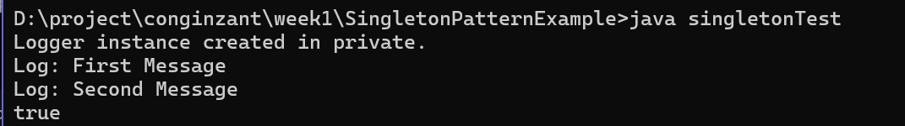
2)
Document.java
public interface Document{
void open();
}
WordDocument.java
public class WordDocument implements Document{
public void open(){
System.out.println("Opening Word Document");
}
}
PdfDocument.java
public class PdfDocument implements Document{
public void open(){
System.out.println("Opening PDF Document");
}
}
ExcelDocument.java
public class ExcelDocument implements Document{
public void open(){
System.out.println("Opening Excel Document");
}
}
DocumentFactory.java
public abstract class DocumentFactory{
public abstract Document createDocument();
}
WordFactory.java
public class WordFactory extends DocumentFactory{
public Document createDocument(){
return new WordDocument();
}
}
PdfFactory.java
public class PdfFactory extends DocumentFactory{
public Document createDocument(){
return new PdfDocument();
}
}
ExcelFactory.java
public class ExcelFactory extends DocumentFactory{
public Document createDocument(){
return new ExcelDocument();
}
}
FactoryTest.java
public class FactoryTest{
public static void main(String[] args){
DocumentFactory wordFactory=new WordFactory();
Document wordDoc=wordFactory.createDocument();
wordDoc.open();
DocumentFactory pdfFactory=new PdfFactory();
Document pdfDoc=pdfFactory.createDocument();
pdfDoc.open();

DocumentFactory excelFactory=new ExcelFactory();
Document excelDoc=excelFactory.createDocument();
excelDoc.open();
}
}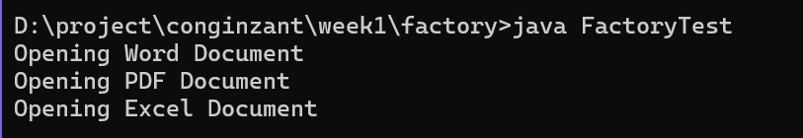

DATASTRUCTURE AND ALGORITHMS:
1)
class Product{
int productId;
String productName;
String category;

Product(int productId,String productName,String category){
this.productId=productId;
this.productName=productName;
this.category=category;
}

public String toString(){
return productId+" "+productName+" "+category;
}
}

public static Product binarySearch(Product[] products,int key){
int low=0;
int high=products.length-1;
while(low<=high){
int mid=(low+high)/2;
if(products[mid].productId==key)
return products[mid];
else if(products[mid].productId<key)
low=mid+1;
else
high=mid-1;
}
return null;
}

public static void main(String[] args){
Product[] linearArray={
new Product(103,"Laptop","Electronics"),
new Product(101,"Mobile","Electronics"),
new Product(105,"Shoes","Fashion"),
new Product(102,"Watch","Accessories"),
new Product(104,"Bag","Fashion")
};

Product[] sortedArray={
new Product(101,"Mobile","Electronics"),
new Product(102,"Watch","Accessories"),
new Product(103,"Laptop","Electronics"),
new Product(104,"Bag","Fashion"),
new Product(105,"Shoes","Fashion")
};

int searchId=104;
Product result1=linearSearch(linearArray,searchId);
if(result1!=null)
System.out.println("Linear Search Result: "+result1);
else
System.out.println("Product Not Found");
Product result2=binarySearch(sortedArray,searchId);

if(result2!=null)
System.out.println("Binary Search Result: "+result2);
else
System.out.println("Product Not Found");
}
}

2)
public class FinancialForecast{
public static double futureValue(double presentValue,double growthRate,int years){
if(years==0)
return presentValue;
return futureValue(presentValue,growthRate,years-1)*(1+growthRate);
}

public static void main(String[] args){
double presentValue=10000;
double growthRate=0.10;
int years=5;

double result=futureValue(presentValue,growthRate,years);

System.out.println("Present Value: "+presentValue);
System.out.println("Growth Rate: "+(growthRate*100)+"%");
System.out.println("Years: "+years);
System.out.println("Future Value: "+result);
}
}
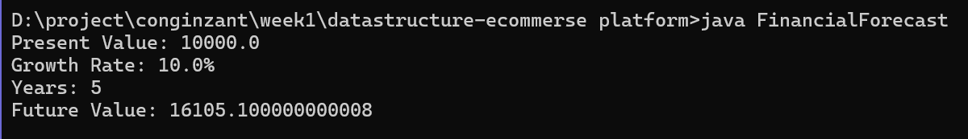
PL/SQL
1: CONTROL STRUCTURES
Scenario 1: Apply 1% Discount to Loan Interest Rates for Customers Above 60 Years
DECLARE
CURSOR cust_cur IS
SELECT CustomerID, DOB
FROM Customers;

v_age NUMBER;
BEGIN
FOR cust_rec IN cust_cur LOOP

v_age := FLOOR(MONTHS_BETWEEN(SYSDATE, cust_rec.DOB) / 12);

IF v_age > 60 THEN
UPDATE Loans
SET InterestRate = InterestRate - 1
WHERE CustomerID = cust_rec.CustomerID;
END IF;

END LOOP;

COMMIT;
END;
/
Scenario 2: Set VIP Status for Customers with Balance Greater Than $10,000
ALTER TABLE Customers
ADD IsVIP VARCHAR2(5);
BEGIN
FOR cust_rec IN (
SELECT CustomerID, Balance
FROM Customers
) LOOP

IF cust_rec.Balance > 10000 THEN
UPDATE Customers
SET IsVIP = 'TRUE'
WHERE CustomerID = cust_rec.CustomerID;
ELSE
UPDATE Customers
SET IsVIP = 'FALSE'
WHERE CustomerID = cust_rec.CustomerID;
END IF;

END LOOP;

COMMIT;
END;
/
Scenario 3: Send Reminders to Customers Whose Loans Are Due Within the Next 30 Days
BEGIN
FOR loan_rec IN (
SELECT C.Name,
L.LoanID,
L.EndDate
FROM Customers C
JOIN Loans L
ON C.CustomerID = L.CustomerID
WHERE L.EndDate BETWEEN SYSDATE AND SYSDATE + 30
) LOOP

DBMS_OUTPUT.PUT_LINE(
'Reminder: Loan ID ' || loan_rec.LoanID ||
' for customer ' || loan_rec.Name ||
' is due on ' || TO_CHAR(loan_rec.EndDate, 'DD-MON-YYYY')
);

END LOOP;
END;
/
EXERCISE 3: STORED PROCEDURES
Scenario 1: Process Monthly Interest for All Savings Accounts
CREATE OR REPLACE PROCEDURE ProcessMonthlyInterest
IS
BEGIN
UPDATE Accounts
SET Balance = Balance + (Balance * 0.01)
WHERE AccountType = 'Savings';

COMMIT;
END;
/
Execute:
EXEC ProcessMonthlyInterest;
Scenario 2: Update Employee Bonus Based on Department
CREATE OR REPLACE PROCEDURE UpdateEmployeeBonus(
p_department IN VARCHAR2,
p_bonus_percent IN NUMBER
)
IS
BEGIN
UPDATE Employees
SET Salary = Salary + (Salary * p_bonus_percent / 100)
WHERE Department = p_department;

COMMIT;
END;
/
Execute:
EXEC UpdateEmployeeBonus('IT', 10);
Scenario 3: Transfer Funds Between Accounts
CREATE OR REPLACE PROCEDURE TransferFunds(
p_from_account IN NUMBER,
p_to_account IN NUMBER,
p_amount IN NUMBER
)
IS
v_balance NUMBER;
BEGIN

SELECT Balance
INTO v_balance
FROM Accounts
WHERE AccountID = p_from_account;

IF v_balance >= p_amount THEN

UPDATE Accounts
SET Balance = Balance - p_amount
WHERE AccountID = p_from_account;

UPDATE Accounts
SET Balance = Balance + p_amount
WHERE AccountID = p_to_account;

COMMIT;

DBMS_OUTPUT.PUT_LINE('Transfer Successful');

ELSE

DBMS_OUTPUT.PUT_LINE('Insufficient Balance');

END IF;

EXCEPTION
WHEN NO_DATA_FOUND THEN
DBMS_OUTPUT.PUT_LINE('Account Not Found');

WHEN OTHERS THEN
ROLLBACK;
DBMS_OUTPUT.PUT_LINE('Error: ' || SQLERRM);
END;
/
Execute:
EXEC TransferFunds(1, 2, 500);

