**Oxidative stress responses in coralline algae**

by

Samantha K.E. Foley and Lucy E. Wall

A report submitted in partial fulfillment of the requirements of

DIRECTED STUDIES AND APPLIED DATA ANALYSIS

at

Bamfield Marine Sciences Centre

Instructor: Daniel M. Wuitchik and Dr. Sara J.S. Wuitchik

Teaching Assistant: Jenna Fleet

©Samantha Foley, 12/2021

Home University: The University of British Columbia

©Lucy Wall, 12/2021

Home University: The University of British Columbia

**Abstract**

Coralline algae are a group of calcified algae in the phylum Rhodophyta, found in marine habitats that range from subtidal reefs to intertidal zones. Bleaching, which results from the degradation of pigments, is a phenomenon observed in algae in response to a number of environmental stressors. Climatic changes may trigger algal cells to accumulate reactive oxygen species (ROS), causing oxidative stress. However, there is ongoing debate surrounding the links between ROS and bleaching. In this study, we investigated the relationship between oxidative stress, photosynthetic efficiency, and colour changes in three coralline species: *Chamberlainium tumidum, Calliarthron tuberculosum,* and *Corallina chilensis.* We hypothesized that ROS exposure would impact both photosynthetic efficiency and colouration, as oxidative stress responses inhibit cellular functioning. We predicted that 1) decreased photosynthetic efficiency would result from increased ROS exposure, 2) a lightening in colour would occur in response to higher ROS levels, and 3) that the differing morphologies of algae would lead to variable, species-specific responses. To replicate oxidative stress, species were submerged in 0, 5, 15, or 30 mM H2O2 for one hour, and then monitored over the following week. Measurements were recorded daily for each specimen, using fluorometry to measure photosynthetic efficiency (YII) and digital image analysis to determine changes in colour intensity. We found that generally photosynthetic activity was inhibited by oxidative stress, and that declines correlated with increased ROS exposure. However, observed partial recoveries of photosynthetic efficiency in some treatments suggested possible resilience to oxidative stress. Colour changes after ROS exposure revealed that species responded differently to oxidative stress, and that the species which did bleach lightened with increased treatment levels. Therefore, this study provides support for the hypothesis that ROS exposure can impact both photosynthetic efficiency and colouration in coralline algae, though responses between species vary. Exploring the links between oxidative stress, photosynthesis, and bleaching helps us understand how corallines may be impacted by altering climatic conditions. As coralline algae are important primary producers and habitat creators, understanding the implications of oxidative stress on algal health is a crucial consideration of marine conservation moving forward.

# **Keywords**

Articulated, Bleaching, Colour intensity, Crustose, Photosynthetic efficiency, Reactive oxygen species

**Introduction**

Changes in global climate are influencing the factors that determine species distributions, community composition, and extinction of organisms worldwide. As anthropogenic pressures contribute to the intensification of these changes, ocean environments are altering (Henson et al, 2016). Increasing temperatures, changing currents, and lowering pH are all factors impacting oceanic processes and species (Irving et al., 2004). As the primary producers of marine environments, algae fulfill crucial roles in biomass production, nutrient cycling, and the conversion of energy into consumable matter to support trophic systems (Laufkötter et al., 2015). In the face of climate change, algae can be threatened by unsuitable novel conditions and intensifying stressors, compromising their ability to support the foundations of marine life (Laufkötter et al., 2015).

Many algae, such as calcified coralline algae (Corallinaceae, Rhodaphyta), are foundational species that create habitats for other marine organisms (Asnaghi et al., 2015; Irving et al., 2004; Vermeij et al., 2011). Coralline algae, in particular, perform several important ecological roles that impact both community succession, and structure. Asnaghi et al. (2015) highlighted the ability of coralline algae to colonize rocky substrates, facilitate the recruitment of other species, and support biodiversity. They also suggest that a diversity of coralline types may increase available habitat for subsequent colonizing species, thus supporting the recovery and succession of marine communities after disturbance events. Kelp forest sub-canopies can also be dominated by coralline algae, and when the forest cover is removed, increased light exposure can cause bleaching in the algae understory (Irving et al., 2004). Bleaching in algae has also been observed in response to changes in environmental factors including pathogen exposure (Liu et al., 2019), pH (Liu et al., 2007), light, and temperature (Martone et al., 2010), though the underlying biological mechanisms of the process are still largely unknown.

Algal bleaching is a process which degrades photosynthetic pigments, leading to losses of colour and potentially to death (Martone et al., 2010). Pigments are responsible for the absorption of light into photosystems which are the functional units where photosynthesis occurs (Rowan, 1989). Photosynthesis is the process driving global primary production, which in the case of algae is the fixing of dissolved inorganic carbon into forms that are accessible to higher trophic levels in marine systems (Carr et al., 2006).Some findings suggest bleaching may be a method used by algae to adjust pigmentation levels in order to acclimate to stressful environments, and that they may be able to recover from these bleaching periods once poor conditions improve (Irving et al., 2004). However, there is ongoing debate surrounding the links between stressful climatic conditions and bleaching in coralline algae.

Despite the limited knowledge of the underlying mechanisms of coralline bleaching, connections between photosynthesis, reactive oxygen, and colouration loss are beginning to emerge. Several studies have explored potential links between algae bleaching and oxidative stress (Liu et al., 2019; Irving et al., 2004; Mallick et al., 2000)*.* Reactive oxygen species (ROS) are a naturally occurring byproduct of photosynthesis that form when electrons associated with electron transport are transferred to oxygen molecules (Mallick et al., 2000). ROS quickly becomes harmful to cells if not regulated, and can lead to cell death and even tissue damage (Rezayian et al., 2019). In a healthy, functioning alga, cellular processes involving complex antioxidant pathways regulate the production and removal of ROS (Mallick et al., 2000). However, when these pathways become inhibited or the production of ROS byproducts increases, ROS accumulates in algal cells. The accumulation of ROS, and the resulting harm to cellular or organismal functioning is known as ‘oxidative stress’ (Mallick et al., 2000; Rezayian et al., 2019). Findings by Mallick et al. (2000) have also linked the effects of oxidative stress to the inhibition of photosynthesis. Hydrogen peroxide (H2O2) is one of the reactive oxygen species that has been measured in algal tissues displaying inhibited cellular functioning (Mallick et al., 2000). In 2019, Liu et al. also observed spikes in H2O2 production in thalli infected by bacterial pathogens. Bleaching effects were observed in the thalli, algae bodies, that had accumulated higher concentrations of H2O2 in their tissues. However, the mechanisms linking oxidative stress and algae bleaching are unresolved (Liu et al., 2019). In a laboratory setting, oxidative stress has been explored in several fleshy, ‘upright’ algae, though it seems comparative studies focused on coralline species and crustose morphologies are relatively unexplored (Liu et al., 2019).

Given lingering uncertainty surrounding the links between oxidative stress, bleaching, and photosynthetic inhibition, we examined the gaps in the current understanding of coralline species and bleaching. While laboratory tests of oxidative and environmental stressors have yielded bleaching effects, it remains unclear if an isolated onset of oxidative stress can trigger bleaching responses. Furthermore, the application of external H2O2 in a laboratory setting as a proxy for oxidative stress has not yet been defined as a method to replicate the bleaching effects observed in the field. With new findings to help answer these questions, we would gain a more informed understanding of how coralline algae respond to oxidative stress, if oxidative stress can trigger bleaching responses, and how photosynthetic inhibition correlates to loss of colouration.

In this study, we set out to explore the question of how photosynthetic activity and bleaching levels are impacted in three different coralline algal species during oxidative stress responses. We tested the hypothesis that exposure to reactive oxygen species would impact photosynthetic activity and colouration due to algal oxidative stress inhibiting cellular processes. Because oxidative stress can inhibit photosynthesis, we predicted that photosynthetic efficiency would decrease following ROS exposure, and that decreased efficiency would correlate with increased ROS concentration. Additionally, lightening of colour would increase with exposure to higher ROS concentrations, as excess H2O2 could lead to the degradation of algal health and pigmentation. Finally, due to the differing morphologies of algae species, we predicted to observe variable and species-specific responses of photosynthetic efficiency and colouration to the array of ROS concentrations.

**Materials and Methods**

Sample collection & acclimation

We collected thalli of the articulated corallines, *Calliarthron tuberculosum* (Postels & Ruprecht, 1840) and *Corallina chilensis* (Decaisne, 1849), and pieces of the crustose coralline, *Chamberlainium tumidum* (Foslie, 1901)*,* from tidepools and rock faces in the mid to high intertidal zone (~1.65m above sea level) at Bluestone point, Bamfield, British Columbia, Canada (48°49'02.1"N, 125°09'48.3"W), in October 2021. We removed *C. tuberculosum* and *C. chilensis* by cutting each thallus at the base, while *C. tumidum* was chiseled from the rock. We placed the samples in a sea table with seawater circulating from the Bamfield Inlet at 8-10℃. We replicated the natural photoperiod by keeping all algae under a photoperiod of 10 L: 14 D, using a black tarp to cover algae during the 14 hours of dark. We allowed the algae to acclimate in these conditions for 1 week, after which we trimmed and cleaned samples to remove any epiphytes. We then monitored each specimen by measuring photosynthetic efficiency and taking digital photographs.

Photosynthetic Measurements

To test for photosynthetic efficiency, measurements were taken the day before the stress event, directly after the stress event following a 15-minute dark-acclimatization, and again for the following 7 days; being dark-acclimated for 14 hours. The photosynthetic efficiency (YII) was recorded using a pulse-amplitude-modulated (PAM) fluorometer (Junior-PAM, Walz, Effeltrich, Germany) which measured the fluorescence of chlorophyll system II (Dummermuth et al, 2003). Specimens were dark-acclimated using the replicated natural photoperiod before being tested.

Photography and colour intensity analysis

To measure changes in colour and track visible bleaching responses, pictures of specimens were taken both before the stress event, and each day after treatment in conjunction with PAM data collection. To prevent the introduction of errors, digital photos were taken under standardized lighting conditions, using a Canon EOS Rebel T3i with manually set white balance and ISO settings, and with the same white background (Martone, 2010). Colour intensity change in algal samples was measured using ImageJ (v 1.36b, National Institutes of Health, Bethesda, Massachusetts, USA) (Martone, 2010). Mean colour intensity values were analyzed and recorded for each algae sample on a scale of 0-255, with black equating to black and white equating to 255. Mean intensity was measured and collected for each sample and compiled into a dataset containing results from each day of the monitoring week. Changes in mean colour intensity for each sample were calculated as the difference between the pre-stress intensity and the intensity measured on the last day of the monitoring week (Day 7).

Stress event & post-stress monitoring

We exposed algal segments to hydrogen peroxide (H2O2) in a one-time stressor to produce an oxidative stress event. We submerged samples of each species in one of the following concentrations of H2O2: 5, 15, or 30 mM, or in seawater as a control (Dummermuth et al, 2003). We created treatment concentrations from a stock solution of 3% hydrogen peroxide and diluted to the corresponding concentration using seawater. We attached a randomly selected sample of each species to a plastic grid card with epoxy, so that three algae were on each card (Fig.S1). We then labeled the cards using a tagging system to track samples. We randomly designated and submerged each card to a tub of one of the four treatment concentrations (n = 8 per concentration; N = 32; Fig.1) and submerged them for one hour. During the stress event, all tubs were kept in a shallow bin of seawater that rested in the circulating sea table to maintain water temperature. After one hour, each card of samples was rinsed off with chilled seawater (8-10 °C) to remove any residual hydrogen peroxide. All samples were then returned to the acclimation conditions. To track for changes in photosynthetic efficiency and colour, specimens were tested at sunrise each day for 7 days following the stress event, to observe any developing responses.

Statistical analysis

We used a Friedman’s test to analyze differences in a species’ photosynthetic efficiency (YII) at each treatment level before and following treatment (Friedman, 1937). We then used a Pairwise Wilcoxon signed-rank test (Woolson, 2007) to determine differences in photosynthetic efficiency across monitoring days. Photosynthetic efficiency data was fitted to a Weibull distribution, and modeled with a Gamlss to observe interactions of both species, and treatment by event day on resulting photosynthetic efficiency (YII) (Rigby & Stasinopoulos, 2005).

We calculated for all replicates of each species, in each treatment level the mean intensities to analyze colour. Change in mean colour intensity (𝚫MI) was calculated as the difference between sampled mean intensities on the day before treatment (Pre-stress) and the last day of monitoring post-treatment (Day 7). We used a Kruskal-Wallis test (Kruskal & Wallis, 1952) followed by a Dunn’s Test (Dunn, 1961) on the 𝚫MI between treatments for each species. Additionally, we performed a Kruskal-Wallis test followed by a Dunn’s test on the 𝚫MI for each species within a given treatment across monitoring days. All Dunn’s test p-values recorded were from an adjusted p-value. We then fit the mean colour intensity to a Reverse Gumbel distribution (Delignette-Muller & Dutang, 2015). We then used a Gamlss to observe the interactions of species and treatment on resulting changes in 𝚫MI (Rigby & Stasinopoulos, 2005). All statistical tests were performed using R studio (R version 4.0.3) (R Core Team, 2021).

**Results**

Impacts of Oxidative Stress on Photosynthetic Efficiency

*Response to Oxidative Stress*

Observing measurements of average photosynthetic efficiency (YII) values before and after treatment in all species (*Chamberlainium tumidum, Calliarthron tuberculosum, and Corallina chilensis*), there were generally larger decreases following treatments of higher concentrations (Fig.2). On Monitoring Day 1, *C. chilensis* exposed to the Low treatment displayed significantly lower photosynthetic efficiency than measured Pre-stress (WX, p=0.017;Fig.3). At both the Mid and High treatments, *C. tumidum* (Mid: WX, p=0.00093; High: WX, p=0.0019), *C. tuberculosum* (Mid: WX, p=0.00082; High: WX, p=0.0028), and *C. chilensis* (Mid: WX, p=0.004; High: WX, p=0.0028), all displayed significant losses in YII by Monitoring Day 1 (Fig.3). Throughout the week of observation, algae of all species in the Control treatments fluctuated slightly in mean YII but remained fairly level overall (*C. tumidum*: FT, 𝛘2=5.25, df=2, p=0.07244; *C. tuberculosum*: FT, 𝛘2=2.25, df=2, p=0.3247; *C. chilensis*: FT, 𝛘2=2.25, df=2, p=0.3247;Fig.2). However, general patterns of post-treatment decreases followed by slight increases in YII were observed in the Low, Mid, and High treatments for all species (Fig.2).

*Stress Response & Recovery*

By examining the YII values recorded before treatment (Pre-stress), one day post-treatment (Monitoring Day 1), and at the end of the monitoring week (Monitoring Day 7), we were able to determine if photosynthetic efficiency altered from pre-stress levels following an oxidative stress event. Our model revealed the contributions of species, treatment, and the interaction of monitoring day with treatment to variation in YII (Table S3). Species contributed significantly to YII (*C. tumidum*: p<e-16; *C. tuberculosum*: p=p<e-16, *C. chilensis*: p=2.37e-10), while only the High treatment significantly contributes to the variation observed in YII independently of observation day (p=0.033218). The interactions of all treatment levels and Monitoring Day 1 were found to significantly impact YII (Low:Day1 p= 0.000577, Mid:Day1 p<2e-16, High:Day1 p<2e-16 ). However, for Monitoring Day 7 only the Mid and High treatments significantly impacted YII (Mid:Day7 p= 1.08e-08, High:Day7 p=1.02e-12).

In the Control treatment , *C. tumidum* (FT, 𝛘2=5.25, df=2, p=0.07244), *C. tuberculosum* (FT, 𝛘2=2.25, df=2, p=0.3247), and *C. chilensis* (FT, 𝛘2=2.25, df=2, p=0.3247) all showed no significant differences in YII from Pre-stress levels on Monitoring Days 1 or 7 (Fig.3A). In the Low treatment, *C. tumidum* (FT, 𝛘2=2.25, df=2, p=0.3247) and *C. tuberculosum* (WX, Pre:Day1 p=0.14; Pre:Day7 p=0.14; Day1:Day7 p=1.00)) also displayed no change in YII across these three days . However, at Low treatment levels *C. chilensis* did display a difference in YII, with Day 1 showing significantly lower than Pre-stress levels (WX, p=0.017;Fig.3B). Day 7 photosynthetic efficiency was also found to be higher than Day 1 in this case (WX, p=0.014), but the levels of Pre-stress and Day 7 were found to be the same (WX, p=0.875). Therefore there was an observed decline in photosynthetic efficiency following stress, which increased by the end of the week to levels that were the same as those observed pre-stress (Fig.3B). *C. chilensis* in the Low treatment was the only group to display this return to Pre-stress YII values by Monitoring Day 7 in any of the Low, Mid, or High treatments (Fig.3).

In the Mid treatment, *C. tumidum* (FT, 𝛘2=13, df=2, p=0.001503), *C. tuberculosum* (FT, 𝛘2=14.25, df=2, p=0.0008047), and *C. chilensis* (FT, 𝛘2=14.25, df=2,p=0.0008047) all showed significant differences in YII, affected by monitoring day (Fig.3C). Both *C. tumidum* (WX, p=0.00932) and *C. chilensis* (WX, p=0.004) decreased in YII from Pre-stress to Day 1, but did not change significantly after that (*C.tumidum*: WX, p=0.44180; *C.chilensis*: WX, p=0.050). YII in *C. tuberculosum* decreased on Day 1 (WX, p=0.0082) and had increased again by Day 7 (WX, p=0.0403), though not back to the YII values observed pre-stress (WX, p=0.0082).

Finally at High treatment levels, *C. tumidum* (FT, 𝛘2=16, df=2, p=0.0003355), *C. tuberculosum* (FT, 𝛘2=14.25, df=2, p=0.0008047), and *C. chilensis* (FT, 𝛘2=16, df=2, p=0.0003355)all displayed significant differences in YII, affected by monitoring day (Fig.3D). All species declined in YII on Day 1 following treatment (*C. tumidum*:WX, p=0.0019; *C. tuberculosum*: WX, p=0.0028; *C. chilensis*: WX, p=0.0028). Furthermore all species displayed a similar pattern of increasing in photosynthetic efficiency between Day 1 and Day 7 (*C. tumidum*: WX, p=0.0019; *C. tuberculosum*: WX, p=0.0180; *C. chilensis*: WX, p=0.0028), though values remained significantly lower than Pre-stress levels (*C. tumidum*: WX, p=0.0019; *C. tuberculosum*: WX, p=0.0028; *C. chilensis*: WX, p=0.0028;Fig.3D).

Impacts of Oxidative Stress on Bleaching

*Image Analysis: Intensity*

Modelled data (Table S8) revealed that the Mid (p=0.00601) and High (p= 2.12e-06) treatment contributed significantly to the variation in the change in mean intensity (𝚫MI) (p=0.00575). Additionally, there was found to be significant contributions of all three species to 𝚫MI, *C. tumidum*: (p<2e-16), *C. tuberculosum*: (p<2e-16)and *C. chilensis*: (p<2e-16).

For each tested species, 𝚫MI responded variably to treatment level (Fig.4). For *C. tumidum*, no significant difference in 𝚫MI resulted from increased H2O2 treatment (Kruskal-Wallis (KW), 𝛘2=1.7725, df=3, p=0.6209;Fig.4A). In all treatments, *C. tumidum* displayed negative mean 𝚫MI values. However, for *C. tuberculosum* (KW, 𝛘2=11.472, df= 3, p=0.00943) and *C. chilensis* (KW, 𝛘2=20.201, df=3, p=0.0001542) 𝚫MI was significantly impacted by H2O2 treatment (Fig.4B,C). 𝚫MI in *C. tuberculosum* was generally positive and increased with H2O2 , though the only significant increase was observed in the High treatment compared to the Control (Dunn’s test (DT), Z=-3.1153149, p=0.01102492;Fig.4B). Similar to *C. tuberculosum*, *C. chilensis* displayed increasing trends with H2O2, and 𝚫MI values were generally positive. 𝚫MI in the Low treatment was the same as the Control (DT, Z=-0.3039332, p=0.761178813), while both the Mid (DT, Z= -2.8493734, p=0.017522175) and High (DT, Z=-3.6851896, p=0.001371195) treatments were significantly higher than the Control (Fig.4C). 𝚫MI of the Mid and High treatments were found to be the same (DT, Z=0.8358162, p=0.80651663), and therefore both increased significantly compared to the Low treatment as well (Mid: DT, Z=-2.5454402, p=0.032742014; High: DT, Z=3.3812564 p=0.003607759; Fig.4C).

There was also a species-specific effect on 𝚫MI, as species significantly contributed to differences in 𝚫MI within each treatment level ​​(KW, 𝛘2=90.663, df=2, p<2.2e-16;Fig.5). In the Control treatment, *C. tuberculosum* and *C. chilensis* did not display different 𝚫MI intensities to each other (DT, Z=0, p=1.00), though they were both significantly higher than that of *C. tumidum* (*C. tuberculosum*: DT, Z=3.942163, p=0.0002422498; *C. chilensis*: DT, Z=-3.942163, p=0.0001614999;Fig.5A)*.* In the Low treatment *C. tuberculosum* and *C. chilensis* did not display different 𝚫MI intensities to each other (DT, Z=-0.0505406, p=0.9596916315) but were both significantly higher than that of *C. tumidum* (*C. tuberculosum*: DT, Z=3.84108228, p=0.0002449861; *C. chilensis*: DT, Z=-3.8916228, p=0.0002987279;Fig.5B)*.* At Mid treatment levels, *C. chilensis* (DT, Z=-4.700272, p=7.79e-06) and *C. tuberculosum* (DT, Z=3.487298, p=9.76e-04) both had significantly higher 𝚫MI’s than *C. tumidum*, but did not differ from each other (DT, Z=-1.212973, p=2.25e-01;Fig.5C). Finally in the High treatment *C. chilensis* (DT, Z=-5.0540556, p=1.30e-06) and *C. tuberculosum* (DT, Z= 4.3464878, p=2.77e-05) both had significantly higher 𝚫MI’s than *C. tumidum*, but were not different from each other (DT, Z=-0.7075678, p=4.79e-01;Fig.5D), consistent with patterns observed in all treatment levels.

**Discussion**

In coralline algae, the potential links between photosynthetic efficiency, bleaching, and oxidative stress have been relatively unexplored. In this study, we set out to investigate the impacts of reactive oxygen species (ROS) on photosynthetic efficiency and colouration. We focused on one crustose species, *Chamberlainium tumidum,* and two articulated species, *Calliarthron tuberculosum* and *Corallina chilensis.* We hypothesized that ROS exposure would impact both photosynthetic efficiency and colouration, as cellular functioning would be inhibited by oxidative stress responses. We predicted that: 1) photosynthetic efficiency would decrease with increased ROS exposure, 2) a lightening in colour would result from increased ROS exposure, and 3) the differing morphologies of species would contribute to variable, species-specific changes in both photosynthetic efficiency and colouration.

In line with our hypothesis, we found that higher oxidative stress could inhibit photosynthesis, generally leading to greater declines in photosynthetic efficiency (YII) with increased H2O2 concentration. Furthermore, oxidative stress was shown to impact colouration in two of the tested species, while one appeared unaffected by treatment. The bleaching responses of *C. tuberculosum* and *C. chilensis* therefore offered support for our hypothesis, while the lack of change in *C. tumidum* did not. Generally, photosynthetic efficiency was found to decrease after stress, and higher treatment levels inhibited efficiency to greater extents. While these results offered some support for our first prediction, support was complicated by the ability of species to fully or partially recover in certain treatments. While *C. tuberculosum* and *C. chilensis* were found to bleach with increased ROS exposure, colour in *C. tumidum* did not alter with treatment. Therefore our second prediction was only partially supported, as not all species responded to increased H2O2 concentrations with lightening in colour. Lastly, our third prediction was also supported by the aforementioned instances of species-specific changes in both photosynthetic efficiency and colour intensity.

Observing changes in photosynthetic efficiency (YII), subjection to oxidative stress revealed variable and species-specific responses (Fig.2). YII measurements also established that species displayed different baselines of photosynthetic efficiency before treatment began (Fig.2). As declines in efficiency represent degraded functioning, relative changes in YII allow us to compare responses to stress across species. In the Control treatment, all species maintained levels of YII that did not fluctuate significantly throughout monitoring (Fig.3). Generally, all species displayed similar patterns in which YII was relatively unaltered in the Control or Low treatments, but did drop in the Mid and High treatments (Fig.3). The only exception to this pattern was in *C. chilensis*, which in addition to the Mid and High treatments also displayed inhibited YII in the Low treatment (p=0.017). Interestingly, *C. chilensis* in the Low treatment was the only sample to exhibit a decline followed by a return to Pre-stress YII levels by the end of the monitoring week. This suggests that while only this species was significantly impacted by the Low treatment, it also displayed a resilience to these ROS levels. In the Mid treatment, we began to observe disparities in resilience amongst species. *C. tumidum* and *C. chilensis* both displayed inhibited YII after ROS exposure, which did not improve by the end of the week. YII in *C. tuberculosum* had begun to recover by the end of the week, but to levels still significantly lower than those observed pre-stress. Therefore at Mid treatment levels, all algae suffered significant inhibitions of photosynthetic activity but *C. tuberculosum* appeared to be the most resilient species. In the High treatment, all species displayed significant declines in photosynthetic efficiency that yielded the steepest declines in YII observed across our study. All species then displayed significant increases in YII by the end of the week, showing partial recoveries and suggesting resilience. However, these increased levels remained significantly lower than those seen pre-stress, showing that high ROS levels yielded declines in YII which were not fully recovered.

Analyzing colour intensity change over the monitoring week, we explored if bleaching would result from oxidative stress. (Fig.4)Bleaching was observed as positive changes in mean intensity (𝚫MI), which quantified a whitening of colour. This was quite notable in both *C. tuberculosum* and *C. chilensis,* ashigher concentrations of H2O2 yielded increased bleaching (Fig.4B,C). The bleaching effects were the most pronounced for *C. tuberculosum* in the High treatment, and for *C. chilensis* in both the Mid and High treatments. However, not all species exhibited bleaching responses with increased oxidative stress, and therefore our second prediction was only partially supported. In the case of *C. tumidum,* samples in all treatments darkened in colour and were indicated by negative 𝚫MI values (Fig.4A). Interestingly, this darkening was observed in the control, as well as the H2O2 treatments, and occurred to the same extent in each. It appears colour change in this species occurred independently of an oxidative stress response. Therefore, we speculate an unmonitored variable of lab conditions, such as light, could have contributed to this phenomenon (Fig.5).

Differences in the extent and direction of colour change partially supported our last prediction that responses to oxidative stress would be variable and species-specific. In the Mid treatment, *C. chilensis* was the only species to display bleaching, suggesting it was more responsive to ROS than the other two species (Fig.4A,B). A distinguishable species-specific response was revealed in the darkening of *C. tumidum* (Fig.5). Our findings suggest that the tested articulated species might respond to oxidative stress through similar mechanisms, while the crustose alga appears to have shown no pigment degradation (Fig.5). Perhaps *C. tumidum* is able to withstand pigment degradation during oxidative stress, but other environmental stressors in conjunction with ROS may trigger bleaching in this species. In line with these findings, studies have shown other coralline algae are able to alter pigmentation in response to changing light intensities (Kim et al., 2013). Where it naturally occurs in the upper intertidal, *C. tumidum* is likely subject to intense light exposure. Therefore, we speculate that the transition to the dimmer light conditions of the laboratory may have triggered a photoacclimation effect which led to a darkening of pigmentation. Further study would be required to understand the impacts of light levels on pigmentation change in *C. tumidum*.

Considered together, photosynthetic efficiency and colour intensity can help inform our understanding of algal health and functioning, particularly in relation to oxidative stress. In this study, we observe that both variables can be significantly impacted by oxidative stress responses, though bleaching does not directly reflect declines in photosynthetic efficiency. By measuring photosynthetic efficiency, we are able to analyze the ability of algae to harness incoming light for photosynthesis. As algae are sustained by photosynthetic processes (Rowan, 1989), inhibited efficiency in response to oxidative stress may threaten the ability of these algae to function and survive. Using intensity change as a measure of pigment degradation, we observed bleaching as a response to oxidative stress in both articulated species at higher ROS levels. As pigments are a necessary component of photosynthetic pathways (Rowan, 1989), the loss of visible pigment by bleaching may have serious implications. In coralline algae, the pigments enabling primary production are chlorophyll A, phycobilins, and carotenoids. These pigments facilitate the absorption of UV radiation, harvest light of a range of wavelengths, and may even protect algae from UV damage (Rowan, 1989). As pigments impact the absorption of light, we speculate that the degradation of pigments in the bleached samples of this study may have contributed to their limited recovery of photosynthetic efficiency. Further experimentation involving long-term monitoring could be carried out to observe if bleached samples are able to recover pigmentation or photosynthetic efficiency over time. This study also revealed how bleaching effects are not necessarily reflective of the metrics of health represented by photosynthetic efficiency. Species in treatments that displayed significant bleaching also displayed partial recoveries in photosynthetic efficiency by the end of monitoring, suggesting that visible bleaching may not be representative of an algae’s photosynthetic ability. Future research exploring the direct influence of pigmentation loss on photosynthetic efficiency could help clarify this relationship.

For future research using methodologies similar to those performed in this study, we suggest several adjustments when measuring photosynthetic efficiency and colour intensity. Limitations of this study included using the PAM spectrofluorometer in a dark room adjacent to the lab, which required samples to be removed from the water for measurement. While time out of the water was kept as brief as possible to take readings, time was variable for each tray of samples throughout the week. Utilizing a fluorometer that can be submerged while taking measurements could help minimize the potential for extraneous temperature or desiccation stressors. Furthermore, as each alga was measured for photosynthetic efficiency using a reading from one point on the thallus, we would suggest implementing randomly placed triplicate measurements to capture an average reading for the overall thallus. Finally, we would suggest using brighter lights for the algae on a fixed photoperiod timer, to ensure natural sunlight is replicated as closely as possible. As our photoperiod was regulated by manually turning on and off lights for the acclimation and monitoring weeks, daily light exposure varied on a few occasions by about 30 minutes-1 hour. To take photos for intensity measurements, the DSLR camera automatically adjusted settings beyond the shutter speed, ISO, and white balance we fixed for all photographs. While this did not appear to cause any abnormalities in the light levels observed in photos, we would suggest a fully manual camera where all settings could be monitored for absolute consistency. Alternatively to creating fixed photography-lighting and camera settings as in this study, using a post-production method to white balance photos post-experiment could be implemented. Additionally, ImageJ was used to analyze colour intensity of algal samples and each alga was hand-traced for analysis. This process would be greatly streamlined by the use of programmed software with the ability to automatically trace algal outlines. This could minimize personal variation in how different researchers interpret outlines in each image, as well as blind researchers to which sample is having a certain response during analysis and reduce biases.

Exploring the consequences of oxidative stress may help us better understand instances of bleaching observed in coralline algae. In the face of climate change, changes in environmental conditions including light, pH, and temperature, have been shown to trigger bleaching responses in algae (Irving et al., 2004). With increased environmental stressors, we may expect to observe increased instances of coralline bleaching. As regions of the ocean face kelp forest losses, resulting increases in light exposure to the sub-canopy have left coralline communities bleached (Irving et al., 2004). In these cases, bleaching may threaten the health and functioning of marine ecosystems, as coralline algae are crucial foundational species (Asnaghi et al., 2015; Irving et al., 2004). As primary producers, algae perform crucial functions including nutrient cycling and the conversion of energy into food sources that support the foundations of marine trophic systems (Laufkötter et al., 2015). Coralline algae create habitat by colonizing rocky substrates and aiding in the recruitment of other species, thus promoting biodiversity (Asnaghi et al., 2015). For example, crustose corallines are a necessary component of tropical reef communities as they recruit and encourage the successful settlement and metamorphosis of coral larvae (Vermeij et al., 2011). Due to their ability to colonize new substrates and lay the foundations of diverse communities, coralline algae may also support the recovery of ecosystems following disturbance events (Asnaghi et al., 2015). Changes in the abundance and diversity of corallines are expected to directly impact the future compositions and densities of macroalgae and corals in tropical reefs (Vermeij et al., 2011). Hence, understanding the responses of coralline algae to oxidative stress can help inform conservation efforts moving forward, ensuring these foundational species are supported as key contributors to marine ecosystems.

The findings of this study showed how ROS exposure can impact both photosynthetic efficiency and colouration through an inhibition of cellular processes. Increased bleaching in two species resulted at higher ROS levels, and photosynthetic ability was inhibited in all species with increased oxidative stress. As such, it is crucial that we understand the complexities in the relationships between oxidative stress responses, photosynthesis, and bleaching in coralline algae.

**Acknowledgments**

We would like to thank the Bamfield Marine Science Centre community for the use of their facility and resources that we have graciously been given access to for our research. Additionally, we would like to acknowledge that our research was conducted on the traditional territories of the Huu-ay-aht First Nations, a Nuu-chah-nulth Nation and signatory to the Maa-nulth First Nations Final Agreement. We are very appreciative of the opportunity to learn about the territories we reside on and the people. This research would not have been possible without our instructors Dr. Patrick Martone, Dan Wuitchik, and Dr. Sara Wuitchik, along with our teaching assistants Jenna Fleet and Elliot Porcher. We are so grateful for their amazing enthusiasm, knowledge, and continual support. Furthermore, we would like to express gratitude to all of our peers in the BMSC Fall Program 202, with special thanks to Payton Arthur, Andrew Bickle, Carter Burtlake, Mike Cheung, Hazel de Haas, and Brenna Lewis for their insightful feedback and endless support through this process.

**References**

Asnaghi, V., Thrush, S. F., Hewitt, J. E., Mangialajo, L., Cattaneo-Vietti, R., & Chiantore, M. (2015). Colonisation processes and the role of coralline algae in rocky shore community dynamics. *Journal of Sea Research, 95*, 132-138. <https://doi.org/10.1016/j.seares.2014.07.012>

Carr, M., Friedrichs, M. A. M., Schmeltz, M., Noguchi Aita, M., Antoine, D., Arrigo, K. R., Asanuma, I., Aumont, O., Barber, R., Behrenfeld, M., Bidigare, R., Buitenhuis, E. T., Campbell, J., Ciotti, A., Dierssen, H., Dowell, M., Dunne, J., Esaias, W., Gentili, B., . . . Yamanaka, Y. (2006). A comparison of global estimates of marine primary production from ocean color. *Deep-Sea Research. Part II, Topical Studies in Oceanography, 53*(5), 741-770. <https://doi.org/10.1016/j.dsr2.2006.01.028>

Delignette-Muller, M. L., & Dutang, C. (2015). fitdistrplus: An R Package for Fitting Distributions*. Journal of Statistical Software*, *64*(4), 1-34. https://www.jstatsoft.org/article/view/v064i04.

Dummermuth, A. L., Karsten, U., Fisch, K. M., König, G. M., & Wiencke, C. (2003). Responses of marine macroalgae to hydrogen-peroxide stress. *Journal of Experimental Marine Biology and Ecology, 289*(1), 103-121. <https://doi.org/10.1016/S0022-0981(03)00042-X>

Dunn, O. J. (1961) Multiple Comparisons among Means. *Journal of the American Statistical Association*, *56(*293), 52-64. DOI: [10.1080/01621459.1961.10482090](https://doi.org/10.1080/01621459.1961.10482090)

Henson, S. A., Beaulieu, C., & Lampitt, R. (2016). Observing climate change trends in ocean biogeochemistry: When and where. *Global Change Biology, 22*(4), 1561-1571. <https://doi.org/10.1111/gcb.13152>

Friedman, M. (1937) The Use of Ranks to Avoid the Assumption of Normality Implicit in the Analysis of Variance. *American Statistical Association*, 32, 675-701.

Irving, A. D., Connell, S. D., & Elsdon, T. S. (2004). Effects of kelp canopies on bleaching and photosynthetic activity of encrusting coralline algae. *Journal of Experimental Marine Biology and Ecology, 310*(1), 1-12.<https://doi.org/10.1016/j.jembe.2004.03.020>

Kim, J., Lam, S. M. N., & Kim, K. Y. (2013). Photoacclimation strategies of the temperate coralline alga corallina officinalis: A perspective on photosynthesis, calcification, photosynthetic pigment contents and growth. *Algae (Korean Phycological Society), 28*(4), 355-363. <https://doi.org/10.4490/algae.2013.28.4.355>

Kruskal, W. H., & Wallis, W. A. (1952) Use of Ranks in One-Criterion Variance Analysis. *Journal of the American Statistical Association*, *47*(260) 583-621. DOI: [10.1080/01621459.1952.10483441](https://doi.org/10.1080/01621459.1952.10483441)

Laufkötter, C., Vogt, M., Gruber, N., Aita-Noguchi, M., Aumont, O., Bopp, L., Buitenhuis, E., Doney, S.C., Dunne, J., Hashioka, T., Hauck, J., Hirata, T., John, J., Le Quere, C., Lima, L.D., Nakano, H., Seferian, R., Totterdell, I., Vichi, M., & Völker, C. (2015). Drivers and uncertainties of future global marine primary production in marine ecosystem models. *Biogeosciences, 12*, 6955-6984. https://doi:10.5194/bg-12-6955-2015

Liu, F., & Pang, S. J. (2010). Stress tolerance and antioxidant enzymatic activities in the metabolisms of the reactive oxygen species in two intertidal red algae grateloupia turuturu and palmaria palmata. *Journal of Experimental Marine Biology and Ecology, 382*(2), 82-87.<https://doi.org/10.1016/j.jembe.2009.11.005>

Liu, W., Au, D. W. T., Anderson, D. M., Lam, P. K. S., & Wu, R. S. S. (2007). Effects of nutrients, salinity, pH and light:Dark cycle on the production of reactive oxygen species in the alga *Chattonella marina*. *Journal of Experimental Marine Biology and Ecology, 346*(1), 76-86.<https://doi.org/10.1016/j.jembe.2007.03.007>

Liu, X., Chen, Y., Zhong, M., Chen, W., Lin, Q., & Du, H. (2019). Isolation and pathogenicity identification of bacterial pathogens in bleached disease and their physiological effects on the red macroalga *Gracilaria lemaneiformis*. *Aquatic Botany, 153*, 1-7.<https://doi.org/10.1016/j.aquabot.2018.11.002>

Mallick, N., & Mohn, F. H. (2000). Reactive oxygen species: Response of algal cells. *Journal of Plant Physiology, 157*(2), 183-193.<https://doi.org/10.1016/S0176-1617(00)80189-3>

Martone, P., Alyono, M., & Stites, S. (2010). Bleaching of an intertidal coralline alga: Untangling the effects of light, temperature, and desiccation. *Marine Ecology. Progress Series (Halstenbek), 416*, 57-67. <https://doi.org/10.3354/meps08782>

R Core Team (2020). R: A language and environment for statistical computing. R Foundation for Statistical Computing, Vienna, Austria. URL [https://www.R-project.org/](https://www.r-project.org/).

Rasband, W.S. (2021) ImageJ, U. S. National Institutes of Health, Bethesda, Maryland, USA, https://imagej.nih.gov/ij/, 1997-2018.

Rezayian, M., Niknam, V., & Ebrahimzadeh, H. (2019). Oxidative damage and antioxidative system in algae. *Toxicology Reports, 6*, 1309-1313. <https://doi.org/10.1016/j.toxrep.2019.10.001>

Rigby, R. A., & Stasinopoulos, D. M. (2005). Generalized additive models for location, scale and shape. *Journal of the Royal Statistical Society: Series C (Applied Statistics), 54*(3), 507-554. <https://doi.org/10.1111/j.1467-9876.2005.00510.x>

Rowan, K. S. (1989). *Photosynthetic Pigments of Algae*. CUP Archive. (pp 6-16) <https://books.google.ca/books?id=aZNOAAAAIAAJ&dq=pigments+in+algae+photosynthesis&lr=&source=gbs_navlinks_s>

Vermeij, M. J. A., Dailer, M. L., & Smith, C. M. (2011). Crustose coralline algae can suppress macroalgal growth and recruitment on hawaiian coral reefs. *Marine Ecology. Progress Series (Halstenbek), 422*, 1-7. <https://doi.org/10.3354/meps08964>

Woolson, R. F. (2007). Wilcoxon signed‐rank test. *Wiley encyclopedia of clinical trials*, 1-3. <https://doi.org/10.1002/9780471462422.eoct979>

**Tables and Figures**



**Figure 1.** Displaying experimental ROS stress exposure set-up in sea table (blue). Grey tubs each contained one sample of each of the three species that was secured to a mesh card. Yellow bins contained 8 replicates for one ROS treatment. Each bin contained 8 tubs of treatment which were each randomly assigned as a 5, 15, or 30 mM H2O2 treatment, or a control of unaltered seawater.

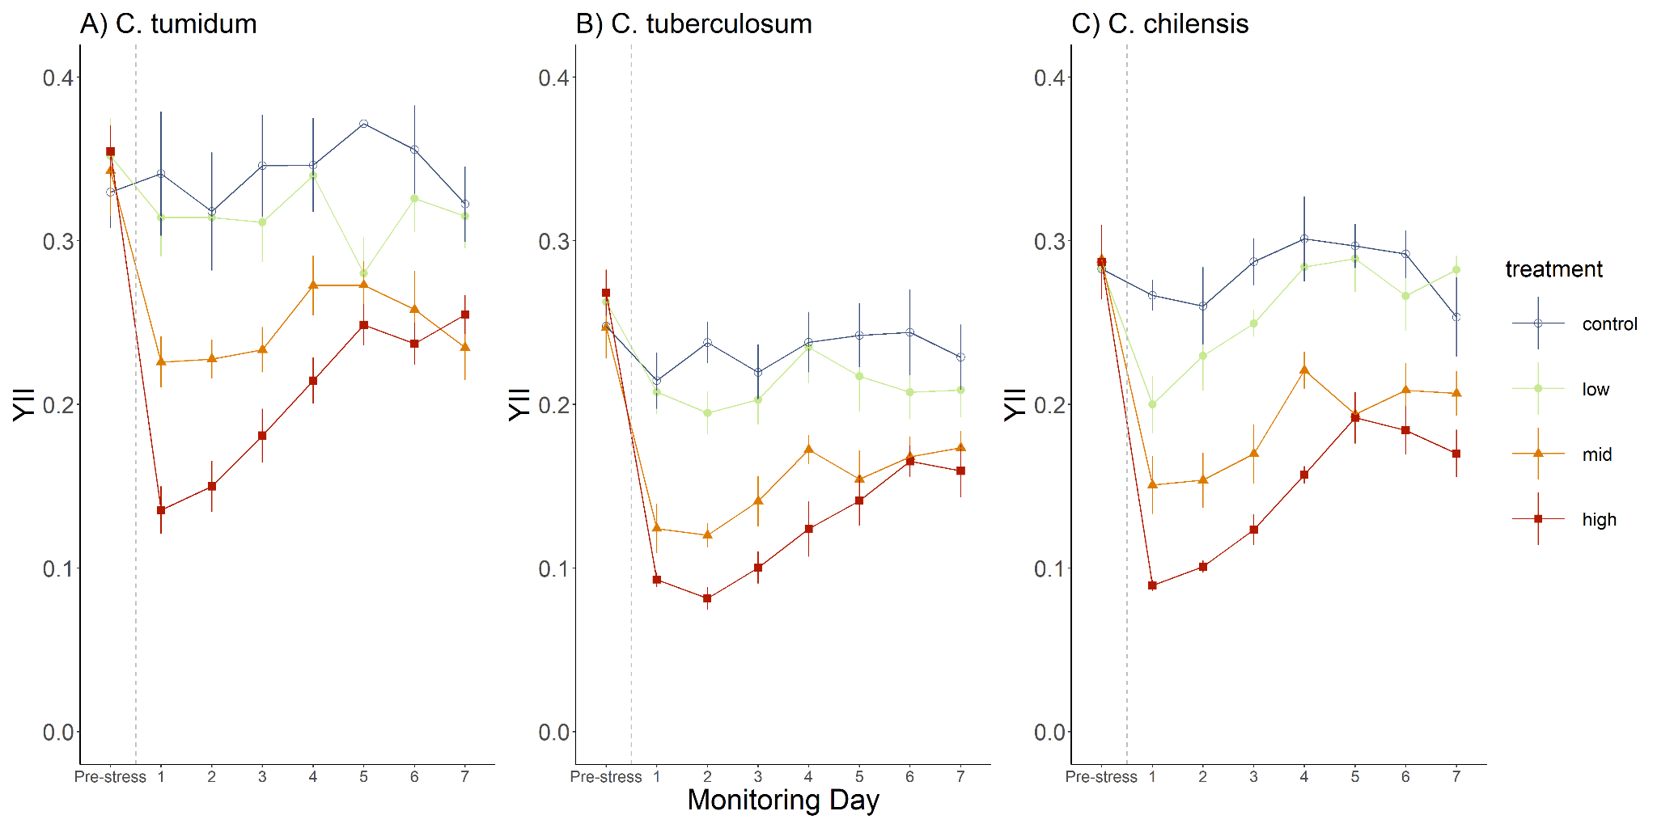

**Figure 2.** Photosynthetic efficiency (YII) of *Chamberlainium tumidum* (A), *Calliarthron tuberculosum* (B), and *Corallina chilensis* (C) taken before and following treatment (Control: 0mM, Low: 5mM, Mid: 15mM, & High: 30mM H2O2). Each point represents the averaged YII values (+_ SE) for a set of eight replicate individuals. Lines connect points that correspond to the same set of replicates measured over the monitoring week. Colour denotes which treatment level a given set of replicates received in an isolated 1-hour H2O2 treatment. The vertical dashed line signifies the time point during monitoring when the stress event took place.

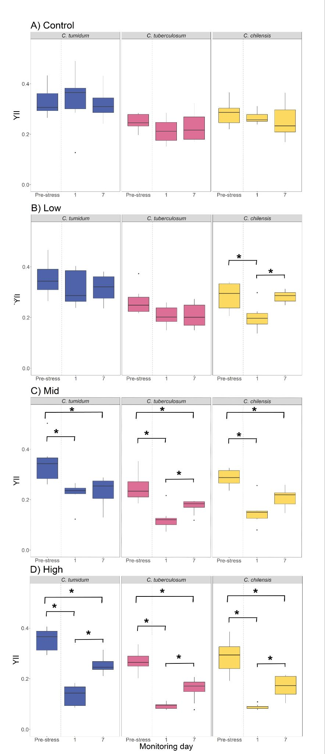

**Figure 3.** Photosynthetic efficiency (YII) at Control (A), Low (B), Mid (C) , and High (D) H2O2 treatments taken before, 1 day, and 7 days following treatment for each tested species. Colour denotes the species (*Chamberlanium tumidum*, *Calliarthron tuberculosum*, or *Corallina chilensis*) of a given set of replicates (n=8). Boxes under one species heading correspond to the same set of replicates measured on three separate days over the monitoring week. Significant differences in YII on each Monitoring Day were found for each species at each treatment level,(Friedman’s Test, followed by a Pairwise Wilcoxon signed-rank test). Significance is denoted by “*”. The vertical dashed line signifies the time point during monitoring when the stress event took place.

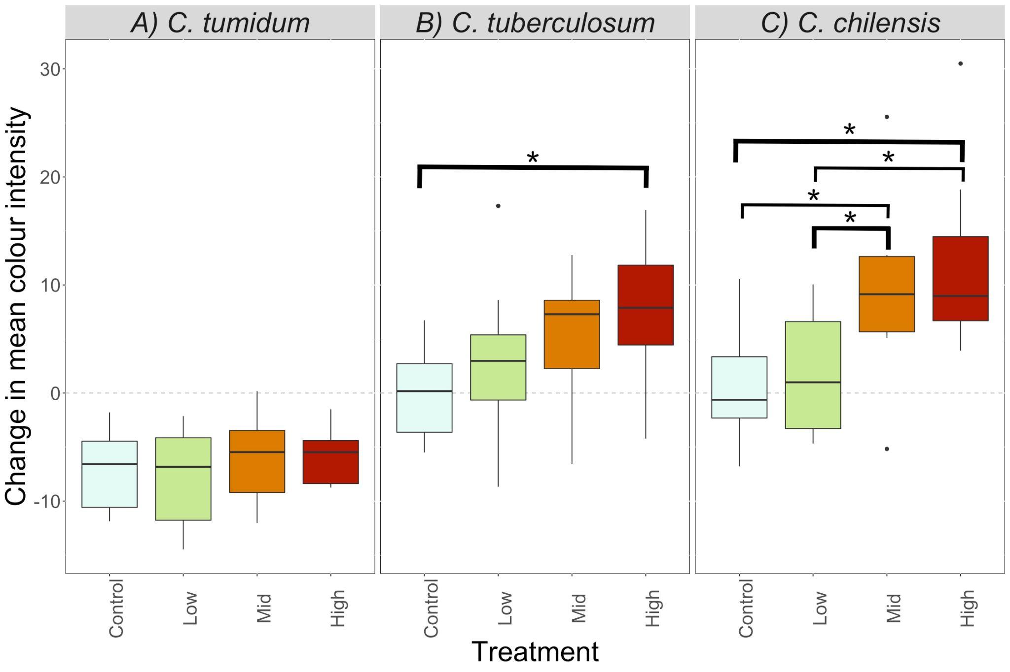

**Figure 4.** Change in mean intensity (𝚫mean intensity) in *Chamberlainium tumidum* (A), *Calliarthron tuberculosum* (B), *Corallina chilensis* (C) from Pre-stress to end of observation week*.* Colour denotes treatment of each H2O2 concentration (Low: 5mM, Mid: 15mM, and High: 30 mM), of a given set of replicates (n=8). The dashed line at 0 represents no change, above the line represents lightning and below the line represents darkening. Significance is denoted by “*”(Dunn’s Test; adj-p<0.05).

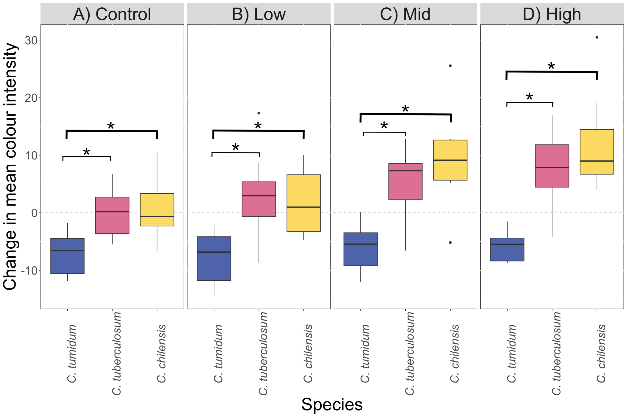

**Figure 5.** Change in mean colour intensity (𝚫MI) for each species (*Chamberlainium tumidum, Calliarthron tuberculosum,* & *Corallina chilensis*) in Control: 0 mM (A) Low: 5mM (B) Mid: 15mM (C) and High: 30 mM (D) H2O2 treatments. Colour denotes the species of a given set of replicates (n=8). The dashed line at 0 represents no change, above the line represents lightning and below the line represents darkening. Significance is denoted by “*”(Dunn’s Test; adj-p<0.05).

**Supplementary Information**

**Table S1.** Friedman Test output summary for PAM data, comparing YII for each species in each treatment across monitoring days. Significant p-values are bolded (p<0.05).

| **Treatment** | **Species** | **Comparison** | **Friedman chi-squared (**𝛘2**)** | **df** |  | **p** |
| --- | --- | --- | --- | --- | --- | --- |
| Control | *C. tumidum* | Pre : Day1 : Day7 | 5.25 | 2 |  | 0.07244 |
| *C. tuberculosum* | Pre : Day1 : Day7 | 2.25 | 2 |  | 0.3247 |
| *C. chilensis* | Pre : Day1 : Day7 | 2.25 | 2 |  | 0.3247 |
| Low | *C. tumidum* | Pre : Day1 : Day7 | 2.25 | 2 |  | 0.3247 |
| *C. tuberculosum* | Pre : Day1 : Day7 | 8.3226 | 2 |  | **0.01559** |
| *C. chilensis* | Pre : Day1 : Day7 | 9.75 | 2 |  | **0.007635** |
| Mid | *C. tumidum* | Pre : Day1 : Day7 | 13 | 2 |  | **0.001503** |
| *C. tuberculosum* | Pre : Day1 : Day7 | 14.25 | 2 |  | **0.0008047** |
| *C. chilensis* | Pre : Day1 : Day7 | 14.25 | 2 |  | **0.0008047** |
| High | *C. tumidum* | Pre : Day1 : Day7 | 16 | 2 |  | **0.0003355** |
| *C. tuberculosum* | Pre : Day1 : Day7 | 14.25 | 2 |  | **0.0008047** |
| *C. chilensis* | Pre : Day1 : Day7 | 16 | 2 |  | **0.0003355** |

**Table S2.** Pairwise Wilcoxon signed-rank test output summary for colour intensity data comparing YII for each species in each treatment across monitoring days. Significant p-values are bolded (p<0.05).

| **Treatment** | **Species** | **Comparison** | **p** |
| --- | --- | --- | --- |
| Low | *C. tuberculosum* | pre:1 | 0.14 |
|  |  | pre:7 | 0.14 |
|  |  | 1:7 | 1.00 |
|  | *C. chilensis* | pre:1 | **0.017** |
|  |  | pre:7 | 0.875 |
|  |  | 1:7 | **0.014** |
| Mid | *C. tumidum* | pre:1 | **0.00093** |
|  |  | pre:7 | **0.00932** |
|  |  | 1:7 | 0.44180 |
|  | *C. tuberculosum* | pre:1 | **0.0082** |
|  |  | pre:7 | **0.0082** |
|  |  | 1:7 | **0.0403** |
|  | *C. chilensis* | pre:1 | **0.004** |
|  |  | pre:7 | **0.004** |
|  |  | 1:7 | 0.050 |
| High | *C. tumidum* | pre:1 | **0.0019** |
|  |  | pre:7 | **0.0019** |
|  |  | 1:7 | **0.0019** |
|  | *C. tuberculosum* | pre:1 | **0.0028** |
|  |  | pre:7 | **0.0028** |
|  |  | 1:7 | **0.0180** |
|  | *C. chilensis* | pre:1 | **0.0028** |
|  |  | pre:7 | **0.0028** |
|  |  | 1:7 | **0.0028** |

**Table S3.** Summary of PAM data Gamlss model output using a Weibull distribution. Significance was compared to Control treatment of *Chamberlainium tumidum* on Pre-stress Monitoring day. Significance codes for p-values are as follows: p= 0 ‘***’ , p<0.001 ‘**’ , p<0.01 ‘*’

| **Variable** | **Estimated std.** | **Std. error** | **t-value** | **Pr>|t|** |
| --- | --- | --- | --- | --- |
| Intercept | -1.03493 | 0.02876 | -35.990 | < 2e-16 *** |
| *Calliarthron tuberculosum* | -0.35708 | 0.01866 | -19.139 | < 2e-16 *** |
| *Corallina chilensis* | -0.35708 | 0.01900 | -12.336 | < 2e-16 *** |
| Low treatment | 0.05109 | 0.03644 | 1.402 | 0.162409 |
| Mid treatment | 0.03033 | 0.03645 | 0.832 | 0.406288 |
| High treatment | 0.07813 | 0.03644 | 2.144 | 0.033218 * |
| Monitoring Day 1 | -0.01566 | 0.03664 | -0.427 | 0.669626 |
| Monitoring Day 7 | -0.04334 | 0.03646 | -1.189 | 0.235894 |
| Low treatment : Monitoring Day 1 | -0.18021 | 0.05154 | -3.497 | 0.000577*** |
| Mid treatment : Monitoring Day 1 | -0.50783 | 0.05153 | -9.855 | < 2e-16 *** |
| High treatment : Monitoring Day 1 | -1.02743 | 0.05161 | -19.908 | < 2e-16 *** |
| Low treatment : Monitoring Day 7 | -0.04928 | 0.05166 | -0.954 | 0.341223 |
| Mid treatment : Monitoring Day 7 | -0.30742 | 0.05158 | -5.960 | 1.08e-08 *** |
| High treatment : Monitoring Day 7 | -0.39229 | 0.05162 | -7.600 | 1.02e-12 *** |

**Table S4.** Kruskal-Wallis output summary for colour intensity data comparing the change in mean intensity of different treatments for all species, and for each individual species. Significant p-values are bolded (p<0.05).

| **Species** | **𝛘2** | **df** | **p-value** |
| --- | --- | --- | --- |
| All species | 14.493 | 3 | **0.002305** |
| *C.tumidum* | 1.7725 | 3 | 0.6209 |
| *C. tuberculosum* | 11.472 | 3 | **0.00943** |
| *C. chilensis* | 20.201 | 3 | **0.0001542** |

**Table S5.** Dunn’s Test output summary for colour intensity data comparing the change in mean intensity between treatments for each species. Significant p-values are bolded (p<0.05).

| **Species** | **Comparison** | **Z** | **p-value** |
| --- | --- | --- | --- |
| *C. tumidum* | Control : High | -0.7978245 | 0.6209 |
|  | Control : Low | 0.4179081 | 1 |
|  | High : Low | 1.2157326 | 1 |
|  | Control : Mid | -0.531883 | 1 |
|  | High : Mid | 0.2659415 | 1 |
|  | Low : Mid | -0.9497911 | 0.7902843 |
|  |  |  |  |
| *C.tuberculosum* | Control : High | -3.1153149 | **0.01102492** |
|  | Control : Low | -1.3297076 | 0.55084391 |
|  | High : Low | 1.7856073 | 0.29665144 |
|  | Control : Mid | -2.5454402 | 0.05457002 |
|  | High : Mid | 0.5698747 | 0.5687627 |
|  | Low : Mid | -1.2157326 | 0.44817357 |
|  |  |  |  |
| *C.chilensis* | Control : High | -3.6851896 | **0.001371195** |
|  | Control : Low | -0.3039332 | 0.761178813 |
|  | High : Low | 3.3812564 | **0.003607759** |
|  | Control : Mid | -2.8493734 | **0.017522175** |
|  | High : Mid | 0.8358162 | 0.80651663 |
|  | Low : Mid | -2.5454402 | **0.032742014** |

**Table S6.** Kruskal-Wallis output summary for colour intensity data comparing the change in mean intensity by species for all treatments, and for each individual treatment. Significant p-values are bolded (p<0.05).

| **Treatment** | **𝛘2** | **df** | **p-value** |
| --- | --- | --- | --- |
| All treatments | 90.663 | 2 | **<2.2E-16** |
| Control | 20.721 | 2 | **3.17E-05** |
| Low | 19.934 | 2 | **4.69E-05** |
| Mid | 23.817 | 2 | **6.73E-06** |
| High | 29.957 | 2 | **3.13E-07** |

**Table S7.** Dunn’s Test output summary for colour intensity data comparing the change in mean intensity between species for each treatment. Significant p-values are bolded (p<0.05).

| **H2O2 Treatment Level** | **Comparison** | **Z** | **p-value** |
| --- | --- | --- | --- |
| All treatments | *C.tuberculosum* : *C.tumidum* | 7.68601 | **3.04E-14** |
|  | *C.tuberculosum* : *C.chilensis* | -1.024377 | **3.06E-01** |
|  | *C. tumidum* :  *C. chilensis* | -8.710388 | **9.09E-18** |
| Control | *C.tuberculosum* : *C.tumidum* | 3.942163 | **0.0002422498** |
|  | *C.tuberculosum* : *C.chilensis* | 0 | 1 |
|  | *C. tumidum* :  *C. chilensis* | -3.942163 | **0.0001614999** |
| Low | *C.tuberculosum* : *C.tumidum* | 3.84108228 | **0.0002449861** |
|  | *C.tuberculosum* : *C.chilensis* | -0.0505406 | 0.9596916315 |
|  | *C. tumidum* :  *C. chilensis* | -3.8916228 | **0.0002987279** |
| Mid | *C.tuberculosum* : *C.tumidum* | 3.487298 | **9.76E-04** |
|  | *C.tuberculosum* : *C.chilensis* | -1.212973 | 2.25E-01 |
|  | *C. tumidum* :  *C. chilensis* | -4.700272 | **7.79E-06** |
| High | *C.tuberculosum* : *C.tumidum* | 4.3464878 | **2.77E-05** |
|  | *C.tuberculosum* : *C.chilensis* | -0.7075678 | 4.79E-01 |
|  | *C. tumidum* :  *C. chilensis* | -5.0540556 | **1.30E-06** |

**Table S8.** Summary of Gamlss model output using a Reverse Gumbel distribution. Significance was compared to Control treatment of *Chamberlainium tumidum.* Significant codes for p-values are as follows: p= 0 ‘***’ , p<0.001 ‘**’ , p<0.01 ‘*’.

| **Variable** | **Estimated std.** | **Std. error** | **t-value** | **Pr>|t| (p-value)** |
| --- | --- | --- | --- | --- |
| Intercept | -10.10461 | 0.97478 | -10.366 | < 2e-16 *** |
| *Calliarthron tuberculosum* | 8.38967 | 0.92445 | 9.075 | < 2e-16 *** |
| *Corallina chilensis* | 10.35686 | 0.94376 | 10.974 | < 2e-16 *** |
| Low treatment | -0.09074 | 1.06175 | -0.085 | 0.93199 |
| Mid treatment | 2.97640 | 1.07097 | 2.779 | 0.00601 ** |
| High treatment | 5.31372 | 1.08522 | 4.896 | 2.12e-06 *** |

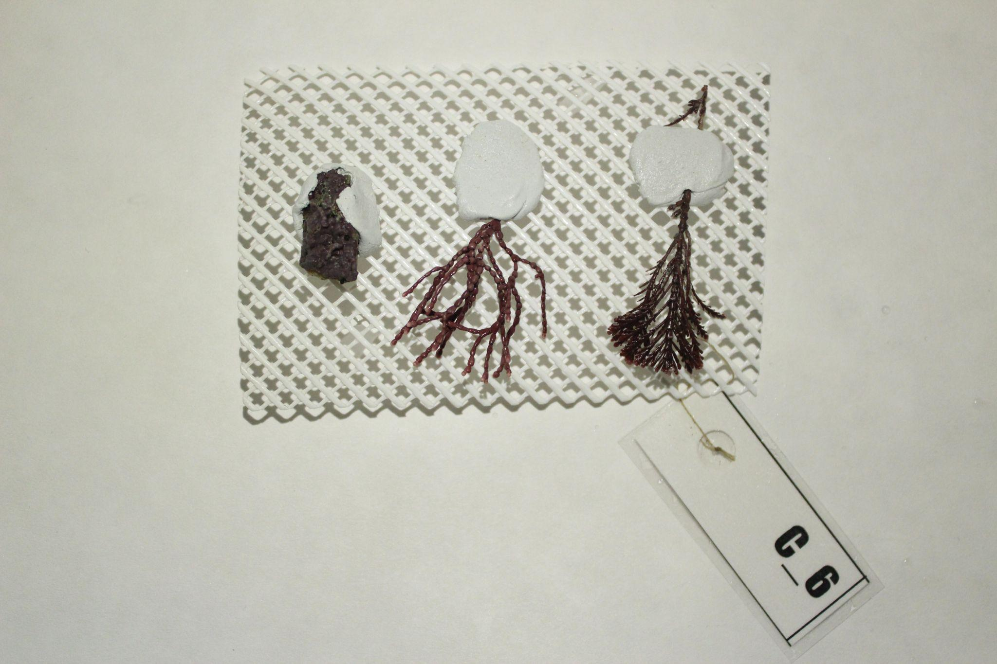

**Figure S1.** Image of a species card. Each card contained one thallus of each tested species (from left to right; *Chamberlainium tumidum, Calliarthron tuberculosum,* and *Corallina chilensis*) epoxied to a plastic grid card.