DOCUMENTATION

ASSIGNMENT No 1

STUDENT NAME: Suciu Andrei
GROUP: 30421

CONTENTS

1. Assignment Objective 3
2. Problem Analysis, Modeling, Scenarios, Use Cases 4
3. Design 6
4. Implementation 9
5. Results 13
6. Conclusions 14
7. Bibliography 15

Assignment Objective

Main Objective
To provide an application capable of calculating the sum, difference, multiplication, and division between two polynomials of various powers.

Sub-Objectives
- Create a model of the problem and divide it into easily manageable sub-problems. – Section 2
- Implement each operation individually. – Sections 3 & 4
- Validate the user input and transform it into usable data. – Section 4
- Create a friendly and intuitive user interface. – Section 4
- Test each component individually and remove bugs. – Section 6
- Test the completed application and remove bugs. – Section 6

Problem Analysis, Modeling, Scenarios, Use Cases

Functional Requirements
The application must be capable of addition, subtraction, multiplication, and division between two polynomials.
The application must be capable of differentiation and integration of one polynomial.
The application must implement a graphical user interface using Java Swing or JavaFx.

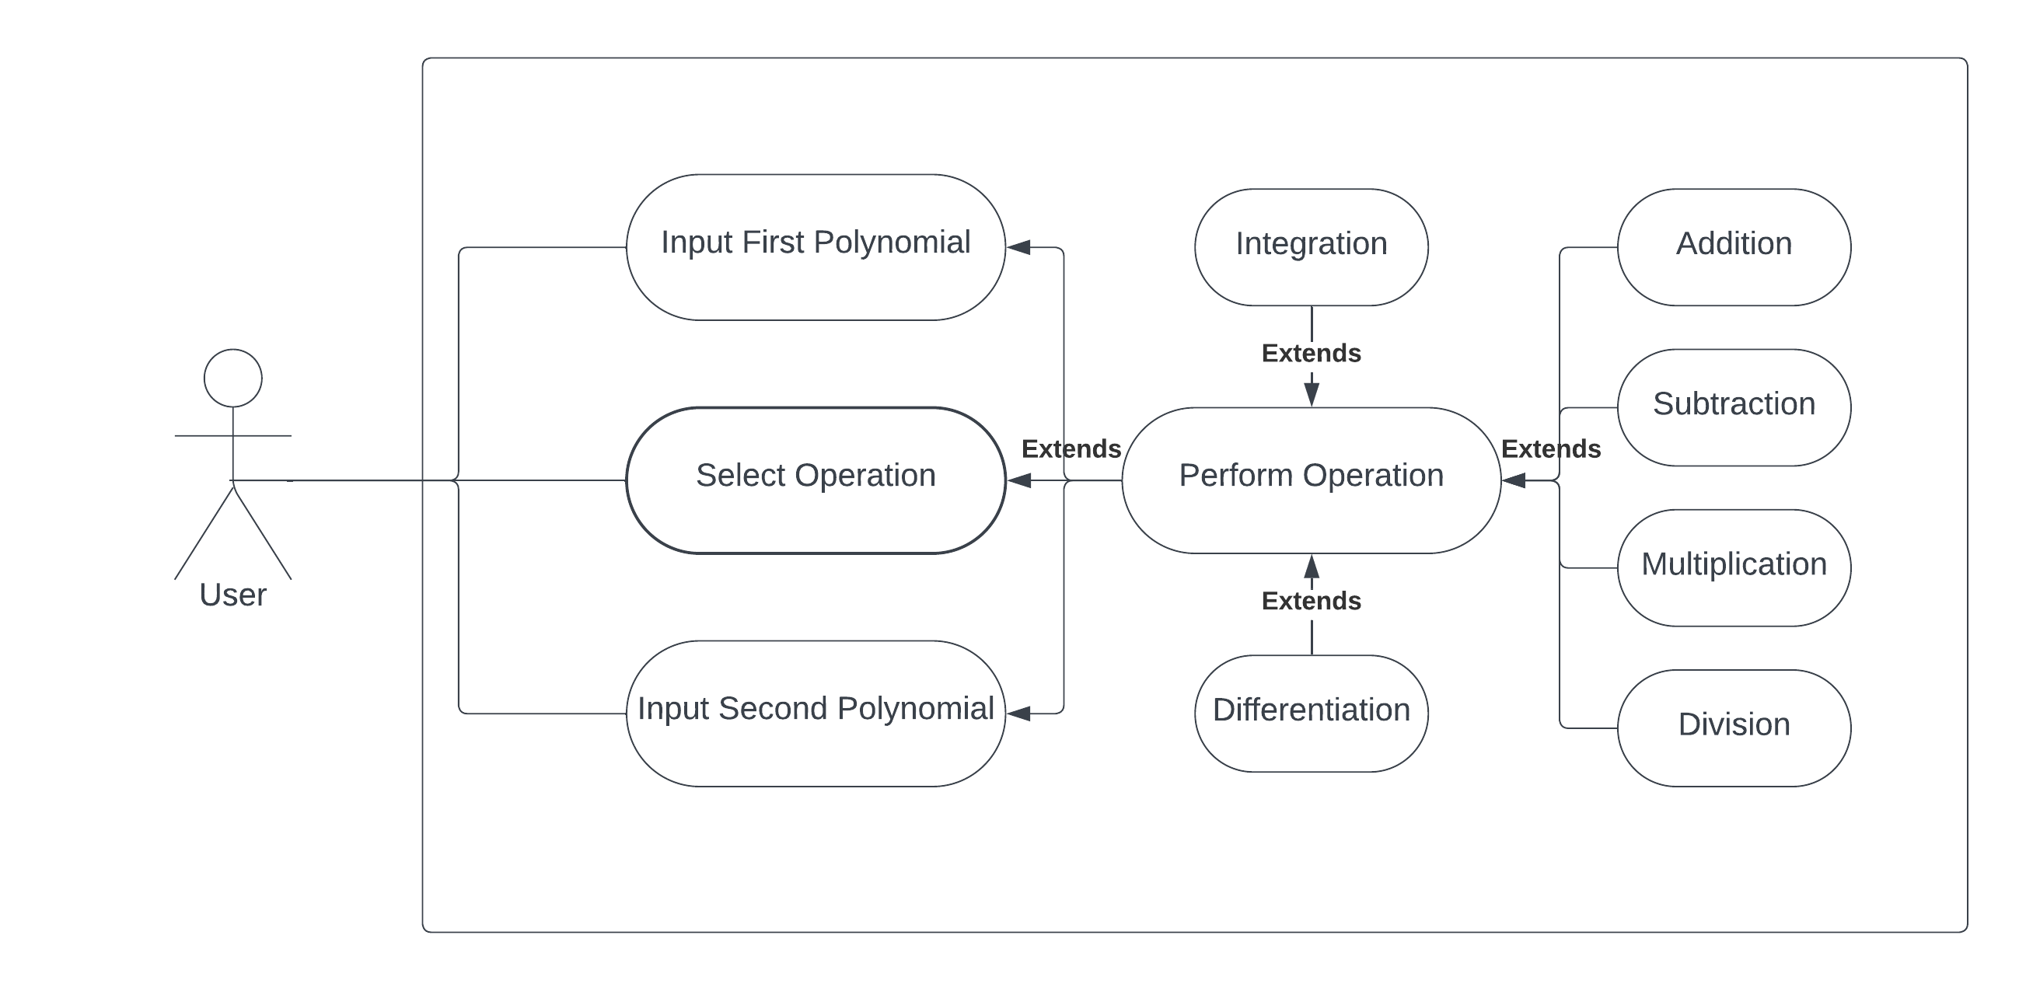
The use case diagram

Use case flow list
- The user first selects the desired operation:
  - Addition
  - Subtraction
  - Multiplication
  - Division
  - Differentiation
  - Integration
- In the case of addition, subtraction, multiplication, or division, the user inputs two polynomials.
- In the case of differentiation or integration, the user is required to input only one polynomial.
- The user gives the command for performing the desired operation.
- In case of an invalid input, the error is displayed.
- The result of the operation is displayed.

Design

Application Architecture
The program uses a three-layered architecture in order to manage the various components present: Model, View, and Controller.
The Model is responsible for the implementation of the Polynomial class and the various operations which can be performed on polynomials.
The View is responsible for the Graphical User Interface and anything the user can see or interact with. This is also where input data will be acquired from, and where output data will be shown.
The Controller acts as the link between the Model and the View. It is responsible for input validation and processing – It turns the user input into usable data, which can then be acted upon with the help of the Model.
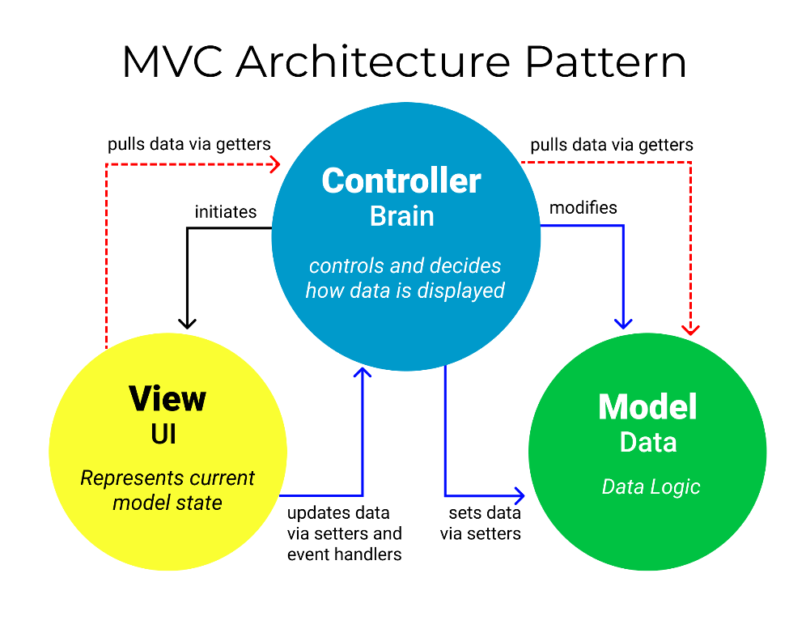
As such, the application is divided into three principal packages each representing one of these three components.
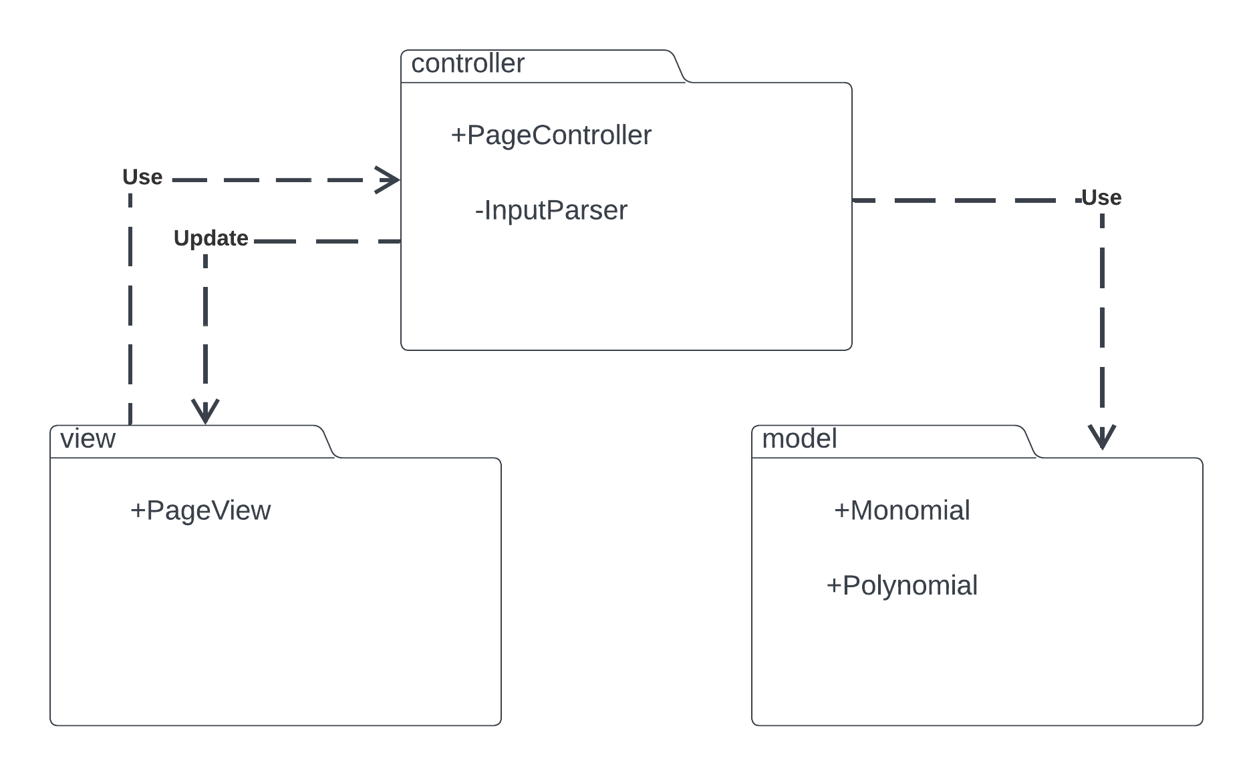

The Controller Package
As shown above, the controller package consists of the PageController and the InputParser. The page controller and the page view are linked to one another, as such they must both have the public access modifier. The InputParser is a helper class which will perform the input validation, implementing a method which will take a String as a parameter, and return a Polynomial to be displayed on the screen.
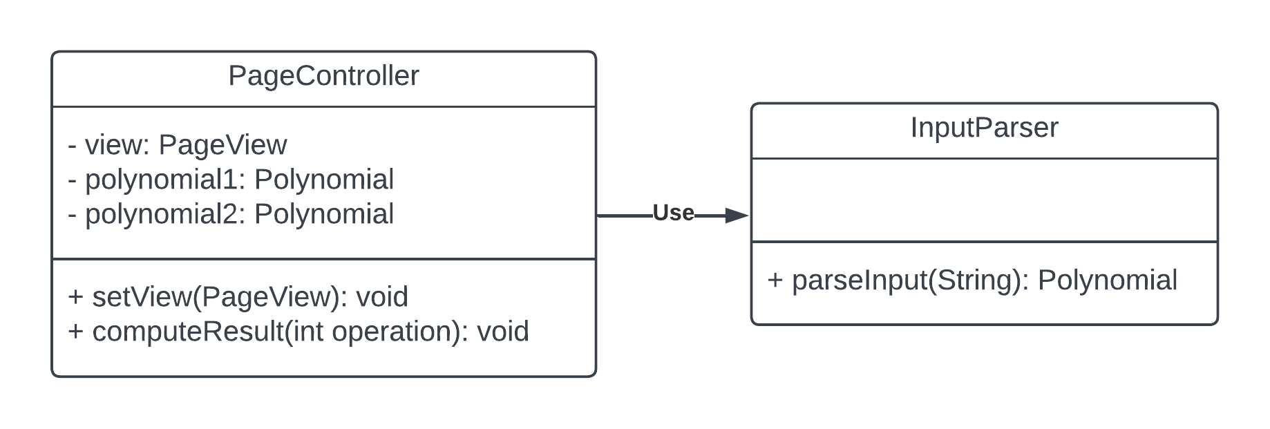

The Model Package
The model package represents the abstractization of the problem. It consists of two classes – Monomial and Polynomial.
The Monomial class was used to model a single monomial and the operations between monomials. This makes the implementation of the Polynomial class easier, as a polynomial is just a collection of monomials, and operations with polynomials reduce to a multitude of operations with monomials. Both classes implement a toString method, which is used to turn the object into a readable string, which can be shown on the screen.
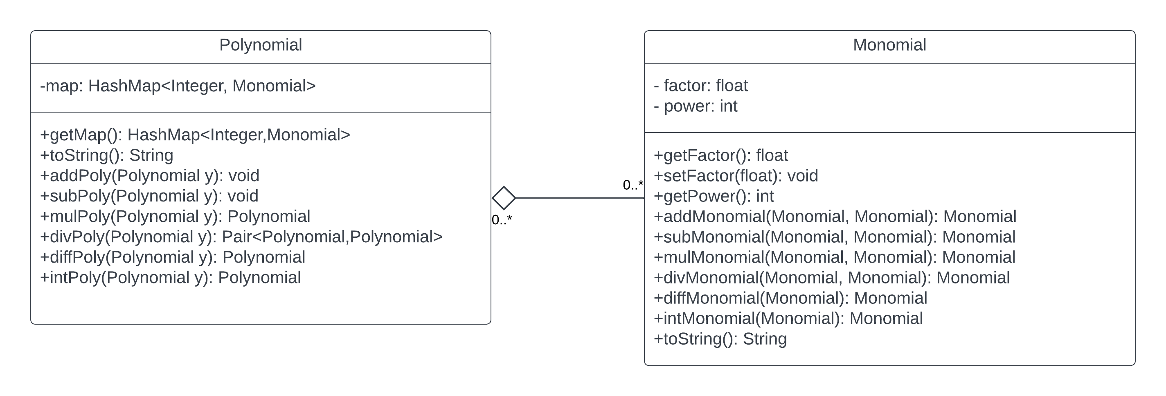
The Polynomial class is implemented using a HashMap to store all its respective monomials. This way we can store a dynamic number of monomials, and we can easily access them by referring to the power, which acts as key. The addition, subtraction, multiplication, division, differentiation operations are implemented, and are described in further detail in section 4.

Implementation

Model
The model of the program contains two principal classes — Monomial and Polynomial.
The Monomial class implements a single monomial, stored as the factor – float, and the power – int (ex: $5x^{6}$,$x^{2}$, or a single number). The intended use is that each power is unique withing a polynomial, and as such, the power field is marked as final. This class implements the following methods: addition, subtraction, multiplication, division, differentiation, integration, and printing. Except for the printing, which deals with a few special cases and formatting, the code is straightforward.
The Polynomial class consists of a HashMap of Monomials, and an int to store the degree of the polynomial. It also implements the same methods as the Monomial.

Addition/Subtraction
The Polynomial class can perform addition with a Monomial or another Polynomial. In order to add a Monomial to the Polynomial, we first search if there is already a monomial with the respective power in the map. If there is, we perform the Monomial-Monomial addition, and we update the map. If there isn’t, we can simply add the new Monomial to the map.
The subtraction is similar, except we must recalculate the of the polynomial if the result of the monomial-monomial subtraction has a factor of 0.
The Polynomial-Polynomial addition and subtraction work by repeatedly adding/subtracting the terms of the second polynomial to the first.

Multiplication
The Polynomial-Polynomial multiplication works by multiplying each term of the first polynomial with each term of the second, and adding every resulting term to the result instance, which is returned at the end.

Division
The algorithm used for dividing polynomials was that of the long division. Firstly, we sort all the terms of each polynomial in descending order, according to their powers. We make a copy of X, the polynomial to be divided, and we divide the largest monomial of this copy by the largest monomial of Y, the polynomial by which we are dividing. The resulting monomial is added to the quotient, and is also multiplied and subtracted from the copy of X. We check if the degree of the copy is smaller than the degree of Y, and if it isn’t, we repeat the last few steps until we can no longer divide, i.e. the degree of Y is larger than of the copy. What is left of this copy is returned as the remainder, together with the quotient.

Differentiation & Integration
The differentiation and integration operations are relatively simple. Each monomial of the polynomial is differentiated or integrated, and they are added to the result which is returned at the end.

Controller
The controller provides the link between the model and the GUI. Its main purpose is to transform the input provided by the user into usable data. This implies input validation, and string formatting. The input is first validated by the PolynomailFormatter class, and then it is turned into an actual polynomial object by the PolynomialMaker.
The PolynomialFormatter uses regex expressions to check for various potential errors in the input. If an error is found, its respective message will be sent back to the controller and displayed on the screen. If no errors are found, the program proceeds to the PolynomialMaker, to turn the String into a Polynomial. This process works by going through the String character by character and using various flags to infer the meaning of the current character. Thus, we obtain the power and the factor of the monomial, which is then added to the result polynomial.

Graphical User interface
The graphical user interface (GUI) was implemented in Swing, with the help of the FlatLaf library, in order to provide a modern and clean look to the project.
It contains a few text fields for input and output polynomials, and a few buttons for selecting the operation and other functionalities.

Further Detail
The main page is divided into three sections: top, middle, which will each be described in more detail.
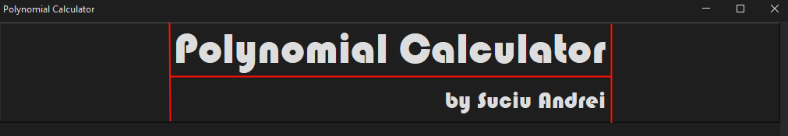
The top section consists of just the title of the project. It was created using the BoxLayout in line mode and contains three elements. The first and last elements are horizontal glues, and the middle element is the auxiliary panelTopSecond which is in page mode Box Layout. It contains the two labels, title and author, aligned to the right. Finally, the top panel was decorated with a bevel border, and a mouse listener was added, in order to open this very document.

The construction of the top panel

The middle section contains the bulk of the UI. It was similarly constructed using various orientations of the BoxLayout. Firstly, some buffers and glues are added, and then the content, partitioned into 3 sections, first, second, and third. The first section contains the text field for the first polynomial, the second section contains the buttons for switching the polynomials, selecting the operation, computing, and the field for the result, while the third section, similarly to the first, contains just the text field for the second polynomial. Each text field has had some methods implemented in order to display placeholder text when they are empty — First Polynomial and Second Polynomial.
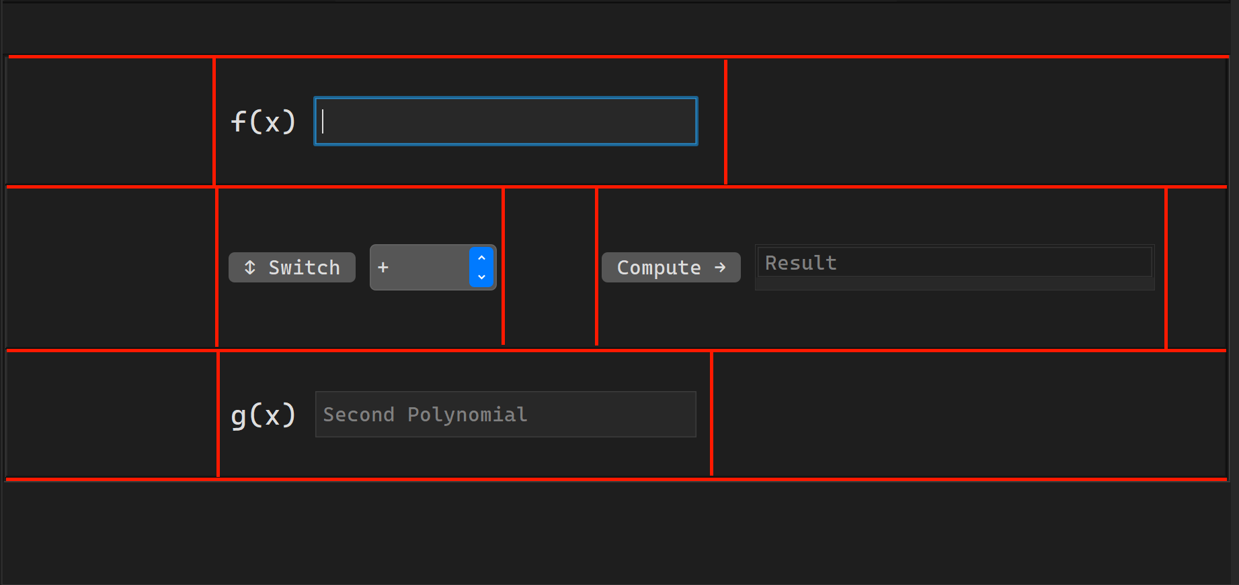

Results

JUnit testing
The Polynomial operations and the input parsing were tested with JUnit. Each operation has a test implemented in the OperationsTest class. The inputs and expected results were given as Strings and as such, the input parsing from String to Polynomial and from Polynomial to String was tested as well. The tests contain regular uses of the operations, as well as edge cases.
As a result of JUnit testing, a few bugs were discovered and subsequently removed, after which all tests passed.
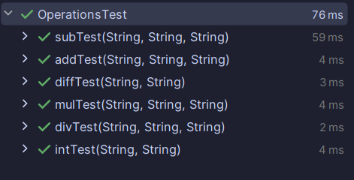

Conclusions
The following should be presented: conclusions, what you have learned from the assignment, future developments.

The application is capable of computing common operations between polynomials of various lengths, sizes, and ranks. The user is able to freely enter polynomials into the text fields and to switch them between each other.
Developing this application brought new challenges to me as a programmer. While I had already grasped the basics of Java development, implementing this project extended my knowledge of programming.
Perhaps the most important skill gained during this project was that of regular expressions. This allows for flexible and easy string manipulation in just a few lines of code.
JUnit testing was another valuable advancement. It represents a streamlined way of testing and debugging code, much faster and more powerful than other alternatives I was using before.
Designing UML diagrams made the planning and development of the project overall simpler, and it made complicated tasks easier to implement. It gave the project structure, and it made the code more organized.

Future Developments
There are many features which make sense to be implemented in this application, among which:
  - The ability to use parentheses in order to do multiplication inside the input fields
  - Visual representation of the polynomials used as a graph
  - The ability to use rational powers, not just integers
  - The implementation of a variable amount of input fields
- The implementation of various constants such as: π, Φ, ℯ
- Further bug testing

Bibliography
The references that were consulted and the libraries used in the project:
- FlatLaf – Flat Look and Feel
- Oracle: Creating a GUI with Swing
- Laboratory Resources for PT
- LucidChart – UML Designer
- Regular Expressions – Nanyang Technical University

