Preparing Linux:

Get docker:
1.Run this command to download the current stable release of Docker Compose:
sudo curl -L "https://github.com/docker/compose/releases/download/1.28.5/docker-compose-$(uname -s)-$(uname -m)" -o /usr/local/bin/docker-compose
2Apply executable permissions to the binary:
sudo chmod +x /usr/local/bin/docker-compose
3.Test the installation.
$ docker-compose --version
docker-compose version 1.28.5, build 1110ad01

Get git:
$ sudo apt install git-all

Create folder for project ‘samsa’:
Clone backend and frontend:
$ git clone …
Start docker in each folder:
$ docker-compose up -d –build
Go to”samsa-backend/app/module/DataFixture/src/DataFixture/Controller/OrganizationFixtureController.php“ and change on what organization your are working.
Get containerID for backend_web:
$ docker ps

Connect to container:
$ docker exec -it <containerID> bash

After connection run this :
php public/index.php run organizationfixture

Connect to backend:
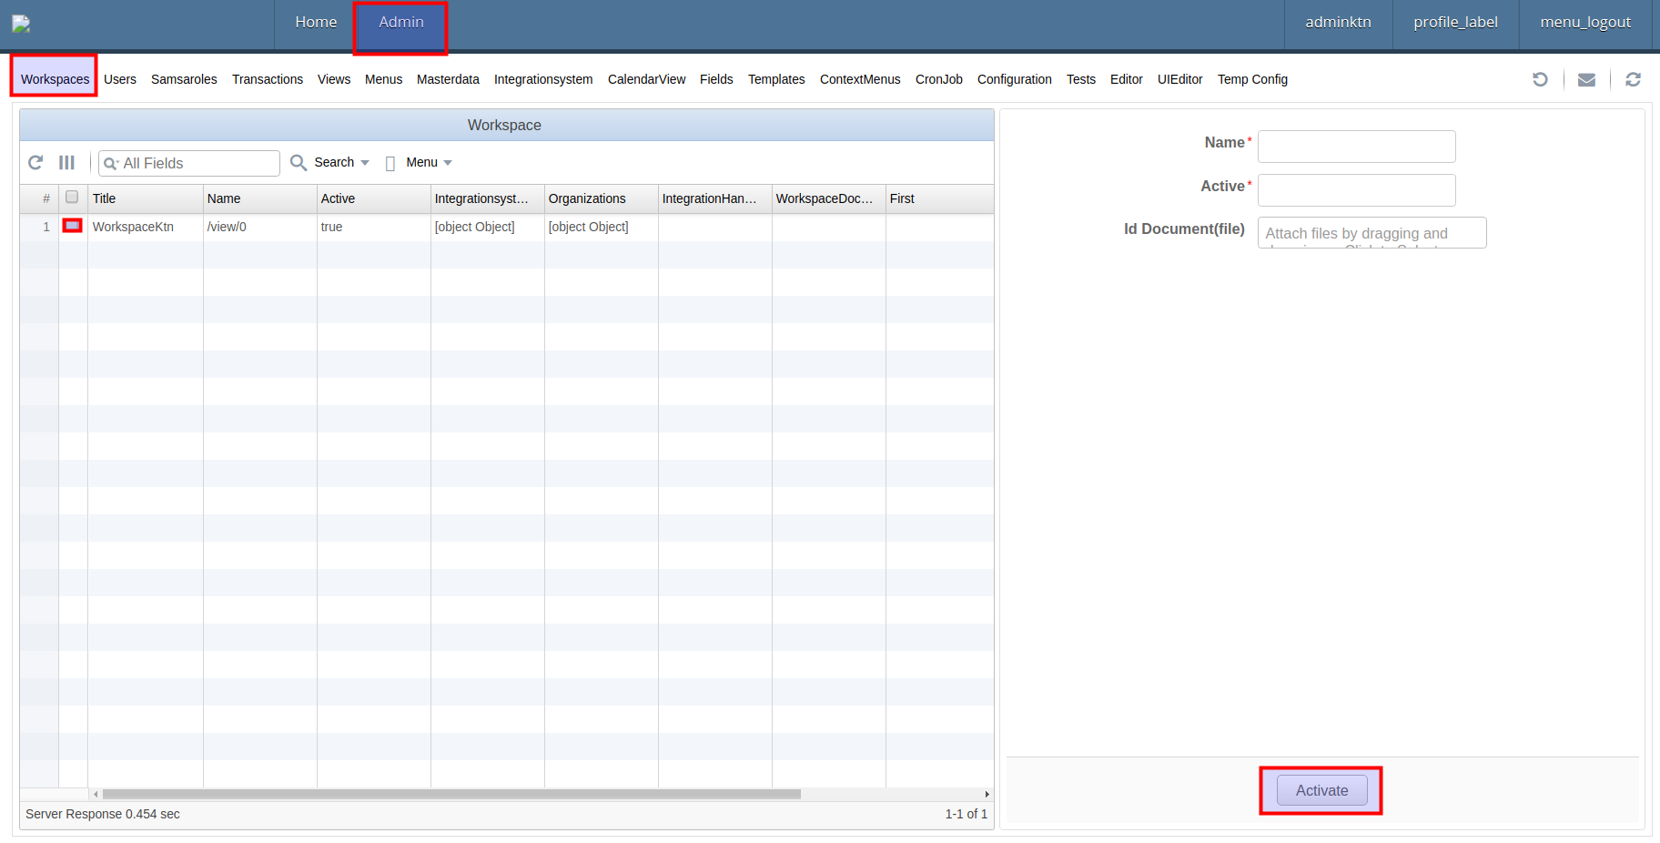
enter in browser http://localhost:8080/ go to admin-workspaces and activate your workspace

Enter test data :
go to Tests select one or more and save.

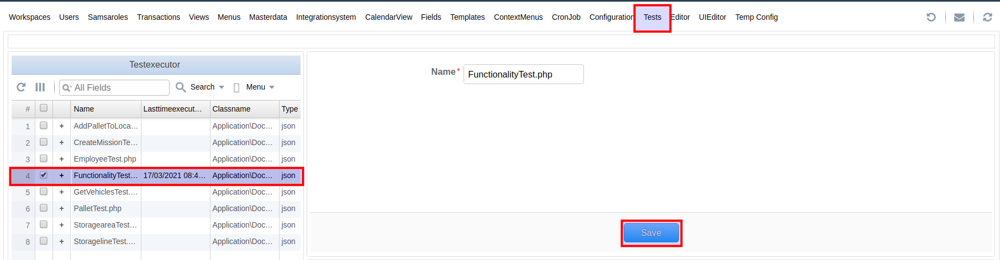

Connect to frontend:
enter in browser http://localhost:3000/
Now you are ready to test.

Explication frontend:
- Inbound:
Information about Pallets (id , creationdate ,etc)
- Missions:
Undone Tasks
- Picking Tasks:
All tasks
- Lines And Locations:

- Warehouse Planning:
Plans for manual tasks
- Avg Planning:
Plans for avg tasks
- Users:
- Line Groups:
- Stock To Manual Transfer:
Enter Pallet id , location of the storage lines and location number to create a manual task from stock to transfer zone with a specific destination group and line type.
- Scan Pallet For Destination:
Enter Pallet id , location and location number to find free destination point (where to deliver pallet) or to put it in the truck
- Transfer Zone To Destination:
Enter Pallet id to move it form transfer zone to destination zone. Here you can add another destination zone or choose another destination.
- Stock to AGV Transfer:
Enter Pallet id , location of the storage lines and location number to create a AGV task from stock to transfer zone with a specific destination group and line type.
- Shifting Pallets:
Here you can pick up pallet or drop one to shift pallets.
- Stock To Destination:
Enter Pallet id , location , location number to move it from stock to destination.
- Stock To Truck:
Enter Pallet id to move it from stock to truck.
- Vehicles:
- Configuration:

