What I've done so far:

Go to Stock To AGV Transfer and create an pallet (enter pallet id ,location for AGV and location number)
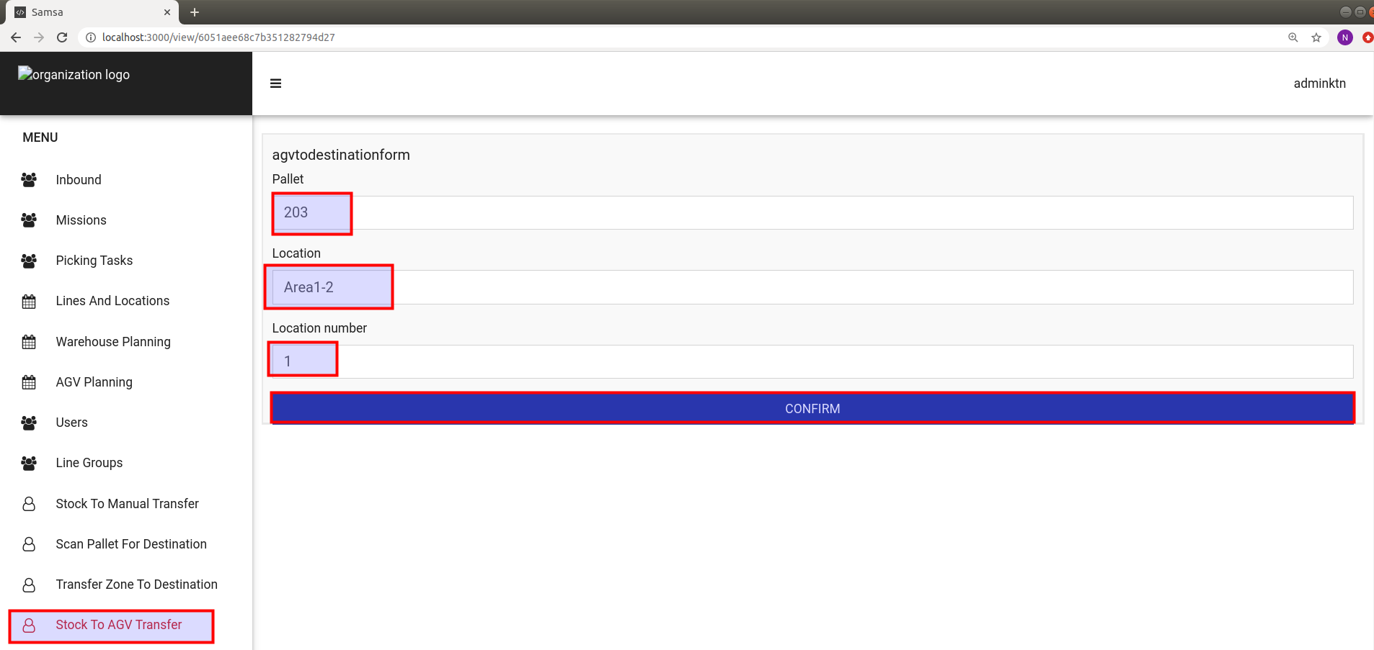
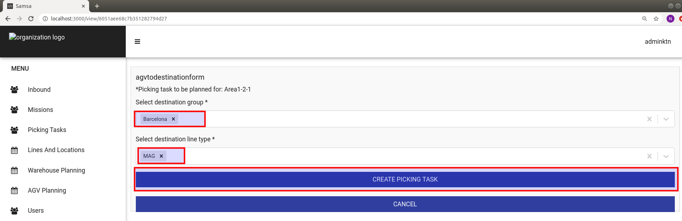
Select destination group and line type.
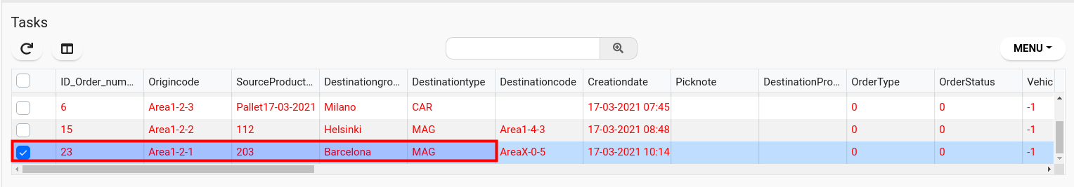
Go to AGV Planning area and find that task you created. Right click and to Manual planning task for execution.

Go to missions and you should find a new mission for agv.

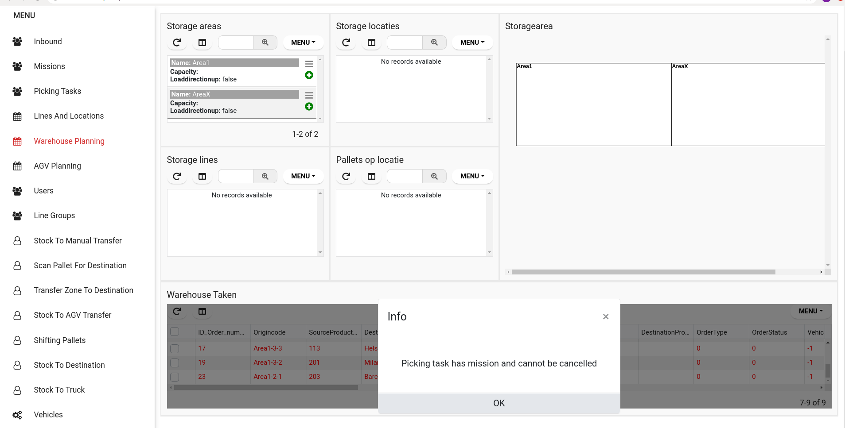
Go back to AGV Planning and right click on task and try to Cancel Task. An error occurs:
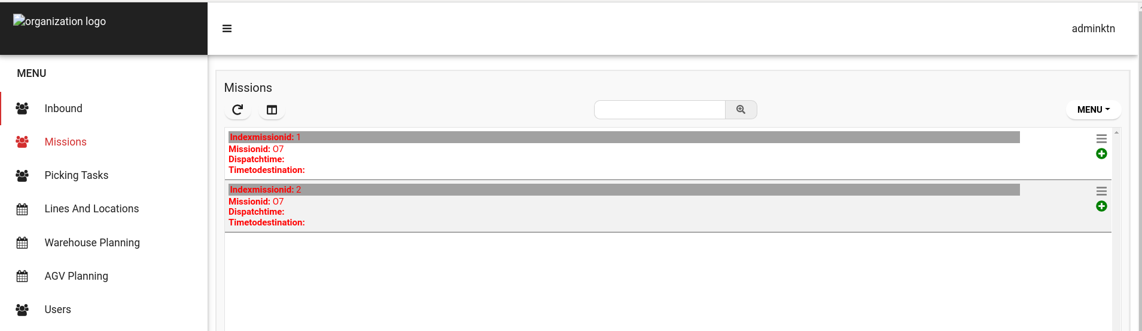
Go in code and change cancelAGVPickingTask in True:

Now Cancel Task works and in mission it will not be anymore that mission for AGV.
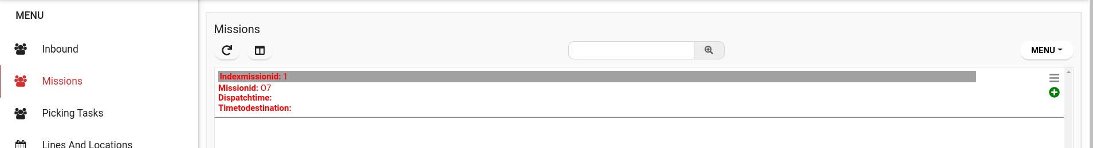

Error and I’ll try to fix it : Storage lines from origin and destination task are locked.
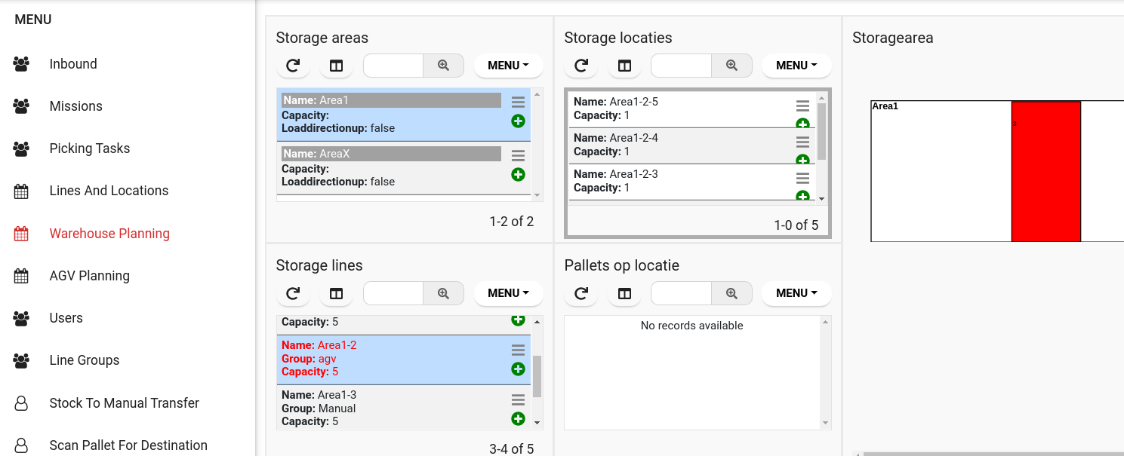
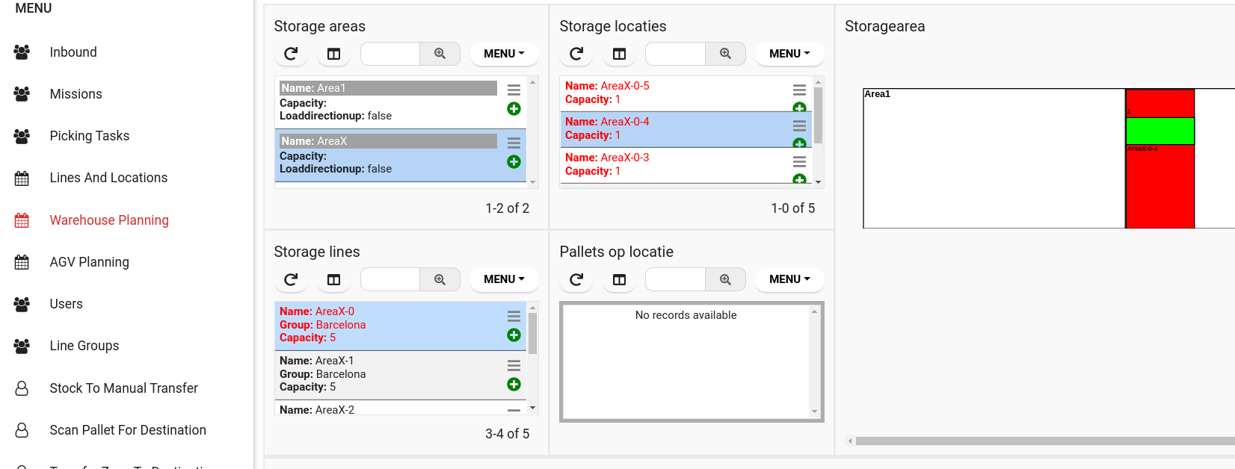
I fixed one of the issues but still...origin line is locked.
I fixed all issue and now lines are unlocked.

