Babysitting - One Child: **$20/hr**

Babysitting - Multiple Children: **$60/hr**

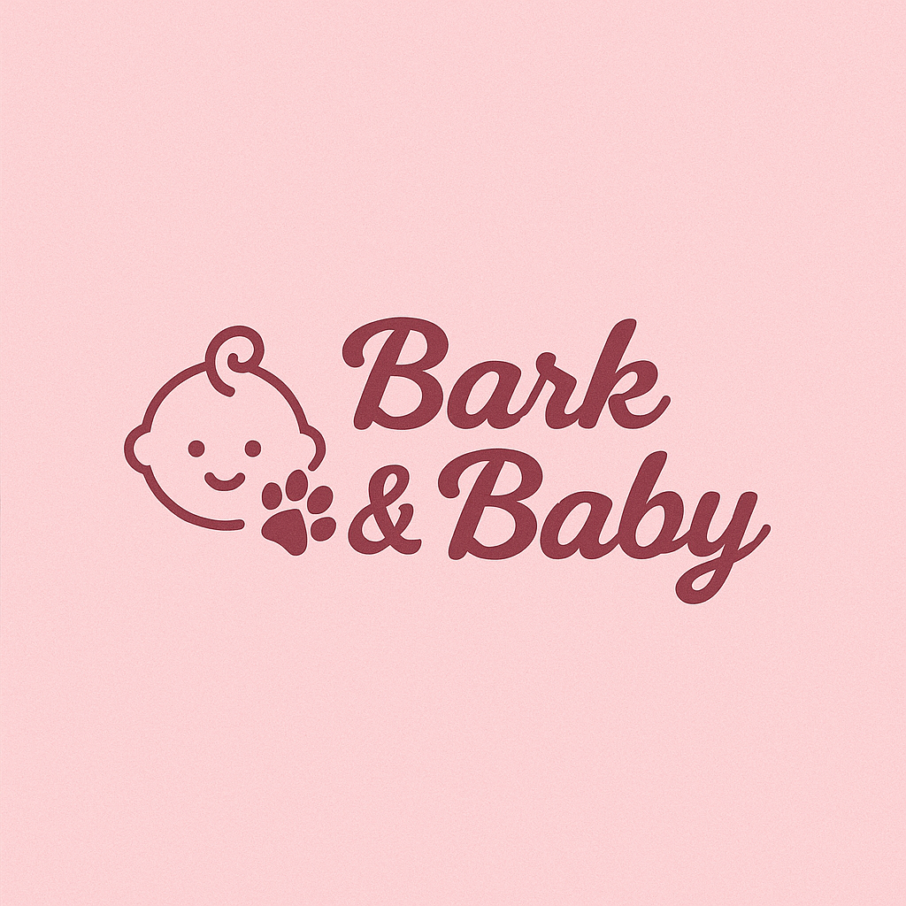Dog Sitting - One Dog: **$16/hr**

Dog Sitting - Multiple Dogs: **$48/hr**