THE ICT UNIVERSITY
FACULTY OF INFORMATION AND COMMUNICATION TECHNOLOGIES
SUMMER 2026 · FINAL EXAMINATION PROJECT REPORT

Lexical and Syntactic Analysis of Informal Urban Communication in Yaoundé
A regular-expression lexer and a table-driven LL(1) parser for code-mixed English, French, Pidgin and slang
Course | Details
Course title | Compiler Construction
Course code | CS4110 (credit value 6)
Instructor | Engr. Tanwi Nkiamboh
Department | ICT
Examination date | Tuesday, September 29, 2026

Group members
Name | Matricule | Role
NJUNG GLORIOUS SAMSIMBOM | ICTU20241398 | Group leader
NDENGUE TAMOKOUE VAN BROWN | ICTU20241479 | Member
BONGANG BERINYUY MEGHEN | ICTU20241385 | Member

Source code: https://github.com/Samsi11/compiler_contruction_yaounde

Table of Contents
1. Introduction 3
2. Methodology and data collection 3
2.1 How the data were collected 3
2.2 Data preparation 3
2.3 Coverage of the topics in the brief 4
2.4 Tools 4
3. Raw collected statements 4
3.1 Usable utterances 4
3.2 Entries excluded from analysis 6
4. Lexical analysis 6
4.1 Token types 6
4.2 Custom lexical specification (regular expressions) 7
4.3 Token tables 8
4.4 Token frequency and variation 9
5. Syntactic analysis 12
5.1 Designing the context-free grammar 12
5.2 Step 1: removing left recursion 13
5.3 Step 2: left factoring 13
5.4 Step 3: FIRST and FOLLOW sets 14
5.5 Step 4: the LL(1) parsing table 16
6. Implementation 18
6.1 Architecture 18
6.2 The table-driven LL(1) parsing algorithm 18
6.3 Worked example: F04 “U don chop?” 18
7. Testing and results 20
7.1 Automated tests 20
7.2 Overall results 20
7.3 Accepted utterances 21
7.4 Rejected utterances and why 23
8. Why Yaoundé communication is linguistically complex 25
9. Limitations and future work 26
10. Conclusion 26
References 26
Appendix A: Vocabulary 26
Appendix B: Running the project 27

Summary
This report describes a mini-language analyzer for informal speech in Yaoundé. A regular-expression lexer turns each phrase into typed, language-tagged tokens. A context-free grammar (CFG) is transformed (left-recursion removal, left factoring), its FIRST/FOLLOW sets are computed, and an LL(1) parsing table drives a table-driven parser. The system was tested on 50 real utterances from a nine-person survey: 31 were accepted and 19 were rejected, each rejection for a documented linguistic reason.

1. Introduction
Yaoundé is a multilingual city. Everyday speech mixes English, French, Pidgin, local-language expressions and youth slang (“franc-anglais”), together with city-specific abbreviations such as brand and utility names. A single short sentence can draw on three or four of these at once, which makes such speech a hard test for tools built around one standard language.
The objective of this project, set out in the examination brief, is to design and implement a mini-language analyzer that performs lexical and syntactic analysis on real expressions from Yaoundé and detects patterns related to commuting, markets, electricity, weather, transport and everyday transactions. We answer it in five steps:
- Collect real phrases with the contributor’s own translation (Sections 2 and 3).
- Analyze lexically: define token types with regular expressions, tag each token with its language, and measure frequency and variation (Section 4).
- Analyze syntactically: build a CFG, remove left recursion, left-factor it, compute FIRST/FOLLOW and build the LL(1) table (Section 5).
- Implement a table-driven LL(1) parser with a desktop interface (Section 6).
- Test the grammar on the collected utterances and explain every acceptance and rejection (Section 7).
Section 8 discusses why Yaoundé communication is linguistically complex, and Section 9 lists limitations. Throughout, a shaded Comment box under each figure or table explains what it shows and why it matters.

2. Methodology and data collection

2.1 How the data were collected
Data were gathered through an online survey form completed by nine contributors on 14 September 2026. The form was organised by topic (taxi and bendskin talk, money matters, rainy season, poor internet and network, market bargaining, electricity, phone credit and mobile money, food, fuel queues and an open topic). For each topic the contributor typed a phrase they had heard or used and, next to it, a plain-English translation.
Phrases were kept exactly as typed, including slang, code-mixing, spelling variants, missing punctuation and emoji. Nothing was corrected. Contributors are referred to by codes (P01 to P09) to protect their privacy.
Comment: how this relates to the brief
The brief asks for transcribed spoken statements. Our data are written survey responses describing phrases that contributors heard or used, so they show the same slang, mixing and mistakes but are not audio transcriptions. We state this openly as a limitation (Section 9).
Presentation clue: say that 50 usable utterances is well above the 10 to 15 required, and that the nine contributors give more variety than one group of three could.

2.2 Data preparation
- Each phrase became one row of corpus.csv with its topic, contributor code, translation and expected parser verdict.
- One form cell held two phrases on separate lines ("I drop aza?" and "Fund my account abeg"); it was split into two utterances (E07, E08).
- The phrase for “Massa Eneo” had no translation; the team supplied it from local usage (a sigh of annoyance when the electricity company Eneo cuts the power).
- 10 entries were excluded: empty answers, entries with no translation, and one contributor whose topic keyword had been typed in the phrase column (columns apparently swapped). They are listed in Section 3.2.
- The result is 50 usable utterances from seven of the nine contributors (P01 and P03 gave nothing usable). Utterances per contributor: P02 8, P04 5, P05 10, P06 5, P07 9, P08 4, P09 9.

2.3 Coverage of the topics in the brief
Topic in the brief | Status | Where it appears in our data
Taxi and commuting issues | Covered | Taxi / bendskin talk column (6 utterances)
Poor internet connectivity | Covered | Internet / network (6)
Limited electricity supply | Covered | Electricity (4)
Market bargaining | Covered | Market bargaining (6)
Rainy season struggles | Covered | Rainy season (7)
Fuel scarcity | Covered | Fuel queues (4)
Roadside business interactions | Partly | Through food and money-matters phrases
Bendskin communication | Partly | Shares one survey column with taxi talk
Security announcements or checkpoints | Not covered | No submissions received
Life at the ICT University | Not covered | No submissions received
(extra) Money, mobile money, food | Added | Money matters (8), mobile money (3), food (5), open (1)

Comment
Two suggested topics (security checkpoints and university life) received no submissions, so we do not claim coverage of them. The brief lists topics “such as”, so it is not an exhaustive requirement.

2.4 Tools
The analyzer is written in Python 3 using only the standard library (re, csv, tkinter, unittest). The lexical rules are read from an editable vocabulary file, and the whole project is kept in a Git repository so results can be reproduced with a few commands (Appendix B).

3. Raw collected statements

3.1 Usable utterances
The table lists every usable utterance verbatim, with the translation the contributor gave. Spelling, capitalisation, spacing and emoji are unchanged.
ID | Topic | By | Statement (as typed) | Contributor’s translation
T01 | Taxi / bendskin | P02 | Fou le camp | Leave this place
T02 | Taxi / bendskin | P04 | Yu no serios | You’re not serious
T03 | Taxi / bendskin | P05 | Enlève ta brouette la sur la route | Remove your trash car from the road
T04 | Taxi / bendskin | P06 | Lef me for that achombo house | Drop me off and that local restaurant
T05 | Taxi / bendskin | P07 | I get na 400 | You are trying to bargain from the price the bike man gave you to 400
T06 | Taxi / bendskin | P09 | Na how | How are you
E01 | Money matters | P02 | Ne joue pas avec Mon argent salo | Don’t play with my money fool
E02 | Money matters | P04 | That do small | That money is small
E03 | Money matters | P05 | Gère moi non nkap | Give back my money
E04 | Money matters | P06 | You get some twenty pongos for Dey ? | Do you have twenty thousand francs
E05 | Money matters | P07 | I send my aza make you fund me fapnkolo | Should I send my account details so you can send me 5000frs
E06 | Money matters | P09 | A fit see some small 100k🤣🤣🤣 | Could you please borrow me some money ,100k perhaps😭🤣
E07 | Money matters | P08 | I drop aza? | Should I send my account details?
E08 | Money matters | P08 | Fund my account abeg | Please can you send me some money
R01 | Rainy season | P02 | Na which bad luck this too nor? | What type of bad luck is this?
R02 | Rainy season | P04 | Rain do worry bad | Rain is disturbing
R03 | Rainy season | P05 | Massah yacob il fait froid | Places are cold
R04 | Rainy season | P07 | Enter motomoto | Enter mud
R05 | Rainy season | P08 | Motomoto | Mud
R06 | Rainy season | P09 | Do rain so eh | This rain like this eh
R07 | Rainy season | P06 | This rain so na weather four two and. A half | During this rainy season the rain and cold warrants you to cuddle up with a Partner
I01 | Internet / network | P02 | Mtn Va tous nous montrer au pays ci | Mtn will show us all types of things in this country
I02 | Internet / network | P04 | Network poor bad | The network is poor
I03 | Internet / network | P05 | Orange et le réseau nkangian | Orange and weak internet
I04 | Internet / network | P06 | MTN ns craze | The isp called MTN has very poor service
I05 | Internet / network | P07 | Yehum MTN | Disappointed at MTN
I06 | Internet / network | P09 | Make single pole go offline make network cam back | Let single people go offline so we can have good network🤣
K01 | Market bargaining | P02 | Venez me tromper | Come and cheat me
K02 | Market bargaining | P04 | Levam for this price | Leave it at this price
K03 | Market bargaining | P05 | Majumbum depuis longtemps | I have money since
K04 | Market bargaining | P07 | Last market | What they sell around the closing time of the market
K05 | Market bargaining | P08 | Last price | Minimum price the seller can't go Below
K06 | Market bargaining | P09 | Ei over deer | It’s too expensive
L01 | Electricity | P02 | Massa Eneo | Ugh, this Eneo (a sigh of annoyance when Eneo cuts the electricity)
L02 | Electricity | P05 | E.N.E.O | Eneo has done it again
L03 | Electricity | P07 | Ndon ya SOCADEL | Disappointed at SOCADEL
L04 | Electricity | P09 | Light no dey | There’s no light
C01 | Phone credit & Mobile Money | P05 | Gère ton OM | Give me your orange money
C02 | Phone credit & Mobile Money | P07 | Abeg momo me | Please send me money through mobile money
C03 | Phone credit & Mobile Money | P09 | Abeg momo me 2k | Please send me 2k via momo
F01 | Chop / food | P02 | La nouriture si dja | This food is nice
F02 | Chop / food | P05 | Chop rice chop rice | Eat rice and don’t touch my meat
F03 | Chop / food | P06 | I di find. Grind | I’m looking for food
F04 | Chop / food | P07 | U don chop? | Have you eaten?
F05 | Chop / food | P09 | You get chop for house | Do you have any food at home
U01 | Fuel queues | P02 | Fair vite nor | Do fast
U02 | Fuel queues | P05 | Le carburant est chère | Fuel is expensive
U03 | Fuel queues | P07 | Petrol don short | The available amount of fuel can not go round
U04 | Fuel queues | P09 | Petrol don deer | Petrol is now so expensive
O01 | Open topic | P05 | Le pater la | The president

Comment
This is the raw material for everything that follows: the lexical rules, the vocabulary and the grammar were all derived from these lines. Notice the mix inside single lines, such as French negation with a slang word (E01) or Pidgin verbs with English nouns (T04).

3.2 Entries excluded from analysis
ID | By | Phrase typed | Translation typed | Reason for exclusion
X01 | P01 | Taxi | (none) | Single word equal to the topic label; no translation given.
X02 | P03 | Taxi | Leave me at the junction | Topic label in the phrase column; the 'meaning' looks like the real utterance (columns appear swapped).
X03 | P03 | Money | Lent me some money | Same swapped-column pattern as X02.
X04 | P03 | Rain | The roads are destroyed by the rain | Same swapped-column pattern as X02.
X05 | P03 | Poor network | Network is poor | Same swapped-column pattern as X02.
X06 | P03 | Bargain | Reduce the price | Same swapped-column pattern as X02.
X07 | P03 | Electricity | Light left since in the morning | Same swapped-column pattern as X02.
X08 | P03 | Credit | (none) | Single word equal to the topic label; no translation given.
X09 | P03 | Food | Any new words | Topic label with a non-answer as the meaning.
X10 | P09 | No | (none) | No translation given.

4. Lexical analysis

4.1 Token types
A token is a word (or symbol) labelled with a type that says what grammatical role it can play. The lexer produces 18 token types. Each word also carries a language tag (EN English, FR French, PDG Pidgin, SLG local slang), which is how code-mixing is detected.
Token type | Meaning | Examples from the data
NOUN | Common and proper nouns, including slang nouns | nkap, house, achombo, réseau, Eneo
VERB | Main verbs (imperatives and finite forms) | chop, lef, momo, fund, gère
PRON | Personal pronouns | I, yu, u, moi, il
DET | Articles, possessives, demonstratives | le, la, my, that, tous
ADJ | Adjectives | small, deer, chère, nkangian, craze
ADV | Adverbs and intensifiers | how, vite, back, offline, over
AUX | Tense and aspect auxiliaries | don, di, fit, do, va
COP | Copulas (“is”) | na, est, si
NEG | Negation words | no, pas, non
NEG_PRE | First half of French ne ... pas | ne
PREP | Prepositions | for, avec, sur, au, depuis
CONJ | Conjunctions | make, et, and
NUM | Number words and numeric literals | twenty, four, 400, 2k, 100k
SLANG | Exclamations and discourse slang | abeg, massa, ndon ya, ei, salo
PART | Sentence-final particles | nor, eh
QMARK | The question mark | ?
WORD | A word that is not in the vocabulary | yacob, ns, half
INVALID | Any other character (emoji, stray full stop) | 🤣, .

Comment: how the brief’s categories map to our design
Nouns and verbs are the NOUN and VERB types. Slang words (exclamations such as abeg, massa and yehum) are the SLANG type, plus slang nouns such as nkap that carry the tag SLG. Code-mixed expressions are found by the language tag on every token: an utterance with tokens from two or more languages is code-mixed.
Presentation clue: 37 of 50 utterances (74.0%) are code-mixed.

Examples of code-mixed utterances, with the language of each word in brackets:
ID | Words with language tag | Languages
T04 | Lef(PDG) me(EN) for(EN) that(EN) achombo(SLG) house(EN) | English + Pidgin + Slang
E01 | Ne(FR) joue(FR) pas(FR) avec(FR) Mon(FR) argent(FR) salo(SLG) | French + Slang
I03 | Orange(EN) et(FR) le(FR) réseau(FR) nkangian(SLG) | English + French + Slang
E05 | I(EN) send(EN) my(EN) aza(SLG) make(PDG) you(EN) fund(EN) me(EN) fapnkolo(SLG) | English + Pidgin + Slang
I06 | Make(PDG) single(EN) pole(PDG) go(EN) offline(EN) make(PDG) network(EN) cam(PDG) back(EN) | English + Pidgin
U01 | Fair(FR) vite(FR) nor(PDG) | French + Pidgin
K06 | Ei(PDG) over(EN) deer(PDG) | English + Pidgin
F01 | La(FR) nouriture(FR) si(UNK) dja(UNK) | French

4.2 Custom lexical specification (regular expressions)
The lexical specification works like a LEX/FLEX rule file. Each token type has its own regular expression, built from the words listed for that type in vocabulary.csv (134 entries). Four generic rules follow for numbers, the question mark, unknown words and any other character. All rules are joined into one master pattern and tried in order; the first rule that matches wins.
# | Token type | Regular expression (L = [A-Za-zÀ-ÿ]) | Words
1 | VERB | (?<!L)(?i:tromper|montrer|enlève|venez|enter|worry|…)(?!L) | 24
2 | NOUN | (?<!L)(?i:nouriture|carburant|brouette|majumbum|…)(?!L) | 36
3 | PRON | (?<!L)(?i:nous|you|moi|me|yu|il|i|u|a)(?!L) | 9
4 | DET | (?<!L)(?i:which|tous|that|this|some|ton|mon|le|la|ta|my)(?!L) | 11
5 | ADJ | (?<!L)(?i:nkangian|single|serios|small|short|froid|…)(?!L) | 13
6 | ADV | (?<!L)(?i:longtemps|offline|back|over|vite|how|too|so|ci)(?!L) | 9
7 | AUX | (?<!L)(?i:don|fit|do|di|va)(?!L) | 5
8 | COP | (?<!L)(?i:est|na|si)(?!L) | 3
9 | NEG | (?<!L)(?i:pas|non|no)(?!L) | 3
10 | NEG_PRE | (?<!L)(?i:ne)(?!L) | 1
11 | PREP | (?<!L)(?i:depuis|avec|for|sur|au)(?!L) | 5
12 | CONJ | (?<!L)(?i:make|and|et)(?!L) | 3
13 | NUM | (?<!L)(?i:twenty|four|two)(?!L) | 3
14 | SLANG | (?<!L)(?i:ndon\s+ya|massah|massa|yehum|salo|abeg|ei)(?!L) | 7
15 | PART | (?<!L)(?i:nor|eh)(?!L) | 2
16 | NUM | \d+(?:[.,]\d+)?(?i:frs|fcfa|f|k)?(?![A-Za-zÀ-ÿ0-9]) | –
17 | QMARK | \? | –
18 | WORD | L+(?:'L+)? | –
19 | INVALID | \S | –

- (?<!L) and (?!L) are word-boundary checks: a short word such as a can never match inside sala.
- (?i:...) makes matching case-insensitive, so Le, le and LE are the same word.
- A two-word entry such as ndon ya becomes ndon\s+ya, so it is one token whatever the spacing.
- The last rule \S catches any leftover character and labels it INVALID, so nothing is silently dropped.
Comment
Adding a word to vocabulary.csv regenerates the regular expression for its type automatically. The rules are therefore a real lexical specification (regular expressions per token type) that grows with the data rather than a fixed list in code.
Presentation clue: explain that the lexer is a deterministic scanner, exactly what LEX would generate, only written in Python.

Vocabulary size by token type and language:
Type | EN | FR | PDG | SLG | UNK | Total
NOUN | 16 | 10 | 2 | 8 | 0 | 36
VERB | 9 | 9 | 6 | 0 | 0 | 24
PRON | 3 | 3 | 3 | 0 | 0 | 9
DET | 5 | 6 | 0 | 0 | 0 | 11
ADJ | 6 | 2 | 3 | 1 | 1 | 13
ADV | 6 | 3 | 0 | 0 | 0 | 9
AUX | 0 | 1 | 4 | 0 | 0 | 5
COP | 0 | 1 | 1 | 0 | 1 | 3
NEG | 0 | 2 | 1 | 0 | 0 | 3
NEG_PRE | 0 | 1 | 0 | 0 | 0 | 1
PREP | 1 | 4 | 0 | 0 | 0 | 5
CONJ | 1 | 1 | 1 | 0 | 0 | 3
NUM | 3 | 0 | 0 | 0 | 0 | 3
SLANG | 0 | 0 | 2 | 5 | 0 | 7
PART | 0 | 0 | 2 | 0 | 0 | 2

4.3 Token tables
Every utterance was tokenized. Each token is shown as word followed by its TYPE and language (·FR, ·PDG, ·SLG, ·EN). Tokens without a language are numbers, punctuation and unknown words.
ID | Tokens
T01 | Fou VERB·FR le DET·FR camp NOUN·FR
T02 | Yu PRON·PDG no NEG·PDG serios ADJ·PDG
T03 | Enlève VERB·FR ta DET·FR brouette NOUN·FR la DET·FR sur PREP·FR la DET·FR route NOUN·FR
T04 | Lef VERB·PDG me PRON·EN for PREP·EN that DET·EN achombo NOUN·SLG house NOUN·EN
T05 | I PRON·EN get VERB·EN na COP·PDG 400 NUM
T06 | Na COP·PDG how ADV·EN
E01 | Ne NEG_PRE·FR joue VERB·FR pas NEG·FR avec PREP·FR Mon DET·FR argent NOUN·FR salo SLANG·SLG
E02 | That DET·EN do AUX·PDG small ADJ·EN
E03 | Gère VERB·FR moi PRON·FR non NEG·FR nkap NOUN·SLG
E04 | You PRON·EN get VERB·EN some DET·EN twenty NUM·EN pongos NOUN·SLG for PREP·EN Dey VERB·PDG ? QMARK
E05 | I PRON·EN send VERB·EN my DET·EN aza NOUN·SLG make CONJ·PDG you PRON·EN fund VERB·EN me PRON·EN fapnkolo NOUN·SLG
E06 | A PRON·PDG fit AUX·PDG see VERB·EN some DET·EN small ADJ·EN 100k NUM 🤣 INVALID 🤣 INVALID 🤣 INVALID
E07 | I PRON·EN drop VERB·EN aza NOUN·SLG ? QMARK
E08 | Fund VERB·EN my DET·EN account NOUN·EN abeg SLANG·PDG
R01 | Na COP·PDG which DET·EN bad ADJ·EN luck NOUN·EN this DET·EN too ADV·EN nor PART·PDG ? QMARK
R02 | Rain NOUN·EN do AUX·PDG worry VERB·EN bad ADJ·EN
R03 | Massah SLANG·SLG yacob WORD il PRON·FR fait VERB·FR froid ADJ·FR
R04 | Enter VERB·EN motomoto NOUN·SLG
R05 | Motomoto NOUN·SLG
R06 | Do AUX·PDG rain NOUN·EN so ADV·EN eh PART·PDG
R07 | This DET·EN rain NOUN·EN so ADV·EN na COP·PDG weather NOUN·EN four NUM·EN two NUM·EN and CONJ·EN . INVALID A PRON·PDG half WORD
I01 | Mtn NOUN·EN Va AUX·FR tous DET·FR nous PRON·FR montrer VERB·FR au PREP·FR pays NOUN·FR ci ADV·FR
I02 | Network NOUN·EN poor ADJ·EN bad ADJ·EN
I03 | Orange NOUN·EN et CONJ·FR le DET·FR réseau NOUN·FR nkangian ADJ·SLG
I04 | MTN NOUN·EN ns WORD craze ADJ·PDG
I05 | Yehum SLANG·SLG MTN NOUN·EN
I06 | Make CONJ·PDG single ADJ·EN pole NOUN·PDG go VERB·EN offline ADV·EN make CONJ·PDG network NOUN·EN cam VERB·PDG back ADV·EN
K01 | Venez VERB·FR me PRON·EN tromper VERB·FR
K02 | Levam VERB·PDG for PREP·EN this DET·EN price NOUN·EN
K03 | Majumbum NOUN·SLG depuis PREP·FR longtemps ADV·FR
K04 | Last ADJ·EN market NOUN·EN
K05 | Last ADJ·EN price NOUN·EN
K06 | Ei SLANG·PDG over ADV·EN deer ADJ·PDG
L01 | Massa SLANG·SLG Eneo NOUN·EN
L02 | E.N.E.O NOUN·EN
L03 | Ndon ya SLANG·SLG SOCADEL NOUN·EN
L04 | Light NOUN·EN no NEG·PDG dey VERB·PDG
C01 | Gère VERB·FR ton DET·FR OM NOUN·FR
C02 | Abeg SLANG·PDG momo VERB·PDG me PRON·EN
C03 | Abeg SLANG·PDG momo VERB·PDG me PRON·EN 2k NUM
F01 | La DET·FR nouriture NOUN·FR si COP dja ADJ
F02 | Chop VERB·PDG rice NOUN·EN chop VERB·PDG rice NOUN·EN
F03 | I PRON·EN di AUX·PDG find VERB·EN . INVALID Grind NOUN·PDG
F04 | U PRON·PDG don AUX·PDG chop VERB·PDG ? QMARK
F05 | You PRON·EN get VERB·EN chop VERB·PDG for PREP·EN house NOUN·EN
U01 | Fair VERB·FR vite ADV·FR nor PART·PDG
U02 | Le DET·FR carburant NOUN·FR est COP·FR chère ADJ·FR
U03 | Petrol NOUN·EN don AUX·PDG short ADJ·EN
U04 | Petrol NOUN·EN don AUX·PDG deer ADJ·PDG
O01 | Le DET·FR pater NOUN·FR la DET·FR

Comment
Read one row as the lexer output that the parser receives. Rejected utterances still tokenize: for example R03 contains yacob as WORD (unknown), and E06 ends with three INVALID emoji tokens.

4.4 Token frequency and variation
The statistics below are computed by analysis.py over the 50 usable utterances.
Measure | Value | Meaning
Utterances | 50 | Usable phrases analysed
Tokens | 211 (average 4.22 per utterance) | Utterances are short, fragmentary speech
Type-token ratio | 0.688 | 139 distinct words / 202 word tokens; higher means more varied
Words used only once | 101 of 139 (72.7%) | Most vocabulary is rare, so a fixed word list keeps growing
Code-mixing ratio | 56.7% | Share of language-tagged tokens that are not English
Code-mixed utterances | 37 of 50 (74.0%) | Utterances with two or more languages
Out-of-vocabulary words | 3 | yacob, half, ns

Interpretation
- Function words dominate the top ranks (me 5; le, la, for, i, na, chop 4 each) while 72.7% of distinct words appear once. Content vocabulary is diverse, which is why the lexicon has to be data-driven.
- English is a minority: only 84 of 194 tagged tokens (43.3%) are English; French is 25.8%, Pidgin 23.2% and local slang 7.7%.
- One meaning, many forms: money is written argent (French), nkap, pongos, fapnkolo and majumbum (slang); transferring money is gère, fund, send, drop and momo. A parser that relies on one spelling would miss most of them.
- Money is the most mixed topic: all 8 money utterances mix two or more languages.

Token types | Language of tagged tokens  Top 15 words
  Type | Count | Share
  NOUN | 46 | 21.8%
  VERB | 33 | 15.6%
  DET | 22 | 10.4%
  PRON | 19 | 9.0%
  ADJ | 18 | 8.5%
  ADV | 10 | 4.7%
  SLANG | 9 | 4.3%
  AUX | 9 | 4.3%
  PREP | 8 | 3.8%
  COP | 6 | 2.8%
  NUM | 6 | 2.8%
  CONJ | 5 | 2.4%
  INVALID | 5 | 2.4%
  NEG | 4 | 1.9%
  QMARK | 4 | 1.9%
  PART | 3 | 1.4%
  WORD | 3 | 1.4%
  NEG_PRE | 1 | 0.5%
  Language | Count | Share
  English (EN) | 84 | 43.3%
  French (FR) | 50 | 25.8%
  Pidgin (PDG) | 45 | 23.2%
  Slang (SLG) | 15 | 7.7%
  Word | Count
  me | 5
  le | 4
  la | 4
  for | 4
  i | 4
  na | 4
  chop | 4
  get | 3
  do | 3
  you | 3
  make | 3
  abeg | 3
  bad | 3
  this | 3
  rain | 3

Utterances, tokens and code-mixed utterances by topic:
Topic | Utterances | Tokens | Code-mixed
Electricity | 4 | 8 | 3
Chop / food | 5 | 22 | 3
Fuel queues | 4 | 13 | 3
Internet / network | 6 | 30 | 5
Market bargaining | 6 | 17 | 4
Phone credit & Mobile Money | 3 | 10 | 2
Money matters | 8 | 48 | 8
Open topic | 1 | 3 | 0
Rainy season | 7 | 35 | 6
Taxi / bendskin | 6 | 25 | 3

Concept variation: the same meaning expressed with different surface forms (language in brackets, × = times seen).
Concept | Surface forms found
ACCOUNT | aza [SLG] ×2, account [EN] ×1
EXPENSIVE | deer [PDG] ×2, chère [FR] ×1
FOOD | nouriture [FR] ×1, grind [PDG] ×1
FUEL | petrol [EN] ×2, carburant [FR] ×1
LEAVE | fou [FR] ×1, lef [PDG] ×1, levam [PDG] ×1
MONEY | argent [FR] ×1, nkap [SLG] ×1, pongos [SLG] ×1, fapnkolo [SLG] ×1, majumbum [SLG] ×1
NETWORK | network [EN] ×2, réseau [FR] ×1
TRANSFER | gère [FR] ×2, fund [EN] ×2, momo [PDG] ×2, send [EN] ×1, drop [EN] ×1
WEAK_SERVICE | poor [EN] ×1, nkangian [SLG] ×1, craze [PDG] ×1

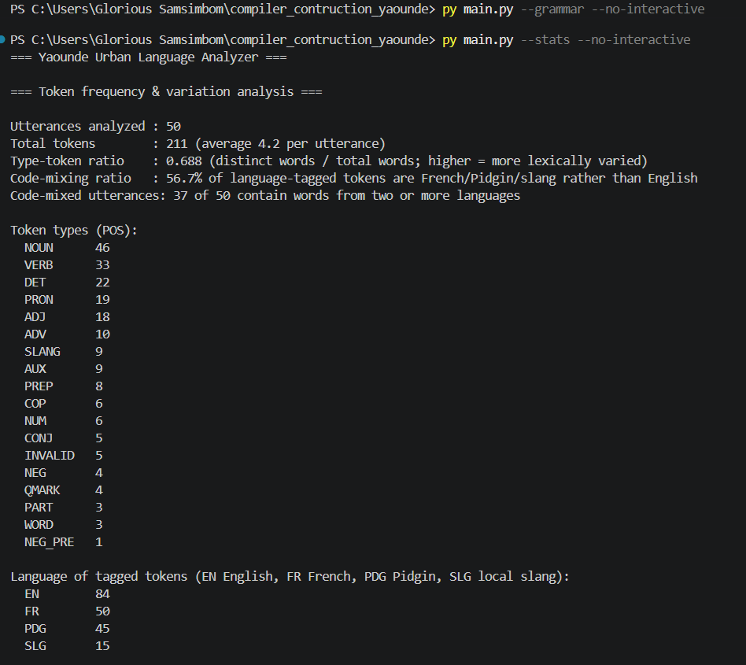  Figure 1: Output of `py main.py --stats` (summary, token types, languages). | 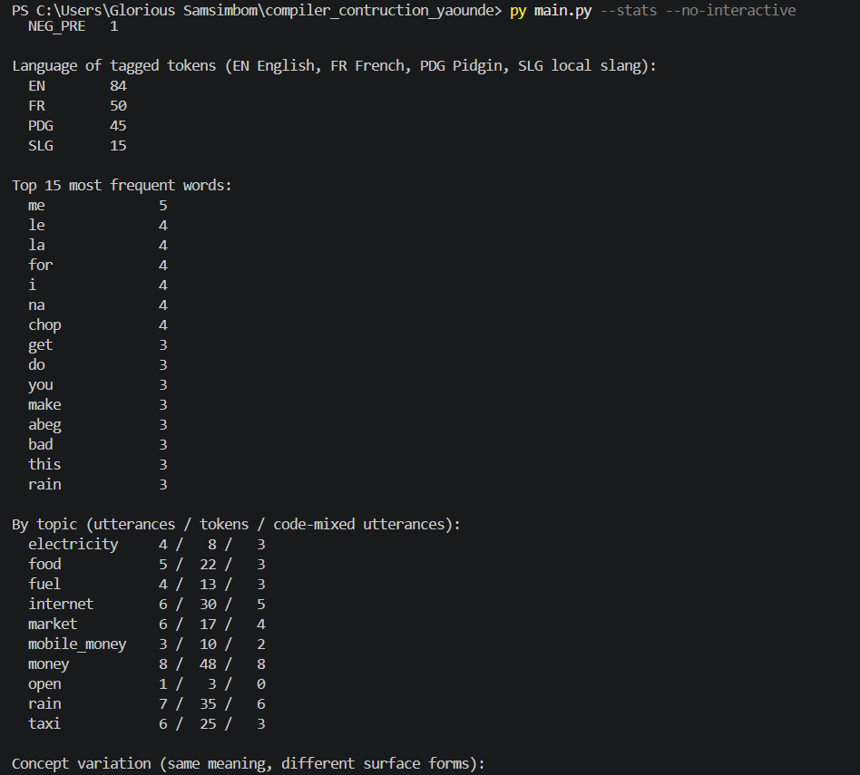  Figure 2: Same command: top words and counts by topic.

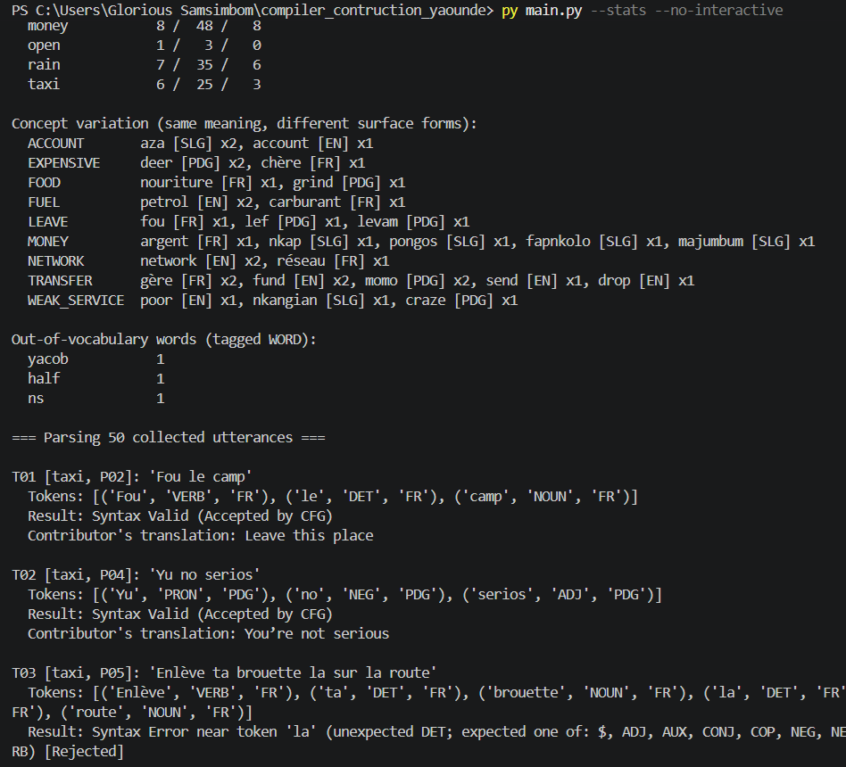
Figure 3: Same command: concept variation and out-of-vocabulary words.
Comment
These screenshots are the program’s own output, so every number in the tables above can be reproduced with py main.py --stats --no-interactive.
Presentation clue: the out-of-vocabulary list is short (yacob, ns, half) only because the vocabulary was built from these same utterances. On new speech it would be longer, which we say honestly in the limitations.

5. Syntactic analysis

5.1 Designing the context-free grammar
A context-free grammar (CFG) is a set of rewrite rules that describes which sequences of token types form a valid sentence. We looked at the accepted shapes in the data and wrote rules for them:
- Imperatives: Fou le camp; Enter motomoto; Gère ton OM (verb + object).
- Subject + predicate: Yu no serios; Petrol don short; Le carburant est chère (copula, aspect marker don, negation no).
- French negation ne ... pas: Ne joue pas avec Mon argent salo.
- Double objects and clause chains: I send my aza make you fund me fapnkolo.
- Fragments, exclamations and particles: Last price; Massa Eneo; Fair vite nor.
Symbol | Stands for
S | a whole utterance
LEAD | optional leading exclamation
UTT | one or more clauses joined by a conjunction
CLAUSE | one clause (fragment, imperative or subject + predicate)
PRED | what is said about the subject
AUXC | what follows an aspect auxiliary
NEGC | what follows a negation word
COMP | complement of a copula
ADJP | one or more adjectives
VP | verb phrase (with French ne...pas if present)
VP1 | first thing after the verb
VPOBJ | second object or trailing PPs
VP2 | any number of prepositional phrases
PP | preposition + noun phrase
NP | noun phrase
NPN | non-pronoun noun phrase
NBAR | noun core: adjectives, numerals and noun compounds
TAIL | final particle / exclamation and question mark
TAILW | the final particle or exclamation
QM | optional question mark

The CFG as designed (ε means “nothing”; upper-case words that never appear on the left are token types):
S -> LEAD UTT TAIL
LEAD -> SLANG | ε
UTT -> UTT CONJ CLAUSE | CONJ CLAUSE | CLAUSE
CLAUSE -> NP PRED | NP | VP | COP COMP | ADV ADJP
PRED -> VP | COP COMP | AUX AUXC | NEG NEGC | ADJP
AUXC -> ADJP | VP
NEGC -> ADJP | VP
COMP -> ADJP | ADV | ADV ADJP
ADJP -> ADJP ADJ | ADJ
VP -> NEG_PRE VERB NEG VP1 | VERB VP1
VP1 -> PRON VPOBJ | NPN VP2 | PP VP2 | ADV VP2 | ε
VPOBJ -> NP VP2 | VP2
VP2 -> PP VP2 | ε
PP -> PREP NP
NP -> PRON | NPN
NPN -> DET NBAR | NBAR
NBAR -> NBAR NOUN | NOUN | ADJ NOUN | ADJ NUM | NUM
TAIL -> TAILW QM
TAILW -> PART | SLANG | ε
QM -> QMARK | ε
Comment
The grammar is deliberately a fragment: it describes the shapes seen most often, not the whole language. Utterances outside these shapes are rejected on purpose, which is discussed in Sections 7 and 8.
Presentation clue: S is the start symbol; LEAD and TAIL wrap the optional exclamation at the start and the particle or question mark at the end.

5.2 Step 1: removing left recursion
A rule such as A -> A x | y calls itself first (left recursion). A top-down parser would expand A forever without consuming a token. The standard fix rewrites A -> A x | y as A -> y A' and A' -> x A' | ε. Three rules were left-recursive:
Rule | Before | After
UTT | UTT -> UTT CONJ CLAUSE | CONJ CLAUSE | CLAUSE | UTT -> CONJ CLAUSE UTT' | CLAUSE UTT'  UTT' -> CONJ CLAUSE UTT' | ε
ADJP | ADJP -> ADJP ADJ | ADJ | ADJP -> ADJ ADJP'  ADJP' -> ADJ ADJP' | ε
NBAR | NBAR -> NBAR NOUN | NOUN | ADJ NOUN | ADJ NUM | NUM | NBAR -> NOUN NBAR' | ADJ NOUN NBAR' | ADJ NUM NBAR' | NUM NBAR'  NBAR' -> NOUN NBAR' | ε

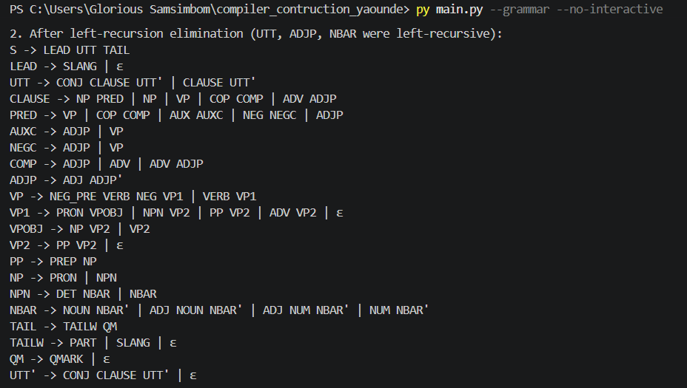
Figure 4: Program output for step 2 (`py main.py --grammar`): the grammar after left-recursion elimination.
Comment
UTT, ADJP and NBAR are the places where the data repeat a unit: several clauses, several adjectives, several nouns (achombo house). The helper symbols UTT', ADJP' and NBAR' express the repetition without left recursion. All other rules had none and were left unchanged by the algorithm.

5.3 Step 2: left factoring
When two rules for the same symbol start identically, one token of lookahead cannot decide which to use. Left factoring pulls out the shared start: A -> x y | x z becomes A -> x A' and A' -> y | z. Three symbols needed it:
Rule | Before (after step 1) | After
CLAUSE | CLAUSE -> NP PRED | NP | VP | COP COMP | ADV ADJP | CLAUSE -> VP | COP COMP | ADV ADJP | NP CLAUSE'  CLAUSE' -> PRED | ε
COMP | COMP -> ADJP | ADV | ADV ADJP | COMP -> ADJP | ADV COMP'  COMP' -> ε | ADJP
NBAR | NBAR -> NOUN NBAR' | ADJ NOUN NBAR' | ADJ NUM NBAR' | NUM NBAR' | NBAR -> NOUN NBAR' | NUM NBAR' | ADJ NBAR''  NBAR'' -> NOUN NBAR' | NUM NBAR'

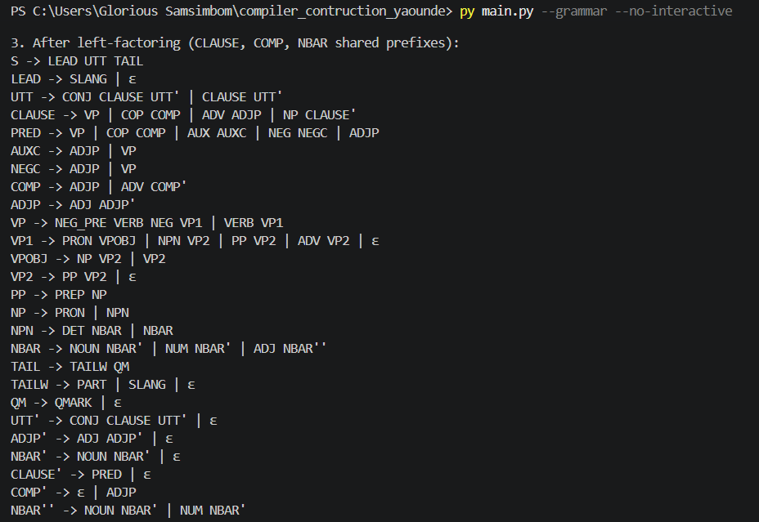
Figure 5: Program output for step 3: the final LL(1)-ready grammar after left factoring.
Comment
CLAUSE is the clearest case: a subject noun phrase may or may not be followed by a predicate (NP PRED versus just NP). After factoring the parser reads the NP first and decides afterwards through CLAUSE'. This is the grammar the parser actually uses.

5.4 Step 3: FIRST and FOLLOW sets
FIRST(X) is the set of token types that can begin a string derived from X (ε is included if X can derive nothing). FOLLOW(X) is the set of token types that can appear immediately after X. Both are computed by repeating the standard rules until nothing changes.
Symbol | FIRST | FOLLOW
S | ADJ, ADV, CONJ, COP, DET, NEG_PRE, NOUN, NUM, PRON, SLANG, VERB | $
LEAD | SLANG, ε | ADJ, ADV, CONJ, COP, DET, NEG_PRE, NOUN, NUM, PRON, VERB
UTT | ADJ, ADV, CONJ, COP, DET, NEG_PRE, NOUN, NUM, PRON, VERB | $, PART, QMARK, SLANG
CLAUSE | ADJ, ADV, COP, DET, NEG_PRE, NOUN, NUM, PRON, VERB | $, CONJ, PART, QMARK, SLANG
PRED | ADJ, AUX, COP, NEG, NEG_PRE, VERB | $, CONJ, PART, QMARK, SLANG
AUXC | ADJ, NEG_PRE, VERB | $, CONJ, PART, QMARK, SLANG
NEGC | ADJ, NEG_PRE, VERB | $, CONJ, PART, QMARK, SLANG
COMP | ADJ, ADV | $, CONJ, PART, QMARK, SLANG
ADJP | ADJ | $, CONJ, PART, QMARK, SLANG
VP | NEG_PRE, VERB | $, CONJ, PART, QMARK, SLANG
VP1 | ADJ, ADV, DET, NOUN, NUM, PREP, PRON, ε | $, CONJ, PART, QMARK, SLANG
VPOBJ | ADJ, DET, NOUN, NUM, PREP, PRON, ε | $, CONJ, PART, QMARK, SLANG
VP2 | PREP, ε | $, CONJ, PART, QMARK, SLANG
PP | PREP | $, CONJ, PART, PREP, QMARK, SLANG
NP | ADJ, DET, NOUN, NUM, PRON | $, ADJ, AUX, CONJ, COP, NEG, NEG_PRE, PART, PREP, QMARK, SLANG, VERB
NPN | ADJ, DET, NOUN, NUM | $, ADJ, AUX, CONJ, COP, NEG, NEG_PRE, PART, PREP, QMARK, SLANG, VERB
NBAR | ADJ, NOUN, NUM | $, ADJ, AUX, CONJ, COP, NEG, NEG_PRE, PART, PREP, QMARK, SLANG, VERB
TAIL | PART, QMARK, SLANG, ε | $
TAILW | PART, SLANG, ε | $, QMARK
QM | QMARK, ε | $
UTT' | CONJ, ε | $, PART, QMARK, SLANG
ADJP' | ADJ, ε | $, CONJ, PART, QMARK, SLANG
NBAR' | NOUN, ε | $, ADJ, AUX, CONJ, COP, NEG, NEG_PRE, PART, PREP, QMARK, SLANG, VERB
CLAUSE' | ADJ, AUX, COP, NEG, NEG_PRE, VERB, ε | $, CONJ, PART, QMARK, SLANG
COMP' | ADJ, ε | $, CONJ, PART, QMARK, SLANG
NBAR'' | NOUN, NUM | $, ADJ, AUX, CONJ, COP, NEG, NEG_PRE, PART, PREP, QMARK, SLANG, VERB

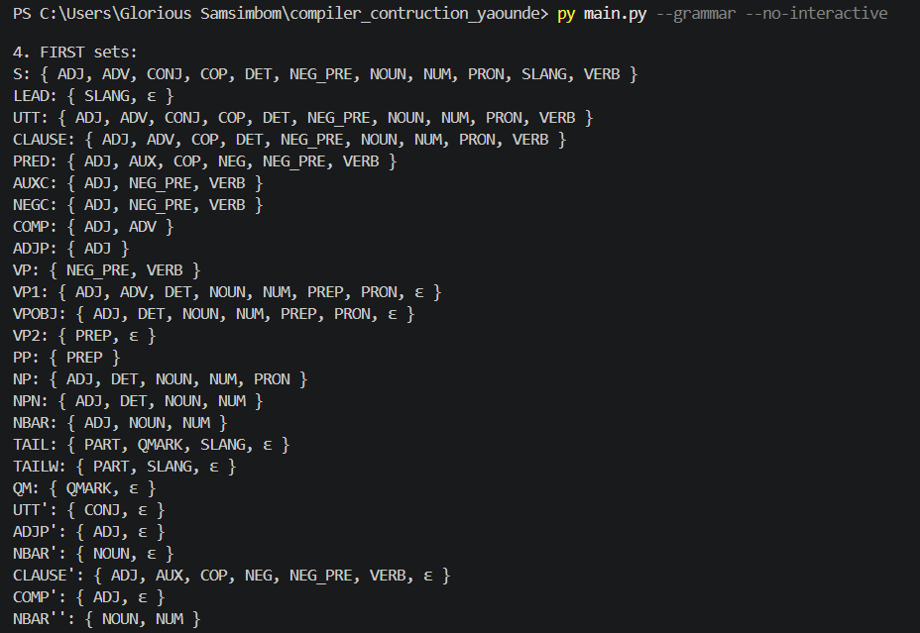  Figure 6: FIRST sets as printed by the program. |  | 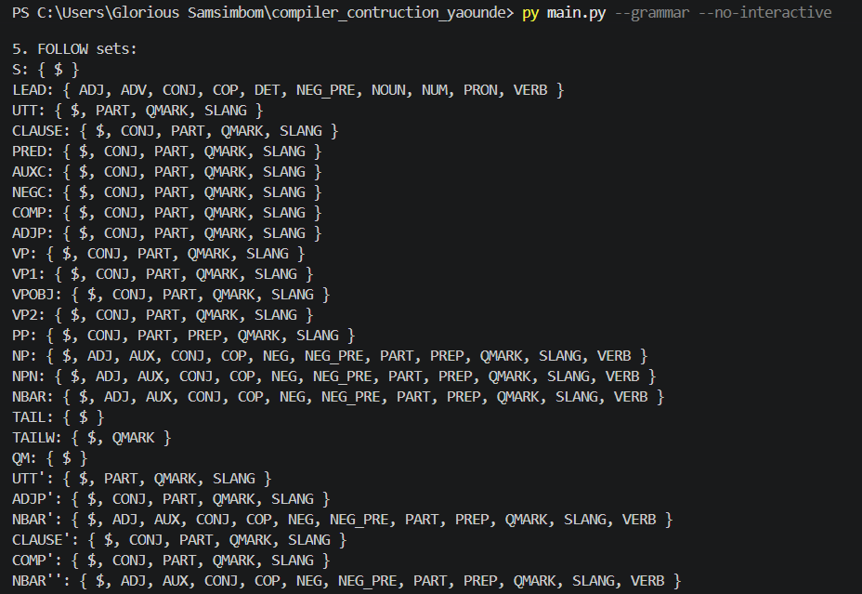  Figure 7: FOLLOW sets as printed by the program.
Comment
Worked example: FIRST(VP1) contains ε because VP1 may be empty (an intransitive verb such as chop in U don chop). So the parser needs FOLLOW(VP1), which contains CONJ, PART, QMARK, SLANG and $, to know when to choose the empty rule.
Presentation clue: FIRST answers “which rule starts with this token?”; FOLLOW answers “when may I stop?”.

5.5 Step 4: the LL(1) parsing table
The table M[X, a] tells the parser which rule to use when the symbol on top of the stack is X and the next token type is a. It has 153 filled cells. A grammar is LL(1) only if no cell holds two different rules; the builder raises an error if that happens, and none occurred. Columns are split over two tables (part 1: ADJ, ADV, AUX, CONJ, COP, DET, NEG, NEG_PRE, NOUN; part 2: NUM, PART, PREP, PRON, QMARK, SLANG, VERB, $). An empty cell means a syntax error.
Part 1
 | ADJ | ADV | AUX | CONJ | COP | DET | NEG | NEG_PRE | NOUN
S | LEAD UTT TAIL | LEAD UTT TAIL |  | LEAD UTT TAIL | LEAD UTT TAIL | LEAD UTT TAIL |  | LEAD UTT TAIL | LEAD UTT TAIL
LEAD | ε | ε |  | ε | ε | ε |  | ε | ε
UTT | CLAUSE UTT' | CLAUSE UTT' |  | CONJ CLAUSE UTT' | CLAUSE UTT' | CLAUSE UTT' |  | CLAUSE UTT' | CLAUSE UTT'
CLAUSE | NP CLAUSE' | ADV ADJP |  |  | COP COMP | NP CLAUSE' |  | VP | NP CLAUSE'
PRED | ADJP |  | AUX AUXC |  | COP COMP |  | NEG NEGC | VP
AUXC | ADJP |  |  |  |  |  |  | VP
NEGC | ADJP |  |  |  |  |  |  | VP
COMP | ADJP | ADV COMP'
ADJP | ADJ ADJP'
VP |  |  |  |  |  |  |  | NEG_PRE VERB NEG VP1
VP1 | NPN VP2 | ADV VP2 |  | ε |  | NPN VP2 |  |  | NPN VP2
VPOBJ | NP VP2 |  |  | VP2 |  | NP VP2 |  |  | NP VP2
VP2 |  |  |  | ε
PP
NP | NPN |  |  |  |  | NPN |  |  | NPN
NPN | NBAR |  |  |  |  | DET NBAR |  |  | NBAR
NBAR | ADJ NBAR'' |  |  |  |  |  |  |  | NOUN NBAR'
TAIL
TAILW
QM
UTT' |  |  |  | CONJ CLAUSE UTT'
ADJP' | ADJ ADJP' |  |  | ε
NBAR' | ε |  | ε | ε | ε |  | ε | ε | NOUN NBAR'
CLAUSE' | PRED |  | PRED | ε | PRED |  | PRED | PRED
COMP' | ADJP |  |  | ε
NBAR'' |  |  |  |  |  |  |  |  | NOUN NBAR'

Part 2
 | NUM | PART | PREP | PRON | QMARK | SLANG | VERB | $
S | LEAD UTT TAIL |  |  | LEAD UTT TAIL |  | LEAD UTT TAIL | LEAD UTT TAIL
LEAD | ε |  |  | ε |  | SLANG | ε
UTT | CLAUSE UTT' |  |  | CLAUSE UTT' |  |  | CLAUSE UTT'
CLAUSE | NP CLAUSE' |  |  | NP CLAUSE' |  |  | VP
PRED |  |  |  |  |  |  | VP
AUXC |  |  |  |  |  |  | VP
NEGC |  |  |  |  |  |  | VP
COMP
ADJP
VP |  |  |  |  |  |  | VERB VP1
VP1 | NPN VP2 | ε | PP VP2 | PRON VPOBJ | ε | ε |  | ε
VPOBJ | NP VP2 | VP2 | VP2 | NP VP2 | VP2 | VP2 |  | VP2
VP2 |  | ε | PP VP2 |  | ε | ε |  | ε
PP |  |  | PREP NP
NP | NPN |  |  | PRON
NPN | NBAR
NBAR | NUM NBAR'
TAIL |  | TAILW QM |  |  | TAILW QM | TAILW QM |  | TAILW QM
TAILW |  | PART |  |  | ε | SLANG |  | ε
QM |  |  |  |  | QMARK |  |  | ε
UTT' |  | ε |  |  | ε | ε |  | ε
ADJP' |  | ε |  |  | ε | ε |  | ε
NBAR' |  | ε | ε |  | ε | ε | ε | ε
CLAUSE' |  | ε |  |  | ε | ε | PRED | ε
COMP' |  | ε |  |  | ε | ε |  | ε
NBAR'' | NUM NBAR'

Comment: how to read the table
Example 1: the row CLAUSE under column DET holds NP CLAUSE', so a clause starting with an article (le, my, that) is parsed as a noun phrase first.
Example 2: the row VP1 under column PREP holds PP VP2, so a verb followed directly by a preposition (Levam for this price) reads a prepositional phrase.
Example 3: the row VP2 under column CONJ holds ε, so after the verb phrase the parser stops and lets the conjunction make start a new clause.

6. Implementation

6.1 Architecture
File | Responsibility
vocabulary.csv | The lexicon: word, token type, language, concept and note. Edited by hand; drives the lexer.
lexer.py | Builds one regex rule per token type and scans a phrase into tokens (Section 4.2).
grammar.py | The raw CFG plus generic algorithms: left-recursion removal, left factoring, FIRST, FOLLOW and the LL(1) table.
parser.py | Table-driven LL(1) parser with a step trace, a parse tree and precise error messages.
corpus.csv / corpus.py | The 50 test utterances with translation, topic and expected verdict.
analysis.py | Token frequency, language mix, per-topic figures and concept variation (Section 4.4).
main.py | Command-line interface: parses the corpus and prints the grammar steps and statistics.
gui.py | Desktop interface (Tkinter) with tokens, parse tree, parse trace, results and grammar windows.
test_pipeline.py | Nine automated tests (Section 7.1).

6.2 The table-driven LL(1) parsing algorithm
The parser keeps a stack that starts with $ S. It repeats the following until it accepts or fails:
X = top of stack ; a = kind of the next token
if X == $ and a == $ : ACCEPT
elif X is a terminal : if X == a then pop X and advance else ERROR (expected X)
else : rule = M[X, a]
if rule is empty then ERROR (list the tokens M allows for X)
else pop X and push the right-hand side of rule in reverse order
While it runs, the parser also builds the parse tree and records every step. On an error it reports the offending token and the token types that would have been accepted, for example: Syntax Error near token 'la' (unexpected DET; expected one of: $, ADJ, AUX, ...).

6.3 Worked example: F04 “U don chop?”
The utterance means “Have you eaten?”. Tokens: U (PRON), don (AUX), chop (VERB), ? (QMARK). The trace below is generated by the program:
Step | Stack (top on the right) | Remaining input | Action
1 | $ S | PRON AUX VERB QMARK $ | S -> LEAD UTT TAIL
2 | $ TAIL UTT LEAD | PRON AUX VERB QMARK $ | LEAD -> ε
3 | $ TAIL UTT | PRON AUX VERB QMARK $ | UTT -> CLAUSE UTT'
4 | $ TAIL UTT' CLAUSE | PRON AUX VERB QMARK $ | CLAUSE -> NP CLAUSE'
5 | $ TAIL UTT' CLAUSE' NP | PRON AUX VERB QMARK $ | NP -> PRON
6 | $ TAIL UTT' CLAUSE' PRON | PRON AUX VERB QMARK $ | match PRON
7 | $ TAIL UTT' CLAUSE' | AUX VERB QMARK $ | CLAUSE' -> PRED
8 | $ TAIL UTT' PRED | AUX VERB QMARK $ | PRED -> AUX AUXC
9 | $ TAIL UTT' AUXC AUX | AUX VERB QMARK $ | match AUX
10 | $ TAIL UTT' AUXC | VERB QMARK $ | AUXC -> VP
11 | $ TAIL UTT' VP | VERB QMARK $ | VP -> VERB VP1
12 | $ TAIL UTT' VP1 VERB | VERB QMARK $ | match VERB
13 | $ TAIL UTT' VP1 | QMARK $ | VP1 -> ε
14 | $ TAIL UTT' | QMARK $ | UTT' -> ε
15 | $ TAIL | QMARK $ | TAIL -> TAILW QM
16 | $ QM TAILW | QMARK $ | TAILW -> ε
17 | $ QM | QMARK $ | QM -> QMARK
18 | $ QMARK | QMARK $ | match QMARK
19 | $ | $ | accept

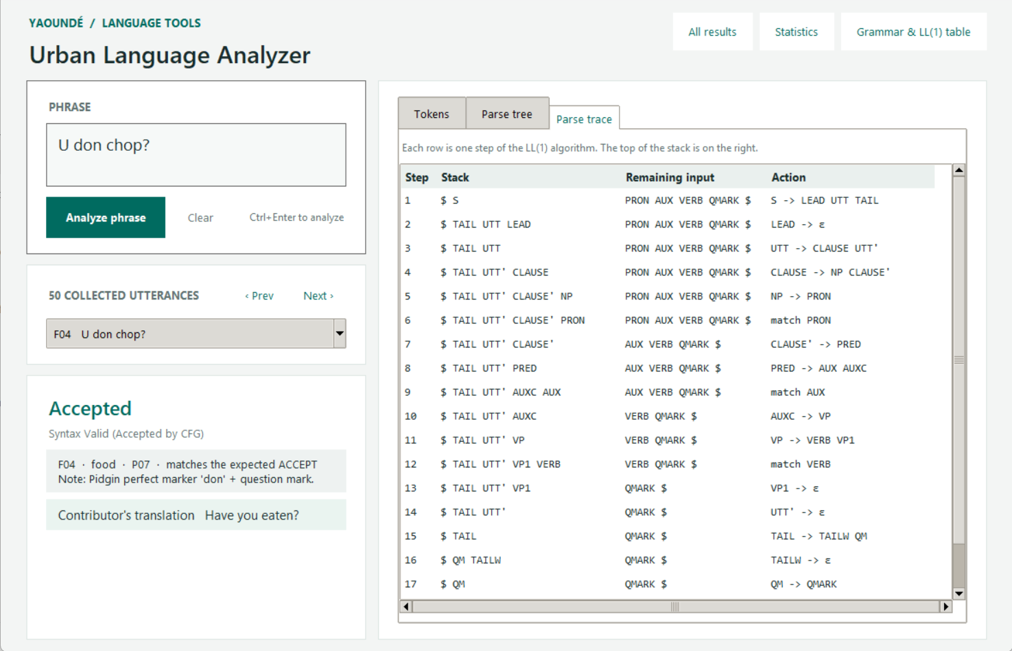
Figure 8: The same trace in the desktop interface (Parse trace tab).
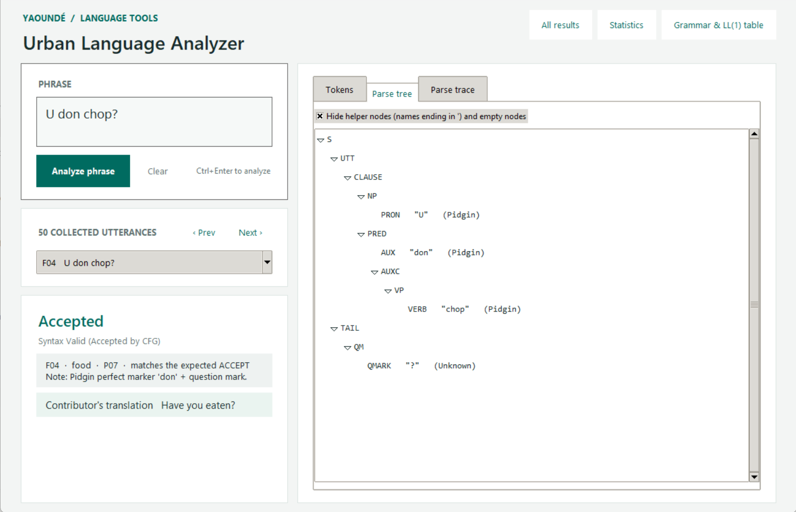
Figure 9: The resulting parse tree (Parse tree tab), with helper nodes hidden.
Comment
Follow the steps: S expands to LEAD UTT TAIL; LEAD becomes ε; UTT reads the clause; the subject U is matched, then don is recognised as an aspect auxiliary (PRED -> AUX AUXC) and chop as the verb; finally TAIL matches the question mark and $ ends the parse.
Presentation clue: the parse tree shows the structure the trace built. U is the subject NP, don chop the predicate and ? the tail.

7. Testing and results

7.1 Automated tests
Test | What it checks
test_dotted_abbreviation_is_one_token | E.N.E.O is scanned as one NOUN token, not four.
test_number_with_suffix | 2k and 100k are NUM tokens.
test_two_word_exclamation | Ndon ya (extra spaces) is a single SLANG token.
test_question_mark_unknown_word_and_emoji | ? is QMARK, an unknown word is WORD, an emoji is INVALID.
test_word_boundaries | sala is not split into a smaller word.
test_left_recursion_elimination | A -> A a | b becomes A -> b A' and A' -> a A' | ε.
test_left_factoring | S -> a b | a c becomes S -> a S' and S' -> b | c.
test_project_grammar_is_ll1_and_was_transformed | Both transformations changed our grammar and the LL(1) table was built without conflict.
test_every_collected_utterance_gets_its_expected_verdict | All 50 utterances get the verdict recorded in the corpus.

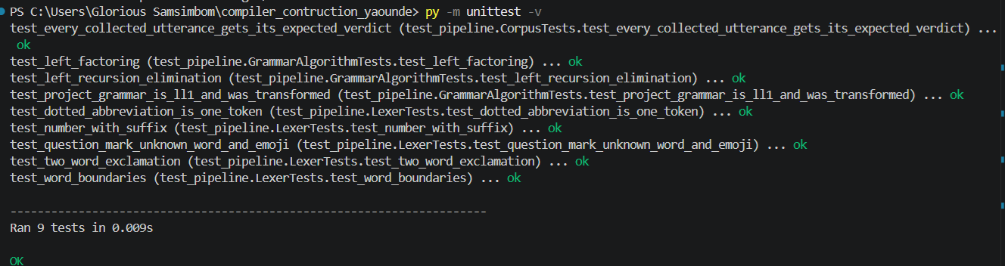
Figure 10: `py -m unittest -v`: all 9 tests pass.
Comment
The last test is the important one: it re-runs the whole pipeline on every collected utterance and fails if any verdict changes, so the results below cannot silently drift from what the grammar does.

7.2 Overall results
Topic | Utterances | Accepted | Rejected | Accepted share
Taxi / bendskin | 6 | 4 | 2 | 66.7%
Money matters | 8 | 4 | 4 | 50.0%
Rainy season | 7 | 2 | 5 | 28.6%
Internet / network | 6 | 4 | 2 | 66.7%
Market bargaining | 6 | 4 | 2 | 66.7%
Electricity | 4 | 4 | 0 | 100.0%
Phone credit & Mobile Money | 3 | 3 | 0 | 100.0%
Chop / food | 5 | 2 | 3 | 40.0%
Fuel queues | 4 | 4 | 0 | 100.0%
Open topic | 1 | 0 | 1 | 0.0%
Total | 50 | 31 | 19 | 62.0%

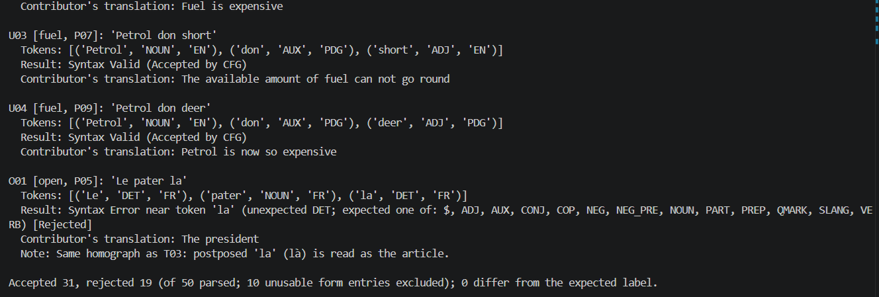
Figure 11: `py main.py --no-interactive`: the last entries and the summary line (31 accepted, 19 rejected, 0 differ from the expected label).
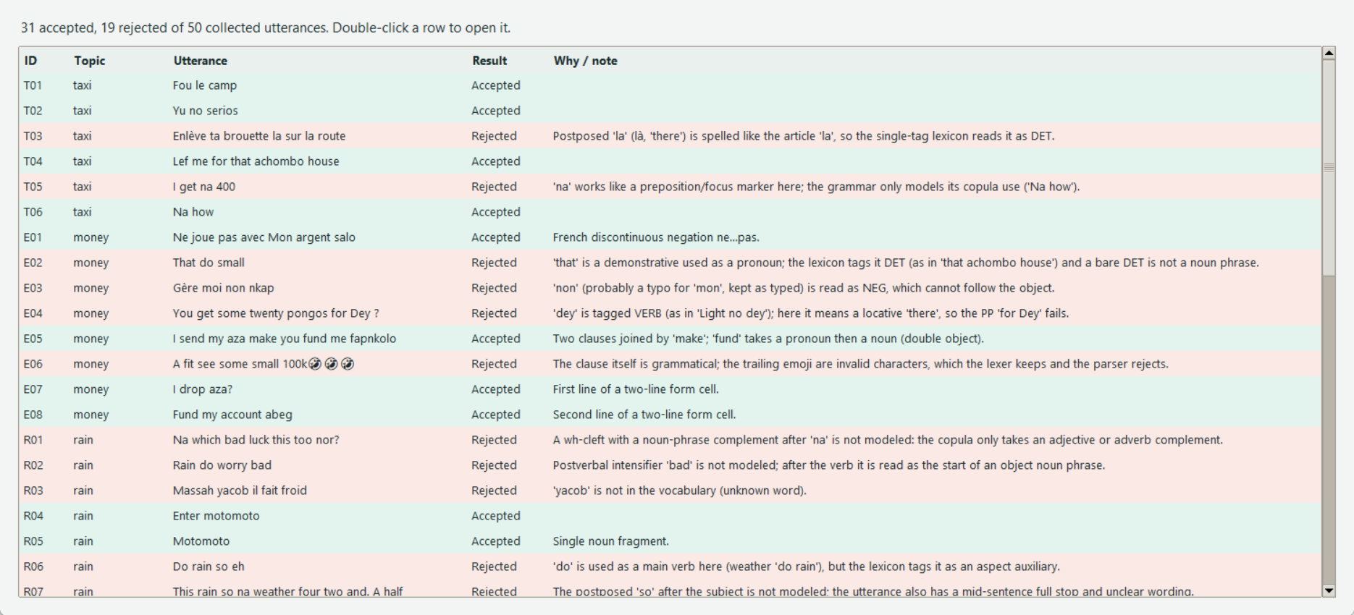
Figure 12: The “All results” window: accepted rows are green, rejected rows red, each with its reason.
Comment
31 of 50 utterances (62.0%) are accepted. This figure is optimistic: the grammar was designed from these same utterances, so it measures how well the rules describe the sample, not how well they would generalise. The rejections are as informative as the acceptances (Section 7.4).

7.3 Accepted utterances
ID | Utterance | Contributor’s translation | Structure recognised by the grammar
T01 | Fou le camp | Leave this place | imperative verb phrase
T02 | Yu no serios | You’re not serious | subject + negation
T04 | Lef me for that achombo house | Drop me off and that local restaurant | imperative verb phrase  prepositional phrase
T06 | Na how | How are you | subjectless copular clause
E01 | Ne joue pas avec Mon argent salo | Don’t play with my money fool | imperative verb phrase  French ne...pas negation; prepositional phrase; final exclamation
E05 | I send my aza make you fund me fapnkolo | Should I send my account details so you can send me 5000frs | subject + verb phrase | subject + verb phrase  clauses joined by a conjunction; double object
E07 | I drop aza? | Should I send my account details? | subject + verb phrase  question mark
E08 | Fund my account abeg | Please can you send me some money | imperative verb phrase  final exclamation
R04 | Enter motomoto | Enter mud | imperative verb phrase
R05 | Motomoto | Mud | noun-phrase fragment
I02 | Network poor bad | The network is poor | subject + predicate adjective
I03 | Orange et le réseau nkangian | Orange and weak internet | noun-phrase fragment | subject + predicate adjective  clauses joined by a conjunction
I05 | Yehum MTN | Disappointed at MTN | noun-phrase fragment  leading exclamation
I06 | Make single pole go offline make network cam back | Let single people go offline so we can have good network🤣 | subject + verb phrase | subject + verb phrase  leading conjunction; clauses joined by a conjunction
K02 | Levam for this price | Leave it at this price | imperative verb phrase  prepositional phrase
K04 | Last market | What they sell around the closing time of the market | noun-phrase fragment
K05 | Last price | Minimum price the seller can't go Below | noun-phrase fragment
K06 | Ei over deer | It’s too expensive | adverb + adjective  leading exclamation
L01 | Massa Eneo | Ugh, this Eneo (a sigh of annoyance when Eneo cuts the electricity) | noun-phrase fragment  leading exclamation
L02 | E.N.E.O | Eneo has done it again | noun-phrase fragment
L03 | Ndon ya SOCADEL | Disappointed at SOCADEL | noun-phrase fragment  leading exclamation
L04 | Light no dey | There’s no light | subject + negation
C01 | Gère ton OM | Give me your orange money | imperative verb phrase
C02 | Abeg momo me | Please send me money through mobile money | imperative verb phrase  leading exclamation
C03 | Abeg momo me 2k | Please send me 2k via momo | imperative verb phrase  leading exclamation; double object
F01 | La nouriture si dja | This food is nice | subject + copula + complement
F04 | U don chop? | Have you eaten? | subject + aspect marker (AUX)  question mark
U01 | Fair vite nor | Do fast | imperative verb phrase  final particle
U02 | Le carburant est chère | Fuel is expensive | subject + copula + complement
U03 | Petrol don short | The available amount of fuel can not go round | subject + aspect marker (AUX)
U04 | Petrol don deer | Petrol is now so expensive | subject + aspect marker (AUX)

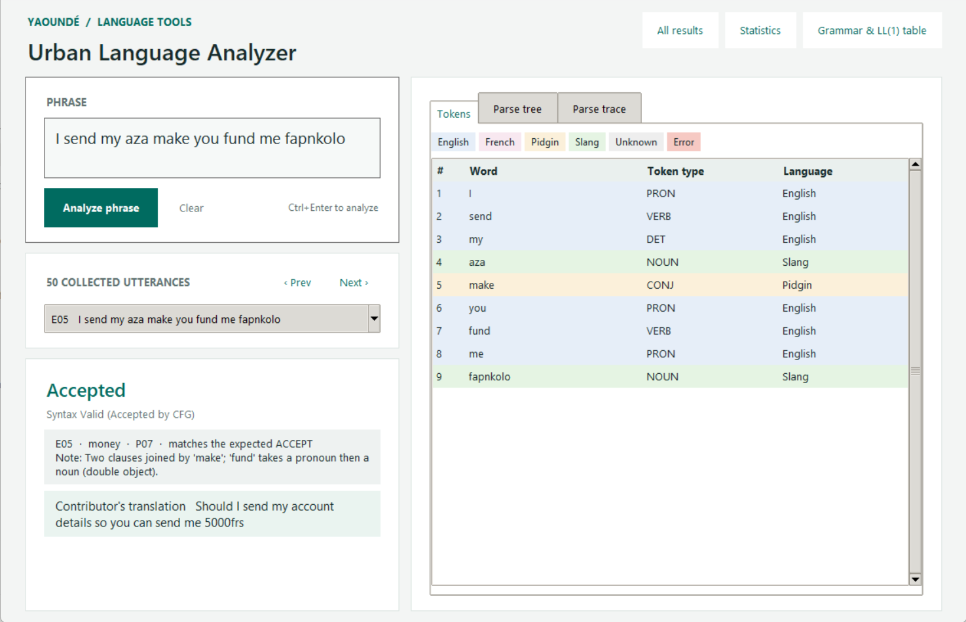
Figure 13: Accepted utterance E05 in the interface: tokens coloured by language (English blue, Pidgin yellow, slang green).
Comment
E05 (“I send my aza make you fund me fapnkolo”) shows the strengths of the grammar in one line: two clauses chained by the Pidgin conjunction make, a double object (fund me fapnkolo) and three languages (English, Pidgin, slang).

7.4 Rejected utterances and why
Each rejection is deliberate and documented. The column “Stops at” is the first token the parser could not accept.
ID | Utterance | Stops at | Reason
T03 | Enlève ta brouette la sur la route | unexpected DET 'la' | Postposed 'la' (là, 'there') is spelled like the article 'la', so the single-tag lexicon reads it as DET.
T05 | I get na 400 | unexpected COP 'na' | 'na' works like a preposition/focus marker here; the grammar only models its copula use ('Na how').
E02 | That do small | unexpected AUX 'do' | 'that' is a demonstrative used as a pronoun; the lexicon tags it DET (as in 'that achombo house') and a bare DET is not a noun phrase.
E03 | Gère moi non nkap | unexpected NEG 'non' | 'non' (probably a typo for 'mon', kept as typed) is read as NEG, which cannot follow the object.
E04 | You get some twenty pongos for Dey ? | unexpected VERB 'Dey' | 'dey' is tagged VERB (as in 'Light no dey'); here it means a locative 'there', so the PP 'for Dey' fails.
E06 | A fit see some small 100k🤣🤣🤣 | invalid character '🤣' | The clause itself is grammatical; the trailing emoji are invalid characters, which the lexer keeps and the parser rejects.
R01 | Na which bad luck this too nor? | unexpected DET 'which' | A wh-cleft with a noun-phrase complement after 'na' is not modeled: the copula only takes an adjective or adverb complement.
R02 | Rain do worry bad | end of input | Postverbal intensifier 'bad' is not modeled; after the verb it is read as the start of an object noun phrase.
R03 | Massah yacob il fait froid | unknown word 'yacob' | 'yacob' is not in the vocabulary (unknown word).
R06 | Do rain so eh | unexpected AUX 'Do' | 'do' is used as a main verb here (weather 'do rain'), but the lexicon tags it as an aspect auxiliary.
R07 | This rain so na weather four two and. A half | unexpected ADV 'so' | The postposed 'so' after the subject is not modeled; the utterance also has a mid-sentence full stop and unclear wording.
I01 | Mtn Va tous nous montrer au pays ci | unexpected DET 'tous' | The floating quantifier 'tous' between the auxiliary 'va' and the verb is not modeled.
I04 | MTN ns craze | unknown word 'ns' | 'ns' is not in the vocabulary (unknown word).
K01 | Venez me tromper | unexpected VERB 'tromper' | Serial verbs ('venez' + 'tromper') are not modeled: after a verb and pronoun object no second verb is allowed.
K03 | Majumbum depuis longtemps | unexpected PREP 'depuis' | A verbless noun phrase followed by a prepositional phrase is not modeled.
F02 | Chop rice chop rice | unexpected VERB 'chop' | Two juxtaposed imperatives with no conjunction are not modeled.
F03 | I di find. Grind | invalid character '.' | The mid-utterance full stop is an invalid character for the grammar.
F05 | You get chop for house | unexpected VERB 'chop' | 'chop' is tagged VERB (its usual use in this data); here it is a noun ('food') right after another verb, which a single-tag lexicon cannot resolve.
O01 | Le pater la | unexpected DET 'la' | Same homograph as T03: postposed 'la' (là) is read as the article.

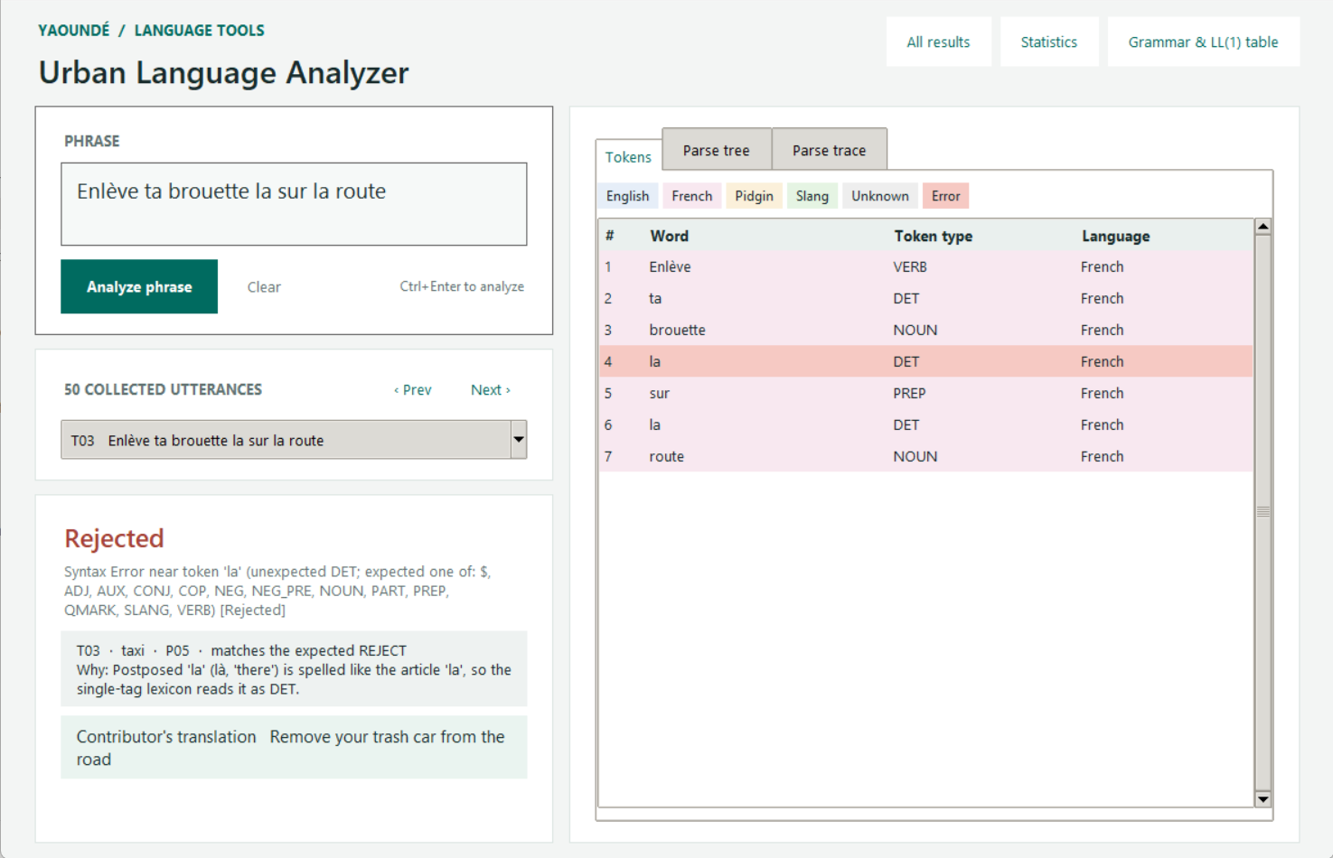
Figure 14: Rejected T03: the red row is the first `la`, where the parser stopped; the panel shows the reason.
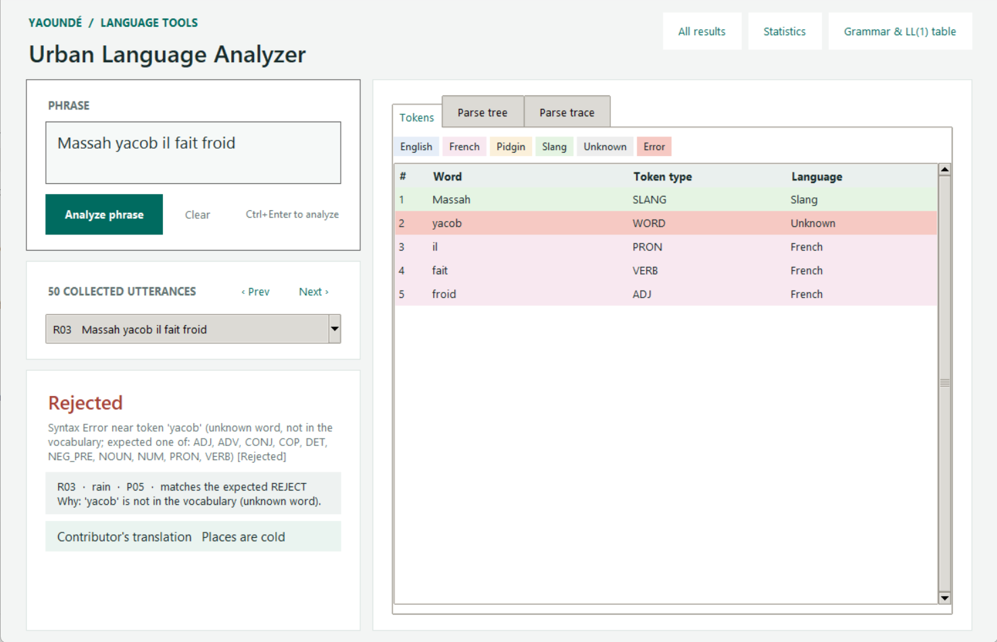
Figure 15: Rejected R03: `yacob` is not in the vocabulary, so it is tagged WORD (unknown).
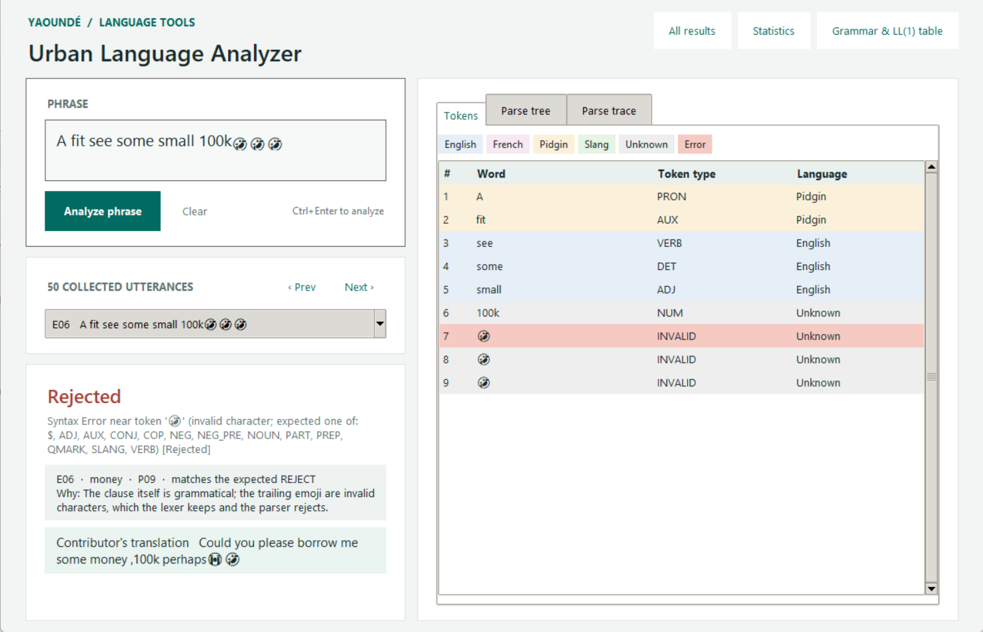
Figure 16: Rejected E06: the clause is valid but the three emoji are INVALID characters.
Comment: three kinds of rejection
Out-of-vocabulary or invalid input (R03 yacob, I04 ns, E06 emoji, F03 full stop): a lexical problem, detected by the lexer.
Words with several roles (T03/O01 la, F05 chop, E04 dey, T05 na, E02 that, R06 do): the lexicon gives each word one tag, so the grammar cannot tell which role is meant.
Constructions not modelled (K01 serial verbs, F02 juxtaposed imperatives, K03 verbless phrase + PP, R01 wh-cleft, R02 postverbal bad, I01 floating tous, E03 non): valid speech that lies outside our grammar fragment.

8. Why Yaoundé communication is linguistically complex
The results above are not only technical; they show how the speech itself resists a conventional compiler front end.

8.1 Several languages in one sentence
English and French are both official, and Pidgin, local languages and youth slang sit alongside them. In our data only 43.3% of tagged tokens are English and 37 of 50 utterances mix two or more languages. E01, “Ne joue pas avec Mon argent salo”, wraps a slang insult (salo) in a French negation frame; T04 puts a Pidgin verb, English function words and a slang noun (achombo) in one noun phrase.

8.2 One form, several functions
The same spelling plays different grammatical roles. la is an article in “la nouriture” and a postposed “there” in “Le pater la”; chop is a verb in “U don chop?” and a noun (food) in “You get chop for house”; dey is an existential verb in “Light no dey” and a locative “there” in “for Dey”; na is a copula in “Na how” and behaves like a preposition in “I get na 400”. A lexer that assigns one tag per word, followed by an LL(1) parser with one token of lookahead, cannot resolve these without context.

8.3 No standard spelling
Words are written as they sound: serios, deer for “dear” (expensive), nouriture, fair for “faire”, levam for “leave am”. The concept-variation table shows the same idea written many ways (money: argent, nkap, pongos, fapnkolo, majumbum). Every variant has to be listed or normalised.

8.4 Creative, short-lived vocabulary
Slang such as nkap, aza, pongos, fapnkolo, achombo, motomoto and ndon ya appears in no standard dictionary; meanings come from the contributors’ own translations. Names of companies and services (MTN, Orange, Eneo, SOCADEL, momo, OM) are part of daily speech too. Vocabulary changes quickly, so a fixed lexicon ages fast.

8.5 Oral, informal structure
The data are full of fragments (Motomoto; Last price), serial verbs (Venez me tromper), sentence-final particles (nor, eh), repetition (Chop rice chop rice), postposed particles (so, la) and expressive emoji. Few utterances are complete subject-verb-object sentences, so a grammar built for standard sentences covers only part of the speech.

8.6 What this means for a compiler design
A context-free grammar and a deterministic parser are good for the regular core and for teaching. Full coverage would need contextual tagging (to resolve la, chop, dey, na), spelling normalisation, and an ambiguity-tolerant parser (Earley or GLR) or a statistical model. Our rejected utterances point directly at where each of these would be needed.

9. Limitations and future work
- Data: 50 written utterances from one survey. The brief expects transcribed speech; ours are typed descriptions, and two topics (security checkpoints, university life) are missing.
- Evaluation: the grammar and lexicon were designed on the same 50 utterances, so the acceptance rate and the low out-of-vocabulary count are optimistic. A held-out test set is needed.
- Single-tag lexicon: each word has one token type, which causes the la/chop/dey/na rejections.
- Scope of the grammar: no serial verbs, wh-clefts, postposed particles or verbless phrase-plus-PP.
- Future work: collect and transcribe spoken data; add contextual tagging; try an SLR(1) or Earley parser and compare; add spelling normalisation.

10. Conclusion
We built a working analyzer for informal Yaoundé speech: a regular-expression lexer with a data-driven lexicon and language tags, a CFG that was transformed into an LL(1) grammar with FIRST/FOLLOW sets and a conflict-free parsing table, and a table-driven parser with a trace, a parse tree and precise errors. On 50 real utterances it accepted 31 and rejected 19, and every rejection is explained. The rejections show why Yaoundé speech is hard to analyse: heavy code-mixing, words with several roles, unstable spelling and fast-changing slang.

References
[1] Aho, A. V., Lam, M. S., Sethi, R. and Ullman, J. D. (2006). Compilers: Principles, Techniques, and Tools, 2nd edition. Pearson.
[2] Kießling, R. and Mous, M. (2004). Urban youth languages in Africa. Anthropological Linguistics, 46(3), 303-341.
[3] Python Software Foundation. The re module documentation (regular expression operations), python.org.
[4] The ICT University, Faculty of ICT (2026). CS4110 Compiler Construction final examination brief, Summer 2026.

Appendix A: Vocabulary
The 134 entries of vocabulary.csv (word, token type, language). Entries for si and dja were inferred from the contributors’ word-by-word translations and should be confirmed.
Word | Type | Lang | Word | Type | Lang | Word | Type | Lang
bad | ADJ | EN | non | NEG | FR | avec | PREP | FR
chère | ADJ | FR | pas | NEG | FR | depuis | PREP | FR
craze | ADJ | PDG | ne | NEG_PRE | FR | for | PREP | EN
deer | ADJ | PDG | account | NOUN | EN | sur | PREP | FR
dja | ADJ | UNK | achombo | NOUN | SLG | a | PRON | PDG
froid | ADJ | FR | argent | NOUN | FR | i | PRON | EN
last | ADJ | EN | aza | NOUN | SLG | il | PRON | FR
nkangian | ADJ | SLG | brouette | NOUN | FR | me | PRON | EN
poor | ADJ | EN | camp | NOUN | FR | moi | PRON | FR
serios | ADJ | PDG | carburant | NOUN | FR | nous | PRON | FR
short | ADJ | EN | e.n.e.o | NOUN | EN | u | PRON | PDG
single | ADJ | EN | eneo | NOUN | EN | you | PRON | EN
small | ADJ | EN | fapnkolo | NOUN | SLG | yu | PRON | PDG
back | ADV | EN | grind | NOUN | PDG | abeg | SLANG | PDG
ci | ADV | FR | house | NOUN | EN | ei | SLANG | PDG
how | ADV | EN | light | NOUN | EN | massa | SLANG | SLG
longtemps | ADV | FR | luck | NOUN | EN | massah | SLANG | SLG
offline | ADV | EN | majumbum | NOUN | SLG | ndon ya | SLANG | SLG
over | ADV | EN | market | NOUN | EN | salo | SLANG | SLG
so | ADV | EN | motomoto | NOUN | SLG | yehum | SLANG | SLG
too | ADV | EN | mtn | NOUN | EN | cam | VERB | PDG
vite | ADV | FR | network | NOUN | EN | chop | VERB | PDG
di | AUX | PDG | nkap | NOUN | SLG | dey | VERB | PDG
do | AUX | PDG | nouriture | NOUN | FR | drop | VERB | EN
don | AUX | PDG | om | NOUN | FR | enlève | VERB | FR
fit | AUX | PDG | orange | NOUN | EN | enter | VERB | EN
va | AUX | FR | pater | NOUN | FR | fair | VERB | FR
and | CONJ | EN | pays | NOUN | FR | fait | VERB | FR
et | CONJ | FR | petrol | NOUN | EN | find | VERB | EN
make | CONJ | PDG | pole | NOUN | PDG | fou | VERB | FR
est | COP | FR | pongo | NOUN | SLG | fund | VERB | EN
na | COP | PDG | pongos | NOUN | SLG | gère | VERB | FR
si | COP | UNK | price | NOUN | EN | get | VERB | EN
la | DET | FR | rain | NOUN | EN | go | VERB | EN
le | DET | FR | réseau | NOUN | FR | joue | VERB | FR
mon | DET | FR | rice | NOUN | EN | lef | VERB | PDG
my | DET | EN | route | NOUN | FR | levam | VERB | PDG
some | DET | EN | socadel | NOUN | EN | momo | VERB | PDG
ta | DET | FR | weather | NOUN | EN | montrer | VERB | FR
that | DET | EN | four | NUM | EN | see | VERB | EN
this | DET | EN | twenty | NUM | EN | send | VERB | EN
ton | DET | FR | two | NUM | EN | tromper | VERB | FR
tous | DET | FR | eh | PART | PDG | venez | VERB | FR
which | DET | EN | nor | PART | PDG | worry | VERB | EN
no | NEG | PDG | au | PREP | FR

Appendix B: Running the project
py gui.py desktop interface
py main.py --no-interactive parse all 50 utterances
py main.py --grammar grammar steps, FIRST/FOLLOW and LL(1) table
py main.py --stats token frequency and variation
py -m unittest -v run the 9 automated tests
Python 3.9 or newer is required; the only optional component is Tkinter for the desktop interface.

