For the users who want to run this meshing tool without external tool, the following section expands on the format of Varai2D raw data – txt file.

Example 1:

In-order to create the surface above, we need the following inputs

######################################################

####### Samson Mano's Varai2D Raw Data ###############

######################################################

[+] End Points, 6

0, -657.82177734375, -250.38616943359375

1, -657.82177734375, 249.61383056640625

2, 142.17822265625, 249.61383056640625

3, 142.17822265625, -0.38616943359375

4, -531.089111328125, 55.554443359375

5, -331.089111328125, 55.554443359375

[+] Lines, 4

0, 0, 1

1, 1, 2

2, 2, 3

3, 0, 3

[+] Arcs, 2

4, 4, 5

c0, -431.089111328125, 60.027915954589844

c1, -431.089111328125, 160.1279296875

5, 4, 5

c0, -431.089111328125, 51.08096694946289

c1, -431.089111328125, -49.019046783447266

[+] Surfaces, 2

0, {1, 2, 3, 0}, n@1

n0[5, 4]

1, {5, 4}, n@0

######################################################

######################################################

Input: End points

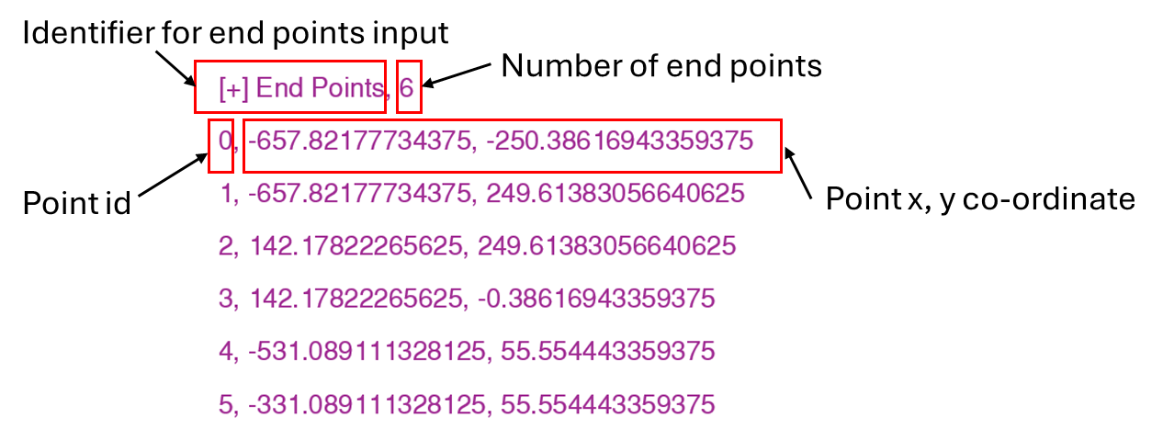

Input: Lines

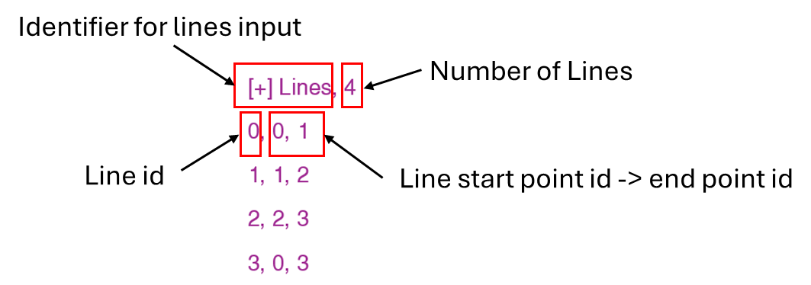

Input: Arcs

To create a circular arc, we need four points. The end points are already given. The points co is the arc center point and c1 is the point on the circular arc.

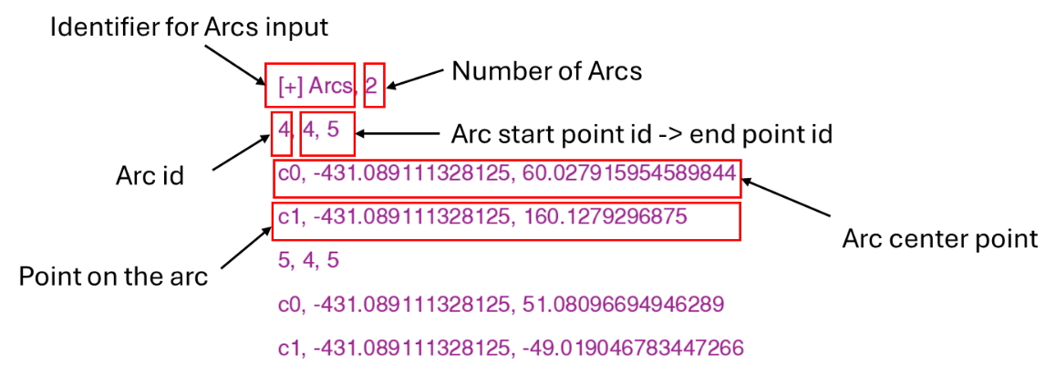

Input: Surface

The most important input to run the mesher is the surface input. Without the surface input the file will not be read by the mesher. Surface input covers the nesting data.

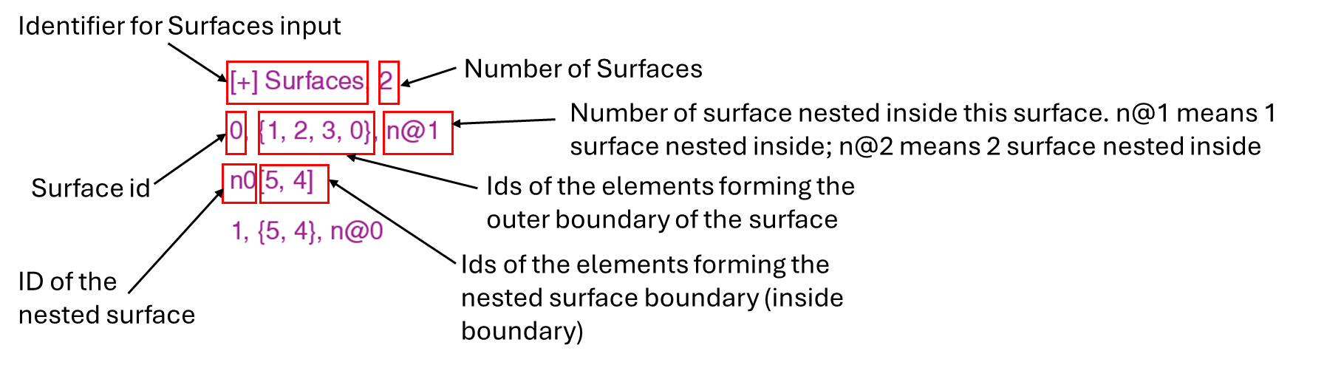

Example 2:

The surface input to form the below surface is shown below. This surface has two nested boundaries inside.

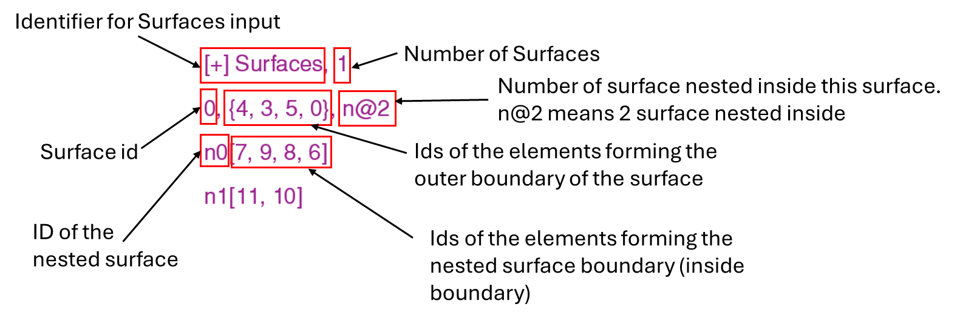

Result from the mesher:

