# How to use 2D Triangle Mesh Generator

2D Triangular mesh generator is an implementation of Constrained Delaunay Triangulation to create 2D triangular meshes. This tool can be used to create 2D triangular meshes which can be exported as text file. Multiple closed boundaries can be meshed.

## Before starting.

This tool uses Modern OpenGL for Graphics.

To Zoom in & Out: Ctrl + Scroll Up/ Down

To Pan the view: Ctrl + Right Click Drag

To Zoom to fit the view: Ctrl + F

Using this tool involves 3 Steps,

## Step 1: Create closed boundaries.

Use varai2D surface to create 2D surfaces that needed to be meshed. Below is the location of varai2D software

<https://github.com/Samson-Mano/Draw2D_geometry>

<https://github.com/Samson-Mano/Draw2D_geometry/tree/main/Varai2D_portable>

Below is an example showing 4 surfaces.

Export the surface as Raw data (*.txt)

## Step 2: Import the Raw surface data into 2D triangle mesh generator.

Open 2D Triangle mesh Generator and Import the Raw surface data from varai2D

File -> Import Geometry

Below shows the geometry inside 2D Triangle mesh generator.

## Step 3: Setup the meshing parameter and create mesh.

Go to Mesh -> Create Mesh to open the mesh creation panel. Selected surface is highlighted in Cyan and mesh control points shown in brown. Edge panel shows the list of boundary edges of the surface. Adjust the edge density to change the mesh size or set the Element size for the entire surface. Click on Create mesh to create the mesh

After meshing three surfaces out of four.

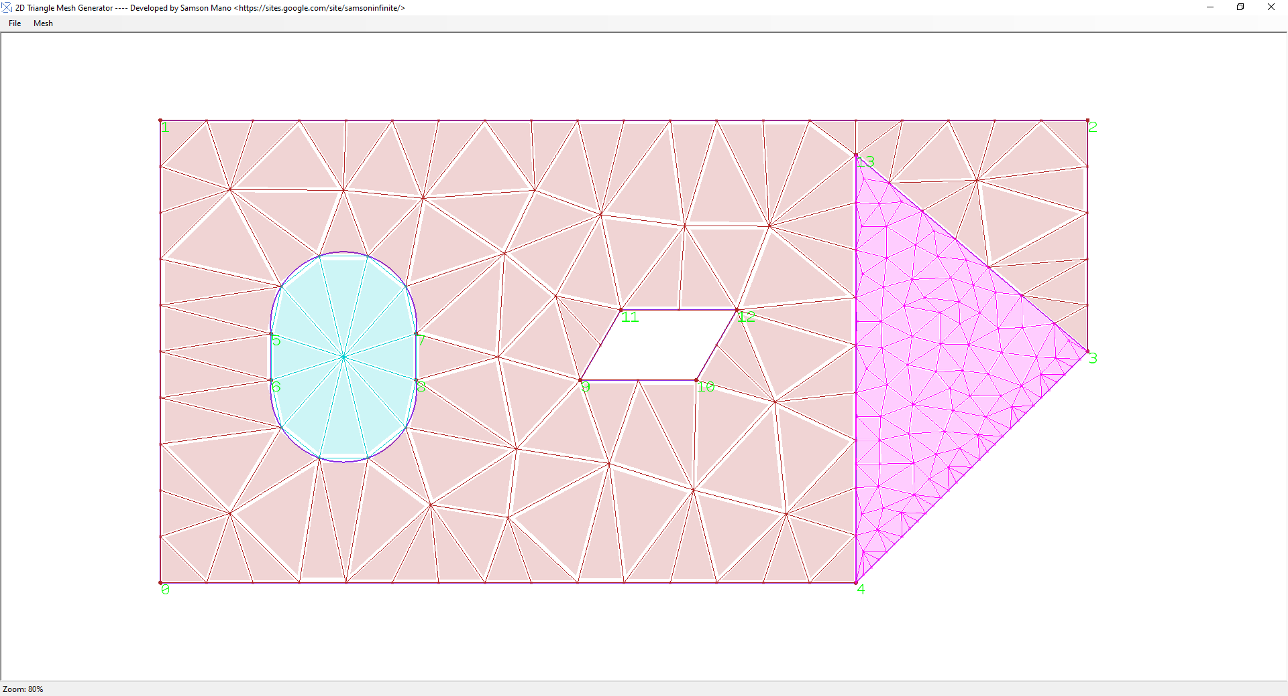

Go to Mesh -> Export mesh to export the mesh as Raw Data