|  |
| --- |
|  |

Samson Mano

saminnx@gmail.com

<https://sites.google.com/site/samsoninfinite/>

[https://github.com/Samson-Mano](%20https://github.com/Samson-Mano)

Position based dynamics

Formulation of PBD for compliant constrained dynamics

# Constraint dynamics

Constrained dynamics is a fundamental concept in physics simulations, particularly in the realms of computer graphics where it is employed to realistically model the behavior of both rigid and soft bodies. Constrained dynamics refers to the study and simulation of physical systems whose motion is restricted in some way by constraints. A constraint can be anything that limits the freedom of a system to move, such as joints, springs, or collision with other bodies.

## Algorithm

|  |
| --- |
| Algorithm: XPBD: Position-Based Simulation of Compliant Constrained Dynamics by Miles Macklin, Matthias M¨uller, Nuttapong Chentanez.  Input: Initial positions (xi0), velocities (vi0), masses (mi), external force function fext, time step Δt, solver iteration count  Output: Updated positions and velocities of particles  1. Initialize each particle i  **For each** particle i **do**  xi = xi0 // Set initial position  vi = vi0 // Set initial velocity  wi = 1 / mi // Compute inverse mass  **End For**  2. Simulation Loop  **Repeat**  // Update velocities with external force  **For each** particle i **do**  vi = vi + Δt * wi * fext(t, xi)  **End For**  // Update positions based on new velocities  **For each** particle i **do**  pi = xi + Δt * vi  **End For**  // Solve constraints specified times  **For** 1 to solveriteration **do**  projectConstraints(C_1, C_2, ..., C_M, p_1, p_2, ..., p_N)  **End For**  // Correct velocities and update positions  **For each** particle i **do**  vi = (pi - xi) / Δt  xi = pi  End For  **Until** simulation ends |

## Equation of motion

The equation of a general systems is,

Let the global force vector is given by Q and the constraint force is given by ,

The global equation governing the system becomes,

is the constraint reaction force.

The global notation for the constraint equation w.r.t q is given by C(q). By applying chain rule,

The matrix below is called the Jacobian of C

Differentiating above w.r.t time again gives

Substituting for in the above equation gives,

Setting to zero gives the below expression,

Or

Using the method of Lagrange multipliers, the direction of the optimal global constraint force is given by,

Substituting,

Like the inertial force, the damping and spring restoring force can be derived in the same way,

The final constraint equation for spring mass system is given by,

## Development of the constrained equation

Equations from the paper XPBD: Position – Based Simulation of Compliant Constrained Dynamics, Miles Macklin, Matthias Muller, Nuttapong Chentanez.

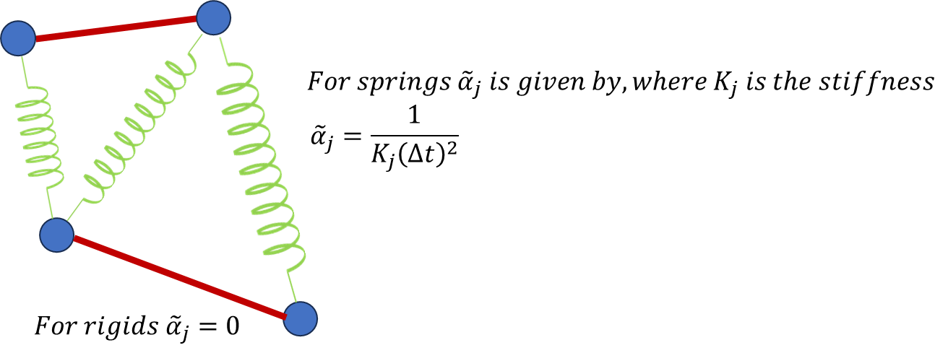

## Distance Constraint

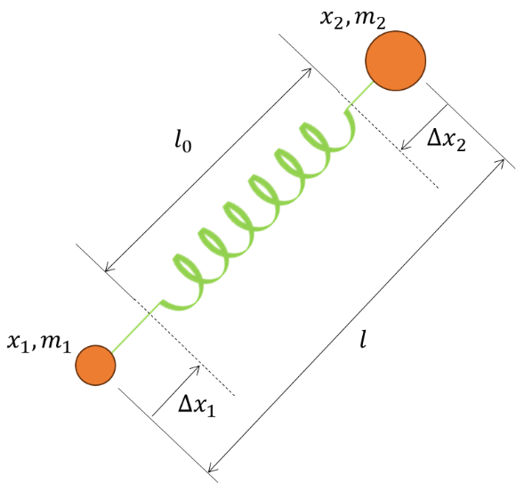

## Lagrange Multiplier MPC

Inclined rigid element.

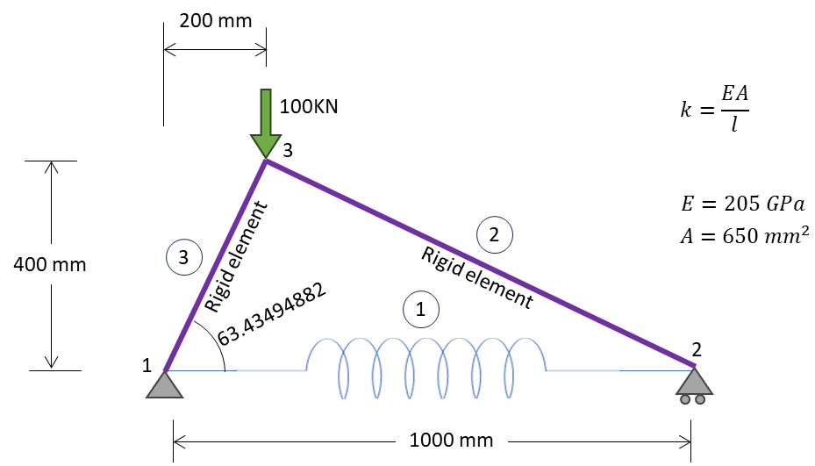

|  |  |  |
| --- | --- | --- |
|  | Element stiffness matrix |  |
|  | The direction cosines, |  |
|  | Direction cosine transformation matrix, |  |
|  | Element stiffness matrix | 1.0 |
|  | For element 1, |  |
|  |  | 2.0 |
|  | For element 2, |  |
|  |  | 3.0 |
|  | For element 3, |  |
|  |  |  |
|  |  | 4.0 |
|  | Global stiffness matrix | 5.0 |
|  | Appending the constraints to the global stiffness equation gives, |  |
|  |  | 6.0 |
|  | Adjunction process: Lagrange multiplier augmented bordered stiffness matrix |  |
|  |  |  |
|  | After applying the essential boundary condition. The matrix reduces to |  |
|  |  | 7.0 |
|  | Applying the stiffness values |  |
|  |  |  |
|  |  | 8.0 |
|  | Solving the above equation gives |  |
|  |  | 9.0 |
|  |  |  |
|  |  |  |

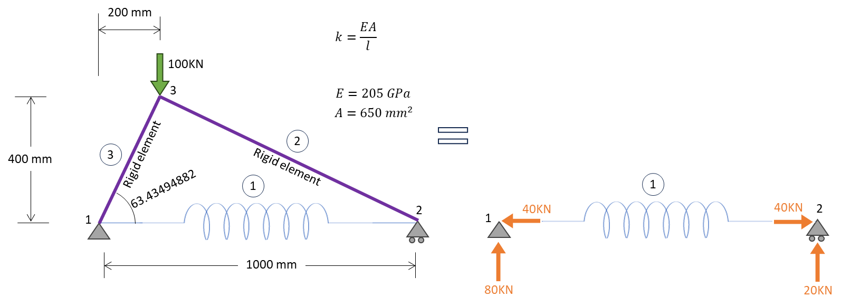

|  |  |  |
| --- | --- | --- |
|  | Exact solution is given by, |  |
|  |  |  |
|  |  | 1.0 |
|  | Rigid element 2 |  |
|  |  |  |
|  |  |  |
|  | Substituting and | 2.0 |
|  | Rigid element 3 |  |
|  |  |  |
|  |  |  |
|  | Substituting and | 3.0 |
|  | Solving eqn 2.0 and 3.0 |  |
|  |  |  |
|  |  |  |

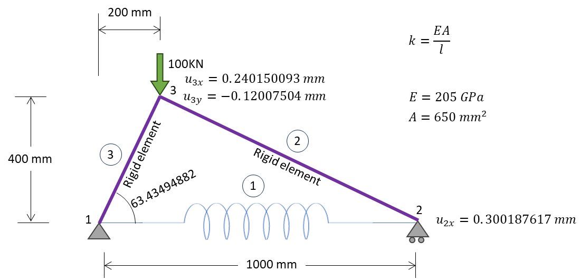

## Generalized Eigen Value problem – Lagrange multiplier MPC

Below is the free vibration generalized eigen value problem of a dynamic system without damping.

|  |  |  |
| --- | --- | --- |
|  | Generalized eigen value problem of mass – spring system | 1.0 |
|  | MPC – Lagrange Multiplier method, multiplier – augmented system, bordered equation is, |  |
|  |  | 2.0 |
|  | The solution to the eigen value problem defined in eqn 2 is complicated by the presence of many null elements in the involved matrices. We can use change of variables to overcome this difficulty. |  |
|  | Change of variable | 3.0 |
|  |  | 4.0 |
|  | Substitute the eqn 4.0 in eqn 2.0 | 5.0 |
|  | Pre-multiply the eqn 5.0, by the below |  |
|  |  | 6.0 |
|  | On a side note, Is the following expression valid? |  |
|  | Then, | 7.0 |
|  | Substitute eqn 7.0 in eqn 6.0 Mass matrix null lower block. |  |
|  | Simplifying the above equation gives the below standard eigen value problem. | 8.0 |
|  |  |  |
|  |  |  |
|  |  |  |
|  |  |  |