|  |
| --- |
|  |

Samson Mano

saminnx@gmail.com

<https://sites.google.com/site/samsoninfinite/>

[https://github.com/Samson-Mano](%20https://github.com/Samson-Mano)

EM WAVE PROPAGATION

Modelling oscillation of charged particle

# Introduction

## Charged particle

A charged particle is a particle with an electric charge. Electric charge (q) is the physical property of mater that causes it to experience a force when placed in an electromagnetic field. Electric charge can be positive or negative (commonly carried by protons and electrons respectively, by convention). Like charges repel each other and unlike charges attract each other. An object with no net charge is referred to as electrically neutral.

Coulomb's law can be stated as a simple mathematical expression. The scalar form gives the magnitude of the vector of the electrostatic force F between two point charges q1 and q2, but not its direction. If r is the distance between the charges, the magnitude of the force is

|  |  |  |
| --- | --- | --- |
|  | Columb’s law: |  |

where ε0 is the electric constant. If the product q1q2 is positive, the force between the two charges is repulsive; if the product is negative, the force between them is attractive.

## Electric field

An electric field is a vector field that associates to each point in space the Coulomb force experienced by a unit test charge. In the simplest case, the field is considered to be generated solely by a single source point charge.

|  |  |  |
| --- | --- | --- |
|  | Electric field due to stationary point charge is:  Where er is the radial unit vector. |  |

## Electric potential

The electric potential, or voltage, is the difference in potential energy per unit charge between two locations in an electric field.

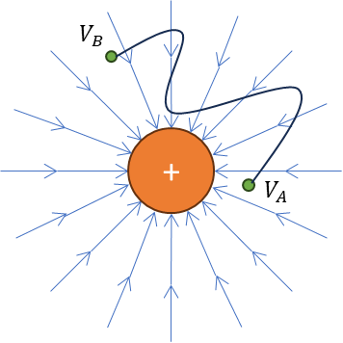

A charge q moving in a constant electric field E experience a force F = qE from that field. Gauss law states that the word done by the force is path independent. The difference in potential energy per unit charge between two locations in an electric field is given by

The electric potential at point r is given by

The path independency is due to the fact in electrostatics .

## Accelerating charged particle

Accelerating charges produce changing electric and magnetic fields. Changing electric fields produce magnetic fields and changing magnetic fields produce electric fields. This interplay between induced electric and magnetic fields leads to propagating electromagnetic waves. Electromagnetic waves can propagate through free space.

Assume a charge q located near the origin is accelerating. It therefore produces electromagnetic radiation. At some position r in space and at some time t, the electric field of the electromagnetic wave produced by the accelerating charge is given by

|  |  |  |
| --- | --- | --- |
|  | Electric field due to accelerating point charge is:  Where er is the radial unit vector. |  |

## Derivation of the Larmor’s formula

Consider a charged particle which is at rest until time t = 0, experiences an acceleration a for an infinitesimal time interval ∆t, and then continues to move with uniform velocity.

In Region I the electric field lines have not yet received the information about the acceleration, so they will look as if the particle is at rest, and nothing has changed. However, the field lines in Region II have received the information that the particle has accelerated, so they will match up to the final position of the particle (point A).

Solving for the acceleration yields

The kink in the electric field lines in the electromagnetic waves that propagates through space.

Where,

## Maxwell’s Equation

1. Gauss law for Electric field

The Gauss theorem connects the ‘flow’ of electric field lines (flux) to the charges within the enclosed surface in simple terms. The net charge in the volume contained by a closed surface is exactly proportional to the net flux through the closed surface.

The net electric flow stays 0 if no charges are contained by a surface. The number of electric field lines entering the surface equals the number of field lines exiting the surface.

1. Gauss law for magnetic field

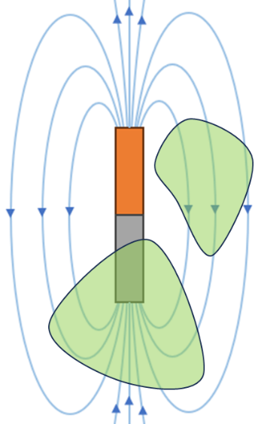

The net magnetic flux through any closed surface is equal to zero. There are no magnetic charges. Magnetic field lines always close in themselves. No matter how the (closed) Gaussian surface is chosen, the net magnetic flux through it always vanishes.

1. Differential form of Faraday’s law

A circulating electric field is produced by a magnetic field that changes with time.

1. Ampere – Maxwell’s law

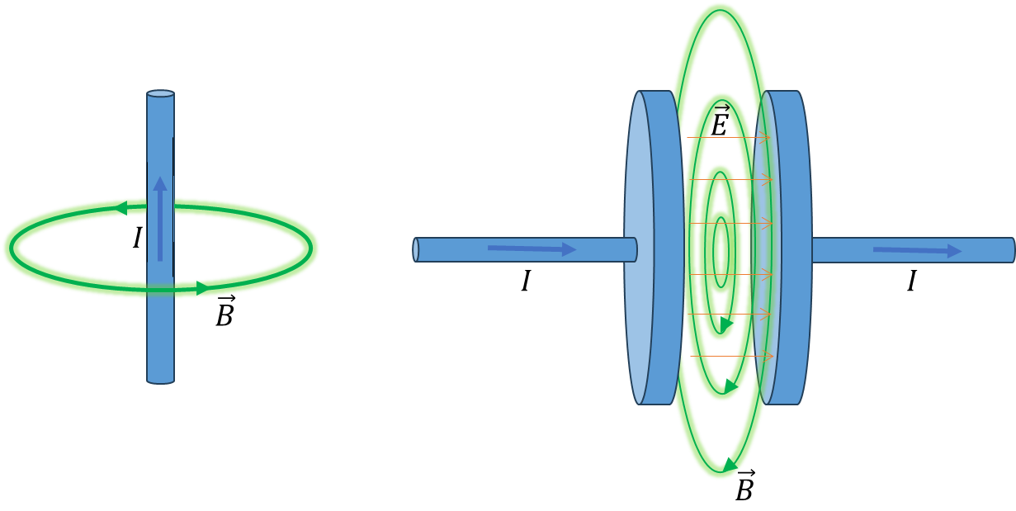

An electric current or a changing electric flux through a surface produces a circulating magnetic field around any path that bounds that surface.

A circulating magnetic field is produced by an electric current and by an electric field that changes with time.

Electric current density is proportional to the electric field.

## Inputs for implementation

The inputs for implementation are the path of the particle, frequency of oscillation and number of cycles. Path options will be closed curve or open curve. The path extend will be scaled to unit square.

