**C Charts**

1. **A hospital introduced hip protectors to reduce the frequency of injury-producing patient falls. The hip protectors were introduced in July. The following table records the number of injury-producing falls from January through December. Create and interpret a c chart for patient falls. Were the hip protectors effective in reducing injury-producing falls?**

**Figure 1**

*C Chart for Patient Falls*

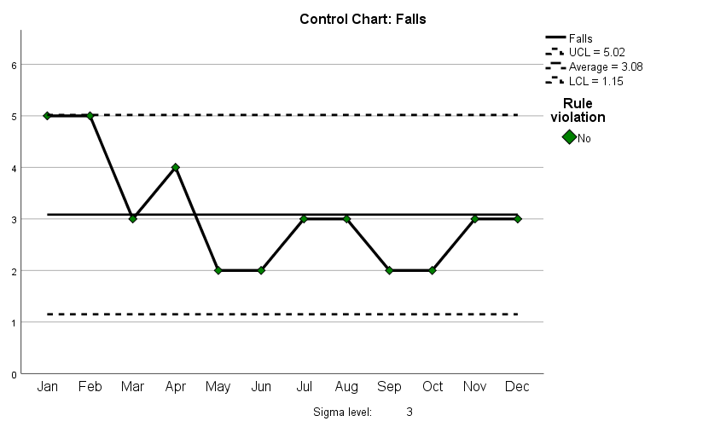

Based on the C chart, patient falls at the facility are stable and in control, since all the falls are within the control limits and follow a seemingly random pattern. The chart also indicates a decline in the number of falls, post the implementation of hip protectors. The average fall at the facility pre-hip protector implementation was 3.5 (S.D. =1.38, n = 6), which reduced to an average of 2.67 (S.D. = .52, n = 6) post the implementation of hip protectors. This suggests that the hip protectors effectively reduced injury-producing falls at the facility.

1. **The director of medical records conducts a monthly audit of 50 medical records to identify coding errors. National statistics indicate that approximately 15% of medical records contain errors, and in the past, the director has found multiple errors in a single record. Create a c chart to analyze performance. Interpret the department’s performance based on your control chart and identify any issues that should be investigated. Is the department doing a good job?**

**Figure 2**

*C Chart for Medical Records Coding Errors*

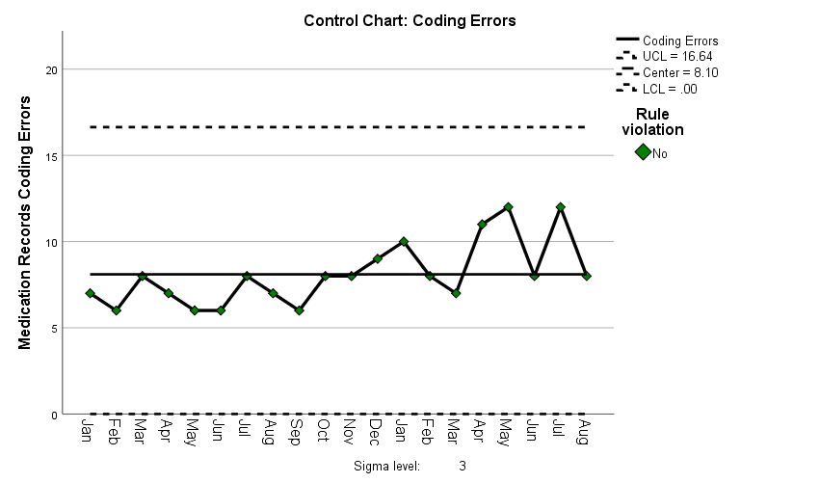

Medical records coding errors at the facility are in control since all the values fall within the control limits. However, there seems to be a positive trend that indicates increasing medical records coding errors over time, implying that the process could be out of control in the future. The facility should identify any systemic causes for the increasing trend and effectively address them to ensure the process remains in control. Also, on average, the facility records 16.2% errors, with an LCL of 0% and a UCL of 33.28%, indicating that the facility’s errors are above the national average. The facility should implement strategies to reduce coding errors and enhance its data integrity.

1. **The chief medical officer is concerned that the long lengths of stay at her hospital may be the result of missed oxygen treatments. She has enacted a program to reduce the number of missed treatments. The data records the number of missed oxygen treatments over the past 40 weeks. The improvement program was introduced in week 20. Was the program effective?**

**Figure 3**

*C Chart for Missed Oxygen Treatments*

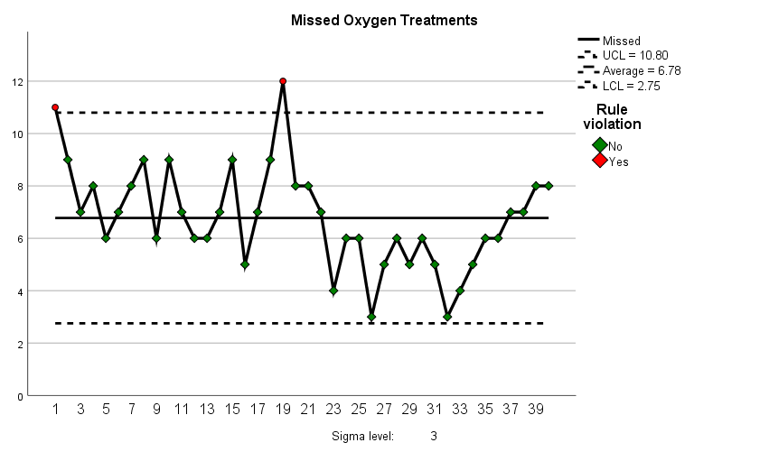

Although the process seems stable due to the randomness of missed oxygen treatments, it is out of control since the first and nineteenth records are above the UCL. However, the program can be considered effective due to the reduced counts of missed oxygen treatments from an average of 7.8 (S.D. = 1.77, n = 20) in the pre-program implementation period to an average of 5.75 (S.D. = 1.52, n = 20).

1. **Implementing regular nursing rounds has been demonstrated to increase patient satisfaction and reduce patient falls. A hospital has collected data on ten patients per month over the past 24 months. For the first twelve months, the hospital did not have a formal rounding system. During the second period, nurses were required to make rounds on an hourly basis from 8:00 AM through 8:00 PM and every two hours from 8:00 PM to 8:00 AM. Create a c chart to determine the effect of the rounding system on the use of call lights. Did the rounding program reduce patients’ use of call lights? Are there any issues that should be investigated?**

**Figure 4**

*C Chart for Call Lights Usage*

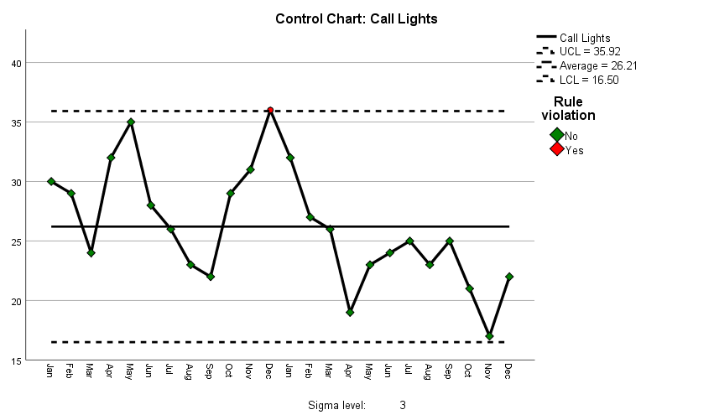

The process is out of control since the twelfth month as call lights usage above the UCL. However, the implementation of regular nursing rounds seems to have reduced the use of call lights at the facility from an average of 28.75 (S.D. = 4.45, n = 12) to 23.67 (S.D. = 23.67, n = 12). The chart confirms the decline, as most of the post-regular nursing rounds are below the central line.

1. **To supplement their patient satisfaction survey, End Result Hospital conducts in-depth telephone interviews with past patients. The interviews are based on a 1% sample of the completed surveys from the prior month. The sample varies widely due to differences in monthly admissions, the rate at which surveys are completed, and the willingness of patients to participate in the telephone interview. These concerns range from the effectiveness of medical treatment to the cleanliness and comfort of the patient room and ease of parking. The interviewer addresses the same items found on the patient satisfaction survey, solicits additional information for any item on which the patient indicated performance was less than “Good” or “Very Good,” and provides the patients with the opportunity to voice any other concerns. Create a control chart to summarize the results. Are patient concerns stable?**

**Figure 5**

*C Chart for Patient Concerns Recorded on Calls*

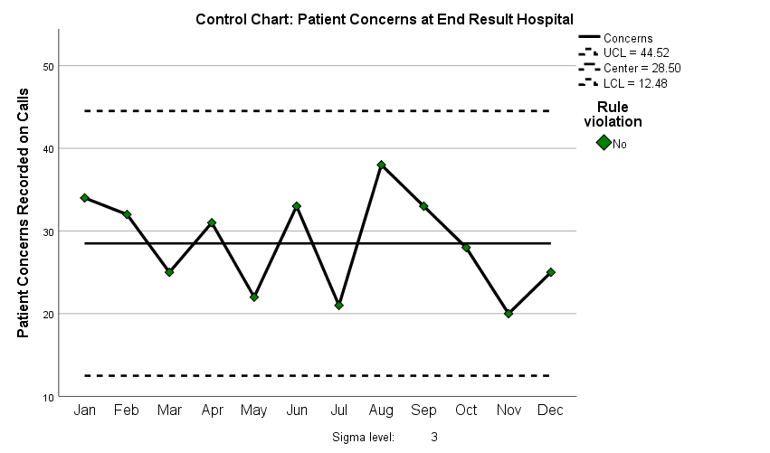

Patients’ concerns at the facility are in control since all the values fall within the control limits. However, the process may be unstable since the concerns follow slightly predictable increasing and decreasing patterns over time, indicating that the concerns may become out of control in the future if a similar trend continues. The facility should identify any systemic and operational causes for the concerns and address them to ensure that the facility’s concerns are purely due to random occurrences.